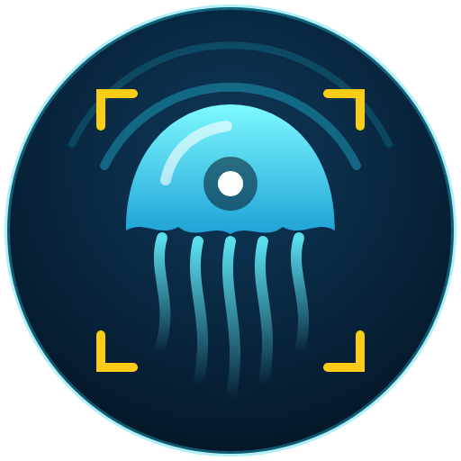
JellyWatch AI
Detect · Predict · Alert — early warning for jellyfish blooms on the UAE coast
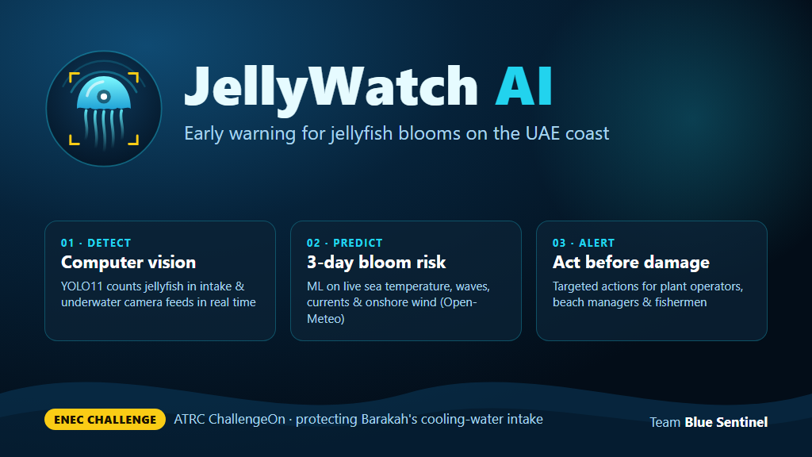
Proposal — ATRC ChallengeOn · ENEC Challenge
“How might we advance the sustainable management of seasonal jellyfish blooms in coastal environments?”
Team Blue Sentinel · Yosef

1. Executive summary
SLIDE 1 · AI that warns Barakah, beaches and fishermen about jellyfish blooms up to 3 days before they arrive.
Seasonal jellyfish blooms can block the seawater cooling intakes of coastal power plants, forcing power reductions or emergency shutdowns, and they also close beaches and damage fishing gear. Today, operators typically discover a bloom when the intake screens are already clogged.
JellyWatch AI turns this emergency into a planned operation with three layers:
- Detect — a computer-vision model (YOLO11, fine-tuned on jellyfish) counts and tracks jellyfish in real time on intake and underwater cameras.
- Predict — a machine-learning model reads real ocean and weather data (sea temperature, waves, currents, onshore wind, season) and forecasts bloom risk 0–100 for today and the next 3 days at each monitored site.
- Alert — targeted, actionable alerts for plant operators (prepare screens, increase cleaning), beach managers (swimming caution) and fishermen (avoid zone), with live camera evidence instantly raising the risk.
A working prototype already exists: detector (test mAP@50 = 0.79), live 3-day risk forecast on real Open-Meteo data for Barakah, Abu Dhabi Corniche and Ruwais, an alert engine and an interactive dashboard. The next step is a pilot with a real camera at the Barakah intake and ENEC's historical screen-cleaning logs to replace our clearly-labelled synthetic training labels.
What | Status today
Jellyfish detector (video, image, webcam) | Working — test mAP@50 0.79, precision 0.84
3-day bloom risk per site | Working — real ocean & weather inputs; synthetic labels (declared)
Alerts for 3 audiences | Working — in dashboard; Telegram integration ready
Dashboard (map, live detection, forecast, alerts) | Working — Streamlit web app

2. Introduction & team overview
SLIDE 2 · Team Blue Sentinel — a solo builder with hands-on real-time computer-vision experience.
Team name: Blue Sentinel. A sentinel that watches the sea so that people and infrastructure do not have to react too late.
Member | Role | Relevant experience
Yosef | Founder · AI & software lead (end-to-end: data, models, dashboard, pitch) | Built AI Fit — a real-time pose-tracking web app with MediaPipe (live camera → model → feedback loop). JellyWatch reuses the same real-time vision pattern for the ocean.

Why we are well placed
- Experience shipping real-time computer vision on ordinary hardware (laptop / web).
- Built and trained the full prototype end-to-end: data pipelines, model training, forecasting, alerting and UI.
- Lean, low-cost approach: free open data, open-source models, runs on a laptop GPU or CPU.

Declared use of AI tools
As permitted by the challenge rules, we used an AI coding assistant (Claude Code by Anthropic) to speed up code scaffolding, debugging, documentation and visual design. All design decisions — choice of datasets, bloom drivers, risk thresholds, alert actions, honest labelling of synthetic data — were reviewed and owned by the team, and every component can be explained and demonstrated by the team in its own words. All trained models and results were produced by running our own code on our own machine.

3. The problem and why it matters
SLIDE 3 · Jellyfish blooms are a known, recurring threat to coastal energy security — and today they are managed reactively.

What happens during a bloom
- Power plants: dense swarms are sucked into seawater cooling intakes, clog the travelling screens and filters, reduce cooling-water flow and can force power reduction or a precautionary shutdown. Well-documented international cases include nuclear plants in Sweden (Oskarshamn, 2013), Scotland (Torness, 2011) and the USA (Diablo Canyon, 2008).
- Beaches & tourism: stings close swimming areas and harm visitor safety and the UAE's tourism image.
- Fisheries: heavy jellyfish catch tears nets, spoils the haul and costs fishermen time and income.

Why it matters for the UAE and ENEC
- Barakah supplies up to a quarter of the UAE's electricity; its availability depends on reliable seawater cooling from the Arabian Gulf.
- The Gulf is warm, shallow and semi-enclosed; rising sea temperatures and coastal development are expected to favour jellyfish.
- Operators currently lack an early, site-specific warning — the response starts when screens are already blocked, which is the most expensive moment to act.

The gap we address
Today | With JellyWatch AI
Bloom noticed when screens clog | Risk forecast up to 3 days ahead + live camera confirmation
Generic, manual observation | Automatic counting, tracking and density per camera
One-size-fits-all reaction | Targeted actions for operators, beaches and fishermen
Jellyfish removed as waste | Planned collection and valorisation of biomass

4. Proposed solution and approach
SLIDE 4 · Three layers — Detect, Predict, Alert — that work today on open data and scale to ENEC's own sensors.

4.1 Detect — computer vision on intake & underwater cameras
- Model: YOLO11s (Ultralytics), transfer-learned from COCO and fine-tuned on a single class “jellyfish”.
- Training data (all open, no account needed): Roboflow Aquarium (CC BY 4.0), Aalborg University Brackish — frames from a permanently mounted underwater camera, the closest public analogue to an intake camera (CC BY 4.0), and Google Open Images V7 “Jellyfish” close-ups. Images of fish, crabs and sharks are kept as negatives so the model does not fire on other animals.
- Outputs per frame: jellyfish count, unique individuals (ByteTrack multi-object tracking), and a smoothed density score (rolling mean of count). Density thresholds map to camera levels Low / Medium / High / Critical.
- Accuracy: held-out test set mAP@50 = 0.79, mAP@50-95 = 0.49, precision = 0.84, recall = 0.68 (validation mAP@50 = 0.85).

4.2 Predict — 3-day bloom risk per site
- Inputs (real): Open-Meteo Marine & Weather APIs — sea-surface temperature, wave height, ocean current speed/direction, wind speed/direction, solar radiation; history since 2022 and a 4-day forecast.
- Features: onshore wind component calculated for each coastline's orientation, consecutive calm-sea days, 7-day SST warming trend, SST anomaly vs monthly climatology, current strength, seasonality.
- Model: Gradient Boosting classifier → probability × 100 = risk score; levels Low (<30), Medium (30–55), High (55–80), Critical (≥80). Every forecast comes with plain-language drivers (e.g. “calm sea 5 days; onshore wind 14 km/h”).
- Labels: no public daily bloom record exists for the Gulf, so labels are generated from a transparent expert rule (see Assumptions). This is clearly declared and designed to be replaced by ENEC records.

4.3 Alert — the right action for the right people
Audience | Example alert | Recommended action
Plant operators | High jellyfish risk at intake in ~24h | Prepare screens, increase cleaning frequency, deploy booms/bubble curtain, brief control room on possible load reduction
Beach managers | Swimming caution advised | Purple flag, lifeguard patrol, first-aid kits, public advisory
Fishermen | Avoid zone X | Avoid nearshore zone, shorten soak times, report sightings
Each alert carries level, location, validity time, drivers and the recommended action. Fusion: when a camera sees a high density, today's forecast risk is immediately raised, so a real observation always overrides a calm forecast.

5. System design
SLIDE 5 · From camera pixels and ocean data to a concrete action — in one pipeline.
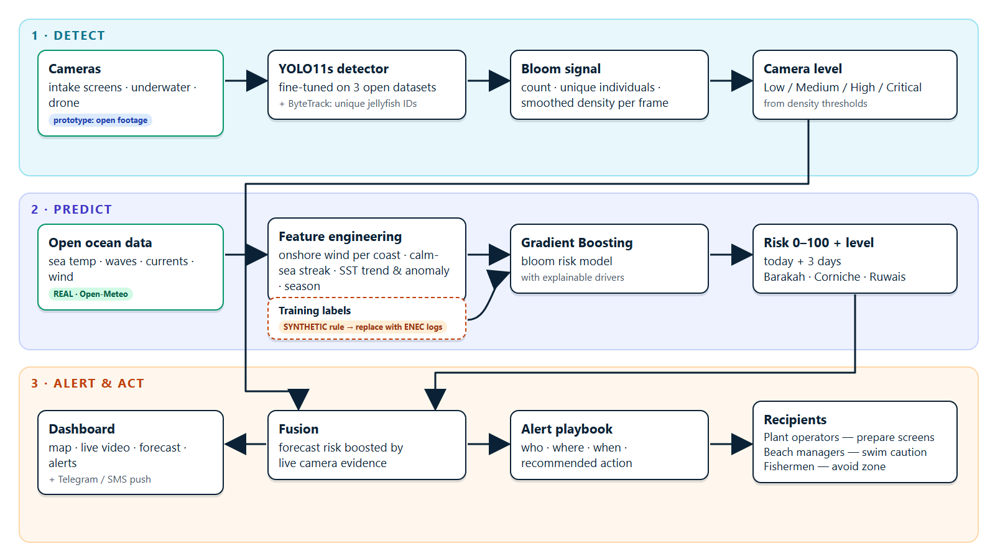
Figure 1 — JellyWatch AI architecture
Component | Technology | Runs on
Detector + tracker | YOLO11s, ByteTrack, OpenCV (Python) | Edge GPU / laptop; CPU fallback
Data ingestion | Open-Meteo Marine/Weather APIs (no key); synthetic fallback if offline | Any server
Risk model | scikit-learn Gradient Boosting, pandas | CPU, milliseconds per forecast
Alert engine | Rule playbook per audience; Telegram/SMS connector | Any server
Dashboard | Streamlit, folium (Esri basemap), plotly | Web browser

The design is modular: any camera (intake, underwater, drone), any additional data source (sonar, satellite chlorophyll, ENEC screen-pressure sensors) or any new recipient channel can be added without changing the rest of the pipeline.

6. Intended impact
SLIDE 6 · Fewer forced shutdowns, safer beaches, protected livelihoods — and jellyfish turned from waste into a resource.
Stakeholder | Impact
ENEC / Barakah operators | Hours-to-days of lead time to prepare screens and crews; fewer emergency power reductions; better-planned maintenance; protection of grid stability and energy security
Beach managers & public | Earlier, targeted swimming advisories; fewer stings; protected tourism experience
Fishermen | Avoid high-risk zones, fewer torn nets and spoiled catches
Environment & science | A continuous, open record of jellyfish presence and ocean conditions — data that does not exist today for the Gulf

Sustainable management — the circular angle
Early warning makes it possible to collect jellyfish offshore before they reach the intake instead of disposing of them as clogging waste. Collected biomass can be valorised — collagen for cosmetics and biomedicine, fertiliser and soil conditioner, animal feed and, for edible species, food — creating value from a problem. JellyWatch provides the “where and when” that such a collection programme needs.

How we will measure impact
- Lead time between first alert and screen-pressure rise at the intake (target: ≥ 24 h).
- Share of real bloom events preceded by a High/Critical alert (hit rate) and false-alarm rate.
- Avoided power-reduction hours and reduced emergency cleaning interventions vs previous seasons.

7. Feasibility and real-world implementation
SLIDE 7 · Low-cost, open-source and buildable now — the prototype already runs on a laptop.

Implementation roadmap
Phase | Duration | What happens
0 · Prototype | Done | Detector, risk model, alerts, dashboard on open data
1 · Data partnership | 1–2 months | Access ENEC intake-screen and cleaning logs, EAD jellyfish surveys; retrain risk model on real events
2 · Pilot camera | 2–3 months | 1–2 underwater cameras at the Barakah intake; fine-tune detector on local species and water turbidity
3 · Validation season | One bloom season | Run in shadow mode next to current procedures; measure lead time, hit rate, false alarms
4 · Operational roll-out | After validation | Integrate alerts with control-room systems; extend to beaches, desalination plants and fishing communities

Practical considerations
- Hardware: standard IP underwater cameras with lighting and wipers; an edge GPU box or existing plant server. The detector already runs in real time on a laptop GPU (RTX 2060).
- Cost: open-source software and free ocean data; main costs are cameras, installation and maintenance.
- Integration & security: read-only, one-way data flow from cameras to the analytics network; no connection to plant control systems is required — alerts are advisory to human operators.
- Data governance: no personal data is processed; camera views face the water.

Risks and mitigations
Risk | Mitigation
Turbid water / bio-fouling reduces camera visibility | Lighting, wipers, cleaning schedule; add sonar as a second sensor
Few real bloom records for training | Start with expert rule (declared), retrain as ENEC logs arrive; active learning from operator feedback
Local species differ from training data | Fine-tune on footage from the pilot camera (a few hundred labelled frames)
Alert fatigue | Tunable thresholds per site; one alert per site per horizon; operator feedback loop

8. How we would test and demonstrate the solution
SLIDE 8 · A live demo today, and a measurable pilot tomorrow.

Live demonstration (if shortlisted)
- Open the dashboard: the map shows today's risk at Barakah, Corniche and Ruwais from live ocean data.
- Show the alerts feed with drivers and recommended actions per audience.
- Run the detector on bloom footage: boxes, count, tracked individuals and density rise in real time.
- Camera evidence is fused into the forecast: Barakah's risk jumps and a new alert for plant operators appears instantly.
- Show the 3-day forecast, the “why” (feature importance) and the last-12-months risk pattern on real weather.

Technical validation
- Detector: precision, recall and mAP on a held-out test set (already reported); next on labelled frames from the Barakah intake.
- Risk model: time-based back-testing (train on past seasons, test on the most recent) — today against synthetic labels; in the pilot against ENEC bloom/cleaning events, reporting hit rate, false-alarm rate and average lead time.
- End-to-end: shadow-mode operation for one season alongside current procedures; operators rate alert usefulness.

Success criteria for the pilot
Metric | Target
Detector precision on intake footage | ≥ 0.85
Bloom events preceded by a High/Critical alert | ≥ 70 %
Median warning lead time | ≥ 24 hours
False alarms per month per site | ≤ 2

9. Visuals, mock-ups and prototype
SLIDE 9 · It already works — map, live detection, forecast and alerts in one dashboard.
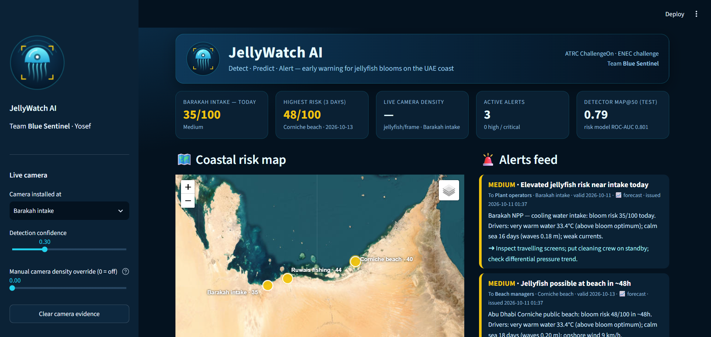
Figure 2 — JellyWatch AI dashboard: KPIs, coastal risk map and alerts feed (live data)
[image missing: docs/img/detection.png]
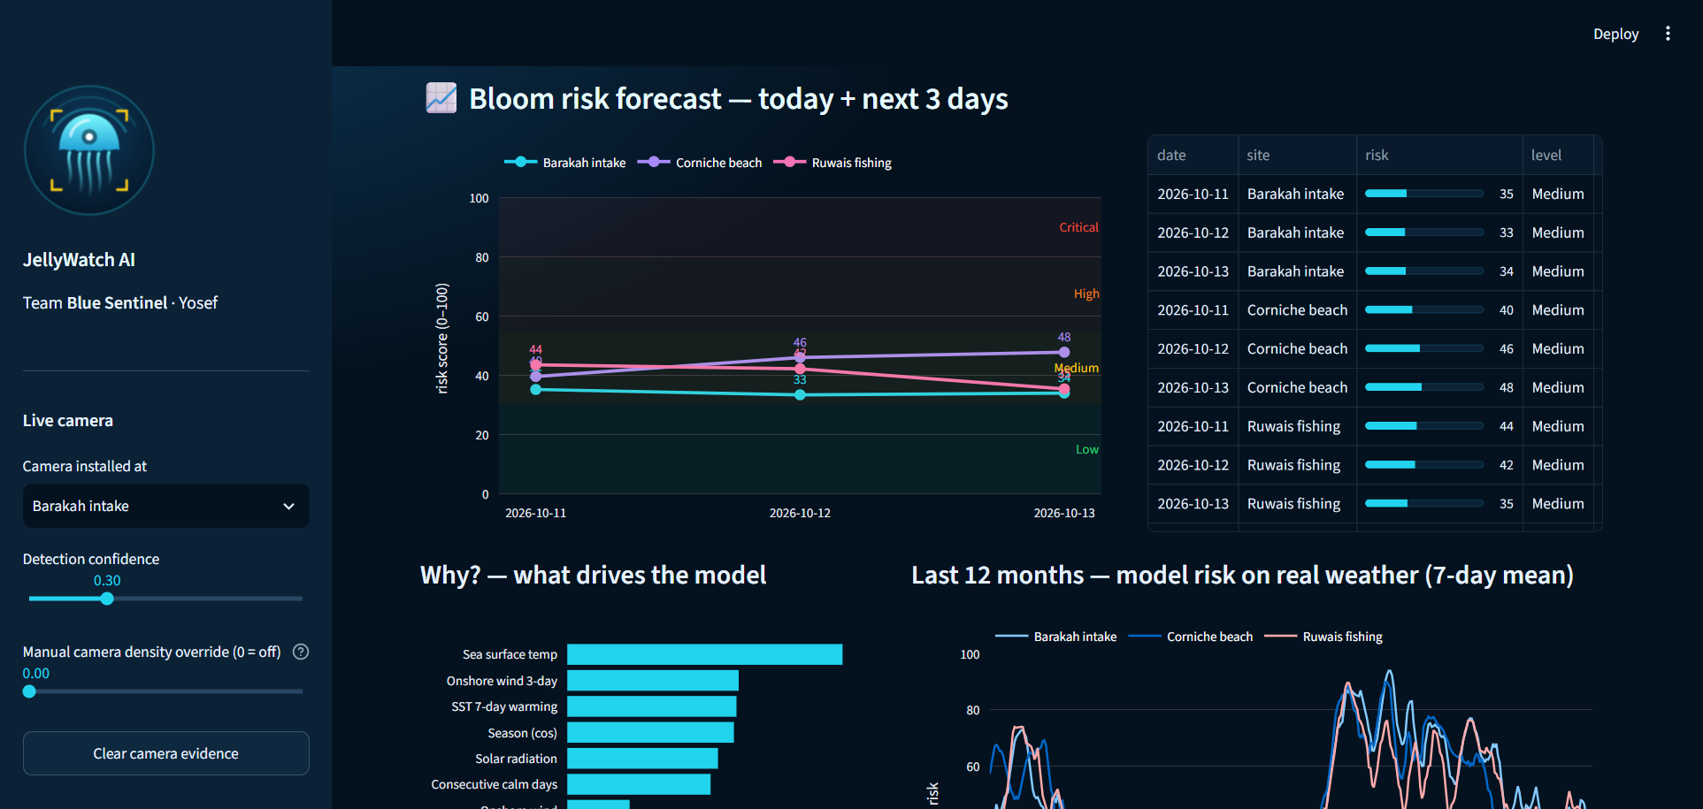
Figure 4 — 3-day bloom risk forecast per site and model explainability

Prototype facts
Item | Value
Detector | YOLO11s, test mAP@50 0.79 · precision 0.84 · recall 0.68
Risk model | Gradient Boosting · ROC-AUC 0.801 on the most recent 12 months (vs synthetic labels)
Ocean/weather history | 5211 site-days of real data since 2022 (3 sites)
Code | Python · open-source stack · runs on a laptop

10. Assumptions, data sources and next steps
SLIDE 10 · No dataset was provided — here is every assumption we made, stated openly.

Assumptions
# | Assumption | Why / how it will be replaced
A1 | Blooms are favoured by warm water (≈24–33 °C, optimum ≈30 °C), a warming trend, several calm-sea days, onshore wind, weak currents and the spring–summer season | Encoded as a transparent expert rule to create synthetic training labels; replaced by ENEC/EAD bloom records
A2 | Camera density thresholds: Medium ≥ 2, High ≥ 5, Critical ≥ 10 jellyfish per frame (smoothed) | Calibrate against intake screen-pressure data during the pilot
A3 | Site coordinates for Barakah intake, Abu Dhabi Corniche and Ruwais are approximate | Replace with exact intake / beach / fishing-zone coordinates
A4 | Open-Meteo model data is representative of near-shore conditions at each site | Add ENEC / NCM in-situ sensors where available
A5 | Demo videos (public moon-jellyfish footage) stand in for an intake camera | Pilot camera footage from Barakah
A6 | Alerts are advisory; humans decide on operational actions | Integrate with existing ENEC procedures

What is real vs synthetic
Component | Status
Sea temperature, waves, currents, wind (history + forecast) | REAL — Open-Meteo (CC BY 4.0)
Detector training images | REAL — Aquarium (Roboflow), Brackish (Aalborg University), Open Images V7 (Google)
Risk-model training labels | SYNTHETIC — expert rule + noise (declared)
Demo footage | DEMO — Wikimedia Commons, not filmed at Barakah

Next steps
- Real camera at the Barakah intake; real ENEC/EAD bloom and screen-cleaning data.
- Sonar and drone integration; satellite chlorophyll and sea-surface temperature as additional features.
- Jellyfish collection and valorisation programme (collagen, fertiliser, feed, food) as the sustainable-management loop.
- Arabic/English mobile alerts for fishermen; API for the plant control room.

