target_volatility | log_return | log_price
count | 567.000000 | 570.000000 | 571.000000
mean | 0.021187 | 0.001741 | 4.907112
std | 0.038455 | 0.041885 | 0.432551
min | 0.000000 | -0.288092 | 4.300274
25% | 0.004615 | -0.005685 | 4.536570
50% | 0.008986 | 0.000000 | 4.657644
75% | 0.017910 | 0.006974 | 5.394654
max | 0.331213 | 0.400243 | 5.564520

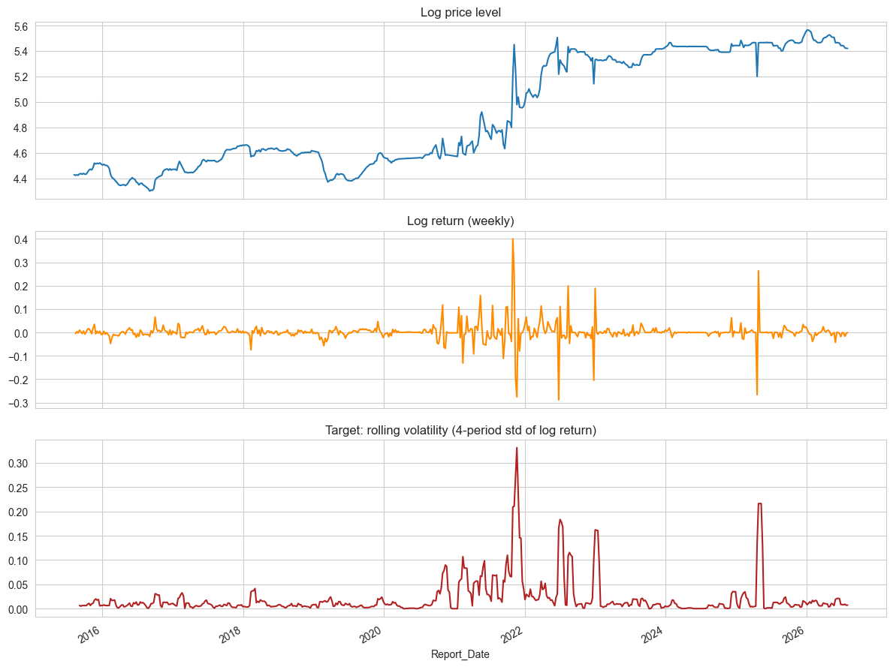

pearson_corr_with_target
season_2021Yala | 0.409271
Raw red | 0.278968
season_2021-2022Maha | 0.217418
Raw White | 0.204095
season_2020-2021Maha | 0.149656
National_Yield_Efficiency | -0.140078
Kurunegala_Rice (long grain) | 0.137703
Anuradhapura_Rice (long grain) | 0.135031
Colombo City_Rice (long grain) | 0.130202
Samba 1 | 0.114154
season_2023-2024Maha | -0.113114
season_2020Yala | 0.110584
season_2024-2025Maha | 0.109735
Exchange_Rate | 0.109564
Exchange_Rate_lag1 | 0.107960
Anuradhapura_Rice (white) | -0.107323
Exchange_Rate_lag2 | 0.105919
Temp_Min_C | -0.103801
Exchange_Rate_lag4 | 0.102196
Nadu 2 | 0.097661
season_2019-2020Maha | -0.095520
Samba 2 | 0.094749
Temp_Max_C | -0.093831
season_2022Yala | 0.093292
Colombo City_Rice (white) | 0.085427
season_2025Yala | -0.083713
Kurunegala_Rice (white) | -0.083531
season_2016-2017Maha | -0.082184
Supply_YoY_Change_% | -0.081650
season_2018Yala | -0.078330
season_2015-2016Maha | -0.076948
season_2023Yala | -0.072123
FAO_Pesticides_total_Use_per_area_of_cropland_kg_ha | 0.070170
Nadu | 0.069355
Is_Extreme_Heat | -0.069115
season_2019Yala | -0.068632
season_2017-2018Maha | -0.068539
season_2018-2019Maha | -0.067208
season_2017Yala | -0.066214
Nadu 1 | 0.063711
season_2015Yala | -0.062795
CBSL_Wage_Manuring | 0.060377
CBSL_Producer_Price_Paddy_LKR | 0.058146
season_2022-2023Maha | -0.056585
Exchange_Rate_30d_PctChange | 0.053825
CBSL_Wage_Threshing | 0.043888
CBSL_Wage_Sowing | 0.041175
season_2024Yala | -0.040738
CBSL_Wage_Spraying | 0.040574
CBSL_Wage_Ploughing_with_Mammoties | 0.038024
Rainfall_14d_Cumulative | 0.035967
CBSL_Wage_Transplanting_and_Harvesting | 0.034745
CBSL_Wage_Ploughing_with_Ploughs | 0.034497
season_2016Yala | -0.031732
CBSL_Wage_Winnowing | 0.031335
Exchange_Rate_logret | 0.029085
Kurunegala_Rice (medium grain) | -0.027357
Imported Rice | -0.017443
Total_Production_MT | 0.017310
Rainfall_mm | 0.011377
Colombo City_Rice (medium grain) | 0.007670
Anuradhapura_Rice (medium grain) | 0.003231
National Average_Fuel (diesel) | NaN
National Average_Fuel (petrol-gasoline) | NaN
National Average_Fuel (diesel)_logret | NaN
National Average_Fuel (petrol-gasoline)_logret | NaN

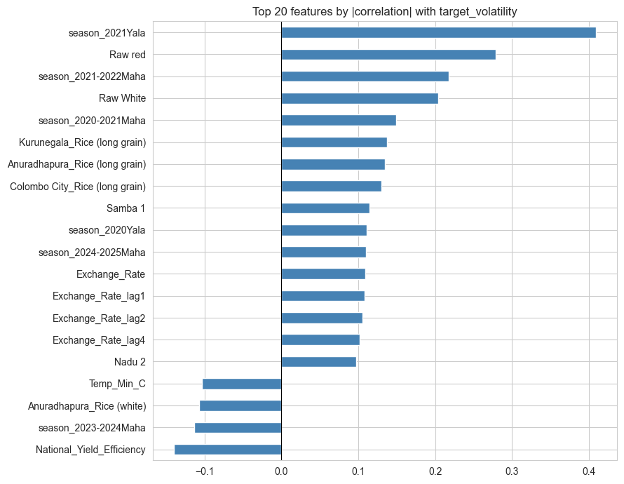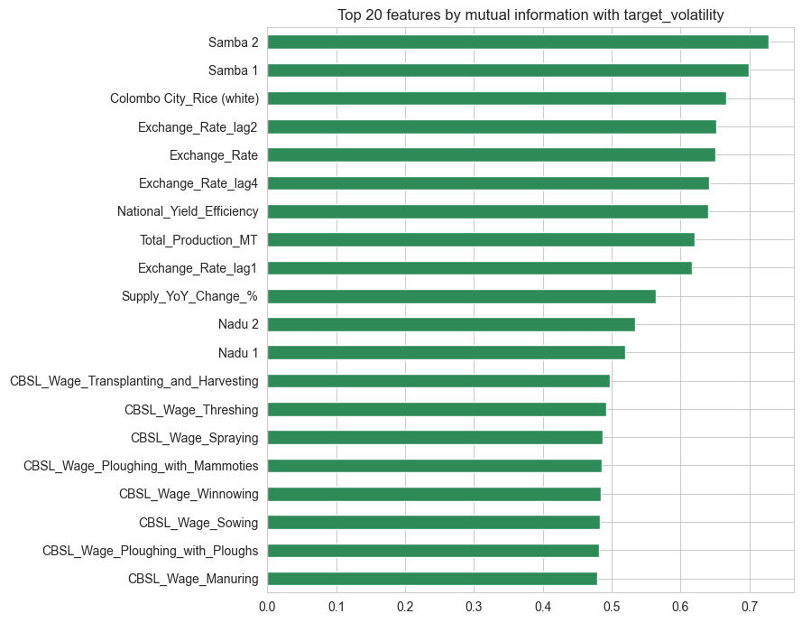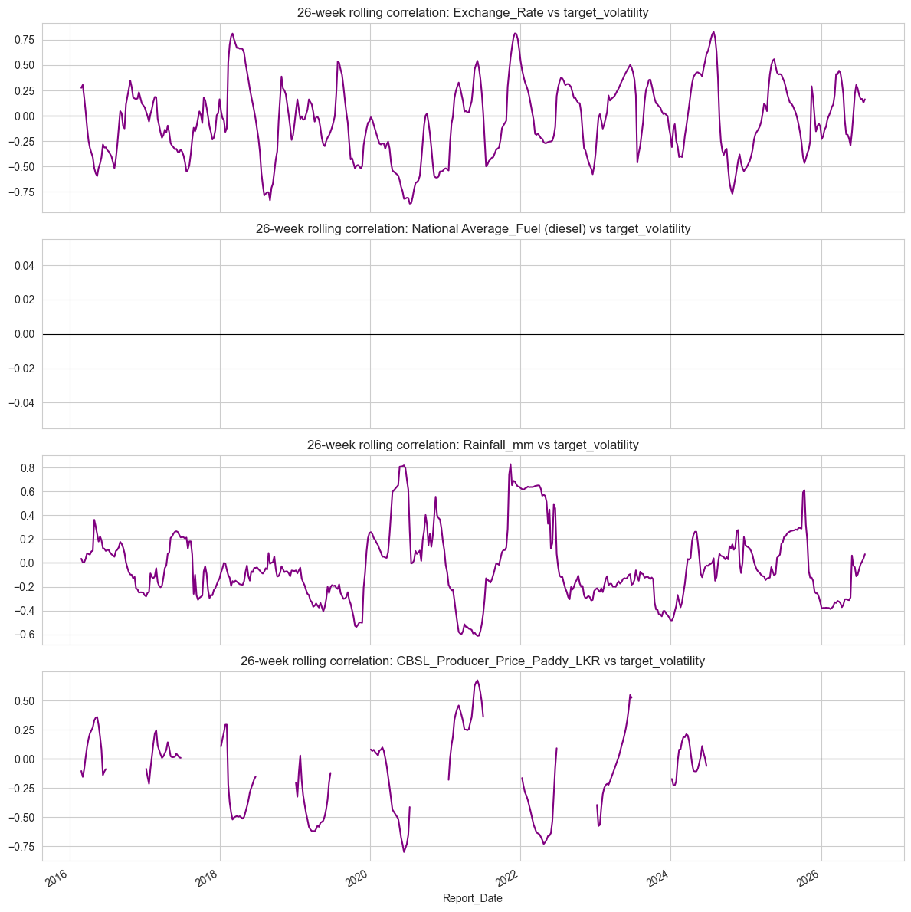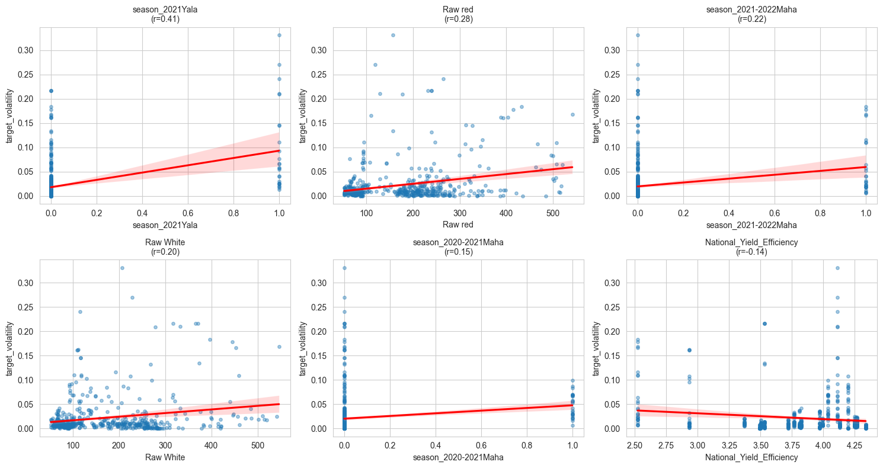
feature | VIF
22 | Exchange_Rate_lag1 | 14305.247872
6 | Exchange_Rate | 13577.266358
23 | Exchange_Rate_lag2 | 1219.863876
24 | Exchange_Rate_lag4 | 475.534450
13 | Colombo City_Rice (white) | 76.008761
15 | Kurunegala_Rice (medium grain) | 42.074636
12 | Colombo City_Rice (medium grain) | 32.202830
19 | Exchange_Rate_logret | 25.243879
9 | Anuradhapura_Rice (medium grain) | 18.655961
8 | Anuradhapura_Rice (long grain) | 10.475867
11 | Colombo City_Rice (long grain) | 9.396885
14 | Kurunegala_Rice (long grain) | 8.834273
10 | Anuradhapura_Rice (white) | 7.718295
16 | Kurunegala_Rice (white) | 6.114276
7 | Exchange_Rate_30d_PctChange | 5.683854
5 | National_Yield_Efficiency | 4.318819
3 | Raw White | 3.708857
2 | season_2021-2022Maha | 3.294889
1 | Raw red | 2.837305
0 | season_2021Yala | 1.386293
4 | season_2020-2021Maha | 1.210907
18 | National Average_Fuel (petrol-gasoline) | 0.000000
17 | National Average_Fuel (diesel) | 0.000000
20 | National Average_Fuel (diesel)_logret | NaN
21 | National Average_Fuel (petrol-gasoline)_logret | NaN

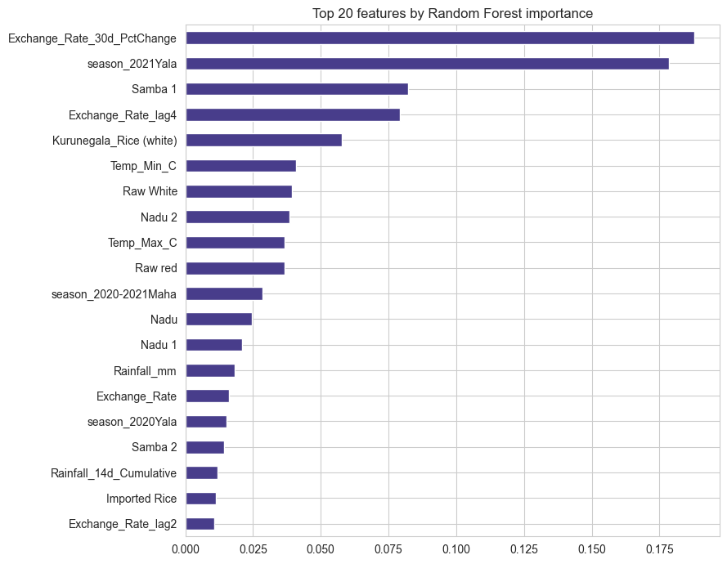
rf_importance
Exchange_Rate_30d_PctChange | 0.187849
season_2021Yala | 0.178580
Samba 1 | 0.082318
Exchange_Rate_lag4 | 0.079168
Kurunegala_Rice (white) | 0.057666
Temp_Min_C | 0.040754
Raw White | 0.039377
Nadu 2 | 0.038350
Temp_Max_C | 0.036766
Raw red | 0.036709
season_2020-2021Maha | 0.028555
Nadu | 0.024424
Nadu 1 | 0.020965
Rainfall_mm | 0.018361
Exchange_Rate | 0.016229
season_2020Yala | 0.015197
Samba 2 | 0.014165
Rainfall_14d_Cumulative | 0.011936
Imported Rice | 0.011188
Exchange_Rate_lag2 | 0.010766

abs_pearson | mutual_info | rf_importance
Exchange_Rate_30d_PctChange | 0.053825 | 0.123376 | 0.187849
season_2021Yala | 0.409271 | 0.070921 | 0.178580
Samba 1 | 0.114154 | 0.698662 | 0.082318
Exchange_Rate_lag4 | 0.102196 | 0.641651 | 0.079168
Kurunegala_Rice (white) | 0.083531 | 0.291478 | 0.057666
Temp_Min_C | 0.103801 | 0.002108 | 0.040754
Raw White | 0.204095 | 0.280459 | 0.039377
Nadu 2 | 0.097661 | 0.534280 | 0.038350
Temp_Max_C | 0.093831 | 0.089866 | 0.036766
Raw red | 0.278968 | 0.233769 | 0.036709
season_2020-2021Maha | 0.149656 | 0.080941 | 0.028555
Nadu | 0.069355 | 0.328335 | 0.024424
Nadu 1 | 0.063711 | 0.519350 | 0.020965
Rainfall_mm | 0.011377 | 0.046422 | 0.018361
Exchange_Rate | 0.109564 | 0.650806 | 0.016229
season_2020Yala | 0.110584 | 0.089194 | 0.015197
Samba 2 | 0.094749 | 0.728252 | 0.014165
Rainfall_14d_Cumulative | 0.035967 | 0.078076 | 0.011936
Imported Rice | 0.017443 | 0.402131 | 0.011188
Exchange_Rate_lag2 | 0.105919 | 0.651995 | 0.010766

