Martínez Coronel Brayan Yosafat

# Código VHDL

library IEEE;

use IEEE.STD_LOGIC_1164.ALL;

use IEEE.STD_LOGIC_ARITH.ALL;

use IEEE.STD_LOGIC_UNSIGNED.ALL;

entity pila is

generic (

pc_size : integer := 16;

n : integer := 3

);

Port ( PC_in : in STD_LOGIC_VECTOR (pc_size-1 downto 0);

clk, clr, WPC, UP, DW : in STD_LOGIC;

PC_out : out STD_LOGIC_VECTOR (pc_size-1 downto 0);

SP : out STD_LOGIC_VECTOR (n-1 downto 0)

);

end entity;

architecture Behavioral of pila is

type arreglo is array (0 to (2**n - 1)) of STD_LOGIC_VECTOR (pc_size-1 downto 0);

signal pointers : arreglo := (others=>(others=>'0'));

signal aux_sp : STD_LOGIC_VECTOR (n-1 downto 0);

begin

process (clk, clr, UP, DW, WPC)

variable v_sp : integer := 0;

begin

if (clr = '1') then

v_sp := 0;

pointers <= (others=>(others=>'0'));

elsif (rising_edge(clk)) then

if (UP = '1') then

v_sp := v_sp + 1;

elsif (DW = '1') then

v_sp := v_sp - 1;

else

v_sp := v_sp;

end if;

if (WPC = '1') then

pointers(v_sp) <= PC_in;

else

pointers(v_sp) <= pointers(v_sp) + 1;

end if;

aux_sp <= conv_std_logic_vector(v_sp, n);

end if;

end process;

PC_out <= pointers(conv_integer(aux_sp));

SP <= aux_sp;

end Behavioral;

# Código del TEST-BENCH

library IEEE;

library STD;

use STD.TEXTIO.ALL;

use IEEE.std_logic_TEXTIO.ALL;

use IEEE.STD_LOGIC_1164.ALL;

entity t_pila is

-- Port ( );

end entity;

architecture Behavioral of t_pila is

constant pc_size : integer := 16;

constant n : integer := 3;

constant clk_period : time := 10 ns;

component pila is

generic (

pc_size : integer := pc_size;

n : integer := n

);

Port ( PC_in : in STD_LOGIC_VECTOR (pc_size-1 downto 0);

clk, clr, WPC, UP, DW : in STD_LOGIC;

PC_out : out STD_LOGIC_VECTOR (pc_size-1 downto 0);

SP : out STD_LOGIC_VECTOR (n-1 downto 0)

);

end component;

signal PC_in : STD_LOGIC_VECTOR (pc_size-1 downto 0);

signal clk, clr, WPC, UP, DW : STD_LOGIC;

signal PC_out : STD_LOGIC_VECTOR (pc_size-1 downto 0);

signal SP : STD_LOGIC_VECTOR (n-1 downto 0);

begin

test: pila port map (

PC_in => PC_in,

clk => clk,

clr => clr,

WPC => WPC,

UP => UP,

DW => DW,

PC_out => PC_out,

SP => SP

);

clk_process : process

begin

clk <= '0';

wait for clk_period/2;

clk <= '1';

wait for clk_period/2;

end process;

stim_proc: process

file ARCH_SALIDA : TEXT;

variable LINEA_SALIDA : line;

file ARCH_ENTRADA : TEXT;

variable LINEA_ENTRADA : line;

variable CADENA : string (1 to 4);

variable v_PC_in : STD_LOGIC_VECTOR (pc_size-1 downto 0);

variable v_clr, v_WPC, v_UP, v_DW : STD_LOGIC;

variable v_PC_out : STD_LOGIC_VECTOR (pc_size-1 downto 0);

variable v_SP : STD_LOGIC_VECTOR (n-1 downto 0);

begin

file_open(ARCH_ENTRADA, "C:\Users\yosaf\Desktop\Sexto\Arquitectura\Practica7\entradas.txt", READ_MODE);

file_open(ARCH_SALIDA, "C:\Users\yosaf\Desktop\Sexto\Arquitectura\Practica7\salidas.txt", WRITE_MODE);

readline(ARCH_ENTRADA, LINEA_ENTRADA); -- salta la primera linea

CADENA := " SP";

write(LINEA_SALIDA, CADENA, right, CADENA'LENGTH + 1);

CADENA := " PC";

write(LINEA_SALIDA, CADENA, right, CADENA'LENGTH + 1);

writeline(ARCH_SALIDA, LINEA_SALIDA);-- escribe la linea en el archivo

WAIT FOR 100 NS;

FOR I IN 0 TO 27 LOOP

readline(ARCH_ENTRADA, LINEA_ENTRADA); -- lee una linea completa

Hread(LINEA_ENTRADA, v_PC_in);

PC_in <= v_PC_in;

read(LINEA_ENTRADA, v_clr);

clr <= v_clr;

read(LINEA_ENTRADA, v_WPC);

WPC <= v_WPC;

read(LINEA_ENTRADA, v_UP);

UP <= v_UP;

read(LINEA_ENTRADA, v_DW);

DW <= v_DW;

WAIT UNTIL RISING_EDGE(clk); --ESPERO AL FLANCO DE SUBIDA

v_PC_out := PC_out;

v_SP := SP;

Hwrite(LINEA_SALIDA, v_SP, right, 5);

Hwrite(LINEA_SALIDA, v_PC_out, right, 5);

writeline(ARCH_SALIDA, LINEA_SALIDA);-- escribe la linea en el archivo

end loop;

file_close(ARCH_ENTRADA); -- cierra el archivo

file_close(ARCH_SALIDA); -- cierra el archivo

wait;

end process;

end Behavioral;

# Diagrama RTL

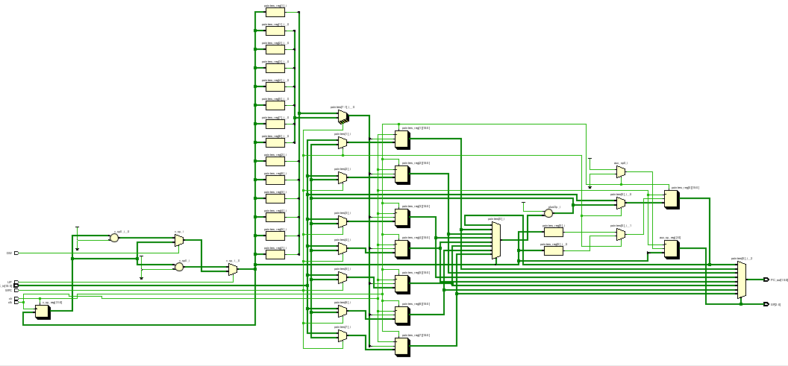

# Forma de onda

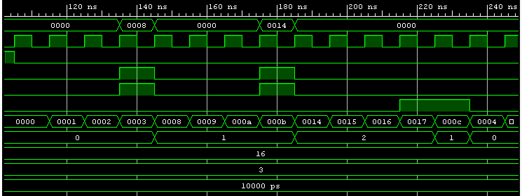

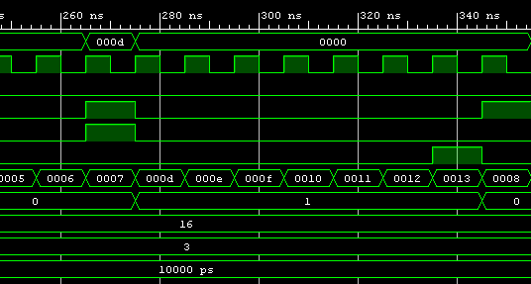

# Archivos

## Entrada

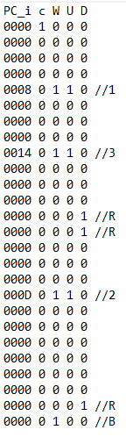

## Salida

