Martínez Coronel Brayan Yosafat

# Implementación del Procesador

library IEEE;

use IEEE.STD_LOGIC_1164.ALL;

use WORK.PAQUETE_DATOS.ALL;

entity ESCOMIPS is

Port (

CLR, CLK : in STD_LOGIC;

t_alu, t_RR1, t_RR2, t_PC, t_bus_SR : out STD_LOGIC_VECTOR (15 downto 0);

t_inst : out STD_LOGIC_VECTOR (24 downto 0)

);

end ESCOMIPS;

architecture Behavioral of ESCOMIPS is

signal D, fun_code : STD_LOGIC_VECTOR (3 downto 0);

signal op_code : STD_LOGIC_VECTOR (4 downto 0);

signal microinst : STD_LOGIC_VECTOR (19 downto 0);

begin

unidad : unidad_control Port map (

CLK => CLK,

CLR => CLR,

D => D,

sufix => fun_code,

prefix => op_code,

microinst => microinst

);

datos : ruta Port map (

clk => CLK,

clr => CLR,

WPC => microinst(16),

UP => microinst(18),

DW => microinst(17),

SHE => microinst(12),

DIR => microinst(11),

WR => microinst(10),

WD => microinst(2),

SR2 => microinst(15),

SWD => microinst(14),

SR => microinst(1),

SDMP => microinst(19),

SDMD => microinst(3),

SOP1 => microinst(9),

SOP2 => microinst(8),

SEXT => microinst(13),

alu_op => microinst(7 downto 4),

prefix => op_code,

flags => D,

sufix => fun_code,

t_alu => t_alu,

t_RR1 => t_RR1,

t_RR2 => t_RR2,

t_PC => t_PC,

t_bus_SR => t_bus_SR,

t_inst => t_inst

);

end Behavioral;

# Diagrama RTL

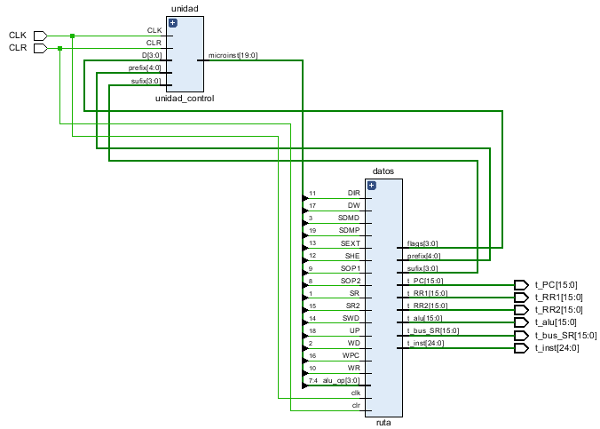

# Suma en bucle

## Código de memoria de programa

library IEEE;

use IEEE.STD_LOGIC_1164.ALL;

use IEEE.STD_LOGIC_ARITH.ALL;

use IEEE.STD_LOGIC_UNSIGNED.ALL;

entity memoria_programa is

generic (

m : integer := 10;

n : integer := 25

);

Port ( pc : in STD_LOGIC_VECTOR (m-1 downto 0);

inst : out STD_LOGIC_VECTOR (n-1 downto 0)

);

end entity;

architecture Behavioral of memoria_programa is

type arreglo is array (0 to (2**m - 1)) of STD_LOGIC_VECTOR (n-1 downto 0);

signal mem : arreglo := (others=>(others=>'0'));

constant code_LI : std_logic_vector (4 downto 0) := "00001";

constant code_ADD : std_logic_vector (4 downto 0) := "00000";

constant code_SWI : std_logic_vector (4 downto 0) := "00011";

constant code_ADDI : std_logic_vector (4 downto 0) := "00101";

constant code_BNEI : std_logic_vector (4 downto 0) := "01110";

constant code_NOP : std_logic_vector (4 downto 0) := "10110";

constant code_B : std_logic_vector (4 downto 0) := "10011";

constant fun_ADD : std_logic_vector (3 downto 0) := "0000";

constant SU : std_logic_vector (3 downto 0) := "0000";

constant R0 : std_logic_vector (3 downto 0) := "0000";

constant R1 : std_logic_vector (3 downto 0) := "0000";

begin

mem(0) <= code_LI & R0 & x"0001"; -- R0 = 1

mem(1) <= code_LI & R1 & x"0007"; -- R1 = 7

mem(2) <= code_ADD & R1 & R1 & R0 & SU & fun_ADD; -- ADD R1 = R1 + R0

mem(3) <= code_SWI & R1 & x"0005"; -- Mem[5] = R1

mem(4) <= code_B & SU & x"0002"; -- B 2

inst <= mem(conv_integer(pc));

end Behavioral;

## simulación

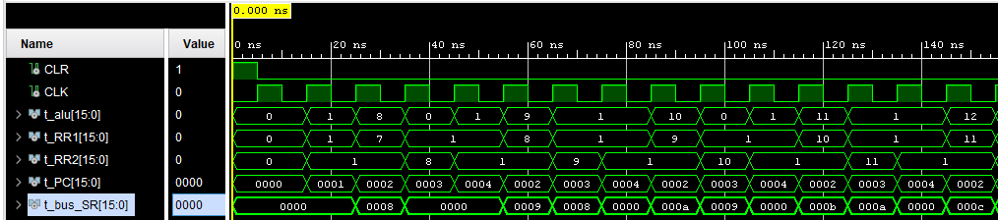

## Tabla de resultados

|  |  |  |  |  |  |  |  |  |  |  |  |
| --- | --- | --- | --- | --- | --- | --- | --- | --- | --- | --- | --- |
| Bus | T1 | T2 | T3 | T4 | T5 | T6 | T7 | T8 | T9 | T10 | T11 |
| PC | 0 | 1 | 2 | 3 | 4 | 2 | 3 | 4 | 2 | 3 | 4 |
| Inst | LI R0 1 | LI R1 7 | ADD R1 R0 | SWI R1 5 | B 2 | ADD R1 R0 | SWI R1 5 | B 2 | ADD R1 R0 | SWI R1 5 | B 2 |
| Read 1 | 0 | 1 | 7 | 1 | 1 | 8 | 1 | 1 | 9 | 1 | 1 |
| Read 2 | 0 | 1 | 1 | 8 | 1 | 1 | 9 | 1 | 1 | 10 | 1 |
| ALU | 0 | 1 | 8 | 0 | 1 | 9 | 1 | 1 | 10 | 0 | 1 |
| BUS SR | 0 | 0 | 8 | 0 | 0 | 9 | 8 | 0 | 10 | 9 | 0 |

# Mínimo del arreglo y Fibonacci de ese número

## Código de memoria de programa

library IEEE;

use IEEE.STD_LOGIC_1164.ALL;

use IEEE.STD_LOGIC_ARITH.ALL;

use IEEE.STD_LOGIC_UNSIGNED.ALL;

entity memoria_programa is

generic (

m : integer := 10;

n : integer := 25

);

Port ( pc : in STD_LOGIC_VECTOR (m-1 downto 0);

inst : out STD_LOGIC_VECTOR (n-1 downto 0)

);

end entity;

architecture Behavioral of memoria_programa is

type arreglo is array (0 to (2**m - 1)) of STD_LOGIC_VECTOR (n-1 downto 0);

signal mem : arreglo := (others=>(others=>'0'));

constant code_LI : std_logic_vector (4 downto 0) := "00001";

constant code_LWI : std_logic_vector (4 downto 0) := "00010";

constant code_LW : std_logic_vector (4 downto 0) := "10111";

constant code_SW : std_logic_vector (4 downto 0) := "00100";

constant code_SWI : std_logic_vector (4 downto 0) := "00011";

constant code_ADDI : std_logic_vector (4 downto 0) := "00101";

constant code_BGTI : std_logic_vector (4 downto 0) := "10001";

constant code_BLTI : std_logic_vector (4 downto 0) := "01111";

constant code_BLETI : std_logic_vector (4 downto 0) := "10000";

constant code_BNEI : std_logic_vector (4 downto 0) := "01110";

constant code_NOP : std_logic_vector (4 downto 0) := "10110";

constant code_B : std_logic_vector (4 downto 0) := "10011";

constant code_fun : std_logic_vector (4 downto 0) := "00000";

constant fun_ADD : std_logic_vector (3 downto 0) := "0000";

constant SU : std_logic_vector (3 downto 0) := "0000";

constant R0 : std_logic_vector (3 downto 0) := "0000";

constant R1 : std_logic_vector (3 downto 0) := "0001";

constant R2 : std_logic_vector (3 downto 0) := "0010";

constant R3 : std_logic_vector (3 downto 0) := "0011";

constant R4 : std_logic_vector (3 downto 0) := "0100";

constant R5 : std_logic_vector (3 downto 0) := "0101";

constant R6 : std_logic_vector (3 downto 0) := "0110";

constant R7 : std_logic_vector (3 downto 0) := "0111";

begin

--Inicializar arreglo

mem(0) <= code_LI & R0 & x"0000"; -- R0 = 0

mem(1) <= code_LI & R1 & x"0007"; -- R1 = #

mem(2) <= code_SW & R1 & R0 & x"000"; -- Mem[R0 + 0] = R1

mem(3) <= code_LI & R1 & x"0003"; -- R1 = #

mem(4) <= code_SW & R1 & R0 & x"001"; -- Mem[R0 + 1] = R1

mem(5) <= code_LI & R1 & x"000A"; -- R1 = #

mem(6) <= code_SW & R1 & R0 & x"002"; -- Mem[R0 + 2] = R1

mem(7) <= code_LI & R1 & x"00A0"; -- R1 = #

mem(8) <= code_SW & R1 & R0 & x"003"; -- Mem[R0 + 3] = R1

mem(9) <= code_LI & R1 & x"000B"; -- R1 = #

mem(10) <= code_SW & R1 & R0 & x"004"; -- Mem[R0 + 4] = R1

mem(11) <= code_LI & R1 & x"0060"; -- R1 = #

mem(12) <= code_SW & R1 & R0 & x"005"; -- Mem[R0 + 5] = R1

mem(13) <= code_LI & R1 & x"00B2"; -- R1 = #

mem(14) <= code_SW & R1 & R0 & x"006"; -- Mem[R0 + 6] = R1

mem(15) <= code_LI & R1 & x"00A0"; -- R1 = #

mem(16) <= code_SW & R1 & R0 & x"007"; -- Mem[R0 + 7] = R1

mem(17) <= code_LI & R1 & x"0A00"; -- R1 = #

mem(18) <= code_SW & R1 & R0 & x"008"; -- Mem[R0 + 8] = R1

mem(19) <= code_LI & R1 & x"00C0"; -- R1 = #

mem(20) <= code_SW & R1 & R0 & x"009"; -- Mem[R0 + 9] = R1

mem(21) <= code_LI & R1 & x"0017"; -- R1 = #

mem(22) <= code_SW & R1 & R0 & x"00A"; -- Mem[R0 + 10] = R1

mem(23) <= code_LI & R1 & x"00B9"; -- R1 = #

mem(24) <= code_SW & R1 & R0 & x"00B"; -- Mem[R0 + 11] = R1

mem(25) <= code_LI & R1 & x"0C01"; -- R1 = #

mem(26) <= code_SW & R1 & R0 & x"00C"; -- Mem[R0 + 12] = R1

mem(27) <= code_LI & R1 & x"00B2"; -- R1 = #

mem(28) <= code_SW & R1 & R0 & x"00D"; -- Mem[R0 + 13] = R1

mem(29) <= code_LI & R1 & x"0003"; -- R1 = #

mem(30) <= code_SW & R1 & R0 & x"00E"; -- Mem[R0 + 14] = R1

--Obtener el menor del arreglo

mem(31) <= code_LI & R2 & x"000E"; -- R2 = 14

mem(32) <= code_LW & R1 & R0 & x"000"; -- R1 = Mem[R0 + 0]

mem(33) <= code_BGTI & R2 & R0 & x"006"; --if (R0 > R2) goto 33+6

mem(34) <= code_LW & R3 & R0 & x"000"; -- R3 = Mem[R0 + 0]

mem(35) <= code_BGTI & R1 & R3 & x"002"; --if (R3 > R1) goto 35+2

mem(36) <= code_ADDI & R1 & R3 & x"000"; -- ADDI R1 = R3 + 0

mem(37) <= code_ADDI & R0 & R0 & x"001"; -- ADDI R0 = R0 + 1

mem(38) <= code_B & SU & x"0021"; -- B 33

--Fibonacci

mem(39) <= code_LI & R4 & x"0000"; -- R4 = 0

mem(40) <= code_BLETI & R4 & R1 & x"009"; --if (R1 <= R4) goto 40+9

mem(41) <= code_LI & R5 & x"0000"; -- R5 = 0

mem(42) <= code_LI & R6 & x"0001"; -- R6 = 1

mem(43) <= code_fun & R7 & R5 & R6 & SU & fun_ADD; -- ADD R7 = R5 + R6

mem(44) <= code_SW & R7 & R4 & x"00F"; -- Mem[R4 + 15] = R7

mem(45) <= code_ADDI & R4 & R4 & x"001"; -- ADDI R4 = R4 + 1

mem(46) <= code_ADDI & R5 & R6 & x"000"; -- ADDI R5 = R6 + 0

mem(47) <= code_ADDI & R6 & R7 & x"000"; -- ADDI R6 = R7 + 0

mem(48) <= code_BGTI & R4 & R1 & x"FFB"; --if (R1 > R4) goto 48-5

mem(49) <= code_NOP & SU & SU & SU & SU & SU;

mem(50) <= code_B & SU & x"0031"; -- B 49

inst <= mem(conv_integer(pc));

end Behavioral;

## Simulación

Primero se inicializa el arreglo

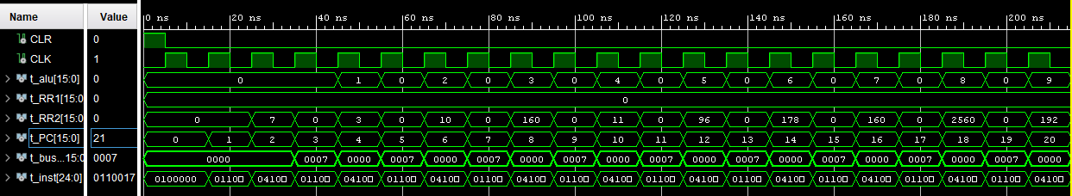

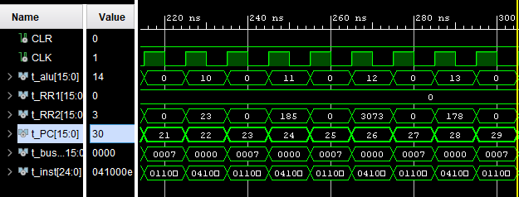

Luego se busca el menor de los números

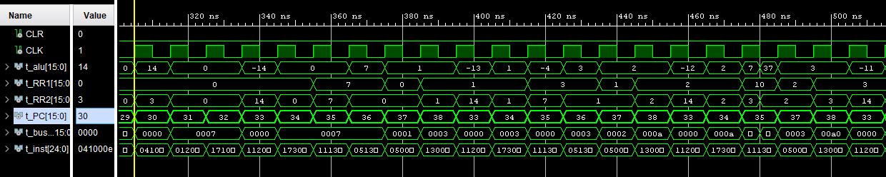

Entra en bucle 15 veces (el tamaño del arreglo) y obtiene el menor. Ahora se calculan los términos de la serie. Entra en bucle el número menor encontrado.

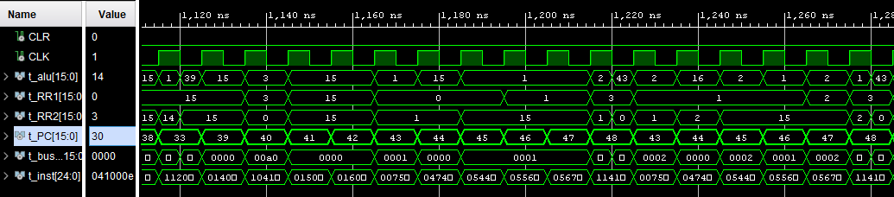

Al final llega al NOP y B

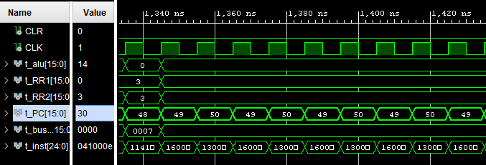

## Tabla de resultados

|  |  |  |  |  |  |  |  |  |  |  |  |
| --- | --- | --- | --- | --- | --- | --- | --- | --- | --- | --- | --- |
| Bus | T1 | T2 | T3 | T4 | T5 | T6 | T7 | T8 | T9 | T10 | T11 |
| PC | 0 | 0 | 1 | 2 | 3 | 4 | 5 | 6 | 7 | 8 | 9 |
| Inst | 0 | LI R0 0 | LI R0 7 | Mem[R0 + 0] = R1 | LI R1 = 3 | Mem[R0 + 0] = R1 | LI R1 = 10 | Mem[R0 + 0] = R1 | LI R1 = 160 | Mem[R0 + 0] = R1 | LI R1 = 11 |
| Read 1 | 0 | 0 | 0 | 0 | 0 | 0 | 0 | 0 | 0 | 0 | 0 |
| Read 2 | 0 | 0 | 7 | 0 | 3 | 0 | 10 | 0 | 160 | 0 | 11 |
| ALU | 0 | 0 | 0 | 0 | 1 | 0 | 2 | 0 | 3 | 0 | 4 |
| BUS SR | 0 | 0 | 0 | 7 | 0 | 7 | 0 | 7 | 0 | 7 | 0 |