SISTEM INFORMASI KERJA PRAKTIK (SIKP)

(BRD)

BATAS KERJA PRAKTIK

Yose Awanaustus Salawngi

05 2020

*Version 1.00*

# Document Revisions

|  |  |  |  |
| --- | --- | --- | --- |
| **Date** | **Version Number** | **Document Changes** | **Name** |
|  |  |  |  |
|  |  |  |  |
|  |  |  |  |
|  |  |  |  |
|  |  |  |  |
|  |  |  |  |
|  |  |  |  |
|  |  |  |  |
|  |  |  |  |
|  |  |  |  |

# Approvals

|  |  |  |  |  |
| --- | --- | --- | --- | --- |
| **Role** | **Name** | **Title** | **Signature** | **Date** |
| Front End | Julio |  |  | Senin, 15 Juni 2020 |
| Banck End | Dycha |  |  | Senin, 15 Juni 2020 |
| Documment Write | Yose |  |  | Senin, 15 Juni 2020 |
|  |  |  |  |  |
|  |  |  |  |  |
|  |  |  |  |  |

# Introduction

## Objectives

Dalam kegiatan Kerja Praktik (KP) pada Universitas Kristen Duta wacana dibutuhkan data-data user dalam sebuah sistem yang sudah terintegrasi dengan baik.

* Fitur ini koor dapat melakukan set batas pengajuan KP

## Project Scope

Membuat sebuah sistem batas_KP yang didalamnya user koor dapat melakukan set batas pengajuan KP

### Functionality

* Dapat melakukan set pengajuan

### Non Functionality

* Dapat di akses 24 jam dalam satu hari dengan komputer, laptop dan smartphone.

## System Perspective

### Assumptions

* Data yang dimasukan bisa disimpan dengan baik
* Data ditampilkan dengan baik
* Migrasi data sudah dilakukan dengan baik

### Constraints

* Hanya Koor yang dapat melakukan set Batas KP

### Risks

* Human Error.
* Kesalahan melakukan set Batas_kp

### Issues

* Kesalahan dalam melakukan input

# Business Process Overview

## Current Business Process (As-Is)

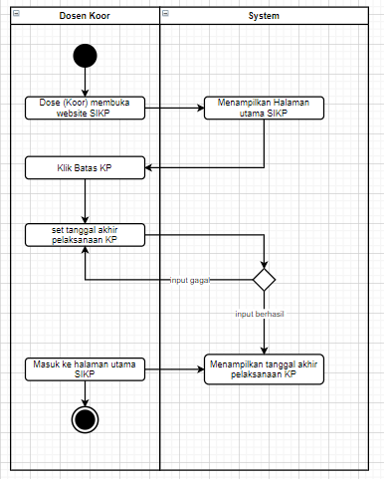

## Proposed Business Process (To-Be)

1. Terdapat 1 aktor yaitu User

2. User dapat Melakukan set batas akhir pelaksanaan

3. Setelah melakukan set maka tanggal yang telah ditentukan disimpan



# User and System Requirements

The requirements in this document are prioritized as follows:

|  |  |  |
| --- | --- | --- |
| **Value** | **Rating** | **Description** |
| 1 | Critical | This requirement is critical to the success of the project. The project will not be possible without this requirement. |
| 2 | High | This requirement is high priority, but the project can be implemented at a bare minimum without this requirement. |
| 3 | Medium | This requirement is somewhat important, as it provides some value but the project can proceed without it. |
| 4 | Low | This is a low priority requirement, or a “nice to have” feature, if time and cost allow it. |
| 5 | Future | This requirement is out of scope for this project, and has been included here for a possible future release. |

## Functional Requirements

|  |  |  |  |  |  |
| --- | --- | --- | --- | --- | --- |
| **Req#** | **Priority** | **Description** | **Rationale** | **Use Case Reference** | **Impacted Stakeholders** |
|  | | | | | |
| BTSKP_A_1 | 1 | Aktor dapat melakukan set tanggal pengajuan | Sistem dapat menampilkan tanggal yang sudah di set oleh aktor |  | Koor |
|  |  |  |  |  |  |
|  |  |  |  |  |  |
|  |  |  |  |  |  |

## Non-Functional Requirements

|  |  |
| --- | --- |
| **ID** | **Requirement** |
|  |  |
|  |  |
|  |  |
|  |  |
|  |  |
|  |  |
|  |  |

# Appendices

## List of Acronyms

## Glossary of Terms

## Related Documents