Software Requirements Specification (SRS)

Foreign Travel Management System (FTMS)
Prepared for the Ministry of Agriculture
This document provides a detailed technical and functional specification for the Foreign Travel Management System (FTMS).

System Workflow
The following infographic illustrates the workflow approval process implemented in FTMS.
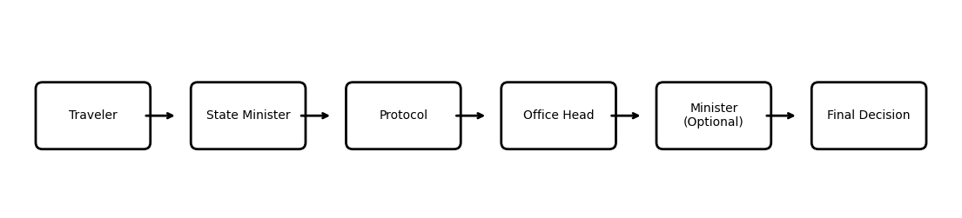

Introduction
- FTMS is a web-based workflow automation platform for managing official foreign travel requests.
- The system digitizes submission, approval, reporting, and historical management.

Objectives
- Automate foreign travel approvals.
- Improve transparency and accountability.
- Centralize travel records and reports.
- Improve decision-making and monitoring.

Technology Stack
- Frontend: React.js
- Backend: Node.js + Express.js
- Database: PostgreSQL
- Authentication: JWT
- Charts and Analytics: Recharts
- Email Notifications: Nodemailer
- File Upload Management: Multer
- Hosting: PM2 + Nginx/IIS

Core Features
- Role-based authentication
- Travel request submission
- Multi-stage approval workflow
- Amendment and resubmission
- PDF generation
- Dashboard analytics
- Historical travel management
- Email notifications

Security Requirements
- Password hashing
- JWT authentication
- Role-based authorization
- Secure API endpoints
- SQL injection prevention
- File upload validation

Deployment Environment
- Frontend hosted using Nginx or IIS
- Backend managed using PM2
- PostgreSQL database server
- Linux or Windows Server support

Future Enhancements
- Audit logging
- SMS integration
- Digital signature support
- Mobile application
- Advanced analytics dashboard

