R Notebook

knitr::include_graphics("MVR1.PNG")

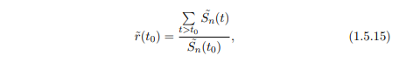

knitr::include_graphics("data.PNG")

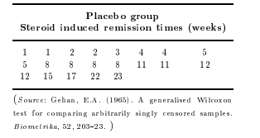

time <- c(1,1,2,2,3,4,4,5,5,8,8,8,8,11,11,12,12,15,17,22,23)  
rep <- c(1,2,3,4,5,8,11,12,15,17,22,23)

knitr::include_graphics("MVR2.PNG")

 Valores no repetidos

St <- c()  
for ( i in 1:length(rep)){  
   
 St[i] <- sum(time > rep[i])  
   
}  
  
St <- St/21  
  
plot(rep,St)

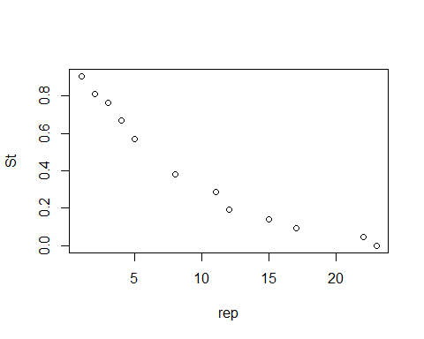

entonces

knitr::include_graphics("MVR1.PNG")



rt0 <- sum(St[-1])/St[1]  
rt0

## [1] 4.368421