**LEC 2 Task (Youssef Samy Youssef)**

In this lab1: you have to create a baremetal Software to send a “learn-in-depth:” using UART

**Tools:-**

* QEMU
* GNU ARM TOOLCHAIN

**C:\Users\asus\AppData\Local\Packages\5319275A.WhatsAppDesktop_cv1g1gvanyjgm\TempState\33E8075E9970DE0CFEA955AFD4644BB2\WhatsApp Image 2024-06-14 at 00.00.57_7b43ceca.jpgBoard:**

**Codes:**

*Create files*

C:\Users\asus\AppData\Local\Packages\5319275A.WhatsAppDesktop_cv1g1gvanyjgm\TempState\11B921EF080F7736089C757404650E40\WhatsApp Image 2024-06-14 at 00.13.50_78dbbaaa.jpg

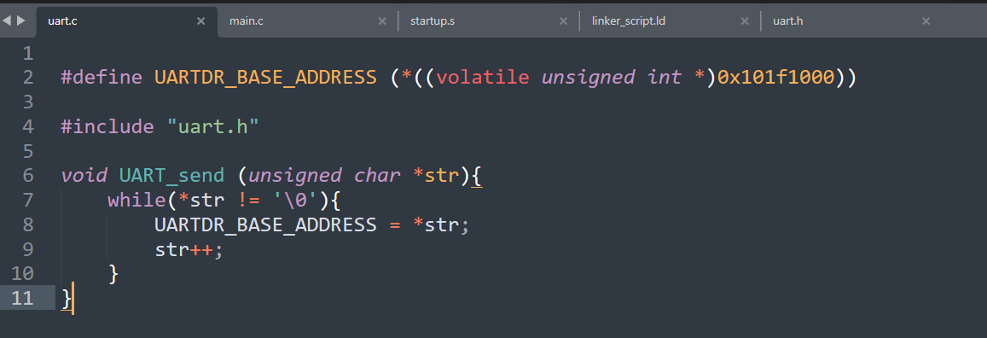

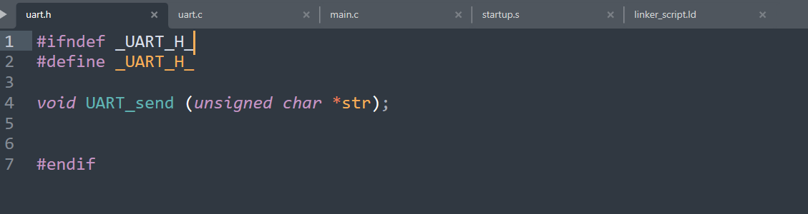

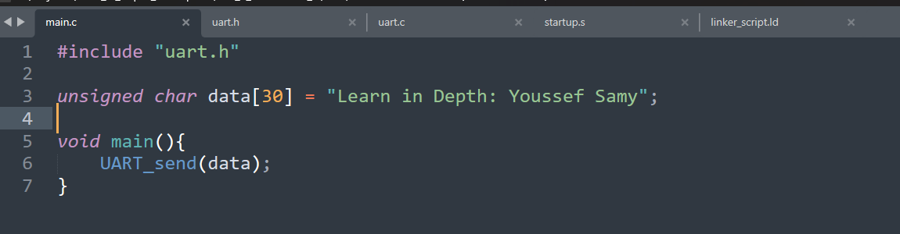

*Help*

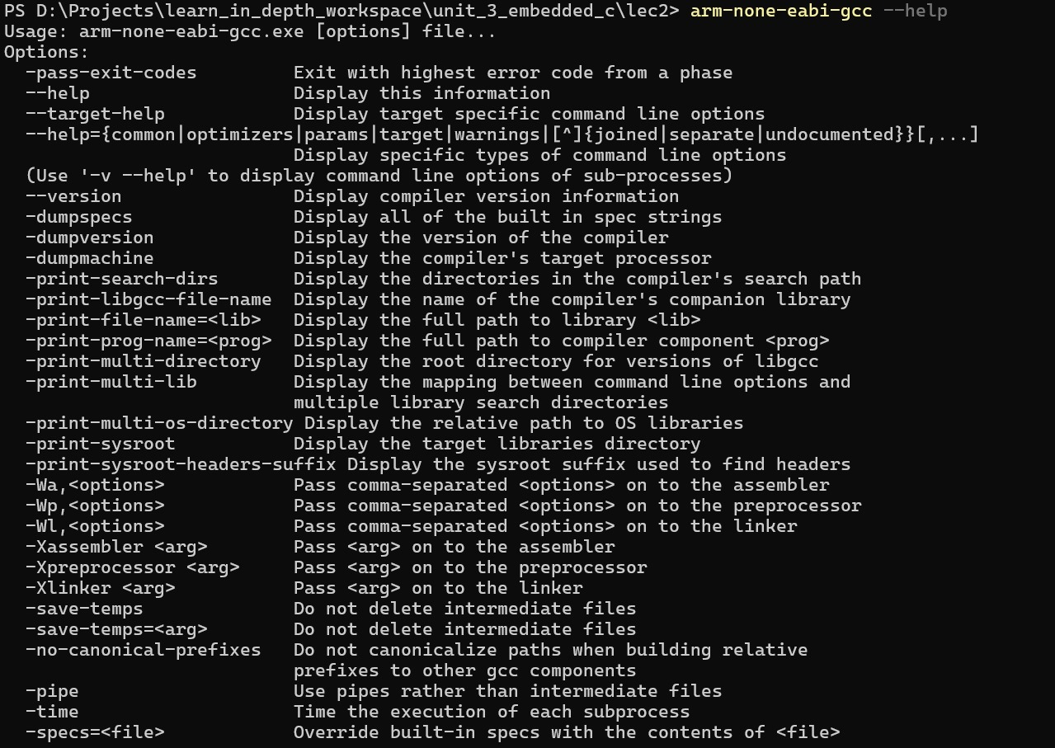

*Build .c to .o*





Objdump help

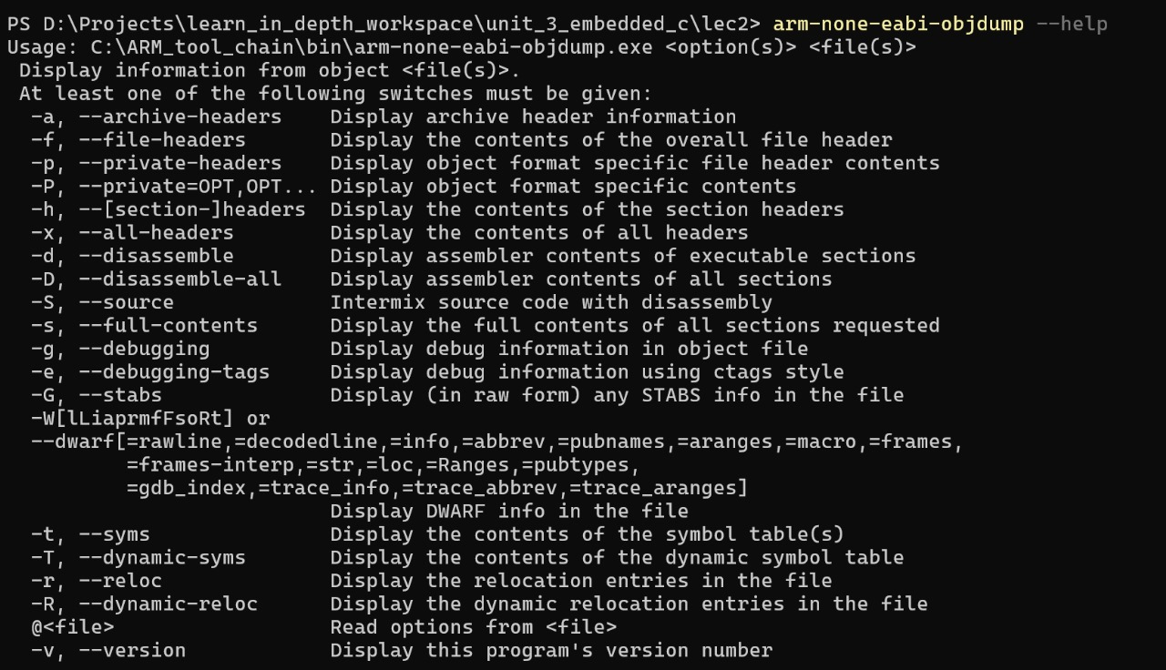

Objdump sections headers

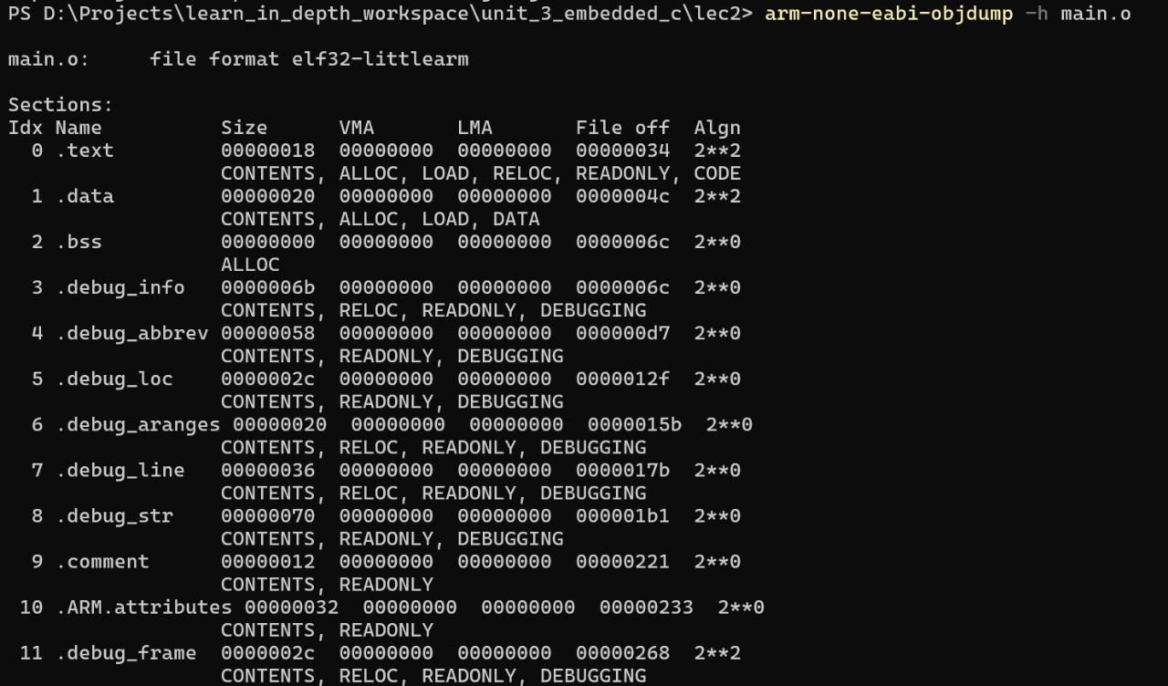

Objdump dissembler

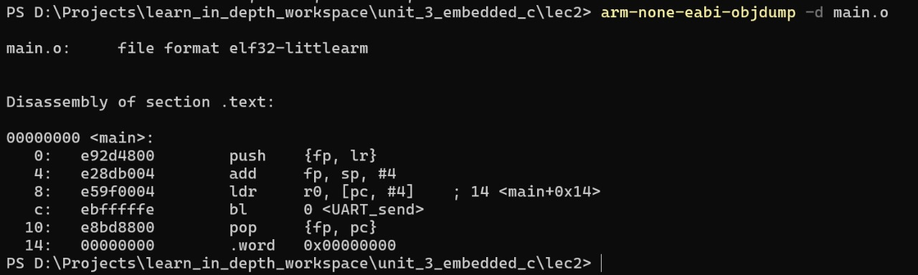

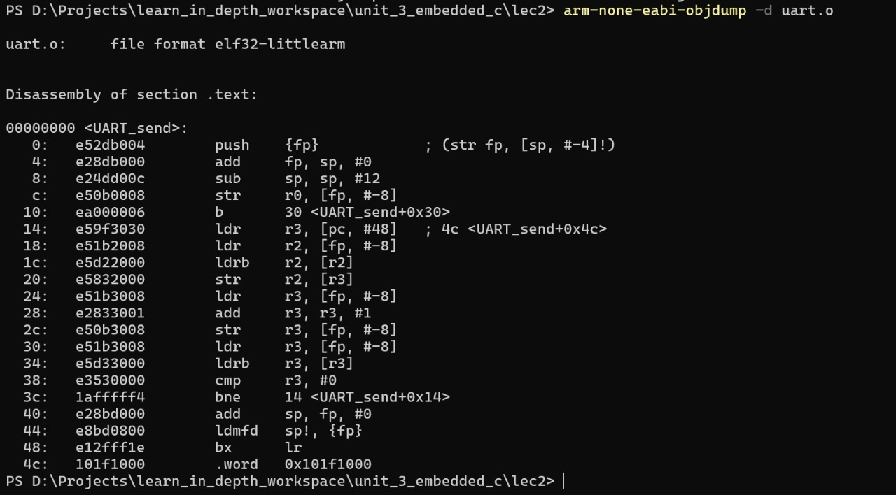

Objdump source

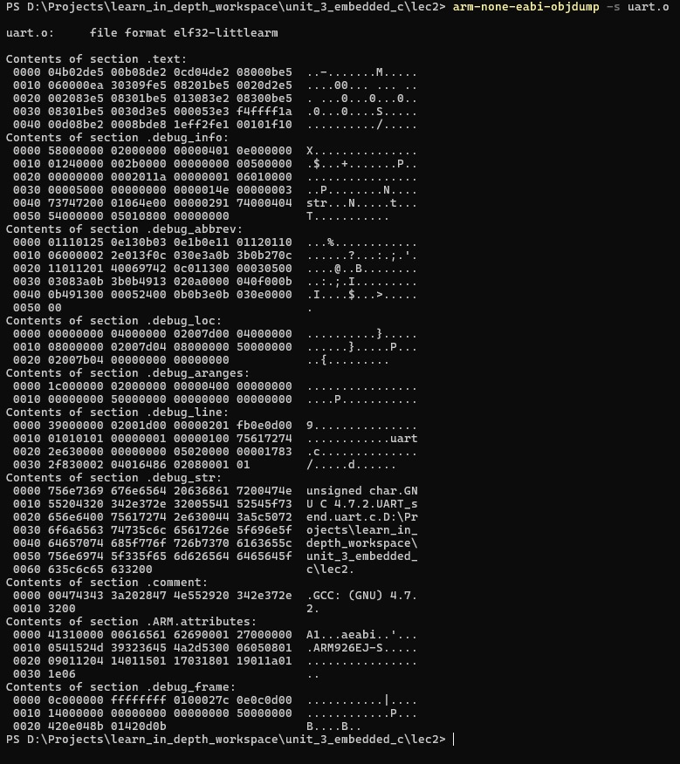

Startup.s file

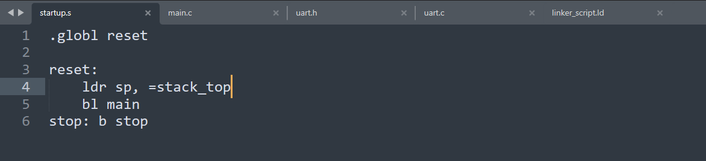

Assemlber startup.s



Objdump

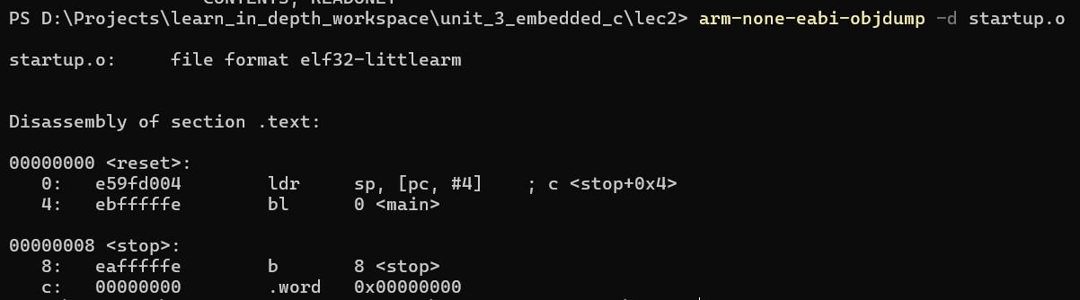

See symbols



C:\Users\asus\AppData\Local\Packages\5319275A.WhatsAppDesktop_cv1g1gvanyjgm\TempState\FFEABD223DE0D4EACB9A3E6E53E5448D\WhatsApp Image 2024-06-14 at 00.54.11_0c497407.jpg

Linker script

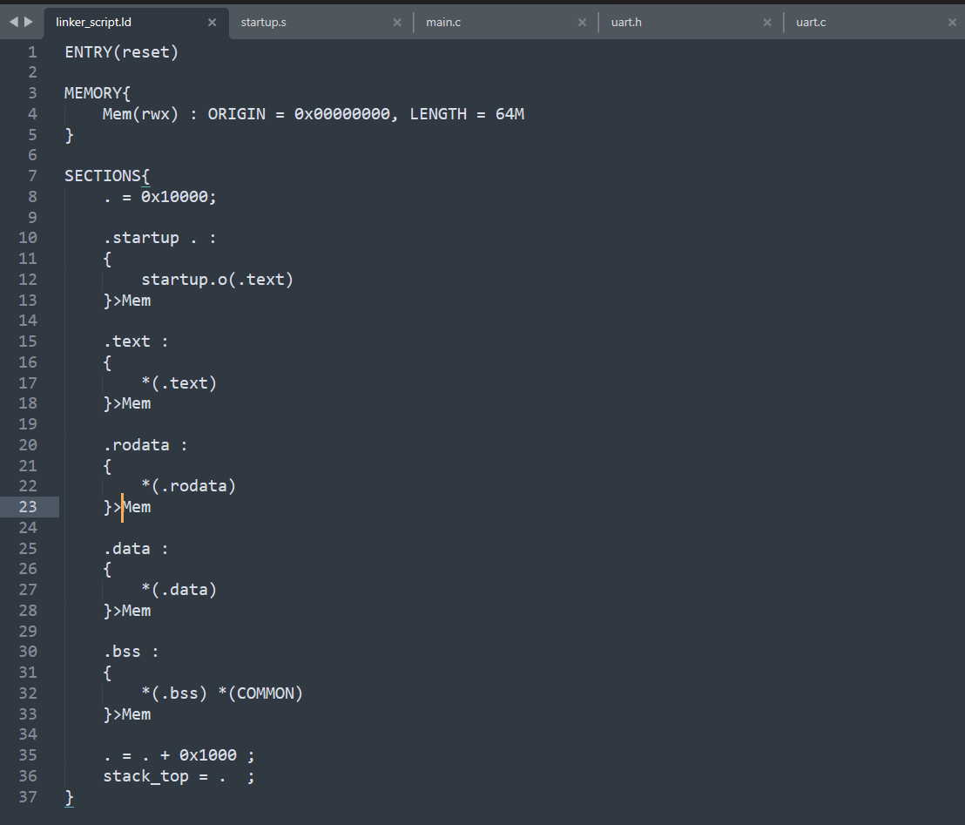

Linke object files

C:\Users\asus\AppData\Local\Packages\5319275A.WhatsAppDesktop_cv1g1gvanyjgm\TempState\069D3BB002ACD8D7DD095917F9EFE4CB\WhatsApp Image 2024-06-14 at 01.06.30_f59c2087.jpg

Objdump

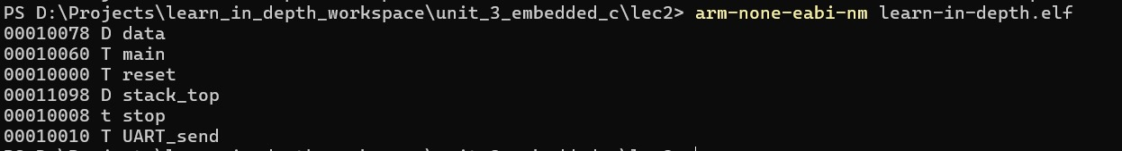

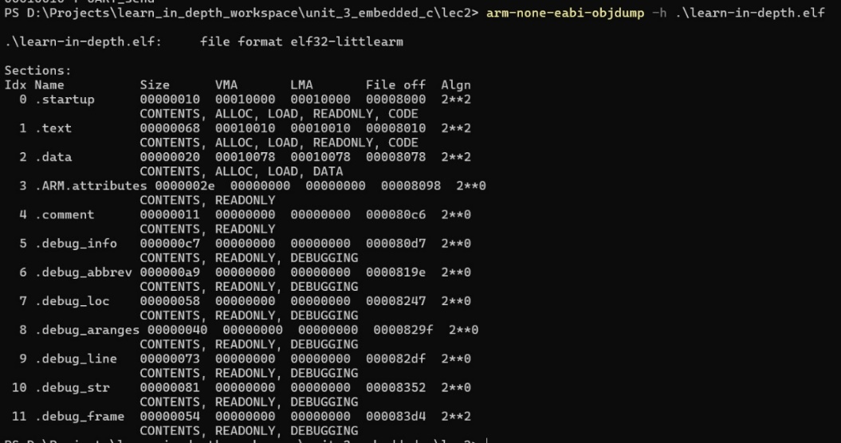

Read elf

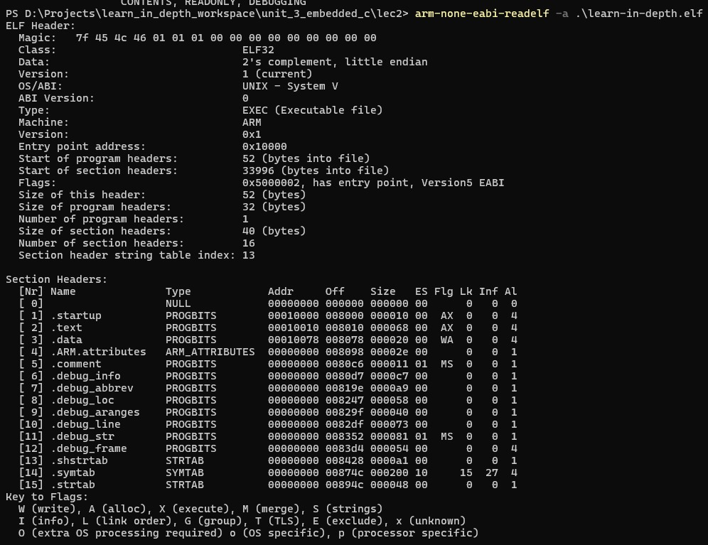

Generate binary files

C:\Users\asus\AppData\Local\Packages\5319275A.WhatsAppDesktop_cv1g1gvanyjgm\TempState\F5DEAEEAE1538FB6C45901D524EE2F98\WhatsApp Image 2024-06-14 at 01.13.35_b485870f.jpg

Simulate the code

