***Youssef Samy***

***Data structure unit 4, les1***

***LIFO (static alloc, dynamic alloc)***

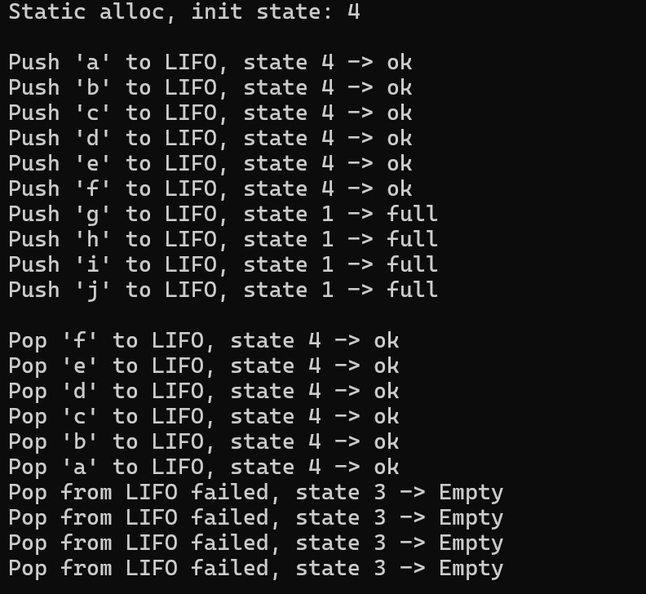

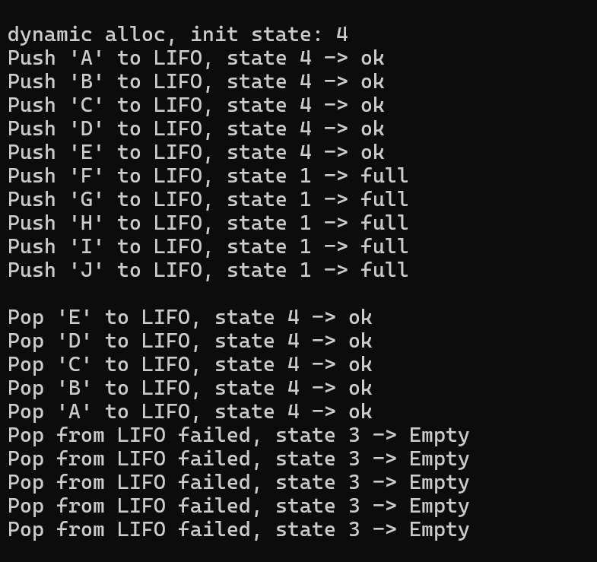

***FIFO (static alloc, dynamic alloc)***

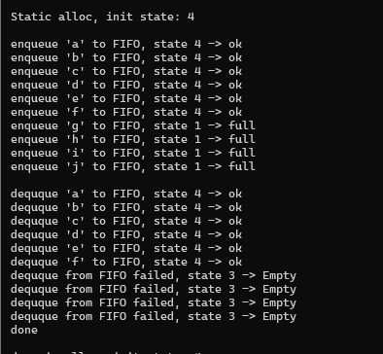

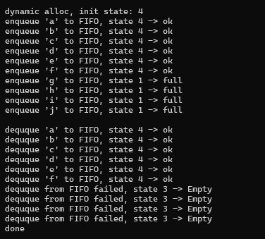

***Linked List***

***Menu***

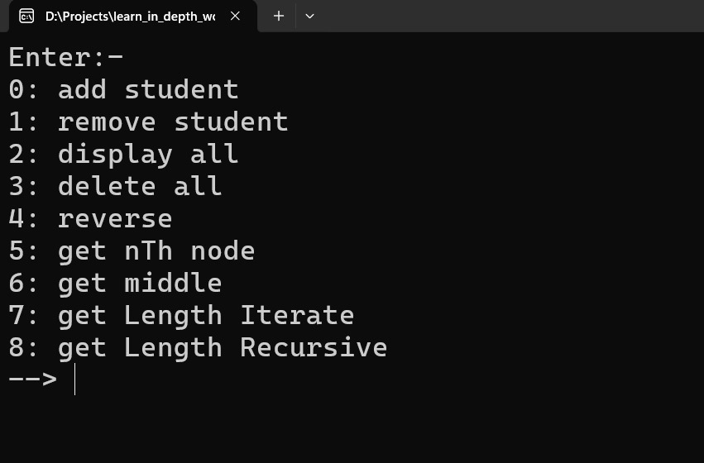

***Add items***

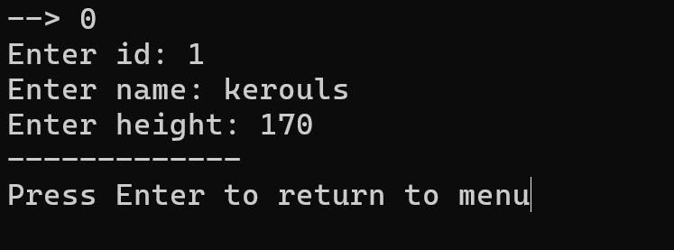

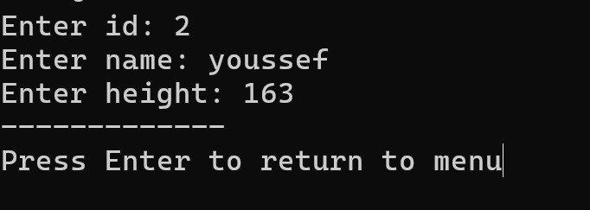

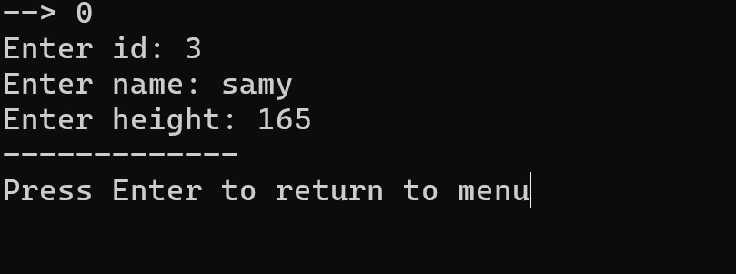

***Display all***

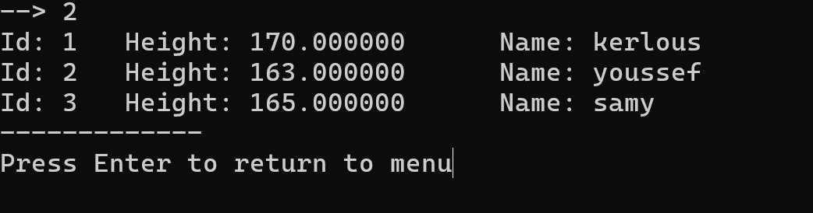

***Get middle***

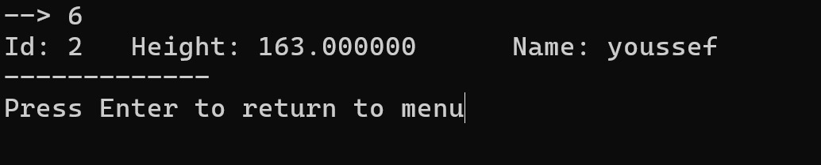

***Get length iterative***

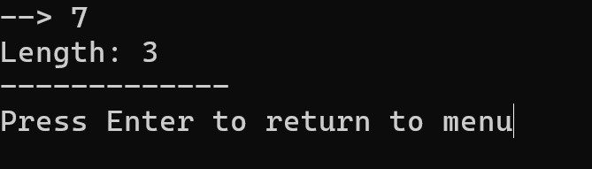

***Get length recursive***

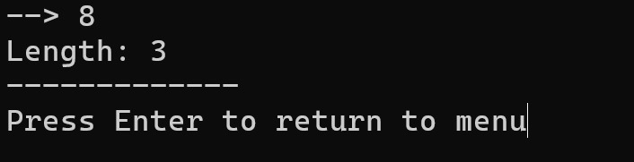

***Get nth node from end***

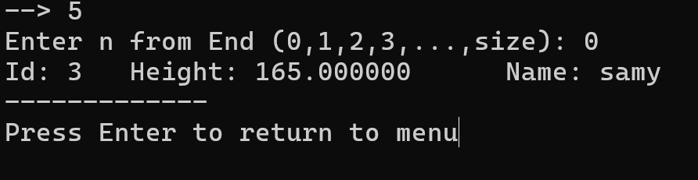

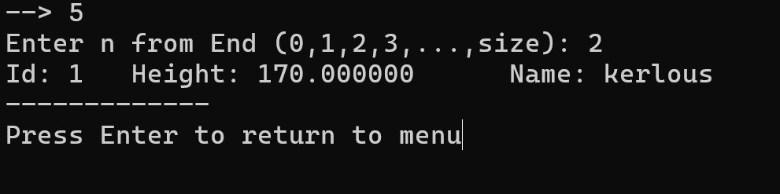

***Reverse list***

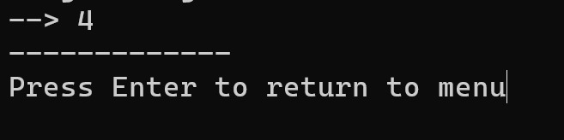

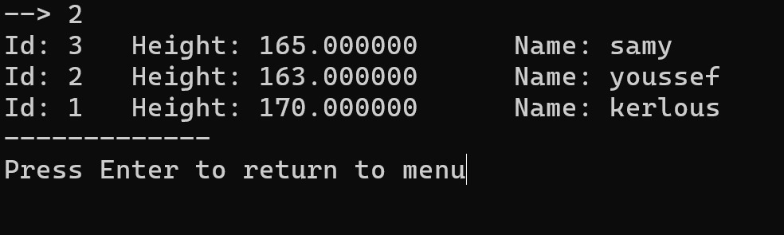

***Delete all***

