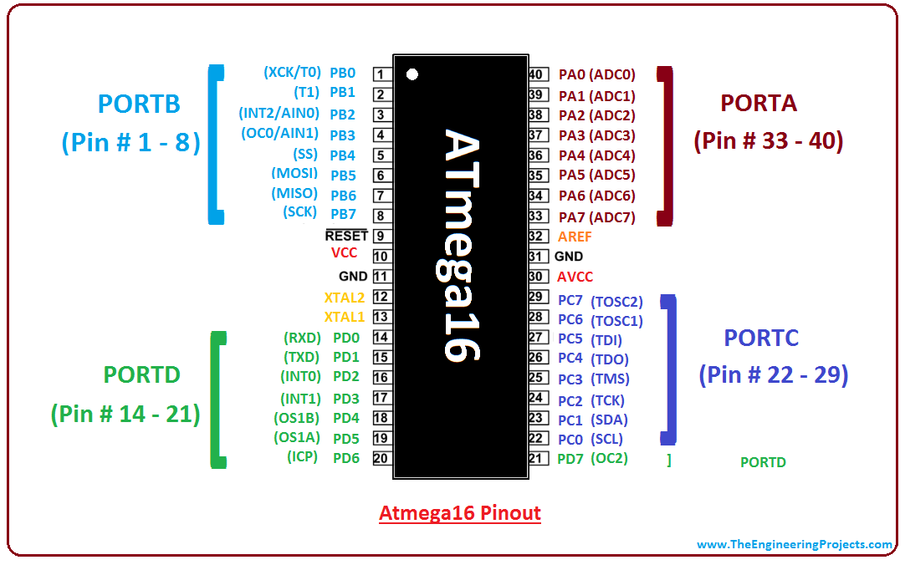

***Tasks:-***

**🡪Motor Driver L298 (master + slave)**

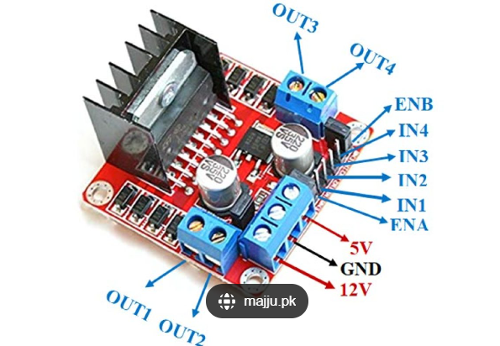 Create motor driver

Use pins

ENA 🡪 PB3 (don’t access this pin by code)

ENB 🡪 PB3 (don’t access this pin by code)

IN4 🡪 PB7

IN3 🡪 PB6

IN2 🡪 PB5

IN1 🡪 PB4

**🡪UART to operate Bluetooth (master)**

Please obey the datasheet of Bluetooth (#stop bits, baud rate, parity check, Data length).

**🡪UART to operate IR receiver (slave)**

Use baud rate 1200

2 stop bits

Data length 8

even parity check

**🡪Timer 0, driver to operate FPWM mode (master + slave)**

Implement code to operate fast pwm mode

**🡪LEDs, driver to control 4 leds (master + slave)**

Pins A0, A1, A2, A3

Led Active high

**🡪Timer 2, (master)**

Generate frequency 38 kHZ on pin “D7” with 0.5 duty cycle,

use CTC / normal mode

**🡪GIE (master + slave)**

Driver to enable and disable global interrupt

**🡪Timer 1, (master + slave)**

Call an ISR every 50 milli second

use CTC / normal mode