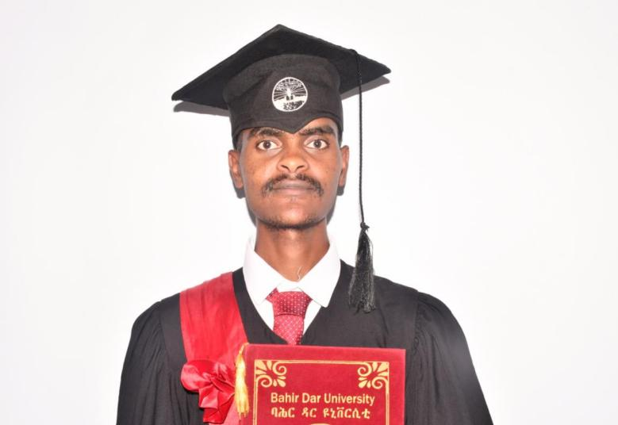

Summery
I am Yoseph Tilahun a Computer Science graduate from Bahir Dar University with skills in Fullstack development,mobile app development. I am passionate about technology, problem-solving, and continuous learning, and I am committed to applying my technical and creative skills to contribute effectively to organizational goals and innovation.

Collaborated with development teams to solve technical problems.

Tested and de

Skills

Fullstack development
 Mobile app
development
Hobbies

Reading
watch technology related videos

contact

 0905217674

yositilahun21@gmail.com https://www.linkedin.com/feed/
https://github.com/Yoseph2123/Computer-science2123
 Bahirdar, Ethiopia

PROJECTS

School management system:
Description:
Developed a web-based student management system that manages student registration, attendance, academic records, and report generation, improving school administration efficiency.
- Home based service finding solution:
A platform that connects home owners to home baseed service providers

Language
- Amharic – Native
- English – Professional Working Proficiency

Web development
- Laravel
- HTML5
- CSS3
- Bootstrap
- MySQL

Tecknical skills
Languages
- PHP
- JavaScript
- Python
Mobile app developmet
- React native

Internship Experiance
Boost Software Development Company
Position: Software Development InternResponsibilities:
- Assisted in developing and maintaining web applications.
- Participated in software design and implementation activities.
- Collaborated with development teams to solve technical problems.
- Tested and debugged application features.
- Prepared technical documentation and reports.

Education
Bahir Dar University
Bachelor of Science (B.Sc.) in Computer Science
Expected Graduation: 2026
Relevant Courses:
- Data Structures and Algorithms
- Database Systems
- Software Engineering
- Web Development
- Mobile Application Development
- Computer Networks
- Operating Systems

