CYBERSPHERE: A NEXT-GENERATION CYBERSECURITY AND TECH TALENT MARKETPLACE WITH INTEGRATED SKILL ASSESSMENTS AND E-COMMERCE ECOSYSTEM

COMP 010 - FINAL PROJECT IN INFORMATION MANAGEMENT

Polytechnic University of the Philippines - Sto. Tomas Campus
Bachelor of Science in Information Technology

Members:
Fukuhara, Yoshinobu N.
Limutos, Gerald P.
Mabalot, Marck Jedrick S.
Managa, Emmanuel B.
Saavedra, Francis R.

June 2026

- Brief Description of the Database Application

CyberSphere is a web-based database application designed to serve as an integrated ecosystem for the Philippine technology and cybersecurity industry. Developed using PHP and MySQL , the system centralizes professional networking, recruitment workflows, practical skill validation, and digital commerce into a single platform.
To support these operations, the underlying database is structured to manage and process data across three core modules:
- Social Job Networking Data: The database stores and retrieves user profiles (including IT professionals, students, and recruiters), uploaded credentials, resumes, and portfolios. It also manages community-generated content such as job vacancy postings, applicant availability posts, comments, and direct messaging records.

- Recruitment and Assessment Tracking: The system manages the recruitment lifecycle by storing applicant tracking data, interview schedules, and candidate rankings. Additionally, it records the results and evaluations of real-time technical assessments, capturing data from the integrated web development and network simulation sandboxes.

- E-Commerce and Transactions: The database maintains a catalog of digital products—such as technical books, certification reviewers, coding templates, and online courses. It records transaction histories, product listings, and order management details utilizing the Philippine Peso (PHP).
By consolidating these distinct data streams, the CyberSphere database application eliminates the fragmented nature of traditional tech recruitment, allowing for seamless data flow between candidate sourcing, skill validation, and professional development.

- ERD & Database Schema

- Business Process Description

CyberSphere operates as an integrated technology talent marketplace and e-commerce platform. The system manages multiple types of users, specifically applicants, recruiters, and administrators. The following user information is stored: user ID, full name, email, password, and their specific role. Recruiters are associated with companies, and the following company information is kept: company ID, name, description, and website URL.

Recruiters post job opportunities on the platform. The following job information is stored: job ID, title, description, and posting status. Applicants submit applications for these open positions. The system tracks each application, and the following application information is kept: application ID, the specific applicant, the job applied for, application status, and the date applied.

To validate technical skills, recruiters conduct live technical assessments, such as web development or networking sandboxes. The following assessment information is stored: assessment ID, title, assessment type, and description. When an applicant completes an exam, the system records the assessment results, keeping the result ID, the specific application it belongs to, the score, and recruiter feedback.

Finally, the platform includes a digital marketplace where users can buy and sell technical learning materials. The following product information is kept: product ID, title, price in PHP, file URL, and the user who is selling it. Users can purchase these products using local gateways, and the following order information is stored: order ID, the buyer, total amount, payment method (such as GCash or Maya), and transaction status.

- Normalization Process

ERD

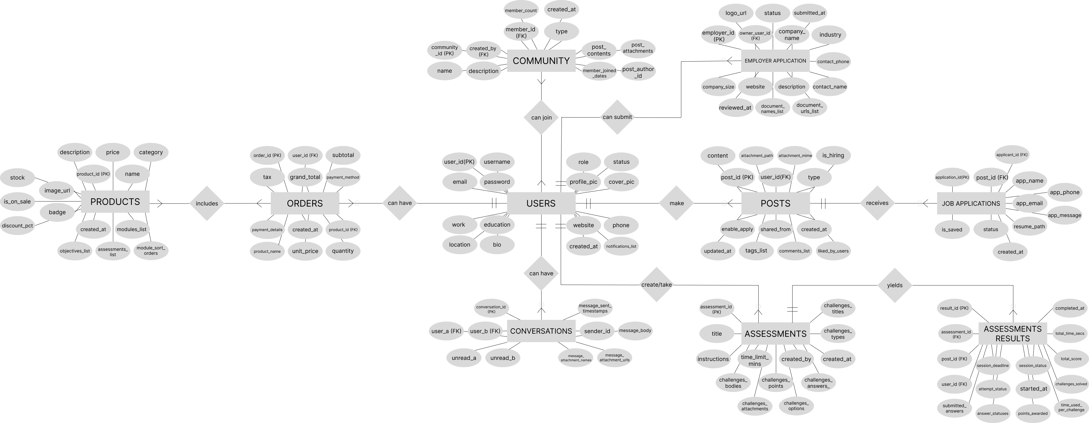

USER AND SOCIAL

1NF
Users
User_work
User_Education
Posts
Post_tags

Post_likes
Comments

2NF
ALL CLEAR

3NF
Users
User_Profiles

User_Work
User_Education
Posts

Post_Attatchments
Job_Post_Details
Post_Tags

Post_Likes
Comments
Notifications

JOB AND CAREER BOARD

1NF
Job_Application

2NF
ALL CLEAR

3NF
Job_Application
Saved_Jobs

MARKETPLACE AND CURRICULUM

1NF
Products
Product_Module
Product_Objectives
Product_Assesment
Orders

2NF
Orders
Order_Items

3NF
Product_Modules
Product_Objectives
Product_Assessments
Product_Categories

Products
Orders
Order_Items

COMMUNITIES AND GROUPS

1NF
Community
Community_Members
Community_Posts

2NF
ALL CLEAR

3NF
Community
Community_Members
Community_Posts
Community_Post_Attachments

MESSAGING SYSTEM

1NF
Conversation
Messages
Message_Attachments

2NF
ALL CLEAR

3NF
Conversation
Messages
Message_Attachments

SKILL ASSESSMENT

1NF
Assessments
Assessment_Challanges
Challenge_Attachments
Challenge_Options
User_Results
User_Challenge_Answers
2NF
ALL CLEAR

3NF
Assessment
Assessment_Challenges
Challenge_Attachments
Challenge_Options
Assessment_Session
User_Assessment_Atempts
User_Challenge_Answers

EMPLOYERS

1NF
Employer_Application
Employer_Documents

2NF
ALL CLEAR

3NF
Employers

Employer_Applications
Employer_Application_Documents

- Data Dictionary
- Screenshot of UI

