**Robotathon Rules 2014**

CHECKPOINT DUE DATES

|  |  |
| --- | --- |
| Design approved by Valvano | 10/3 |
| Blinky LED/Running demo | 10/10 |
| Moving base/soldering | 10/17 |
| Wall Following | 10/24 |
| Line Following | 10/31 |
| Figure 8 | 11/7 |
| Finding an Object | 11/24 |
| Square Dance | 11/24 |

THE COMPETITION:

This year’s competition is a version of a standard obstacle course for robots. It includes several challenges that will help teach basic concepts and competence regarding robotics, design, and teamwork.

The competition will be held on the evening of November 24th, 2014. (Monday before Thanksgiving)

BASIC RULES:

A robot is defined as including the provided launchpad and a battery pack that can be switched on with the battery’s power switch. Robots should be no larger than 1’x1’x1’. The start box will be used for reference. A team may not damage another team’s robot or the field. A robot also cannot leave particle like substances on the the field (i.e., do not drop sand, glitter, marbles, etc. behind you). In addition, do not use fire, animals, toxic chemicals, or some combination of those (for many reasons). Doing any of these, will result in disqualification from the competition. At the end of the competition, RAS will keep the robot, but teams should feel free to continue working on these throughout the year.

THE LAYOUT:

The field is laid out in a series of panels, each with a specific challenge. The panels are all wide enough to accommodate both robots side by side, and will have equal challenges for both side. The panels are Start, Terrain, Ramp, Squiggle, Left Turn, Right Turn, and End/Flag. This design is meant to be modular so that the competition may be randomized at the event. This will be randomly determined at the beginning of each wave of the competition. These panels have been chosen so that careful design and clever AI must be developed in order to fully succeed. All panels, with the exception of the turn panels, are 4 feet by 2 feet when laid flat. The turn panels are 4 feet by 4 feet.The side on which the robot starts will randomly be decided for each match.

THE PANELS:

(Field picture at bottom)

-START: Consists of two starting boxes, and a black line leading out onto the main part of the course. The start panel also has a 3.5” wall on the left and right sides.

-TERRAIN: This panel has 3 obstacle pieces perpendicular to direction of travel attached to the top for traversing. There are black lines spanning the panel.

-RAMP: The ramp panel consists of 2 pieces of wood attached by a hinge (each 4’ X 1’) so that they can be folded into a ramp of varying angles (no more than a 15 degree angle from the horizontal). In addition, this panel will have black lines spanning the panel.

-SQUIGGLE: This panel has two curving black lines in an identical pattern.

-TURNS: The two turn panels test each robot’s ability to turn. Inside turns have a black line, while outside turns have a wall on the outer side. (Wall is a 3.5” tall). Each path will have 1 left and 1 right turn.

-END/FLAG: This “panel” is not actually a wooden piece. After the final randomized panel, there will be a flag 1’ after the line, and halfway between the two tracks. Raising the flag off the ground indicates completing the obstacle course. A robot that does so immediately wins the match. Raising the flag is defined as meeting all of the following criteria:

* the robot is touching the flag
* the flag is not touching the ground

RULES OF PLAY:

The teams will place the robots in the starting box. They cannot move from this position until the match is started. Once the robot leaves the starting box, the team members are not allowed to touch the robot except to reset it. Matches last two minutes or end as soon as either robot raises the flag.

The team members are allowed to reset their robot as many times as they wish within the allotted time, which is two minutes, for the match. Resetting entails placing the robot within its starting box again. The clock does not stop for this. The robot must be reset to fit within the original 1’ cube before the robot returns to play.

[*For example: Team 1 has a movable arm on their robot that extends past the 1’ cube. In their initial configuration, the arm is retracted and fits within dimensions. They start the match and the robot’s stylish flame decal falls off when the arm extends. It gets caught in the wheel and the robot gets stuck. A team member decides that they should reset the robot. She picks up the robot and moves it back into the starting box. She decides that it would take too much time to put the sticker back on the robot, so she leaves it outside the field when the robot is reset. She also must retract the arm into its starting position so it can fit within the starting box. During this time, Team 2 has gained a considerable lead, so Team 1 tries to reset their robot as quickly as possible.*]

Touching the opposing team’s robot with any body parts during a match will result in forfeiting the match. Only team members should be handling their own robot during the match.

If a robot drives off the field, that team MUST reset their robot to the starting box. A robot drives off the field when any part of the robot making contact with the floor outside of the field. The only exception to this rule is after the robot has completed all of the randomized panels and moves on to collect the flag. Then the robot may leave the field without being reset.

If two robots become entangled, the clock is stopped, and both robots are reset. The clock will then be resumed. Any indication of intentional entanglement will result in forfeiting the match. Entanglement is defined as a position where one robot has grabbed or hooked another robot. Entanglement and intentional entanglement will be decided at judge’s discretion.

[*For example: Team 1 decided to make a robot that walks like a spider. Team 2 has some wires sticking out behind their robot. One of the legs of Team 1’s robot gets caught in the wires. The judge stops the clock immediately. So far, 40 seconds have elapsed in the match. Since the entanglement was unintentional, the robots are placed back in the starting boxes and the match resumes when both teams are ready. The clock starts again at 40 seconds.*]

A match is won in the following ways:

1. If a robot lifts the flag, it wins the match.
2. If neither robot lifts the flag in the allotted time of 2 minutes, the first robot to touch the flag wins.
3. If neither robot touches the flag in the allotted time, the robot that is furthest along the course at the end of the allotted time is the winner. The robot’s position is determined by the location of the center of its battery pack.
4. In the event that both robots are at the exact same position on the course, the robot that arrived at the position first wins.
5. If the robots are still tied, a fair coin determines the winner.

If both robots have stopped making progress, the teams can mutually agree to end the match early. At that point the match ends.

*[For example: Team 1 found out that its line sensor was not functioning properly. Their robot was stuck by a wall, and they realized resetting would not help their robot move further in the competition. Team 2 had structural issues and couldn’t make it over the bump in the first panel. They realized they couldn’t fix it and reset it within the two minutes. There was still over a minute left in the match, but both teams decided the additional time was futile. They agreed to call the match. Team 1 was further in the obstacle course, so they won the match.*]

THE PARTS:

Each team will have access to the following parts:

-A LM4F Launchpad Board

-2 Pieces of 1’x2’ Lexan

-1 touch Sensor

-2 IR Sensors

-2 servo Motors

-1 Line Sensor

-1 Servo

-1 Metal Caster

-2 Wheels

-Up to $50 worth of additional parts of their own choosing, including any extra parts from the RAS Office. RAS will not reimburse students for any purchases made.

CHECKPOINTS:

The checkpoints are a way to make sure teams stay on track. There will be several checkpoints throughout the competition - the dates are listed at the top of this document. Completion of a checkpoint before the date will award points towards the final scoring for the team. At least 2 mentors who are not your own must be present in order to pass off a checkpoint.

-Design approved by Valvano - Make a sketch of your robot, get Dr. Valvano to sign off on the

sketch.

-Blinky LED/Running demo - Set up the project in Keil and flash code to the LM4F to make

an external led blink

-Moving base/soldering - Solder the power regulator circuit together (see diagram below), and create a base. Get said base to move.

-Wall Following - Get your robot to follow a wall at a constant distance from the wall

-Line Following - Get your robot to follow a black electrical tape line on the ground

-Figure 8 - Get your robot to do a figure 8 lap around 2 cones spaced 3’ apart.

-Find an Object - Get your robot to find an object (can) in an open field (approx. 4’ x 4’ area).

Your robot needs to find the object and stop at it. The robot will be placed in the middle

of the field, and the can will randomly be placed somewhere in the area.

-Square Dance - Get your robot to move around 4 obstacles set up in a rectangle of variable dimensions, and return to where it started. This challenge will be strict (i.e., your robot should not have much deviation from a square shape and must stop on the same place as where it started)

SCORING:

A team will be scored on their progress and the success of their robot at the competition event.

Checkpoints are in place that will grant teams points toward the score at competition. When a checkpoint is completed, the team will be awarded the checkpoint’s Point Value. If completed by midnight of the assigned date, teams will be granted the checkpoint’s Bonus Points. There will be one due per week until the competition date.

At the event, the obstacle course will be run as a series of 1v1 races, the winner of which will progress through bracket system. The loser will drop down into a second bracket system, and will continue in the competition. The event is double elimination, so once you lose a second time, you are eliminated from the event. Points will be awarded to the each team based on how they scored in comparison to other team.

Here is the breakdown for points:

|  |  |  |  |
| --- | --- | --- | --- |
| **Checkpoint** | **Point Value** | **Checkpoint Date** | **Bonus Points** |
| Valvano Design Approval | 10 | Oct 3 | 5 |
| Blinky LED/Demo | 10 | Oct 10 | 5 |
| Moving Base | 10 | Oct 17 | 5 |
| Wall Following | 20 | Oct 24 | 10 |
| Line Following | 20 | Oct 31 | 10 |
| Figure 8 | 20 | Nov 7 | 10 |
| Finding an Object | 15 | Nov 24 | 0 |
| Square Dance | 15 | Nov 24 | 0 |

|  |  |
| --- | --- |
| **Competition Place** | **Score** |
| 1st place | 100 |
| 2nd place | 80 |

RESOURCES:

-Software Instructions/RASware (API): <https://github.com/ut-ras/Rasware2013>

-Field:

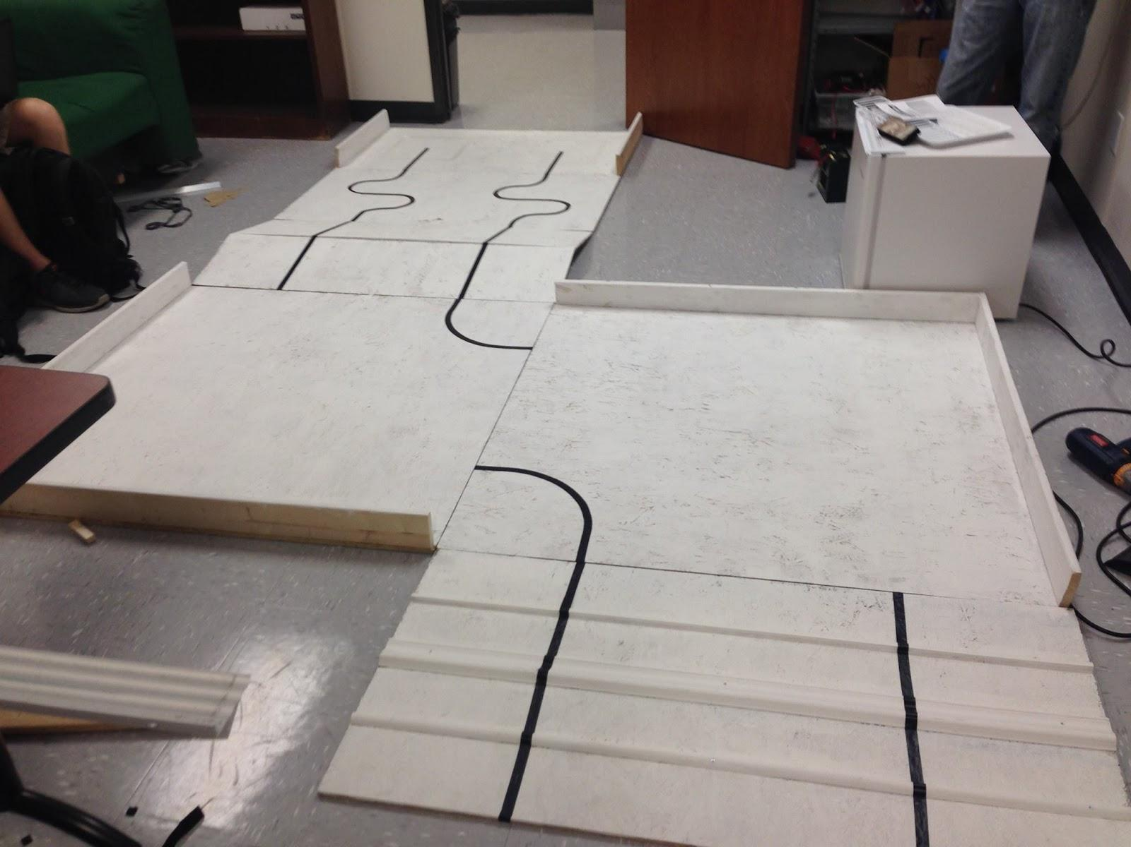

-Power Regulator Circuit Diagram:

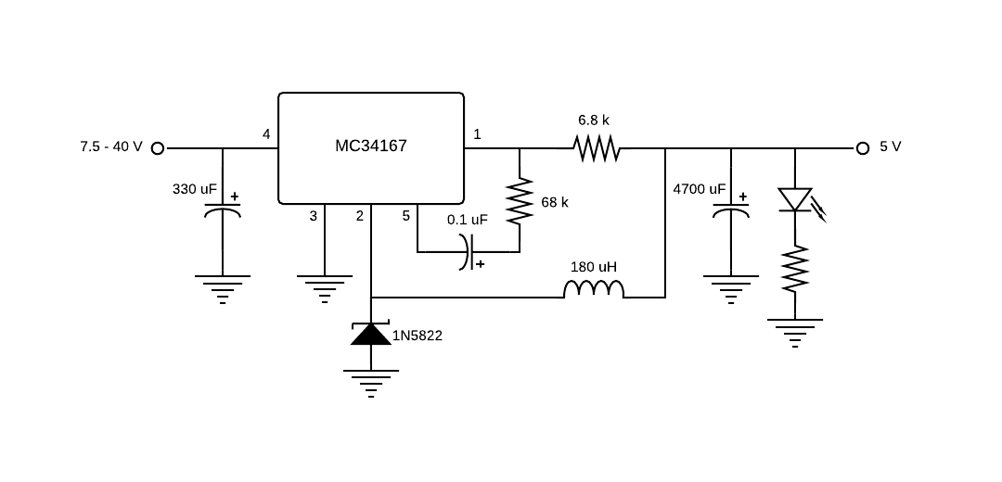

UPDATES:

10/05/2014 - Robotathon clarification overhaul.