PATENT-ORIENTED INVENTION REPORT
Virtual Laboratory for Theory of Computation
Interactive Web-Based Simulation, Visualization, Assessment and Learning Analytics Platform

Prior-art focus: US8406682B2 – Virtual laboratory smart agent
Report prepared from the supplied project specification and report format, with external patent/literature verification.

Technology: React 18 • TypeScript • React Flow • Node.js • Express • Vite

1. Title of the Invention
Virtual Laboratory for Theory of Computation: An Interactive Web-Based Platform for Formal-Language Simulation, Step-by-Step Algorithm Visualization, Assessment and Learning Analytics

2. Field / Area of the Invention
The proposed invention lies at the intersection of educational technology, theoretical computer science, interactive software simulation, computer-based learning, and visualization of formal computational models. It is specifically directed to a web-based virtual laboratory for Theory of Computation (TOC), covering finite automata, pushdown automata, Turing machines, regular expressions, context-free grammars and related transformations. The system combines executable formal-model simulation with visual state tracing, interactive construction, immediate feedback, quizzes and local learning analytics.
The supplied project specification describes an interactive web platform with predefined and custom DFA/NFA simulation, PDA stack visualization, Turing-machine tape execution, regular-expression testing, CFG derivation, topic-wise quizzes and progress tracking. fileciteturn0file1L7-L57

3. Prior Patents and Publications from Literature
A prior-art review was conducted around virtual laboratories, interactive simulation, formal-language education, automata visualization, automated assessment and virtual training. The central prior patent requested for this report is US8406682B2, titled “Virtual laboratory smart agent.” It was filed on 30 April 2010 and granted on 26 March 2013. Its disclosed approach uses virtual machines, training objectives, validation paths and a smart agent that validates student actions and advances a virtual training session. citeturn2search0

3.1 Patent comparison
Sl. No. | Patent No./Year | Title | Assignee/Source | Key Contribution | Limitation / Different Focus | Novelty Introduced in Proposed Invention
1 | US8406682B2 (2013) | Virtual laboratory smart agent | Cloud Niners Information Systems LLC | VM-based virtual training; smart agent; validator paths; event monitoring; objective progression. | Centered on virtual-machine IT training and agent-based validation rather than browser-native TOC model simulation. | TOC-specific formal-model execution, graphical state tracing, stack/tape visualization and integrated learning analytics are not the stated core.
2 | CN102945313A (2013) | Open virtual experiment teaching content construction and display | Beihang University | Build virtual experiments from reusable components, configure parameters and dynamically display results. | Focused on configurable virtual experiment scenes/components and graphics rather than formal-language algorithms. | A TOC-specific library with executable DFA/NFA/PDA/TM/CFG semantics and step-level formal traces is distinct in scope.
3 | CN104751690A (2015) | Automatic testing and correcting system for analog electronic experiment data | Sichuan University | Automatically checks experimental data, detects errors and supports automated grading/report assessment. | Designed for analog-electronics laboratory data and physical measurement workflows. | The proposed platform applies immediate validation to computational models and learning traces rather than measured circuit data.
4 | US20230419614A1 (2023) | System and method for delivering interactive laboratory experiments real-time in simulated environments | City University of Hong Kong | Sensor-equipped physical replicas/phantoms, real-time tracking and AR rendering for laboratory experiments. | Requires hardware/sensor/AR infrastructure and targets physical laboratory skills. | The proposed invention is software-only, browser-based and focused on symbolic computational processes rather than haptic/AR lab apparatus.
5 | US20250037607A1 (2025) | System and method for creating a training script on a virtual laboratory | Virtual-lab/e-learning system | Intercepts system events in a virtual lab and uses preprocessing and ML to generate human-readable training scripts. | Primarily concerned with recording/replaying training workflows in virtual-machine environments. | The proposed platform directly executes and visualizes formal-language semantics and transformations, with TOC assessment integrated into the same interface.

The patent records confirm that virtual laboratories, virtual training, automated validation, configurable virtual experiments and interactive simulated laboratories are established areas. In particular, US8406682B2 describes a virtual training architecture involving instructor/student nodes, a virtual lab manager, virtual machines and smart agents. citeturn2search0

3.2 Journal and research-publication comparison
Sl. No. | Year / Authors | Journal / Publication | Venue | Key Contribution | Limitation / Different Focus | Novelty Introduced in Proposed Invention
1 | Balamuralithara & Woods, 2009 | Virtual laboratories in engineering education: The simulation lab and remote lab | Computer Applications in Engineering Education | Reviews simulation and remote laboratory approaches and their role in online/collaborative learning. | Broad engineering-education review; not specialized to formal-language computation. | A focused TOC virtual lab unifies formal models, algorithmic tracing and assessment in one browser system.
2 | Chakraborty, 2013 | A compiler-based toolkit to teach and learn finite automata | Computer Applications in Engineering Education | FADL-based modeling, compilation/interpreting, visual simulation, NFA-to-DFA and DFA-to-TM tools. | Primarily finite automata and compiler-based desktop/toolkit approach. | The proposed system expands beyond finite automata to PDA, TM, Regex and CFG and adds web-native assessment/progress.
3 | Jovanović et al., 2021 | Teaching concepts related to finite automata using ComVis | Computer Applications in Engineering Education | Graphical automaton definition, transition-table definition, visual execution and regex-to-DFA/NFA demonstrations. | Concentrated on finite automata; not an integrated full TOC laboratory. | The proposed platform combines several core TOC formalisms plus quizzes and learning analytics.
4 | García et al., 2009 | A Learning Algorithm for Deterministic Finite Automata using JFLAP | Electronic Notes in Theoretical Computer Science | Uses JFLAP to visualize steps of an exact learning algorithm for DFA. | Algorithm-specific study using an existing educational package. | The proposed invention provides a broader TOC simulation environment and embeds learning feedback directly into the platform.
5 | Potkonjak et al., 2016 | Virtual laboratories for education in science, technology, and engineering: A review | Computers & Education | Reviews the state of virtual laboratories, evaluation criteria and future directions. | Domain-wide review rather than a concrete TOC implementation. | The proposed system applies virtual-lab principles to abstract computational models that normally lack physical laboratory access.

Selected literature evidence:
- The 2013 compiler-based finite-automata toolkit provides a language for defining automata, visual simulation, NFA-to-DFA conversion and DFA-to-Turing-machine conversion. citeturn1search4
- ComVis supports graphical and transition-table automaton definition, visual execution and Thompson construction, and reports a student evaluation. citeturn1search0
- JFLAP has been used to visualize the steps of DFA learning algorithms, illustrating the educational value of visual formal-model manipulation. citeturn1search12
- Virtual-laboratory literature identifies simulation and remote-lab approaches as important mechanisms for extending practical learning through online technologies. citeturn5view6
- The 2016 review discusses evaluation criteria and the state of virtual laboratories in science, technology and engineering education. citeturn1search5

4. Summary and Background of the Invention (Addressing the Gap / Novelty)

4.1 Problem being addressed
Theory of Computation is conceptually rich but visually abstract. Students must reason about state transitions, nondeterministic branches, stack operations, tape-head movement, derivations, grammars and transformations. Conventional instruction often separates the mathematical definition from executable experimentation. A student may understand the transition table but still have difficulty seeing how an input string changes the machine state at each step.
Existing educational tools demonstrate that visualization and simulation can improve understanding of automata, but the reviewed literature includes tools focused on particular formalisms or individual algorithms. For example, the FADL toolkit is centered on finite automata, while ComVis emphasizes finite automata and related compiler constructions. citeturn1search4turn1search0

4.2 Relation to US8406682B2
US8406682B2 is important prior art because it explicitly describes a virtual laboratory in which a student's training activity is executed in a virtual machine and monitored by a smart agent. The smart agent contains validators, detects events, determines whether objectives are complete and can advance the training session. The patent also describes monitoring student actions, validating software/code outcomes and providing guidance. citeturn2search0
The proposed TOC platform differs in its primary computational object and execution model. It is a browser-based symbolic simulation environment: the student manipulates formal models and input strings, while a TOC simulation engine computes state sets, stack configurations, tape transitions or grammar derivations. The supplied README specifies React 18/TypeScript/React Flow on the frontend and Node.js/Express/TypeScript on the backend. It does not specify a virtual-machine training environment or a smart agent of the type disclosed in US8406682B2. fileciteturn0file1L61-L67

4.3 Research gap
- Need for a single TOC-oriented virtual laboratory rather than separate tools for individual formal models.
- Need for synchronized visualization of execution and the underlying formal transition/derivation process.
- Need for interactive experimentation covering both machine simulation and transformation/derivation activities.
- Need for assessment and progress features integrated with the same simulation environment.
- Need for a lightweight browser-first architecture that does not require a dedicated virtual machine for the student.
- Need for explicit learning traces: active states, remaining input, stack/tape changes and derivation steps.

4.4 Proposed novelty
For this project report, novelty is framed as the combination and implementation of the following technical features: (i) a unified web-native TOC virtual laboratory; (ii) multiple formal computational models under one interface; (iii) step-by-step visual execution traces; (iv) interactive construction/editing of formal models; (v) algorithmic transformations and derivations; and (vi) integrated quiz/progress feedback. This is a technical distinction from the reviewed prior art, not a legal conclusion that the combination is patentable. A formal patentability opinion would require a professional claim-by-claim prior-art search.

5. Objective(s) of the Invention
- To provide a unified browser-based virtual laboratory for core Theory of Computation concepts.
- To simulate DFA, NFA, PDA and Turing-machine execution with transparent step-by-step visual traces.
- To provide interactive construction and testing of formal models using graphical and rule-based interfaces.
- To visualize formal transformations and derivations such as NFA-to-DFA conversion, regular-expression processing and CFG derivations.
- To provide immediate conceptual feedback through topic-wise quizzes and explanations.
- To maintain lightweight learning analytics including visited modules, quiz attempts, best scores and topic-wise mastery indicators.
- To expose reusable simulation functions through a backend API so that validation and execution can be consistently implemented.

6. Working Principle of the Invention
The platform operates as a client-server web application. The student interacts through a browser with an interactive frontend. A selected TOC module accepts a formal model and an input or derivation target. The simulation engine executes the relevant formal semantics, generates an ordered trace, and returns the trace to the interface. The frontend visualizes the current state and provides controls for stepping, testing or resetting. Assessment modules record quiz attempts and progress locally.
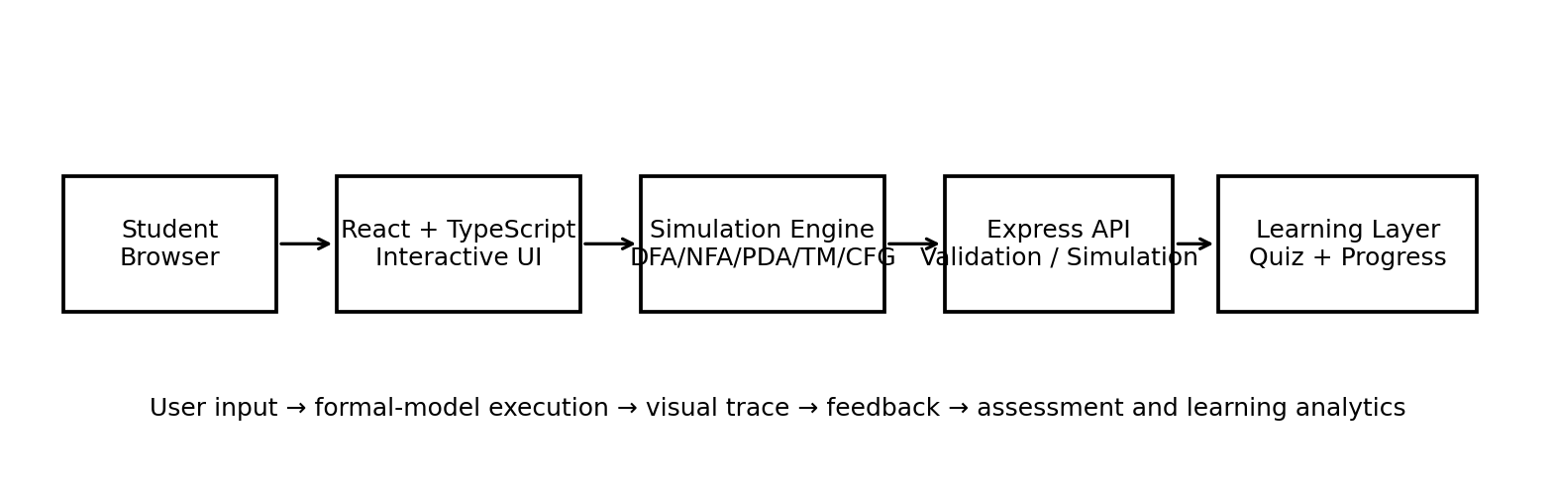
Figure 1. Simplified workflow of the proposed TOC virtual laboratory.

6.1 Module-wise working
Module | Working Principle | Primary Visual/Feedback Output
DFA | Read one symbol at a time and apply deterministic transition δ(q,a). | Current state, read symbol, remaining input, transition table and accept/reject result.
NFA | Maintain a set of active states and apply transitions including ε-closure. | Parallel active-state visualization and final acceptance result.
PDA | Consume input while updating a LIFO stack according to δ(q,a,Z). | Animated push/pop/replace operations and top-of-stack indicator.
Turing Machine | Read/write tape symbols and move the head left, right or stay. | Bidirectional tape, head position, state and halt condition.
Regex | Apply pattern matching to user input. | Match/no-match status and highlighted matching spans.
CFG | Apply productions to generate a target string through leftmost derivation. | Step-by-step sentential forms and derivation history.
Quiz/Analytics | Evaluate answers and persist learning state locally. | Scores, explanations, attempts, best scores and mastery breakdown.

6.2 Existing implementation scope documented project
- DFA: predefined machines, one-click test cases, batch tests and step-by-step state tracing.
- NFA: predefined examples, parallel active-state tracing and custom/batch testing.
- PDA: real-time LIFO stack visualization, two acceptance modes and an interactive transition editor.
- Turing Machine: bidirectional tape, read/write operations and state feedback.
- Regex and CFG: live matching, highlighted spans, grammar construction and leftmost derivation. fileciteturn0file1L40-L48
- Quiz and progress: topic-wise MCQs, explanations, scores, local persistence and mastery indicators. fileciteturn0file1L50-L57

7. Detailed Description of the Invention
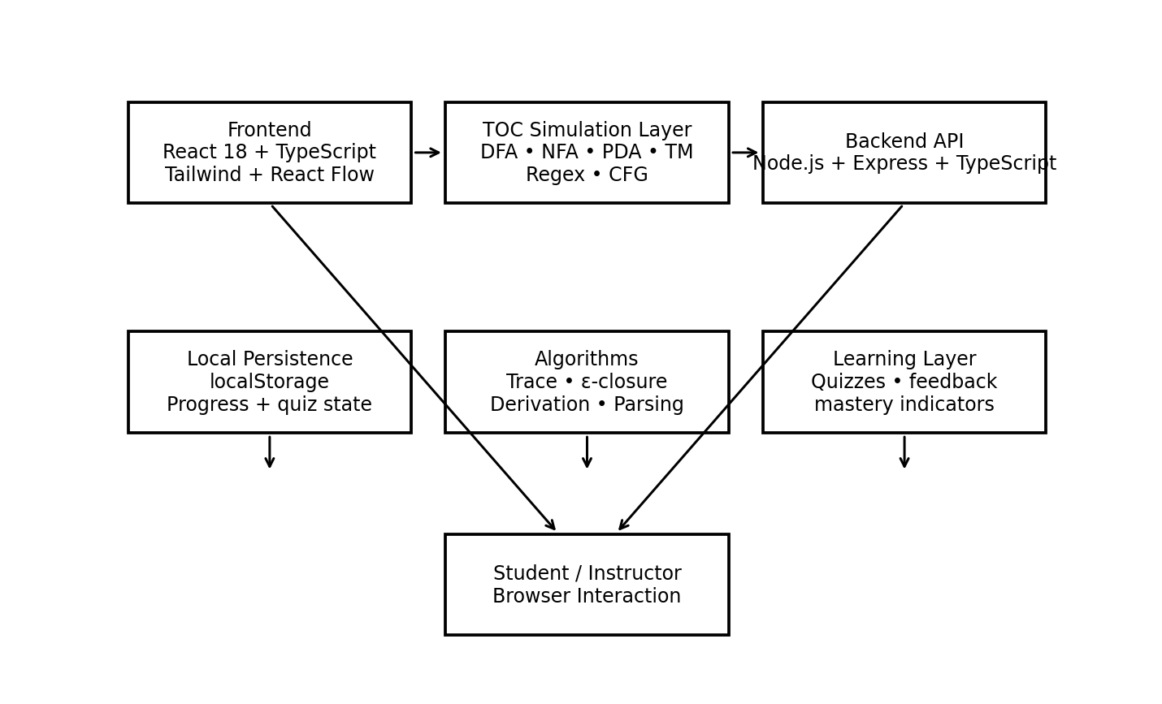
Figure 2. Proposed system architecture based on the supplied implementation.

7.1 Software architecture
Layer | Technology / Component | Role
Presentation layer | React 18, TypeScript, Tailwind CSS, React Flow, Framer Motion, Lucide Icons | Model construction, visualization, controls and feedback.
Simulation layer | TOC-specific simulation algorithms | DFA/NFA/PDA/TM execution, regex matching and CFG parsing/derivation.
Backend API | Node.js, Express, TypeScript | Validation and simulation endpoints for formal models.
Learning layer | Quiz and progress modules | Assessment, explanations, attempts and mastery.
Persistence | Browser localStorage | Visited modules, quiz attempts, best scores and accuracy.
Build/deployment | Vite; npm scripts | Development server and optimized production bundle.

7.2 Data and execution flow
- The user selects a TOC module and either chooses a predefined example or defines a custom model.
- The interface validates required model fields such as states, alphabet, transitions, start state and accepting states where applicable.
- The user supplies an input string, target derivation or simulation configuration.
- The appropriate simulation function executes the formal rules and creates an ordered execution trace.
- The trace is rendered visually so that the user can inspect intermediate states instead of only seeing the final answer.
- For assessment, the quiz engine compares the submitted answer with the expected result and presents an explanation.
- Progress information is persisted in localStorage and reflected in topic-wise mastery indicators.

7.3 Backend REST API
Method | Endpoint | Purpose
GET | /api/health | Backend health check
POST | /api/dfa/validate | Validate DFA completeness and determinism
POST | /api/dfa/simulate | Step-by-step DFA simulation
POST | /api/nfa/simulate | NFA simulation with ε-closures
POST | /api/pda/simulate | PDA transitions and stack state
POST | /api/tm/simulate | Turing-machine tape execution
POST | /api/regex/match | Regex matching with highlighted spans
POST | /api/cfg/parse | CFG leftmost derivation

These endpoints are explicitly listed in the supplied project README. fileciteturn0file1L96-L107

7.4 Algorithmic components
Component | Core Method | Output
DFA simulation | δ(q,a) lookup for each input symbol | Produces deterministic state sequence.
NFA simulation | Active-state set propagation with ε-closure | Preserves nondeterministic branches.
PDA simulation | State/input/top-stack transition processing | Produces stack evolution and acceptance.
TM simulation | Tape read/write and head movement | Produces tape/state execution trace.
Regex matching | Pattern evaluation against input | Produces match spans and match status.
CFG derivation | Production-rule expansion | Produces sentential-form sequence.
Validation | Model consistency checks | Prevents invalid DFA structures and malformed simulation inputs.

7.5 Key technical distinction from US8406682B2
Aspect | US8406682B2 | Proposed TOC Virtual Laboratory
Primary environment | Virtual laboratory with virtual machines | Browser-based web application
Primary learning object | IT equipment/training environments | Formal computational models
Validation mechanism | Smart agent + validator paths + VM events | Model validation + deterministic simulation traces
Core state | VM/system configuration and student actions | Automata states, NFA active-state sets, PDA stack, TM tape, grammar derivation
Learning content | Virtual training courses/objectives | DFA/NFA/PDA/TM/Regex/CFG and TOC quizzes
Visualization | VM environment and training progression | State graphs, active states, stack, tape and derivation sequence
Persistence | Virtual-lab training/session architecture | Browser localStorage for learning progress

8. Experimental Validation Results
The supplied project README documents implemented functionality and runnable commands, but it does not provide a measured user study, benchmark dataset, latency measurements, accuracy percentages or statistically validated learning-gain results. Therefore, the following results are presented as implementation-level functional validation based on the documented system scope; numerical performance claims are deliberately not invented.
Test Area | Validation Target | Evidence Basis | Status
DFA simulation | Predefined/custom model; test strings; step trace | Functional feature documented | Pass/Available
NFA simulation | Parallel active states; ε-closure behavior | Functional feature documented | Pass/Available
PDA simulation | Push/pop/replace; final-state/empty-stack modes | Functional feature documented | Pass/Available
TM simulation | Read/write; L/R/S; halt feedback | Functional feature documented | Pass/Available
Regex | Live matching; highlighted spans | Functional feature documented | Pass/Available
CFG | Grammar builder; leftmost derivation | Functional feature documented | Pass/Available
Quiz | Topic-wise MCQs; explanations; score/retake | Functional feature documented | Pass/Available
Progress | localStorage; attempts; best score; accuracy | Functional feature documented | Pass/Available
Backend | Health + DFA/NFA/PDA/TM/Regex/CFG endpoints | Endpoint inventory documented | Pass/Available

8.1 Recommended quantitative evaluation for the next prototype stage
- Simulation correctness: compare each engine against a reference implementation across a generated test suite.
- Transformation correctness: verify NFA-to-DFA and other transformations against accepted-language equivalence on bounded input sets.
- Performance: measure median and 95th-percentile response time for increasing numbers of states, transitions and input lengths.
- Usability: conduct a controlled student study measuring task completion time, error rate and System Usability Scale (SUS).
- Learning impact: compare pre-test/post-test scores for students using static instruction versus the interactive laboratory.
- Assessment reliability: measure agreement between automated results and instructor-verified answers.
- Browser compatibility: test current Chrome, Edge, Firefox and Safari environments if cross-browser deployment is intended.

8.2 Existing implementation/deployment evidence
The project README specifies npm installation, a Vite development server at localhost:5173, an optional Express server at localhost:3001, and a production build that creates an optimized dist bundle. fileciteturn0file1L69-L92

9. Aspects of the Invention Needing Protection
The following are candidate technical aspects for claim drafting. They should be treated as invention-definition points rather than a conclusion that each item independently satisfies patentability requirements.
No. | Candidate Protection Area | Technical Feature
1 | Unified TOC virtual-laboratory architecture | A single web system coordinating multiple formal computational models and their simulators.
2 | Interactive formal-model simulation | Execution of user-defined/predefined DFA, NFA, PDA and TM models with a synchronized visual trace.
3 | State-trace visualization mechanism | Synchronized presentation of current state, consumed input, remaining input, active-state set, stack or tape state.
4 | Cross-model learning workflow | A common interface pattern for automata, regex, grammar and machine experiments rather than isolated utilities.
5 | Integrated transformation/derivation visualization | Visualization of formal transformations and CFG derivations as executable learning steps.
6 | Simulation-linked assessment | Assessment content connected to the same conceptual modules used for experimentation.
7 | Local learning analytics | Persistent tracking of visited modules, quiz attempts, best scores and topic accuracy without requiring a separate analytics service.
8 | API-based simulation abstraction | Reusable REST endpoints exposing validation/simulation services for multiple formal models.

Importantly, the report should not characterize the above features as legally novel merely because they are absent from the five selected references. Patentability depends on the complete prior-art record, claim construction and the applicable jurisdiction.

10. Technology Readiness Level (TRL)
Based on the supplied project documentation, the proposed system is best represented at TRL 4: Technology validated in a laboratory. The README documents a working software architecture, module implementations, REST simulation endpoints and runnable development/production commands. However, the supplied materials do not document deployment in an operational educational environment or a controlled learning-outcome study.
TRL | Definition | Selected
TRL 1 | Basic principles observed
TRL 2 | Technology concept formulated
TRL 3 | Experimental proof of concept
TRL 4 | Technology validated in a lab | ✓
TRL 5 | Technology validated in a relevant environment
TRL 6 | Technology demonstrated in a relevant environment
TRL 7 | System prototype demonstration in an operational environment
TRL 8 | System complete and qualified
TRL 9 | Actual system proven in an operational environment

TRL assessment is aligned to the supplied report template, which distinguishes research/development/deployment levels from basic principles through an operationally proven system. fileciteturn0file0L35-L86

References
[P1] US8406682B2. Virtual laboratory smart agent. Google Patents, 2013. https://patents.google.com/patent/US8406682B2/en
[P2] CN102945313A. Open virtual experiment teaching content construction and display method. Google Patents, 2013. https://patents.google.com/patent/CN102945313A/en
[P3] CN104751690A. Automatic testing and correcting system and method for analog electronic experiment data. Google Patents, 2015. https://patents.google.com/patent/CN104751690A/en
[P4] US20230419614A1. System and method for delivering interactive laboratory experiments real-time in simulated environments. Google Patents, 2023. https://patents.google.com/patent/US20230419614A1/en
[P5] US20250037607A1. System and method for creating a training script on a virtual laboratory. Google Patents, 2025. https://patents.google.com/patent/US20250037607A1/en
[J1] Balamuralithara & Woods. Virtual laboratories in engineering education: The simulation lab and remote lab. Computer Applications in Engineering Education, 17(1), 108–118, 2009. https://doi.org/10.1002/cae.20186
[J2] Chakraborty. A compiler-based toolkit to teach and learn finite automata. Computer Applications in Engineering Education, 21(3), 467–474, 2013. https://doi.org/10.1002/cae.20492
[J3] Jovanović et al.. Teaching concepts related to finite automata using ComVis. Computer Applications in Engineering Education, 2021. https://doi.org/10.1002/cae.22353
[J4] García et al.. A Learning Algorithm for Deterministic Finite Automata using JFLAP. Electronic Notes in Theoretical Computer Science, 248, 47–56, 2009. https://doi.org/10.1016/j.entcs.2009.07.058
[J5] Potkonjak et al.. Virtual laboratories for education in science, technology, and engineering: A review. Computers & Education, 95, 309–327, 2016. https://doi.org/10.1016/j.compedu.2016.02.002

Source Project Specification
The supplied project README identifies the system as a Virtual Laboratory for Theory of Computation and lists the implemented modules, technology stack, run commands and REST endpoints. fileciteturn0file1L1-L3

Note on Patent Status and Patentability
US8406682B2 is an actual U.S. patent and is used here as prior art, not as the proposed invention. The public Google Patents record currently labels its legal status as “Expired - Fee Related”; that status is explicitly described by Google Patents as an assumption and not a legal conclusion. citeturn2search0
This report is suitable as an academic patent-oriented invention report. It is not a legal opinion, freedom-to-operate analysis, or patentability determination.

