Supplementary Material

Low-Density lipoprotein triglyceride and coronary heart disease risk: evidence from Mendelian Randomization
You Lu¹, PhD, Anand Rohatgi², MD, FAHA, FASPC, and Yilin Yoshida¹*, PhD, MPH, FAHA

¹Section of Endocrinology, Deming Department of Medicine, Tulane University, New Orleans, LA, 70112, USA
²Division of Cardiology, UT Southwestern Medical Center, Dallas, TX, 75390, USA
You Lu: ylu6@tulane.edu
Anand Rohatgi: Anand.Rohatgi@UTSouthwestern.edu
Yilin Yoshida: yyoshida1@tulane.edu

*Corresponding author at: Section of Endocrinology and Metabolism, Deming Department of Medicine, Tulane University, New Orleans, LA, 70112, USA.
Email address: yyoshida1@tulane.edu (Y. Yoshida).
Phone: 504-988-6271

Short running title: LDL-TG and CHD Risk : Mendelian Randomization Evidence

Table of Contents

Materials and Methods
Supplementary Figure 1. Flow chart of sample selection of LDL-TG NMR data
Supplementary Figure 2. Two-sample MR leave-one-out sensitivity analysis for elevated LDL-TG to risk of CHD
Supplementary Figure 3. Funnel plot to access the robustness of using single SNPs as instrument variable in inversed variance weighted method
Supplementary Figure 4. MR scatter plots for the direction of elevated LDL-TG level to risk of CHD
Supplementary Figure 5. Comparison of F-statistics between coding-consequence (all SNPs) and non-coding sequence (selected SNPs)
Supplementary Table 1. Example of cross validated SNPs in the coding sequence
Supplementary Table 2. Example of cross validated SNPs in the non-coding sequence
Supplementary Table 3. Full list of identified SNPs with mapped region
Reference

Materials and Methods
LDL-TG specific GWAS on UKB participants
Individuals with valid LDL-TG nuclear magnetic resonance (NMR) measurement were included. At UKB, NMR biomarkers were measured from baseline EDTA plasma samples obtained from non-fasting blood draws in a random subset of UK Biobank participants [1]. We excluded participants who had withdrawn consent, had discordance between genetically inferred and self-reported sex, or had sex-chromosome aneuploid (Supplementary Figure 1). To reduce bias from population stratification, we further restricted the analysis to participants with genetically inferred European ancestry using a K-means clustering algorithm with K = 4, excluding those classified as non-European ancestry [2]. Before association testing, LDL-TG values were inverse rank-normalized to have a mean of 0 and standard deviation of 1, enabling scale-free interpretation of genetic effect estimates [3]. GWAS was performed using BOLT-LMM, a linear mixed model approach that accounts for cryptic relatedness and population structure through the random-effect components [4]. Age, sex, ApoB, fasting time, defined as the interval between last caloric intake and blood draw, and genotyping array, defined as a binary indicator for the UK BiLEVE array versus UKB Axiom array, were adjusted in the LDL-TG GWAS model. Because BOLT-LMM accounts for relatedness and population structure in mixed-model framework, genetic principal components were not included as fixed-effect covariates [3]. We used PLINK2 [5] to perform genotype quality control. According to the reference [4], the PLINK2 parameters were defined as follow: variants were retained if they had a minor allele frequency (MAF) ≥ 0.01 and minor allele count (MAC) ≥ 20 to ensure sufficient information content were captured at lower-frequency sites [6, 7]. The single nucleotide polymorphism (SNP)s with genotype missingness > 0.01 and individuals with genotype call rate ≤ 0.9 were excluded [8].

Genetic instrument selection
To construct genetic instruments for LDL-TG, the exposure variable, we first selected SNPs associated with LDL-TG at genome-wide significance (P < 5$×$10⁻⁸ ) [9]. We additionally constructed a relaxed instrument set using a suggestive association threshold of P < 1$×$10⁻⁶, with weak-instrument assessment applied throughout [10]. To ensure independence among instruments, linkage disequilibrium (LD) clumping was performed using European ancestry reference panel from the 1000 Genomes Project Consortium [11]. Independent variants were retained using r² < 0.001 within a 10,000-kb window, keeping the most strongly associated SNP within each locus [12]. For each retained SNP, we calculated the first stage F-statistic and excluded instruments with F <10 to reduce potential weak instrument bias [13].
The summary statistics of CHD, the outcome, were obtained from the GWAS Catalog database: https://www.ebi.ac.uk/gwas/home, with study accession ID: GCST90132314. In total, this study included 1,165,690 participants, comprising 181,522 CHD cases and 984,168 controls [14].

Mendelian randomized analyses
Exposure and outcome summary statistics were harmonized by aligning effect alleles across the LDL-TG and CHD GWAS datasets. Palindromic A/T and C/G variants were evaluated using effect-allele frequencies to resolve potential strand ambiguity. Variants with unresolved ambiguity, particularly those with MAF ≈ 0.5, were excluded [15]. We used the Inverse-variance weighted (IVW) method as the primary two-sample MR approach to estimate the causal effect of genetically predicted LDL-TG on CHD risk [16]. Steiger filtering was applied to confirm that genetic instruments explained more variance in LDL-TG than in CHD [17]. To evaluate the robustness of the MR findings and assess potential horizontal pleiotropy, we performed MR-Egger regression and weighted-median analysis [12, 18]. In addition, leave-one-out analyses were conducted to assess whether the overall MR estimate was driven by any single instrument. For loci with complex LD or prior pleiotropy concerns, we additionally performed colocalization to verify that the exposure and outcome share the same causal signal [19].

Supplementary Figure 1. Flow chart of sample selection of LDL-TG NMR data

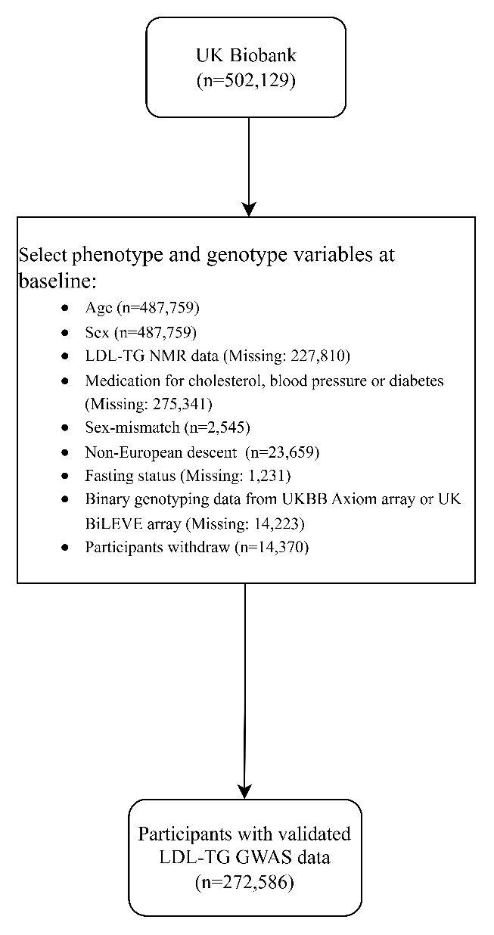

Supplementary Figure 2. Two-sample MR leave-one-out sensitivity analysis for elevated LDL-TG to risk of CHD

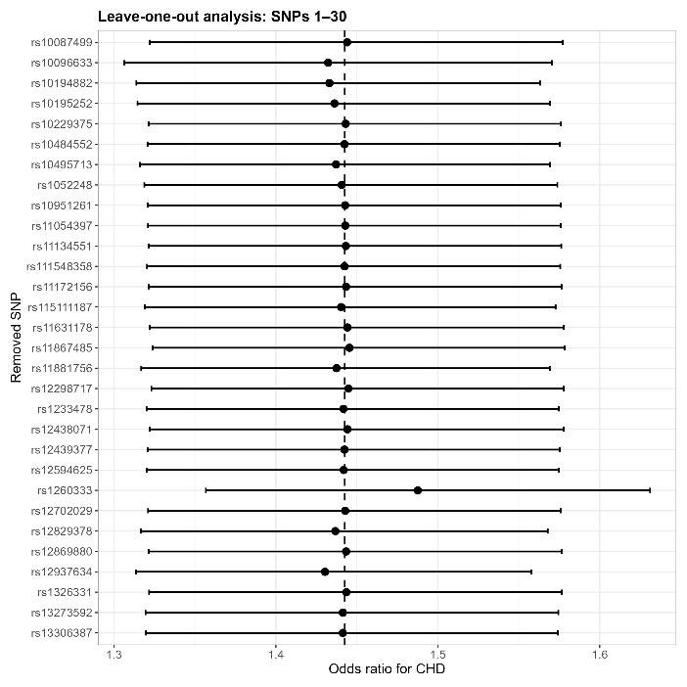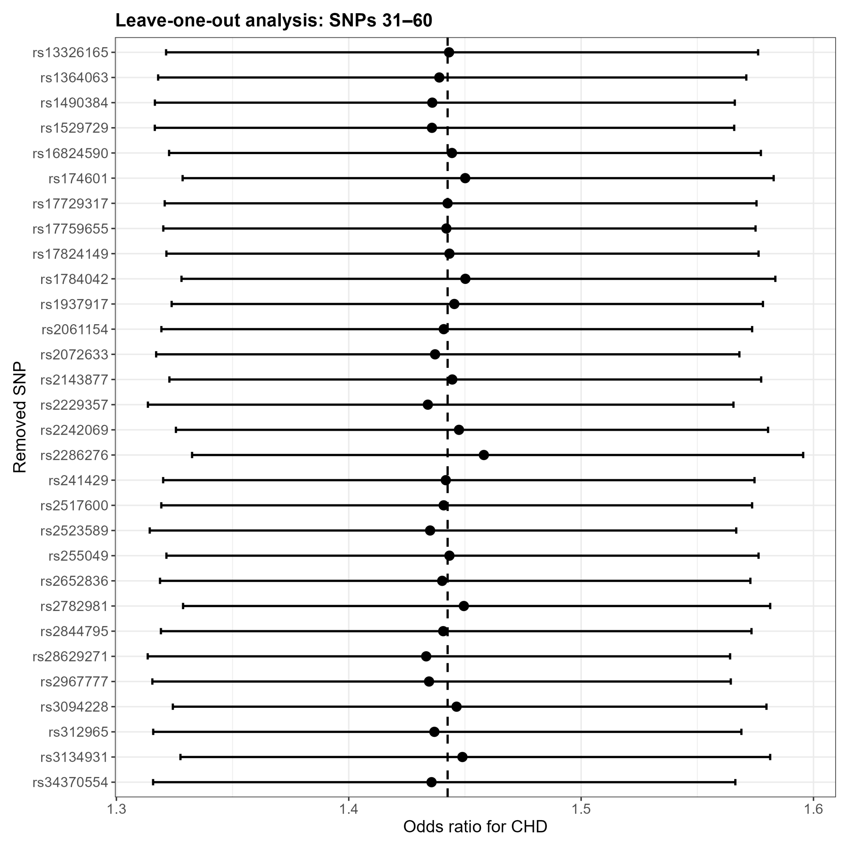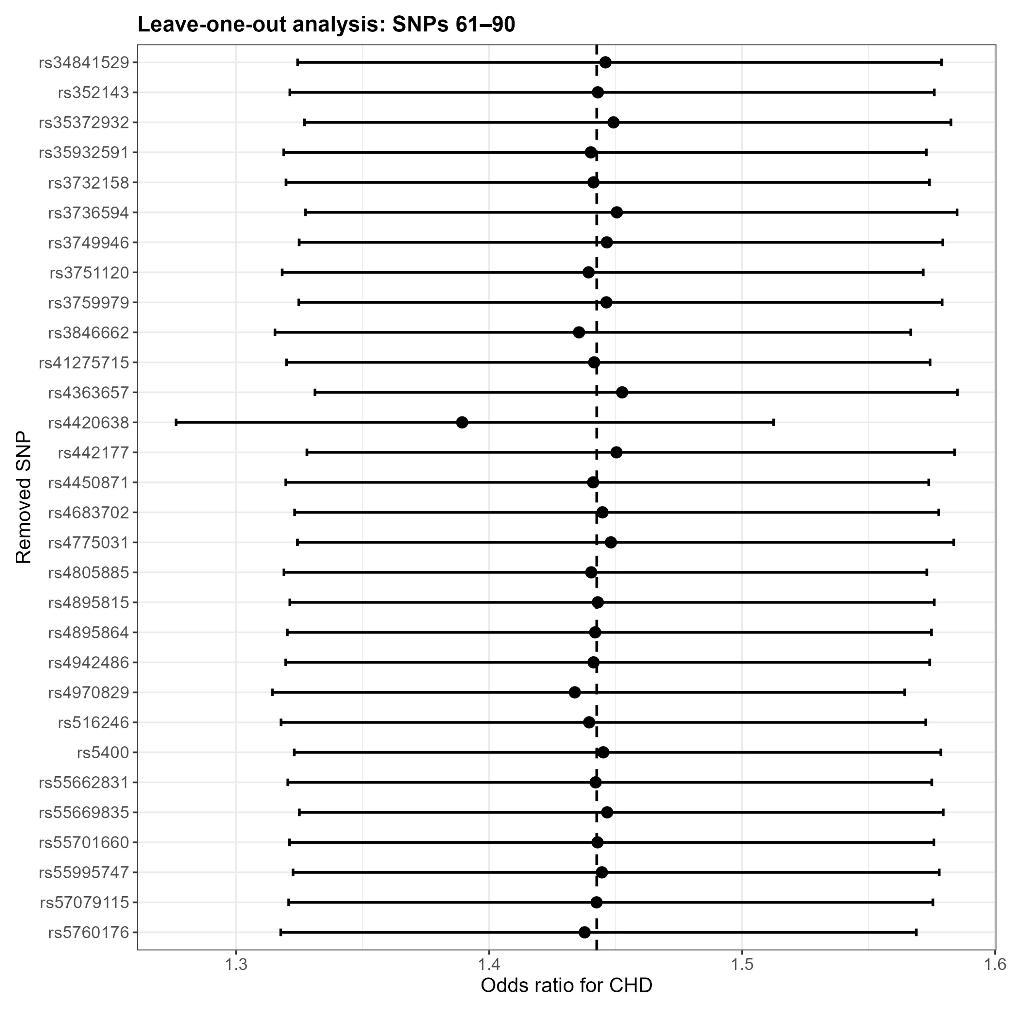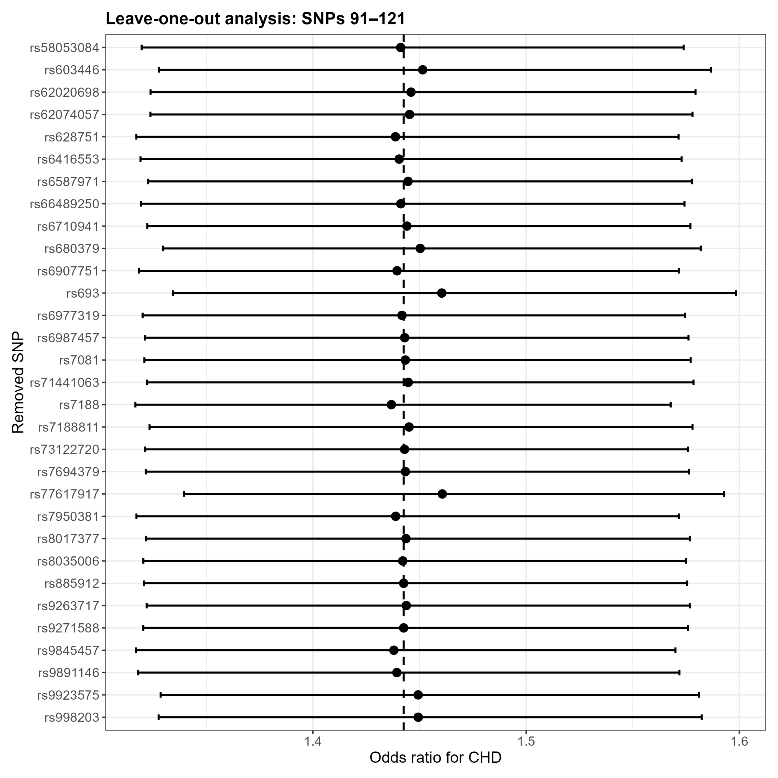
A
B
C
D
Supplementary Figure 3. Funnel plot to access the robustness of using single SNPs as instrument variable in inversed variance weighted method
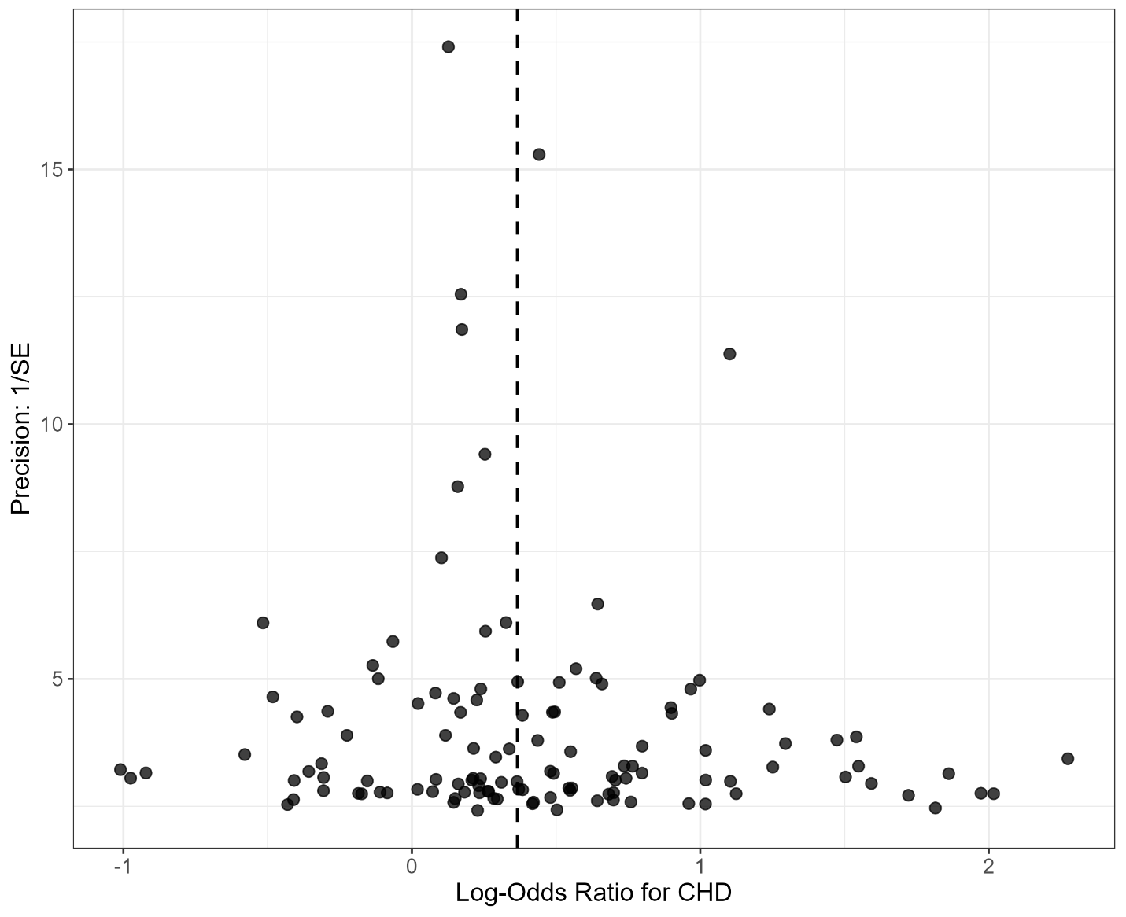
Notes: SE: standard error of the beta coefficient/effect estimate, CHD: coronary heart disease.

Supplementary Figure 4. MR scatter plots for the direction of elevated LDL-TG level to risk of CHD
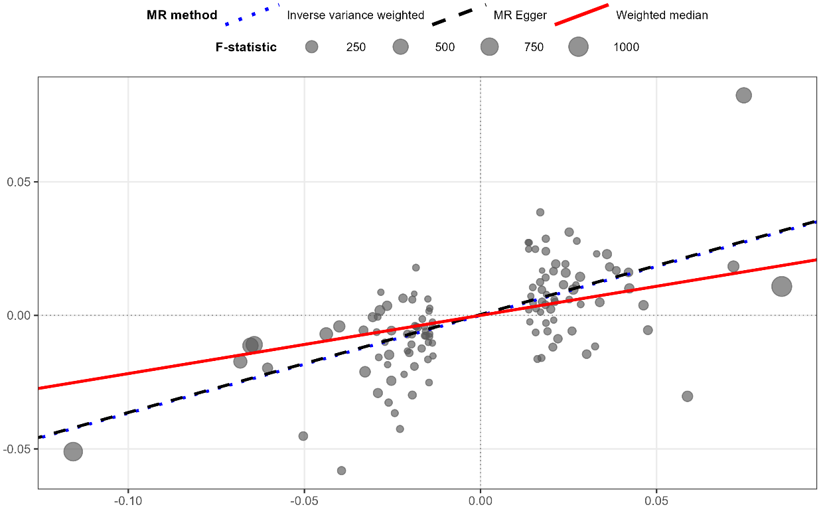
SNPs effects on LDL-TG
SNPs effects on CHD

Supplementary Figure 5. Comparison of F-statistics between coding-consequence (all SNPs) and non-coding sequence (selected SNPs)
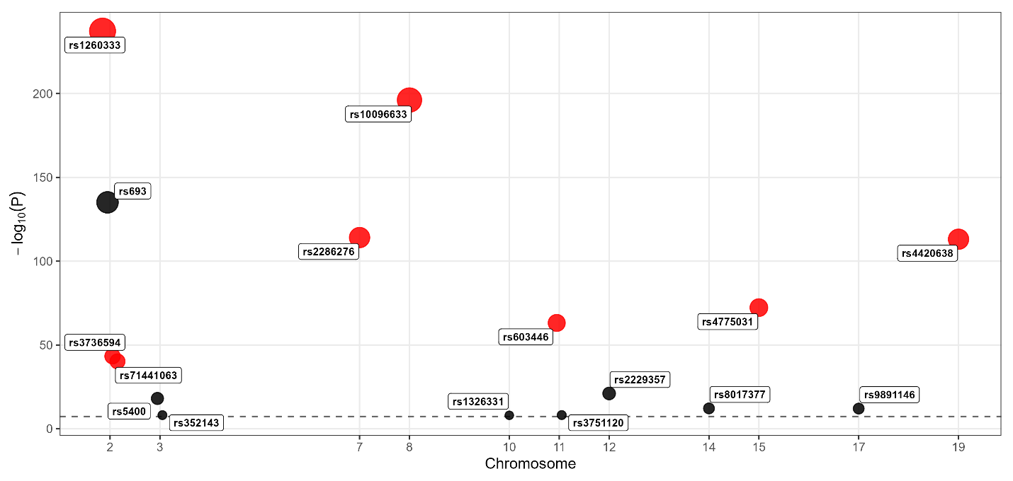
Notes: black solid oval: SNPs in coding sequence, red solid oval: selected SNPs in non-coding sequence.

Supplementary Table 1. Example of cross validated SNPs in the coding sequence
SNP | Mapped Gene/Region | Reported trait | PubMed ID | Study type
rs693 | APOB | ApoB, TG, TC, LDL-C and lower HDL-C | 28874158 | Meta-analysis
rs5400 | SLC2A2 | Glycemic traits, metformin response | 27500523 | GWAS
rs352143 | TWF2 / TLR9 region | Tuberculosis | 25616954 | Multicenter study
rs1326331 | EXOC6 / SEC15L1 | Late-onset Alzheimer disease | 16385451 | Comparative study
rs3751120 | FLRT1, MACROD1 | CAD among African Americans | 28396569 | Multicenter study
rs2229357 | INHBC, INHBE | CAD risk general | 28714975 | GWAS
rs8017377 | NYNRIN | LDL-C | 20686565, 24097068 | GWAS
rs9891146 | C17orf58 | Type 2 diabètes susceptible variants | 29632382 | Meta-analysis

Supplementary Table 2. Example of cross validated SNPs in the non-coding sequence
SNP | Mapped Gene | Location | Closest SNP | Reported trait | PubMed ID | Sample size
rs11631178, rs8035006 | ALDH1A2; LIPC | chr15q21.3 | rs1800588, rs10468017 | LDL-TG to CHD | 30685440 | N=487

Supplementary Table 3. Full list of identified SNPs with mapped region
SNP | F-statistics | Mapped Gene/Region | In non-coding sequence | Chromosome
rs4970829 | 59.86 | SARS1 | Yes | 1
rs6587971 | 58.77 | Not mapped | Yes | 1
rs2061154 | 32.49 | LYPLAL1-AS1 | Yes | 1
rs1260333 | 1083.68 | GCKR | Yes | 2
rs693 | 613.79 | APOB | No | 2
rs3736594 | 192.1 | MRPL33 | Yes | 2
rs71441063 | 178.17 | ATRAID; CAD | Yes | 2
rs10195252 | 154.41 | COBLL1 | Yes | 2
rs7081 | 132.29 | SLC5A6 | Yes | 2
rs312965 | 77.24 | TDRD15 | Yes | 2
rs111548358 | 72.81 | Not mapped | Yes | 2
rs10495713 | 67.87 | Not mapped | Yes | 2
rs66489250 | 63.76 | BABAM2 | Yes | 2
rs10194882 | 55.3 | Not mapped | Yes | 2
rs17759655 | 54.98 | BABAM2 | Yes | 2
rs55669835 | 40.68 | FAM117B | Yes | 2
rs35932591 | 37.06 | Not mapped | Yes | 2
rs55701660 | 31.92 | LINC01822 | Yes | 2
rs6710941 | 31.85 | CENPA | Yes | 2
rs115111187 | 28 | TTLL4 | Yes | 2
rs3732158 | 27.89 | HS1BP3 | Yes | 2
rs16824590 | 27.39 | NOP58; SNORD70 | Yes | 2
rs5400 | 77.03 | SLC2A2 | No | 3
rs9845457 | 50.04 | MSL2 | Yes | 3
rs13326165 | 32.37 | STAB1 | Yes | 3
rs352143 | 32.08 | TWF2 | No | 3
rs4683702 | 27.77 | Not mapped | Yes | 3
rs442177 | 118.14 | AFF1 | Yes | 4
rs7694379 | 27.51 | Not mapped | Yes | 4
rs4450871 | 27.48 | Not mapped | Yes | 4
rs41275715 | 27.1 | MTTP | Yes | 4
rs3846662 | 49.86 | CERT1; HMGCR | Yes | 5
rs11134551 | 37.17 | Not mapped | Yes | 5
rs57079115 | 27.84 | Not mapped | Yes | 5
rs9271588 | 104.6 | HLA-DQA1 | Yes | 6
rs2523589 | 96.22 | HLA-B; MIR6891 | Yes | 6
rs1052248 | 91.48 | LST1; NCR3 | Yes | 6
rs3094228 | 90.71 | HCP5 | Yes | 6
rs628751 | 86.07 | Not mapped | Yes | 6
rs35372932 | 82.41 | HLA-DRB1 | Yes | 6
rs998203 | 68.24 | CHP1P2; IGF2R | Yes | 6
rs3134931 | 54.25 | NOTCH4 | Yes | 6
rs2517600 | 45.51 | TRIM31; TRIM31-AS1 | Yes | 6
rs2844795 | 41.64 | TRIM31; TRIM31-AS1 | Yes | 6
rs885912 | 40.99 | TRIM26 | Yes | 6
rs1233478 | 37.14 | LINC02829 | Yes | 6
rs3749946 | 37.12 | HCP5; MICB-DT | Yes | 6
rs4895864 | 36.29 | L3MBTL3 | Yes | 6
rs241429 | 31.68 | PSMB8; TAP2 | Yes | 6
rs2072633 | 31.67 | CFB; CYP21A2; NELFE | Yes | 6
rs1490384 | 28.19 | Not mapped | Yes | 6
rs10484552 | 27.73 | LINC02569 | Yes | 6
rs9263717 | 27.49 | PSORS1C1 | Yes | 6
rs6907751 | 27.38 | PEX6 | Yes | 6
rs4895815 | 27.19 | Not mapped | Yes | 6
rs2286276 | 517.23 | TBL2 | Yes | 7
rs10951261 | 50.36 | ADAP1; COX19 | Yes | 7
rs6977319 | 32.46 | BAZ1B | Yes | 7
rs10229375 | 31.83 | MIR4284; STX1A | Yes | 7
rs13306387 | 28.16 | GCK; MYL7 | Yes | 7
rs58053084 | 27.61 | GCK | Yes | 7
rs12702029 | 27.44 | CHLSN; GPER1 | Yes | 7
rs10096633 | 894.51 | Not mapped | Yes | 8
rs13273592 | 68.46 | Not mapped | Yes | 8
rs6987457 | 45.38 | Not mapped | Yes | 8
rs34370554 | 40.99 | Not mapped | Yes | 8
rs10087499 | 31.86 | Not mapped | Yes | 8
rs17729317 | 28.37 | TRPS1 | Yes | 8
rs2782981 | 36.3 | Not mapped | Yes | 10
rs1326331 | 31.6 | EXOC6 | No | 10
rs1937917 | 27.91 | AKR1C5P | Yes | 10
rs603446 | 283.27 | ZPR1 | Yes | 11
rs1784042 | 99.66 | SIDT2; TAGLN | Yes | 11
rs7950381 | 91.24 | SIK3 | Yes | 11
rs174601 | 68.13 | FADS2 | Yes | 11
rs34841529 | 37 | Not mapped | Yes | 11
rs3751120 | 32.25 | FLRT1; MACROD1 | No | 11
rs2229357 | 90.56 | INHBC; INHBE | No | 12
rs4363657 | 73.49 | SLCO1B1 | Yes | 12
rs12829378 | 36.31 | RFLNA | Yes | 12
rs11054397 | 31.7 | Not mapped | Yes | 12
rs11172156 | 27.62 | R3HDM2 | Yes | 12
rs12298717 | 27.35 | RFX4 | Yes | 12
rs4942486 | 45.44 | BRCA2 | Yes | 13
rs12869880 | 32.14 | GAS6; GAS6-AS1 | Yes | 13
rs8017377 | 50.15 | NYNRIN | No | 14
rs4775031 | 325.18 | ALDH1A2 | Yes | 15
rs62020698 | 104.94 | FDPSP4; UBR1 | Yes | 15
rs11631178 | 100.64 | ALDH1A2; LIPC | Yes | 15
rs55995747 | 81.86 | ALDH1A2; LIPC; LIPC-AS1 | Yes | 15
rs12438071 | 76.84 | ALDH1A2; LIPC; LIPC-AS1 | Yes | 15
rs2242069 | 58.78 | TP53BP1 | Yes | 15
rs2652836 | 37.22 | Not mapped | Yes | 15
rs12594625 | 36.07 | ALDH1A2; AQP9; MTCYBP23; MTND5P32 | Yes | 15
rs12439377 | 27.14 | HAUS2; MYL12BP1 | Yes | 15
rs8035006 | 27.11 | LIPC | Yes | 15
rs6416553 | 23.84 | CRTC3 | Yes | 15
rs28629271 | 68.02 | PKD1L3 | Yes | 16
rs7188811 | 32.45 | C16orf96; UBALD1 | Yes | 16
rs9923575 | 32.41 | Not mapped | Yes | 16
rs3759979 | 32.26 | COG8; NIP7; TMED6 | Yes | 16
rs255049 | 31.93 | DPEP3 | Yes | 16
rs1364063 | 31.88 | Not mapped | Yes | 16
rs9891146 | 49.68 | C17orf58 | No | 17
rs12937634 | 41.28 | ZNF652; ZNF652-AS1 | Yes | 17
rs17824149 | 32.61 | TM4SF5 | Yes | 17
rs55662831 | 28.24 | DNAH2 | Yes | 17
rs11867485 | 27.22 | CD300LG | Yes | 17
rs62074057 | 23.88 | TBX21 | Yes | 17
rs4420638 | 512.62 | APOC1 | Yes | 19
rs516246 | 99.82 | FUT2 | Yes | 19
rs11881756 | 41.66 | CEACAM16-AS1 | Yes | 19
rs4805885 | 40.52 | PEPD | Yes | 19
rs2967777 | 36.43 | MYO1F | Yes | 19
rs7188 | 31.8 | KANK2 | Yes | 19
rs1529729 | 27.34 | SMARCA4 | Yes | 19
rs77617917 | 146.09 | PCIF1 | Yes | 20
rs680379 | 36.78 | LINC01723 | Yes | 20
rs2143877 | 28.26 | Not mapped | Yes | 20
rs73122720 | 23.92 | RNU6ATAC38P; WFDC3 | Yes | 20
rs5760176 | 27.47 | GSTT4; GSTTP2 | Yes | 22
Notes: yellow rows are all SNPs that are in the coding sequence, green rows are selected SNPs that are in the non-coding sequence.

Reference
1. Julkunen, H., et al., Atlas of plasma NMR biomarkers for health and disease in 118,461 individuals from the UK Biobank. Nature communications, 2023. 14(1): p. 604.
2. Horikoshi, M., et al., Genome-wide associations for birth weight and correlations with adult disease. Nature, 2016. 538(7624): p. 248-252.
3. Richardson, T.G., et al., Characterising metabolomic signatures of lipid-modifying therapies through drug target mendelian randomisation. PLoS biology, 2022. 20(2): p. e3001547.
4. Bycroft, C., et al., The UK Biobank resource with deep phenotyping and genomic data. Nature, 2018. 562(7726): p. 203-209.
5. Purcell, S., et al., PLINK: a tool set for whole-genome association and population-based linkage analyses. The American journal of human genetics, 2007. 81(3): p. 559-575.
6. Christakoudi, S., et al., GWAS of allometric body-shape indices in UK Biobank identifies loci suggesting associations with morphogenesis, organogenesis, adrenal cell renewal and cancer. Scientific reports, 2021. 11(1): p. 10688.
7. Zhou, W., et al., Scalable generalized linear mixed model for region-based association tests in large biobanks and cohorts. Nature genetics, 2020. 52(6): p. 634-639.
8. Marees, A.T., et al., A tutorial on conducting genome‐wide association studies: Quality control and statistical analysis. International journal of methods in psychiatric research, 2018. 27(2): p. e1608.
9. Chen, Z., et al., Revisiting the genome-wide significance threshold for common variant GWAS. G3, 2021. 11(2): p. jkaa056.
10. Duggal, P., et al., Establishing an adjusted p-value threshold to control the family-wide type 1 error in genome wide association studies. BMC genomics, 2008. 9(1): p. 516.
11. c, G.P.C.C.a.A.A.a.a.g.c.b.A.G.R.g.u.e., et al., A global reference for human genetic variation. Nature, 2015. 526(7571): p. 68-74.
12. Bowden, J., G. Davey Smith, and S. Burgess, Mendelian randomization with invalid instruments: effect estimation and bias detection through Egger regression. International journal of epidemiology, 2015. 44(2): p. 512-525.
13. Lee, S. and W. Lee, A Review of Mendelian Randomization: Assumptions, Methods, and Application to Obesity-Related Diseases. Journal of Obesity & Metabolic Syndrome, 2025. 34(1): p. 14.
14. Aragam, K.G., et al., Discovery and systematic characterization of risk variants and genes for coronary artery disease in over a million participants. Nat Genet, 2022. 54(12): p. 1803-1815.
15. Hemani, G., et al., The MR-Base platform supports systematic causal inference across the human phenome. elife, 2018. 7: p. e34408.
16. Burgess, S., A. Butterworth, and S.G. Thompson, Mendelian randomization analysis with multiple genetic variants using summarized data. Genet Epidemiol, 2013. 37(7): p. 658-65.
17. Hemani, G., K. Tilling, and G. Davey Smith, Orienting the causal relationship between imprecisely measured traits using GWAS summary data. PLoS genetics, 2017. 13(11): p. e1007081.
18. Bowden, J., et al., Consistent estimation in Mendelian randomization with some invalid instruments using a weighted median estimator. Genetic epidemiology, 2016. 40(4): p. 304-314.
19. Giambartolomei, C., et al., Bayesian test for colocalisation between pairs of genetic association studies using summary statistics. PLoS genetics, 2014. 10(5): p. e1004383.

