Supplementary Material

Title: Low-Density lipoprotein triglyceride and coronary heart disease risk: evidence from Mendelian Randomization

Table of Contents
Supplementary Figure 1. Flow chart of sample selection of LDL-TG NMR data
Supplementary Figure 2. Two-sample MR leave-one-out sensitivity analysis for elevated LDL-TG to risk of CHD
Supplementary Figure 3. Funnel plot to access the robustness of using single SNPs as instrument variable in inversed variance weighted method
Supplementary Figure 4. MR scatter plots for the direction of elevated LDL-TG level to risk of CHD
Supplementary Figure 5. Comparison of F-statistics between coding-consequence (all SNPs) and non-coding sequence (selected SNPs)
Supplementary Table 1. Example of cross validated SNPs in the coding sequence
Supplementary Table 2. Example of cross validated SNPs in the non-coding sequence
Supplementary Table 3. Full list of identified SNPs with mapped region

Supplementary Figure 1. Flow chart of sample selection of LDL-TG NMR data

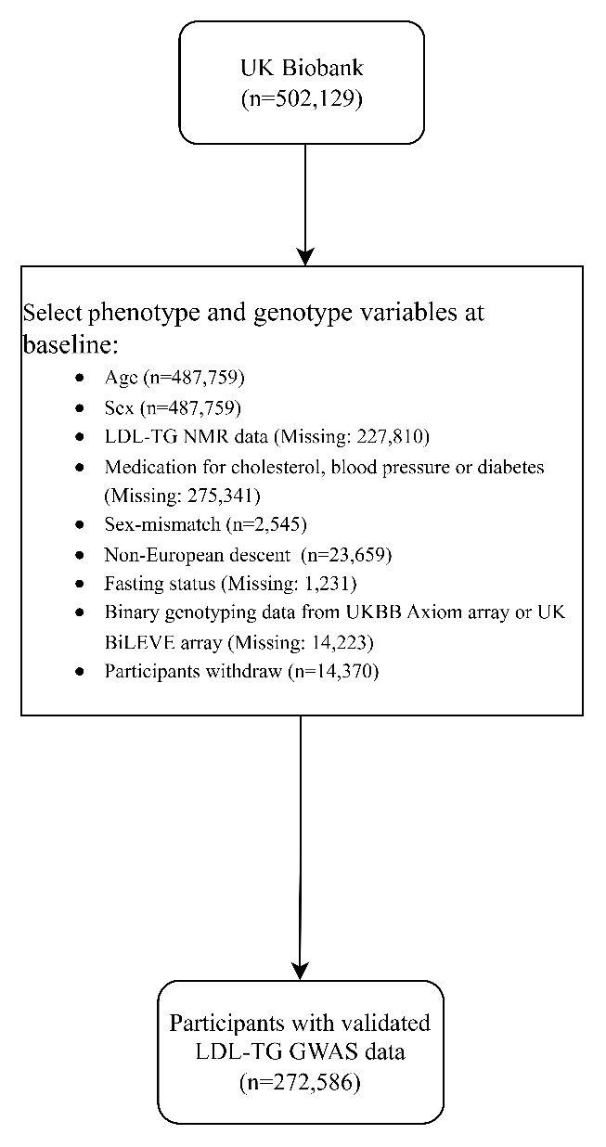

Supplementary Figure 2. Two-sample MR leave-one-out sensitivity analysis for elevated LDL-TG to risk of CHD

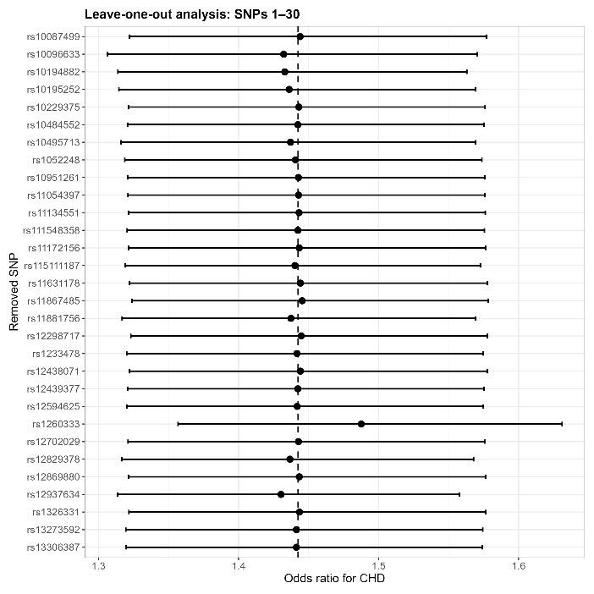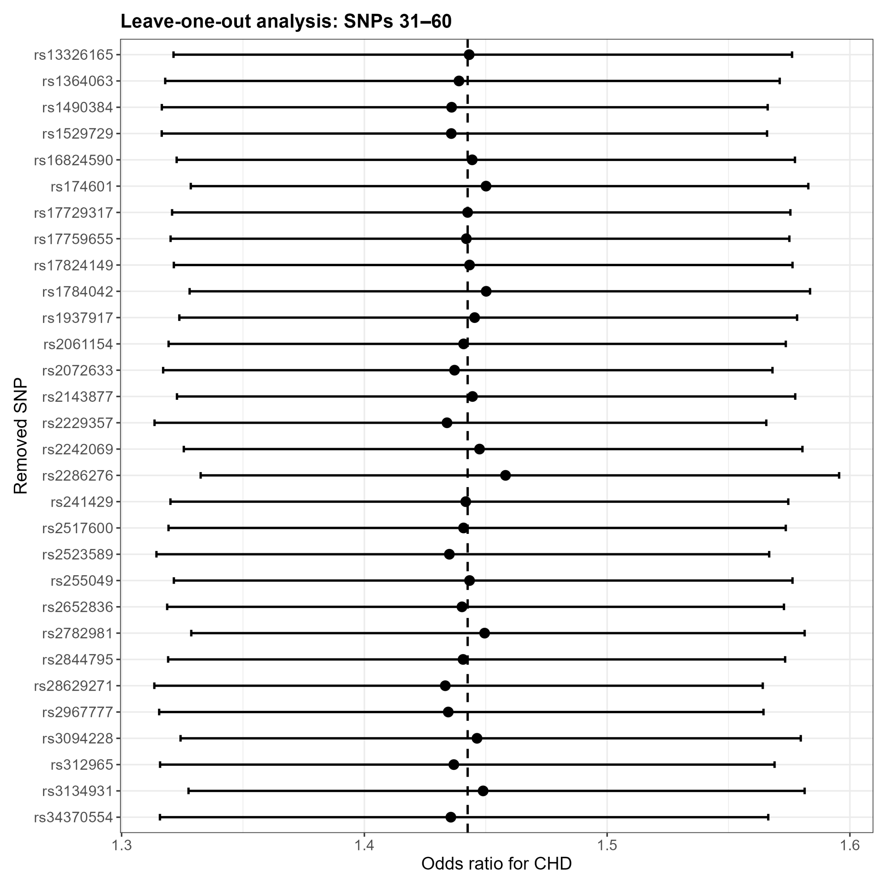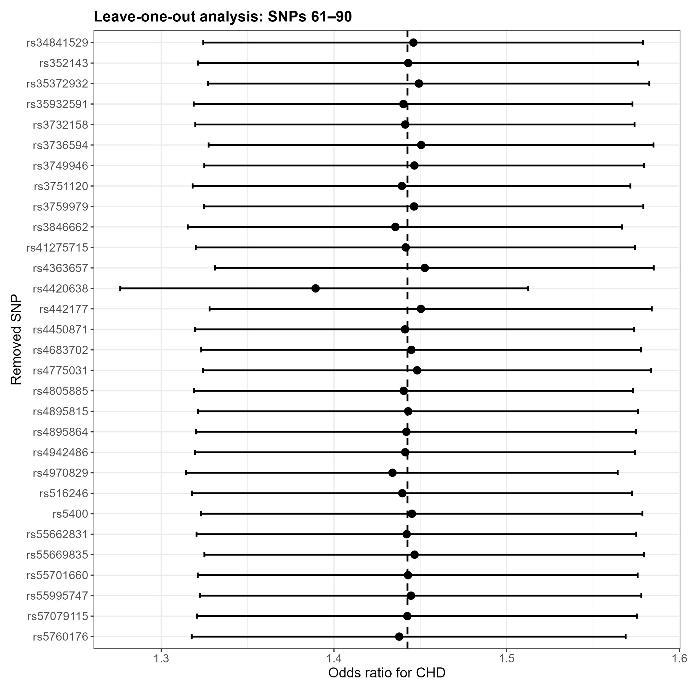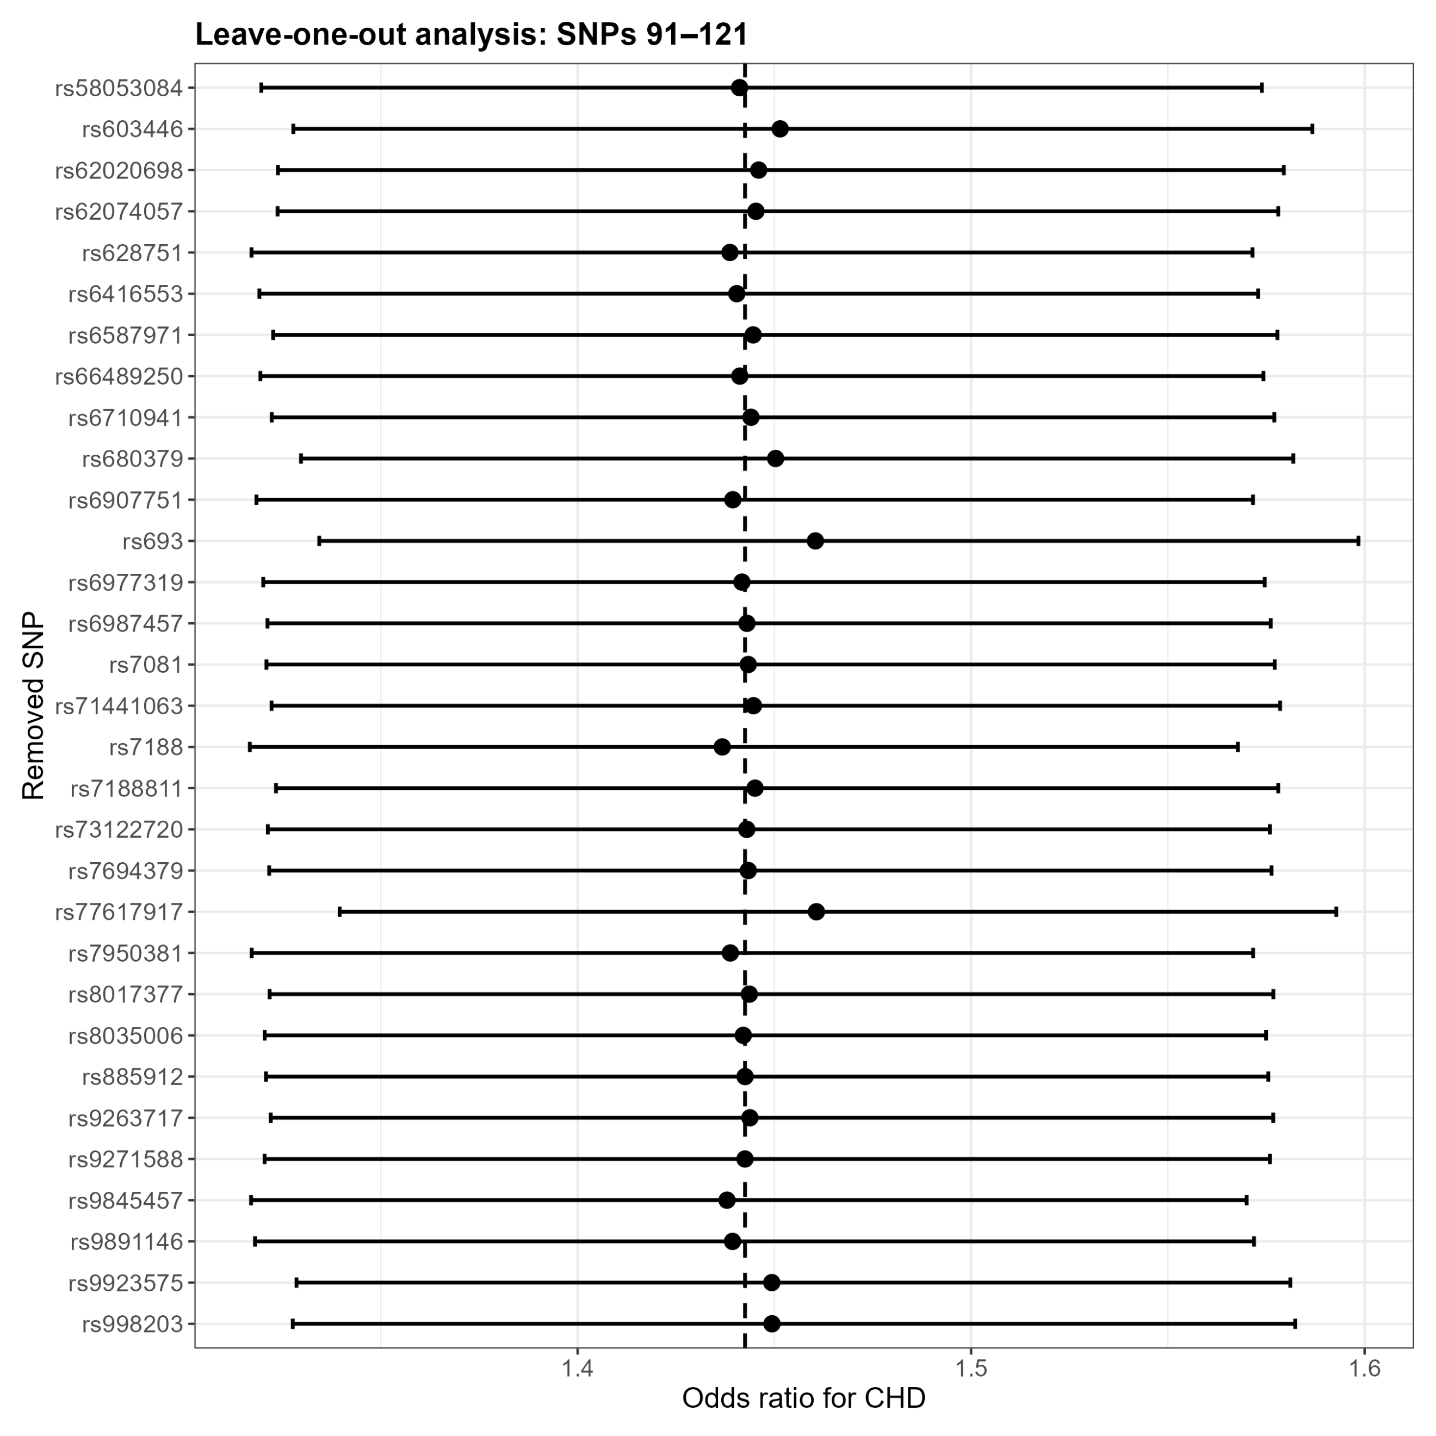
A
B
C
D
Supplementary Figure 3. Funnel plot to access the robustness of using single SNPs as instrument variable in inversed variance weighted method
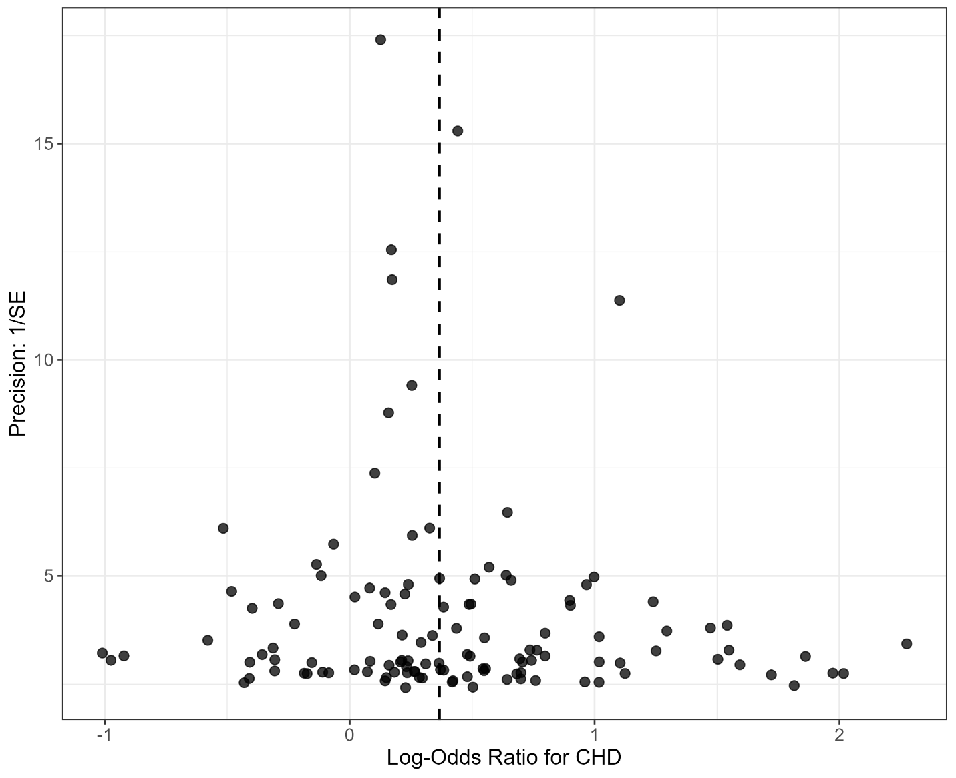
Notes: SE: standard error of the beta coefficient/effect estimate, CHD: coronary heart disease.

Supplementary Figure 4. MR scatter plots for the direction of elevated LDL-TG level to risk of CHD
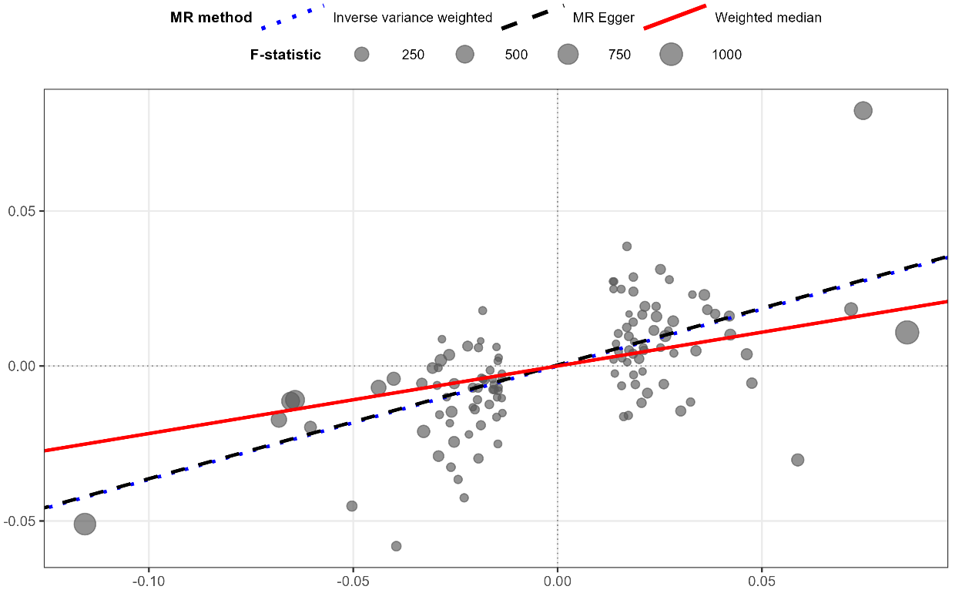
SNPs effects on LDL-TG
SNPs effects on CHD

Supplementary Figure 5. Comparison of F-statistics between coding-consequence (all SNPs) and non-coding sequence (selected SNPs)
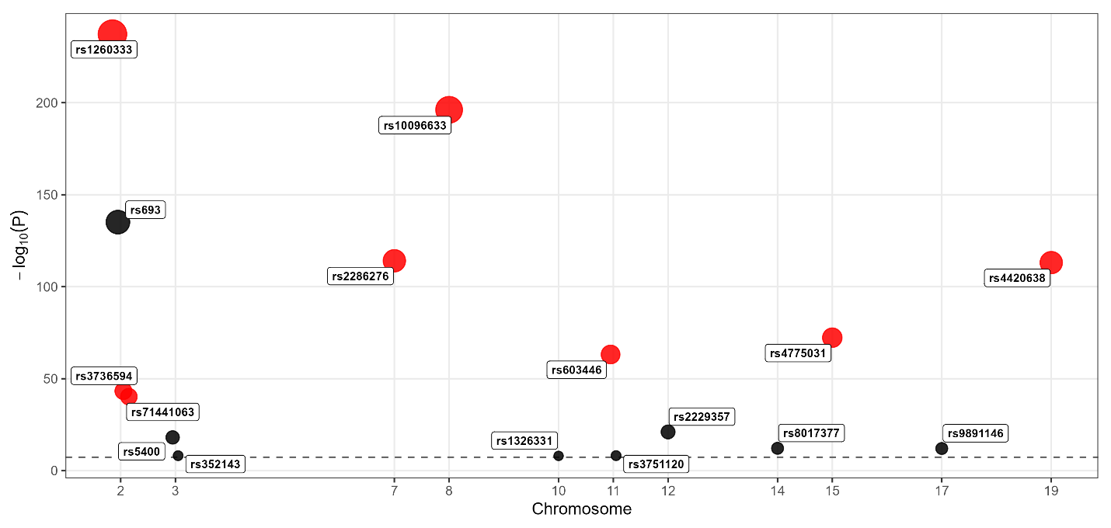
Notes: black solid oval: SNPs in coding sequence, red solid oval: selected SNPs in non-coding sequence.

Supplementary Table 1. Example of cross validated SNPs in the coding sequence
SNP | Mapped Gene/Region | Reported trait | PubMed ID | Study type
rs693 | APOB | ApoB, TG, TC, LDL-C and lower HDL-C | 28874158 | Meta-analysis
rs5400 | SLC2A2 | Glycemic traits, metformin response | 27500523 | GWAS
rs352143 | TWF2 / TLR9 region | Tuberculosis | 25616954 | Multicenter study
rs1326331 | EXOC6 / SEC15L1 | Late-onset Alzheimer disease | 16385451 | Comparative study
rs3751120 | FLRT1, MACROD1 | CAD among African Americans | 28396569 | Multicenter study
rs2229357 | INHBC, INHBE | CAD risk general | 28714975 | GWAS
rs8017377 | NYNRIN | LDL-C | 20686565, 24097068 | GWAS
rs9891146 | C17orf58 | Type 2 diabètes susceptible variants | 29632382 | Meta-analysis

Supplementary Table 2. Example of cross validated SNPs in the non-coding sequence
SNP | Mapped Gene | Location | Closest SNP | Reported trait | PubMed ID | Sample size
rs11631178, rs8035006 | ALDH1A2; LIPC | chr15q21.3 | rs1800588, rs10468017 | LDL-TG to CHD | 30685440 | N=487

Supplementary Table 3. Full list of identified SNPs with mapped region
SNP | F-statistics | Mapped Gene/Region | In non-coding sequence | Chromosome
rs4970829 | 59.86 | SARS1 | Yes | 1
rs6587971 | 58.77 | Not mapped | Yes | 1
rs2061154 | 32.49 | LYPLAL1-AS1 | Yes | 1
rs1260333 | 1083.68 | GCKR | Yes | 2
rs693 | 613.79 | APOB | No | 2
rs3736594 | 192.1 | MRPL33 | Yes | 2
rs71441063 | 178.17 | ATRAID; CAD | Yes | 2
rs10195252 | 154.41 | COBLL1 | Yes | 2
rs7081 | 132.29 | SLC5A6 | Yes | 2
rs312965 | 77.24 | TDRD15 | Yes | 2
rs111548358 | 72.81 | Not mapped | Yes | 2
rs10495713 | 67.87 | Not mapped | Yes | 2
rs66489250 | 63.76 | BABAM2 | Yes | 2
rs10194882 | 55.3 | Not mapped | Yes | 2
rs17759655 | 54.98 | BABAM2 | Yes | 2
rs55669835 | 40.68 | FAM117B | Yes | 2
rs35932591 | 37.06 | Not mapped | Yes | 2
rs55701660 | 31.92 | LINC01822 | Yes | 2
rs6710941 | 31.85 | CENPA | Yes | 2
rs115111187 | 28 | TTLL4 | Yes | 2
rs3732158 | 27.89 | HS1BP3 | Yes | 2
rs16824590 | 27.39 | NOP58; SNORD70 | Yes | 2
rs5400 | 77.03 | SLC2A2 | No | 3
rs9845457 | 50.04 | MSL2 | Yes | 3
rs13326165 | 32.37 | STAB1 | Yes | 3
rs352143 | 32.08 | TWF2 | No | 3
rs4683702 | 27.77 | Not mapped | Yes | 3
rs442177 | 118.14 | AFF1 | Yes | 4
rs7694379 | 27.51 | Not mapped | Yes | 4
rs4450871 | 27.48 | Not mapped | Yes | 4
rs41275715 | 27.1 | MTTP | Yes | 4
rs3846662 | 49.86 | CERT1; HMGCR | Yes | 5
rs11134551 | 37.17 | Not mapped | Yes | 5
rs57079115 | 27.84 | Not mapped | Yes | 5
rs9271588 | 104.6 | HLA-DQA1 | Yes | 6
rs2523589 | 96.22 | HLA-B; MIR6891 | Yes | 6
rs1052248 | 91.48 | LST1; NCR3 | Yes | 6
rs3094228 | 90.71 | HCP5 | Yes | 6
rs628751 | 86.07 | Not mapped | Yes | 6
rs35372932 | 82.41 | HLA-DRB1 | Yes | 6
rs998203 | 68.24 | CHP1P2; IGF2R | Yes | 6
rs3134931 | 54.25 | NOTCH4 | Yes | 6
rs2517600 | 45.51 | TRIM31; TRIM31-AS1 | Yes | 6
rs2844795 | 41.64 | TRIM31; TRIM31-AS1 | Yes | 6
rs885912 | 40.99 | TRIM26 | Yes | 6
rs1233478 | 37.14 | LINC02829 | Yes | 6
rs3749946 | 37.12 | HCP5; MICB-DT | Yes | 6
rs4895864 | 36.29 | L3MBTL3 | Yes | 6
rs241429 | 31.68 | PSMB8; TAP2 | Yes | 6
rs2072633 | 31.67 | CFB; CYP21A2; NELFE | Yes | 6
rs1490384 | 28.19 | Not mapped | Yes | 6
rs10484552 | 27.73 | LINC02569 | Yes | 6
rs9263717 | 27.49 | PSORS1C1 | Yes | 6
rs6907751 | 27.38 | PEX6 | Yes | 6
rs4895815 | 27.19 | Not mapped | Yes | 6
rs2286276 | 517.23 | TBL2 | Yes | 7
rs10951261 | 50.36 | ADAP1; COX19 | Yes | 7
rs6977319 | 32.46 | BAZ1B | Yes | 7
rs10229375 | 31.83 | MIR4284; STX1A | Yes | 7
rs13306387 | 28.16 | GCK; MYL7 | Yes | 7
rs58053084 | 27.61 | GCK | Yes | 7
rs12702029 | 27.44 | CHLSN; GPER1 | Yes | 7
rs10096633 | 894.51 | Not mapped | Yes | 8
rs13273592 | 68.46 | Not mapped | Yes | 8
rs6987457 | 45.38 | Not mapped | Yes | 8
rs34370554 | 40.99 | Not mapped | Yes | 8
rs10087499 | 31.86 | Not mapped | Yes | 8
rs17729317 | 28.37 | TRPS1 | Yes | 8
rs2782981 | 36.3 | Not mapped | Yes | 10
rs1326331 | 31.6 | EXOC6 | No | 10
rs1937917 | 27.91 | AKR1C5P | Yes | 10
rs603446 | 283.27 | ZPR1 | Yes | 11
rs1784042 | 99.66 | SIDT2; TAGLN | Yes | 11
rs7950381 | 91.24 | SIK3 | Yes | 11
rs174601 | 68.13 | FADS2 | Yes | 11
rs34841529 | 37 | Not mapped | Yes | 11
rs3751120 | 32.25 | FLRT1; MACROD1 | No | 11
rs2229357 | 90.56 | INHBC; INHBE | No | 12
rs4363657 | 73.49 | SLCO1B1 | Yes | 12
rs12829378 | 36.31 | RFLNA | Yes | 12
rs11054397 | 31.7 | Not mapped | Yes | 12
rs11172156 | 27.62 | R3HDM2 | Yes | 12
rs12298717 | 27.35 | RFX4 | Yes | 12
rs4942486 | 45.44 | BRCA2 | Yes | 13
rs12869880 | 32.14 | GAS6; GAS6-AS1 | Yes | 13
rs8017377 | 50.15 | NYNRIN | No | 14
rs4775031 | 325.18 | ALDH1A2 | Yes | 15
rs62020698 | 104.94 | FDPSP4; UBR1 | Yes | 15
rs11631178 | 100.64 | ALDH1A2; LIPC | Yes | 15
rs55995747 | 81.86 | ALDH1A2; LIPC; LIPC-AS1 | Yes | 15
rs12438071 | 76.84 | ALDH1A2; LIPC; LIPC-AS1 | Yes | 15
rs2242069 | 58.78 | TP53BP1 | Yes | 15
rs2652836 | 37.22 | Not mapped | Yes | 15
rs12594625 | 36.07 | ALDH1A2; AQP9; MTCYBP23; MTND5P32 | Yes | 15
rs12439377 | 27.14 | HAUS2; MYL12BP1 | Yes | 15
rs8035006 | 27.11 | LIPC | Yes | 15
rs6416553 | 23.84 | CRTC3 | Yes | 15
rs28629271 | 68.02 | PKD1L3 | Yes | 16
rs7188811 | 32.45 | C16orf96; UBALD1 | Yes | 16
rs9923575 | 32.41 | Not mapped | Yes | 16
rs3759979 | 32.26 | COG8; NIP7; TMED6 | Yes | 16
rs255049 | 31.93 | DPEP3 | Yes | 16
rs1364063 | 31.88 | Not mapped | Yes | 16
rs9891146 | 49.68 | C17orf58 | No | 17
rs12937634 | 41.28 | ZNF652; ZNF652-AS1 | Yes | 17
rs17824149 | 32.61 | TM4SF5 | Yes | 17
rs55662831 | 28.24 | DNAH2 | Yes | 17
rs11867485 | 27.22 | CD300LG | Yes | 17
rs62074057 | 23.88 | TBX21 | Yes | 17
rs4420638 | 512.62 | APOC1 | Yes | 19
rs516246 | 99.82 | FUT2 | Yes | 19
rs11881756 | 41.66 | CEACAM16-AS1 | Yes | 19
rs4805885 | 40.52 | PEPD | Yes | 19
rs2967777 | 36.43 | MYO1F | Yes | 19
rs7188 | 31.8 | KANK2 | Yes | 19
rs1529729 | 27.34 | SMARCA4 | Yes | 19
rs77617917 | 146.09 | PCIF1 | Yes | 20
rs680379 | 36.78 | LINC01723 | Yes | 20
rs2143877 | 28.26 | Not mapped | Yes | 20
rs73122720 | 23.92 | RNU6ATAC38P; WFDC3 | Yes | 20
rs5760176 | 27.47 | GSTT4; GSTTP2 | Yes | 22
Notes: yellow rows are all SNPs that are in the coding sequence, green rows are selected SNPs that are in the non-coding sequence.

