Lab Session 2
Managing Multiple Environments Using Helm
Create a reusable Helm Chart for an NGINX web server. Deploy the same chart into Development, QA, Staging, and Production environments using separate values files and Kubernetes namespaces. Verify the Helm releases, Pods, Services, and environment-specific configurations.
Aim
To understand how Helm uses one reusable chart with different values files to manage multiple application environments.
Files We Nedd to Create:
nginx-environments/
- Chart.yaml
- values.yaml
- values-dev.yaml
- values-qa.yaml
- values-staging.yaml
- values-prod.yaml
templates/
- deployment.yaml
- service.yaml
Environment Configuration
For this experiment, use the following configuration:
Environment | Namespace | Release name | Replicas
Development | development | nginx-dev | 1
QA | qa | nginx-qa | 1
Staging | staging | nginx-staging | 2
Production | production | nginx-prod | 3

Step 1: Verify Kubernetes
Open the Killercoda Kubernetes Playground and run:
kubectl get nodes
Step 2: Verify Helm
helm version
Part A: Create the Helm Chart
Step 3: Create the Chart Directory
mkdir -p nginx-environments/templates
Step 4: Create Chart.yaml

cat > nginx-environments/Chart.yaml <<'EOF'
apiVersion: v2
name: nginx-environments
description: NGINX Helm Chart for multiple environments
type: application
version: 1.0.0
appVersion: "1.27"
EOF

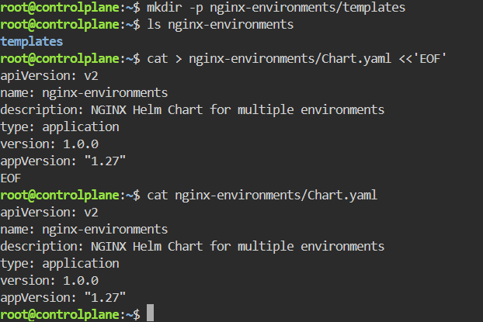

Step 5: Create the Default values.yaml

cat > nginx-environments/values.yaml <<'EOF'
replicaCount: 1

environment: default

image:
repository: nginx
tag: "1.27-alpine"
pullPolicy: IfNotPresent

service:
type: ClusterIP
port: 80
EOF

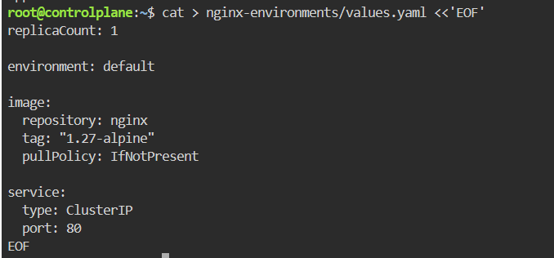
Step 6: Create the Deployment Template
cat > nginx-environments/templates/deployment.yaml <<'EOF'
apiVersion: apps/v1
kind: Deployment

metadata:
name: {{ .Release.Name }}
labels:
app: {{ .Release.Name }}
environment: {{ .Values.environment }}

spec:
replicas: {{ .Values.replicaCount }}

selector:
matchLabels:
app: {{ .Release.Name }}

template:
metadata:
labels:
app: {{ .Release.Name }}
environment: {{ .Values.environment }}

spec:
containers:
- name: nginx
image: "{{ .Values.image.repository }}:{{ .Values.image.tag }}"
imagePullPolicy: {{ .Values.image.pullPolicy }}

ports:
- containerPort: 80

env:
- name: APP_ENVIRONMENT
value: {{ .Values.environment | quote }}
EOF

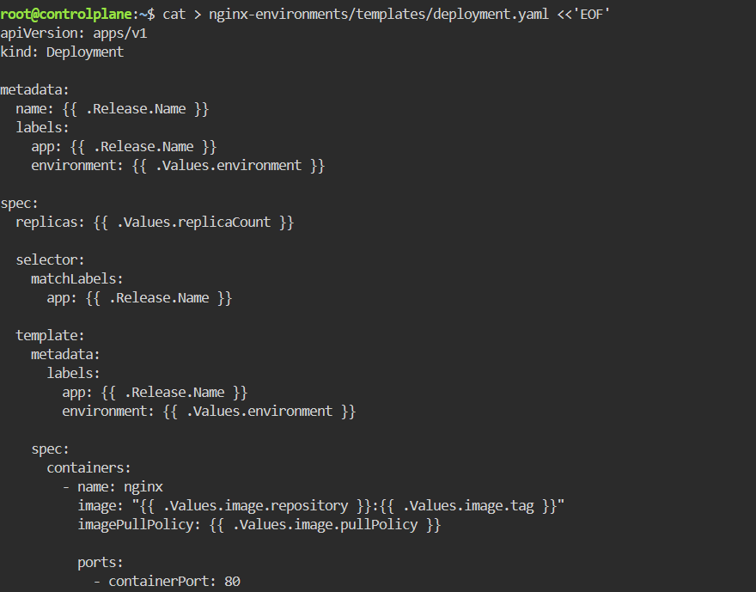

Step 7: Create the Service Template
cat > nginx-environments/templates/service.yaml <<'EOF'
apiVersion: v1
kind: Service

metadata:
name: {{ .Release.Name }}-service
labels:
environment: {{ .Values.environment }}

spec:
type: {{ .Values.service.type }}

selector:
app: {{ .Release.Name }}

ports:
- port: {{ .Values.service.port }}
targetPort: 80
EOF
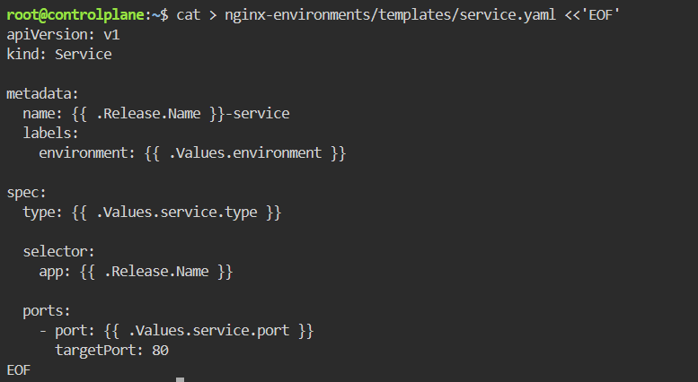
Part B: Create Environment-Specific Values Files
Step 8: Create Development Values
cat > nginx-environments/values-dev.yaml <<'EOF'
replicaCount: 1

environment: development

image:
repository: nginx
tag: "1.27-alpine"
pullPolicy: IfNotPresent

service:
type: ClusterIP
port: 80
EOF
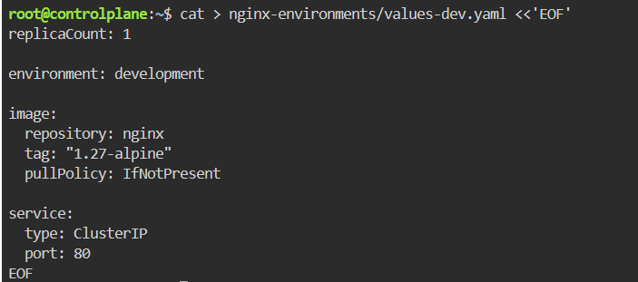
Step 9: Create QA Values
cat > nginx-environments/values-qa.yaml <<'EOF'
replicaCount: 1

environment: qa

image:
repository: nginx
tag: "1.27-alpine"
pullPolicy: IfNotPresent

service:
type: ClusterIP
port: 80
EOF
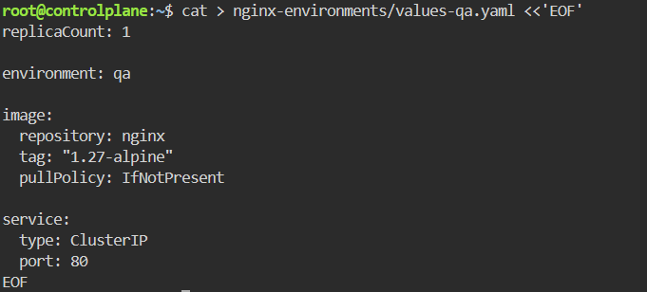
Step 10: Create Staging Values
cat > nginx-environments/values-staging.yaml <<'EOF'
replicaCount: 2

environment: staging

image:
repository: nginx
tag: "1.27-alpine"
pullPolicy: IfNotPresent

service:
type: ClusterIP
port: 80
EOF
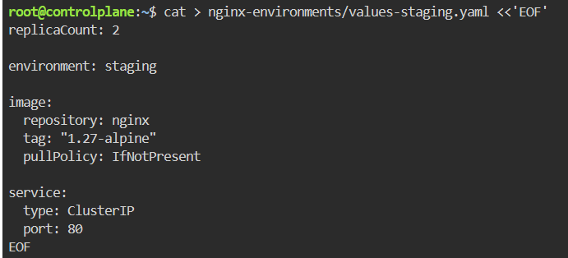
Step 11: Create Production Values
cat > nginx-environments/values-prod.yaml <<'EOF'
replicaCount: 3

environment: production

image:
repository: nginx
tag: "1.27-alpine"
pullPolicy: IfNotPresent

service:
type: ClusterIP
port: 80
EOF
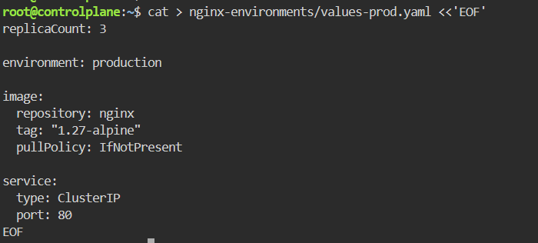
Step 12: Check the Chart Structure
find nginx-environments -type f

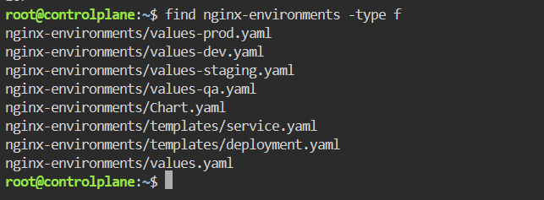
Part C: Validate the Helm Chart
Step 13: Check the Chart
helm lint ./nginx-environments
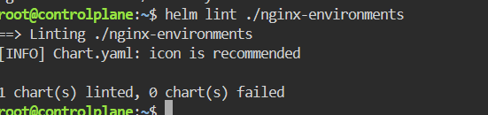
Step 14: Preview the Development Configuration
helm template nginx-dev ./nginx-environments \
-f nginx-environments/values-dev.yaml
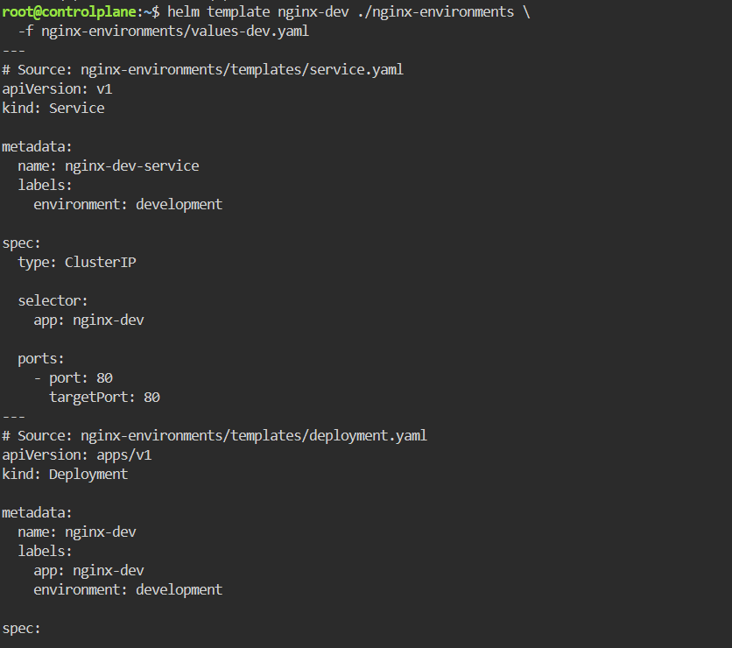
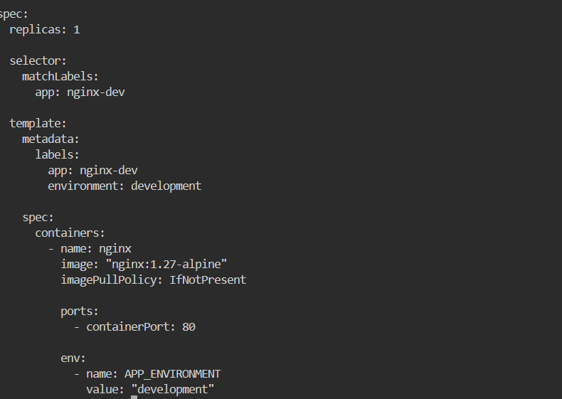
Part D: Create Kubernetes Namespaces
We will use one Kubernetes namespace for each environment.
Step 15: Create the Namespaces
kubectl create namespace development
kubectl create namespace qa
kubectl create namespace staging
kubectl create namespace production
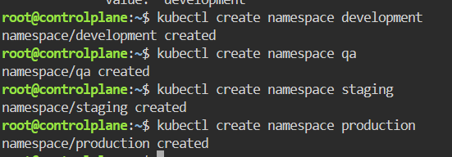
Verify:
kubectl get namespaces
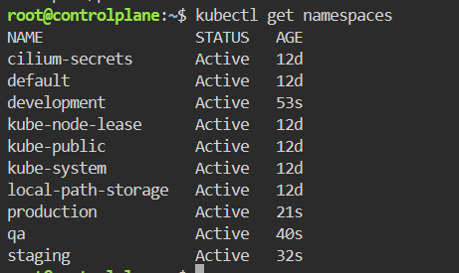
Part E: Deploy the Four Environments
Step 16: Deploy Development

helm install nginx-dev ./nginx-environments \
-f nginx-environments/values-dev.yaml \
--namespace development

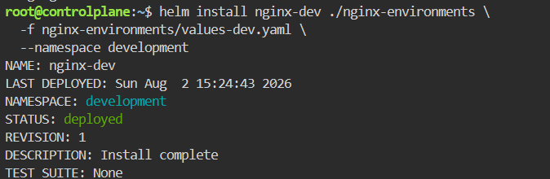
Step 17: Deploy QA
helm install nginx-qa ./nginx-environments \
-f nginx-environments/values-qa.yaml \
--namespace qa
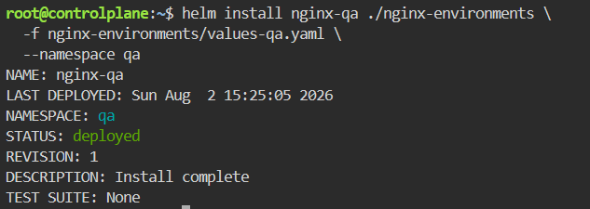
Step 18: Deploy Staging

helm install nginx-staging ./nginx-environments \
-f nginx-environments/values-staging.yaml \
--namespace staging

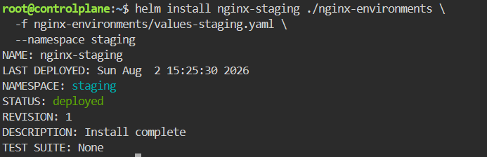
Step 19: Deploy Production
helm install nginx-prod ./nginx-environments \
-f nginx-environments/values-prod.yaml \
--namespace production

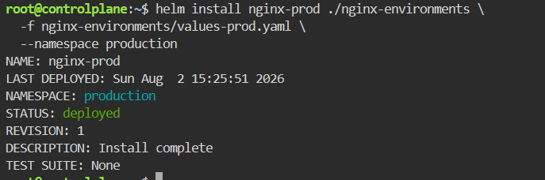
Part F: Verify All Environments
Step 20: List All Helm Releases
helm list --all-namespaces
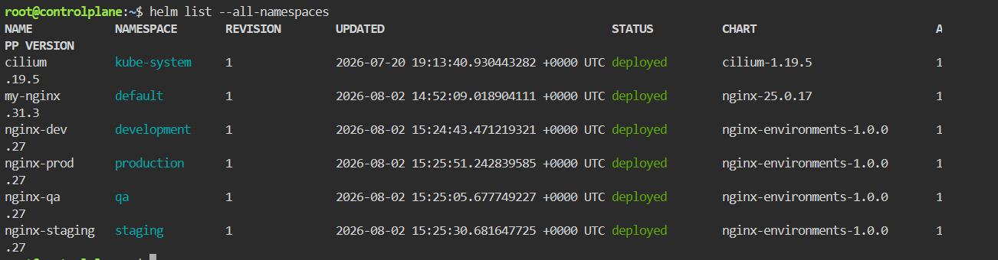

Step 21: Check Development Pods
kubectl get pods -n development
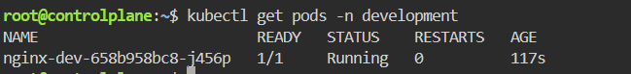
Step 22: Check QA Pods
kubectl get pods -n qa
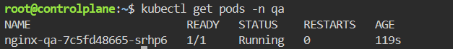

Step 23: Check Staging Pods
kubectl get pods -n staging

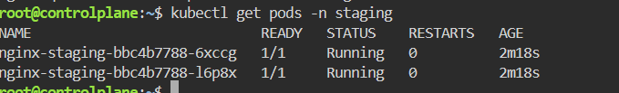
Step 24: Check Production Pods
kubectl get pods -n production

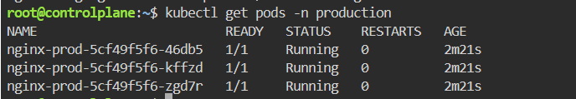
Step 25: Check All Pods Together
kubectl get pods --all-namespaces
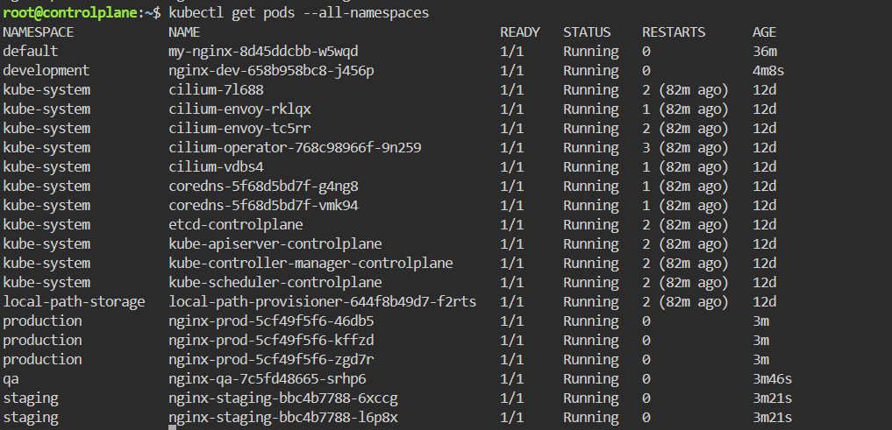
Step 26: Check Services
kubectl get services --all-namespaces
Step 27: Check Deployments
kubectl get deployments --all-namespaces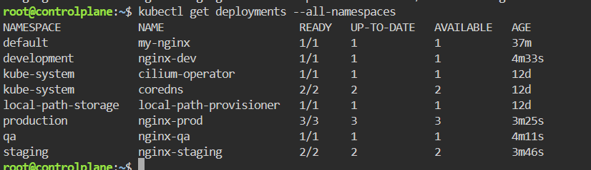
Part G: Verify Environment Values
Step 28: Check Development Values
helm get values nginx-dev -n development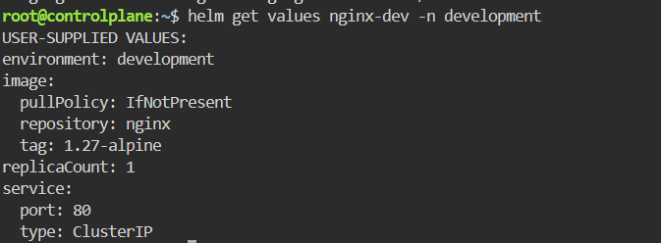

Step 29: Check Production Values
helm get values nginx-prod -n production

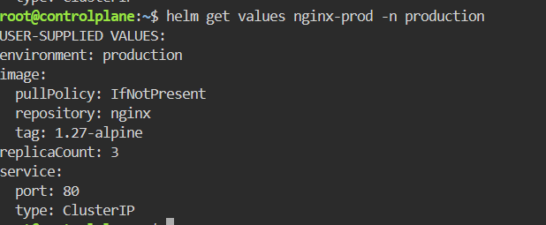
Part H: Make a Change Only in Development
Suppose developers need two Pods in Development. Production should not be affected.
Step 30: Upgrade Development
helm upgrade nginx-dev ./nginx-environments \
-f nginx-environments/values-dev.yaml \
--set replicaCount=2 \
--namespace development

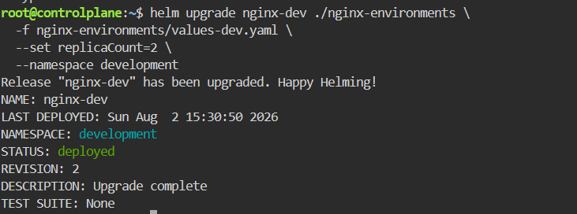
kubectl get pods -n development
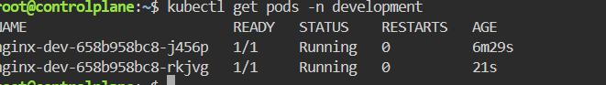
kubectl get pods -n production

