鈴木義叶 (25140127)

練習問題1

```c
// student.h
#ifndef STUDENT_H
#define STUDENT_H

struct students {
int id;
char name[50];
int math;
int english;
int physics;
};

#endif
```

```c
// main.c
#include <stdio.h>
#include <string.h>
#include "student.h"

int main(void) {
struct students student1;
printf("学習番号下4桁を入力してください: ");
scanf("%d", &student1.id);
printf("名前を入力してください: ");
scanf("%s", student1.name);
printf("数学の点数を入力してください: ");
scanf("%d", &student1.math);
printf("英語の点数を入力してください: ");
scanf("%d", &student1.english);
printf("物理の点数を入力してください: ");
scanf("%d", &student1.physics);

double ave = (student1.math + student1.english + student1.physics) / 3.0;
printf("%s(学習番号下4桁: %d)の3科目の平均点は、%lf点です\n", student1.name, student1.id, ave);
return 0;
}
```

実行結果
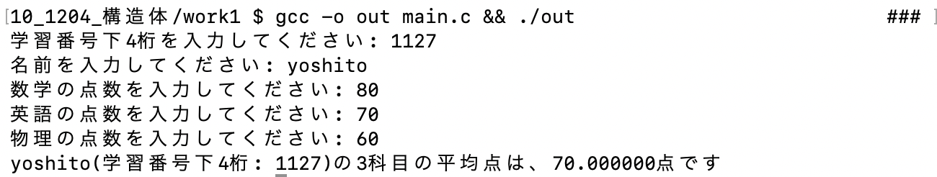

練習問題2

```c
// student.h
#ifndef STUDENT_H
#define STUDENT_H

#define NUM_STUDENTS 2
#define MAX_SUBJECTS 10
#define MAX_SUBJECTS_LONG 20

typedef struct structName {
char name[50];
char *subjects[MAX_SUBJECTS];
int subjectCount;
} students;

#endif
```

```c
// main.c
#include <stdio.h>
#include <stdlib.h>
#include <string.h>
#include "student.h"

int main(void) {
students student[NUM_STUDENTS];
for(int i=0; i<NUM_STUDENTS; i++) {
printf("%d人目の学生情報を入力してください。: \n", i+1);
printf("名前: ");
scanf("%s", student[i].name);
printf("受講している科目の数: ");
scanf("%d", &student[i].subjectCount);
printf("受講している教科名を入力してください。: \n");
for(int j=0; j<student[i].subjectCount; j++) {
printf("%d番目の教科名: ", j+1);
char subject[MAX_SUBJECTS_LONG];
scanf("%s", subject);
student[i].subjects[j] = malloc(sizeof(char) * strlen(subject) + 1);
strcpy(student[i].subjects[j], subject);
}
printf("\n");
}

printf("---------------------------------\n");

for(int i=0; i<NUM_STUDENTS; i++) {
printf("学生名: %s\n", student[i].name);
printf("受講している教科: \n");
for(int j=0; j<student[i].subjectCount; j++) {
printf("- %s\n", student[i].subjects[j]);
}
printf("\n");
}

for (int i = 0; i < NUM_STUDENTS; i++) {
for (int j = 0; j < student[i].subjectCount; j++) {
free(student[i].subjects[j]);
}
}

return 0;
}
```

実行結果
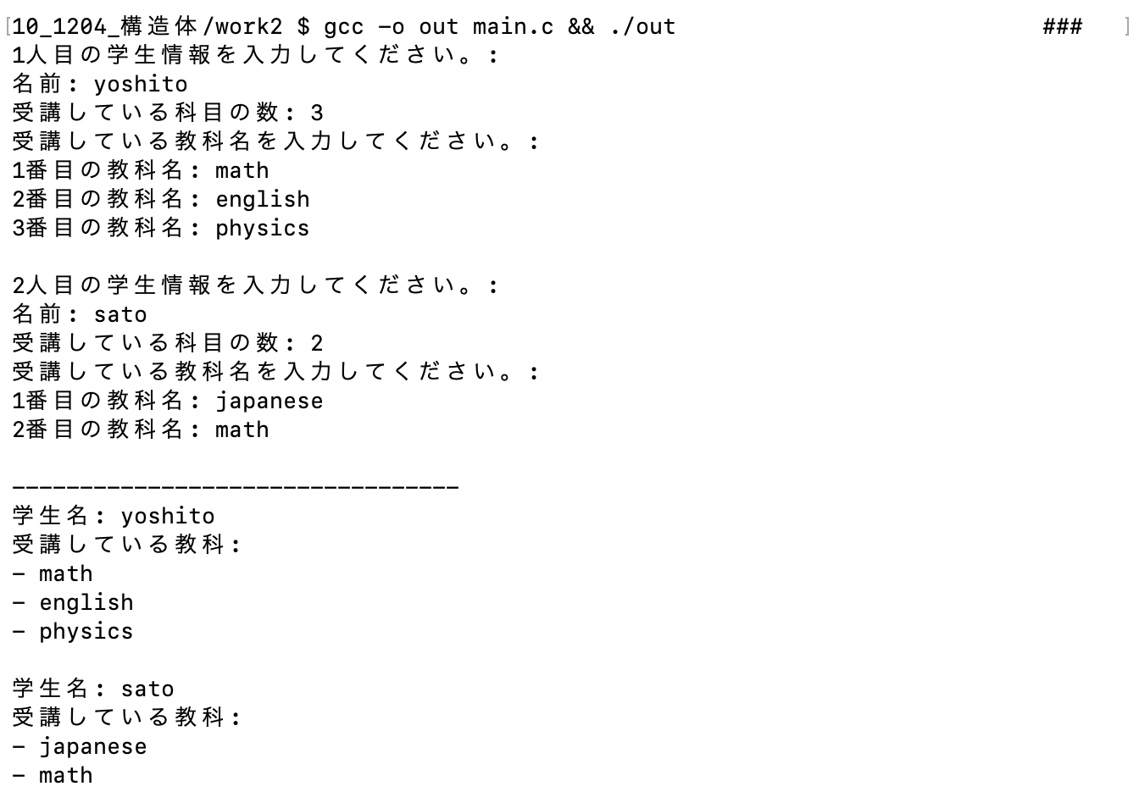

練習問題3

```c
// header.h
#ifndef HEADER_H
#define HEADER_H

#define NUM_FRUIT 3
#define MAX_PRODUCT_NAME_LONG 50

typedef struct structName {
char name[50];
int stock;
int price;
} Item;

void printItem (Item item);
void discountToLowStock (Item *items, int n, int thresh, int p);
void printPriceByName (Item *items, int n, const char *name);

#endif
```

```c
// main.c
#include <stdio.h>
#include <string.h>
#include "header.h"

int main(void) {
Item items[NUM_FRUIT];
char names[NUM_FRUIT][MAX_PRODUCT_NAME_LONG] = {"Apple", "Banana", "Orange"};
int stocks[NUM_FRUIT] = {50, 10, 5};
int prices[NUM_FRUIT] = {100, 80, 200};
for(int i=0; i<NUM_FRUIT; i++) {
strcpy(items[i].name, names[i]);
items[i].stock = stocks[i];
items[i].price = prices[i];
printItem(items[i]);
}

discountToLowStock(items, NUM_FRUIT, 10, 20);

for(int i=0; i<NUM_FRUIT; i++) {
printItem(items[i]);
}

printPriceByName(items, NUM_FRUIT, "Cherry");
printPriceByName(items, NUM_FRUIT, "Orange");
return 0;
}
```

```c
// function.c
#include <stdio.h>
#include <string.h>
#include "header.h"

void printItem(Item item) {
printf("name: %s", item.name);
printf(" / ");
printf("stock: %d", item.stock);
printf(" / ");
printf("price: %dJPY\n", item.price);
}

void discountToLowStock (Item *items, int n, int thresh, int p) {
for(int i=0; i<n; i++) {
if(items[i].stock < thresh) {
items[i].price -= items[i].price * p / 100;
}
}
}

void printPriceByName (Item *items, int n, const char *name) {
for(int i=0; i<n; i++) {
if(!strcmp(items[i].name, name)) {
printf("item %s 's price is %dJPY\n", items[i].name, items[i].price);
return;
}
}
printf("item %s is not found.\n", name);
}
```

実行結果
