鈴木義叶 (25140127)

練習問題2
```c
#include <stdio.h>
#include <math.h>

int main(void) {
int N = 100;
double x, y;

double xmin = 0;
double xmax = 6;
double deltax = (xmax - xmin) / (double)N;

FILE *fp = fopen("sincurve.csv", "w");
for (int n=0; n<N; n++) {
x = deltax * n;
y = sin(x);
fprintf(fp, "%lf, %lf\n", x, y);
}
fclose(fp);
return 0;
}
```

グラフ

演習問題1

```c
#include <stdio.h>
#include <stdlib.h>

int main() {
int no;
int mat[50];
int i, j, tmp;

printf("\n");
printf("\nデータの数(2~50)を入れてください n=");
scanf("%d", &no);

printf("\n -----発生した乱数---------");
for (i=0; i<no; i++) {
mat[i] = rand();
if ((i % 5) == 0)
printf("\n");
printf("%15d", mat[i]);
}
printf("\n");

for (i=0; i<no; i++) {
for (j=i+1; j<no; j++) {
if (mat[i] < mat[j]) {
tmp = mat[j];
mat[j] = mat[i];
mat[i] = tmp;
}
}
}

printf("\n -----並べ替え後の乱数---------");
for (i=0; i<no; i++) {
if ((i % 5) == 0)
printf("\n");
printf("%15d", mat[i]);
}
printf("\n -----おしまい---------");

printf("\n");

return 0;
}
```
実行結果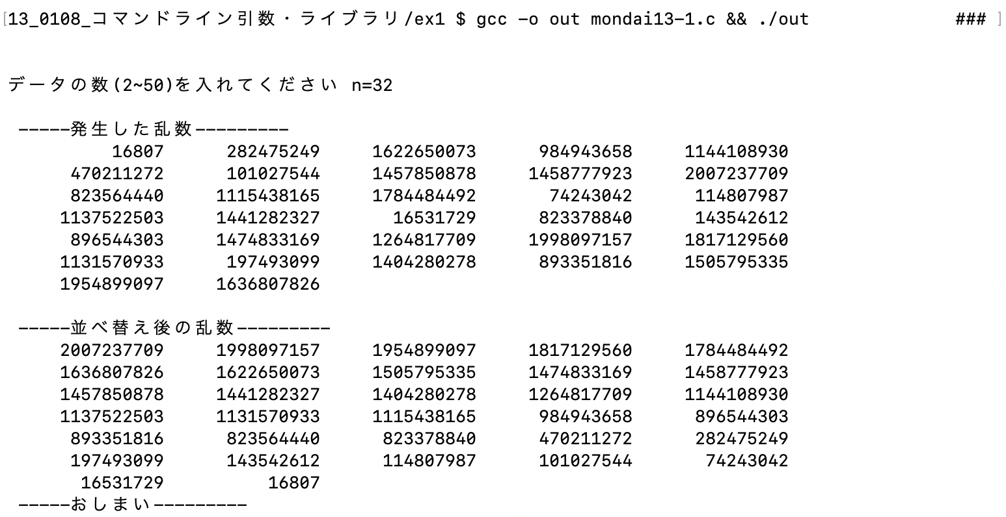

演習問題2

```c
// mylib.h
#ifndef MYLIB_H

#define MYLIB_H

typedef struct {
int year;
int month;
int day;
int hour;
} Date;

struct book {
Date today;
char title[100];
int number;
};

#endif
```

```c
// mon13-2.c
#include <stdio.h>
#include <string.h>
#include "mylib.h"
#include <time.h>

void main ()
{
struct book zousyo01;

//----------初期化 --------
Date now;

time_t t1 = time(NULL);
struct tm *local = localtime(&t1);

now.year = local->tm_year +1900;
now.month = local->tm_mon +1;
now.day = local->tm_mday;
now.hour = local->tm_hour;

zousyo01.today = now;
strcpy(zousyo01.title,"パンどろぼう");
zousyo01.number = 101;

printf("%04d年 %02d月 %02d日 %02d時 %s %2d\n",zousyo01.today.year, zousyo01.today.month, zousyo01.today.day , zousyo01.today.hour, zousyo01.title, zousyo01.number);
}
```

実行結果

