鈴木義叶 (25140127)

練習問題1

```c
// header.h
#ifndef STUDENT_H
#define STUDENT_H

#define MAX_NAME_LENGTH 50

typedef struct structName {
char name[MAX_NAME_LENGTH];
int score;
} Student;

void inputStudents(Student *students, int n);
void printStudents(const Student *students, int n);
double averageScore(const Student *students, int n);
const Student *findTopStudent(const Student *students, int n);

#endif
```

```c
// main.c
#include "student.h"
#include <stdio.h>
#include <stdlib.h>

int main(void) {
int numberOfStudents;
printf("input the number of students: ");
scanf("%d", &numberOfStudents);
Student *students = malloc(sizeof(Student) * numberOfStudents);

inputStudents(students, numberOfStudents);
printStudents(students, numberOfStudents);
double average = averageScore(students, numberOfStudents);
const Student *topStudent = findTopStudent(students, numberOfStudents);

printf("Average score: %.0f\n", average);
printf("Top student name and score: %s, %d\n", topStudent->name,
topStudent->score);
free(students);
return 0;
}
```

```c
// student.c
#include "student.h"
#include <stdio.h>
#include <stdlib.h>

void inputStudents(Student *students, int n) {
for (int i = 0; i < n; i++) {
printf("input the %d -th student info:\n", i + 1);
printf("name: ");
scanf("%s", students[i].name);
printf("score: ");
scanf("%d", &students[i].score);
}
}

void printStudents(const Student *students, int n) {
printf("***************student info.: ***************\n");
for (int i = 0; i < n; i++) {
printf("name: %s, score: %d\n", students[i].name, students[i].score);
}
printf("*********************************************\n");
}

double averageScore(const Student *students, int n) {
double sum = 0;
for (int i = 0; i < n; i++) {
sum += students[i].score;
}
return sum / n;
}

const Student *findTopStudent(const Student *students, int n) {
const Student *topStudent = &students[0];
for (int i = 1; i < n; i++) {
if (students[i].score > topStudent->score) {
topStudent = &students[i];
}
}
return topStudent;
}
```

実行結果
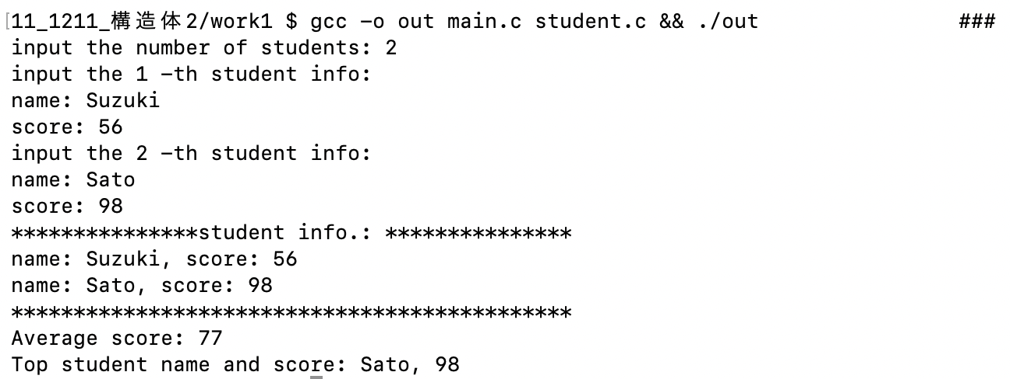

練習問題2

```c
// header.h
#ifndef HEADER_H
#define HEADER_H

typedef struct vec {
double x;
double y;
} Vec;

typedef struct triangle {
Vec a;
Vec b;
double area;
} Triangle;

Triangle initializeTriangle(double a_x, double a_y, double b_x, double b_y);
void printVec(const Vec *v);
void calcArea(Triangle *t);
void printArea(const Triangle *t);

#endif
```

```c
// main.c
#include "header.h"
#include <stdio.h>

int main(void) {
double a_x, a_y, b_x, b_y;
printf("Enter the element values of the vector: \n");
printf("a_x: ");
scanf("%lf", &a_x);
printf("a_y: ");
scanf("%lf", &a_y);
printf("b_x: ");
scanf("%lf", &b_x);
printf("b_y: ");
scanf("%lf", &b_y);

Triangle t = initializeTriangle(a_x, a_y, b_x, b_y);

printVec(&t.a);
printVec(&t.b);

calcArea(&t);
printArea(&t);

return 0;
}
```

```c
// function.c
#include "header.h"
#include <stdio.h>

Triangle initializeTriangle(double a_x, double a_y, double b_x, double b_y) {
Triangle t;
t.a.x = a_x;
t.a.y = a_y;
t.b.x = b_x;
t.b.y = b_y;
return t;
}

void printVec(const Vec *v) {
printf("Vector: (%lf, %lf)\n", v->x, v->y);
}

void calcArea(Triangle *t) {
t->area = 0.5 * (t->a.x * t->b.y - t->a.y * t->b.x);
if (t->area < 0) {
t->area = -t->area;
}
}

void printArea(const Triangle *t) {
printf("Area: %lf\n", t->area);
}
```

実行結果
