Safe Penetration Testing Auditor
This document describes the design, functionality, and safe usage of the Safe Penetration Testing Auditor, a Python-based educational script for performing basic, non-intrusive network reconnaissance on systems the user is authorized to assess.

Table of Contents
- 1. Overview
- 2. Scope & Legal/Ethical Use
- 3. Requirements
- 4. How to Run the Script
- 5. Program Architecture
- 6. Function Reference
- 7. Ports Scanned
- 8. Audit Workflow
- 9. Understanding the Output
- 10. Security Observations Logic
- 11. Limitations
- 12. Suggested Extensions
- 13. Conclusion

1. Overview
The Safe Penetration Testing Auditor (safe_pentest_auditor.py) is a lightweight, command-line Python script designed for educational security auditing. Given a target hostname or IP address, it performs a basic TCP port scan against a fixed list of common service ports, attempts a simple HTTP/HTTPS banner check on any detected web ports, and prints a plain-language summary of potentially risky exposed services.
The tool is intentionally limited in scope: it does not attempt exploitation, brute-forcing, vulnerability scanning, or any intrusive action. It is built for learning fundamental networking and security-auditing concepts — such as how port scanning and service banner grabbing work — in a controlled, authorized lab environment.

2. Scope & Legal/Ethical Use
This section defines the boundaries within which the tool is intended to be used.

2.1 Authorized Use Only
- Only run this script against hosts you own (e.g. your own home lab, virtual machines, or personal devices).
- Only run this script against third-party systems if you have explicit, documented, written permission (e.g. a signed penetration-testing engagement or a bug bounty program's defined scope).
- Scanning systems without authorization is illegal in most jurisdictions, even if no damage is caused — the act of unauthorized access attempts itself is typically the offense.

2.2 What This Tool Does NOT Do
- It does not exploit any vulnerability it finds.
- It does not attempt to log in, brute-force credentials, or bypass authentication.
- It does not scan the full 65,535-port range — only a small, fixed list of common ports.
- It does not evade firewalls, intrusion detection systems, or rate limiting.

2.3 Recommended Lab Practice
For learning purposes, run this script only against 127.0.0.1 (localhost), a personal virtual machine, or a deliberately vulnerable training environment (e.g. a local VM built for security education).

3. Requirements
Requirement | Details
Python version | Python 3.x (uses f-strings and standard library only)
Dependencies | None — uses only Python's built-in socket, sys, datetime, and urllib modules
Operating System | Cross-platform (Windows, macOS, Linux) — anywhere Python 3 runs
Network access | Requires the ability to open outbound TCP connections to the target

4. How to Run the Script
The script is run from the command line and takes exactly one argument: the target hostname or IP address.
python safe_pentest_auditor.py <target>

4.1 Example — Local Machine
python safe_pentest_auditor.py 127.0.0.1

4.2 Example — Authorized Lab Host
python safe_pentest_auditor.py 192.168.1.50

4.3 Missing Argument Behavior
If the script is run without a target argument, it prints usage instructions and exits without performing any scan:
Usage:
python safe_pentest_auditor.py <target>

Example for your own lab:
python safe_pentest_auditor.py 127.0.0.1

5. Program Architecture
The script is organized into four functions plus a main() entry point, each with a single, clear responsibility:
Function | Responsibility
check_port(target, port, timeout) | Attempts a raw TCP connection to a single port; returns True/False for open/closed
check_http(target, port) | Sends an HTTP/HTTPS request to a web port and reads basic response metadata (status, Server header)
run_audit(target) | Orchestrates the full audit: resolves the target, scans all common ports, runs HTTP checks, and prints security observations
main() | Parses command-line arguments and calls run_audit()

6. Function Reference

6.1 check_port()
Opens a TCP socket to the target/port pair using a short timeout (default 0.5 seconds) and calls connect_ex(), which returns 0 on a successful connection rather than raising an exception. This makes it efficient for scanning many ports in sequence.
result = sock.connect_ex((target, port)) return result == 0
The socket is always closed in a finally block, ensuring no connections are left open even if an error occurs.

6.2 check_http()
For ports commonly associated with web services, this function builds a URL (using https:// for port 443, http:// otherwise) and performs a simple GET request via urlopen() with a 3-second timeout. It returns a dictionary describing whether the service responded, its HTTP status code, and the value of the Server response header, if disclosed.
Errors (unreachable host, timeout, protocol mismatch) are caught and result in an "unavailable" response rather than crashing the script.

6.3 run_audit()
This is the main orchestration function. It performs, in order:
- DNS resolution of the target hostname to an IP address
- A loop over all entries in COMMON_PORTS, calling check_port() for each
- A summary table of all ports found open
- HTTP banner checks for any open web ports (80, 443, 8080)
- A rule-based "Security Observations" section flagging risky exposed services

6.4 main()
Validates that exactly one command-line argument was supplied. If not, it prints usage instructions. Otherwise, it passes the argument through to run_audit().

7. Ports Scanned
The script checks a fixed dictionary of 15 commonly used TCP ports, covering a mix of legacy, modern, and database services:
Port | Service | Category
21 | FTP | File transfer (legacy, often unencrypted)
22 | SSH | Secure remote administration
23 | Telnet | Legacy remote administration (unencrypted)
25 | SMTP | Email transmission
53 | DNS | Domain name resolution
80 | HTTP | Web (unencrypted)
110 | POP3 | Email retrieval
139 | NetBIOS | Windows file/printer sharing (legacy)
143 | IMAP | Email retrieval
443 | HTTPS | Web (encrypted)
445 | SMB | Windows file sharing
3306 | MySQL | Database
3389 | RDP | Windows Remote Desktop
5432 | PostgreSQL | Database
8080 | HTTP Proxy | Alternate web / proxy port

8. Audit Workflow
Each run of the script follows the same sequence of steps:
- Print a banner and record the start time.
- Resolve the target hostname to an IP address using socket.gethostbyname(). If resolution fails, the audit stops immediately.
- Iterate through all 15 entries in COMMON_PORTS, printing OPEN or closed for each as it is checked.
- Print a results table listing only the ports found open.
- For any open port in [80, 443, 8080], perform an HTTP/HTTPS check and print the response status and Server header, if available.
- Generate a Security Observations section based on which risky services were detected (see Section 10).
- Print a closing reminder that only authorized systems should be tested.

9. Understanding the Output

9.1 Live Scan Output
While scanning, each port is printed as it is checked, showing OPEN or closed in real time:
Checking 22 (SSH) ... OPEN Checking 23 (Telnet) ... closed

9.2 Results Table
A condensed table lists only the ports found open, with their associated service name:
PORT SERVICE STATUS 22 SSH OPEN

9.3 HTTP Banner Output
If a web port is open, the script reports the HTTP status code and any disclosed Server header — useful for identifying the web server software in use (e.g. "Apache", "nginx"), which can itself be a piece of information worth minimizing in a hardened environment.

10. Security Observations Logic
After the scan completes, the script applies a small set of rule-based checks to flag commonly risky exposed services:
Detected Service | Severity | Observation / Recommendation
Telnet | HIGH | Telnet transmits data (including credentials) unencrypted. Recommend replacing with SSH.
FTP | MEDIUM | Standard FTP is unencrypted. Recommend using SFTP/FTPS or another encrypted transfer method.
SMB | WARNING | SMB has historically been a common attack vector (e.g. EternalBlue). Recommend verifying it is needed and properly patched/secured.
RDP | WARNING | RDP is a frequent target for brute-force and credential-stuffing attacks. Recommend restricting access to trusted networks or a VPN.

If none of the scanned ports are open, the script prints an informational message rather than a warning, since a fully closed common-port surface is generally a positive sign.

11. Limitations
- Only TCP connect-scans a fixed list of 15 ports — it is not a comprehensive scanner like nmap and will miss services running on non-standard ports.
- Does not perform UDP scanning, OS fingerprinting, or service version detection beyond a basic HTTP Server header.
- A short default timeout (0.5s for ports, 3s for HTTP) may produce false negatives on slow or heavily firewalled networks.
- The "Security Observations" logic is a simple keyword match against detected service names, not a real vulnerability assessment — an open port does not by itself confirm a vulnerability or misconfiguration.
- The script performs no logging, output file export, or historical comparison between scans.
- As with any scanner, results can trigger alerts on monitored networks (IDS/IPS, SOC tooling) — this is expected and appropriate when used within an authorized engagement.

12. Suggested Extensions
- Add a configurable port list or full range scanning option via command-line flags
- Add multithreading to speed up scans across many ports or hosts
- Export results to JSON or CSV for record-keeping and reporting
- Add UDP scanning support for services like DNS or SNMP
- Integrate banner grabbing for non-HTTP services (e.g. SSH version strings, SMTP banners)
- Add a scope-confirmation prompt requiring the user to type the target and confirm authorization before scanning proceeds

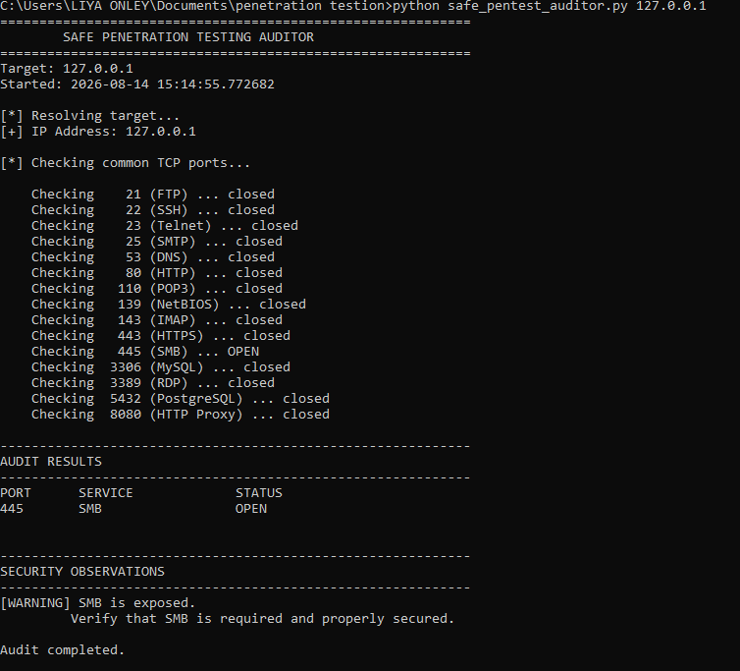
Output Images:

13. Conclusion
The Safe Penetration Testing Auditor is a compact, dependency-free Python tool that introduces the core mechanics of network reconnaissance — port scanning, service identification, and basic banner grabbing — in a form deliberately scoped for learning rather than offensive use. By limiting itself to a small set of common ports, avoiding any exploitation logic, and pairing every scan with plain-language, severity-rated observations, it gives newcomers a safe, readable example of how the first phase of a security assessment works.
Its value lies as much in what it deliberately leaves out as in what it does: no brute-forcing, no vulnerability exploitation, no stealth or evasion techniques. This keeps the tool firmly in the category of an educational and authorized-auditing utility rather than an attack tool, and it should continue to be used strictly against systems the user owns or is explicitly authorized to test.
As a foundation, the script is well suited for extension — into a more configurable scanner, a reporting tool, or a teaching aid for a security course — provided that any enhancements preserve the same core principle demonstrated here: capability should always be paired with clear scope, transparency about limitations, and a persistent reminder that authorization is a precondition, not an afterthought.

