# Collaborators

|  |  |  |  |
| --- | --- | --- | --- |
| **No.** | **ID** | **Full name** | **Email address** |
| 1 | 20120238 | Nguyễn Ngọc Khánh Vy | [20120238@student.hcmus.edu.vn](mailto:20120238@student.hcmus.edu.vn) |
| 2 | 20120246 | Nguyễn Hoàng Anh | [20120246@student.hcmus.edu.vn](mailto:20120246@student.hcmus.edu.vn) |

# The contribution rate of each member

### Task assignment

|  |  |  |  |
| --- | --- | --- | --- |
| **No.** | | **Task description** | **Member in charge** |
| 1 | | Install WEKA & answer questions | 20120246 |
| 2 | 2.1 | Exploring Breast Cancer data set | 20120238 |
| 2.2 | Exploring Weather data set | 20120246 |
| 2.3 | Exploring Credit in Germany data set | 20120238 |
| 3 | | Implement requirements marked even numbers | 20120246 |
| Implement requirements marked odd numbers | 20120238 |

### Contribution rate

# Assess the level of project completion

# The answers to each question and requirement

## Install WEKA

### Requirement 1

* Download WEKA from their website provided.
* Verification: Screenshot that contains the ”Explorer” function in the desktop background.

### Requirement 2

* The selected data set is opened from the file “airline.arff”.

* The meaning of boxes in Preprocess tag is described as follows:
  + **Current Relation**: It gives information about the currently loaded data. Specifically, it shows the name of the relation (or table) as given in the file it was loaded from, how many instances (or rows) there are in the data set, the number of attributes and the total sum of weights across all instances. In this case, the current relation is airline_passengers with 144 instances, 2 attributes and the sum of weights is 144.
  + **Attributes**: This is the area displaying all attributes of the selected data set, which users can view or modify them by using buttons such as Remove, All, None, Invert, and Pattern. As shown above, the airline data set has 2 attributes which are passenger_numbers and Date.
  + **Selected Attribute**: When an attribute showed in attributes window is selected, this window will display the information of that attribute, including name, type, and the number of missing, distinct, and unique values. In addition, other statistical values depending on the data type of that attribute are also shown below (min, max, mean, sd for numeric data and frequency of distinct values for categorical data). In the bottom-right corner, there is a histogram as a visualization for this attribute.
* The meaning of other tags in WEKA Explorer:
  + **Classify:** This is used for building and evaluating classification models. We can choose different algorithms, parameters and evaluation methods to apply to a data set.
  + **Cluster:** This is similar to the Classify tab but applied to clustering models.
  + **Associate:** This is is used for automatically finding associations in a dataset.
  + **Select attributes:** This is used for selecting the most relevant attributes in the data.
  + **Visualize:** This is used for reviewing pairwise scatterplot matrix of each attribute plotted against every other attribute in the loaded dataset. It is useful to get an idea of the shape and relationship of attributes that may aid in data filtering.

## Getting Acquainted With WEKA

### Exploring Breast Cancer data set

#### How many instances does this data set have?

* 286 instances

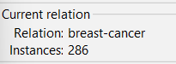

#### How many attributes does this data set have?

* 10 attributes

#### Which attribute is used for the label? Can it be changed? How?

* Class attribute is used for the label.
* It can be changed by click at Class in drop-down list under Selected attributes and choose with attributes you want to used for label.

#### What is the meaning of each attribute?

* Class: no-recurrence-events, recurrence-events
* age: 10-19, 20-29, 30-39, 40-49, 50-59, 60-69, 70-79, 80-89, 90-99.
* menopause: lt40, ge40, premeno.
* tumor-size: 0-4, 5-9, 10-14, 15-19, 20-24, 25-29, 30-34, 35-39, 40-44, 45-49, 50-54, 55-59.
* inv-nodes: 0-2, 3-5, 6-8, 9-11, 12-14, 15-17, 18-20, 21-23, 24-26, 27-29, 30-32, 33-35, 36-39.
* node-caps: yes, no.
* deg-malig: 1, 2, 3.
* breast: left, right.
* breast-quad: left-up, left-low, right-up, right-low, central.
* irradiat: yes, no.

#### Let’s investigate the missing value status in each attribute and describe in general ways to solve the problem of missing values.

* Dataset have 2 attributes have missing value: node-caps with 8 missing, breast-quad with only one missing.
* In Weka, to fill missing value automatically, you can choose ‘Choose’ button in Filter area.



* Expand folder to attribute to find ReplaceMissingValues/ ReplaceMissingWithUserConstant.

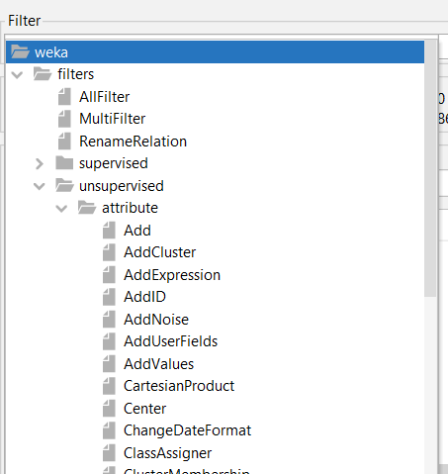

* Click apply to fill missing value.

#### Let’s propose solutions to the problem of missing values in the specific attribute.

#### Let’s explain the meaning of the chart in the WEKA Explorer. Setting the title for it and describing its legend.

* The graph here is a histogram - showing the frequency of occurrence of samples (instances) with corresponding classes (Class) for continuous attributes, and a bar plot with categorical properties (similar functionality).
* If considering a single column, the blue and red colors represent the proportion of instances with the label value of that column that have the corresponding yes, no classes.

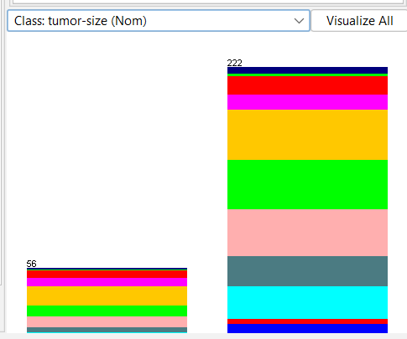

### Exploring Weather data set

#### How many attributes does this data set have? How many samples? Which attributes have data type that is categorical? Which attributes have a data type that is numerical? Which attribute is used for the label?

* The number of attributes: 5
* The number of samples: 14
* Attributes that are categorical: outlook, windy, and play.
* Attributes that are numerical: temperature and humidity.
* Label: play.

#### Let’s list five-number summary of two attributes temperature and humidity. Does WEKA provide these values?

A five-number summary consists of five values: the minimum value, the first quartile (Q1), the median (Q2), the third quartile (Q3), and the maximum value. However, WEKA does not provide all these 5 values as Q1, Q2, and Q3 are not shown in the selected attribute window.

Other available values:

* Temperature attribute: the minimum is 64 and maximum is 85.
* Humidity attribute: the minimum is 65 and maximum is 96.

#### Let’s explain the meaning of all charts in the WEKA Explorer. Setting the title for it and describing its legend.

Each chart represents the percentage of yes and no values (green for yes and red for no) with respect to each value in the range of an attribute. For numerical attribute, the chart is continuous while it is discrete in categorical attribute charts.

#### Let’s move to the Visualize tag. What’s the name of this chart? Do you think there are any pairs of different attributes that have correlated?

* The chart used to visualize this data set is the scatter plot.
* Overall, there are two correlated pairs:
  + Temperature and humidity: inversely proportional (the higher the temperature, the lower the humidity).
  + Temperature and outlook: when it’s sunny, the temperature increases and vice versa.

### Exploring Credit in Germany data set

#### What is the content of the comments section in credit-g.arff (when opened with any text editor) about?

* Content of comments section have 278 lines, about description of German credit dataset.
* Content includes:
  + Title: German Credit data
  + Source Information: information of author
  + Number of instances, number of attributes in 2 dataset (german and german.numer)
  + Description for each attribute in german dataset
  + Cost matrix
  + Relabeled law for 14 attributes: checking_status, credit_history, ...

#### How many samples does the data set have?

* 1000 samples

#### How many attributes?

* 21 attributes

#### Describe any five attributes (must have both discrete and continuous attributes).

* Age: continuous attribute, age in year, maximum is 75, minimum is 19, with mean is 35.546 and standard ... is 11.375.
* Property_magnitude: discrete attribute, property, sample data: ‘real estate’, ‘car’, ‘life insurance’, ‘no known property’
* Residence_since: continuous attribute, present residence since, max is 4, min is 1, with mean is 2.845, standard ... is 1.104.
* Credit_history: discrete attribute, credit history, sample data: ‘ no credits/all paid’, ‘all paid’, ‘existing paid’, ‘delayed previously’, ‘critical/other existing credit’.
* Employment: discrete attribute, present employment since, sample data: ‘unemployment’, ‘<1’, ‘1<=X<4’, ‘4<=X<7’, ‘>=7’.

#### Which attribute is used for the label?

* The name of the class attribute is class.
* Evaluation of the distribution: skewed to one class (good). The good class has twice as many instances as the bad class.

#### Let’s describe the distribution of continuous attributes. (Left skewed or right skewed?)

#### Let’s explain the meaning of all charts in the WEKA Explorer. Setting the title for it and describing its legend.

#### Let’s move to the Select attributes tag. Describe all the options for attribute selection.

* CfsSubsetEval: Evaluates the importance of a subset of attributes by looking at the individual predictability of each feature along with the degree of redundancy between them (the set of attributes is highly correlated with the class attribute and intercorrelate is preferred).
* ClassifierAttributeEval: evaluates the importance of an attribute using a user-specified classifier.
* CorrelationAttributeEval: evaluates the importance of an attribute by measuring the correlation between it and the class using the Pearson correlation coefficient.
* ClassifierSubsetEvaluator: evaluates attribute values on training data or a separate set of cross validation (hold-out).
* PrincipleComponents: use PCA (principal components analysis) algorithm to reduce the number of dimensions (columns) of the data.
* GainRatioAttributeEval: Evaluates the worth of an attribute by measuring the gain ratio with respect to the class.
* IfnoGainAttributeEval: Evaluates the worth of an attribute by measuring the information gain with respect to the class.
* OneRAttributeEval: Evaluates the worth of an attribute by using the OneR classifier.
* ReliefFAttributeEval: Evaluates the worth of an attribute by repeatedly sampling an instance and considering the value of the given attribute for the nearest instance of the same and different class.
* SymmetricalUncertAttributeEval: Evaluates the worth of an attribute by measuring the symmetrical uncertainty with respect to the class.
* WrapperSubsetEval: Evaluates attribute sets by using a learning scheme.

#### Which options should be used to select the 5 attributes with the highest correlation? (Step-by-step description, with step-by-step photos and final results)

* To select the 5 attributes with the highest correlation with the class attribute, use the CorrelationAttributeEval filter.
  + Step 1: Select the Select attribute tab.

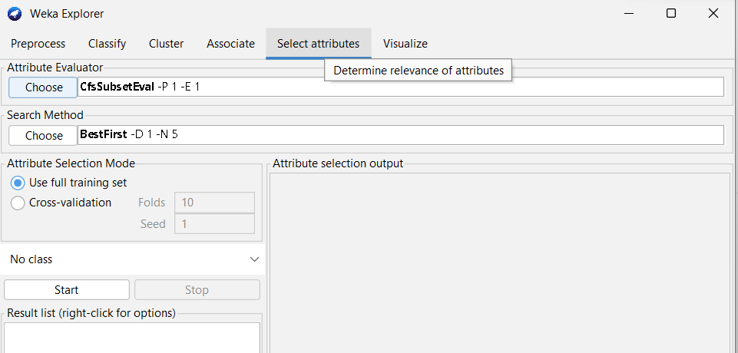

* + Step 2: Click choose in Attribute Evaluator, select CorrelationAttributeEval.

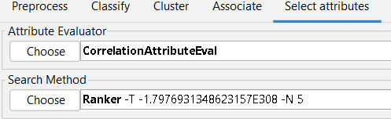

* + Step 3: Click on the text box with the word Ranker to refine the attribute search algorithm. Enter 5 in the numToSelect field to select the 5 attributes that have the highest correlation with the class attribute. Click OK.

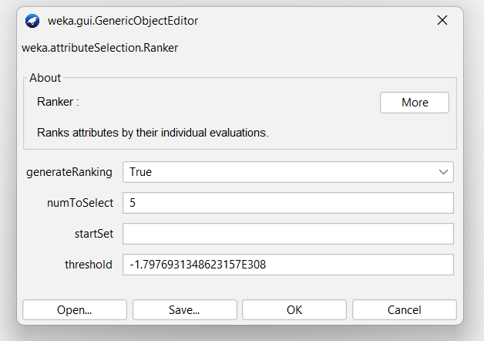

* + Step 4: Select the class attribute in the drop-down list below the Search Method field.

* + Step 5: Click Start and wait for the algorithm to finish running. Observe the results in the text box on the right.

* + Thus, the attributes selected by this algorithm are:
    - checking_status: 0.233
    - duration: 0.215
    - credit_amount: 0.155
    - savings_status: 0.132
    - housing: 0.121

## Preprocessing Data in Python

Extract columns with missing values

* Command line: python list_missing.py <intput> <--print_data> <--out>
* Example:

$ python list_missing.py '..\house-prices.csv'

$ python list_missing.py '..\house-prices.csv' --print_data --out 'list_missing_print_data.csv'

Count the number of lines with missing data.

* Command line: python count_row_nan.py <intput>
* Example:

$ python count_row_nan.py '..\house-prices.csv'

Fill in the missing value using mean, median (for numeric properties) and mode (for the categorical attribute).

Deleting rows containing more than a particular number of missing values (Example: delete rows with the number of missing values is more than 50% of the number of attributes).

Deleting columns containing more than a particular number of missing values (Example: delete columns with the number of missing values is more than 50% of the number of samples).

Delete duplicate samples.

Normalize a numeric attribute using min-max and Z-score methods.

Performing addition, subtraction, multiplication, and division between two numerical attributes

$ python fill_nan.py '..\house-prices.csv' 'fill_na_single_column_mean.csv' LotArea mean

$ python fill_nan.py '..\house-prices.csv' 'fill_na_multi_column_median.csv' LotArea,MSSubClass median

$ python fill_nan.py '..\house-prices.csv' 'fill_na_single_column_mode.csv' MSZoning mode

$ python delete_row_nan.py '..\house-prices.csv' 'delete_row_nan.csv' 0.5

$ python delete_column_nan.py '..\house-prices.csv' 'delete_column_nan.csv' 0.5

$ python norm.py '..\house-prices.csv' 'norm_single_column_min_max.csv' LotArea min-max

$ python norm.py '..\house-prices.csv' 'norm_multi_column_min_max.csv' LotArea,MSSubClass min-max

$ python norm.py '..\house-prices.csv' 'norm_single_column_min_max.csv' LotArea z-score

$ python norm.py '..\house-prices.csv' 'norm_multi_column_min_max.csv' LotArea,MSSubClass z-score

# References