◆ Assignment 04
Assignment 4 — File I/O, Serialization, EF & LINQ
Modules 6–7 · 10 points

⏰ Deadline: Week 5 — Thursday, 11:59 PM

🎯 Scenario
You continue building the Grades Prototype. Today you persist data to files and query it with LINQ. This is direct preparation for EF Core and Web API in the upcoming courses.
Recall the SELECT ... WHERE ... queries from the SQL course — you'll write the same logic here, but from inside C#.
This assignment covers: File I/O, JSON serialization, and EF / LINQ concepts.

Part 1 — File I/O (3 points)
- Write 5 student names to students.txt using File.WriteAllLines.
using System;
using System.Collections.Generic;
using System.Linq;
using System.Text;
using System.Threading.Tasks;
using System.IO;
namespace A4
{
internal class Program
{
static void Main(string[] args)
{
string filepase = @"D:\DEPI\02 C#\A4\student.txt";

File.AppendAllText(filepase, "Mohamed\n");
File.AppendAllText(filepase, "Ali\n");
File.AppendAllText(filepase, "Yossef\n");
File.AppendAllText(filepase, "Ahmed\n");
File.AppendAllText(filepase, "Reda\n");

}
}
}
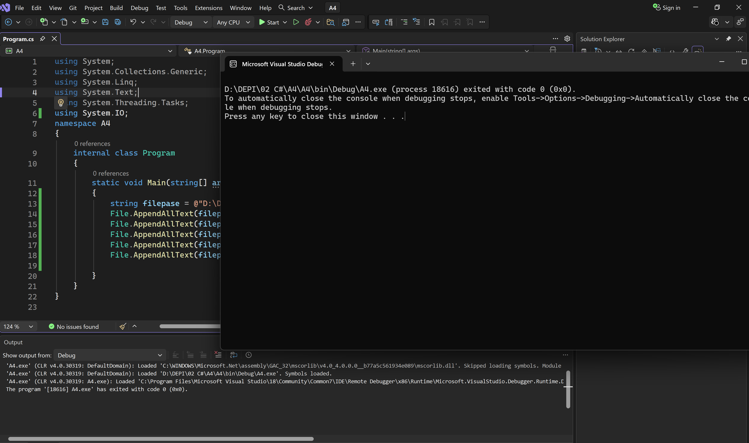
- Read the file with File.ReadAllLines and print each name with its number using for.
using System;
using System.Collections.Generic;
using System.Linq;
using System.Text;
using System.Threading.Tasks;
using System.IO;
namespace A4
{
internal class Program
{
static void Main(string[] args)
{
string filepase = @"D:\DEPI\02 C#\A4\student.txt";

File.AppendAllText(filepase, "Mohamed\n");
File.AppendAllText(filepase, "Ali\n");
File.AppendAllText(filepase, "Yossef\n");
File.AppendAllText(filepase, "Ahmed\n");
File.AppendAllText(filepase, "Reda\n");

string[] student = File.ReadAllLines(filepase);
for(int i = 0;i < student.Length; i++)
{
Console.WriteLine(student[i]);
}

}
}
}
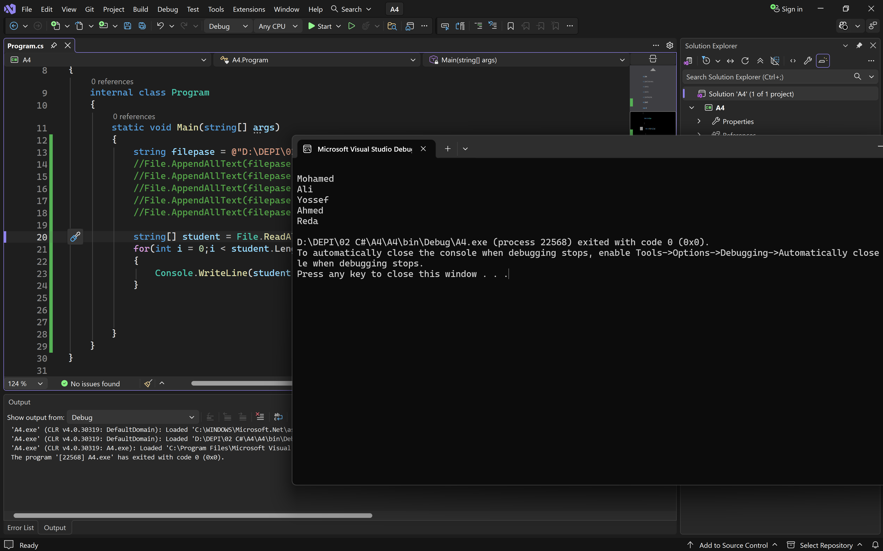
- Use StreamWriter (inside using) to append a new line to log.txt, then read it with StreamReader.
using System;
using System.IO;
class Program
{
static void Main()
{
string filePath = "log.txt";

using (StreamWriter writer = new StreamWriter(filePath, append: true))
{
writer.WriteLine($"Log entry added at: {DateTime.Now}");
}

using (StreamReader reader = new StreamReader(filePath))
{
string content = reader.ReadToEnd();
Console.WriteLine(content);
}
}
}
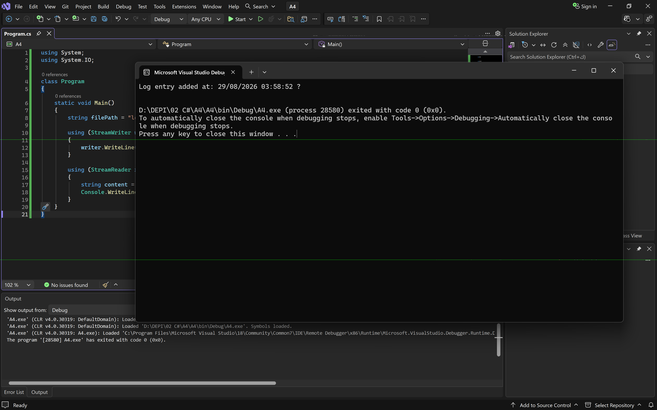

Part 2 — JSON Serialization (2 points)
- Create a class Student with Name and Grade. Serialize an object of it to JSON with JsonSerializer.Serialize and print the result.
using System;
using System.Text.Json;
class Student
{
public string Name { get; set; }
public double Grade { get; set; }
}
class Program
{
static void Main()
{
Student student = new Student
{
Name = "Youssef",
Grade = 95.5
};

string jsonString = JsonSerializer.Serialize(student);

Console.WriteLine(jsonString);
}
}
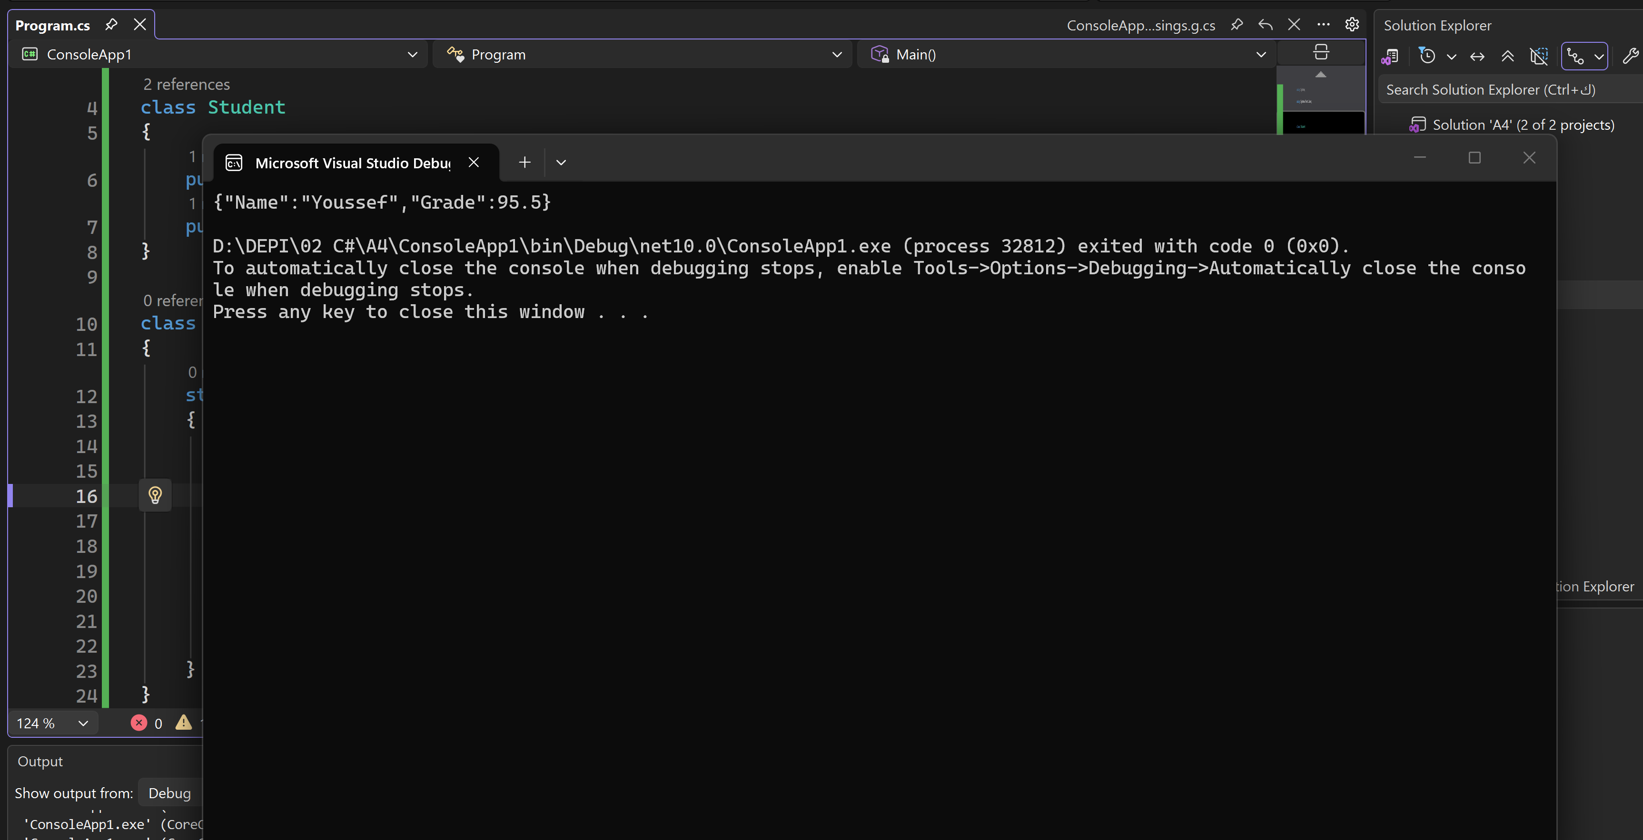
- Deserialize the JSON back into an object with Deserialize and print the Name to confirm it round-tripped correctly.
using System;
using System.Text.Json;
class Student
{
public string Name { get; set; }
public double Grade { get; set; }
}
class Program
{
static void Main()
{
string jsonString = "{\"Name\":\"Youssef\",\"Grade\":95.5}";

Student student = JsonSerializer.Deserialize<Student>(jsonString);

Console.WriteLine($"Student Name: {student.Name}");
}
}
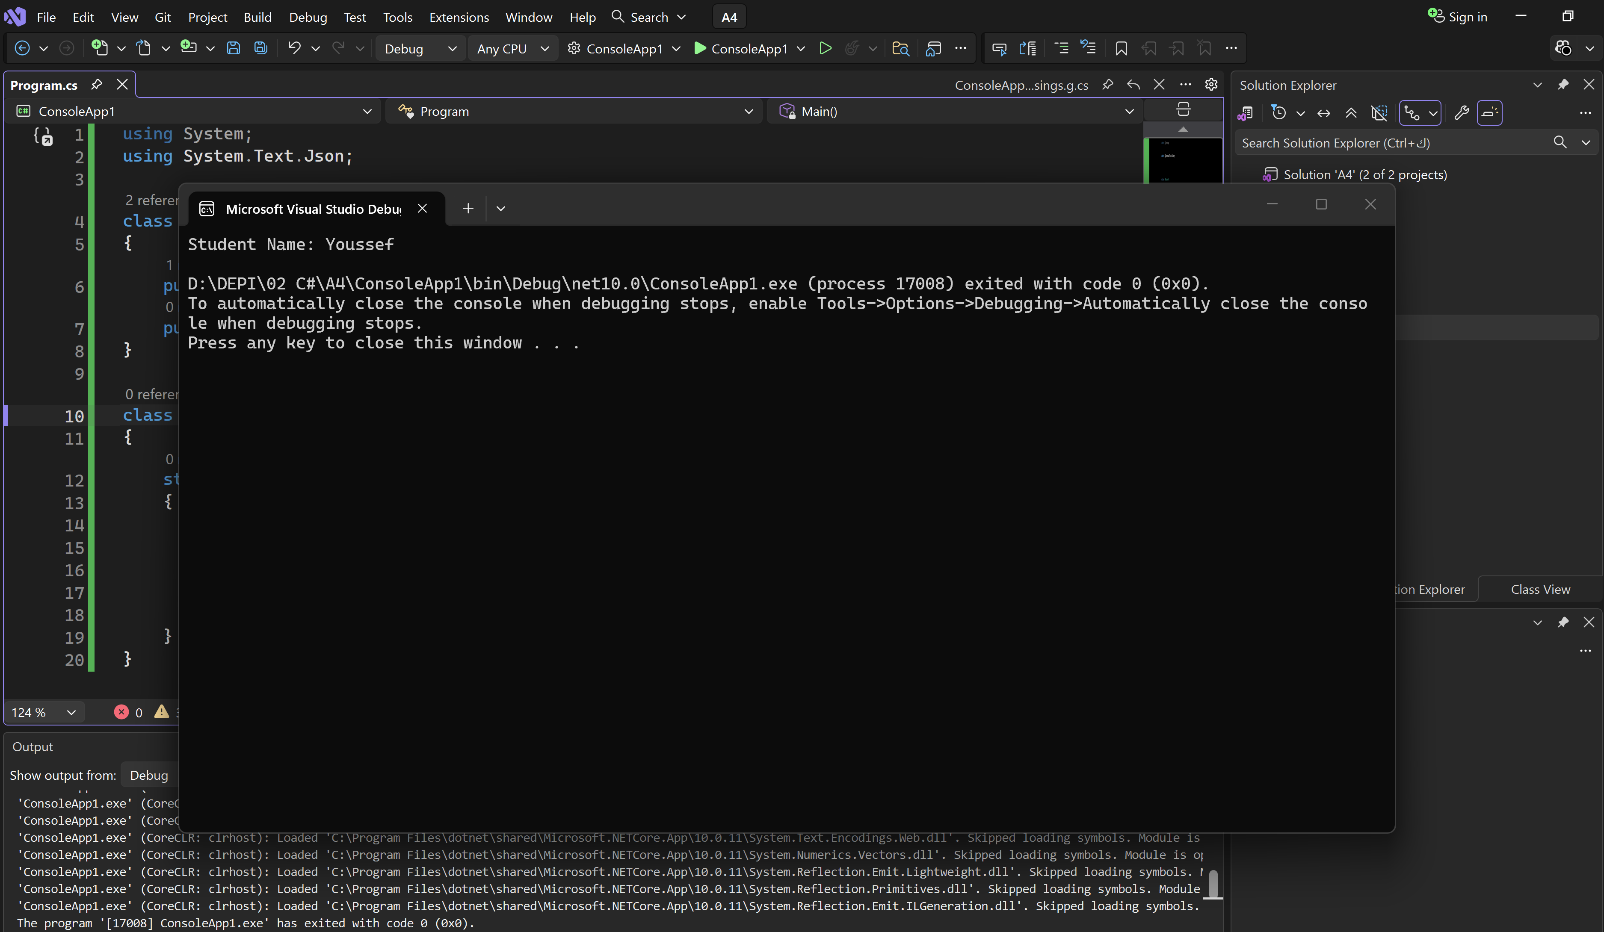

Part 3 — LINQ (3 points)
Create a List<Student> with 5 students of varying grades, then apply:
- A query returning students with grade > 50 ordered descending — use query syntax (from...where...orderby...select).
using System;using System.Collections.Generic;using System.Linq;
class Student
{
public string Name { get; set; }
public double Grade { get; set; }
}
class Program
{
static void Main()
{
List<Student> students = new List<Student>
{
new Student { Name = "Ahmed", Grade = 45.0 },
new Student { Name = "Youssef", Grade = 95.5 },
new Student { Name = "Mona", Grade = 62.0 },
new Student { Name = "Khaled", Grade = 30.0 },
new Student { Name = "Sara", Grade = 88.0 }
};

var filteredStudents = from s in students
where s.Grade > 50
orderby s.Grade descending
select s;

foreach (var student in filteredStudents)
{
Console.WriteLine($"Name: {student.Name}, Grade: {student.Grade}");
}
}
}
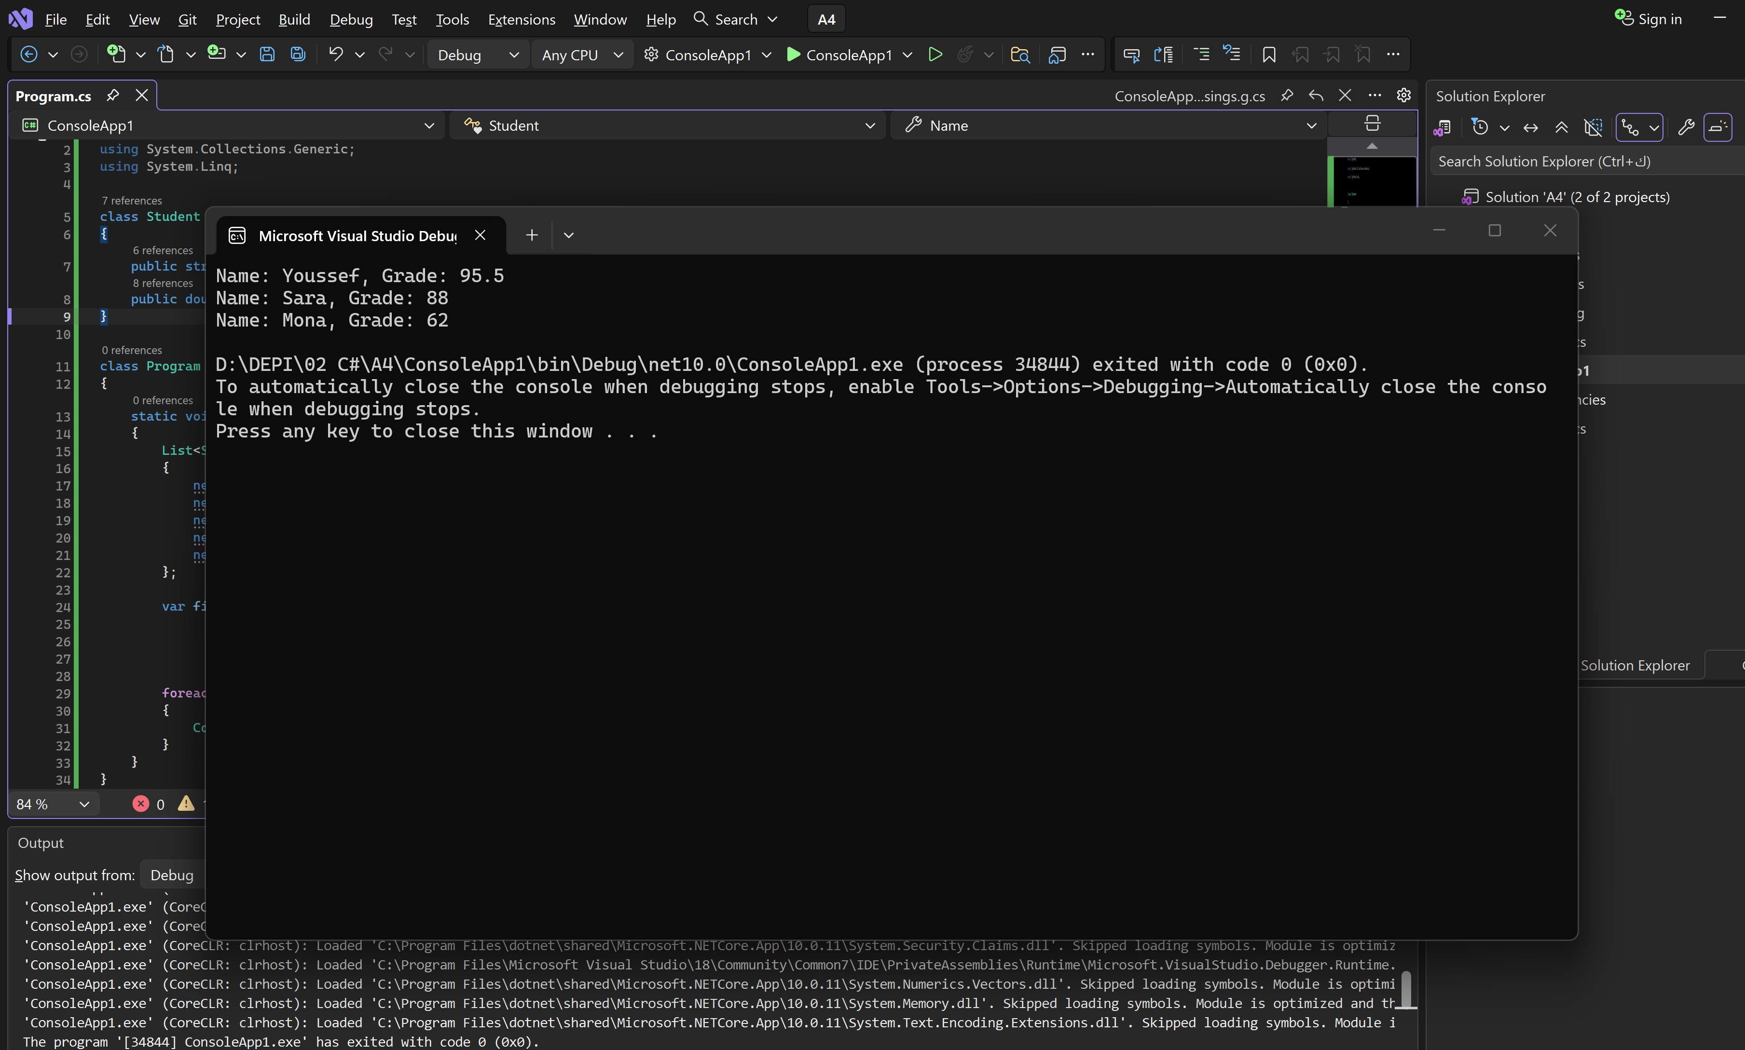
- The same query using method syntax (.Where(...).OrderByDescending(...)).
using System;
using System.Collections.Generic;
using System.Linq;
class Student
{
public string Name { get; set; }
public double Grade { get; set; }
}
class Program
{
static void Main()
{
List<Student> students = new List<Student>
{
new Student { Name = "Ahmed", Grade = 45.0 },
new Student { Name = "Youssef", Grade = 95.5 },
new Student { Name = "Mona", Grade = 62.0 },
new Student { Name = "Khaled", Grade = 30.0 },
new Student { Name = "Sara", Grade = 88.0 }
};

var filteredStudents = students
.Where(s => s.Grade > 50)
.OrderByDescending(s => s.Grade);

foreach (var student in filteredStudents)
{
Console.WriteLine($"Name: {student.Name}, Grade: {student.Grade}");
}
}
}
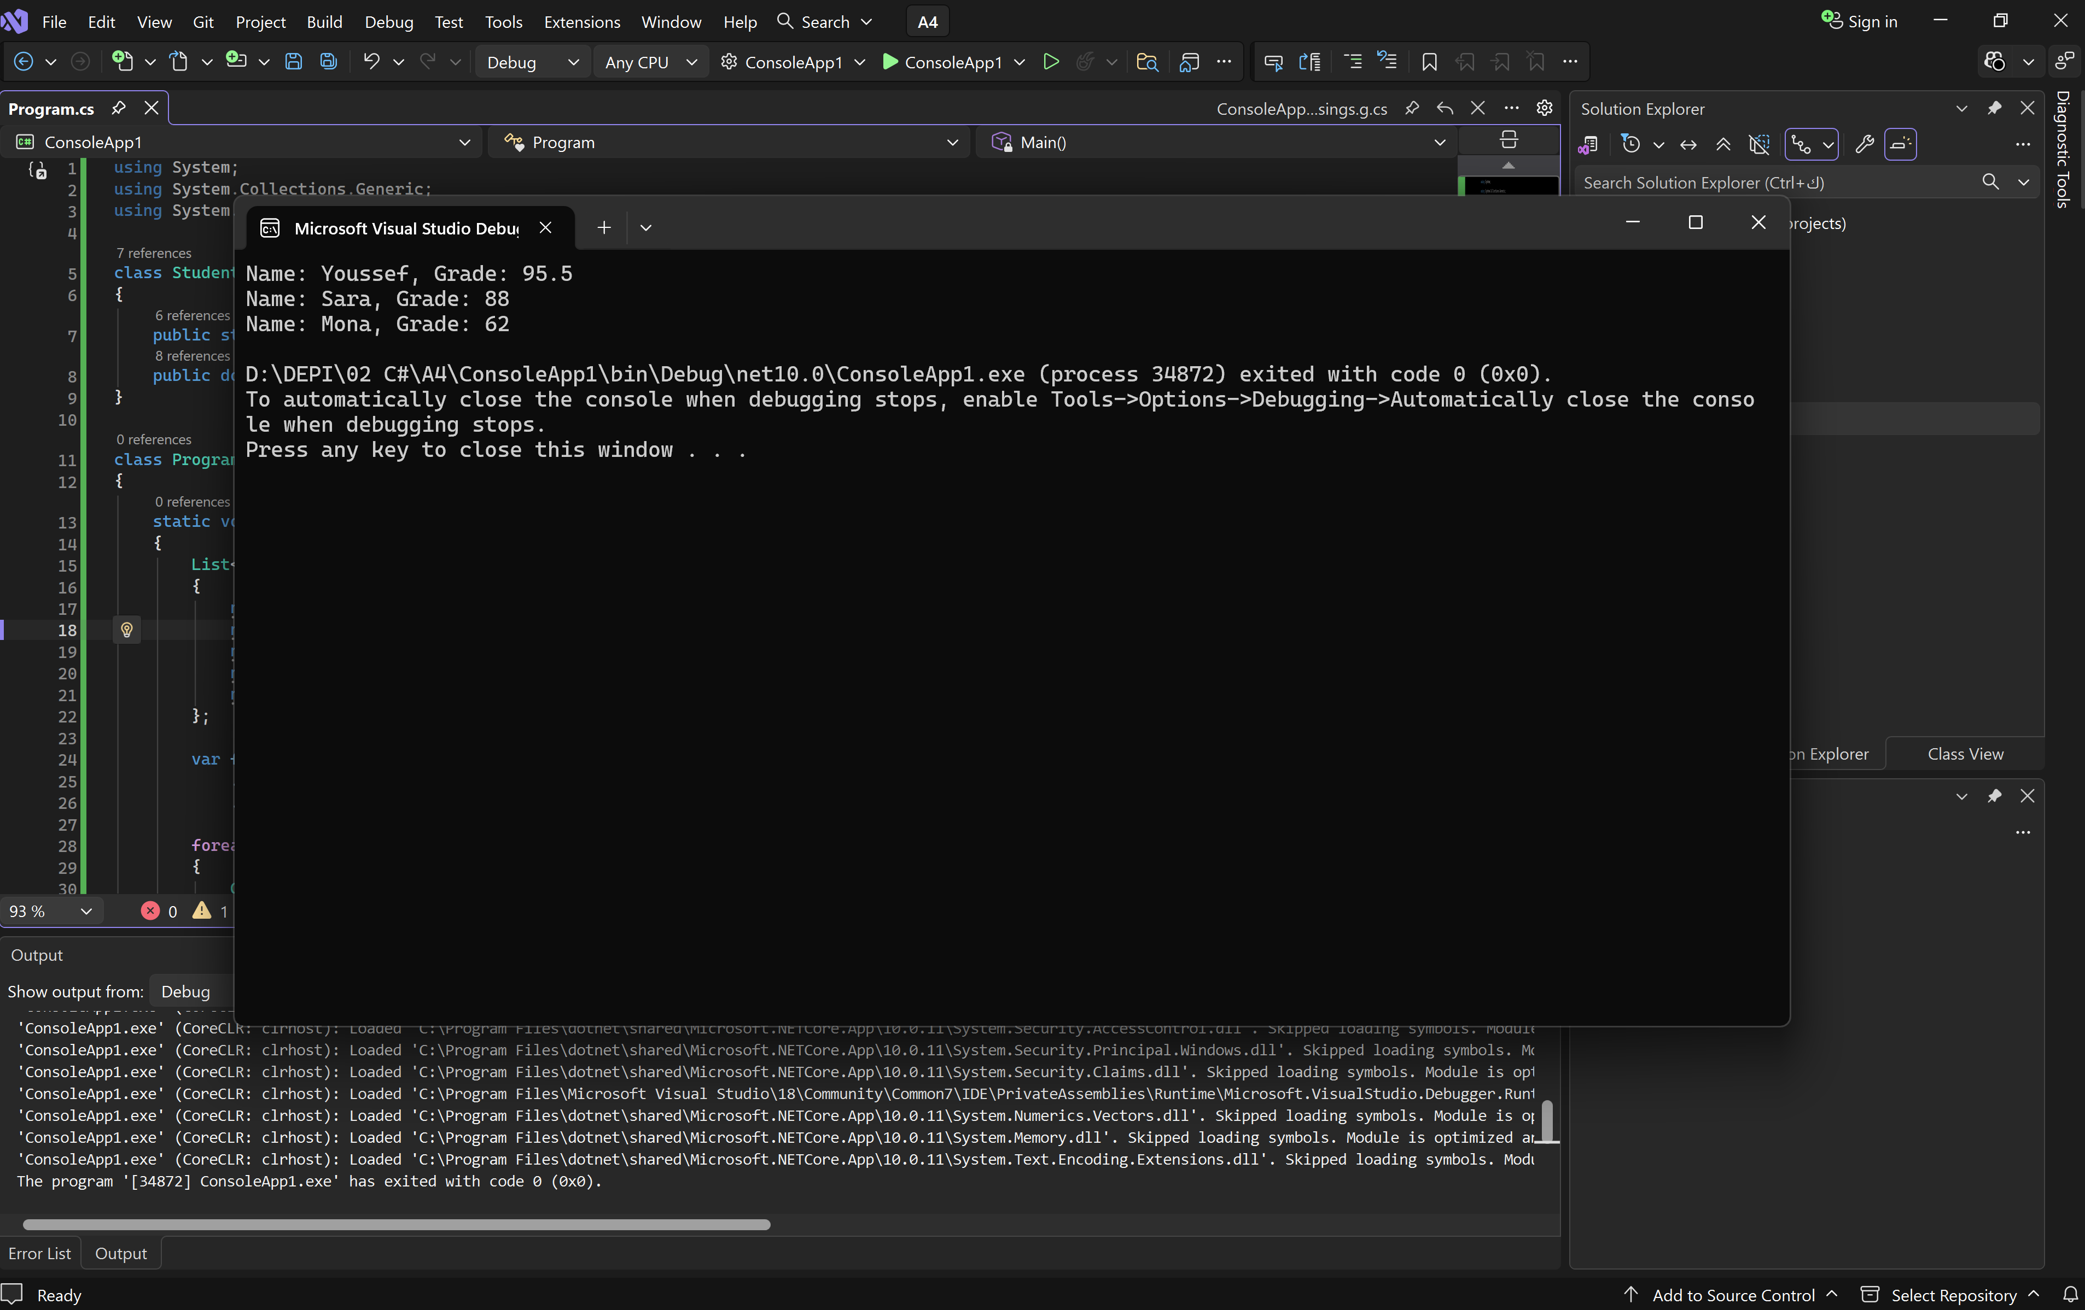
- Compute .Count() of passing students and .Sum(...) of all grades.
using System;
using System.Collections.Generic;
using System.Linq;
class Student
{
public string Name { get; set; }
public double Grade { get; set; }
}
class Program
{
static void Main()
{
List<Student> students = new List<Student>
{
new Student { Name = "Ahmed", Grade = 45.0 },
new Student { Name = "Youssef", Grade = 95.5 },
new Student { Name = "Mona", Grade = 62.0 },
new Student { Name = "Khaled", Grade = 30.0 },
new Student { Name = "Sara", Grade = 88.0 }
};

int passingCount = students.Count(s => s.Grade >= 50);
double totalGradesSum = students.Sum(s => s.Grade);

Console.WriteLine($"Number of passing students: {passingCount}");
Console.WriteLine($"Sum of all grades: {totalGradesSum}");
}
}
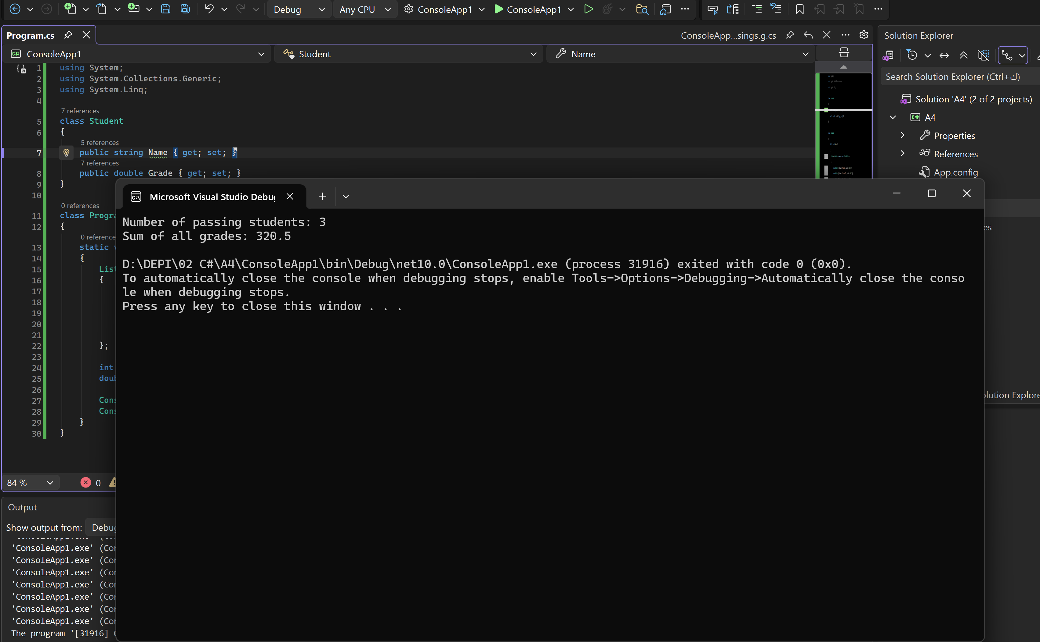

Part 4 — Comprehension (2 points)
- What does Entity Framework do? What is the difference between database-first and code-first?
Entity Framework (EF) is an ORM framework in .NET that lets developers work with databases using C# objects and LINQ instead of writing raw SQL queries.
Database-First vs. Code-First:

Database-First: You design the database on SQL Server first, then EF generates the C# classes for you.

Code-First: You write the C# classes first, then EF creates and updates the database using Migrations.

- Compare LINQ query syntax to SQL: which LINQ keyword maps to SELECT and which to WHERE?
select , where

📤 Submission: .cs file + screenshots + the students.txt file, posted to the group.
💡 Tip: Working code that you understand line by line is what matters — not perfect code. Use breakpoints if something doesn't run.

