# **PIDEV REPORT**

**SAE**

**Realized by :**

Amal ksiksi

Saif eddine louzen

Adel machat

Yosser Dridi

Nermine ghouibi

Khalil hichri

Si0rine hamzaoui

**<<Internship Service managment platform>>**

Academic year 2024/2025

# Table of Contents

Chapter 1 Study of the organism:-----------------------------------------------------------------------4

1. Introduction ----------------------------------------------------------------------------------------------4

2. Study of the existing -------------------------------------------------------------------------------------4

a. Critique of the existing ----------------------------------------------------------------------------------4

b. Proposed solution ---------------------------------------------------------------------------------------6

3. Specification of needs ----------------------------------------------------------------------------------6

a. Identification of actors ----------------------------------------------------------------------------------7

b. Functional requirements ------------------------------------------------------------------------------- 7

c. Non - functional requirements -------------------------------------------------------------------------8

4. Global Use Case Diagram -------------------------------------------------------------------------------9

5. Global class diagram ------------------------------------------------------------------------------------10

6. Mockups ---------------------------------------------------------------------------------------------------11

7. Development Method ------------------------------------------------------------------------------------12

8. Global Architecture ---------------------------------------------------------------------------------------12

a. Logic Architecture ----------------------------------------------------------------------------------------14

b. Physical Architecture ------------------------------------------------------------------------------------15

9. Product Backlog -----------------------------------------------------------------------------------------16

10. Conclusion -----------------------------------------------------------------------------------------------16

# Table of figures

Figure 1 –Symplicity Platform ----------------------------------------------------------------------------------8

Figure 2 –Esprit Platform Figure -------------------------------------------------------------------------------9

Figure 3 –Global Use Case Diagram ------------------------------------------------------------------------13

Figure 4 – Global class diagram -----------------------------------------------------------------------------14

Figure 5 – student interface ----------------------------------------------------------------------------------16

Figure 6 – company interface ------------------------------------------------------------------------------- 16

Figure 7 – Company interface --------------------------------------------------------------------------------16

Figure 8 – Scrum methodology -----------------------------------------------------------------------------17

Figure 9 – Logic Architecture ---------------------------------------------------------------------------------18

Figure 10 – Physical Architecture --------------------------------------------------------------------------18

Figure 11 – Product backlog ---------------------------------------------------------------------------------20

# Chapter1: Study of the organism

**1.Introduction:**

This report presents the creation of a comprehensive internship management platform, designed to streamline the internship process for students, companies, and academic institutions. By leveraging modern technology, the platform aims to enhance efficiency, communication, and collaboration throughout the internship lifecycle.

**2. Study of the existing:**

The existing internship management system suffers from significant drawbacks, including manual application processes, time loss, complexity, and limited access to information. These issues underscore the necessity for a more streamlined and efficient solution.

1. **Critique of the existing :**

This functional aspect involves studying and analyzing similar projects such as Simplicity platform on an international scale and Esprit platform on a national scale in Tunisia

**i. Simplicity platform**

Simplicity SIM (Simplicity Internship Management) was designed to manage the operational process of approval, monitoring, and evaluation of internships. SIM ensures the management of the signing and approval process of agreements between employers and universities.

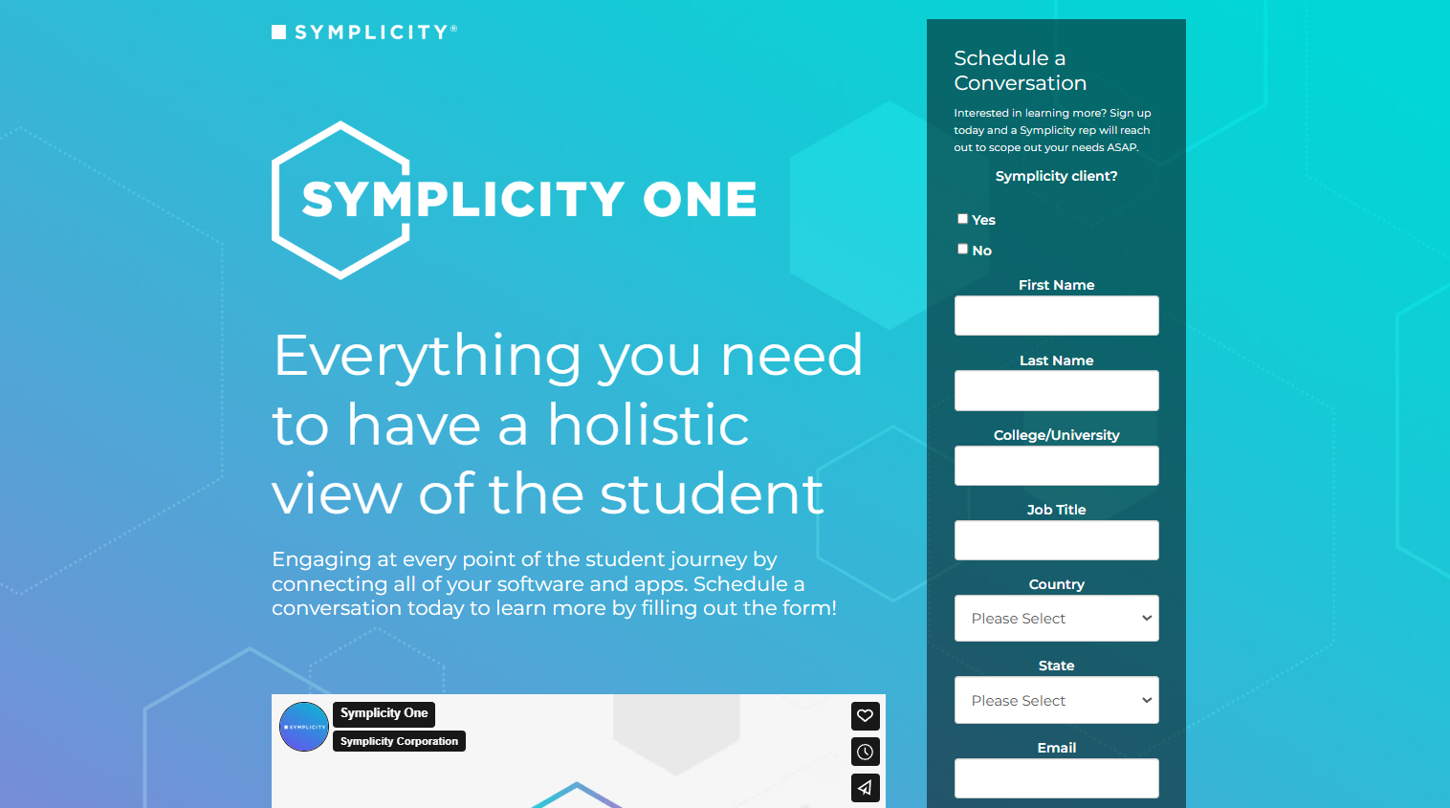

Figure 1 –Symplicity Platform

**• Strengths**

- Its focus on simplifying administrative processes related to internships.

- Tracking capabilities for applications, internship offer management, and communication with companies.

**• Weaknesses**

- A user interface that lacks intuitiveness and navigation difficulties.

- Unstable performance and limited features, such as integration with other tools.

- Customer support may be unsatisfactory due to slow response times and ineffective problem resolution.

**ii. Esprit platform**

In the Esprit platform, we can simply download an internship application or assignment letter through the form below. Only one assignment letter can be obtained.

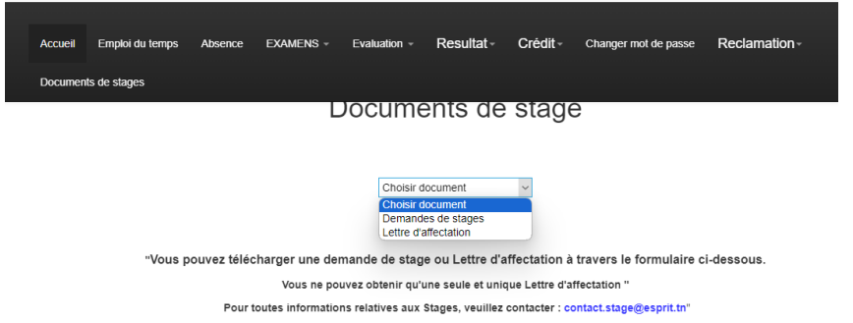

Figure 2 –Esprit Platform

**• Weaknesses**

- Students manually submit internship applications.

- Time Loss (Back and Forth of Students)

- Complexity of Application Process

- Limited Access to Feedback

- Delays in receiving responses from companies/administration

- Lack of centralized information about available internships opportunities

- Difficulty retrieving any document in case of loss

- Administration Paperwork Overload

- Storage and Organization of Paper Documents

**b. Proposed solution** :

In response to the demands and to broaden our reach, we have embarked on the development of a platform that responds and offers these solutions:

• Facilitates real-time communication between companies/ students /administration

• Create an approach for feedback

• Secures data

• Document archiving (in case of loss)

• Simplify internship search

• Make the application process easier

• Easy access to company and student information

• Responsive platform

• Automate and centralize the management of PFE and summer internships

**3. Specification of needs**

In this part, we will reveal the actors and the functionalities of our future system.

**a. Identification of actors:**

The actor is the end user who requests the system to have the information he needs the actors interacting with our system are organized as follows:

• **Super Admin:** Privileged user with comprehensive access and control over the internship management platform.

**• Administration Agent:** Staff member managing administrative tasks related to internships within the educational institution.

**• Company Agent:** Representative within a company responsible for internship-related matters.

**• Student:** Individual enrolled in an educational institution seeking practical experience through internships.

**•Teacher:** he can be a supervisor or expert or jury member

1. **Functional requirements:**

Recognizing the need for an efficient and structured system, the university implemented a comprehensive internship management platform to enhance the experience for students, companies, and administrators. The journey begins with User Management,

ensuring seamless access through login/logout, password recovery, and profile customization.

Companies receive automatically generated accounts, allowing them to post internship offers easily. The Internship Management module streamlines internship listings, allowing administrators to dynamically manage offers. Students can apply directly via the platform or integrate external applications, with built-in tools to generate and submit required documents. Final-year students undertaking PFE (Final Year Project) internships benefit from a collaborative workspace for document sharing and direct communication with supervisors and mentors.

A structured validation system ensures timely submission and approval of deliverables, keeping students on track.

the Soutenance Management feature ensures a well-organized defense process by scheduling presentations, assigning jury members, and integrating communication tools for coordination. Security and backup mechanisms safeguard all essential data. Summer internships, being shorter and more flexible, follow a simplified process with quick application handling, convention management, and digital record-keeping for future reference.

To address challenges, a Complaint Management System enables users to report issues related to applications or placements, ensuring transparency as administrators review and resolve concerns.

Lastly For better engagement, the Forum Management feature fosters discussions between students and company representatives, creating a Q&A space to exchange insights and experiences. With this platform, the university ensures a streamlined, transparent, and structured internship process, making the experience smoother and more efficient for all stakeholders.

**c. Non - functional requirements:**

These are the constraints to be considered to guarantee better operation of the application to be delivered:

• **Security:**

- Encryption of sensitive data

• **Performance:**

- Fast response time

- Ability to handle many simultaneous users

• **System availability 24/7**

**• Scalability:**

- Ability to grow and adapt as the number of users increases without affecting system performance.

**• User-Friendliness:**

- Simple and easy-to-use interface for students, companies, and administration

**4. Global Use Case Diagram**

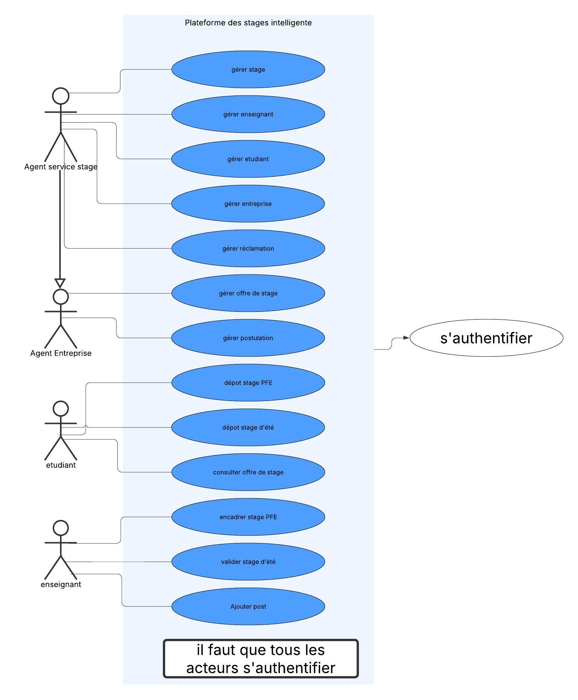 Figure 3 –Global Use Case Diagram

**5. Global class diagram**

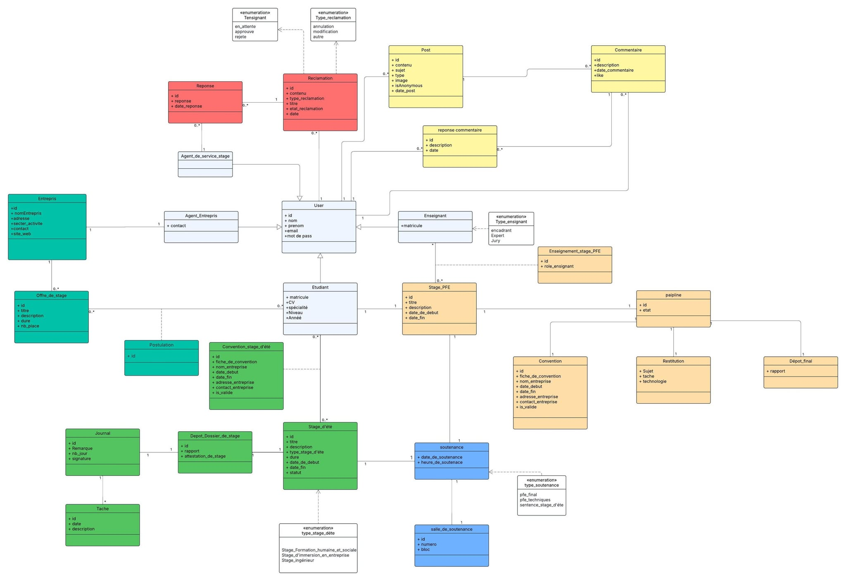

Figure 4 – Global class diagram

**6. Mockups:**

Here is the student part interface: 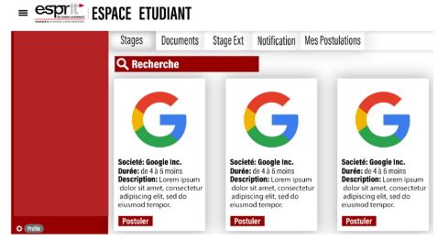

Figure 5 – student interface

Here is the admin part interface:

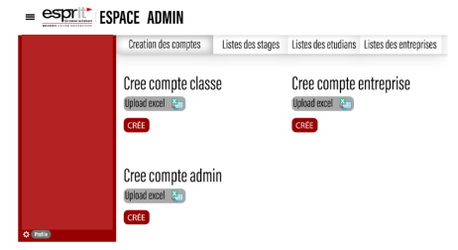

Figure 6 – company interface

Here is the company part interface:

Figure 6 – company interface

**7. Development Method:**

Scrum fosters a culture of learning from mistakes and continuous improvement. It emphasizes adaptation to variables and ongoing learning from errors, allowing teams to adjust to changing elements and requirements throughout development cycles. To effectively utilize SCRUM, a sprint lifecycle is essential. Here's an overview:

1. The Product Owner specifies user stories in the Product Backlog.

2. The team defines the User Stories comprising the Sprint Backlog.

3. The team implements short-term sprint tasks over 2-4 weeks.

4. Daily, the team and Scrum Master review progress, set daily goals, and identify potential hurdles.

5. After completing work, a Sprint review is held to check the increment and adjust the Product Backlog if needed. A final Sprint retrospective discusses potential improvements

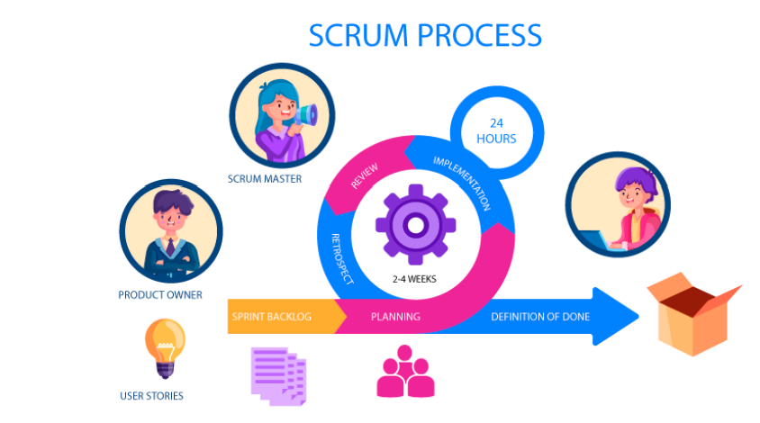

Figure 8 – Scrum methodology

**8. Global class diagram**

**a. Logic Architecture:**

Here is the logic architecture:

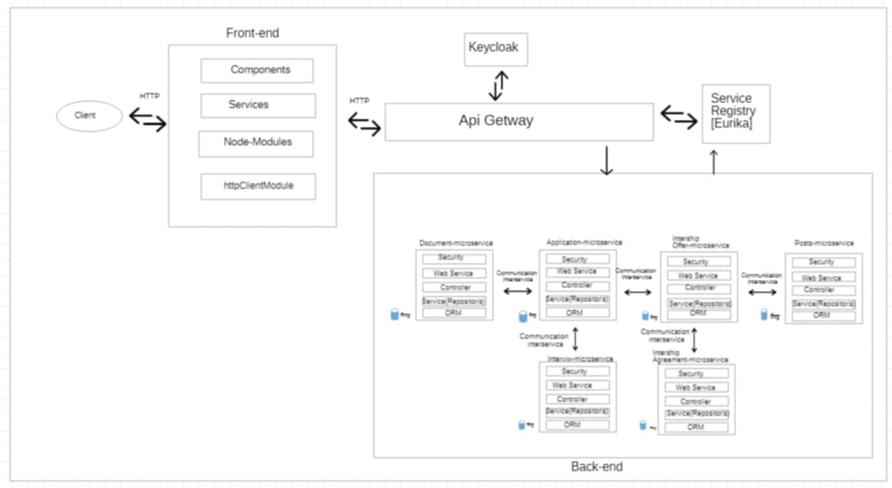

Figure 9 – Logic Architecture

1. 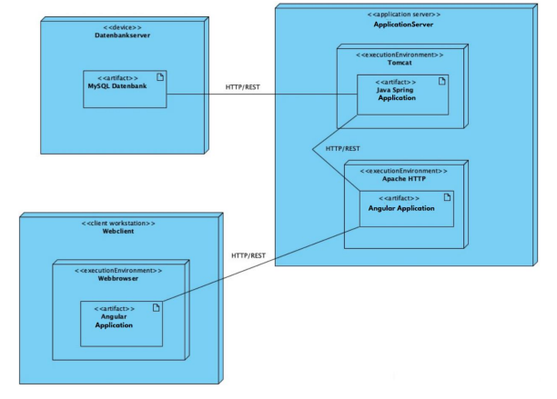**Physical Architecture :**

Figure 1 0 – Physical Architecture

**9. Product Backlog**

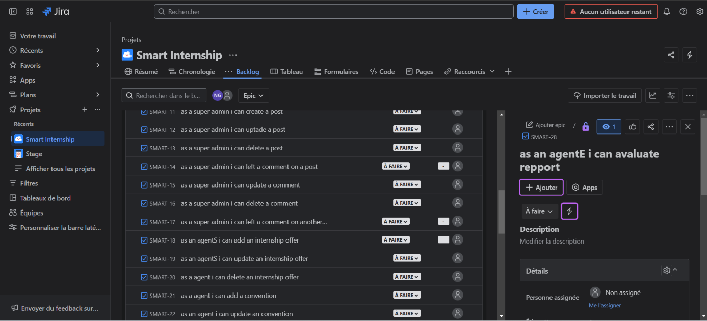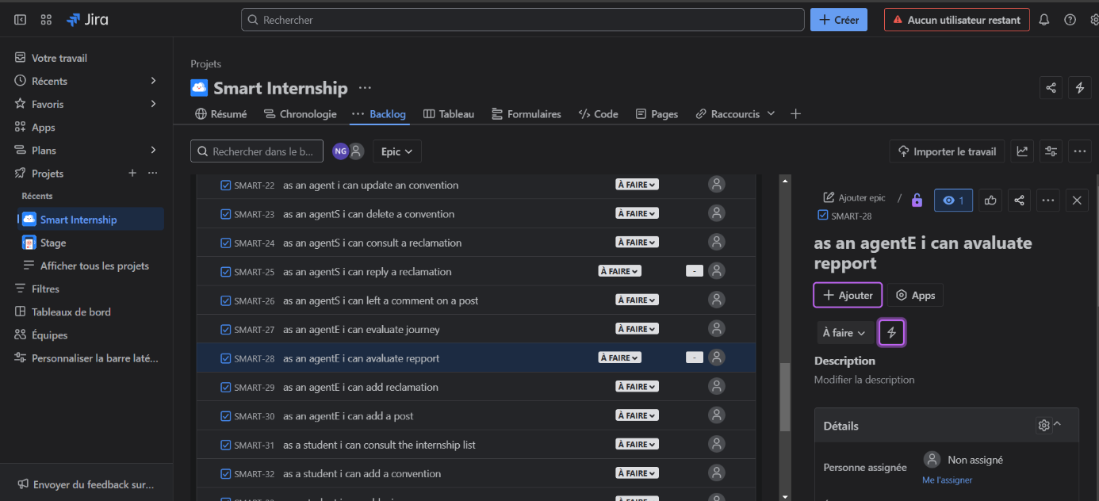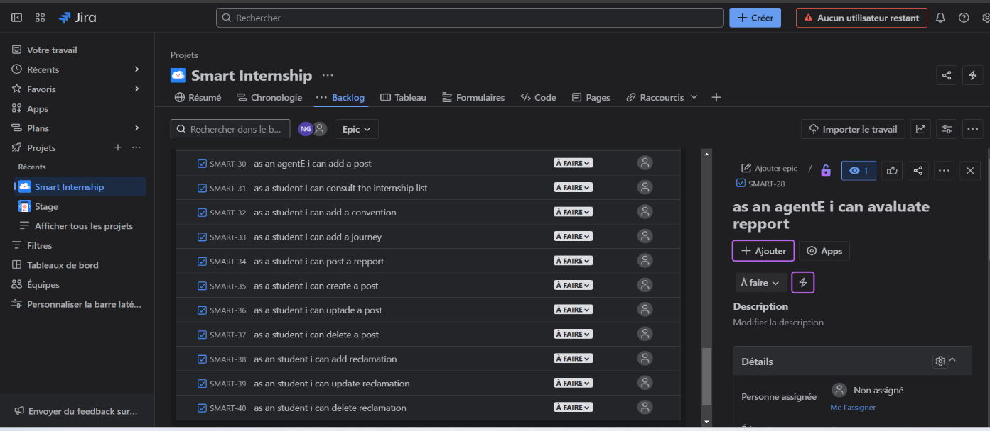Here is the functional product backlog:

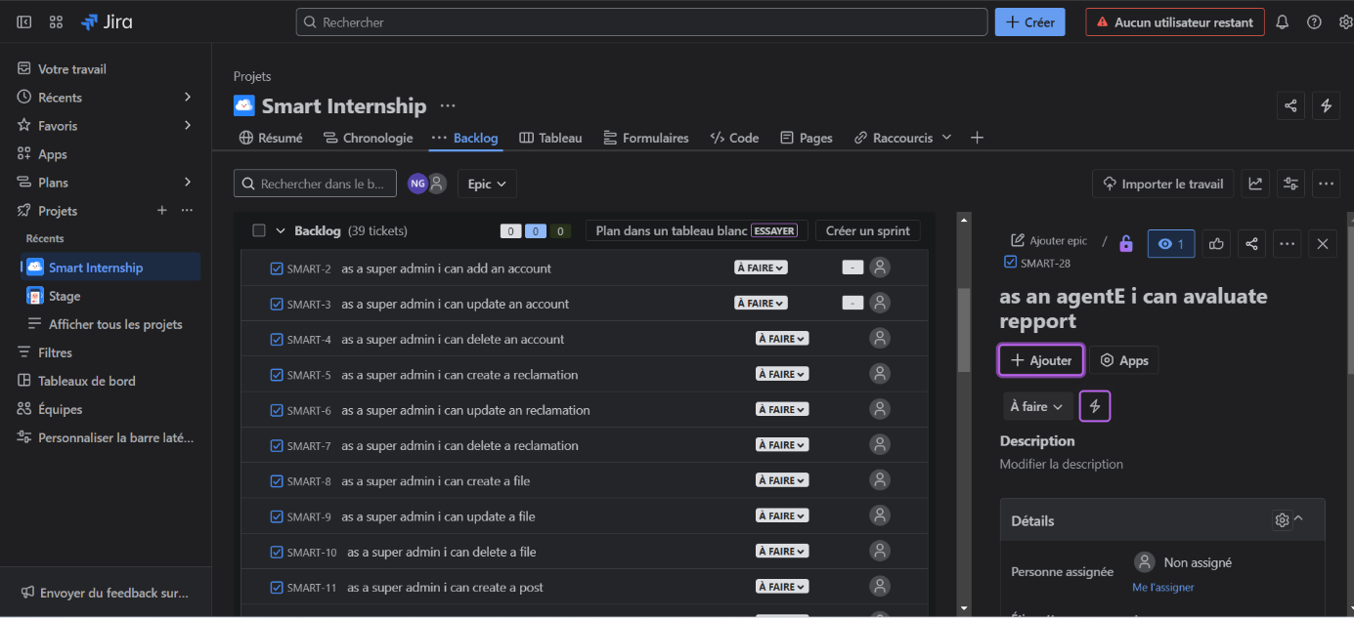

Figure 11 – Product backlog

**10.Conclusion**

In conclusion, our internship management platform addresses key challenges by automating administrative tasks, improving communication, centralizing internship offers, and providing analytical tools for better allocation. By enhancing efficiency and collabortion, it streamlines the entire internship lifecycle for students, companies, and academic institutions.