

RF Test
By: RF Team
01.04.2026

Test Setup:
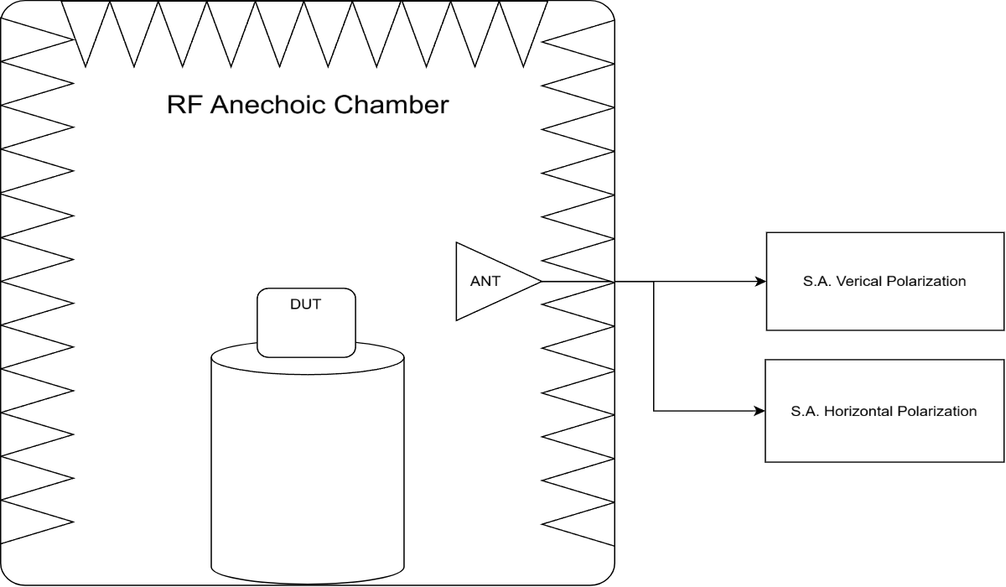

Scope of Testing
1. TRP test

Test Parameters:

Measurement Parameters:
Parameter | Value
Frequency | 707.5MHz  915.2MHz  922.2MHz  927.8MHz  1732.5MHz  1880.0MHz
Tested Power | 14dBm

Firmware / Hardware Versions:
Parameter | Value
FW Version | -
HW Version | -

Unit IDs:
Parameter | Value
Unit IDs | 70B3D5A9F017C80F  70B3D5A9F0173333  70B3D5A9F013DE16  70B3D5A9F013DE18

Radiated Results

LoRa
Unit ID | Frequency | TRP | Max Peak | 3D Graph
70B3D5A9F017C80F | 915.2MHz | 16.40 | 18.42 | 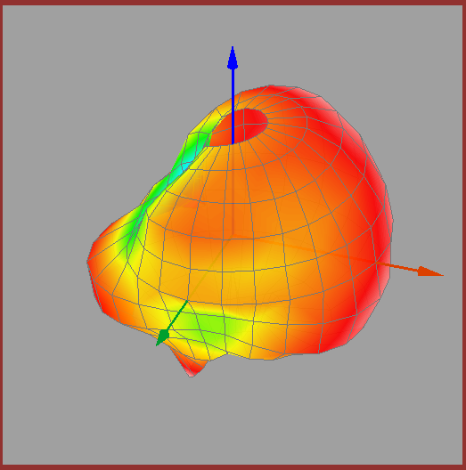
 | 922.2MHz | 15.69 | 17.55 | 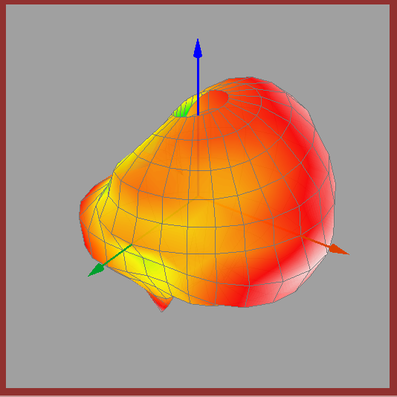
 | 927.8MHz | 15.04 | 16.71 | 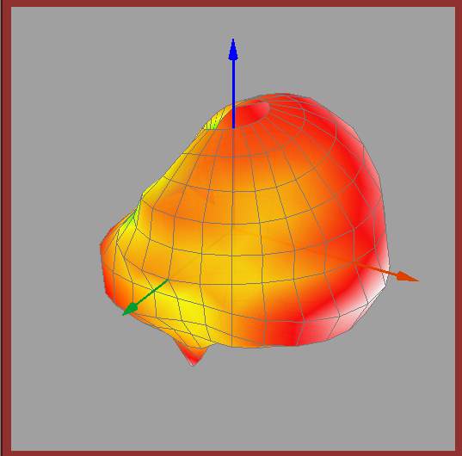
70B3D5A9F0173333 | 915.2MHz | 1.00 | 35.98 | -
 | 922.2MHz | 2.00 | 35.93 | -
 | 927.8MHz | 3.00 | 35.80 | -

LTE
Unit ID | Frequency | TRP | Max Peak | 3D Graph
70B3D5A9F017C80F | 707.5MHz | 16.40 | 18.42 | 
 | 1732.5MHz | 15.69 | 17.55 | 
 | 1880.0MHz | 15.04 | 16.71 | 
70B3D5A9F0173333 | 707.5MHz | 1.00 | 35.98 | -
 | 1732.5MHz | 2.00 | 35.93 | -
 | 1880.0MHz | 3.00 | 35.80 | -

Unit Type 2
Unit ID | Frequency | TRP | Max Peak | 3D Graph
70B3D5A9F013DE16 | 915.2MHz | 16.26 | 19.30 | 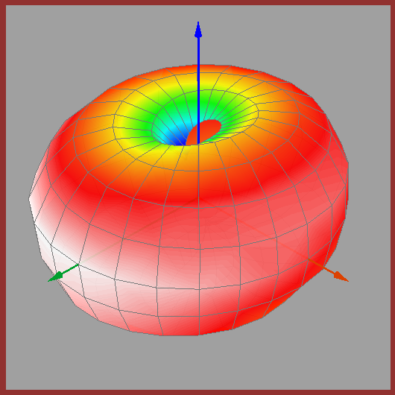
 | 922.2MHz | 16.26 | 19.33 | 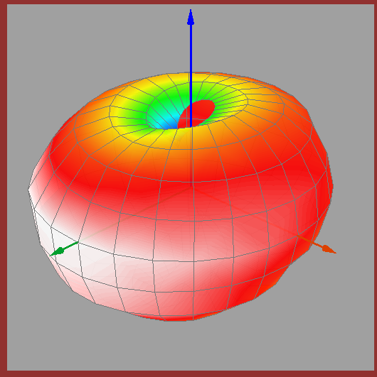
 | 927.8MHz | 16.18 | 19.12 | 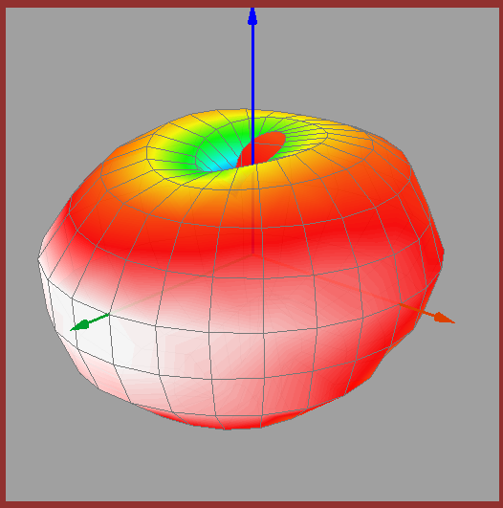
70B3D5A9F013DE18 | 915.2MHz | 16.26 | 19.30 | 
 | 922.2MHz | 16.26 | 19.33 | 
 | 927.8MHz | 16.18 | 19.12 | 
 | 915.2MHz | 16.26 | 19.30 | 
 | 922.2MHz | 16.26 | 19.33 | 
 | 927.8MHz | 16.18 | 19.12 | 

Notes:

