TEST CONSOLE
Operator Manual
Installation, configuration, supported hardware and step-by-step test procedures for the BLE-driven PA test rig.
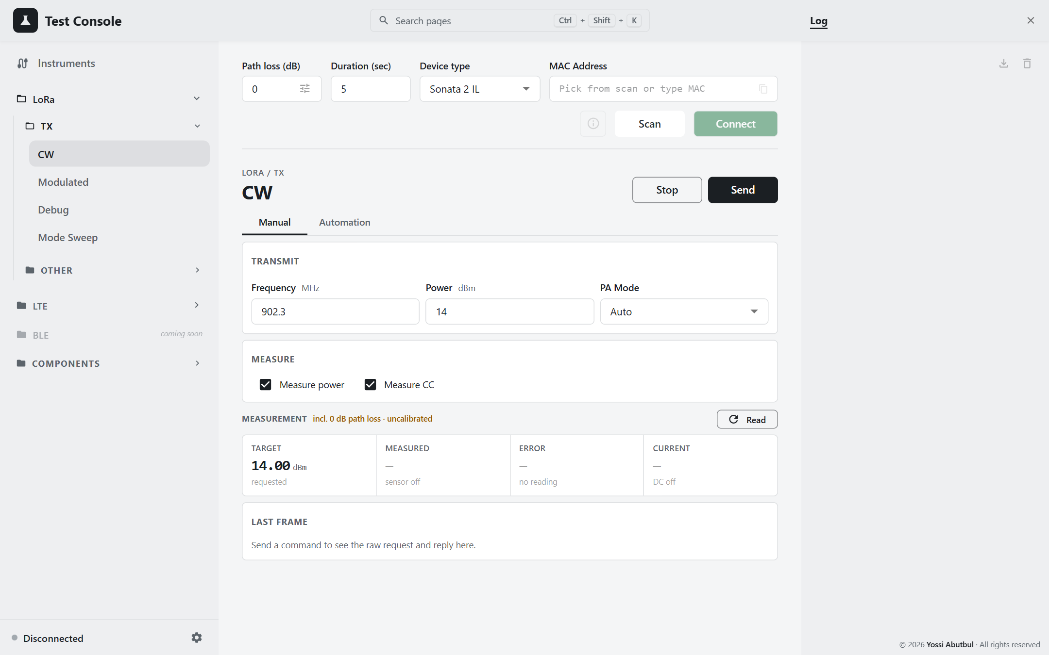
Edition: 22 September 2026
Source revision: dev @ 3b4dbe2
Screenshots: captured from the running application, Light theme

Contents
Introduction 4
About the screenshots 4
Which page do I use? 5
Safety first 5
Conventions 5
1. Installation & configuration 6
1.1 What the PC needs 6
1.2 Drivers 6
1.3 Software dependencies 7
1.4 Installing 8
1.5 Verifying the install 9
1.6 Running the app 9
1.7 Environment variables 10
1.8 Launchers, scripts and IDE configs 11
1.9 The standalone (DUT-only) desktop build 11
1.10 Where settings and files live 11
2. Hardware & connections 13
2.1 Supported devices 13
2.2 Device details 13
2.3 The DUT over BLE 15
2.4 Test setups 16
2.5 Which test needs what 19
3. Using the console 21
3.1 Screen layout 21
3.2 Connecting the DUT 23
3.3 Instruments panel 24
3.4 Path loss 26
3.5 Settings 27
3.6 The measurement card 27
3.7 Preflight: instruments before a test 29
3.8 Log and notifications 29
3.9 Assistant 30
3.10 Search and keyboard shortcuts 30
3.11 DUT-only builds 31
4. LoRa tests 32
4.1 Before any LoRa TX test 32
4.2 CW 33
4.3 Modulated 37
4.4 Debug 38
4.5 Mode Sweep 39
4.6 Load Pull Test 42
5. LTE tests 48
5.1 Concepts: modem key, EARFCN, bands 48
5.2 LTE CW 50
5.3 LTE Modulated 51
5.4 Automation (both pages) 53
5.5 Cautions 55
6. Component pages 56
6.1 Trombone 56
6.2 Switch 57
6.3 Network Analyzer 58
6.4 Power Meter 60
6.5 Signal Generator 61
7. Troubleshooting & reference 63
7.1 Symptoms and fixes 63
7.2 Error status codes 64
7.3 Constants shared across the stack 64
7.4 Export formats at a glance 65
7.5 Known discrepancies 66
7.6 Glossary 66
7.7 Regenerating this manual 67

Introduction
The Test Console is a desk tool for testing an RF power amplifier. It drives a device under test (DUT) over Bluetooth LE, measures it with bench instruments, and records the results.
It has two parts:
- a FastAPI backend on port 8000, which talks to the hardware;
- a React frontend in the browser, where the operator works.
This manual covers the whole application:
- installation and configuration;
- every supported device and how it is connected;
- the console itself;
- each test, step by step.
Figure 1 — The console, LoRa › TX › CW

About the screenshots
- Source: every screenshot was taken from the running application, in the Light theme.
- Example data: screenshots captioned example data show synthetic results, which were seeded into a throw-away browser profile so that tables and charts have something to show. Nothing in them was measured.
- DUT pages: these pages are normally dimmed until a unit is connected. They are shown as they appear once connected. The dimmed state is shown in section 3.1.

Which page do I use?
I want to… | Page | Section
Key a LoRa CW carrier at one setting and read power and current | LoRa › TX › CW (Manual) | 4.2
Sweep LoRa CW over frequency and power with pass/fail | LoRa › TX › CW (Automation) | 4.2
Transmit LoRa or FSK modulation | LoRa › TX › Modulated | 4.3
Set the PA duty-cycle and HP-max registers directly | LoRa › TX › Debug | 4.4
Find the lowest-current PA setting for each power level | LoRa › TX › Mode Sweep | 4.5
Map power and efficiency against load impedance | LoRa › Other › Load Pull Test | 4.6
Test an LTE (Cat-M) unit | LTE › TX › CW / Modulated | 5
Move the trombone, flip the RF switch, read the VNA, use the power meter or signal generator by hand | Components | 6

Safety first
The rig is live hardware. Each of the following controls acts on the physical world immediately, with no confirmation:
Action | Controls
Keys the PA / transmits RF | Send and Run on every TX page; RF On on the Signal Generator page. The VNA transmits its stimulus for as long as it is connected.
Moves the trombone | Move, Step up/down, Go min/max (Trombone page); Jog, Go to Zero/End and Run (Load Pull)
Changes the RF path | Go VNA / Go PCB / Move (Switch page); VNA / PCB (Load Pull). Connecting the RF switch from the Instruments panel moves it to VNA.
Powers the DUT | The DC analyzer supply switch in Settings; the LTE Modem key

These stay on until you turn them off:
- A manual Send on a LoRa TX page keeps the DUT transmitting until you press Stop.
- The LTE modem stays powered until you turn off the Modem key.
- Disconnecting the signal generator does not switch its RF output off.
The Load Pull page has an Emergency stop button (round, red) that is always enabled. The Trombone page has Stop in its header.

Conventions
- Bold text is a label exactly as it appears in the application, for example Run sweep.
- Monospace text is something you type, a file name, or a value on the wire.
- "Path loss" always means the dB figure added to the sensor reading to get the power at the DUT: DUT power = sensor reading + path loss.
- Page names follow the sidebar: Protocol › Group › Page.

1. Installation & configuration

1.1 What the PC needs
The app runs on Windows 10/11 only. The vendor DLLs, the VISA stack and the BLE adapter all assume Windows.
# | Install | Why | Verified version
1 | Python 3.12 (3.11+ works). Tick Add python.exe to PATH. | Runs the backend | 3.12.10
2 | Node.js 20+ LTS (includes npm) | Builds the frontend and runs the dev server | Node 26.5.1 / npm 11.17.0
3 | Git | Two Python packages install straight from GitHub | —
4 | Keysight IO Libraries Suite | Required. Supplies the VISA runtime and the USB instrument driver. | 2026 (21.3.293)
5 | Arcus Drivers and Tools Installer | Required for the trombone motor. Supplies its kernel driver. | 1.43
— | Bluetooth adapter | Talks to the DUT | Windows built-in stack

The Keysight suite provides:
- visa32.dll / visa64.dll in System32;
- the Keysight VISA implementation (ktvisa32.dll, agvisa32.dll);
- the USBTMC kernel driver (ausbtmc.sys) that binds Keysight USB instruments (vendor ID 0x0957);
- Keysight Connection Expert, which is the quickest way to check an instrument is reachable independently of this app.
pyvisa-py is installed as a pure-Python fallback, but do not rely on it for the USB instruments. They are driven through Keysight VISA.

1.2 Drivers
Device | Driver | What you need to do
Keysight USB instruments (N6705B, E5061B) | ausbtmc.sys (USBTMC) | Nothing more; installed with IO Libraries
Arcus DMX-J-SA trombone motor | Performax USB (WinUSB-based) | Two-step install, below
Mini-Circuits power sensor | mcl_pm_NET45.dll (.NET 4.5) | Nothing; the DLL is bundled in the repo and .NET 4.x ships with Windows
Arduino RF switch | FTDI VCP (ftdibus.sys/ftser2k.sys) for the FT232R | Install if the board shows under Other devices
R&S SML03 signal generator | the driver for your USB-to-RS-232 adapter, if you use one | As supplied with the adapter
DUT | Windows Bluetooth | Nothing

Arcus motor driver (two steps)
The dmx-j-sa Python package ships PerformaxCom.dll and SiUSBXp.dll. These are user-mode libraries only. They still need a kernel driver underneath, which neither the repo nor Windows provides. Without it the motor appears in Device Manager as Arcus-USB (USB\VID_1589&PID_A101) with Code 28.
- On the Arcus DMX-J-SA-17 product page, open Software and download Drivers and Tools Installer (1.43).
- Run it as administrator. This step only unpacks files to C:\Program Files (x86)\Arcus Technology\Drivers, Libraries, Source\Performax USB v4.01\.
- Run the unpacked PerformaxUSBInstaller_x64.exe as administrator (install.bat in the same folder picks x64 or x86 for you). This is the step that actually binds the driver.
- Replug the motor, then check that Status reads OK:
Get-PnpDevice -PresentOnly | Where-Object InstanceId -like 'USB\VID_1589*' | Select-Object Status, FriendlyName, InstanceId

FTDI driver for the RF switch
The Arduino board presents an FT232R (USB\VID_0403&PID_6001). Without the VCP driver it never gets a COM port.
- In Device Manager, right-click FT232R USB UART → Update driver → Search automatically.
- If Windows Update is blocked, download the package from https://ftdichip.com/drivers/vcp-drivers/.
- Check that a USB Serial Port (COMn) shows Status: OK:
Get-PnpDevice -PresentOnly -Class Ports | Select-Object Status, FriendlyName
Clone FT232R chips are refused by current FTDI drivers ("NON GENUINE DEVICE FOUND"). A board with a clone chip has to be replaced (a CH340-based board works); a different driver will not fix it.

Bundled DLLs
These live in the repo and are registered at startup by backend/hw/dll_setup.py. You never copy them by hand.
backend/hw/dlls/
motor/ PerformaxCom.dll, SiUSBXp.dll (Arcus DMX-J-SA)
power_sensor/ mcl_pm_NET45.dll (Mini-Circuits)

1.3 Software dependencies

Python (requirements.txt)
These are minimum versions (>=), not exact pins. The "installed" column is what the rig's .venv currently runs.
Package | Minimum | Installed | Used for
fastapi | 0.110 | 0.140.13 | Web API
uvicorn[standard] | 0.27 | 0.52.0 | Web server
pydantic | 2.6 | 2.13.4 | Request validation
bleak | 0.22 | 3.0.2 | BLE to the DUT
openpyxl | 3.1 | 3.1.5 | Excel import and export
pyvisa | 1.16 | 1.16.2 | VISA instruments
pyvisa-py | 0.8 | 0.8.1 | Fallback VISA backend
pyserial | 3.5 | 3.5 | RF switch, signal generator
rf-instruments (git) | — | 0.2.0 | power_sensor, dc_power_analyzer, network_analyzer wrappers
dmx-j-sa (git) | — | 0.1.0 | Arcus motor wrapper
pythonnet | 3.0.3 | 3.1.0 | Loads the Mini-Circuits .NET DLL
numpy | 1.26 | 2.5.1 | Needed by network_analyzer

rf-instruments declares no dependencies of its own, which is why pythonnet and numpy are listed explicitly. pytest is not listed. Install it separately to run the backend tests.

Frontend (frontend/package.json)
React 19.2, MUI 6.5, TanStack Query 5, React Router 7, Recharts 2.15, Vite 8, TypeScript 6, Vitest 3, ESLint 10. Everything is installed by npm install.
Script | What it does
npm run dev | Vite dev server with hot reload on :5173
npm run build | Type-check (tsc -b), then production build into frontend/dist
npm test | Vitest, run once
npm run lint | ESLint

1.4 Installing

Scripted (recommended on a new PC)
powershell -ExecutionPolicy Bypass -File .\scripts\setup-new-pc.ps1
The script:
- Logs everything to setup-log.txt next to the clone.
- Checks Python, Documents-folder redirection, disk space, antivirus, the VISA DLLs, and Keysight USB devices.
- Clones into C:\dev\test-console (or pulls if it is already there).
- Installs uv, creates .venv with Python 3.12, and installs the requirements.
- Checks that pyvisa loads and that the wrappers import.
It clones to C:\dev rather than Documents on purpose: a redirected Documents folder (OneDrive, network share) makes pip fail with [Errno 9] Bad file descriptor.

Manual
python -m venv .venv
.\.venv\Scripts\python.exe -m pip install -r requirements.txt
cd frontend; npm install

1.5 Verifying the install
Check that pyvisa is bound to Keysight VISA and that instruments are listed:
.\.venv\Scripts\python.exe -c "import pyvisa; rm = pyvisa.ResourceManager(); print(rm.visalib); print(rm.list_resources())"
Expected output (the library path must be visa32.dll, not pyvisa-py):
Visa Library at C:\Windows\system32\visa32.dll
('USB0::0x0957::0x0F07::MY50000200::0::INSTR', ...)
Then check that the wrappers import:
.\.venv\Scripts\python.exe -c "import dc_power_analyzer, power_sensor, network_analyzer; print('wrappers ok')"

1.6 Running the app

Every day: the launcher
Double-click Test Console.bat in the repo root. It:
- installs node_modules if they are missing;
- rebuilds the frontend if any source is newer than frontend/dist;
- starts the backend on :8000;
- opens the browser once /health answers.
Press Ctrl+C in its window for a clean shutdown, which releases BLE and every instrument.
Test Console (dev).bat does the same but also runs Vite with hot reload on :5173.

Development: two terminals
Backend. Use this form whenever instruments are attached:
.\.venv\Scripts\python.exe -m uvicorn backend.main:app --timeout-graceful-shutdown 3 --port 8000
Frontend:
cd frontend; npm run dev
Open http://localhost:5173. Vite proxies these backend paths to :8000: /ble, /capabilities, /chat, /device, /instruments, /motor, /servo, /test, /health. API documentation is at http://localhost:8000/docs.
Do not use --reload with hardware attached. The reload worker starts under the base interpreter instead of the venv. It loses the DLL search path, and VISA then fails with VI_ERROR_LIBRARY_NFOUND. For the same reason, always name the venv interpreter explicitly. A bare python picks up whichever interpreter is first on PATH.
Backend changes need a restart. Without --reload nothing is picked up until the process restarts. A stale process is the usual explanation for a route answering 404/405/422.

Production (one terminal, no proxy)
cd frontend; npm run build
.\.venv\Scripts\python.exe -m uvicorn backend.main:app --port 8000
The backend serves the built UI at http://localhost:8000/. Assets are cached for a year and index.html is never cached, so a rebuild shows up without a hard refresh.

Running the tests
.\.venv\Scripts\python.exe -m pytest -q
cd frontend; npx tsc -b; npm test; npx eslint src

1.7 Environment variables
All of these are read by the backend. The frontend reads none.

General
Variable | Default | Effect
INSTRUMENTS_ENABLED | unset | Unset: instruments are available if their packages import. 1/true/yes/on forces them available; 0/false/no/off forces the DUT-only view (see section 1.9).
MCL_PM_DLL_DIR | set automatically to backend/hw/dlls/power_sensor | Where the Mini-Circuits DLL is searched for first
LOCALAPPDATA / APPDATA | OS | Desktop build only: its data folder is %LOCALAPPDATA%\TestConsole

Assistant (optional)
The Assistant is off by default. Turn it on with CHAT_ENABLED=1, then restart the backend. Setup is described in section 3.9.
Variable | Default | Effect
CHAT_ENABLED | off | Whether the Assistant tab and the /chat routes exist. Read on every request.
GEMINI_API_KEY | none | Google AI Studio key. If unset, the key is read from a .gemini_key file in the repo root. Read on every request.
GEMINI_MODEL | gemini-3.6-flash | Model to ask
CHAT_RPM_LIMIT | 4 | Questions per rolling minute
CHAT_RPD_LIMIT | 18 | Questions per day (resets at midnight Pacific)
CHAT_TPM_LIMIT | 200000 | Tokens per rolling minute; 0 disables the limit
GEMINI_THINKING_LEVEL | LOW | HIGH for more reasoning; empty sends no preference
CHAT_ANSWER_STYLE | minimal | minimal answers in one or two sentences; detailed explains its reasoning
CHAT_MAX_OUTPUT_TOKENS | 1200 | Maximum answer length
CHAT_TEMPERATURE | 0.2 | Sampling temperature
CHAT_TIMEOUT_S | 60 | Request timeout
CHAT_MAX_CONTEXT_CHARS | 24000 | Limit on the results text sent with a question
CHAT_MAX_BLOCK_CHARS | 12000 | Limit per results block
CHAT_MAX_HISTORY_TURNS | 8 | Past turns re-sent with each question
CHAT_MAX_UPLOAD_BYTES | 12582912 (12 MiB) | Largest workbook you can attach

Except for CHAT_ENABLED and the key, these variables are read once at startup and need a backend restart to take effect.
The repo README lists 8 per minute and 200 per day. Those figures are out of date. The code defaults are 4 and 18, which were lowered to match what the free tier actually allows.

1.8 Launchers, scripts and IDE configs
File | Purpose
Test Console.bat | Runs scripts\launch.ps1 (see section 1.6)
Test Console (dev).bat | The same with -Dev (Vite hot reload)
scripts/launch.ps1 | Options -Dev, -NoBuild, -NoBrowser, -Port 8000. Refuses to start if :8000 is held by something other than this backend, or :5173 is busy in dev mode.
scripts/setup-new-pc.ps1 | New-PC install (see section 1.4). Options -Dest, -RepoUrl.
scripts/build-app.ps1 | Desktop build. Options -Zip, -NoFrontend, -NoVenv.
scripts/sml_probe.py | Diagnoses the SML03 serial link: python scripts\sml_probe.py COM6 COM7 tries every baud rate and handshake. Do not point it at the Arduino's port; opening that port resets the Arduino.
.vscode/launch.json | Backend (use this one with hardware), Backend (reload — no hardware), Frontend (vite), and a compound configuration that starts both
.claude/launch.json | Frontend: npm run dev on :5173

1.9 The standalone (DUT-only) desktop build
This is a self-contained Windows app for a PC with no rig: no Python, no Node, no drivers. It drives the DUT over BLE. The rig pages are shown greyed out.
powershell -ExecutionPolicy Bypass -File scripts\build-app.ps1 -Zip
- Output is dist\TestConsole\ (about 35 MB) and dist\TestConsole.zip.
- To use it, unzip anywhere and double-click TestConsole.exe. The browser opens on the console. Closing the console window stops the app.
- On first launch Windows SmartScreen warns about it. Click More info → Run anyway.
- The build deliberately leaves out pyvisa, the instrument wrappers, the motor wrapper, pythonnet, numpy and pyserial. The build script fails if pyvisa can be imported in the build venv.
- It uses port 8000 if free, otherwise a random free port.
To preview the greyed-out UI on the rig without building anything, set INSTRUMENTS_ENABLED=0 and restart the backend.

1.10 Where settings and files live

In the browser
These settings live in the browser's localStorage, so they belong to that browser profile on that PC.
Key | Holds | Default
app-theme-pref | Theme: dark / mid / light / system | mid
active-page-v1 | Last page opened | LoRa › TX › CW
path-loss-db-v1 | Default path loss (dB) | 0
path-loss-table-v1 | Per-frequency path-loss table | empty
device-type-v1 | BLE scan name filter | Sonata 2 IL
mac-nicknames-v1 | MAC → nickname | empty
dc-supply-voltage-v1 | DC supply voltage in Settings | 3.6 V
dc-supply-enabled-v1 | DC supply switch. Always reset to off on load. | off
log-panel-width-v1, dock-tab-v1 | Right-hand dock width and tab | 340 px, Log
lte-bands-v1, lte-channel-unit-v1 | LTE bands in use, EARFCN/MHz | 2, 4, 12; EARFCN
*-page-snapshot-v1/v2 | Each page's form values and automation results (CW, Modulated, LTE CW, LTE Modulated, Load Pull, Power Meter, Signal Generator) | —

These live in sessionStorage, which survives a reload but is lost when the tab closes: the Log (log-entries-v1) and the Assistant conversation (chat-messages-v1).
Not saved anywhere:
- instrument addresses and the DC analyzer channel (discovery refills them);
- the scan duration and scan results;
- the RF-path confirmation on Load Pull;
- Mode Sweep form settings.

On disk
File | Written by
.gemini_key (repo root; %LOCALAPPDATA%\TestConsole in the desktop build) | You. It holds the Assistant key and is git-ignored.
.chat-quota.json | The backend: the Assistant's usage counters (git-ignored)

The backend writes no log files; it logs to its console window. Exports (CSV and xlsx) are never stored on the server. They download through the browser, which shows a Save As dialog where it supports one.

2. Hardware & connections

2.1 Supported devices
Device | Model | Interface | Address you give the app | Driver
Power sensor | Mini-Circuits USB smart power sensor (PWR-SEN-4GHS / PWR-6GHS; 9 kHz – 4 GHz) | USB, via the vendor .NET DLL (not VISA) | Sensor serial number, e.g. 11501120012. Leave blank to use the first sensor found. | Bundled mcl_pm_NET45.dll
DC power analyzer | Keysight N6705B | USB-TMC over VISA | USB0::0x0957::0x0F07::<serial>::0::INSTR, plus a channel (1–4, default 3) | Keysight IO Libraries
Network analyzer (VNA) | Agilent/Keysight E5061B ENA | USB-TMC over VISA | USB0::0x0957::0x1309::<serial>::0::INSTR | Keysight IO Libraries
Signal generator | Rohde & Schwarz SML03 (9 kHz – 3.3 GHz) | RS-232 through pyserial, null-modem cable | COM port, e.g. COM5, plus a baud rate (default 9600) | USB-serial adapter driver
RF switch | Servo driven by an Arduino (FTDI FT232R, VID_0403&PID_6001) | USB serial, 9600 8N1 | COM port, e.g. COM4 | FTDI VCP
RF trombone motor | Arcus DMX-J-SA stepper (3,200 pulses per revolution; 400 pulses/mm on the trombone) | USB, via PerformaxCom.dll | Device index 0–15 (the Instruments panel shows the product name, e.g. jsa00) | Arcus Performax USB (two-step install)
DUT | LoRa / LTE (Cat-M) meter | Bluetooth LE | MAC address, taken from a scan | Windows Bluetooth
Spectrum analyzer | R&S FSW26 | VISA | — | Listed as "Coming Soon"; cannot be connected from the UI
Configurable attenuator | 50PA-847 | — | — | Listed as "Coming Soon"; set by hand

Each device's rows in the Instruments panel are shown in section 3.3.

2.2 Device details

Mini-Circuits power sensor
- How to connect: give it a serial number, or leave the field blank to take the first sensor found. Some DLL builds cannot connect by serial and quietly take the first sensor. If several sensors are plugged in, check the IDN shown after connecting.
- Calibration frequency: each test sets it to its own transmit frequency before reading. The Power Meter page does not set it.
- No-signal reading: a reading of −100 dBm or lower means no signal. The sensor reports about −997 dBm when it sees nothing. Test pages retry up to 12 times at 125 ms intervals (about 1.5 s) and then fail with "no signal at power sensor … increase the settle time". Mode Sweep retries 5 times at 100 ms.
- Measurement range: Load Pull colours readings by where they fall in the sensor's range. Raw readings above +10 dBm or below −20 dBm are marginal; above +16 dBm or below −25 dBm they are poor.

Keysight N6705B DC power analyzer
- Role: supplies the DUT and measures its current (and voltage, where it is shown). Default channel is 3.
- Supply control: the supply is switched from Settings → DC ANALYZER SUPPLY (see section 3.5). The app never turns it on by itself.
- Voltage scaling: the backend halves the programmed voltage and doubles the read-back (DC_VOLTAGE_SCALE = 2.0), because this rig's hardware doubles it. The figure in the UI is the voltage at the DUT.
- USB enumeration only happens at boot. Connect the USB cable before powering the unit on. Hot-plugging a running instrument produces nothing. If it is missing: rear switch off, wait 30 s, switch on.
- Discovery: always press re-scan (↻) in the Instruments panel before connecting. The wrapper's built-in default address has a placeholder serial, and the real resource string carries an extra ::0:: field.

Agilent/Keysight E5061B network analyzer
- On connect, the app sets internal trigger and continuous sweep (TRIG:SOUR INT, INIT:CONT ON). The source is then transmitting for the whole time the VNA is connected.
- The app controls: start and stop frequency, and up to 9 markers.
- Set these on the front panel instead: number of points, IF bandwidth and source power.
- How markers are read: they are kept on the PC and read from the swept S11/S21 trace at the nearest sweep point. The markers you see on the instrument's screen are only a courtesy copy.
- Timeouts: VISA commands time out after 10 s; trace reads after 30 s.

R&S SML03 signal generator
- Serial settings: RS-232, 8N1, CR+LF line endings, DTR/RTS asserted. Baud rates offered: 1200, 2400, 4800, 9600, 19200, 38400, 57600,
  - The rate must match Utilities → System → RS232 on the instrument.
- Cable: a null-modem cable is required. If CTS and DSR both read low, the app says so; it means a straight-through cable, or the instrument is off.
- Connecting changes nothing. There is no reset and no output command.
- Limits: the app accepts 9 kHz – 3.3 GHz and −145 to +20 dBm. The datasheet maximum is +13 dBm; the extra headroom is left because these units can over-range.

Arduino RF switch (servo)
- Protocol: ASCII, 9600 8N1, one command per line:
  - <0–180> moves to that angle;
  - VNA / PCB go to the stored presets;
  - VNA SET / PCB SET store the current position as a preset;
  - *IDN? identifies the board.
- Presets live on the Arduino, so they survive power cycles.
- Opening the port without a reset: the port is opened with DTR/RTS held low, so opening it does not reset the Arduino. Port scans list ports without opening them. Opening would reset the board, and on CH340 adapters that can lock up the Windows driver ("PermissionError 13").
- Position is not read back. The app shows the last angle it commanded, or the angle the Arduino reports after moving to a preset.

Arcus DMX-J-SA trombone motor
- Settings applied on connect: high speed 5,000 pulses/s, low speed 500, acceleration 300 ms, run current 2,000 mA, idle current 300 mA. Connecting energises the motor; disconnecting releases its holding torque.
- Soft limits: the controller has none of its own. They exist only once Zero and End are both captured on the Load Pull page, and they are held in backend memory. A backend restart clears them. Until they are set, moves are not limited.
- After a power cycle, the controller's position counter may no longer match the saved Zero/End. Recapture both.

How instrument calls are serialised
Every instrument has its own single-thread queue with a 25 s timeout (backend/api/instruments/_bus.py), because two callers on one VISA session throw it out of step. If a call is still stuck after the timeout, further calls to that instrument fail at once with "…is not responding to a previous command; disconnect and reconnect it". Disconnect and reconnect that instrument; there is no need to restart the server.

2.3 The DUT over BLE

Discovery
- Name filter: the scan lists every advertiser. The Device type selector then filters by advertised name (case-insensitive substring):
Device type | Matches names containing
All | anything
CAT-M 2 | CATM2
Sonata 2 IL (default) | Sonata2IL
Interpreter G2 | int2g

- Connect timeout: connecting looks for the device for up to 15 s.
- Keep-alive: while connected, the backend reads the GAP Device Name every 5 s to keep the link alive. It skips the read if a command ran in the last 5 s.
- Unexpected drops: if the link drops without the operator pressing Disconnect, the backend tries to reconnect 3 times, 2 s apart.

Frame format
[opcode : 2 bytes][length : 2 bytes, little-endian][payload]
Multi-byte fields are little-endian. Byte 0 of the reply payload is the status; 0 means OK. Only one command is in flight at a time, and the default reply timeout is 5 s.
Command | Opcode | Payload
LoRa TX Power (CW page) | 17 50 | freq_hz u32 · power_dbm u8 · pa_mode u8 (0 Off, 1 On, 2 Auto)
LoRa Modulated | 19 50 | bandwidth u8 (0 = 125 k, 1 = 250 k, 2 = 500 k; 0 for FSK) · freq_hz u32 · power u8 · modem u32 (0 FSK, 1 LoRa) · datarate u32 (SF or bit/s)
LoRa CW Debug | 28 50 | freq_hz u32 · pa_mode u8 · power u8 · pa_duty_cycle u8 · hp_max u8
StopTest | 18 50 | empty
LTE Modem ON / OFF | 2B 50 / 2C 50 | empty (ON may take up to 10 s)
LTE CW | 24 50 | cmd u8 (3 start, 1 abort) · EARFCN u32 · time_ms u32 · power u32 in 0.01 dBm · offset_hz i32
LTE Modulated | 23 50 | as CW up to the power field, then bandwidth · mcs · rb_count · rb_start · nb_index (u8 each)

After every StopTest, the backend makes the next command wait until 1.5 s have passed. Without that pause the DUT stops answering after two or three points and can drop the BLE link. That is why sweeps take about 2 s per point on top of the settle time.

Meter information
The (i) button in the connection row reads these from the unit: Device ID, firmware, MAC, App Mode, and the primary and secondary channel. It can also write App Mode and the channels. See section 3.2.
Setting | Values
App modes | 0 Development, 1 ATE Tester, 2 Production, 3 Storage, 4 Deployment, 5 RF Test, 6 Test
Primary channel | NONE, CATM, LORA_FIXED
Secondary channel | NONE, LORA_DRIVEBY, OMS

2.4 Test setups
The diagrams below show how the rig is cabled for each kind of test. Solid lines carry RF, dashed lines carry DC, and dotted lines carry control signals (USB, serial, BLE) back to the PC.
Path loss. On every setup, the loss between the DUT's RF port and the power sensor (cables, attenuator, coupler, switch) is entered as path loss in the connection row. The app adds it to every sensor reading. Calibrate it at each test frequency, as described in section 3.4.

A. LoRa / LTE TX tests: CW, Modulated, Debug, Mode Sweep
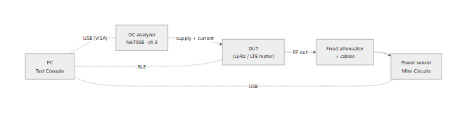
- Required: the BLE DUT. The power sensor and DC analyzer are needed for readings.
- Without instruments: the manual CW pages can transmit with the instruments unticked. Every other TX page offers Send anyway / Run anyway, which leaves the readings blank.
- Mode Sweep requires both instruments.
- Before transmitting, make sure the attenuator can take the DUT's maximum power, and that the sensor sees no more than its damage level.

B. Load Pull
This is the app's own setup diagram. Open it with View setup on the Load Pull page.
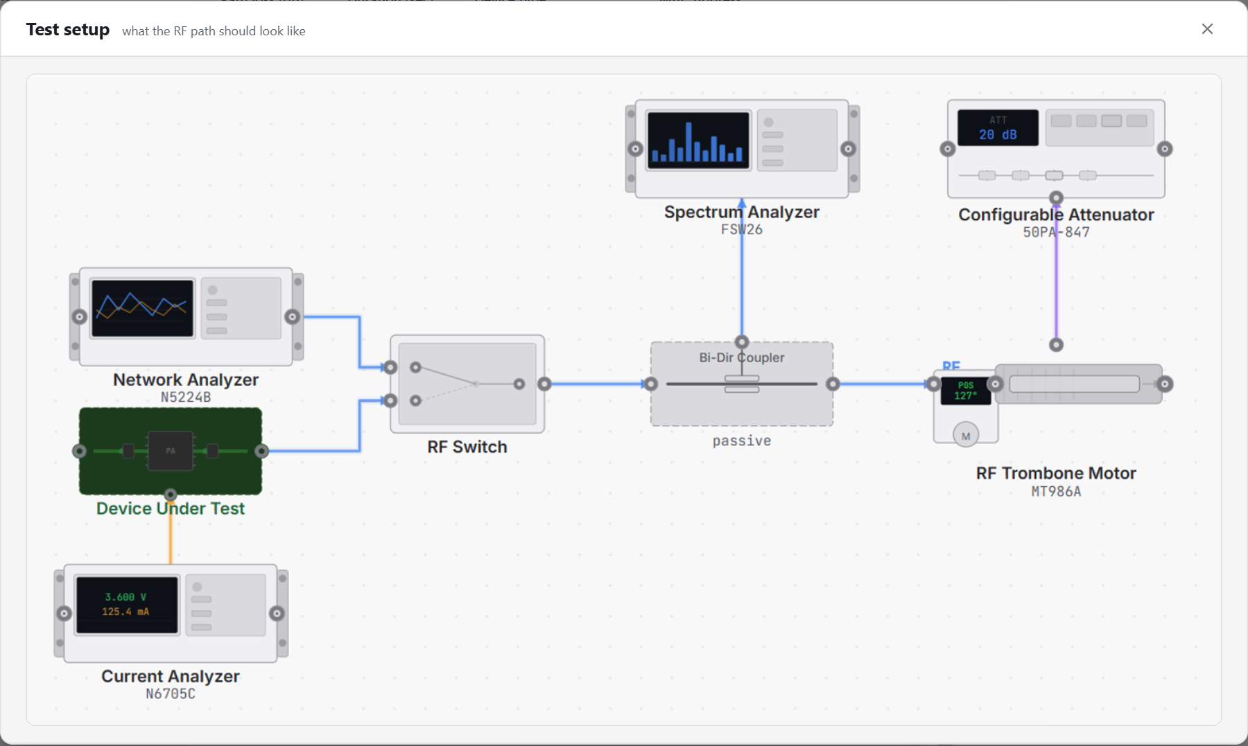
Figure 2 — Load Pull test setup, as shown in the app
What a Load Pull run actually drives and reads:
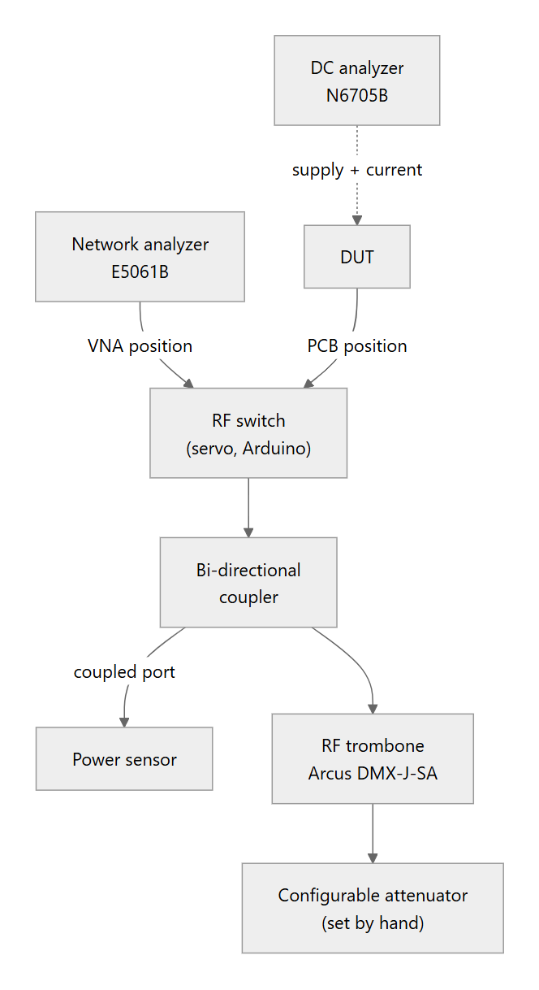
Every instrument also connects to the PC:
Instrument | Link to the PC
VNA, DC analyzer | USB (VISA)
Power sensor, trombone | USB
RF switch | USB serial
DUT | BLE

- Switch on VNA: the analyzer measures the load the trombone presents, giving R, jX and S11.
- Switch on PCB: the DUT transmits into that load while power and current are measured.
- Trombone: changing its length moves the load around the Smith chart.
- Attenuator: changing it moves the load inward or outward.
Check the bench against these differences. The drawing labels the analyzer N5224B, the supply N6705C, the trombone MT986A, and shows a spectrum analyzer (FSW26) on the coupler tap. The app itself drives an E5061B, an N6705B and an Arcus DMX-J-SA. It measures power with the Mini-Circuits power sensor; the page's own checklist reads "DUT to switch to coupler to power sensor". The spectrum analyzer is not used by any test yet.

C. Network analyzer and trombone on their own
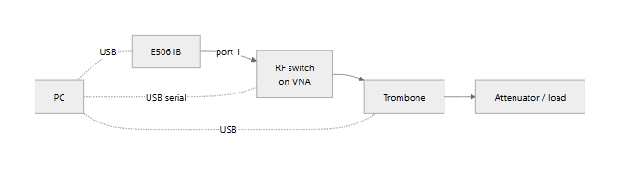
Use this with the Components pages to check the trombone's Smith-chart circle by hand before a Load Pull. Press Go VNA on the Switch page first.

D. Power meter and signal generator (bench checks)
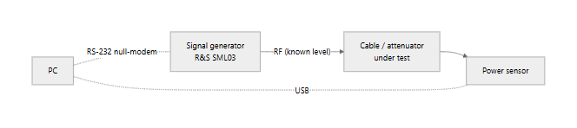
A quick way to measure the path loss of a cable or attenuator:
- Set a known level on the Signal Generator page and press RF On.
- Read it on the Power Meter page.
- The difference between the two is the path loss. Enter it in the path-loss table at that frequency.

2.5 Which test needs what
✔ required · ○ used if connected (or you can continue without it) · — not used
Test | BLE DUT | Power sensor | DC analyzer | VNA | RF switch | Trombone | Signal gen
LoRa CW (Manual) | ✔ | ○ ticked | ○ ticked | — | — | — | —
LoRa CW (Automation) | ✔ | ○ | ○ | — | — | — | —
LoRa Modulated | ✔ | ○ | ○ | — | — | — | —
LoRa Debug | ✔ | ○ | ○ | — | — | — | —
Mode Sweep | ✔ | ✔ | ✔ | — | — | — | —
Load Pull | ✔ | ✔ | ✔ | ✔ | ✔ | ✔ | —
LTE CW (Manual) | ✔ | ○ ticked | ○ ticked | — | — | — | —
LTE CW / Modulated | ✔ | ○ | ○ | — | — | — | —
Trombone page | — | — | — | — | — | ✔ | —
Switch page | — | — | — | — | ✔ | — | —
Network Analyzer page | — | — | — | ✔ | — | — | —
Power Meter page | — | ✔ | — | — | — | — | —
Signal Generator page | — | — | — | — | — | — | ✔

"○ ticked" means the instrument is used only when its Measure box is ticked on the Manual tab.

3. Using the console

3.1 Screen layout
Figure 3 — The console
Area | What it holds
Top bar | The logo and title, the page search (Ctrl+Shift+K), and the dock tabs (Log, and Assistant when it is enabled).
Sidebar (left) | Instruments, then the page tree. Its footer shows the BLE status (Connected / Disconnected, plus the device name) and the Settings gear.
Connection row | Along the top of every page: path loss, scan duration, device type, MAC address, meter info, Scan, Connect.
Page | Breadcrumb (e.g. LORA / TX), title, the page's action buttons on the right, then its sections.
Dock (right) | Log or Assistant. Drag its left edge to resize it (240–720 px); close it with the X.

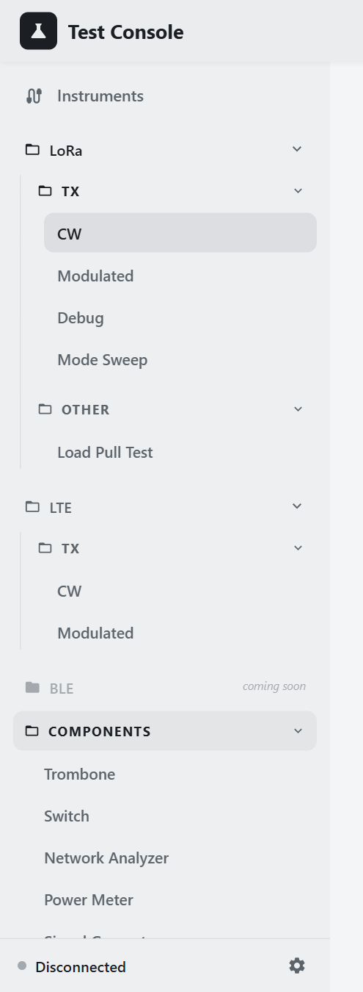
Figure 4 — Sidebar with every folder open
The page tree:
- LoRa › TX: CW, Modulated, Debug, Mode Sweep.
- LoRa › Other: Load Pull Test.
- LTE › TX: CW, Modulated.
- BLE: coming soon.
- Components: Trombone, Switch, Network Analyzer, Power Meter, Signal Generator.
"Other" and Components start collapsed, except for the folder holding the page you are on.
Pages stay loaded. Every page is loaded once at startup, and switching pages only hides and shows them. So form values, results and a running automation all survive navigation.
DUT pages are dimmed until a unit is connected. The TX pages (LoRa CW, Modulated, Debug, Mode Sweep; LTE CW, Modulated) fade to 60 % and ignore clicks until the DUT is connected and its command channel is ready. The Components pages and Load Pull are never dimmed.
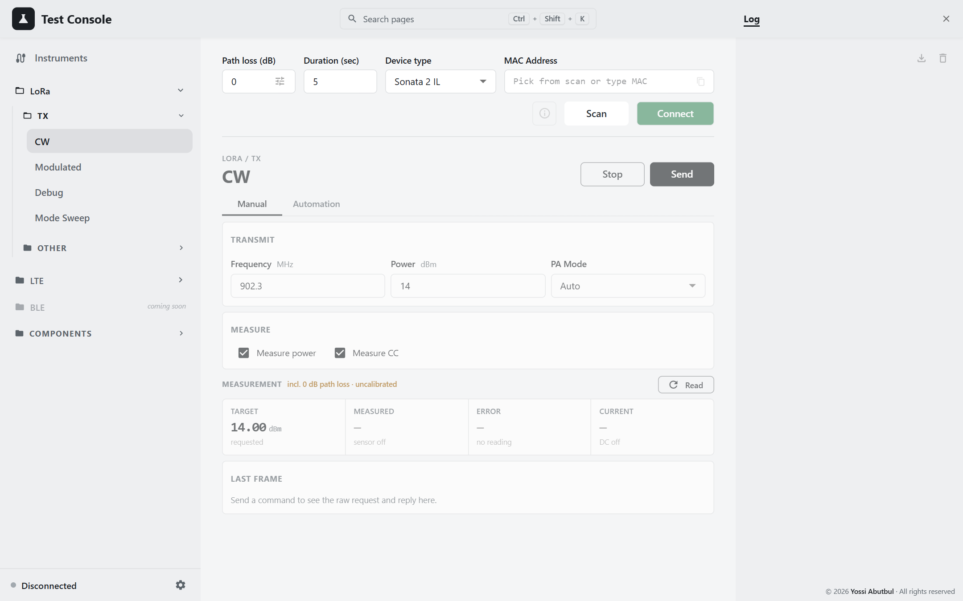
Figure 5 — A DUT page with no unit connected
On a narrow window (under 1200 px), the sidebar and dock fold away. Click the logo to show the menu; press Esc or click outside it to close it again.

3.2 Connecting the DUT
Field | Meaning
Path loss (dB) | Default path loss. The tune icon opens the per-frequency table (see section 3.4).
Duration (sec) | Scan length, 1–30 s, default 5. Not saved.
Device type | Name filter: All, CAT-M 2, Sonata 2 IL (default), Interpreter G2. Saved.
MAC Address | The device picker, with placeholder "Pick from scan or type MAC".
(i) | Meter information (connected only).
Scan / Stop | Starts a BLE scan, or ends it early.
Connect / Disconnect | Connects to the chosen device, or disconnects.

Procedure
- Choose the Device type.
- Press Scan. Devices appear as they are heard, strongest signal first, and the list opens by itself. The log shows Scan started (5s).
- Pick the unit. You can type to filter the list:
  - by MAC, with or without colons (7054 finds 70:54:…);
  - by advertised name;
  - by nickname.
- Press Connect. The sidebar footer turns green with the device name, and the TX pages become usable.
- When finished, press Disconnect. A deliberate disconnect is never auto-reconnected.
Connect is enabled only for a MAC that appeared in the current scan. After a page reload, scan again first. Typing a MAC is not enough. If the backend is still connected when you reload, the field refills by itself.
Next to the MAC field:
- Copy copies the MAC without colons.
- Edit nickname (pencil) names a unit, e.g. "Lab unit #3".
  - The nickname appears as a coloured tag, and nicknamed units sort to the top of the picker.
  - The tag's colour is derived from the MAC, so it stays the same for that unit.
  - Nicknames are stored per browser.
- Clear empties the field.

Meter information
(i) opens Meter Information. The unit is read fresh each time the dialog opens.
Row | Editable?
Connected To, Device ID, FW Version, MAC Address | no
App Mode, Primary Channel, Secondary Channel | yes

Update is enabled only when you have changed something. It sends, in order:
- the channels (if you changed them);
- the app mode (if you changed it);
- save-and-reset (only if the channels changed and the unit accepted them).
The unit reboots after either change, so the BLE link drops and the dialog closes. Reconnect and re-read to confirm the change stuck. The outcome appears as a toast, for example "Channels set to X + Y" or "The unit refused the channel change (status N)".

3.3 Instruments panel
Open it with Instruments at the top of the sidebar. The icon turns green when any instrument is connected.
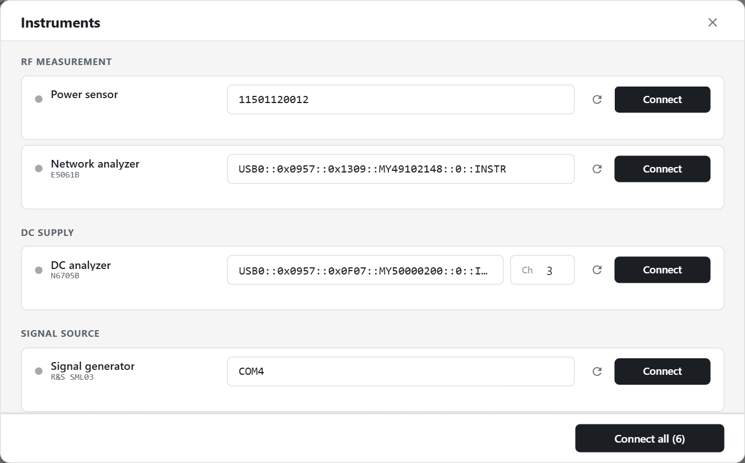
Figure 6 — Instruments panel
Section | Instrument | What to enter
RF MEASUREMENT | Power sensor | Serial number (blank = first sensor found)
RF MEASUREMENT | Network analyzer (E5061B) | VISA resource
DC SUPPLY | DC analyzer (N6705B) | VISA resource and Ch (1–4, default 3)
SIGNAL SOURCE | Signal generator (R&S SML03) | COM port. The placeholder wrongly shows a VISA example; use the Signal Generator page to choose the baud rate.
SWITCHING | RF switch (Servo (Arduino)) | The USB-serial COM port, e.g. COM4
MOTION | RF trombone motor (Arcus DMX-J-SA) | Device (e.g. jsa00)
COMING SOON | Spectrum analyzer (FSW26), Configurable attenuator (50PA-847) | Disabled

How it works
- Opening the panel runs discovery for every instrument that is not connected. Empty address fields are filled with the best match:
  - an IDN containing N6705, E5061 or FSW for the VISA instruments;
  - otherwise the first result.
Results that clearly belong to another model are hidden. Discovery gives up after 20 s, silently.
- Re-scan (↻) discovers that row again. Every entry in the dropdown shows its IDN, or no IDN response.
- Connect needs a non-empty address and waits up to 15 s. The status dot is green when connected, red on error, grey when disconnected.
- Connect all (N) / Disconnect all (N) works through the rows one at a time.
- Connecting the RF switch here also moves it to VNA. Connecting it from the Switch page does not.
If a connection fails, the row shows a title, a fix, and a details link to the raw driver text:
Title | Fix
No response | Check power and cable, then retry.
Not found at that address | Re-scan and pick it again.
Already in use | Another program or session holds it. Close it, or disconnect and retry.
Driver not installed | Install the vendor library and restart the backend.
Backend unreachable | Restart the backend.
Rejected by the instrument | Check the address and channel.

Connections live in the backend, so they survive a page reload and are shared between browser tabs. The status is polled every 5 s. Addresses are not saved; opening the panel rediscovers them.

3.4 Path loss
Path loss is the total loss between the DUT and the power sensor. The app adds it to every reading:
DUT power = sensor reading + path loss
- The Path loss (dB) field in the connection row is the default.
- The tune icon inside it opens the per-frequency table:
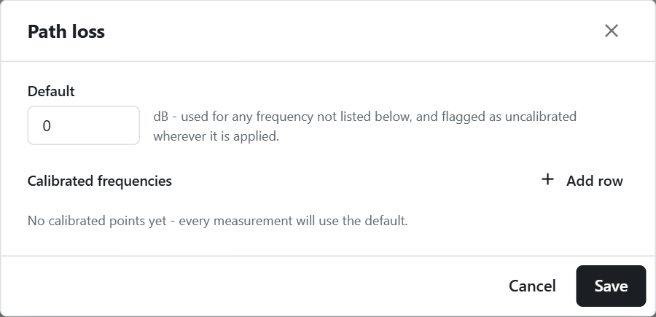
Figure 7 — Path loss table
Rules
- Exact frequencies only. A table entry applies only within ±0.001 MHz of its frequency, and there is no interpolation. Real cable loss is not linear, and guessing between points would hide a gap in the calibration.
- Everything else uses the default and is flagged uncalibrated:
  - in amber on the measurement card;
  - on the path-loss chip;
  - in a warning at the end of an automation run that lists the uncalibrated frequencies.
- Editing the table: two rows cannot share a frequency. Every filled-in row needs a positive frequency and a numeric loss; blank rows are ignored.
- Scope: the default and the table are saved per browser and apply to every page.
- Load Pull and automation runs look the loss up for each point. Mode Sweep uses one value, at its single frequency.
Calibrating a frequency. Measure the path loss with a known source (see section 2.4 D) or a network analyzer. Then add the frequency and loss to the table.

3.5 Settings
The gear in the sidebar footer opens Settings.
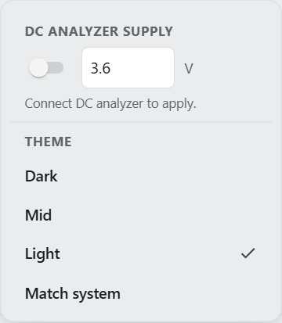
Figure 8 — Settings

DC ANALYZER SUPPLY
- The switch turns the N6705B output on or off. The voltage box takes 0–60 V (default 3.6); a change applies on Enter or when you leave the box.
- The switch works only when the DC analyzer is connected. Otherwise the panel shows "Connect DC analyzer to apply."
- It always shows off when the app loads, and nothing is sent until you flip it. Opening Settings or connecting the analyzer never powers the DUT.

THEME
- Dark, Mid (the default), Light, or Match system.
- Match system follows the operating system's setting, and only ever gives Light or Dark, never Mid.

3.6 The measurement card
This card appears on the manual TX pages (CW, Modulated, Debug, and their LTE equivalents).
Figure 9 — Measurement card on LoRa CW
Tile | Shows
Target | The requested power, in dBm
Measured | Sensor reading + path loss, in dBm, with mW underneath. Or sensor off, not read yet, read failed.
Error | Measured − Target. Green within ±1 dB, amber within ±2 dB, red beyond. After you change the power it shows vs X dBm · read again, because the error is always against the target that was in force when the reading was taken.
Current | mA, with the voltage underneath, or DC off

When readings happen
- After a Send: the card reads by itself after a successful Send, 400 ms later, provided an instrument it needs is connected.
- Read measures again. If nothing is connected, it connects the instruments first.
Header labels
- incl. +X dB path loss, with · uncalibrated in amber when the default was used.
- How long the read took, in ms.
Last frame
Below the card, the collapsible Last frame section shows the raw request and reply of the last command:
- tx: and rx: as hex;
- the reply's opcode and payload;
- ok and the status byte.
It is useful when the DUT refuses a command.

3.7 Preflight: instruments before a test
Pressing Send or Run first checks that the test's instruments are connected. If they are, the test starts straight away. If not, the Connecting instruments dialog connects each missing one in turn, with 15 s each and a countdown.
If any instrument still fails, the dialog becomes Instruments not connected and offers:
Button | Effect
Open Instruments | Cancels the test and opens the Instruments panel
Cancel | Cancels the test; the log shows "cancelled — instruments not ready"
Run anyway / Send anyway | Runs without them. Their columns stay blank.

Pressing Send or Run again while the dialog is open does nothing.

3.8 Log and notifications

Log
- Format: each line reads [HH:MM:SS] [Source] message, newest at the top. Errors are red and warnings amber.
- Sources: DUT, Power Sensor, DC Analyzer, Spectrum, Motor, Sweep, System, Automation, LoadPull, Switch, Servo, VNA, Signal Gen.
- Download saves log-<timestamp>.txt, oldest line first, in the form [HH:MM:SS] LEVEL [Source] message.
- Clear empties the log.
- Retention: the last 500 lines are kept. They survive a reload and are lost when the tab closes.
- Filters: there are none.

Toasts
- Toasts appear in the bottom-right corner.
- Success and info toasts clear themselves after 6 s, with a countdown bar.
- Warnings and errors stay until you close them.
- Some are standing notices that stay while a condition lasts, such as Before running on Load Pull.

Completion dialog
Automation runs, Mode Sweep and Load Pull announce the end of a run with a centred dialog:
Outcome | Dialog
Success | <Test> complete: "N points measured · Took hh:mm:ss"
Some points failed | <Test> finished with errors: "E of N points failed"
You stopped it | <Test> stopped: "Stopped after X of N points"
It failed | <Test> failed, with the reason

Single commands on the TX pages (Send/Stop) only write to the log.

3.9 Assistant
The Assistant is an optional chat in the dock. It reads the results on the page, or a workbook you attach, and answers questions such as "where does the power flatten out?" or "which points look wrong?". It runs on Google Gemini's free tier. Nothing is sent until you ask a question.

Turning it on
- Get a key at https://aistudio.google.com/apikey. Keep the project on the free tier; do not enable billing.
- Store the key in one of these places (the environment variable wins if both are set):
setx GEMINI_API_KEY "paste-the-key-here"
or a one-line .gemini_key file in the repo root, which is git-ignored. Never put the key in a source file or a commit.
- Set CHAT_ENABLED=1 and restart the backend. The Assistant tab appears within a minute; no reload is needed.

Using it
Part | What it does
Quota line | Shows left/limit today · left/limit this min, plus a token bar. It turns amber when running low. While limited it reads Google rate-limited, retry in N s or Local limit reached….
Page chip | Which pages' results go with the question. By default it follows the page on screen (This page (CW)). Click it to tick other pages or none.
Paper clip | Attaches .xlsx, .xlsm, .csv or .tsv. Click an attachment's chip to include or exclude it.
Input | Enter sends, Shift+Enter starts a new line
Bin | Clears the conversation

What travels with a question
- The chips show exactly what is sent with the next question.
- Tables are compacted before sending: constant columns are stated once, and each numeric column gets a min/max/mean line.
- A long run is sampled evenly.
- An attached workbook is digested once, on the backend.
The conversation survives a reload but is lost when the tab closes. Limits are shared by everyone using the console (defaults: 4 a minute, 18 a day). See section 1.7.

3.10 Search and keyboard shortcuts
Keys | Where | Action
Ctrl+Shift+K | anywhere | Open page search; press again to close it
↑ / ↓, Enter, Esc | search | Move through results, open one, close
Esc | a dialog or the floating menu | Close it (the preflight dialog cannot be closed while it is connecting)
Enter | Nickname dialog, DC voltage box | Save / apply
← / → held | Load Pull jog pad (once focused) | Jog the trombone while held

Search matches the protocol, group and page name, so "lte tx" and "sweep" both work.

3.11 DUT-only builds
When the instrument packages are missing (the desktop build, or INSTRUMENTS_ENABLED=0), the app knows from /capabilities:
- Instruments and the rig pages are greyed out, with the reason as a tooltip. The rig pages are Mode Sweep, Load Pull, Trombone, Switch, Network Analyzer, Power Meter and Signal Generator.
- Search leaves those pages out.
- Opening one shows "<Page> needs an instrument".
- The DUT pages keep working. When they would measure, preflight offers Send anyway / Run anyway.

4. LoRa tests

4.1 Before any LoRa TX test
- Cable the rig as in setup A.
- Power the DUT. Connect the DC analyzer and switch on its supply in Settings (3.6 V by default).
- Connect the DUT over BLE (section 3.2).
- Enter the path loss for the frequencies you will use (section 3.4).
- Optionally connect the instruments in advance. Otherwise the preflight connects them when you press Send or Run.

Rules that apply to every LoRa TX page
- Power is a whole number of dBm, 0–255. The backend refuses negative or fractional values (HTTP 422).
- Frequency is entered in MHz and sent as whole Hz. The app does not check it against any band.
- PA Mode is one of Off (0), On (1) or Auto (2).
- Settle is how long the PA stays keyed before the reading. The minimum and default are 400 ms. Below that, the sensor's averaged reading still holds energy from the previous point, so a low-power point reads high while its current reads correctly. That looks like a measurement fault, but it is a timing one.
- A manual Send keeps the DUT transmitting until you press Stop.
- Automation stops the DUT after every point, even when the point failed. The backend then enforces a 1.5 s recovery pause, so allow about 2 s per point on top of Settle. The on-screen estimate (≈) does not include this pause.

Automation panels (CW and Modulated)
The CW and Modulated pages share the same automation panel.
- Range syntax for Freq and Power:
Entry | Means
915 | one value
900-930 | 900 to 930 in steps of 1
900-930:5 | 900 to 930 in steps of 5
902.3,915,927.5 | a list (spaces work too)

- Tolerance: the pass band in ± dB around the set power. Leave it blank for no verdict (N/A). A negative tolerance blocks Run.
- Verdict: PASS when set − tol ≤ measured ≤ set + tol. The measured figure includes path loss.
- Plan order: each row expands to every frequency × every power, in row order.
- Invalid rows: a row with an invalid or blank Freq simply adds no points. Check each row's N steps count.
- Time limit: each point is limited to Settle + 30 s. A point that times out is recorded with its error, and the run carries on.
- Stop: ends the run at once, sends StopTest, and discards the point that was interrupted.
- Results: kept across navigation and reload. Import replaces the table with a previously exported CSV; it does not merge. Graph plots the results. Export writes a CSV.
- CSV file name: <MAC without colons>-<UTC timestamp>.csv, or tx-cw-automation-<ts>.csv / lora-modulated-automation-<ts>.csv when no MAC is known.
The name does not say which page produced the file. Rename your exports.

4.2 CW
LoRa › TX › CW. This page keys an unmodulated LoRa carrier at the frequency, power and PA mode you set, then reads the RF power and the DUT's current.

Manual tab
Figure 10 — LoRa CW, Manual
Field | Unit | Default | Notes
Frequency | MHz | 902.3 | step 0.1
Power | dBm | 14 | whole number, 0–255
PA Mode | — | Auto | Auto / On / Off
Measure power | ☑ | on | read the power sensor after sending
Measure CC | ☑ | on | read the DC analyzer after sending

The Measure boxes are saved, because they describe how the bench is set up. With both unticked, Send only transmits: no instrument is connected or read, and the measurement card is hidden.
Procedure
- Set Frequency, Power and PA Mode, and tick what to measure.
- Press Send. The page then:
  - runs the preflight, if anything is ticked;
  - sends LoRa Power (17 50);
  - reads the card 400 ms later.
- Read the card: Target, Measured, Error (±1 dB) and Current. Press Read to measure again.
- Press Stop to send StopTest. Until you do, the DUT keeps transmitting.
Instruments are connected before transmitting on purpose. A VISA connect takes long enough that the DUT would otherwise transmit with nobody reading.

Automation tab
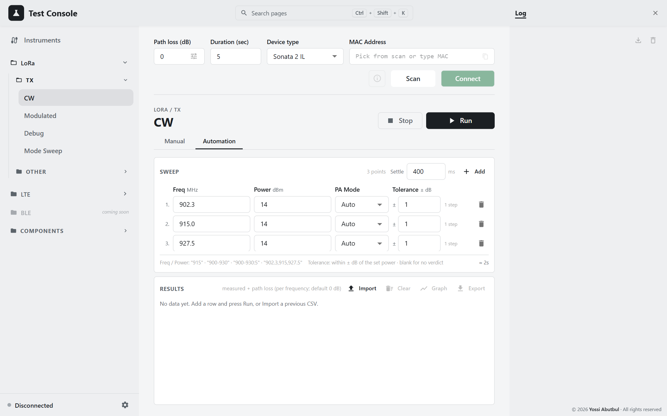
Figure 11 — LoRa CW, Automation
Column | Default | Notes
Freq (MHz) | rows 902.3, 915.0, 927.5 | range syntax
Power (dBm) | 14 | range syntax; blank means 14
PA Mode | Auto | Off / On / Auto
Tolerance (± dB) | 1 | blank means N/A
Settle (panel header) | 400 ms | minimum 400; saved

Procedure
- Edit the rows. Add copies the last row with an empty Freq.
- Check the point count and the ≈ run time. A Settle of 10,000 ms or more is flagged ⚠ as a likely typo.
- Press Run. The preflight connects the power sensor and DC analyzer, then the results table clears.
- For each point the page:
  - sends LoRa Power;
  - waits Settle;
  - reads power and current;
  - adds the path loss for that frequency;
  - judges the point;
  - sends StopTest.
- At the end, a completion dialog appears and the log reports P/T points within limits, with a warning for any uncalibrated frequencies.
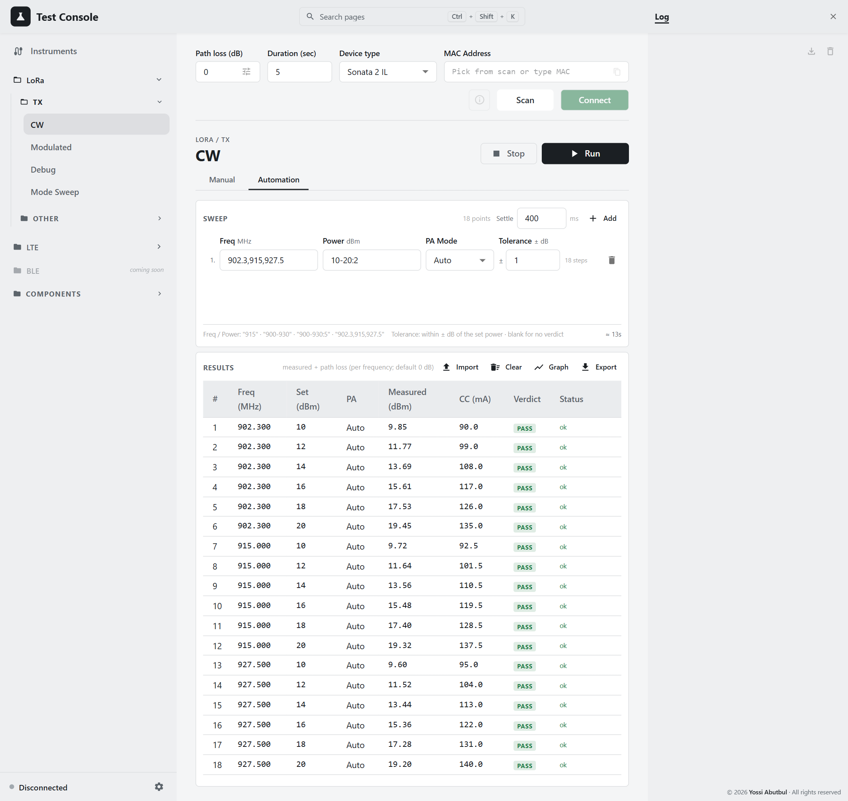
Figure 12 — Automation results, example data
Result column | Meaning
# | point number
Freq (MHz) | frequency
Set (dBm) | requested power
PA | PA mode
Measured (dBm) | sensor reading + path loss
CC (mA) | supply current
Verdict | PASS / FAIL / grey N/A
Status | ok or the error text

Results graph
Graph opens a chart. The X axis is whichever of frequency or set power has more distinct values, with one line per value of the other.
- Tabs: Measured vs Set/Freq and Current vs Set/Freq.
- Legend: click an entry to hide that line.
- ⚙ options: Y min/max, line width, dot size, grid, legend, point labels, connect gaps. These options are not saved.
- Download: saves a PNG at twice the on-screen size.
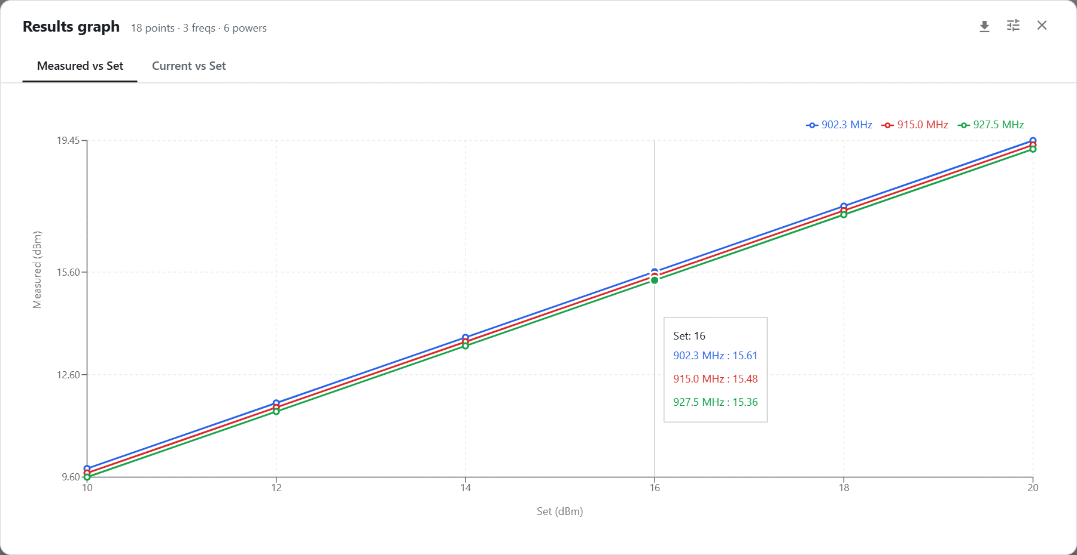
Figure 13 — Results graph, example data

CSV export columns
freq_mhz, set_power_dbm, pa_mode, measured_dbm, current_ma, path_loss_db, margin_db, min_dbm, max_dbm, verdict, ok, status, error
- Timestamps are UTC.
- Import needs at least freq_mhz, set_power_dbm and measured_dbm.
- A verdict already in the file is kept as recorded; it is only recalculated when blank.

4.3 Modulated
LoRa › TX › Modulated. This page transmits LoRa (bandwidth and spreading factor) or FSK (bit rate) modulation, and measures power and current. The power sensor and DC analyzer are always used on this page; there are no Measure boxes.

Manual tab
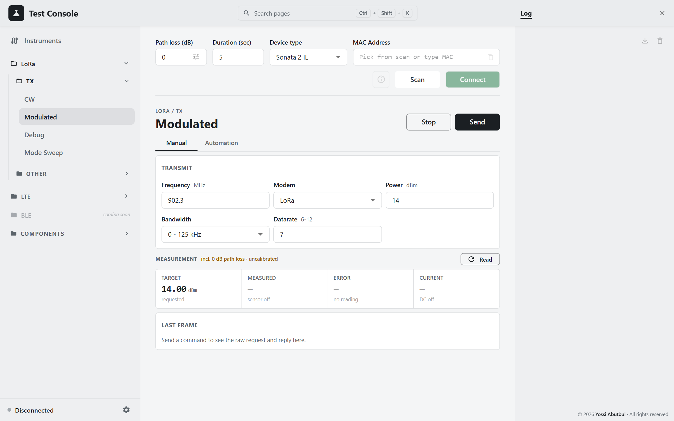
Figure 14 — LoRa Modulated, Manual
Field | Default | Options / range
Frequency (MHz) | 902.3
Modem | LoRa | LoRa (1) / FSK (0)
Power (dBm) | 14 | 0–255, whole numbers
Bandwidth | 0 - 125 kHz | 125 / 250 / 500 kHz (3 - Reserved is disabled). Disabled and sent as 0 for FSK.
Datarate | 7 | SF 6–12 for LoRa

Procedure: set the fields, press Send (preflight, LoRa Modulated 19 50, then an automatic read), check the card, and press Stop.
Use the Automation tab for FSK. The manual Datarate spinner is limited to 6–12, which is fine for a spreading factor but useless as an FSK bit rate.

Automation tab
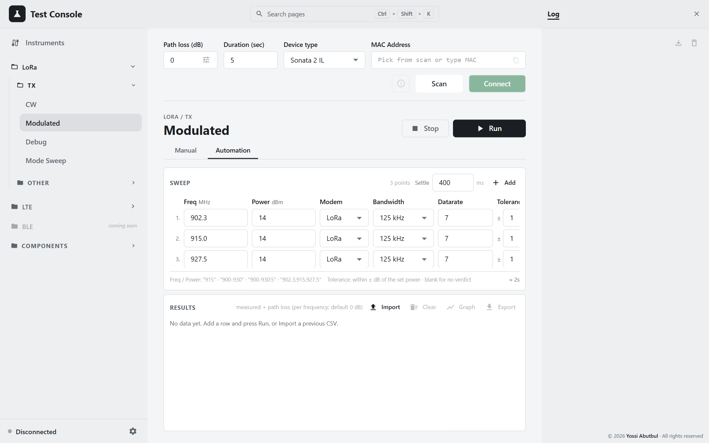
Figure 15 — LoRa Modulated, Automation
Column | Default | Range
Freq, Power | as CW | range syntax
Modem | LoRa | LoRa / FSK. Switching modem resets an invalid datarate to 7 (LoRa) or 50000 (FSK).
Bandwidth | 125 kHz | 125 / 250 / 500 kHz. Ignored for FSK, which always sends 0.
Datarate | 7 | LoRa: SF 6–12. FSK: 1–300,000 bit/s. An invalid value blocks Run.
Tolerance | 1 | ± dB; blank means N/A

Results columns: #, Freq, Set, Modem, BW (— for FSK), DR, Measured, CC, Verdict, Status.
CSV columns: freq_mhz, set_power_dbm, modem, bandwidth_khz, datarate, measured_dbm, current_ma, path_loss_db, margin_db, min_dbm, max_dbm, verdict, ok, status, error
The graph plots only frequency and set power. Rows that differ only in modem, bandwidth or datarate overwrite one another on it. Use the table for those comparisons.

4.4 Debug
LoRa › TX › Debug. A low-level CW transmit (CW Debug, 28 50) that also sets the radio's PA duty cycle and HP max registers directly. It has no automation and no export. The power sensor and DC analyzer are used.
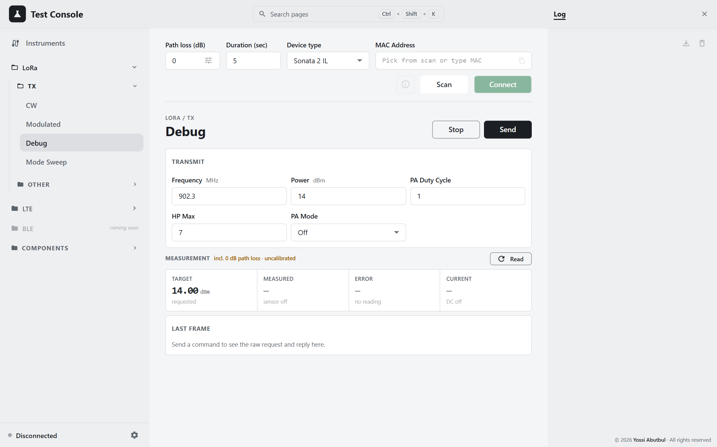
Figure 16 — LoRa Debug
Field | Default | Range
Frequency (MHz) | 902.3
Power (dBm) | 14 | 0–255
PA Duty Cycle | 1 | 1–7
HP Max | 7 | 1–7
PA Mode | Off | Auto / On / Off

Send stays disabled until PA Duty Cycle and HP Max are both within 1–7. 0 hangs the DUT rather than being refused, and this check on the page is the only protection against it. Nothing on this page is saved.
PA Mode defaults to Off here, but to Auto on the CW page. Check it before comparing results from the two pages.

4.5 Mode Sweep
LoRa › TX › Mode Sweep. This test measures the PA across every combination of Power × PA Duty Cycle × HP Max at one frequency. Its purpose is to find, for each output power the DUT actually reaches, the combination that draws the least current.
The loop runs on the backend, so it survives a page reload, and only one sweep can run at a time.
Requires: a connected DUT, the power sensor, and the DC analyzer.
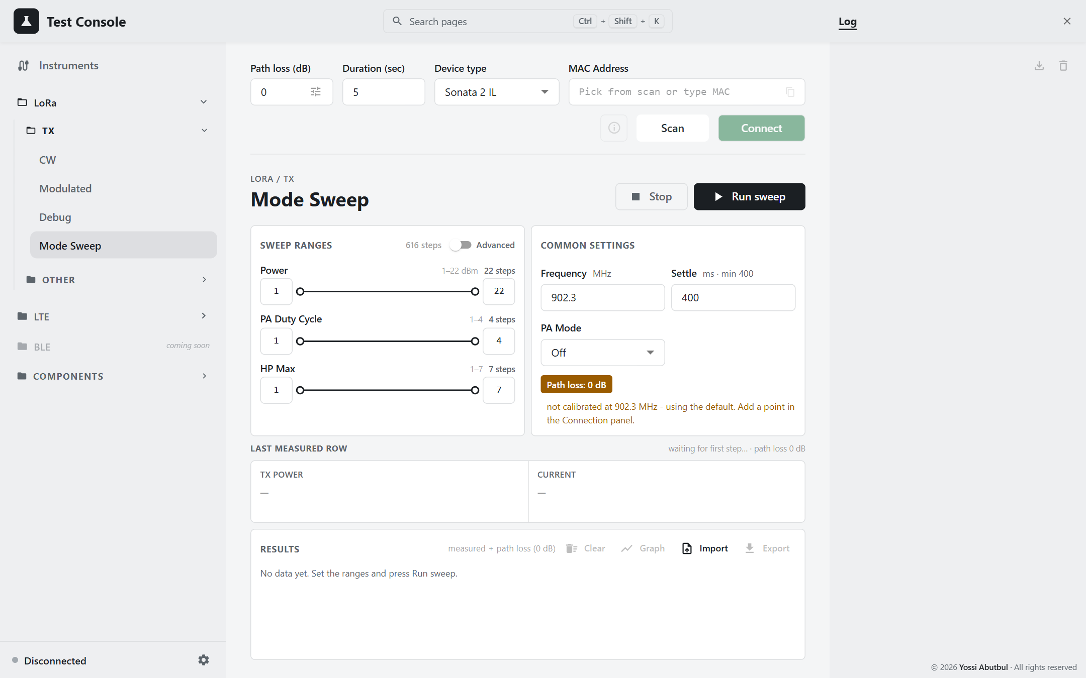
Figure 17 — Mode Sweep

Sweep ranges
Axis | Range | Default
Power | 1–22 dBm | 1–22 (22 steps)
PA Duty Cycle | 1–4 | 1–4 (4 steps)
HP Max | 1–7 | 1–7 (7 steps)

- Steps: every integer in each span is swept. The default plan is 22 × 4 × 7 = 616 steps. The live step count is shown in the panel header.
- Order: HP Max is the outer loop, then PA DC, then Power (the inner loop).
- No zero: 0 is never allowed on any axis, because it hangs the DUT.
- Advanced: sweeps several ranges one after another.
  - Each range appears as a card. Click a card to edit it; Add range adds another.
  - Overlapping ranges are measured twice.
  - Turning Advanced off discards the list.

Common settings
Field | Default | Limits
Frequency (MHz) | 902.3
Settle (ms) | 400 | 400–10,000; raised to 400 when you leave the field
PA Mode | Off | Off / On / Auto

The path loss at this frequency is sent with the sweep and applied by the backend. None of these settings are saved.

Running
- Set the ranges and common settings, and check the step count.
- Press Run sweep. The button then reads Running N/total, and a progress bar runs along the top.
- At each step the backend:
  - sends CW Debug with that combination;
  - waits Settle;
  - reads power (up to 5 retries while it is ≤ −100 dBm);
  - reads current, and voltage if available.
It does not send StopTest between points. The DUT accepts a new CW command while transmitting, and a stop would add 1.5 s to every point (about 16 minutes over 616 points).
- Last measured row shows the latest point. The table fills in as the run goes.
- Stop ends the run after the current point. The DUT is always sent StopTest at the end, however the run ends.
A failed step is recorded with its reason in Status, and the run carries on. For example, DUT rejected the command (status=N).
No pass/fail on this page. Most points land short of their commanded power, and that gap is the thing being measured.

Results
Column | Meaning
# | step number (the same in the workbook)
Power Set (dBm), PA DC, HP Max | the combination
Measured (dBm) | reading + path loss
CC (mA), V (V) | current and voltage
Status | ok or the error

Graph opens Best settings:
- Filtering: rows with no reading, or below −50 dBm, are dropped.
- Grouping: the remaining rows are grouped by measured power, rounded to the nearest dBm.
- Ranking: within each level, rows are ranked by current, lowest first. A missing current counts as the worst, not the best.
- Winner: the lowest-current row in each level, marked with a trophy.
- The chart plots lowest current per power reached. Click it to jump to a level.
Export saves pa_modes_YYYYMMDD_HHMMSS.xlsx, which has these sheets:
- All: every row. It adds Raw [dBm] (the uncorrected reading), and writes PA DC and HP Max in hex, e.g. 0x02.
- Run: the settings the sweep ran with.
- "N dBm": one sheet per rounded power level, sorted by closeness to N.
Import opens a workbook exported by this app, for viewing only. While an imported file is shown, Clear and Export are disabled.
Where results are kept. They are held in backend memory until Clear, the next run, or a backend restart. Export before restarting the backend.

4.6 Load Pull Test
LoRa › Other › Load Pull Test. This test measures how the PA performs as the load impedance it drives changes. At each trombone position it records:
- the load (R + jX, S11), read by the VNA;
- output power;
- supply current;
- efficiency, calculated from the power and current.
The results are plotted on a Smith chart.
Requires: the DUT, the power sensor, the DC analyzer, the VNA, the RF switch and the trombone, cabled as in setup B.
⚠ This page moves the trombone and flips the RF switch. The round red Emergency stop in the header is always enabled, even when no run is in progress, for example during a jog. It halts the motor first, then aborts the run and turns off the DUT's transmitter.
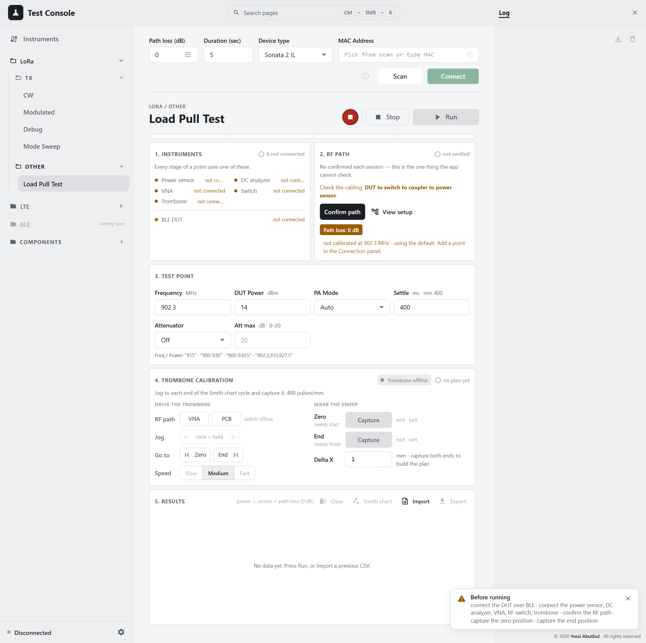
Figure 18 — Load Pull Test
Header tiles: Live position (mm and pulses), Zero, End, and Plan (the number of points).
Before running: the Run button stays disabled until every precondition is met. A Before running notice lists whatever is still missing.

Step 1 · Instruments
This step shows whether each instrument is ready: Power sensor, DC analyzer, VNA, Switch, Trombone, and BLE DUT. Connect the instruments from the Instruments panel, and the DUT from the connection row.

Step 2 · RF path
- Press View setup and compare the bench with the diagram.
- Press Confirm path.
The confirmation is never saved. Cabling is the one thing the app cannot check, so you confirm it again each session.
The path-loss chip turns amber if any planned frequency is uncalibrated.

Step 3 · Test point
Field | Default | Notes
Frequency (MHz) | 902.3 | range syntax, e.g. 900-930:5
DUT Power (dBm) | 14 | range syntax
PA Mode | Auto
Settle (ms) | 400 | minimum 400
Attenuator | Off | Sweep pauses at each setting and asks you to dial it in
Att max (dB) | 20 | 0–20, in 1 dB steps from 0

The page shows the plan size as positions × freqs × powers [× att]. The numbers multiply quickly, so check the total.

Step 4 · Trombone calibration
At 400 pulses/mm, one full circle on the Smith chart is a fixed length of travel. You find that length by jogging and watching the VNA.
- Press VNA (RF path) to put the analyzer on the trombone path.
- Choose a Speed: Slow 400, Medium 800 (default), or Fast 1500 pulses/s.
- Jog: press and hold ← or → while watching the Smith chart on the VNA.
  - You can also click the jog pad and hold the arrow keys.
  - The motor stops as soon as you release, move the pointer off the button, or the pad loses focus.
- At the start of the cycle, press Capture on Zero. Jog to the end of one full cycle and press Capture on End.
  - The soft limits now apply: no move or jog can leave the Zero–End range.
  - Before both ends are captured, there are no limits at all.
- Set Delta X (mm between points; default 1). The page shows N points over L mm.
- Go to › Zero / End moves to a captured end at full speed (5000 pulses/s, about 12.5 mm/s). Use it to check both ends.
To go beyond the range, clear Zero or End first (bin icon). This also lifts the limits.

Step 5 · Run
Press Run. The results table clears. Export first if you need the old data.
For each trombone position:
- The trombone moves to the position and settles.
- The switch goes to VNA. After Settle, the VNA markers are read for every planned frequency, giving R, X and |S11|.
- The switch goes to PCB. After Settle, for each frequency × power:
  - the DUT keys a CW carrier;
  - after Settle, power and current are read (power corrected by that frequency's path loss);
  - the DUT is stopped.
The slow mechanical moves happen once per position. Frequency and power change electronically, which costs almost nothing.
With Attenuator: Sweep, each cycle starts with the dialog Set the attenuator:
- It shows the value to dial in, e.g. "N dB".
- The switch is parked on VNA so you can watch the change take effect.
- The dialog cannot be dismissed by accident, and it waits as long as you need.
- Attenuator is set continues the run; the trombone returns to the start first. Stop run aborts it.
Time limits and failures
- Each point is limited to 3 × Settle + 90 s, and each motor move to 60 s.
- A point that fails is recorded with its error, and the run moves on.
- Stop discards the point in progress, so there are no half-measured rows.
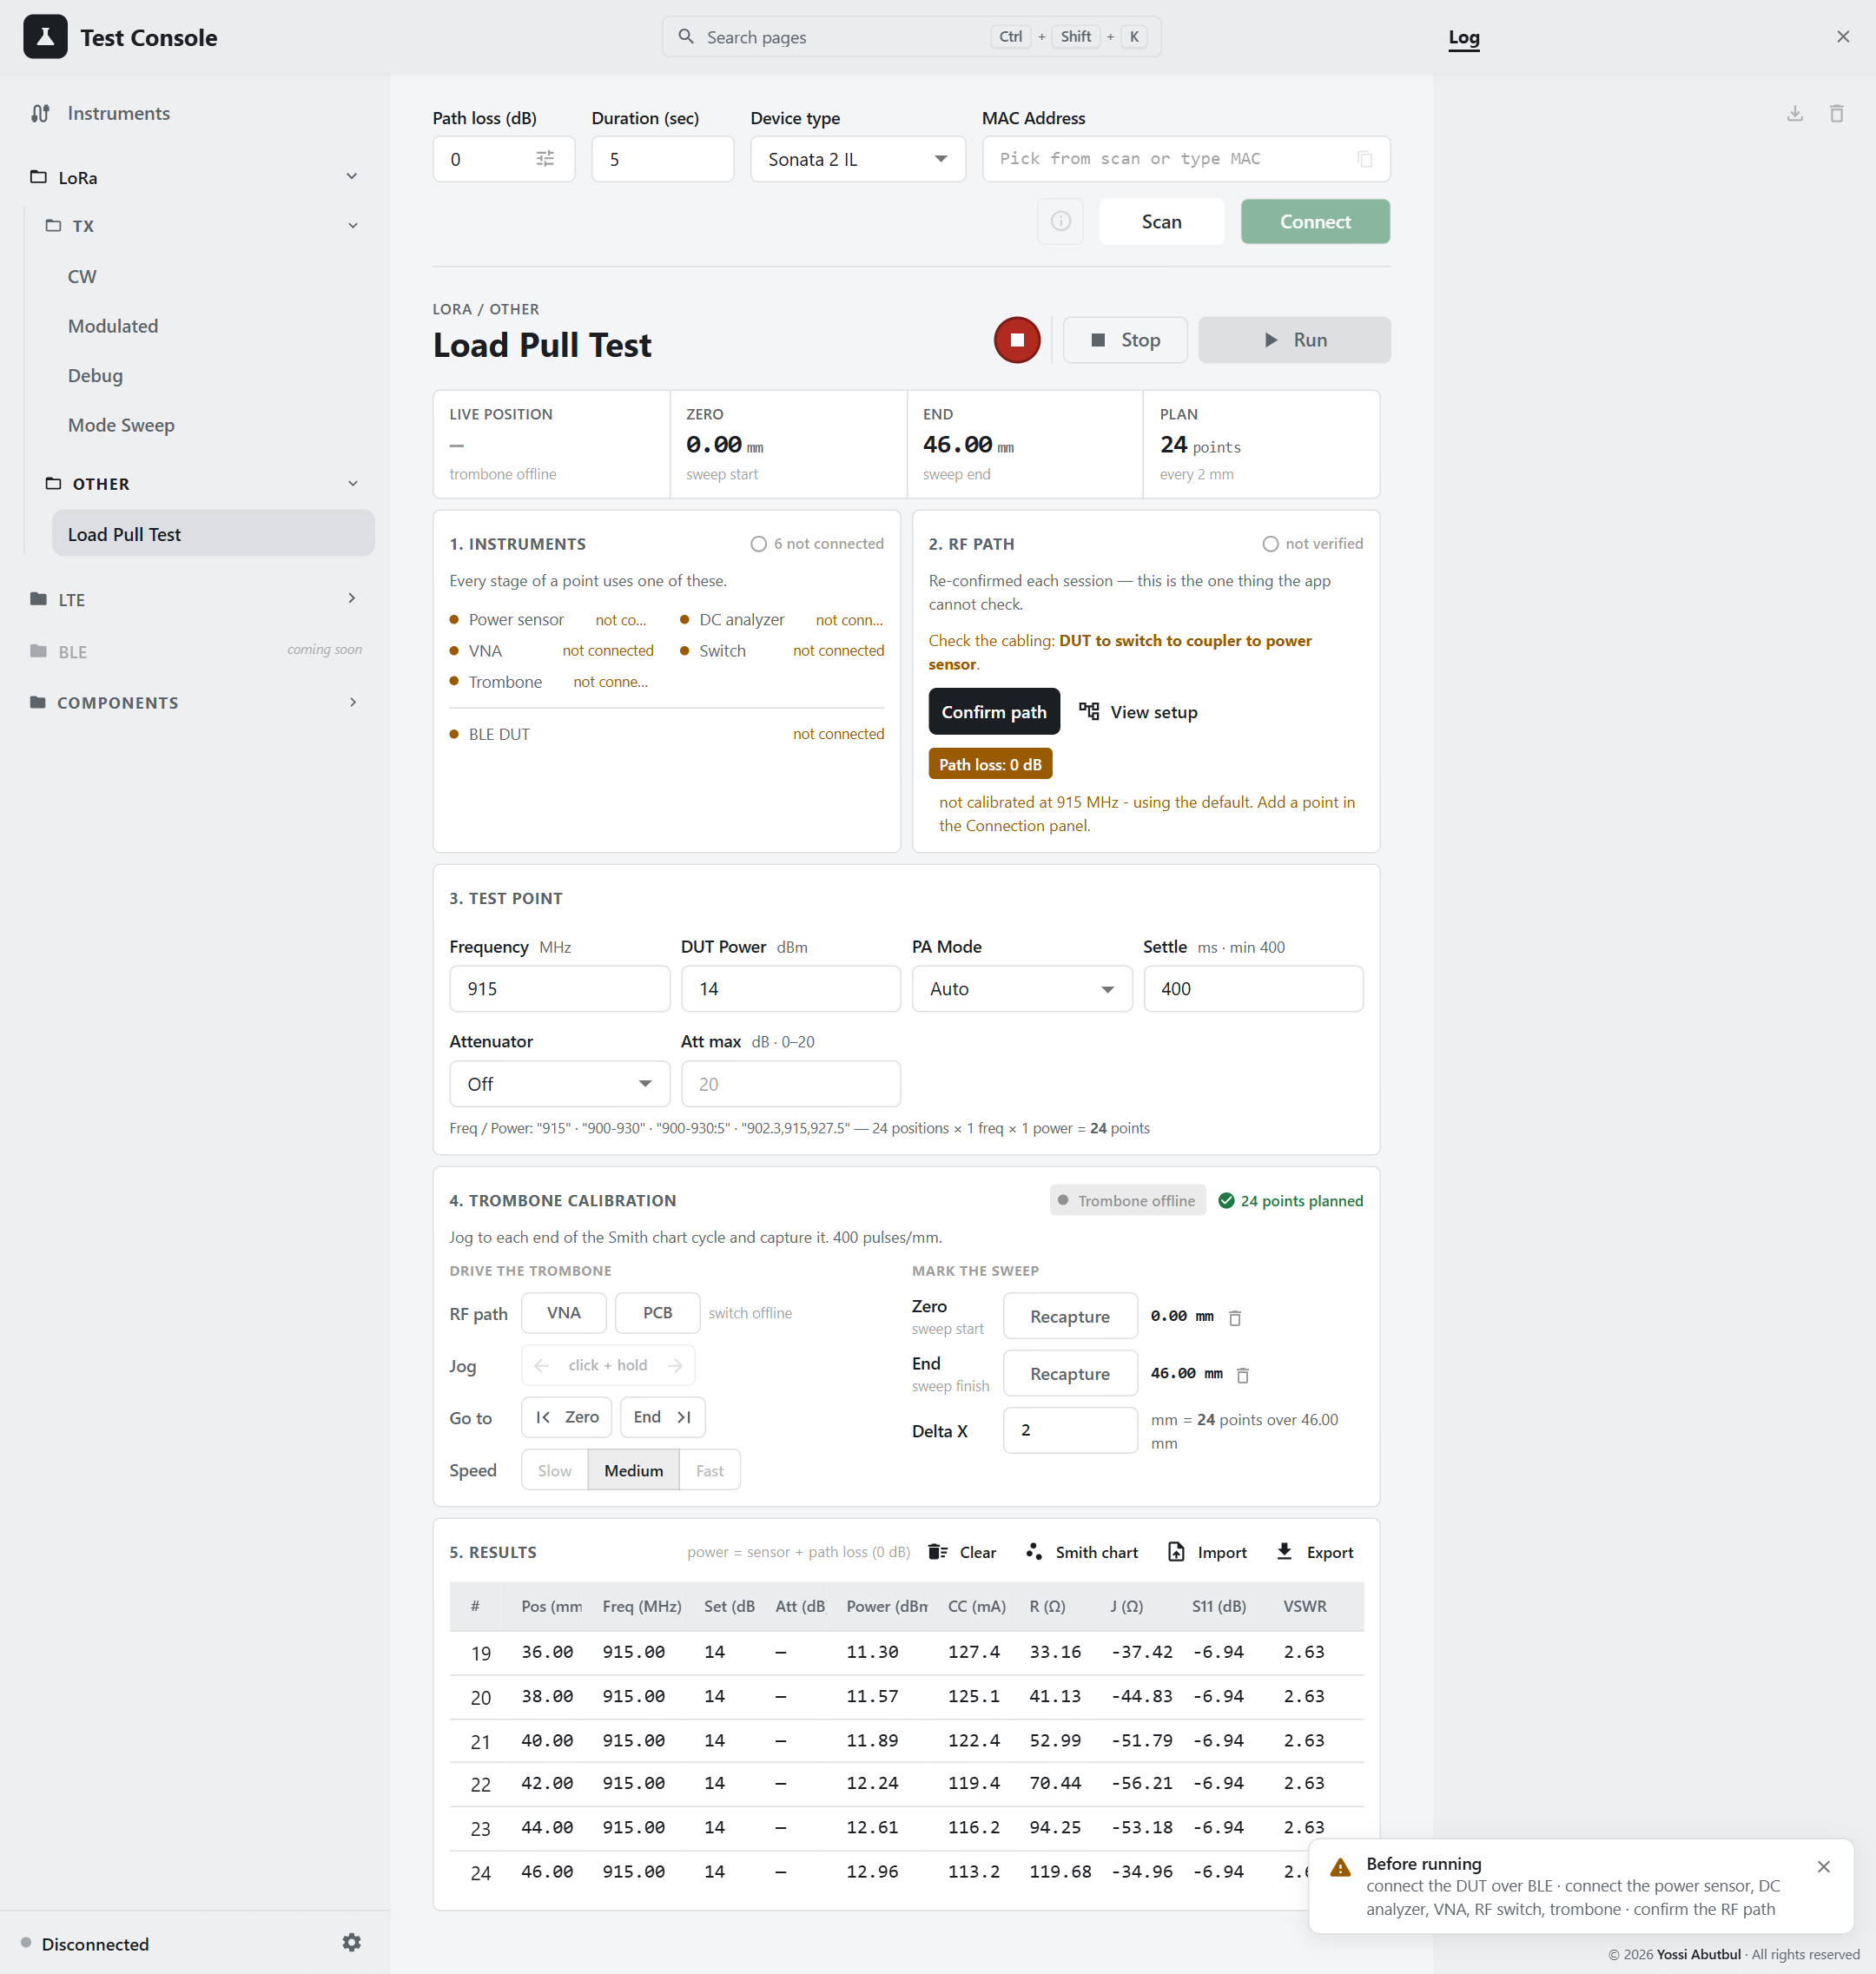
Figure 19 — Load Pull results, example data
Result columns: #, Pos (mm), Freq, Set, Att, Power (dBm), CC (mA), R (Ω), J (Ω), S11 (dB), VSWR, Status.
Power confidence: the Power cell is coloured by where the raw sensor reading sat in the sensor's range:
Raw reading | Rating
between −20 and +10 dBm | normal
+10 to +16 dBm, or −20 to −25 dBm | amber (marginal)
≥ +16 dBm, or ≤ −25 dBm | red (poor)

The raw reading is used because the path-loss correction shifts the number by tens of dB without changing where the sensor actually was in its range.

Smith chart
Smith chart plots the points with Z₀ = 50 Ω, coloured by efficiency (blue = low, red = high):
eff = P_out[W] / (3.6 V × I_cc[A])
- Fixed voltage: the 3.6 V is a constant, not the measured voltage.
- Pickers: when there are several frequencies or powers, Freq and Power pickers choose which one to show. Attenuator settings are always shown together, one line each.
- Details: hover a point for its full measurement.
- Copy chart: puts a PNG on the clipboard.
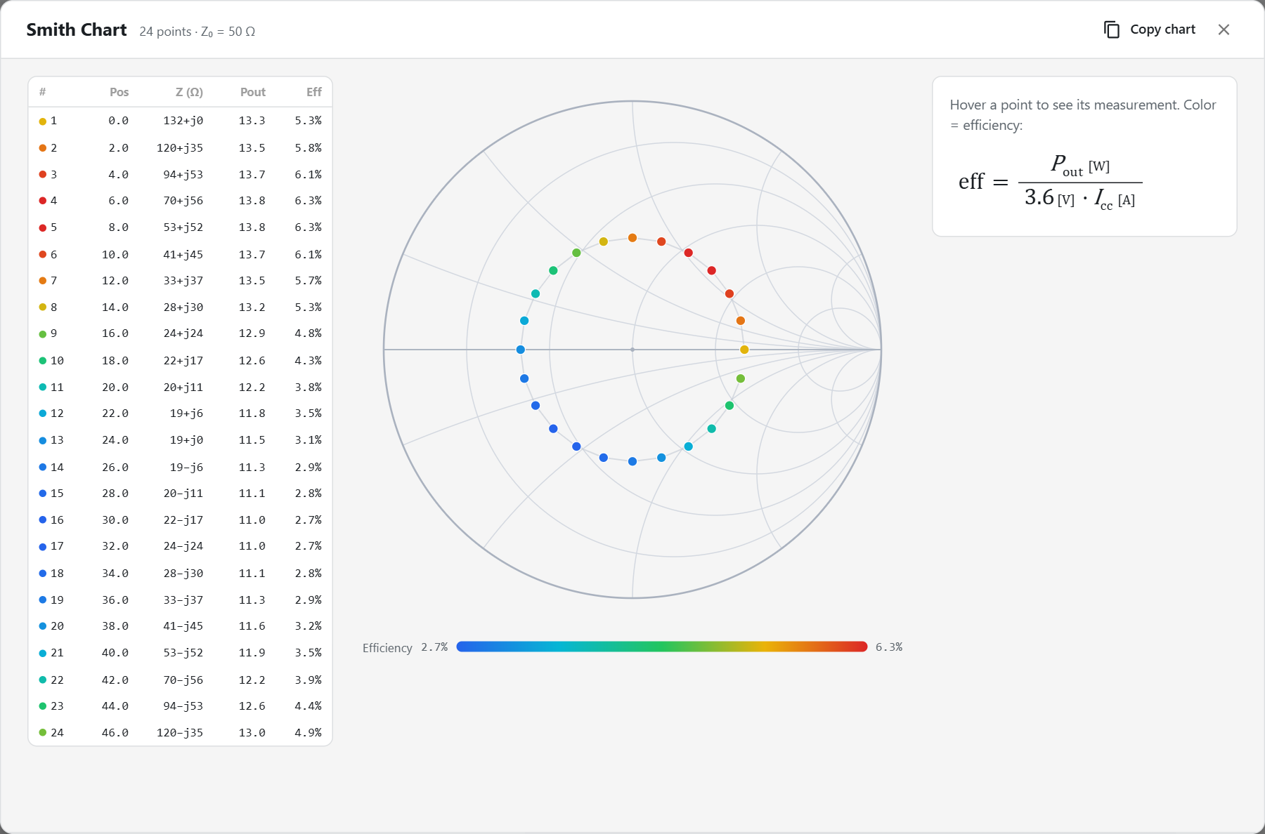
Figure 20 — Smith chart, example data

Export and import
Export saves load_pull_YYYYMMDD_HHMMSS.xlsx (there is no CSV export), with these sheets:
- All: every point. It adds Pos [pulses] and Raw [dBm].
- Run: the settings, Zero/End, Delta X, the path loss at each frequency (marked (uncalibrated) where the default was used), and the DUT's MAC.
- One sheet per frequency: a table for each power, sorted by attenuation.
Import accepts either:
- an exported .xlsx (only its All sheet is read); or
- an older .csv, with optional # key=value header lines and at least the columns pos_mm, pos_pulses, power_dbm, cc_ma, r_ohm, x_ohm, s11_db.
Settings stored in the file are reported, never applied, so an import cannot change what the next Run does.
Safety recap
• Capture both ends before any automated movement.
• Recapture both ends after the motor or the backend restarts.
• Soft limits are held in backend memory only.

5. LTE tests
The LTE pages drive the DUT's Cat-M modem. They use the same cabling as the LoRa TX tests (setup A), the same path loss, and the same preflight.

5.1 Concepts: modem key, EARFCN, bands

The Modem key
The LTE modem is off at rest and takes about 10 s to boot. You control it with the latching Modem off / Modem on key in the page header. The key shows a green lamp when the modem is on.
- Send turns the modem on for you if the page believes it is off. A Turning on modem dialog shows while it boots.
- Only the key turns the modem off. Stop does not, a failed Send does not, and the end of a run does not. The modem is kept up on purpose, so you don't wait 10 s before every Send. The cost is that the DUT stays powered. Turn the key off when you finish.
- The page cannot ask the modem its state. It only remembers what it last did, and it assumes the modem is off after every page reload.
  - If the modem is actually on, the next power-on is refused: "modem on rejected … power it off and on again".
  - To recover, turn the key off, then on.
- The modem runs one test at a time. A START sent while another test is running is silently dropped: the reply looks fine, but the radio keeps its old settings. The page always aborts the test it knows about before sending a new START.

EARFCN or MHz
The EARFCN | MHz switch chooses how you enter the channel.
- EARFCN → frequency always has exactly one answer, using the uplink formula F = F_low + 0.1 × (N − N_offset).
- MHz → EARFCN can be ambiguous, because uplink bands overlap. For example, 1880 MHz is EARFCN 18900 in B2, 26340 in B25 and 38250 in B39. So a MHz value is resolved only within the bands ticked in Bands in use:
  - it matches no ticked band → Not in the selected bands;
  - it matches more than one → In more than one selected band.
The value is snapped to the nearest 100 kHz channel centre.
The unit and band choices are shared by both LTE pages. A change made on one page appears on the other after a page reload.

Bands in use
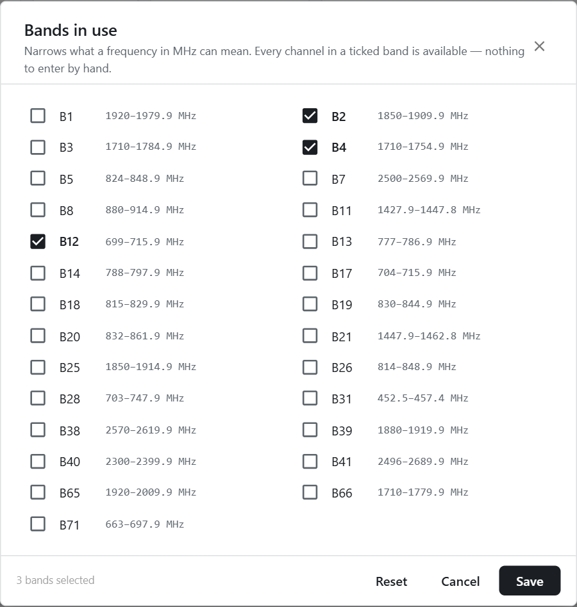
Figure 21 — Bands in use
- Selecting bands: tick the bands this rig works in. The default is B2, B4 and B12. Reset restores that default; Save stores your choice.
- Overlap warning: ticking overlapping bands (for example 2/25/39, 3/4/66, 1/65, 5/26/18/19/20, or 12/17/28) shows the warning Overlapping bands selected. A MHz value in the shared span is then refused until you untick one of the bands.
- Scope: bands only matter in MHz mode.
Supported bands (uplink):
Band | Uplink MHz | EARFCN |  | Band | Uplink MHz | EARFCN
B1 | 1920–1979.9 | 18000–18599 |  | B20 | 832–861.9 | 24150–24449
B2 | 1850–1909.9 | 18600–19199 |  | B21 | 1447.9–1462.8 | 24450–24599
B3 | 1710–1784.9 | 19200–19949 |  | B25 | 1850–1914.9 | 26040–26689
B4 | 1710–1754.9 | 19950–20399 |  | B26 | 814–848.9 | 26690–27039
B5 | 824–848.9 | 20400–20649 |  | B28 | 703–747.9 | 27210–27659
B7 | 2500–2569.9 | 20750–21449 |  | B31 | 452.5–457.4 | 27760–27809
B8 | 880–914.9 | 21450–21799 |  | B38 (TDD) | 2570–2619.9 | 37750–38249
B11 | 1427.9–1447.8 | 22750–22949 |  | B39 (TDD) | 1880–1919.9 | 38250–38649
B12 | 699–715.9 | 23010–23179 |  | B40 (TDD) | 2300–2399.9 | 38650–39649
B13 | 777–786.9 | 23180–23279 |  | B41 (TDD) | 2496–2689.9 | 39650–41589
B14 | 788–797.9 | 23280–23379 |  | B65 | 1920–2009.9 | 131072–131971
B17 | 704–715.9 | 23730–23849 |  | B66 | 1710–1779.9 | 131972–132671
B18 | 815–829.9 | 23850–23999 |  | B71 | 663–697.9 | 133122–133471
B19 | 830–844.9 | 24000–24149

An EARFCN outside every band in this table is refused; the app does not guess a frequency for it.

5.2 LTE CW
LTE › TX › CW. This page transmits an unmodulated tone on an uplink channel and, optionally, reads power and current.
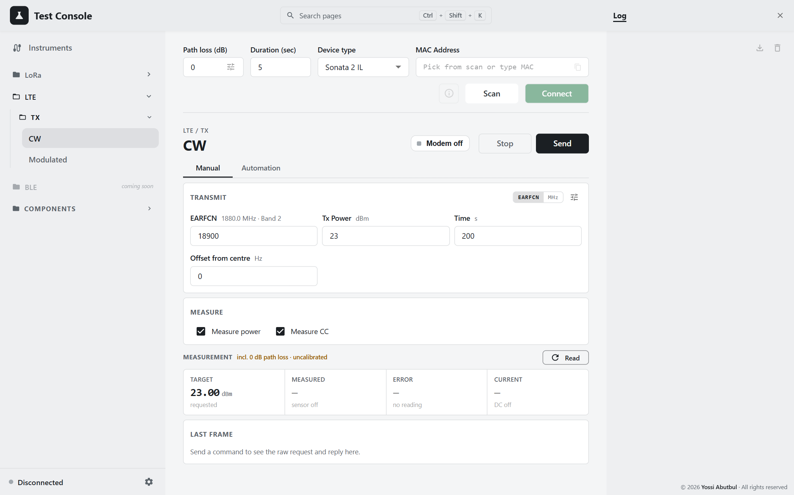
Figure 22 — LTE CW, Manual
Field | Unit | Default | Range
EARFCN / Frequency | — / MHz | 18900 / 1880 | must fall in a known band (see section 5.1)
Tx Power | dBm | 23 | 0–23, step 0.01 (sent in 0.01 dB units)
Time | s | 200 | 0–4,294,967
Offset from centre | Hz | 0 | signed 32-bit
Measure power / Measure CC | ☑ | on | with both off, Send only transmits

The hint under the channel field shows the other unit and the band, for example 1880.0 MHz · Band 2.
Procedure
- Choose EARFCN or MHz and enter the channel. Set Tx Power, Time and Offset.
- Optionally press Modem off to boot the modem ahead of time.
- Press Send. The page:
  - runs the preflight;
  - sends MODEM_ON if needed;
  - aborts any previous test;
  - sends CW START (24 50);
  - reads the measurement card.
- Press Stop to abort the test. The modem stays on.
- Turn the Modem key off when you finish.

5.3 LTE Modulated
LTE › TX › Modulated. This page transmits a modulated uplink with a chosen bandwidth, MCS and resource-block allocation. The power sensor and DC analyzer are always used on this page.
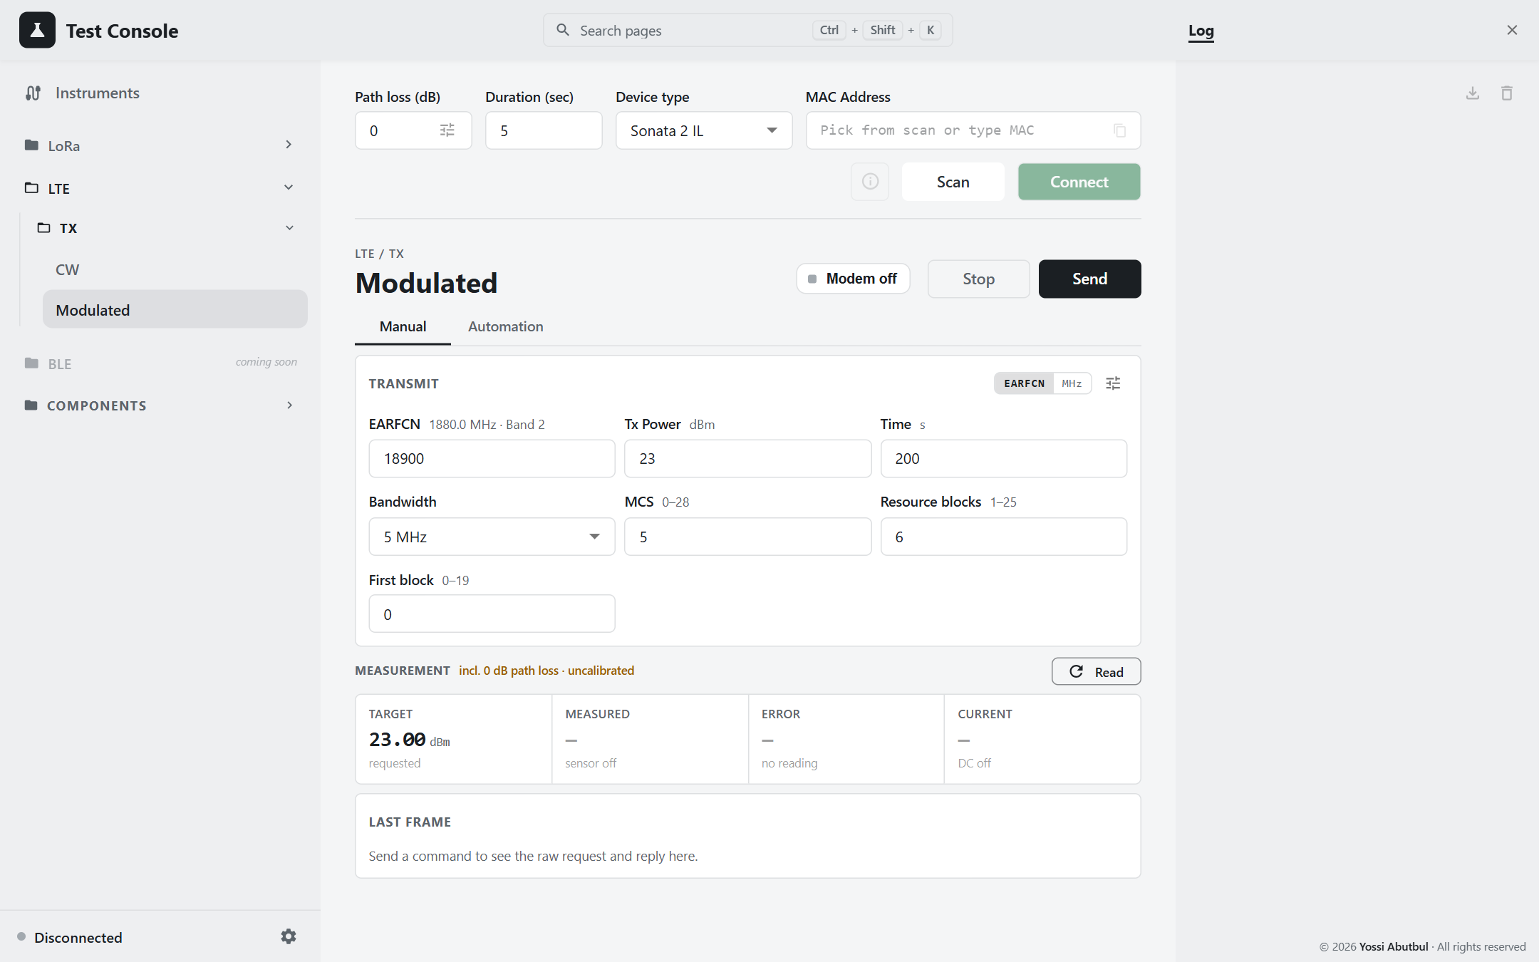
Figure 23 — LTE Modulated, Manual
Field | Default | Range
EARFCN / Frequency | 18900 / 1880
Tx Power (dBm) | 23 | 0–23
Time (s) | 200
Bandwidth | 5 MHz | 1.4 (6 RB), 3 (15), 5 (25), 10 (50), 15 (75), 20 MHz (100 RB)
MCS | 5 | 0–28 (29–31 are reserved for retransmissions)
Resource blocks | 6 | 1 to the channel's maximum
First block | 0 | the allocation must fit: first + count ≤ maximum

Changing Bandwidth clamps the RB fields so the allocation still fits the channel. Send and Stop work as on LTE CW (Modulated opcode 23 50).

5.4 Automation (both pages)
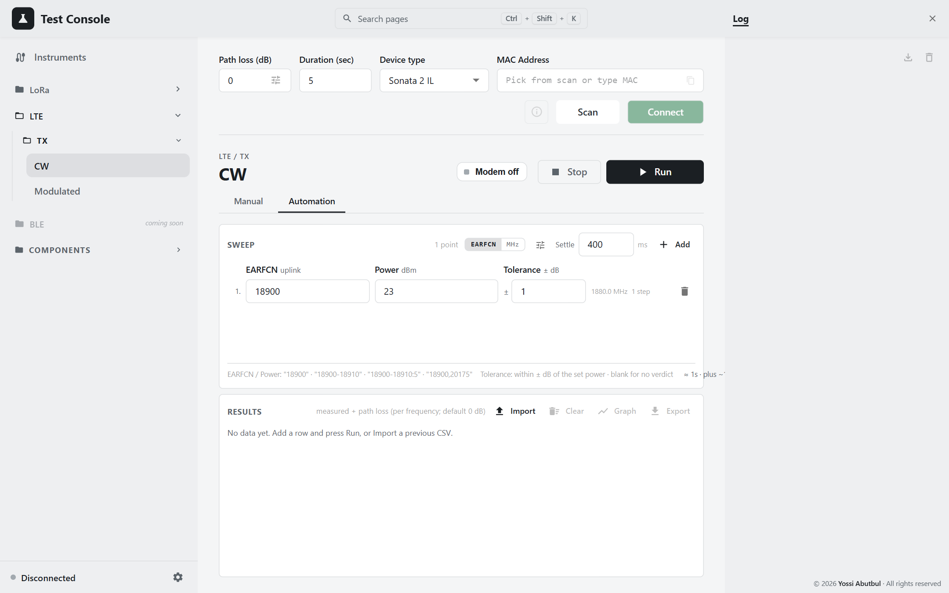
Figure 24 — LTE CW, Automation
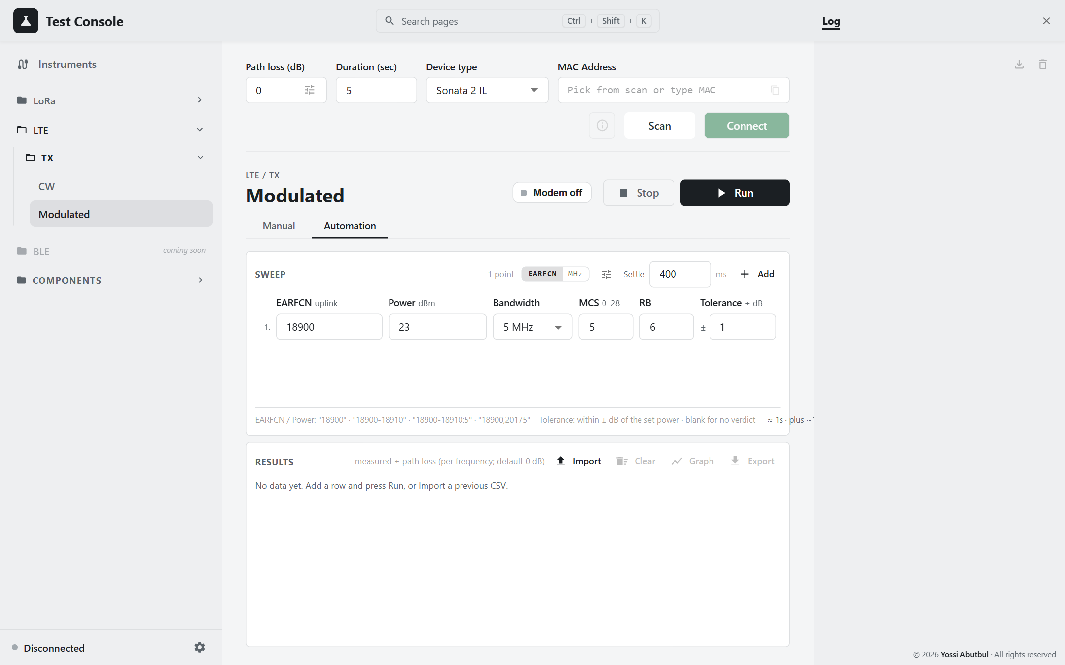
Figure 25 — LTE Modulated, Automation

Row columns
Page | Columns
CW | EARFCN (or Frequency) · Power (dBm) · Tolerance (± dB)
Modulated | the same, plus Bandwidth · MCS · RB

Range syntax:
Mode | Examples
EARFCN | 18900, 18900-18910, 18900-18910:5, 18900,20175
MHz | 1880, 1850-1910, 1850-1910:0.5, 1850,1880,1909.9

- Blank Power means 23 dBm.
- Blank Tolerance means N/A (no verdict). A negative tolerance, or an invalid MCS or RB, blocks Run.
- Channels are the outer loop and powers the inner loop.
Fixed in automation:
- transmit time is 20 s, a backstop only, since each point is aborted as soon as it has been measured;
- CW offset is 0 Hz;
- Modulated first block and NB index are 0.
Estimate: the page shows ≈ duration · plus ~10 s to restart the modem.

Run sequence
- The preflight connects the power sensor and DC analyzer.
- The modem is power-cycled: OFF, then ON, which takes about 10 s. This clears anything left over from the manual tab. If ON is refused, the run fails.
- For each point:
  - START;
  - Settle;
  - read power and current;
  - add the path loss;
  - judge the verdict;
  - ABORT, which is always sent, even after a failure.
Each point is limited to Settle + 40 s.
- At the end, the running test is aborted but the modem is left on. A completion dialog appears, and the log reports p/t points within limits.
Stop aborts at once and discards the point in progress.

Results and CSV
Page | Table columns
CW | #, EARFCN, Freq (MHz) + band, Set, Measured, CC, Verdict, Status
Modulated | the same, plus Signal (e.g. 5 MHz · MCS 5 · 6 RB)

CSV columns:
- CW: earfcn, band, freq_mhz, set_power_dbm, measured_dbm, current_ma, path_loss_db, margin_db, min_dbm, max_dbm, verdict, ok, status, error
- Modulated: adds bandwidth, mcs, rb_count after set_power_dbm.
File names: <MAC>-<UTC timestamp>.csv, or lte-cw-automation-<ts>.csv / lte-modulated-automation-<ts>.csv when no MAC is known.
Import needs earfcn, set_power_dbm, measured_dbm.

5.5 Cautions
- Turn the modem key off when you are done. Nothing else powers the modem down.
- The CW and Modulated pages track the modem separately. A test started on CW is unknown to the Modulated page. Its key may read off while the modem is on, and its first START can be silently dropped. Stop the test and turn the modem off before switching LTE pages. An automation run is safe, because it power-cycles the modem first.
- Manual controls are not locked during an automation run. Pressing the manual Send or Stop during a run disturbs it. Only the modem key is locked.
- Unresolvable channels are dropped silently. A channel entry that is invalid (red) does not block Run as long as another row is valid. Check each row's N steps count.
- The Modulated graph ignores the signal settings. Rows with the same channel and power but different bandwidth, MCS or RB overwrite one another on the graph.

6. Component pages
The Components pages drive one instrument each, by hand. None of them needs the DUT.
- Shared connections: connection state is shared with the Instruments panel. An instrument connected in one place shows as connected in the other.
- No exports: none of these pages exports anything. Results appear on screen and in the Log.
Page | Moves hardware / changes the RF path | Emits RF
Trombone | Move, Step up/down, Go min/max. Connecting energises the motor. | no
Switch | Go VNA, Go PCB, Move. The store buttons overwrite the presets. | no, but it redirects the RF path
Network Analyzer | — | yes: the stimulus runs the whole time it is connected
Power Meter | — | no
Signal Generator | — | RF On. Apply changes a live output.

6.1 Trombone
Components › Trombone. This page moves the RF trombone (Arcus DMX-J-SA), shows where it is, and shows how much travel is left in each direction.
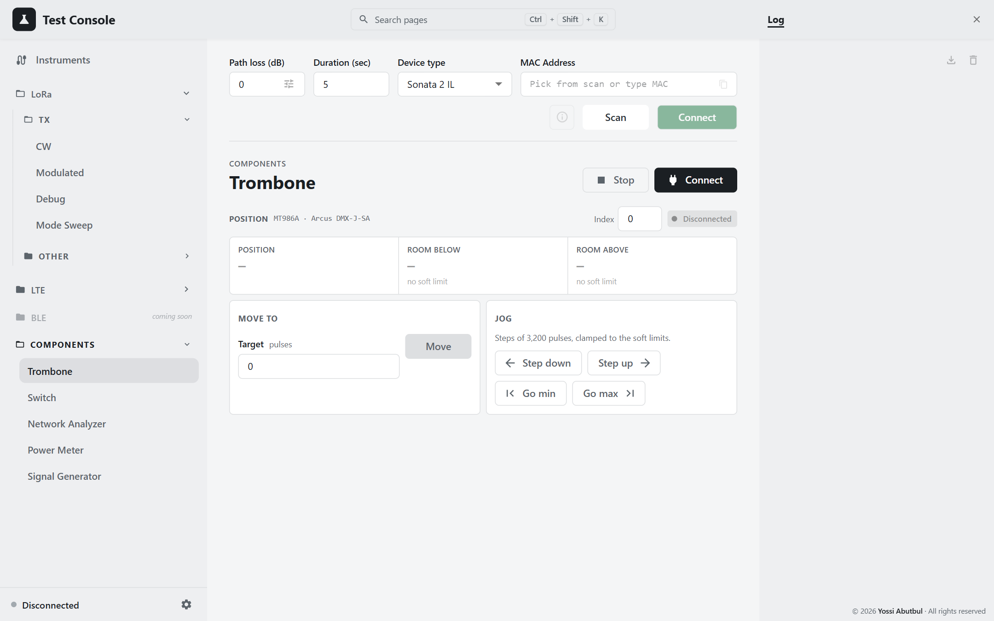
Figure 26 — Trombone

Connecting
While disconnected, enter the Index (0–15, normally 0) and press Connect. You can also connect from the Instruments panel.
The status chip reads Disconnected, Idle or Moving. It is polled every 0.5 s while connected.

Controls
Control | Effect
Target + Move | Absolute move, in pulses (3,200 pulses = 1 revolution; 400 pulses = 1 mm). The target must lie within the soft limits, or within ±1,000,000 if none are set.
Step down / Step up | ±3,200 pulses (one revolution), stopping short at a soft limit
Go min / Go max | Move to the lower or upper soft limit. Disabled when no limits are set.
Stop (header) | Immediate stop, with no deceleration. It also cancels a jog.

Readouts
Readout | Shows
Position | pulses, with N% of travel
Room below / Room above | pulses left to each limit, or no soft limit
Travel bar | shown only when limits exist; turns orange while the motor is moving

Behaviour to know
- Soft limits are set on the Load Pull page, by capturing Zero and End. This page cannot set them. Without them, moves are not limited at all.
- "Complete" does not mean arrived. A move reports complete as soon as the controller accepts it. Wait for the chip to return to Idle.
- Speed is fixed at 5,000 pulses/s here. Reduced-speed jogging is only available on Load Pull.
- Disconnect releases the holding torque.
- No devices found? "no Performax USB devices found" or "device_index out of range" means: check the USB cable and the Index, and check the driver (Code 28; see section 1.2).

6.2 Switch
Components › Switch. This page flips the RF path between the VNA and the PCB (the DUT). It also calibrates the two preset positions, which are stored on the Arduino.
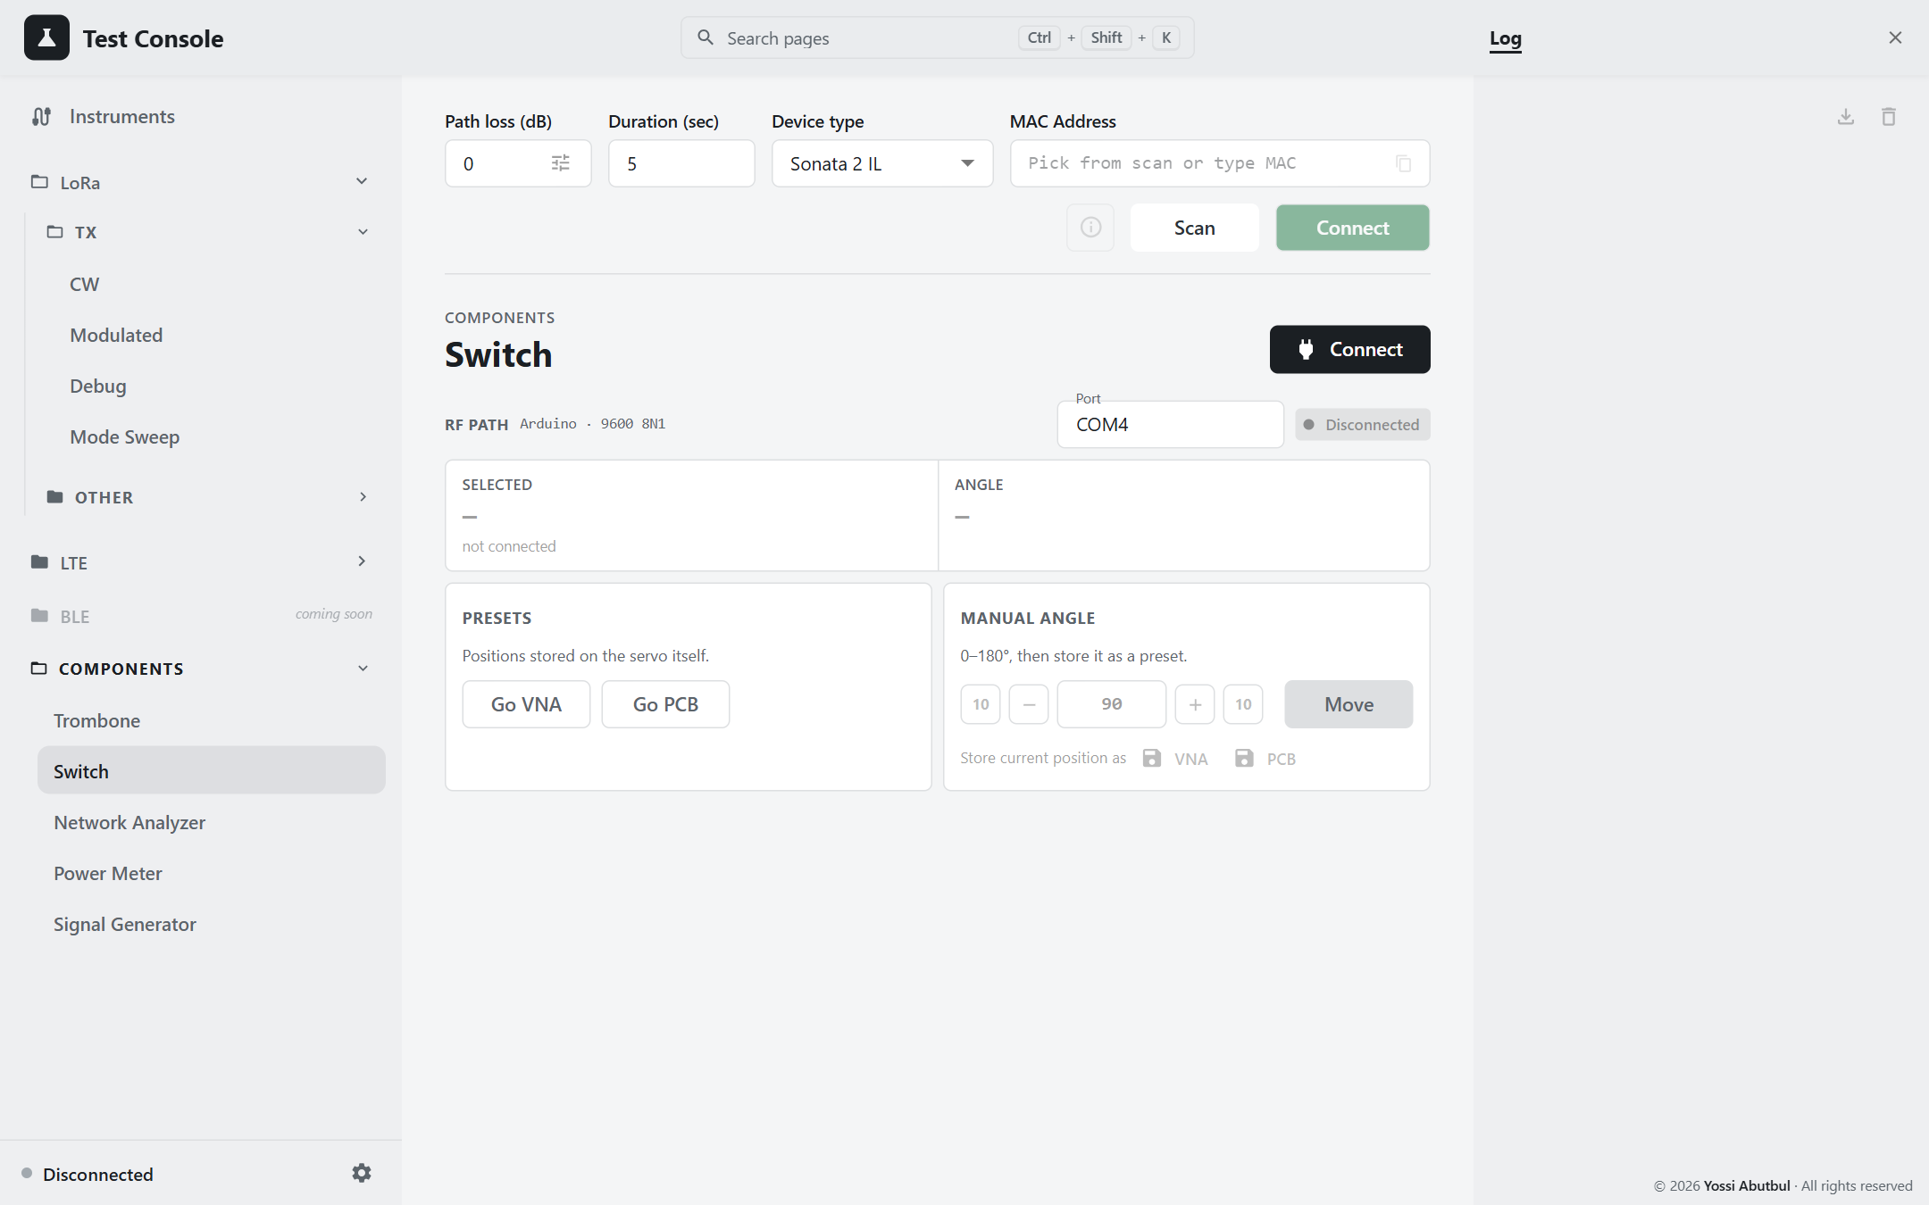
Figure 27 — Switch

Connecting
While disconnected, pick the Port. USB-serial ports are listed first, and the list refreshes each time you open it. Then press Connect. The header shows Arduino · 9600 8N1.

Everyday use
Press Go VNA or Go PCB. The Selected tile confirms which path is active.

Calibrating a preset
- Set an angle with the box or the nudge buttons (−10, −1, +1, +10°), then press Move. Angles run 0–180°. The nudge buttons only change the number; nothing moves until you press Move.
- Check the switch mechanically, adjust, and press Move again.
- Under Store current position as, press VNA or PCB. This stores wherever the servo is now, not the number in the box, and it overwrites the preset without asking.

Behaviour to know
- The PC cannot read the servo's position. The Angle tile shows the last angle commanded, or the angle the Arduino reported after moving to a preset. Otherwise it shows held by the servo.
- Switching with RF live sends the signal to the other port.
- "PermissionError 13" when connecting: unplug and replug the Arduino.

6.3 Network Analyzer
Components › Network Analyzer. This page sets the E5061B's sweep range, places up to 9 markers, and reads S11 (impedance) or S21 (transmission) at them.
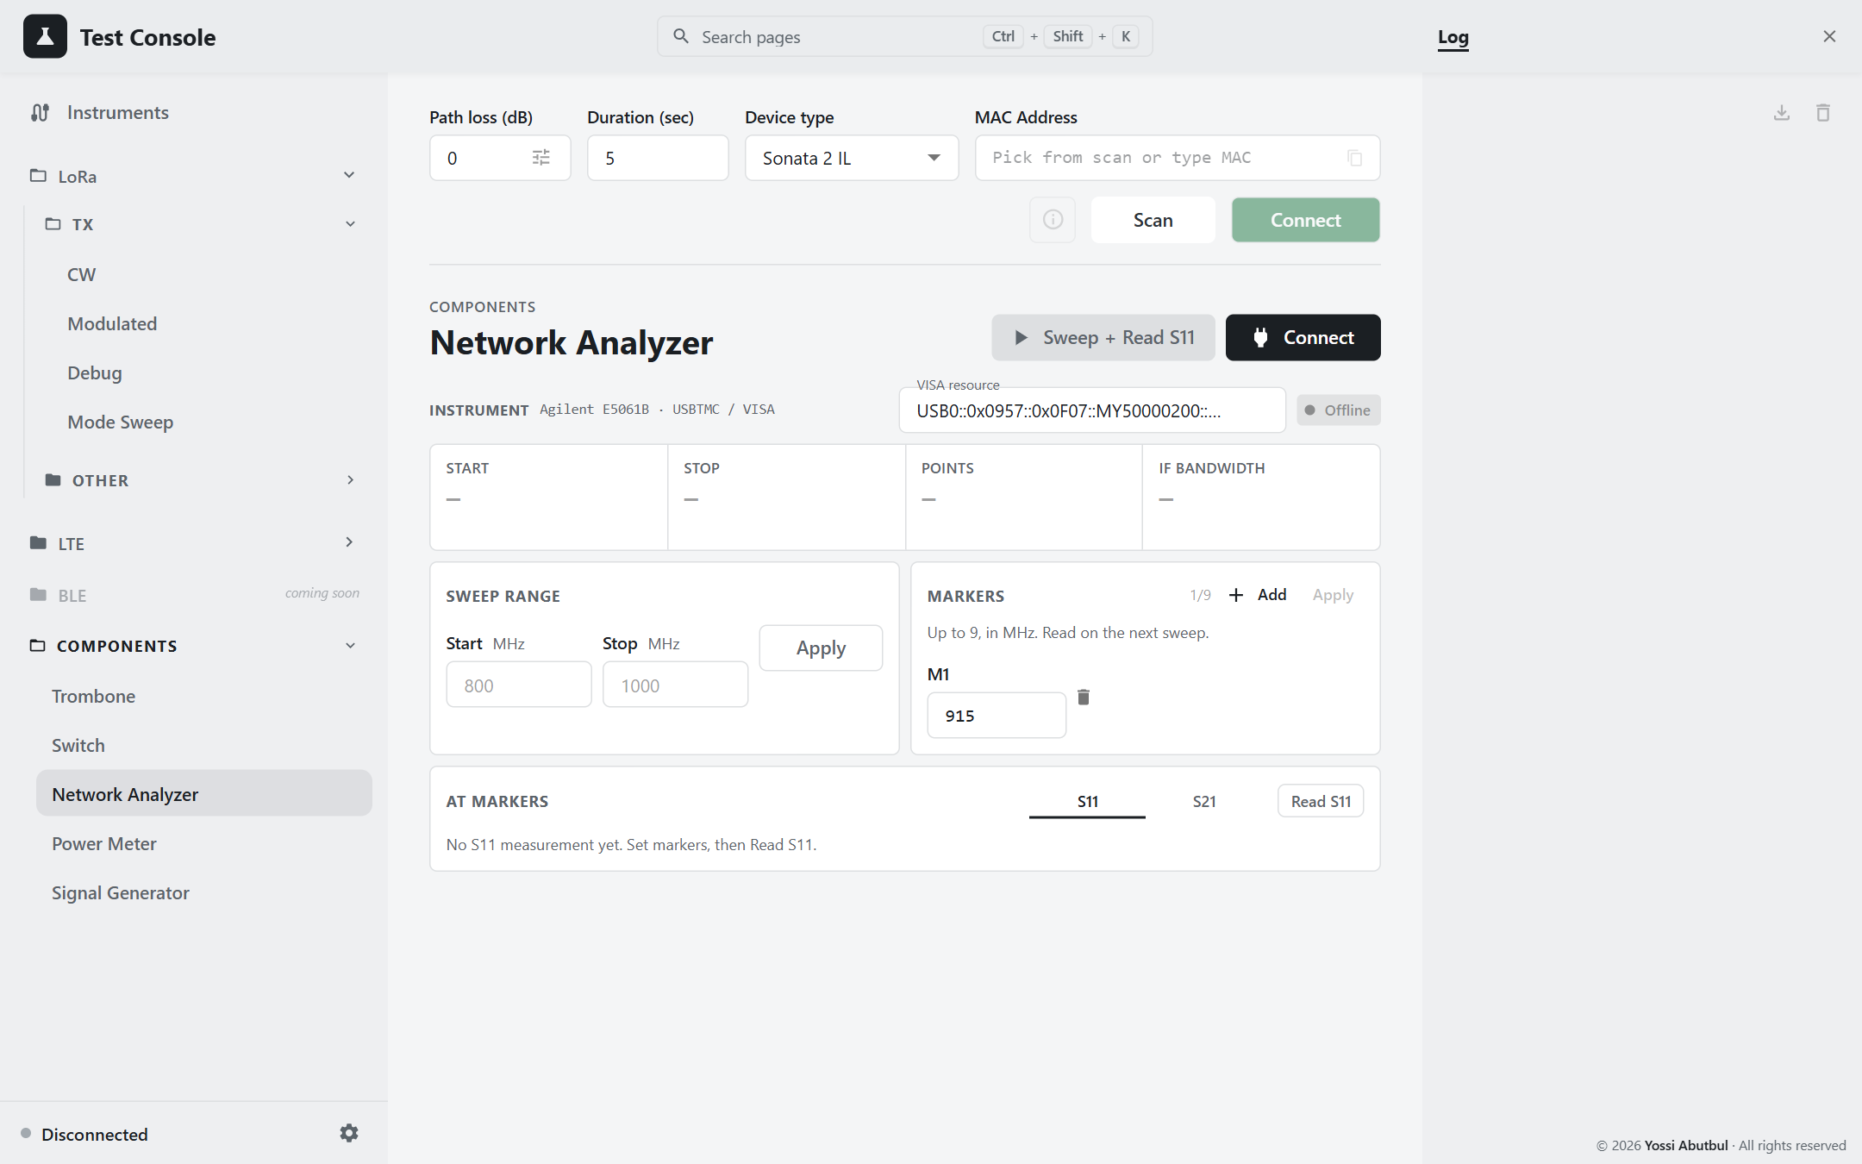
Figure 28 — Network Analyzer

Connecting
Pick the VISA resource (the page runs a VISA scan) and press Connect. The chip reads Online. Connecting switches the analyzer to continuous sweep, so it is transmitting its stimulus from then on.

Procedure
- If the analyzer reaches the DUT path through the RF switch, set the switch to VNA first (Switch page).
- Enter Start and Stop in MHz (defaults 800–1000; filled in from the instrument on first connect), then press Apply.
  - A filled Apply button, with the note "Not applied — the instrument still has the range above.", means your entry differs from what the instrument has.
- Enter markers M1–M9 in MHz (default one marker at 915; the counter shows N/9). Optionally press the markers' Apply to show them on the instrument's screen.
- Choose the S11 or S21 tab, then press Sweep + Read S11/S21 (in the header) or Read.

Readouts
Readout | Shows
Tiles (refreshed every 5 s) | Start, Stop, Points (with the source power in dBm), IF bandwidth. Points, IF bandwidth and source power can only be set on the front panel.
S11 table | Mk, Freq, R (Ω), jX (Ω), |S11| (dB), S11 real/imag (50 Ω reference)
S21 table | Mk, Freq, |S21| (dB), Phase (°), real/imag

Behaviour to know
- Reading does not start a new sweep. It takes the last completed continuous sweep. After changing the range or the cabling, wait one full sweep before reading.
- Markers read the nearest sweep point. On a coarse sweep this can be far from the marker frequency: a 902.3 MHz marker on a 201-point, 3 GHz span reads at 900.21 MHz. Narrow the span or add points for accurate marker values.
- A dead port reads −200 dB.
- "…not responding to a previous command": disconnect and reconnect.

6.4 Power Meter
Components › Power Meter. This page uses the Mini-Circuits sensor as a standalone power meter, with single readings or a continuous trace and statistics.
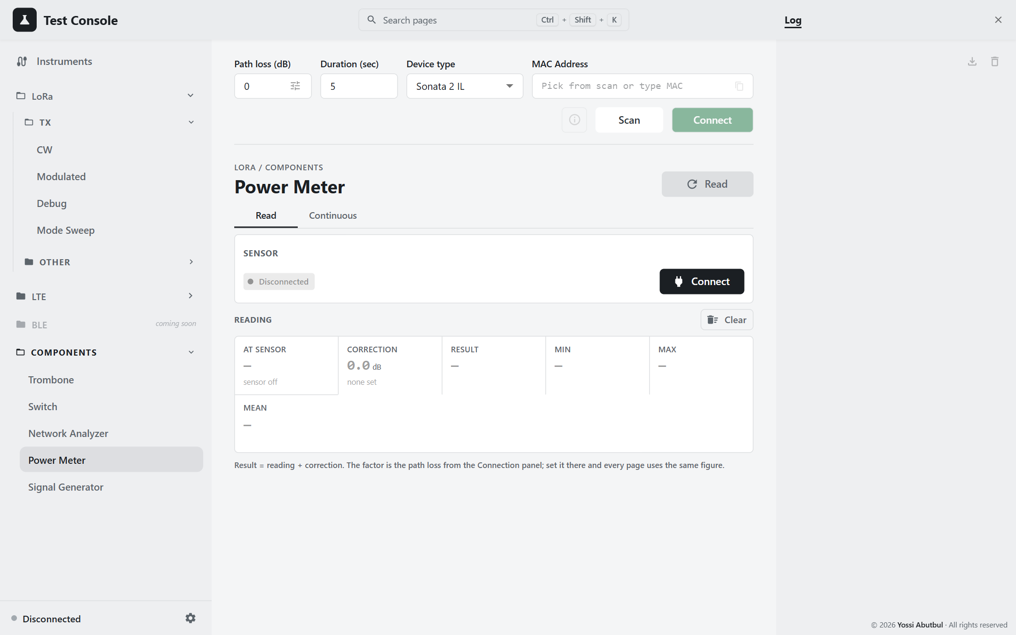
Figure 29 — Power Meter

Connecting
Press Connect. The first sensor found is used. To pick a specific serial, set it in the Instruments panel. The chip shows the model, serial and firmware.

Tabs
Tab | Header button | Notes
Read | Read takes one reading
Continuous | Start / Stop a trace | Every: the interval in ms, default 400, range 200–60,000. The trace pauses when you leave the page and resumes when you come back.

Clear resets the trace and the statistics.

Readouts
Tile | Shows
At sensor | the raw reading. under range - no signal (amber) means ≤ −100 dBm: the sensor sees nothing.
Correction | the default path loss from the connection row. The per-frequency table is not used here, because this page has no frequency.
Result | at sensor + correction, in dBm and mW
Min / Max / Mean | statistics of the result, over up to 500 samples
Recent | the last 10 samples

Behaviour to know
- No frequency is sent. The sensor keeps whatever calibration frequency a test page last set. For accurate absolute readings, run a Send at the frequency you want on a TX page first.
- Readings are stored raw. Changing the path loss re-corrects the whole trace.
- Measurement only. Keep the input below the sensor's damage level; see the Mini-Circuits datasheet.

6.5 Signal Generator
Components › Signal Generator. This page sets the R&S SML03's frequency and level and switches its RF output. Everything shown is read back from the instrument.
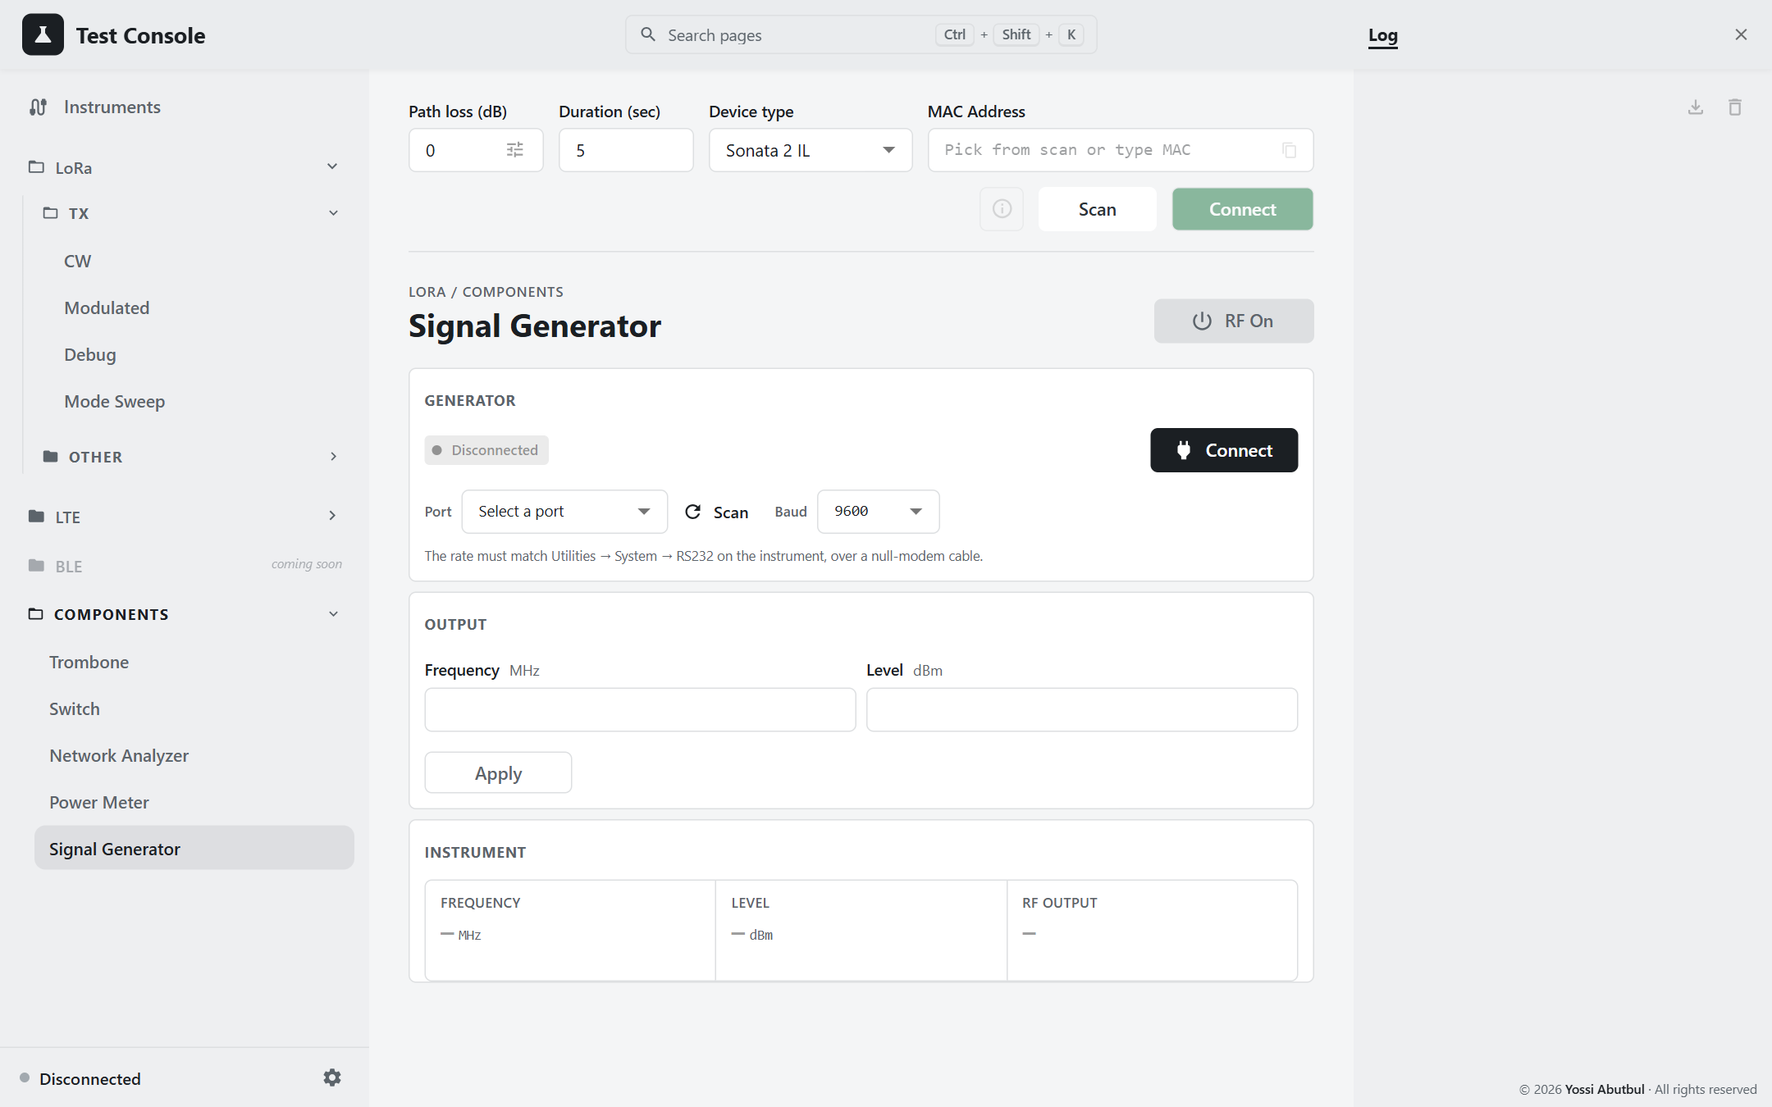
Figure 30 — Signal Generator

Connecting
- On the instrument, set the rate under Utilities → System → RS232, and connect it with a null-modem cable.
- Pick the Port (press Scan if it is missing) and the matching Baud (default 9600), then press Connect. The chip shows the IDN.
Connecting changes nothing on the instrument.

Output
Field | Unit | Range
Frequency | MHz | 0.009 – 3,300
Level | dBm | −145 to +20 (datasheet maximum +13)

Both fields are empty by default and keep what you last typed.
Button | Effect
Apply | Sends the fields that are filled in. The output state is unchanged.
RF On | Sends the typed frequency and level first, then switches the output on, so it never comes on at old settings
RF Off | Switches the output off only

Status and readouts
- not sent yet (amber): what you typed differs from the instrument.
- RF is live (red): the output is on.
- Instrument tiles (every 2.5 s, while the page is open): Frequency, Level, RF output ON/OFF, and the instrument's own error queue.

Behaviour to know
- Disconnect does not switch RF off. Press RF Off first.
- Apply while RF is on changes the live output immediately.
- Connection errors:
  - "no reply … CTS and DSR are both low": the cable is straight-through, or the instrument is off. It is not a baud-rate problem.
  - "no reply … at N baud": the baud rate or cable is wrong.
- Wrong baud rate? scripts\sml_probe.py tries every baud rate and handshake for you.

7. Troubleshooting & reference

7.1 Symptoms and fixes

Instruments
Symptom | Cause and fix
An instrument is missing from the list | Work down the stack. (1) Is it in Device Manager? Get-PnpDevice -PresentOnly | ? InstanceId -like 'USB\VID_0957*' for Keysight. (2) If it is absent altogether, the problem is power, cable or port; a missing driver still shows a yellow-bang device. (3) If it is present but not in VISA, re-run the check in section 1.5. (4) Only if VISA sees it and the app does not, suspect the app.
N6705B never enumerates | It only brings up USB at power-on. Connect the USB cable, switch it off at the rear, wait 30 s, and switch it on.
Connect fails with the default N6705B address | The built-in default has a placeholder serial. Press re-scan (↻) in the Instruments panel to get the real resource string.
VI_ERROR_LIBRARY_NFOUND | The backend is running with --reload, or under a bare python. Restart it with .venv\Scripts\python.exe and no reload. A stale worker can keep port 8000: Get-NetTCPConnection -LocalPort 8000 -State Listen.
"…is not responding to a previous command" | A call is stuck on that instrument's queue. Disconnect and reconnect that instrument; there is no need to restart the server.
Motor: Code 28 in Device Manager | The Arcus kernel driver is missing. Run the unpacked PerformaxUSBInstaller_x64.exe (step 3 in section 1.2). Reinstalling the Python package will not help.
No COM port for the Arduino | The FTDI VCP driver is missing (FT232R under Other devices).
"PermissionError 13" on the switch | Windows is still holding the port. Unplug and replug the Arduino.
Signal generator: no reply | If CTS and DSR are both low, it is the cable (it must be null-modem) or the instrument is off. Otherwise, check the baud rate under Utilities → System → RS232.

DUT and tests
Symptom | Cause and fix
Connect is greyed out | The MAC is not in the current scan. Press Scan first, and check the Device type filter.
TX page is faded and won't respond | The DUT is not connected, or its command channel failed to start. Reconnect.
"No signal at the power sensor" | Check the RF path. Check that the DUT is actually transmitting (look at Last frame). Increase Settle.
A low-power point reads high | Settle is too short; it must be at least 400 ms.
DUT stops answering mid-sweep | The DUT needs 1.5 s after a StopTest. The backend enforces this; if it still happens, disconnect, power-cycle the DUT, and reconnect.
LTE: "modem on rejected" | The page thought the modem was off, but it was on. Turn the key off, then on.
LTE: the channel did not change | A START sent during a live test is silently dropped. Press Stop, then Send again.
Measured power is off by a fixed amount | The path loss is wrong or uncalibrated at that frequency (the chip is amber). Add a table point for that frequency.
Load Pull: Run is disabled | Read the Before running notice. It usually means the path is not confirmed, or Zero/End are not captured.
Load Pull: motor refuses to jog | It is at a soft limit ("already at max/min soft limit"). Clear Zero or End to go further.
Mode Sweep results vanished | They are held in backend memory and are lost on a backend restart. Export after every run.
A route answers 404/405/422 after a code update | The backend is stale. Restart it.

Setup
Symptom | Cause and fix
pip install: [Errno 9] Bad file descriptor | The Documents folder is redirected (OneDrive or a network share). Clone to C:\dev\test-console, or install with uv.
Assistant tab missing | CHAT_ENABLED is not set, or the backend was not restarted after setting it.
Assistant: "No API key on this machine" | Set GEMINI_API_KEY, or create a .gemini_key file (see section 3.9).

7.2 Error status codes
Backend errors reach the UI as HTTP status codes:
Code | Meaning | Typical cause
400 | Bad request | A value outside what the driver accepts
409 | Hardware in the wrong state | Not connected, already running, instrument busy, DUT rejected the command
422 | Validation failed | A field out of range, e.g. Settle below 400 or LTE power above 23
501 | Driver unavailable | Vendor package not installed (DUT-only build)
504 | Timed out | The instrument or DUT did not answer
500 | Unexpected | See the backend console

7.3 Constants shared across the stack
Each of these values is defined once on the backend and once on the frontend, and the two must agree.
Constant | Value | Backend | Frontend
Minimum / default settle | 400 ms | backend/sweep/models.py | frontend/src/lib/settle.ts
Mode Sweep ranges | Power 1–22, PA DC 1–4, HP Max 1–7 | backend/sweep/models.py | tests/powerSweep/PowerSweepPage.tsx
Path loss | DUT = reading + loss; exact-frequency match ±0.001 MHz | SweepConfig.path_loss_db | lib/pathLoss.ts, PathLossContext
No-signal threshold | −100 dBm | api/instruments/__init__.py | tests/powerMeter/PowerMeterPage.tsx
Best-settings under-range | −50 dBm | sweep/export.py | tests/powerSweep/bestSettings.ts
LTE maximum power | 23 dBm | device/lte.py | LTE pages
LTE bandwidth → RB | 1.4/3/5/10/15/20 MHz → 6/15/25/50/75/100; MCS 0–28 | device/lte.py | tests/lteModulated/signal.ts
Discovery timeout | 12 s backend, 20 s frontend (the frontend's must be the longer) | api/instruments/_common.py | context/InstrumentsContext.tsx
Signal generator baud | 9600 | api/instruments/signal_generator.py | api/signalGenerator.ts
Trombone scale | 400 pulses/mm; 3,200 pulses/rev | motor/manager.py | tests/loadPull

7.4 Export formats at a glance
Page | Format | File name | Import?
LoRa CW automation | CSV | <MAC>-<UTC ts>.csv / tx-cw-automation-<ts>.csv | yes (replaces the table)
LoRa Modulated automation | CSV | <MAC>-<ts>.csv / lora-modulated-automation-<ts>.csv | yes
LTE CW automation | CSV | <MAC>-<ts>.csv / lte-cw-automation-<ts>.csv | yes
LTE Modulated automation | CSV | <MAC>-<ts>.csv / lte-modulated-automation-<ts>.csv | yes
Mode Sweep | xlsx: All, Run, one sheet per dBm level | pa_modes_YYYYMMDD_HHMMSS.xlsx | yes (view only)
Load Pull | xlsx: All, Run, one sheet per frequency | load_pull_YYYYMMDD_HHMMSS.xlsx | yes (.xlsx or older .csv)
Results graph | PNG | <MAC>-<power|current>-<ts>.png | —
Smith chart | PNG to the clipboard | — | —
Log | TXT | log-<ts>.txt | —

7.5 Known discrepancies
These are places where the code and the documentation, or the UI, disagree. Each one is described as the code behaves today.
- Assistant limits: the repo README lists 8/min and 200/day. The code defaults are 4/min and 18/day.
- Load Pull setup drawing labels the equipment N5224B / N6705C / MT986A, with an FSW26 on the coupler. The app drives an E5061B, an N6705B and an Arcus DMX-J-SA, and measures power with the Mini-Circuits sensor.
- Load Pull's empty table says "Import a previous CSV", but Export writes xlsx only. Import accepts both.
- DC analyzer channel: the connect route defaults to 1; the UI and the Mode Sweep default to 3.
- The signal generator's Instruments-panel placeholder shows a VISA string, but its address is a COM port.
- The signal generator is not released on a graceful backend shutdown. Its COM port is freed when the process exits.
- Export file names from the CW and Modulated pages (LoRa and LTE) are identical when a MAC is known, so rename them to keep track.

7.6 Glossary
Term | Meaning
DUT | Device under test: the meter being measured
PA | Power amplifier
CW | Continuous wave: an unmodulated carrier
Path loss | dB between the DUT and the sensor, added to readings
Settle | How long the PA stays keyed before a reading is taken
PA Mode | Off / On / Auto selection of the PA
PA Duty Cycle, HP Max | Radio PA registers swept by Mode Sweep and set by Debug
EARFCN | LTE channel number; maps to one uplink frequency
RB / MCS | LTE resource blocks / modulation and coding scheme
Trombone | Motorised variable-length line; rotates the load's phase
Soft limits | Zero–End travel range enforced by the backend
S11 / S21 | Reflection / transmission, measured by the VNA
VSWR | (1 + |Γ|) / (1 − |Γ|)
Preflight | Connecting the needed instruments before a Send or Run

7.7 Regenerating this manual
The manual is built from text sources, so it stays in step with the application:
Path | Holds
docs/manual/source/*.md | The text of each chapter
docs/manual/img/ | Screenshots and rendered diagrams
docs/manual/tools/ | The scripts below

With the backend (:8000) and npm run dev (:5173) running, install the tooling once into a temporary folder:
npm i --no-save --prefix %TEMP%\pw playwright-core docx marked
set NODE_PATH=%TEMP%\pw\node_modules
Then run:
node docs\manual\tools\capture-screenshots.cjs
node docs\manual\tools\render-diagrams.cjs
node docs\manual\tools\build-docx.cjs
- capture-screenshots.cjs re-takes every screenshot in the Light theme, using the installed Google Chrome. It only switches tabs and opens dialogs, and refuses to click anything outside its allow-list, so it never transmits, moves the trombone, or drives the switch.
- render-diagrams.cjs turns the setup diagrams in chapter 2 into images.
- build-docx.cjs assembles Test-Console-User-Manual.docx. When Microsoft Word is installed, it also fills in the table of contents and exports a PDF.

