TEST CONSOLE
Testing Guide
How to set up the bench, run each test, read the results and save them. For operators; no technical background needed.
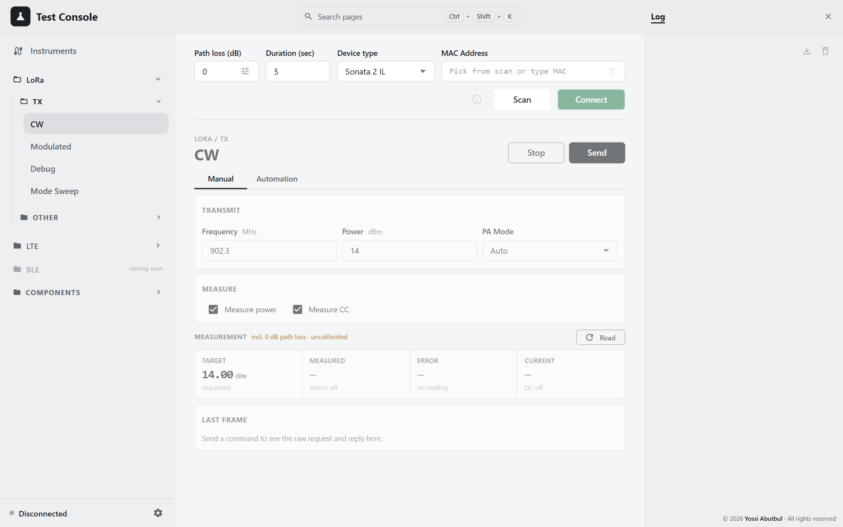
Edition: 18 October 2026
Source revision: main @ d422b00
Screenshots: captured from the running application, Light theme

Contents
Before you start 4
What the console does 4
Safety first 4
Which test do I use? 5
How to read this guide 5
1. Daily setup 6
1.1 Cable the bench 6
1.2 Connect the instruments 6
1.3 Power the DUT 7
1.4 Connect the DUT 8
1.5 Enter the path loss 9
1.6 What happens when you press Send or Run 10
2. Common to every test 11
2.1 Manual and Automation tabs 11
2.2 The measurement card (Manual tab) 11
2.3 Settle time 12
2.4 Entering a list of values (Automation) 12
2.5 Tolerance and verdict 12
2.6 Following a run 12
2.7 Pages remember your work 13
3. LoRa tests 14
3.1 CW — one setting 14
3.2 CW — a list of settings with pass/fail 14
3.3 Modulated 16
3.4 Debug 18
3.5 Mode Sweep — the best setting for each power 19
3.6 Load Pull 20
4. LTE tests 26
4.1 The Modem key 26
4.2 Choosing the channel: EARFCN or MHz 26
4.3 LTE CW — one setting 27
4.4 LTE Modulated — one setting 29
4.5 Automation (both pages) 30
5. Results and saving them 31
5.1 Graphs 31
5.2 Exporting 31
5.3 Importing 32
5.4 The log 32
6. Bench checks 33
6.1 Measuring path loss 33
6.2 Checking the trombone before Load Pull 34
6.3 Watching the DUT's current 34
7. When something goes wrong 36
End-of-day checklist 36
Words used in this guide 36

Before you start
This guide is for the person at the bench. It explains how to run each test on the Test Console, how to read the results and how to save them. It leaves out installation and anything technical; for those, see the full Operator Manual.
Figure 1 — The Test Console

What the console does
The console tests the power amplifier in a meter, called the DUT (device under test). It talks to the DUT over Bluetooth, tells it to transmit, and measures what comes out with the bench instruments:
- the power sensor measures the RF power;
- the DC analyzer powers the DUT and measures the current it draws;
- for Load Pull, the network analyzer, the RF switch and the trombone change and measure the load the DUT drives.

Safety first
The rig is live. These controls act at once, with no "are you sure?":
What happens | Which controls do it
The DUT transmits | Send and Run on every test page; RF On on the Signal Generator page
The trombone moves | Move, Step, Go min/max on the Trombone page; Jog, Go to Zero/End and Run on Load Pull
The RF path changes | Go VNA / Go PCB on the Switch page; VNA / PCB on Load Pull
The DUT is powered | Output On on the DC Analyzer page, the supply switch in Settings, the LTE Modem key

Some things stay on until you turn them off:
- A manual Send on a LoRa page keeps the DUT transmitting until you press Stop.
- The LTE modem stays powered until you turn off the Modem key.
- Disconnecting the signal generator does not switch its RF output off.
Watch the top bar. While anything is live, a coloured tag appears at the top right of the screen on every page: RF ON, DC ON, LTE TX (with the time left) or Run. Click a tag to jump to the page that controls it. If a tag is showing and you didn't expect it, go and turn that output off.
The Load Pull page has a round red Emergency stop, always available. It stops the motor first, then the run, then the transmitter.

Which test do I use?
I want to… | Go to | Chapter
Transmit a LoRa carrier at one setting and read power and current | LoRa › TX › CW, Manual tab | 3
Check LoRa power over several frequencies and powers, with pass/fail | LoRa › TX › CW, Automation tab | 3
Test LoRa or FSK modulation | LoRa › TX › Modulated | 3
Set the PA duty cycle and HP max by hand | LoRa › TX › Debug | 3
Find the lowest-current setting for every power level | LoRa › TX › Mode Sweep | 3
See how power and efficiency change with the load | LoRa › Other › Load Pull Test | 3
Test an LTE (Cat-M) unit | LTE › TX › CW or Modulated | 4
Measure the loss of a cable or attenuator | Signal Generator + Power Meter | 6

How to read this guide
- Bold words are buttons and labels exactly as they appear on screen.
- Page names follow the menu on the left: LoRa › TX › CW.
- Path loss is the loss between the DUT and the power sensor. The console adds it to every reading, so the numbers you see are the power at the DUT.

1. Daily setup
Do these steps once at the start of a session. After that, every test page is ready to use.

1.1 Cable the bench
For all the transmit tests (LoRa and LTE CW, Modulated, Debug, Mode Sweep), cable the bench like this:
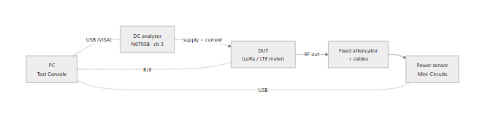
Figure 2 — Cabling for the transmit tests
- The DUT's RF output goes through a fixed attenuator and cables to the power sensor.
- The DC analyzer powers the DUT and measures its current.
- The PC talks to the DUT over Bluetooth and to the instruments over USB.
Protect the sensor. Make sure the attenuator can handle the DUT's full power, and that the power reaching the sensor stays below its damage level.
Load Pull needs a different bench; it is described with the test in chapter 3.

1.2 Connect the instruments
- Click Instruments at the top of the left-hand menu.
- The panel finds the instruments by itself and fills in their addresses. Wait a few seconds for it to finish.
- Press Connect all, or Connect on each instrument you need. A green dot means connected.
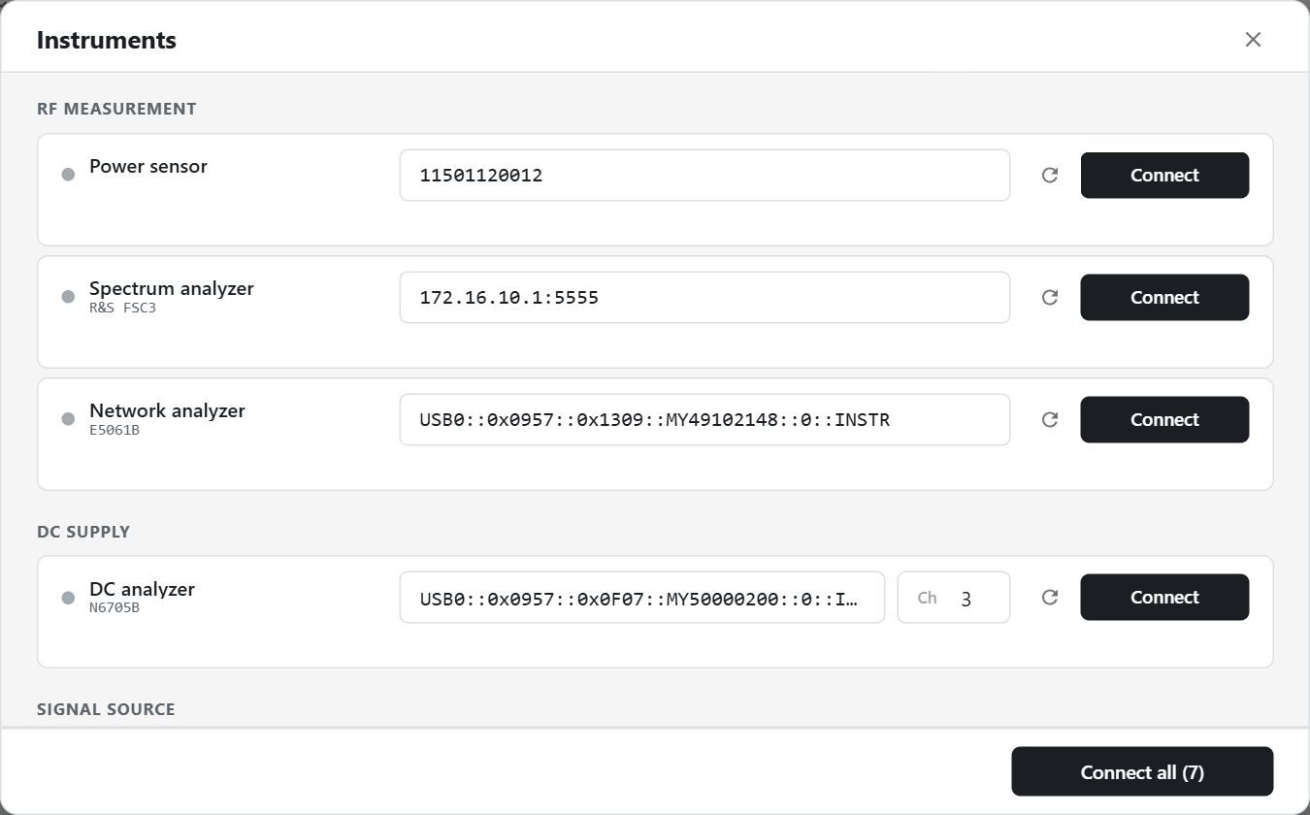
Figure 3 — The Instruments panel
You don't have to do this in advance: when you press Send or Run, the console connects whatever the test needs on its own (see 1.6).
If an instrument won't connect, its row says why and what to do:
Message | What to do
No response | Check the instrument is on and its cable is plugged in, then try again.
Not found at that address | Press the re-scan arrow on that row and pick it again.
Already in use | Another program has it open. Close that program and try again.

1.3 Power the DUT
- Make sure the DC analyzer is connected.
- Open Settings (the gear at the bottom of the left-hand menu).
- Check the voltage (3.6 V by default) and turn the DC analyzer supply switch on.
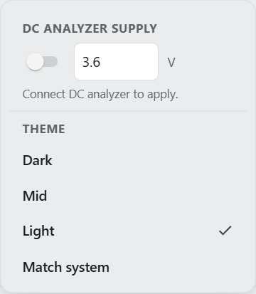
Figure 4 — Settings
For a current limit or to watch the current continuously, use the DC Analyzer page under Components instead.

1.4 Connect the DUT
The row along the top of every page is for the DUT.
- Choose the Device type (for example Sonata 2 IL).
- Press Scan. Units appear as they are found, strongest first.
- Pick your unit from the list. You can type part of its MAC address, its name or its nickname to find it.
- Press Connect. The bottom of the left-hand menu turns green and shows the unit's name.
Connect only works for a unit found in the current scan. If you reload the page, press Scan again first.
Tips:
- The pencil next to the MAC field gives a unit a nickname such as "Lab unit 3". Nicknamed units show a coloured tag and sort to the top.
- The test pages are faded out until a DUT is connected. That is normal.
Figure 5 — A test page before a DUT is connected

1.5 Enter the path loss
The Path loss (dB) box at the top left is the default loss between the DUT and the sensor. The tune icon inside it opens a table of losses per frequency.
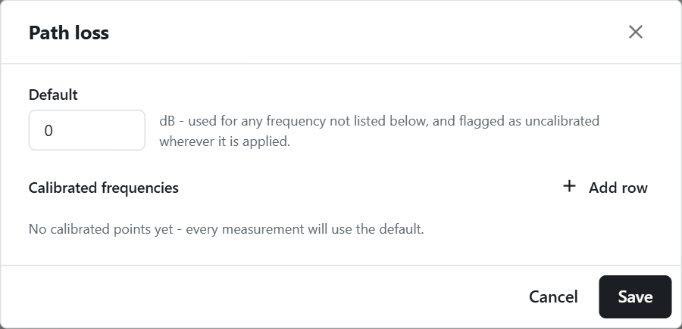
Figure 6 — The path loss table
- Enter a line for every frequency you test at. The console uses a table entry only at exactly that frequency; it does not guess between them.
- Any other frequency uses the default and is marked uncalibrated in amber. Treat its readings with care.
- To measure a loss, see chapter 6.

1.6 What happens when you press Send or Run
Before transmitting, the console checks that the test's instruments are connected. If one is missing, a Connecting instruments box connects it for you. If it still fails, you can choose:
Button | Result
Open Instruments | Stops and opens the Instruments panel so you can fix it
Cancel | Stops; nothing is transmitted
Send anyway / Run anyway | Carries on without that instrument; its readings stay blank

2. Common to every test
The test pages share the same way of working. Learn it once here.

2.1 Manual and Automation tabs
Most test pages have two tabs:
- Manual sends one setting. You press Send, read the result, and press Stop.
- Automation runs a list of settings one after another, judges each one PASS or FAIL, and fills a results table. You press Run, and Stop if you need to end it early.

2.2 The measurement card (Manual tab)
After a Send, the card under the settings takes a reading by itself.
Figure 7 — The measurement card
Tile | Shows
Target | The power you asked for
Measured | The power at the DUT (sensor reading plus path loss)
Error | Measured minus Target: green within ±1 dB, amber within ±2 dB, red beyond
Current | The DUT's supply current in mA, with the voltage under it

- Press Read to measure again without sending.
- If the header says uncalibrated in amber, the path loss for this frequency is the default, not a measured value.
- If you change the power after reading, the Error tile says read again, because it still compares against the old target.

2.3 Settle time
Settle is how long the DUT transmits before the reading is taken. The minimum and default is 400 ms.
If a low-power point reads too high while its current looks right, settle is too short: the sensor is still averaging the previous, stronger point.

2.4 Entering a list of values (Automation)
The frequency and power boxes on the Automation tabs accept a list:
You type | It means
915 | one value
900-930 | 900 to 930 in steps of 1
900-930:5 | 900 to 930 in steps of 5
902.3,915,927.5 | exactly these values

Each row tests every frequency with every power. The number at the end of the row (N steps) shows how many points it adds; a row with a mistake adds 0 steps, so check it before you press Run.

2.5 Tolerance and verdict
Tolerance is the pass band in ± dB around the power you asked for.
- PASS means the measured power is within the tolerance.
- FAIL means it is outside.
- Leave the tolerance blank for no verdict (N/A).

2.6 Following a run
While a run is going:
- a progress bar runs along the top of the panel;
- the panel shows time elapsed and time left;
- a Run tag shows in the top bar, so you can see it from any page;
- the results table fills in point by point.
Before you press Run, the panel shows an estimate of how long the run will take (for example ≈ 4m 10s). The estimate gets more accurate as the run goes.
When the run ends, a box tells you how it went:
Box | Meaning
complete | Every point was measured
finished with errors | Some points could not be measured; their Status says why
stopped | You pressed Stop
failed | The run could not continue; the box gives the reason

"Complete" means every point was measured, not that every point passed. Always check the Verdict column.

2.7 Pages remember your work
You can move between pages during a run; nothing is lost. Settings and results are also kept if you reload the page. A run in progress keeps going while you look at other pages.

3. LoRa tests
Before any LoRa test: the bench is cabled (1.1), the DUT is powered and connected (1.3, 1.4), and the path loss is entered for your frequencies (1.5).

3.1 CW — one setting
LoRa › TX › CW, Manual tab. Transmits a plain carrier and reads the power and current.
Figure 8 — LoRa CW, Manual
- Set Frequency (MHz), Power (dBm, whole numbers) and PA Mode (Auto, On or Off).
- Tick Measure power and Measure CC for the readings you want. With both unticked, Send only transmits.
- Press Send. The card fills in a moment later.
- Check Measured, Error and Current. Press Read to measure again.
- Press Stop. The DUT keeps transmitting until you do.

3.2 CW — a list of settings with pass/fail
LoRa › TX › CW, Automation tab.
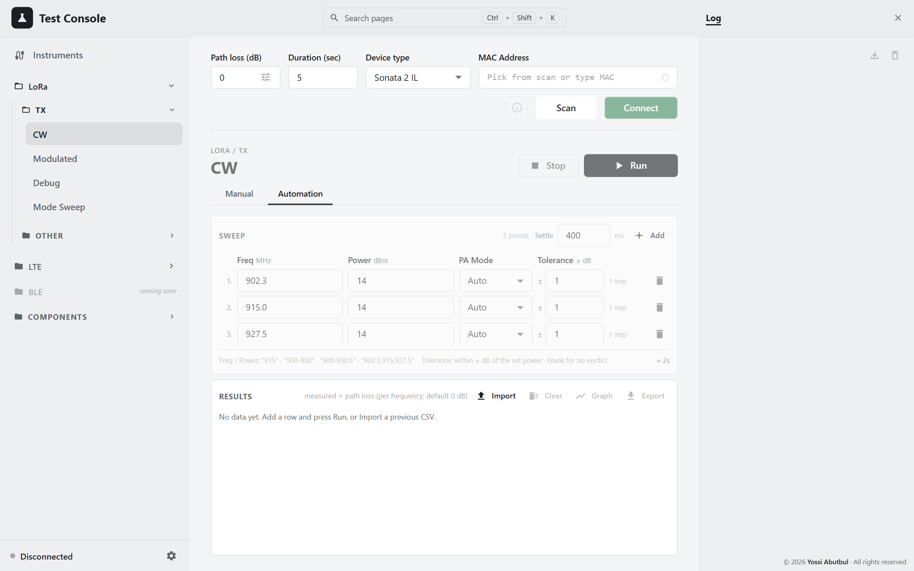
Figure 9 — LoRa CW, Automation
- Fill in the rows: Freq, Power, PA Mode and Tolerance. Use the list format from 2.4. Add adds a row.
- Set Settle in the panel header (400 ms is normal).
- Check the number of points and the time estimate.
- Press Run. The table clears and fills in point by point. The DUT is stopped after every point.
- When the box appears, check the Verdict column.
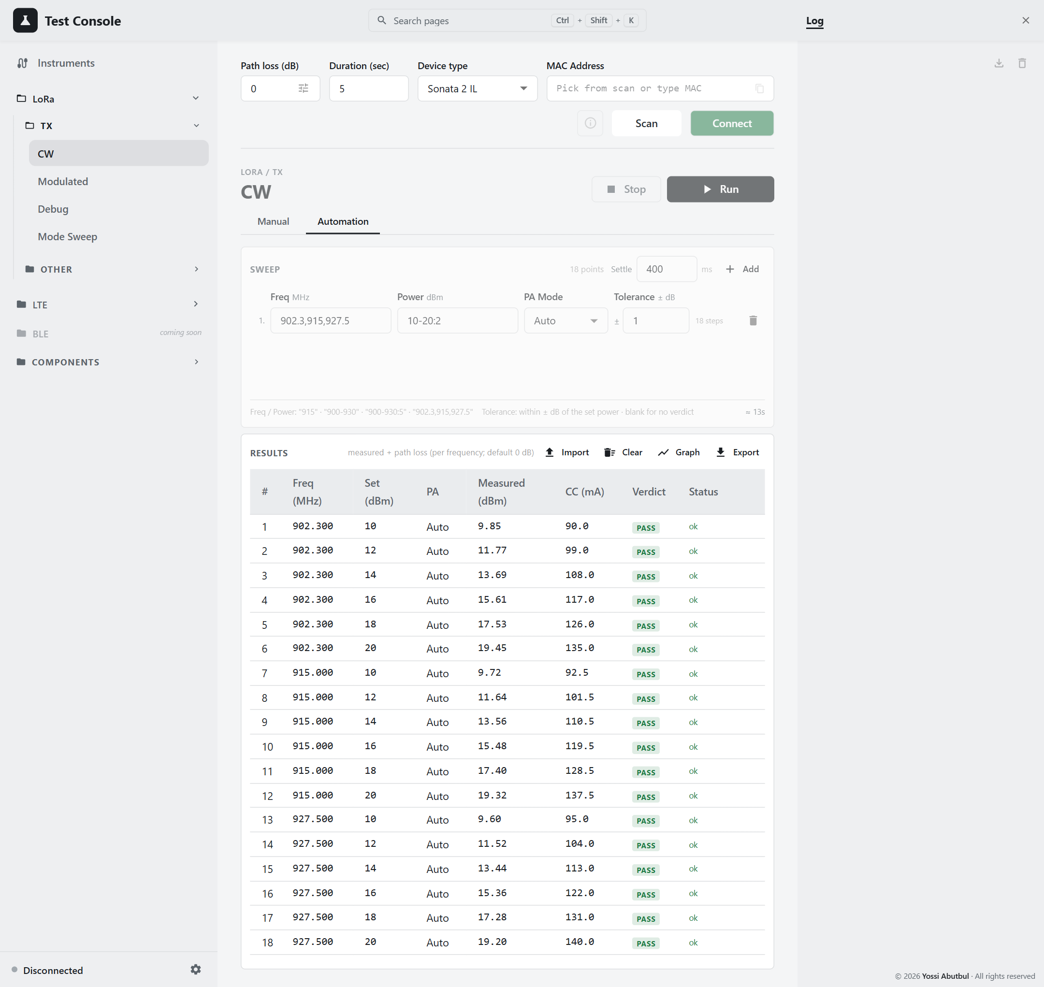
Figure 10 — Results, example data
Column | Meaning
Freq, Set, PA | The setting tested
Measured | The power at the DUT
CC (mA) | The supply current
Verdict | PASS, FAIL or N/A
Status | ok, or why the point could not be measured

To look at the results as a chart, press Graph (see 5.1). To save them, press Export (see 5.2).

3.3 Modulated
LoRa › TX › Modulated. Transmits LoRa or FSK modulation. Power and current are always measured.
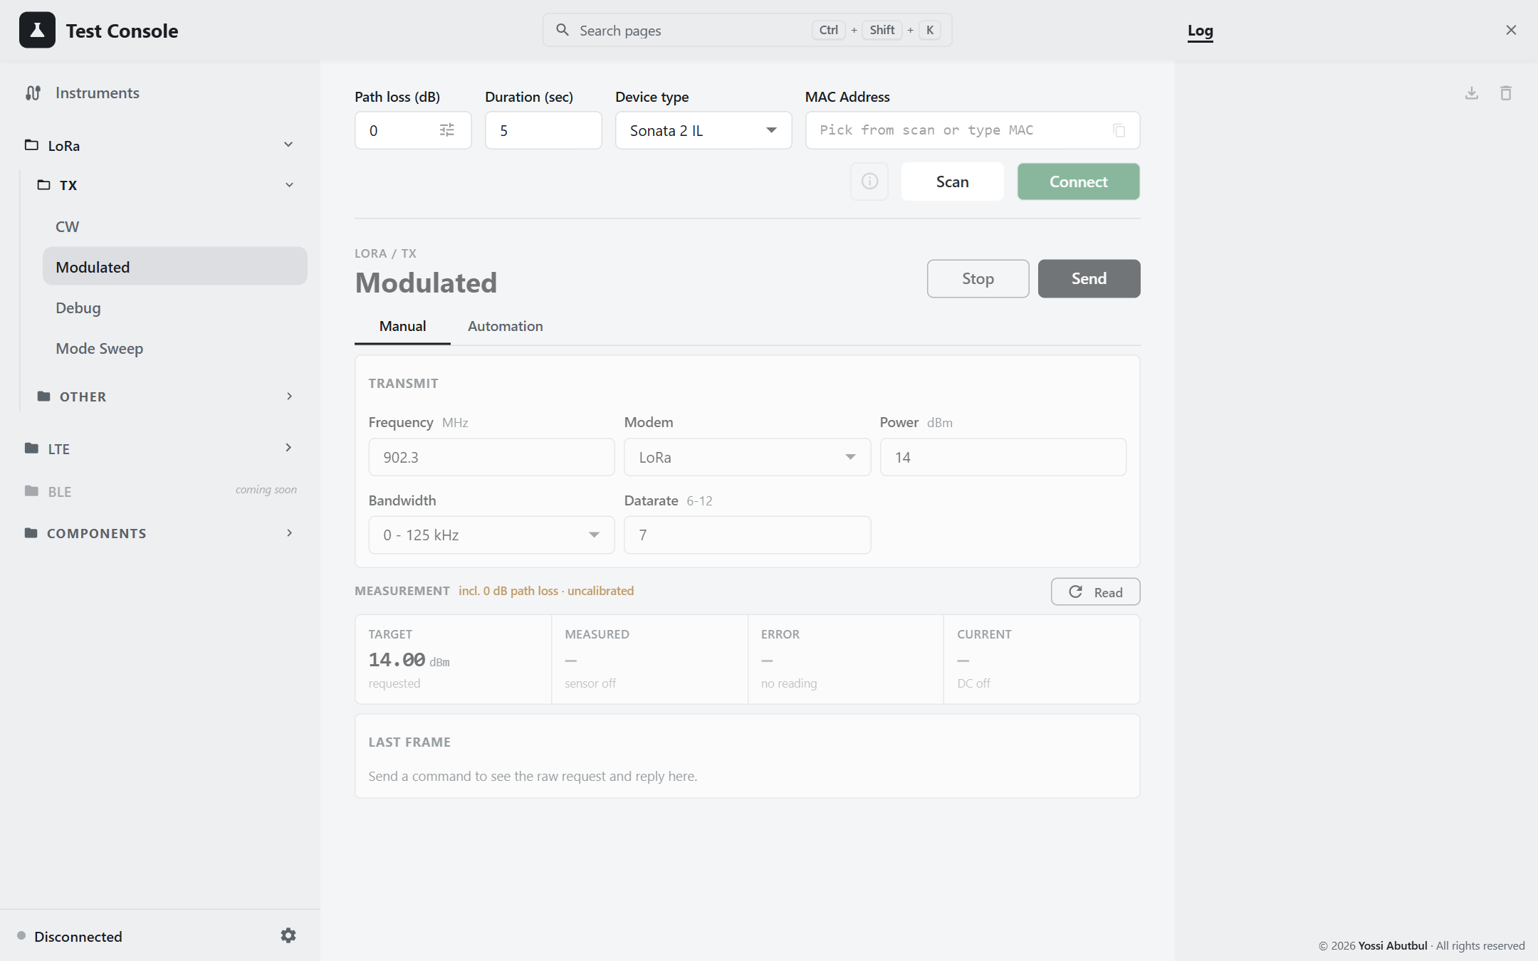
Figure 11 — LoRa Modulated, Manual
Manual: set Frequency, Modem (LoRa or FSK), Power, Bandwidth and Datarate (the spreading factor, 6–12, for LoRa). Press Send, check the card, press Stop.
For FSK, use the Automation tab. The Manual tab's datarate box only goes up to 12, which is too low for an FSK bit rate.
Automation: the same as CW automation, with Modem, Bandwidth and Datarate columns. For FSK the datarate is the bit rate (up to 300,000).
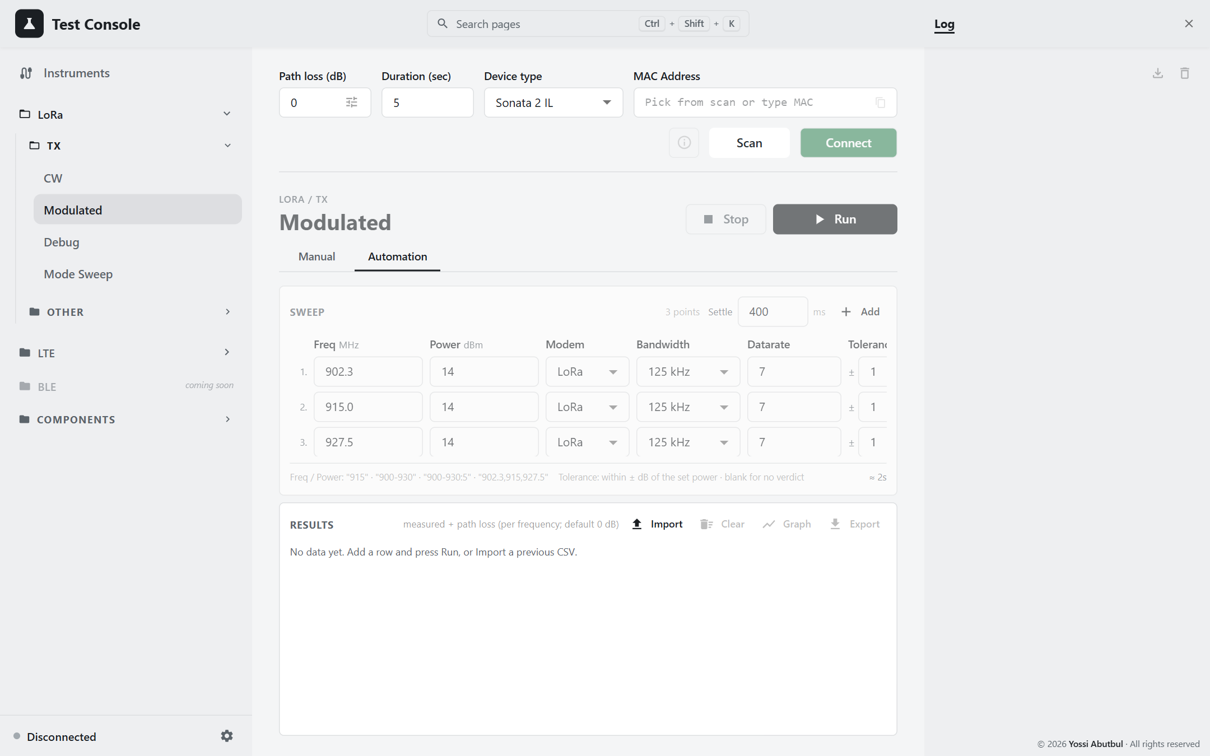
Figure 12 — LoRa Modulated, Automation

3.4 Debug
LoRa › TX › Debug. A carrier where you also set the PA Duty Cycle and HP Max directly. There is no automation and nothing is saved.
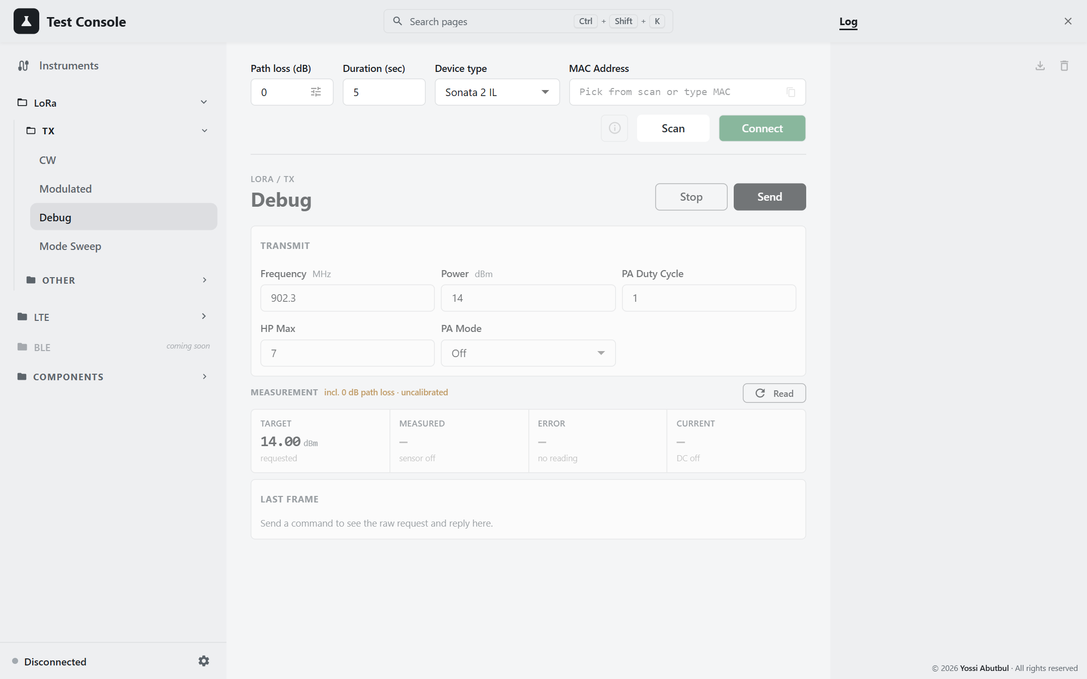
Figure 13 — LoRa Debug
- PA Duty Cycle and HP Max must each be 1 to 7. Send stays disabled otherwise, because 0 makes the DUT stop responding.
- PA Mode starts at Off here, but at Auto on the CW page. Check it before comparing the two pages.

3.5 Mode Sweep — the best setting for each power
LoRa › TX › Mode Sweep. Tries every combination of Power, PA Duty Cycle and HP Max at one frequency, then shows, for each power the DUT actually reaches, the combination that draws the least current.
Needs the DUT, the power sensor and the DC analyzer.
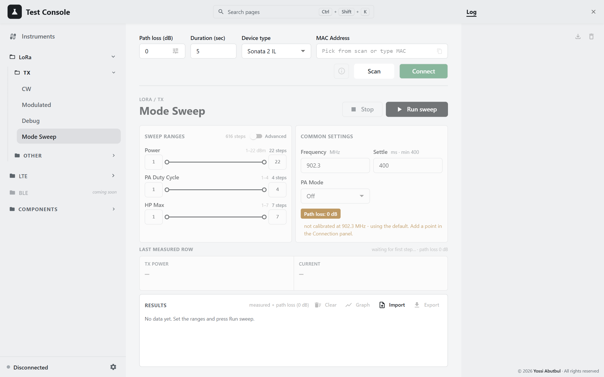
Figure 14 — Mode Sweep
- Set the ranges: Power 1–22 dBm, PA Duty Cycle 1–4, HP Max 1–7. The default plan is 616 steps; the header shows the count and the time it will take.
- Set Frequency, Settle and PA Mode.
- Press Run sweep. The progress bar, the time left and Last measured row show how it is going.
- Stop ends the run after the current point.
There is no pass/fail on this page: most points fall short of the power asked for, and that gap is what the test measures.
Reading the result: press Graph to open Best settings. Each line is one power level the DUT reached, with the combination that held it for the least current (marked with a trophy). Click the chart to jump to a level.
Export after every sweep. The results are kept only until the next run or until the console is restarted.
Your ranges and settings are remembered, so the next sweep starts from them.

3.6 Load Pull
LoRa › Other › Load Pull Test. Measures how the DUT's power, current and efficiency change as the load it drives changes. The results are drawn on a Smith chart.
⚠ This page moves the trombone and switches the RF path. Keep hands clear of the trombone. The round red Emergency stop in the header always works.

The bench
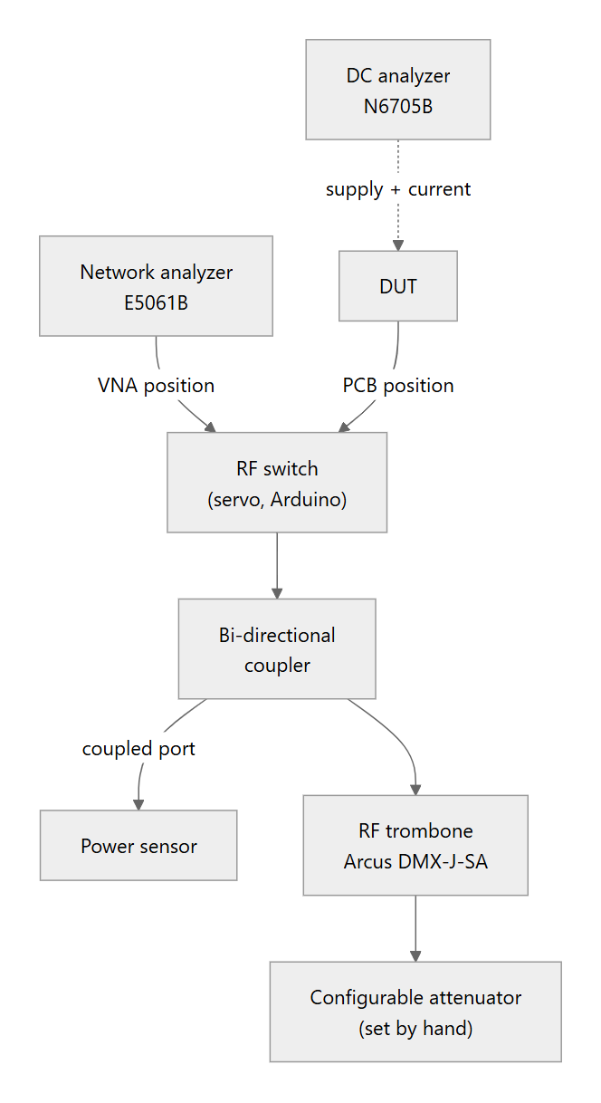
Figure 15 — Load Pull bench
- With the switch on VNA, the network analyzer measures the load the trombone presents.
- With the switch on PCB, the DUT transmits into that load while power and current are measured.
- The trombone length moves the load around the Smith chart; the attenuator moves it in or out.
Press View setup on the page to see the app's own drawing of the bench.
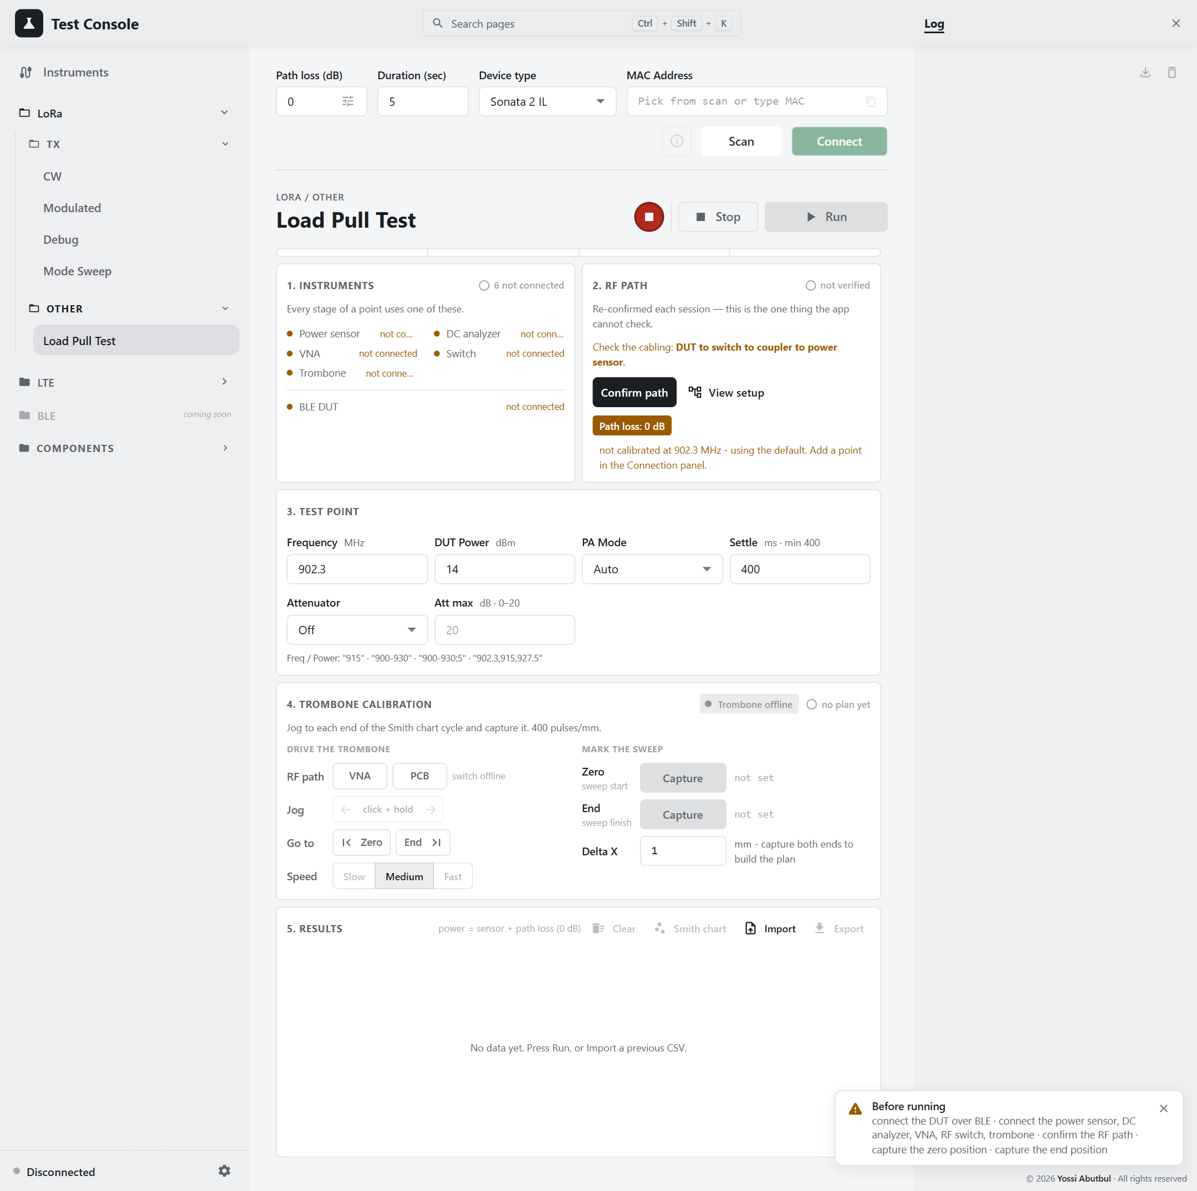
Figure 16 — Load Pull Test
Run stays disabled until everything is ready. A Before running notice lists what is still missing. Work down the page:

Step 1 · Instruments
Each instrument shows whether it is ready: power sensor, DC analyzer, VNA, switch, trombone and the DUT. Connect anything missing.

Step 2 · RF path
- Press View setup and compare the bench with the drawing.
- Press Confirm path. You must do this every session.

Step 3 · Test point
Set Frequency, DUT Power, PA Mode and Settle. Both frequency and power accept a list (2.4). Set Attenuator to Sweep if you want the run to step the attenuator too; it will ask you to set it by hand at each value.
The page shows the size of the plan. The numbers multiply quickly, so check the total and the time estimate.

Step 4 · Trombone calibration
- Press VNA to put the network analyzer on the trombone.
- Choose a jog Speed.
- Press and hold ← or → to jog while watching the Smith chart on the network analyzer. The motor stops the moment you let go.
- At the start of one full circle, press Capture on Zero. Jog to the end of the circle and press Capture on End. From now on the trombone cannot be moved outside Zero–End.
- Set Delta X, the distance between points in mm.
- Use Go to › Zero / End to check both ends.
Before Zero and End are captured, there are no travel limits. Capture them before any automatic movement, and capture them again after the console or the motor has been restarted.

Step 5 · Run
Press Run. The results table is cleared, so export earlier results first. At each trombone position the console measures the load, then the DUT's power and current at every frequency and power. If the attenuator is being swept, a box asks you to set each value; press Attenuator is set to carry on.

Results
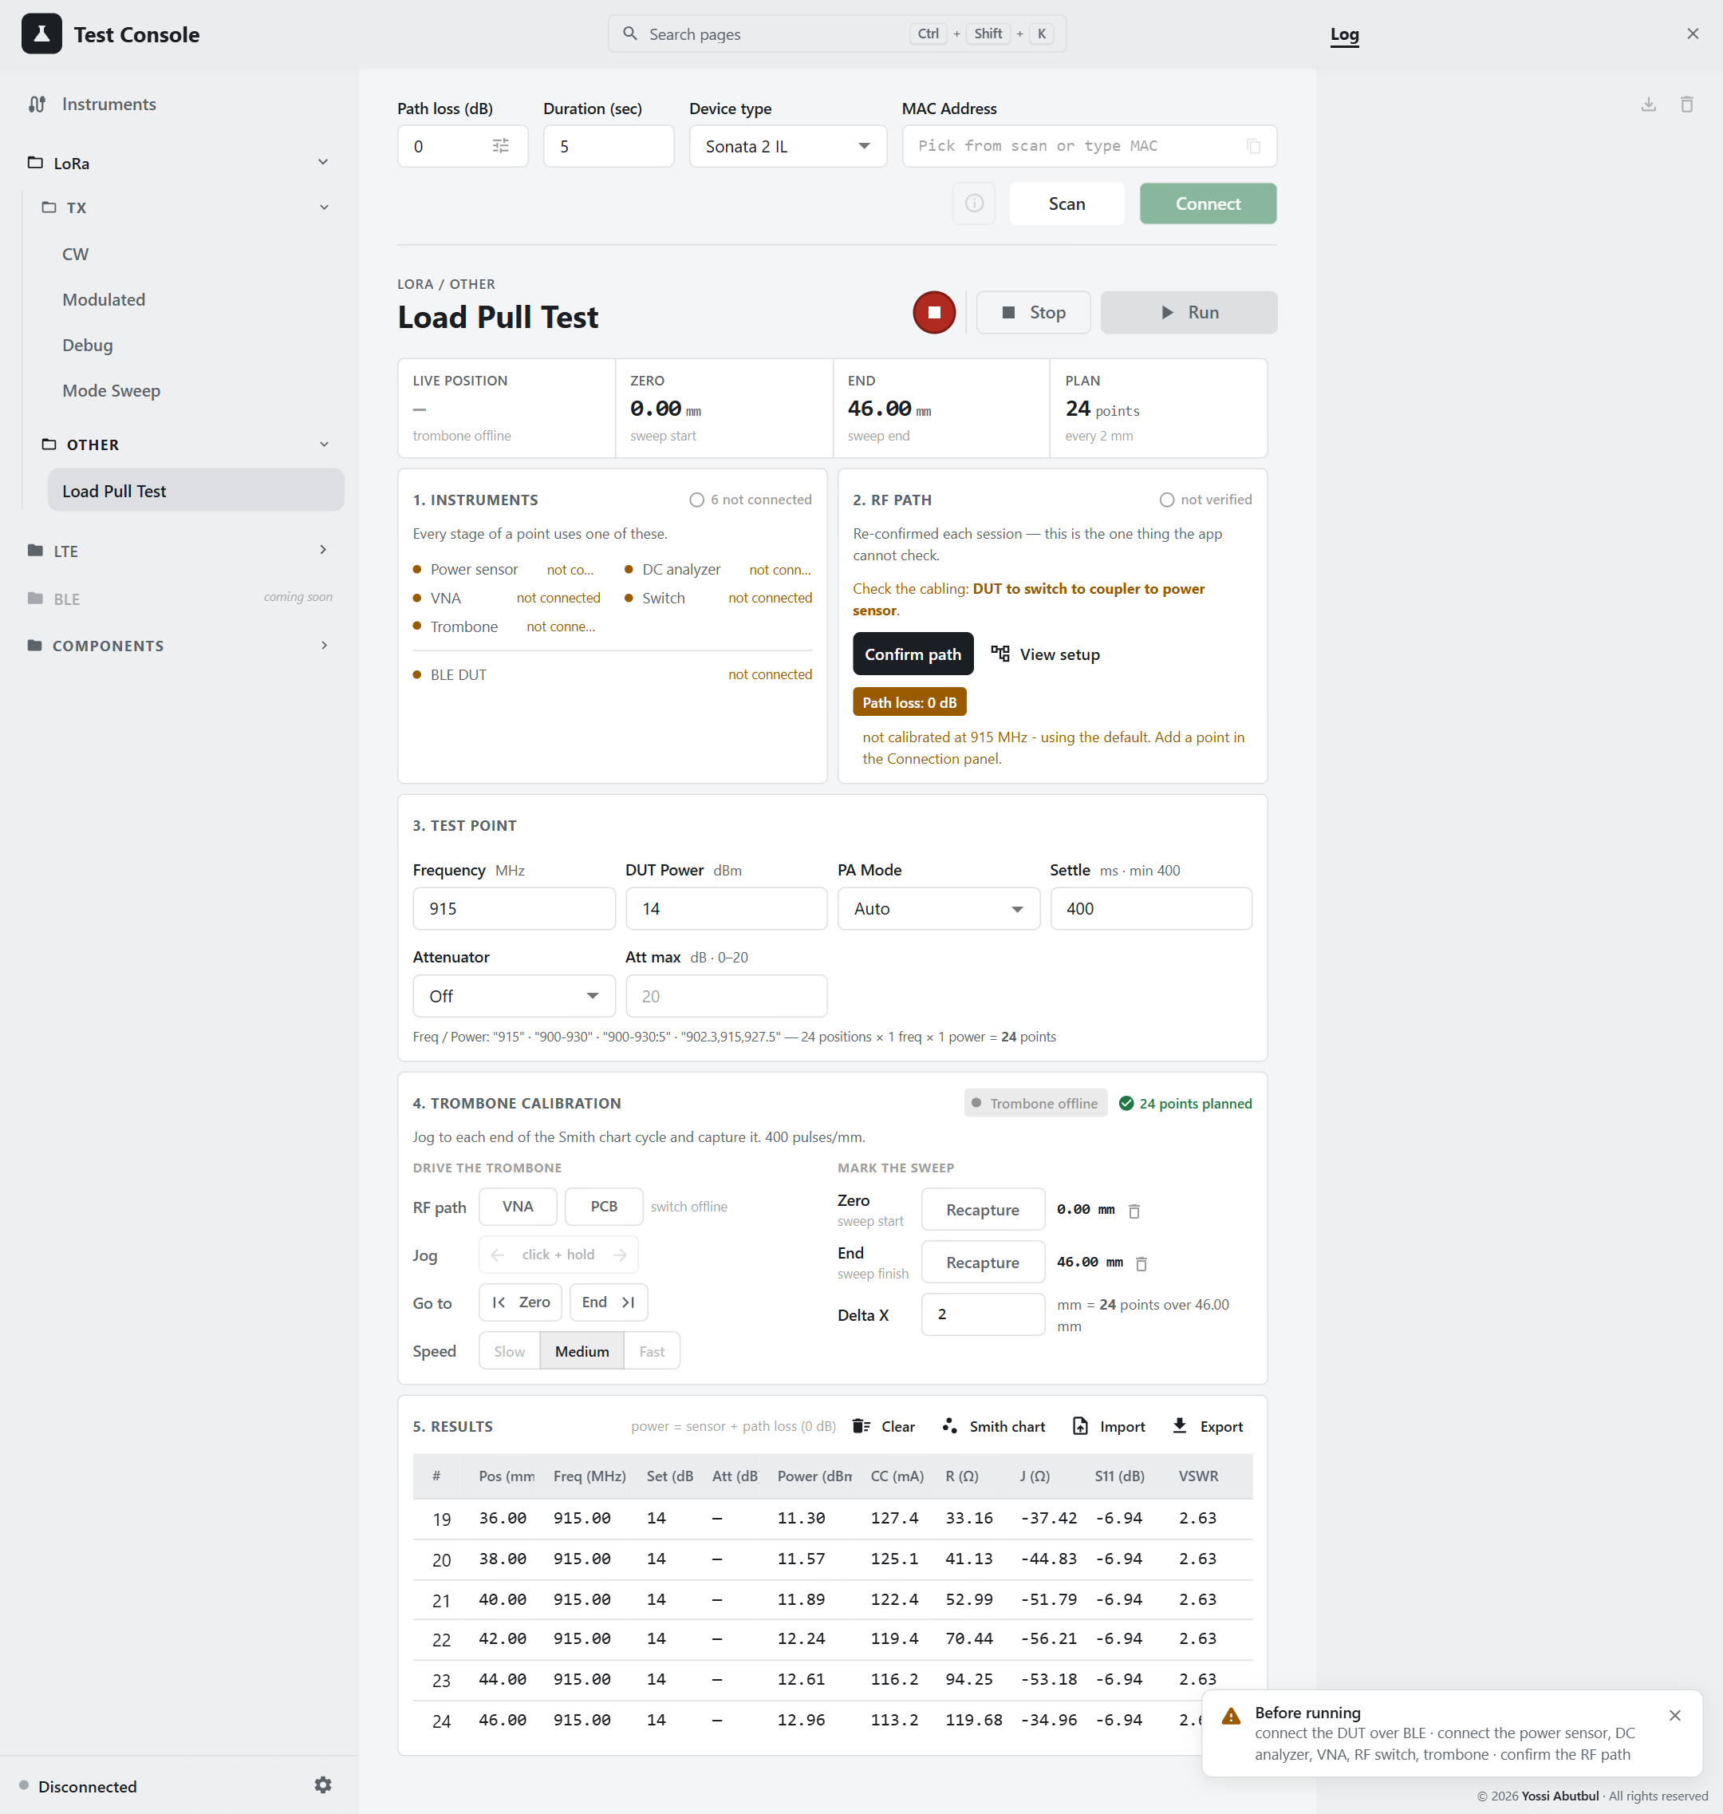
Figure 17 — Load Pull results, example data
Column | Meaning
Pos (mm) | Trombone position
Power (dBm) | Power at the DUT
CC (mA) | Supply current
R (Ω), X (Ω) | The load impedance
S11 (dB), VSWR | How far the load is from 50 Ω

The Power cell is coloured when the sensor was near the edge of its range: amber is marginal, red is unreliable.
Smith chart shows every point, coloured by efficiency (blue low, red high). Hover a point for its numbers; the step number matches the # in the table. With several frequencies or powers, pick which one to show.
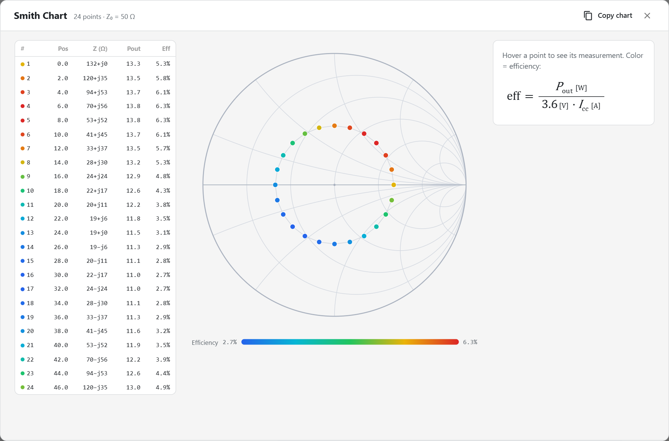
Figure 18 — Smith chart, example data

The Trombone page
Components › Trombone moves the trombone by hand, in mm. It shows the Zero and End captured on Load Pull, and the step buttons move 8 mm at a time. Use it to check the trombone before a Load Pull.
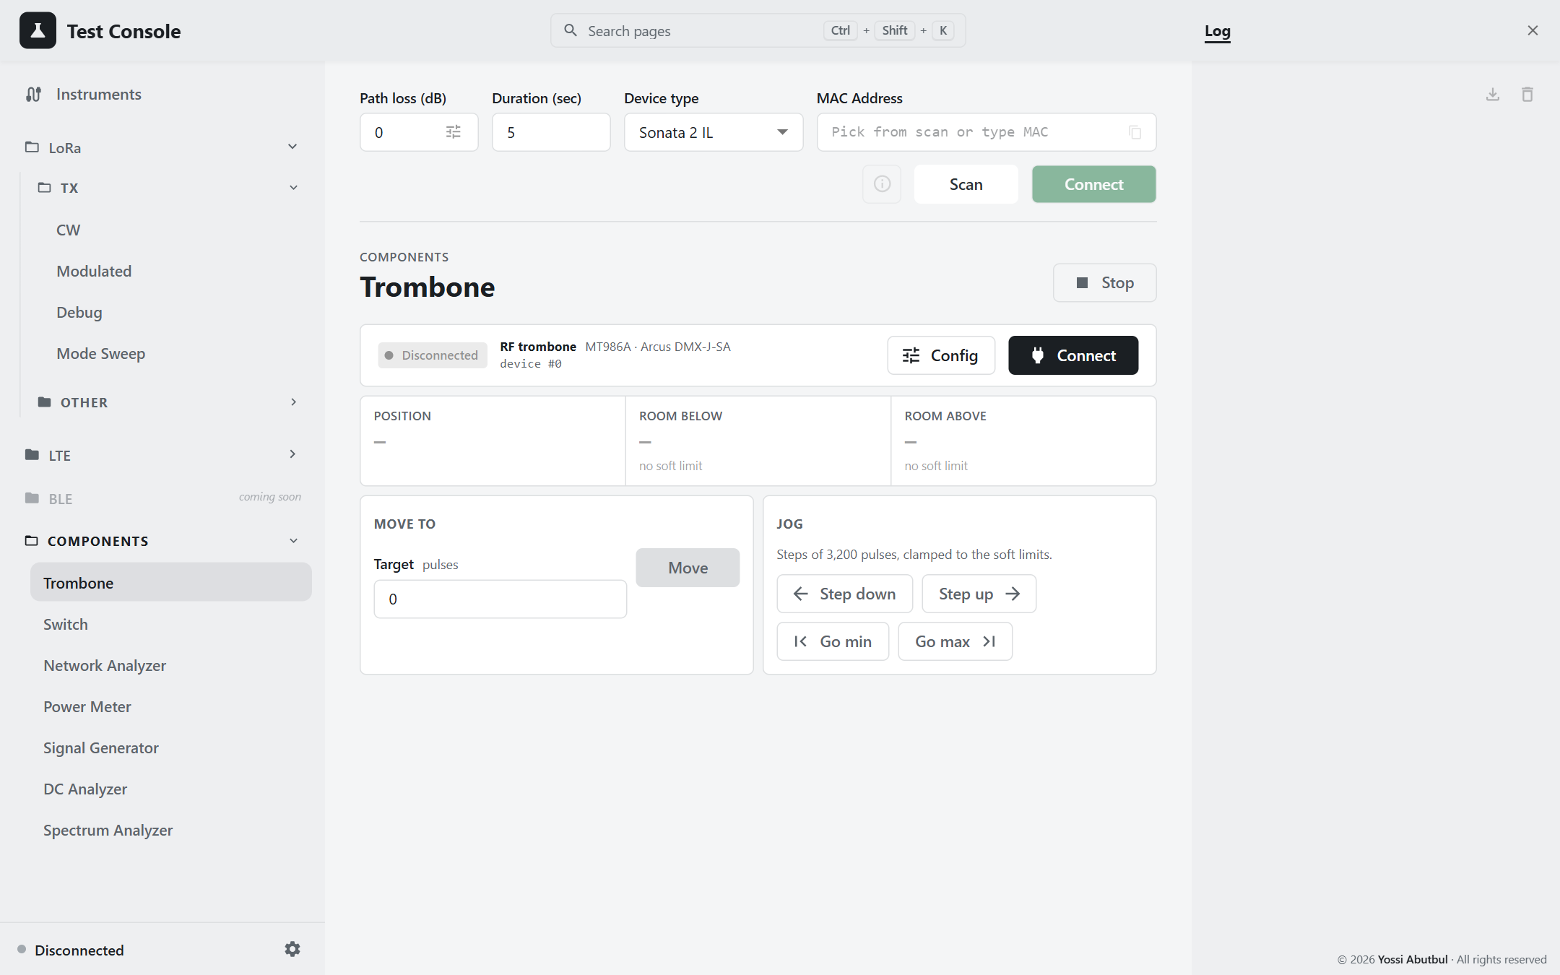
Figure 19 — Trombone

4. LTE tests
The LTE pages use the same bench, path loss and instruments as the LoRa tests.

4.1 The Modem key
The LTE modem is off until you need it and takes about 10 seconds to start. The Modem off / Modem on key in the page header controls it; a green lamp means on.
- Send starts the modem for you if it is off. A box shows while it starts.
- Only the key turns the modem off. Stop doesn't, and neither does the end of a run. Turn the key off when you finish.
- The page can't ask the modem whether it is on; it remembers what it last did. If you see "modem on rejected", turn the key off, then on.
- Stop the test and turn the modem off before switching between the CW and Modulated pages. Each page keeps track of the modem separately.
While a manual transmission is running, an LTE TX tag in the top bar shows how long is left.

4.2 Choosing the channel: EARFCN or MHz
The EARFCN | MHz switch chooses how you enter the channel.
- EARFCN is the LTE channel number. Each one maps to exactly one frequency, shown under the box (for example 1880.0 MHz · Band 2).
- MHz is easier to read, but some frequencies belong to more than one band. The console only looks in the bands ticked under Bands in use (the tune icon). Tick only the bands this rig works in.
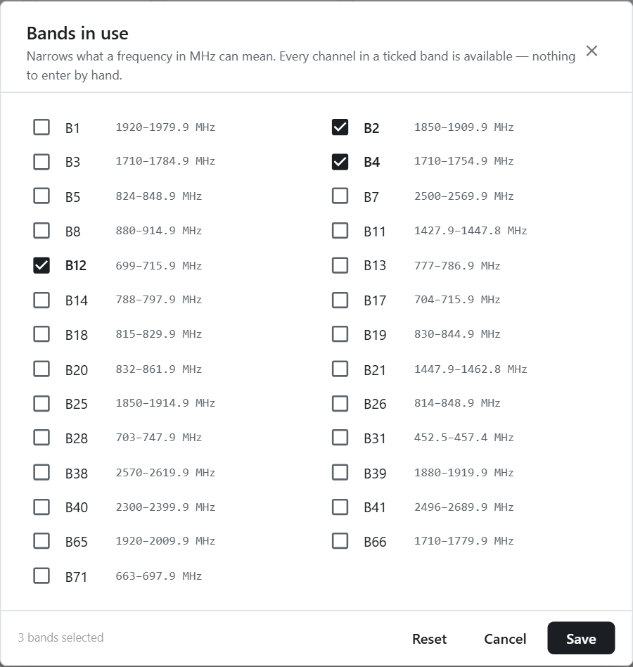
Figure 20 — Bands in use

4.3 LTE CW — one setting
LTE › TX › CW, Manual tab.
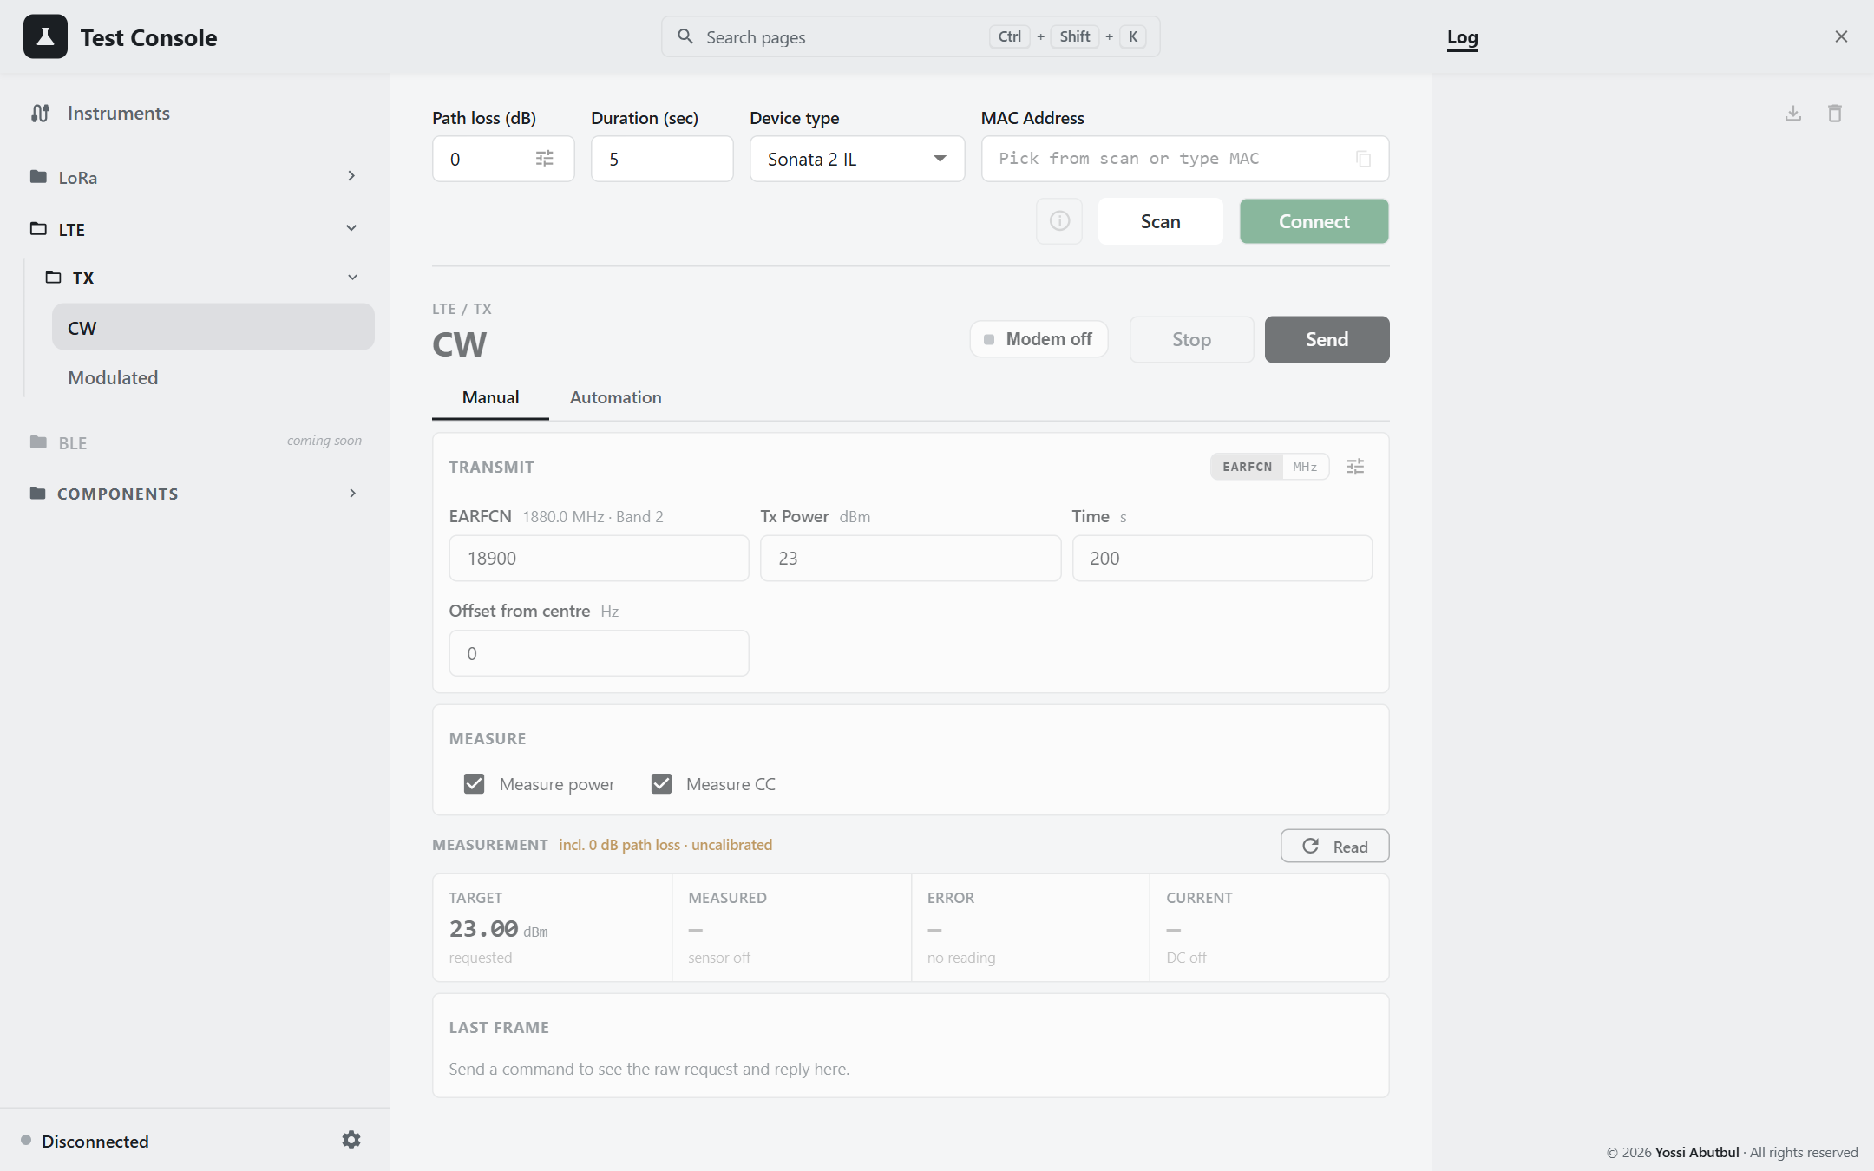
Figure 21 — LTE CW, Manual
- Enter the channel, Tx Power (0–23 dBm), Time (how long to transmit, in seconds) and Offset from centre (usually 0).
- Tick what to measure.
- Press Send. The modem starts if needed, the DUT transmits, and the card fills in.
- Press Stop to end the transmission. The modem stays on.
- Turn the Modem key off when you finish.

4.4 LTE Modulated — one setting
LTE › TX › Modulated, Manual tab. The same as CW, plus the signal:
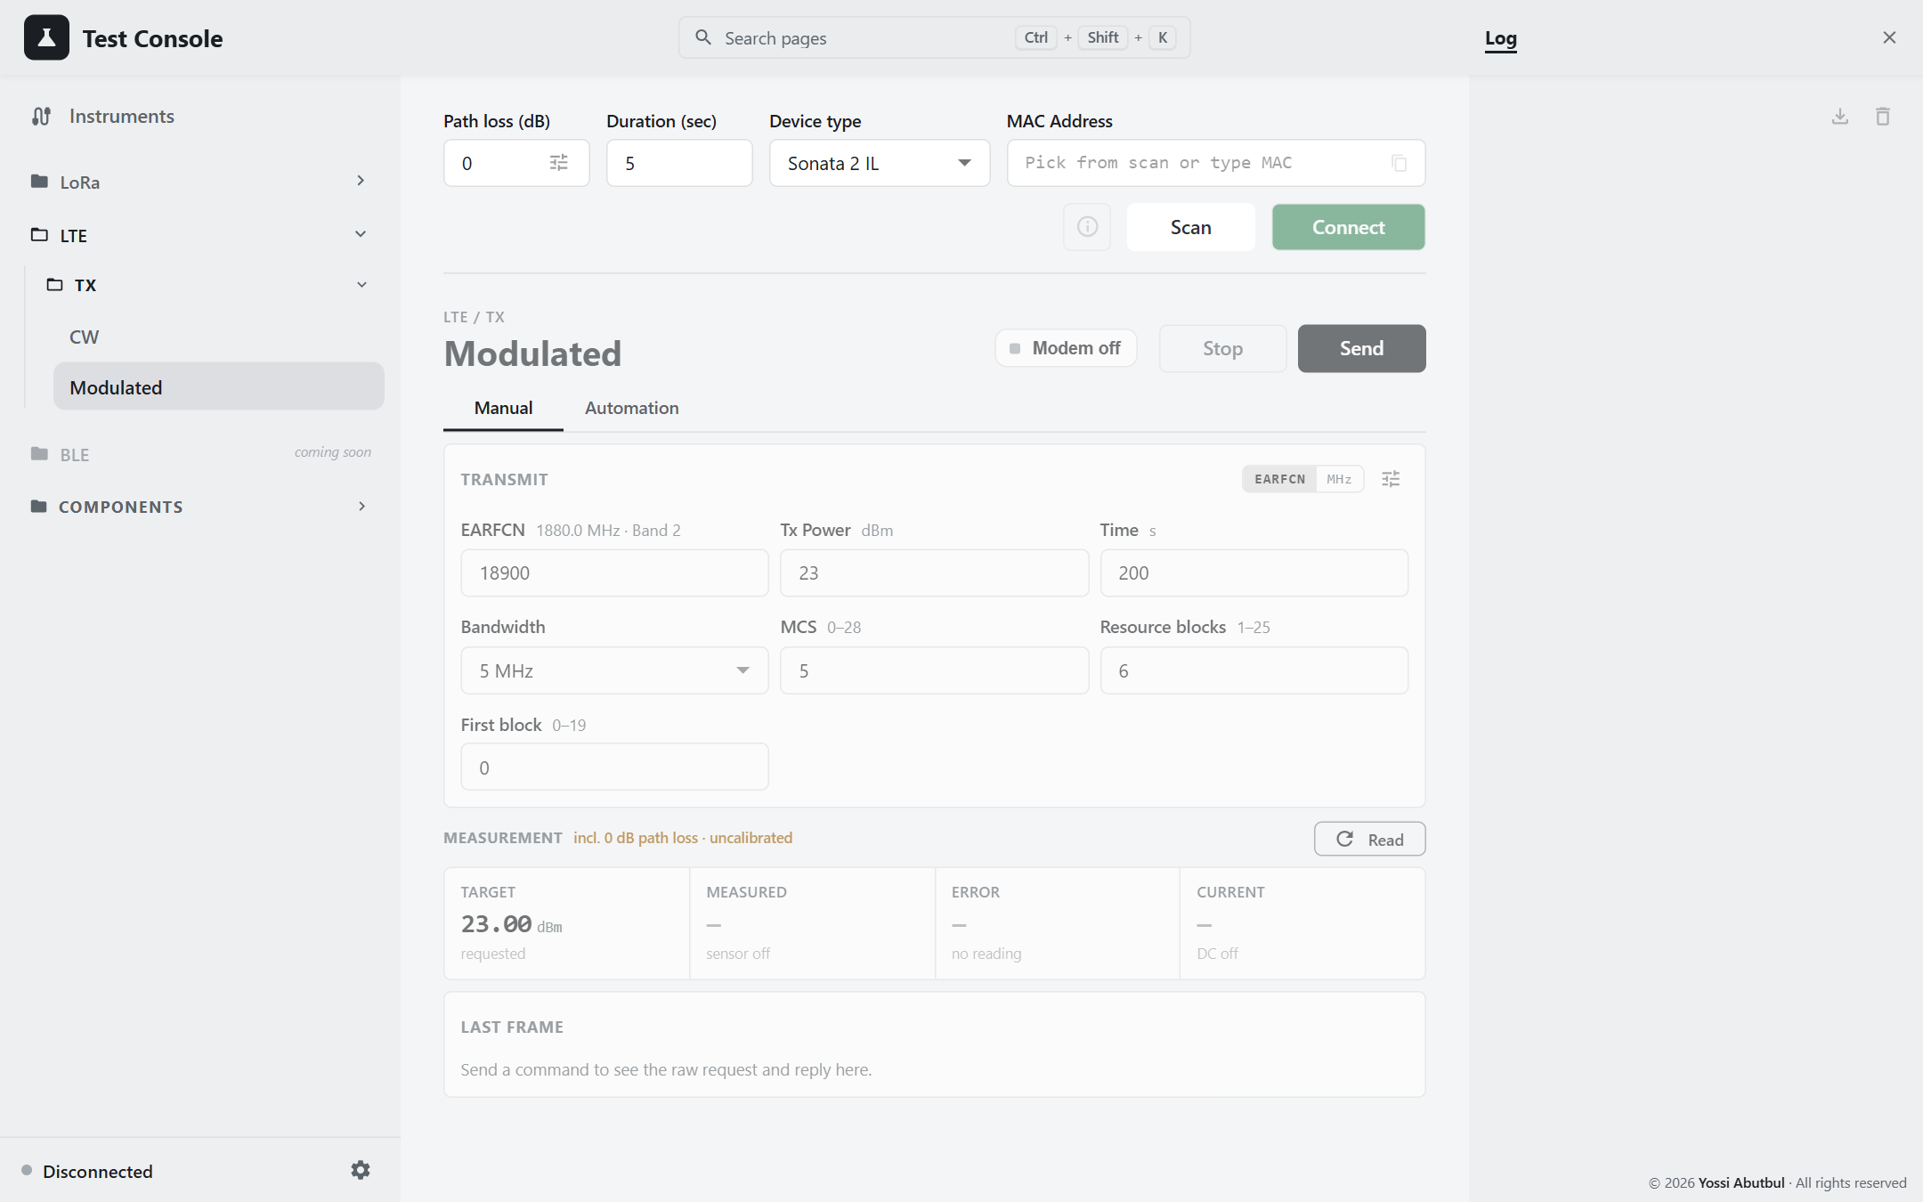
Figure 22 — LTE Modulated, Manual
- Bandwidth: 1.4, 3, 5, 10, 15 or 20 MHz.
- MCS: 0–28.
- Resource blocks and First block: the allocation must fit inside the bandwidth. Changing the bandwidth adjusts them for you.
Power and current are always measured on this page.

4.5 Automation (both pages)
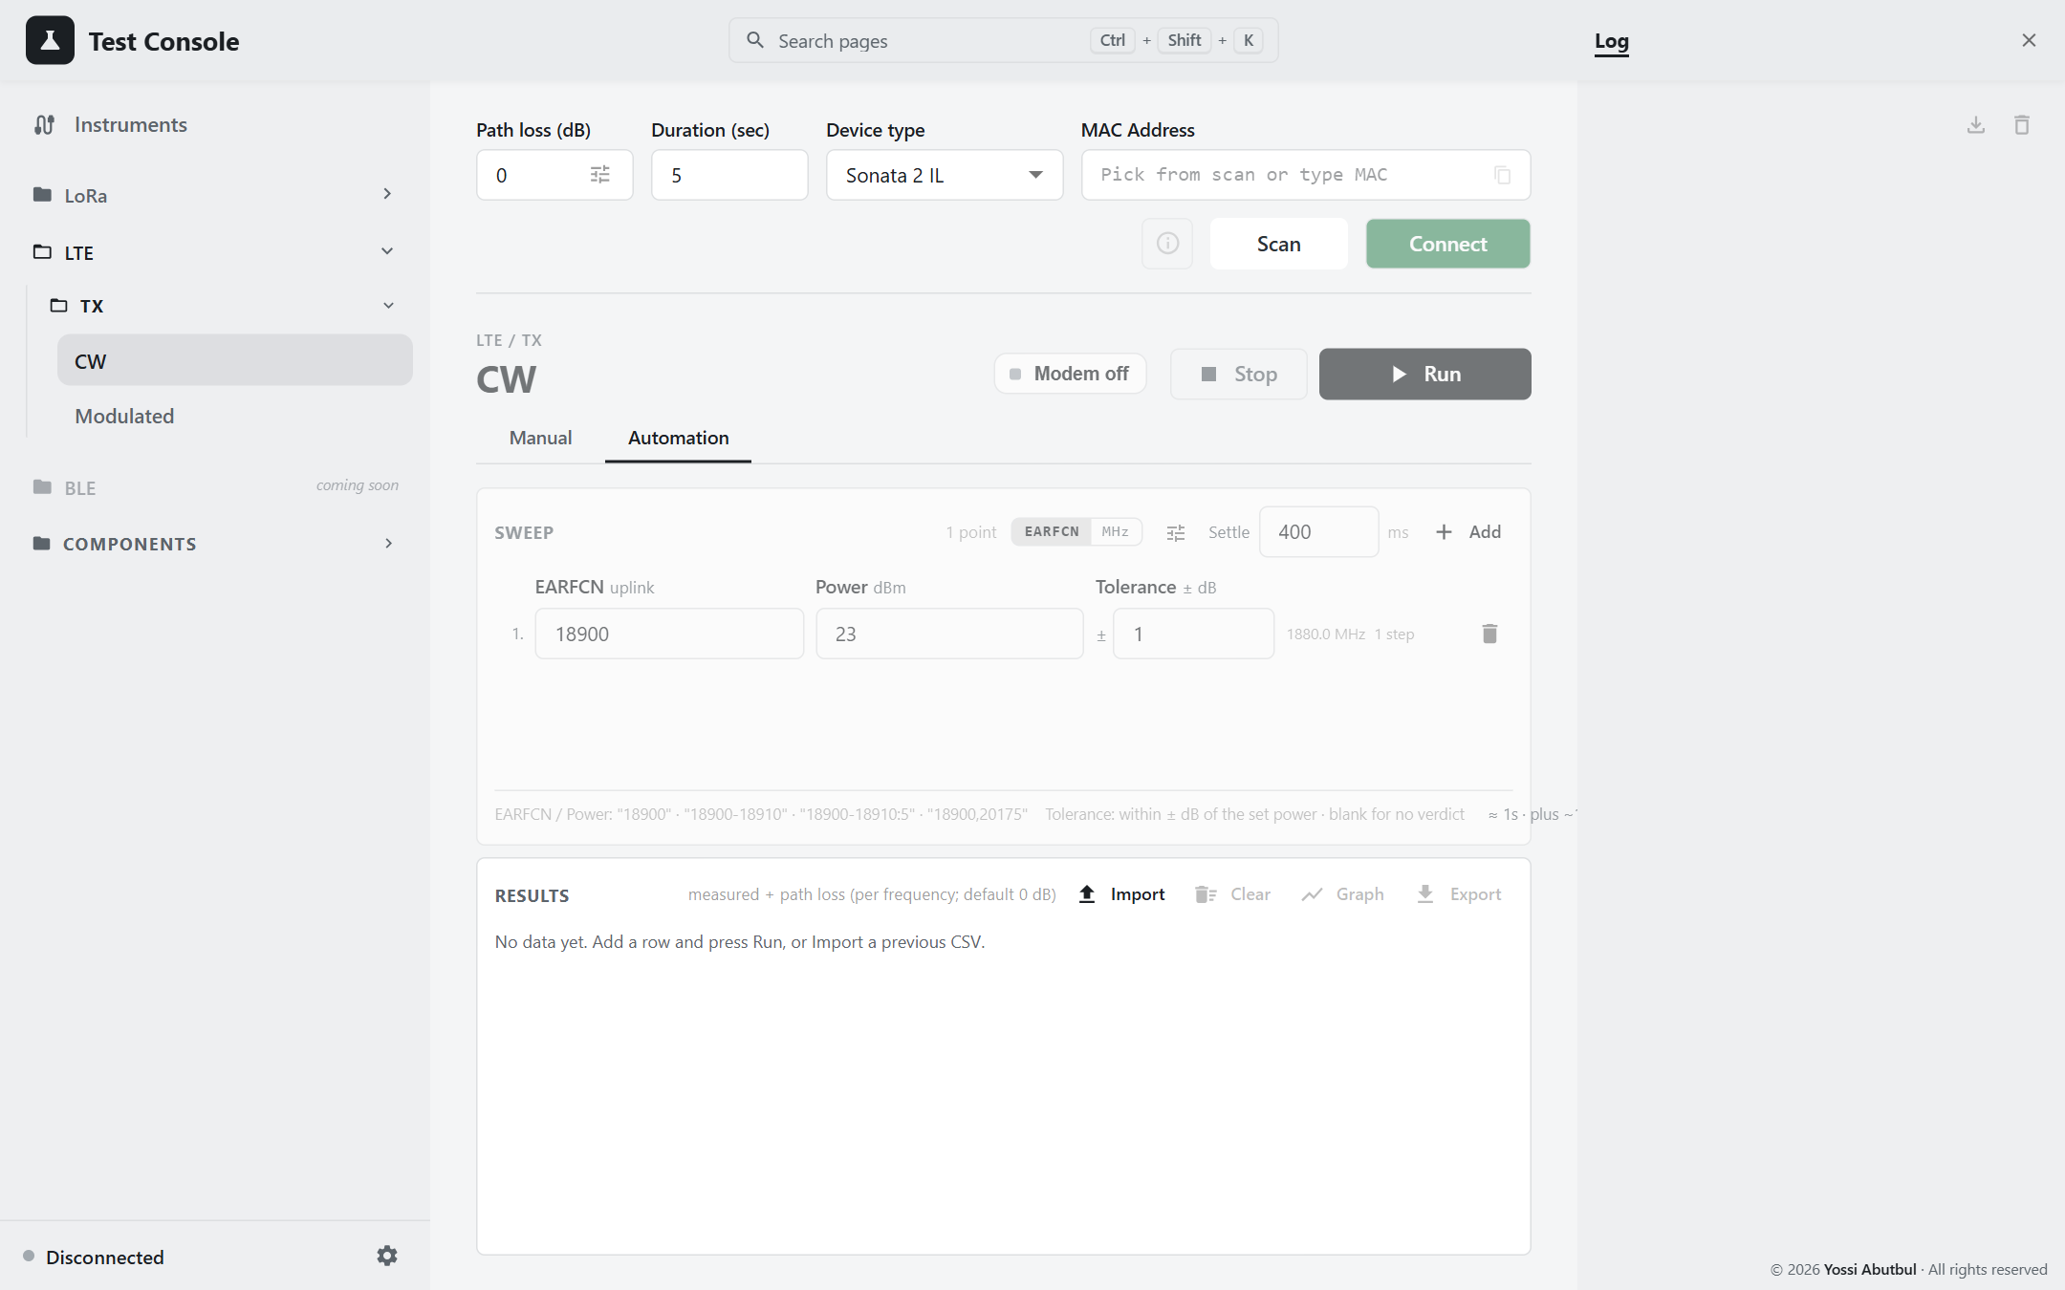
Figure 23 — LTE CW, Automation
- Fill in the rows: channel, Power and Tolerance (plus Bandwidth, MCS and RB on the Modulated page). The list format from 2.4 works for channels too, for example 18900-18910:5.
- Check each row's step count and the time estimate. The estimate includes about 10 s for restarting the modem.
- Press Run. The console restarts the modem first, then measures each point and stops the DUT after it.
- At the end the modem is left on. Turn the key off when you are done.
The results table adds EARFCN and the band to the usual columns; on the Modulated page a Signal column shows the bandwidth, MCS and RBs.
Don't use the Manual tab during a run. Its Send and Stop buttons still work and would disturb the run.

5. Results and saving them

5.1 Graphs
Graph on an Automation tab opens a chart of the results.
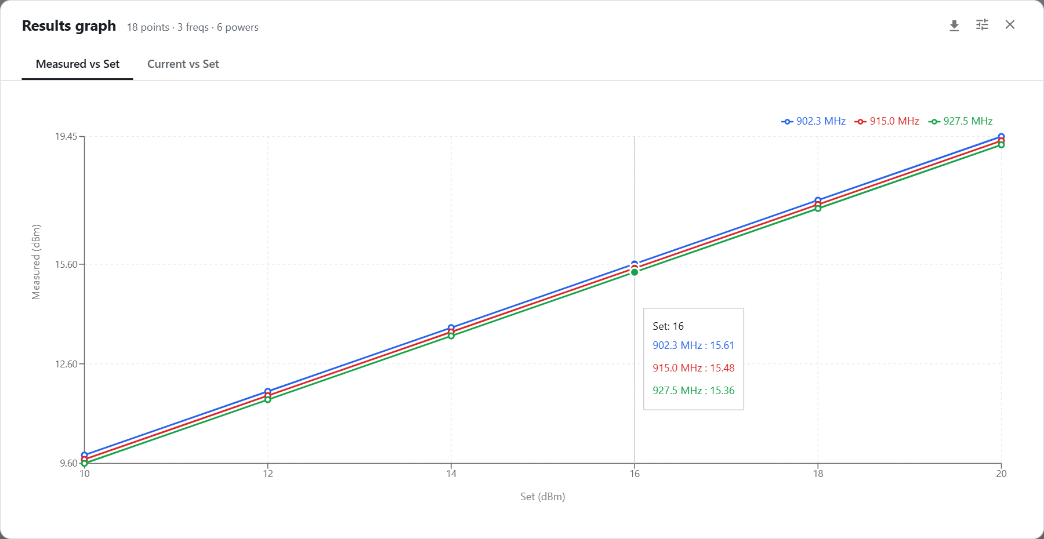
Figure 24 — Results graph, example data
- Two tabs: Measured power and Current, against frequency or set power (whichever has more values).
- Each line is one value of the other setting. On the Modulated pages each modem, bandwidth and datarate combination (or bandwidth, MCS and RB for LTE) gets its own line.
- Click a line in the legend to hide it.
- The options button sets the Y-axis range, the grid and the legend.
- Download saves the chart as a picture.
Mode Sweep's Best settings chart and the Load Pull Smith chart are described with their tests in chapter 3. The Best settings chart has the same download and Y-axis options.

5.2 Exporting
Press Export to save the results.
Test | Saved as
LoRa and LTE automation | A CSV file that opens in Excel
Mode Sweep, Load Pull | An Excel workbook

The file name starts with the DUT's MAC address, then the test, then the date and time, so files sort by unit, then test, then time. For example: D4A1B2C3E4F5_tx-cw-automation_2026-10-18T14-05-31.csv.
What's in an Excel workbook:
- All: every point. Numbers show 2 decimal places; click a cell to see the full value. Failed points are highlighted in red.
- Run: the settings the test ran with, a summary (points measured and failed, lowest and highest power, start and finish time), which DUT and instruments were used, and the path loss.
- Best settings (Mode Sweep): the lowest-current setting for each power, with the current shaded from low to high.
- One sheet per power level (Mode Sweep) or per frequency (Load Pull).
The header row stays in view as you scroll, and every column has a filter.
Export after every run. A new run clears the table, and Mode Sweep results are lost if the console is restarted.

5.3 Importing
Import opens a file you exported earlier, to look at it again.
- On the automation pages, an imported CSV replaces the table; it does not add to it.
- On Mode Sweep and Load Pull, the imported workbook is for viewing. Clear goes back to your own results.
Files exported by older versions of the console still import.

5.4 The log
The Log (icon at the top right) lists everything that happened, newest at the top. Errors are red, warnings amber. Its download button saves it as a text file — useful to attach to a fault report.

6. Bench checks

6.1 Measuring path loss
Do this for every frequency you test at, and again whenever you change a cable or attenuator.
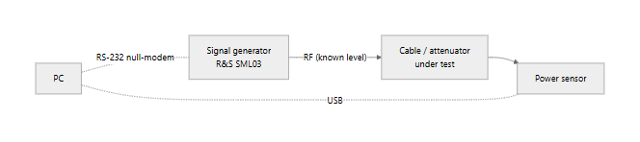
Figure 25 — Bench for a path-loss check
- Connect the signal generator to the input of the cable or attenuator, and the power sensor to its output.
- On Components › Signal Generator, set the frequency and a known level, and press RF On.
- On Components › Power Meter, read the power at the same frequency.
- Path loss = level set − level read. Enter it in the path loss table (1.5) at that frequency.
- Press RF Off on the Signal Generator page. Disconnecting the generator does not turn its output off.
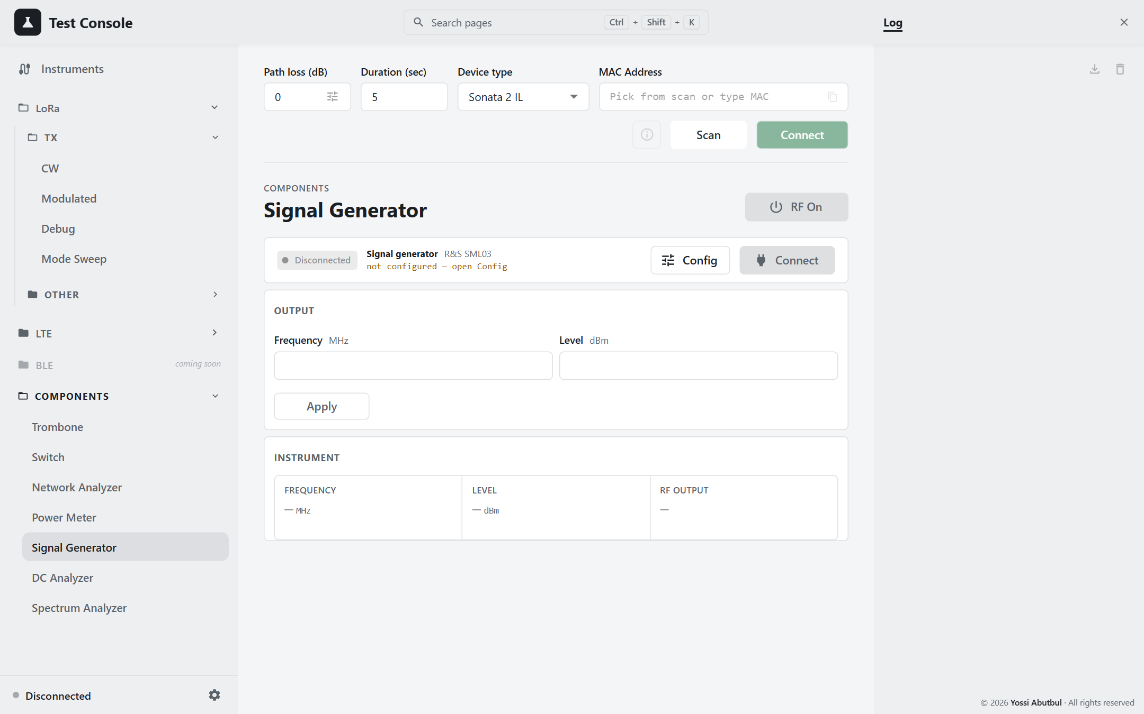
Figure 26 — Signal Generator
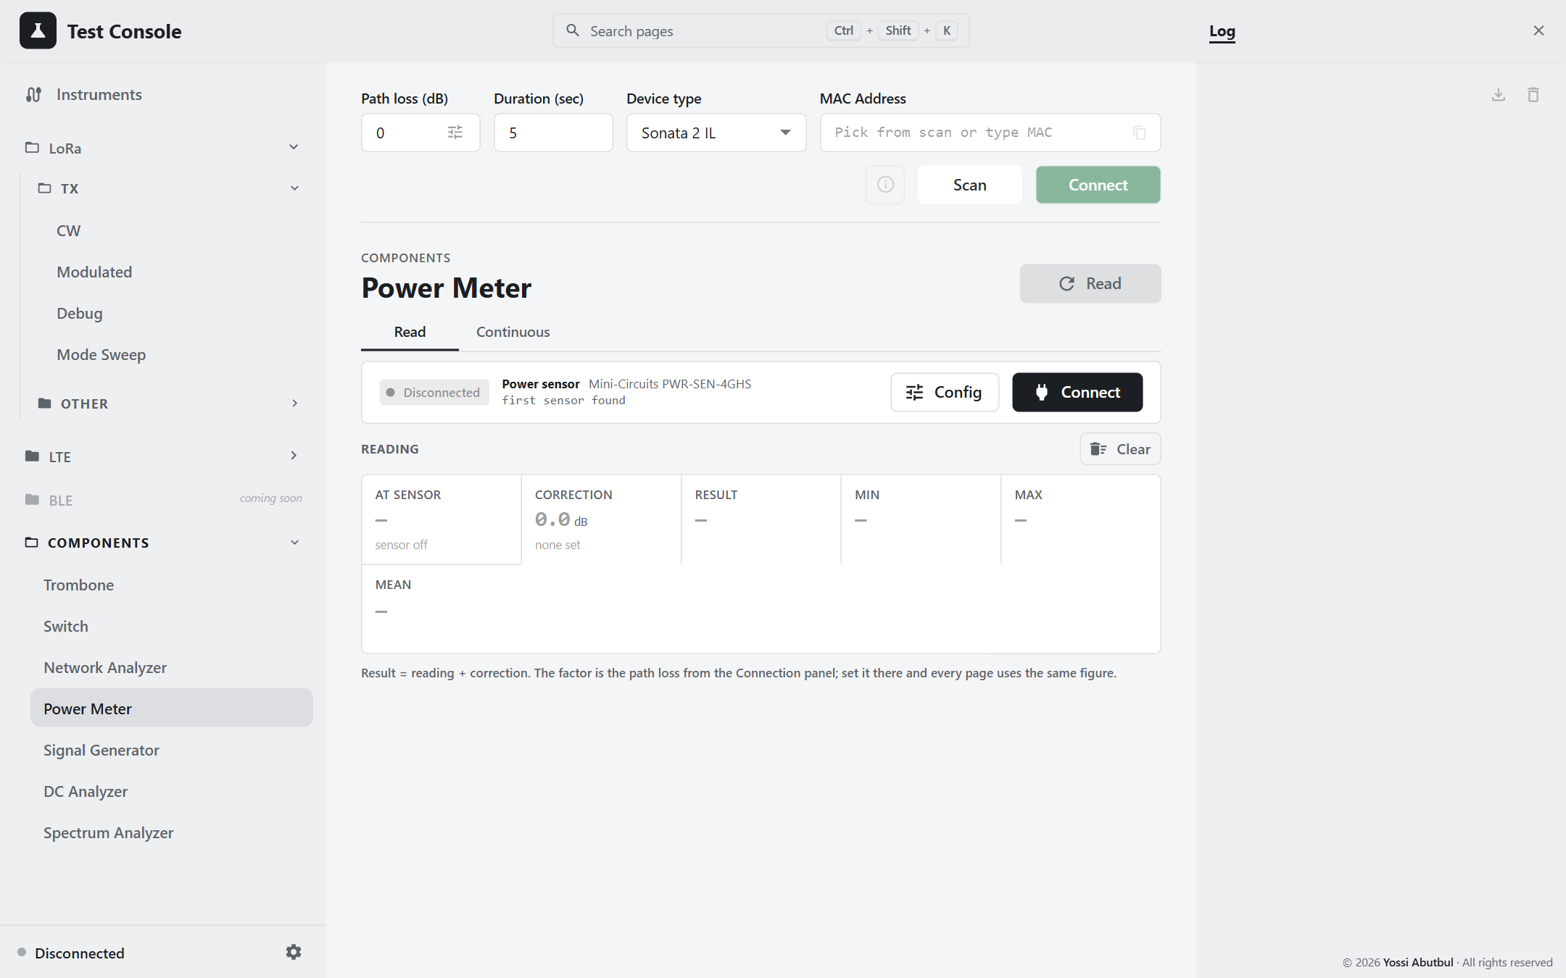
Figure 27 — Power Meter

6.2 Checking the trombone before Load Pull
- Put the switch on VNA: press Go VNA on Components › Switch.
- On Components › Network Analyzer, watch the Smith chart.
- On Components › Trombone, step the trombone and check the load moves smoothly around the chart.

6.3 Watching the DUT's current
Components › DC Analyzer shows the DUT's voltage, current and power live, and lets you set the voltage and a current limit. Output On powers the DUT.
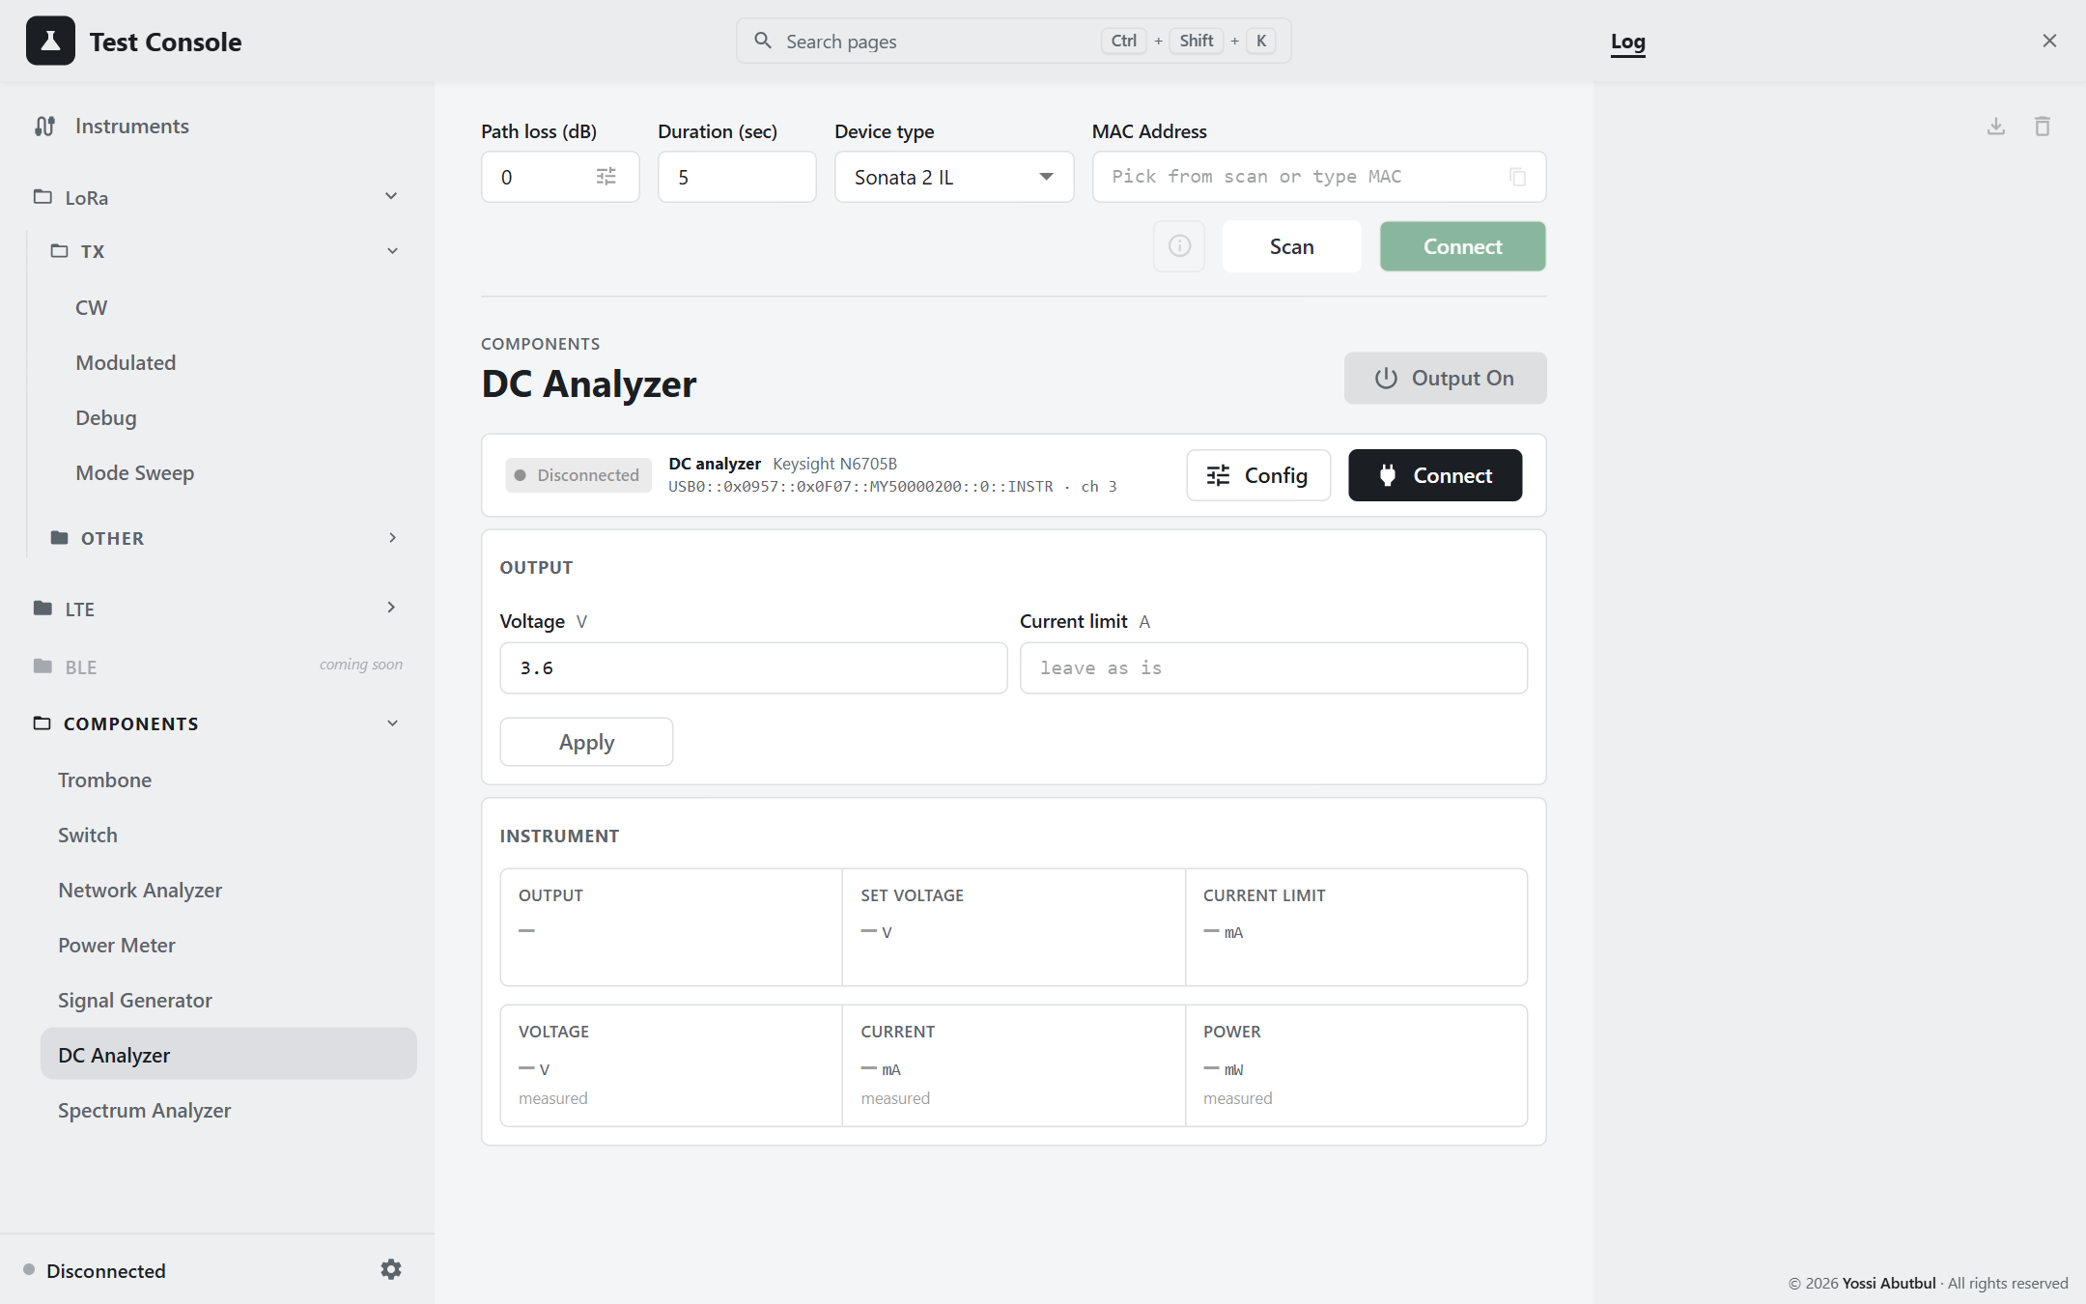
Figure 28 — DC Analyzer

7. When something goes wrong
What you see | What to do
Connect is greyed out | The unit isn't in the current scan. Press Scan, and check the Device type.
The test page is faded and won't respond | The DUT isn't connected. Connect it again.
An instrument won't connect | Read the message on its row in the Instruments panel (1.2). Check power and cables.
"No signal at the power sensor" | Check the RF cables. Check that the DUT is actually transmitting. Try a longer Settle.
A low-power point reads too high | Settle is too short. Use at least 400 ms.
Measured power is off by the same amount everywhere | The path loss is wrong or missing for that frequency (it shows uncalibrated). Measure it (6.1).
The DUT stops answering during a run | Disconnect it, power-cycle it, connect again, and re-run.
LTE: "modem on rejected" | Turn the Modem key off, then on.
LTE: the channel didn't change | Press Stop, then Send again.
Load Pull: Run is greyed out | Read the Before running notice. Usually the path isn't confirmed, or Zero/End aren't captured.
Load Pull: the trombone won't jog further | It is at Zero or End. That is the travel limit working.
Mode Sweep results have gone | They are lost when the console restarts. Export after every run.
A tag in the top bar won't go away | Click it to open the page that controls it, and turn that output off there.

If a problem keeps happening, download the Log (5.4) and pass it on with a description of what you were doing.

End-of-day checklist
- Press Stop on any page that is transmitting.
- Turn the LTE Modem key off.
- On the Signal Generator page, press RF Off.
- Turn the DUT supply off (Settings or the DC Analyzer page).
- Check the top bar: no tags should be showing.
- Export anything you haven't saved.
- Disconnect the DUT.

Words used in this guide
Word | Meaning
DUT | Device under test: the meter being tested
PA | Power amplifier
CW | A plain, unmodulated carrier
Path loss | The loss between the DUT and the sensor, added to every reading
Settle | How long the DUT transmits before the reading
Tolerance | The ± dB window for a PASS
PA Duty Cycle, HP Max | Two PA settings that Mode Sweep tries in every combination
EARFCN | An LTE channel number
MCS / RB | LTE modulation level / resource blocks
Trombone | A motorised line whose length changes the load
Smith chart | A chart of load impedance; the centre is 50 Ω
VSWR | How far the load is from 50 Ω (1.0 is perfect)

