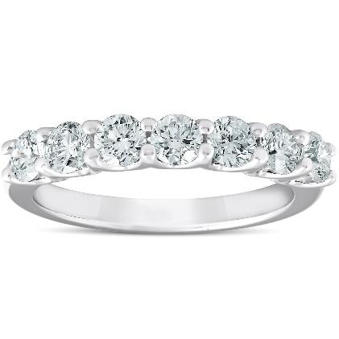
2023-05-06
A123446 A123446
Type of jewelry………………………………..Ring Ring
Metal Type…………………Platinum (328) Platinum (328)
Total Metal Wight………………………..0.0 0.0
Stone Type………………………Natural Diamond Natural Diamond
Stone Total Weight………………………….0.0 0.0
Amount of Stones………………………………0 0
Color Grade…………………………………....D D
Clarity Grade…………………………………….IF IF
Cut Grade………………………………….Excellent Excellent

Additional Comments:

Apprised Retail Price: 0.0$
