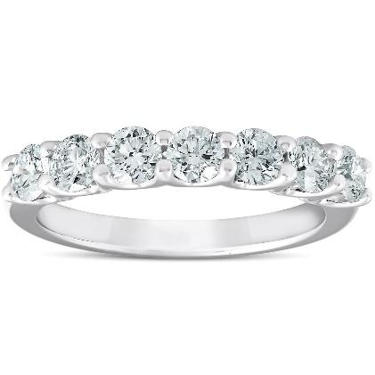
2023-07-10
asfsaf12321321 asfsaf12321321
Type of jewelry………………………………..Ring Ring
Metal Type…………………Rose Gold 18K Rose Gold 18K
Total Metal Wight………………………..0.0 0.0
Stone Type………………………Natural Diamond Natural Diamond
Stone Total Weight………………………….0.00123211 0.00123211
Amount of Stones………………………………123 123
Color Grade…………………………………....D D
Clarity Grade…………………………………….VS2 VS2
Cut Grade………………………………….Excellent Excellent

Additional Comments:
sfasfsfa
Apprised Retail Price: 0.0$

