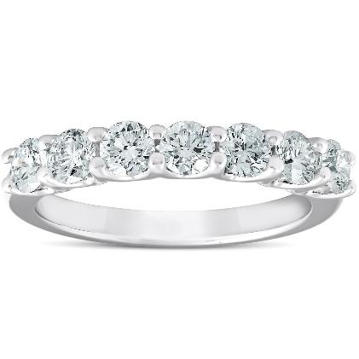
2023-07-18
31221wasd1 31221wasd1
Type of jewelry………………………………..Earrings Earrings
Metal Type…………………Platinum - 328 Platinum - 328
Total Metal Wight………………………..0.0 0.0

Stone Type………………………Lab Grown Diamond Lab Grown Diamond
Stone Total Weight………………………….4.8 4.8
Amount of Stones………………………………4 4
Color Grade…………………………………....D D
Clarity Grade…………………………………….IF IF
Cut Grade………………………………….Excellent Excellent

Additional Comments:
dasgwegw1212
Apprised Retail Price: 2222€

