Deep Learning-Based Plant Disease Identification Using VGG-19, ResNet, Inception, and ViT

1. Dataset Overview and Preprocessing
The dataset used is the PlantVillage Dataset It contains colored images of plant leaves for detecting diseases across various crops.

- Original Size: 54,306 images.
- Classes: 38 classes (e.g., Apple Scab, Tomato Late Blight, Potato Healthy, etc.).
- Resolution: Varied, resized to 224×224×3.
- Key Issue Identified: The dataset contained 21 exact duplicate images (100% identical pixels), which could cause data leakage.

Preprocessing Steps Performed:
1. Copying to Writable Directory
The original dataset is read-only on Kaggle. We copied it to `/kaggle/working/plantvillage_clean` to allow modifications.

2. Duplicate Removal
- Used MD5 hashing to detect identical images.
- Skipped 21 duplicates (kept only the first occurrence).
- Final Clean Dataset: 54,284 unique images.
This step ensures no data leakage and produces honest evaluation results.

3. Dataset Visualization
- Displayed class distribution to check balance.
- Showed sample images from the first 6 classes (3 images per class) after cleaning.
- Purpose: Verify data quality and demonstrate the effect of duplicate removal.

4. Data Splitting
- 70% Training (≈37971images)
- 15% Validation (≈8154 images)
- 15% Testing (≈8159 images)
- Stratified random split with `random_state=42` for reproducibility.
- Images copied to separate folders: `/kaggle/working/plantvillage_split/train`, `val`, `test`.

5. Data Augmentation (using ImageDataGenerator)
- Rescaling: pixel values to [0,1].
- Augmentation techniques applied only on training set:
- Rotation (±20°)
- Width/Height shift (±20%)
- Shear (±20%)
- Zoom (±20%)
- Horizontal flip
- Purpose: Increase diversity, prevent overfitting, and simulate real-world leaf orientations.

2. Model: VGG-19 Architecture from Scratch
We implemented the VGG-19 model exactly as described in the original paper, without using pre-trained weights.

Architecture Details (19 layers):
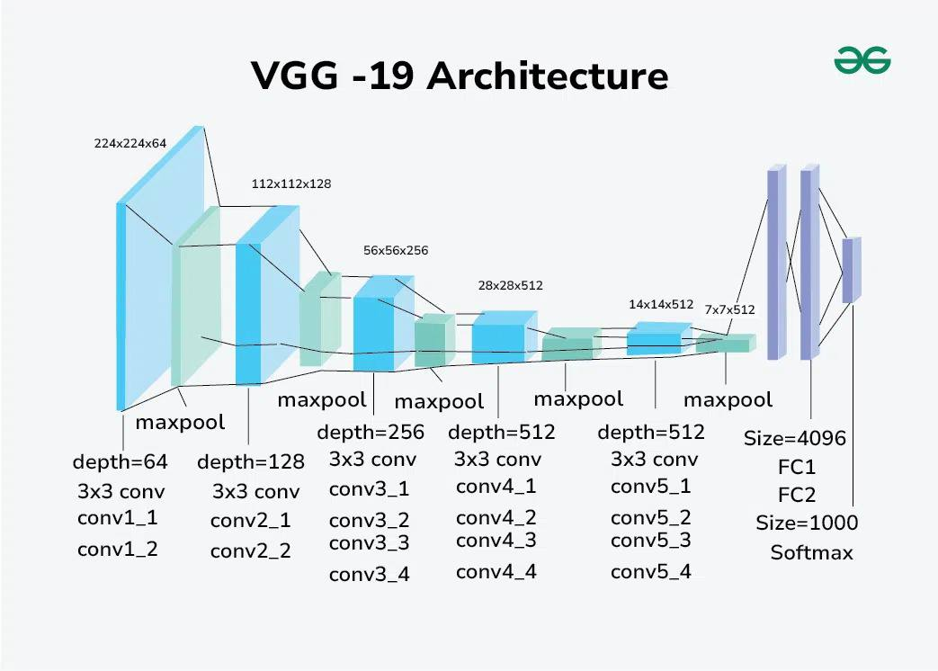
- Input: 224×224×3 RGB image.
- Convolutional Blocks (Feature Extraction):
- Block 1: 2×Conv(64, 3×3) + ReLU + MaxPool → 112×112×64
- Block 2: 2×Conv(128, 3×3) + ReLU + MaxPool → 56×56×128
- Block 3: 4×Conv(256, 3×3) + ReLU + MaxPool → 28×28×256
- Block 4: 4×Conv(512, 3×3) + ReLU + MaxPool → 14×14×512
- Block 5: 4×Conv(512, 3×3) + ReLU + MaxPool → 7×7×512
- Fully Connected Layers (Classification):
- Flatten
- FC1: 4096 neurons + ReLU + Dropout(0.5)
- FC2: 4096 neurons + ReLU + Dropout(0.5)
- FC3: 38 neurons + Softmax (adapted for our 38 classes)
- Total Parameters: ~138 million.
- Activation: ReLU throughout.
- Pooling: 2×2 MaxPooling with stride 2.

Training Configuration:
- Optimizer: Adam (learning rate = 0.001)
- Loss: Categorical Crossentropy
- Metrics: Accuracy
- Batch Size: 16
- Callbacks:
- ModelCheckpoint
- EarlyStopping
- ReduceLROnPlateau

Evaluation Results on Test Set:
- Test Accuracy: 97.623%
- Test Loss: 0.0812
- Confusion Matrix: High diagonal values, minimal misclassifications.
- Classification Report: Precision, Recall, F1-Score
- ROC Curves & AUC: All 38 classes achieved AUC ≈ 0.999–1.000 (perfect separation after cleaning).

References
1. Simonyan, K., & Zisserman, A. (2015). Very Deep Convolutional Networks for Large-Scale Image Recognition. International Conference on Learning Representations (ICLR).
Link: [1409.1556] Very Deep Convolutional Networks for Large-Scale Image Recognition.

2. Kaggle Dataset: https://www.kaggle.com/datasets/abdallahalidev/plantvillage-dataset

