Plant Disease Classification: Model Architectures and Evaluation Documentation

1. Data Preprocessing and Handling Class Imbalance
The PlantVillage dataset, containing images of plant leaves across 38 classes (representing different plant species and their healthy/diseased states), was downloaded from Kaggle. The dataset consists of color images resized to 224x224 pixels for compatibility with the model architectures.

Key preprocessing steps included:
1- Dataset Acquisition: The PlantVillage dataset was downloaded from Kaggle using kagglehub.dataset_download, but references path /kaggle/input/plantvillage dataset/color. It contains color images of plant leaves in 38 classes (healthy or diseased plant species). No resizing here, but prepared for 224x224 later.
2- Dataset Cleaning (Duplicate Removal): Exact duplicates were identified and removed using MD5 hashing on image files. This ensured a clean dataset by skipping copies, resulting in unique images being copied to a new directory (plantvillage_clean).
Outcome: 54,284 unique images, with 21 duplicates removed.
3- Dataset Exploration & Visualization: Displayed random sample images from the first 6 classes (e.g., Apple___Apple_scab) using matplotlib to show the plant and disease.
4- Configuration Setup: Set parameters: IMG_SIZE=224, BATCH_SIZE=16, NUM_EPOCHS=30, FINE_TUNE_EPOCH=10, VALIDATION_SPLIT=0.15, TEST_SPLIT=0.15.
5- Data Splitting: The dataset was split into training (70%), validation (15%), and test (15%) sets using train_test_split from scikit-learn on image path lists , with random_state=42 and shuffle=True. Images were copied to new directories (plantvillage_split/train, val, test).
6- Check Split: Counted images in each set: training 37,971, validation 8,154, test 8,159.
7- Get Class Counts: Computed image counts per class in the original and split sets.
8- Class Distribution Plot: Plotted histograms of class distributions in original, training, validation, and test sets using matplotlib.
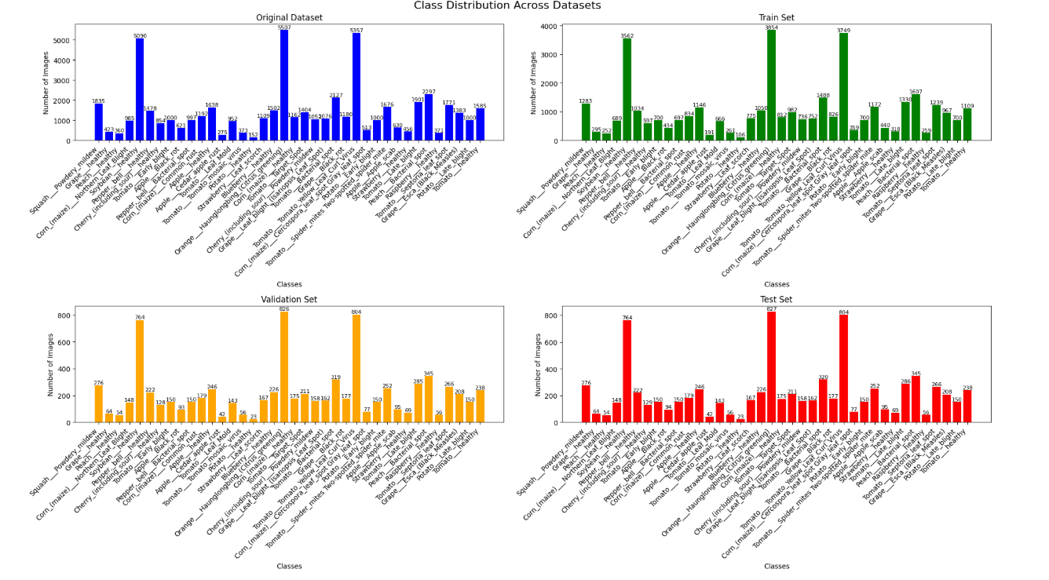
9- Plot Class Distribution in Training: Plotted histogram and percentages of class distribution in the training set, with stats (samples count, largest/smallest class, imbalance ratio = 5.12:1) .
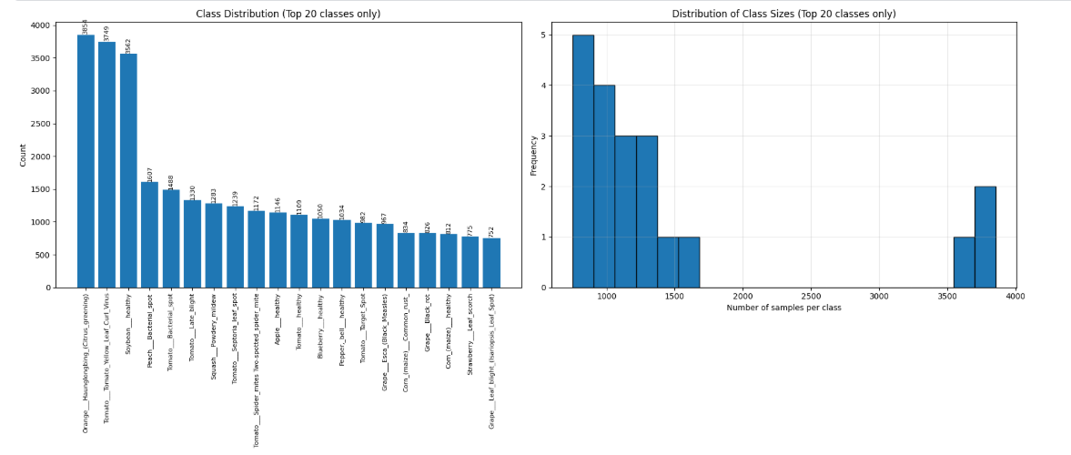

10- Physical Augmentation Step:
- physically augment the data before training:
  - Source: Original training directory (/kaggle/working/plantvillage_split/train).
  - Goal: Balance the dataset by ensuring exactly 1500 images per class (TARGET_COUNT=1500).
    - For classes with fewer than 1500 images: Generate additional augmented images using ImageDataGenerator and save them as new files in /kaggle/working/plantvillage_physical_augmented/<class_name>.
    - For classes with more than 1500 images: Randomly downsample to 1500 by deleting excess files (or selecting a subset).
  - Augmentation parameters used:
    - rotation_range=20
    - width_shift_range=0.2
    - height_shift_range=0.2
    - shear_range=0.1
    - zoom_range=0.15
    - horizontal_flip=True
    - fill_mode='nearest'
    - brightness_range=[0.8, 1.2]
    - channel_shift_range=0.1
    - rescale=1./255
  - Result: After applying physical data augmentation combined with controlled downsampling, the dataset became perfectly balanced, with exactly 1500 images per class stored in the new augmented directory.
  - The class imbalance issue has been fully resolved, achieving an imbalance ratio (max/min) of 1.00, which indicates equal representation across all 38 classes.
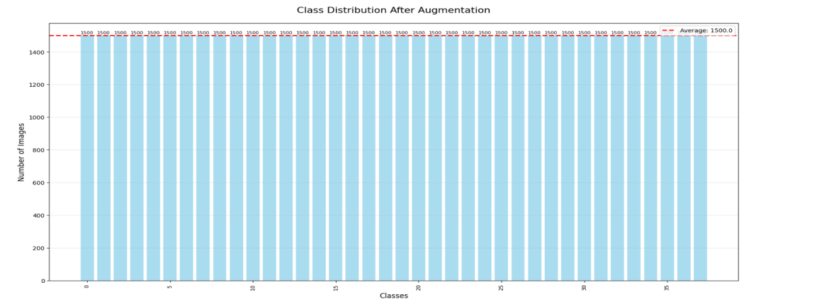

Data Generators :
- Training Generator:
  - Created from the new physically augmented directory (/kaggle/working/plantvillage_physical_augmented).
  - Uses ImageDataGenerator with the above augmentation parameters (on-the-fly during training) + rescale=1./255.
  - target_size=(224, 224)
  - batch_size=32
  - class_mode='categorical'
  - shuffle=True (default)
- Validation Generator:
  - Created from validation directory (/kaggle/working/plantvillage_split/val or equivalent).
  - ImageDataGenerator with only rescale=1./255 (no augmentation).
  - target_size=(224, 224)
  - batch_size=32
  - class_mode='categorical'
  - shuffle=True (default)
- Test Generator:
  - Created from test directory (/kaggle/working/plantvillage_split/test or equivalent).
  - ImageDataGenerator with only rescale=1./255 (no augmentation).
  - target_size=(224, 224)
  - batch_size=32
  - class_mode='categorical'
  - shuffle=False
12- Batch Shape Check: Printed dimensions of one batch (images.shape, labels.shape).
13- Visualize Augmented Samples: Displayed 12 augmented images from a batch with class names. .
14- Validation & Test Generators Creation: validation_generator and test_generator from their directories, batch_size=16, shuffle=False.

2. Detailed Explanation of Architectures Used
Five deep learning architectures were implemented for plant disease classification. Each was trained using transfer learning where applicable, with custom classification heads tailored to the 38-class problem. All models used categorical cross-entropy loss and Adam optimizer, with callbacks for early stopping, learning rate reduction, and model checkpointing.

Model 1: VGG19 (Custom Built)
VGG19 is a deep convolutional neural network (CNN) with 19 layers, emphasizing depth through stacked 3x3 convolutions. The implementation used a Sequential model in Keras:
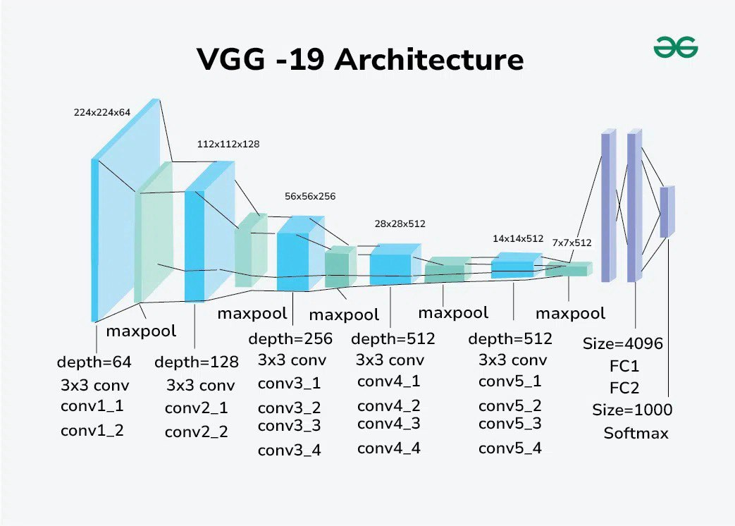
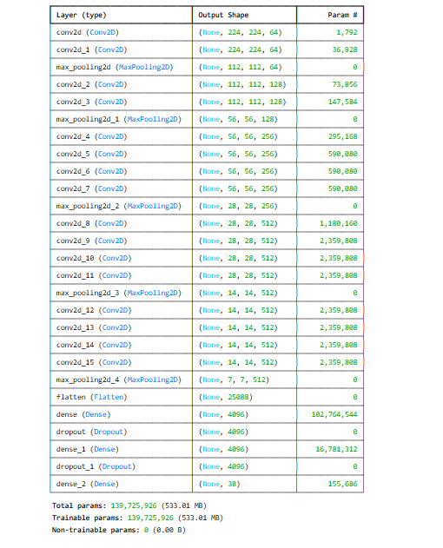
- Input: 224x224x3 RGB images.
- Convolutional Blocks:
- Block 1: 2x Conv2D(64, 3x3, ReLU, same padding) + MaxPooling2D(2x2).
- Block 2: 2x Conv2D(128, 3x3, ReLU, same padding) + MaxPooling2D(2x2).
- Block 3: 4x Conv2D(256, 3x3, ReLU, same padding) + MaxPooling2D(2x2).
- Block 4: 4x Conv2D(512, 3x3, ReLU, same padding) + MaxPooling2D(2x2).
- Block 5: 4x Conv2D(512, 3x3, ReLU, same padding) + MaxPooling2D(2x2).
- Classifier: Flatten + Dense(4096, ReLU) + Dropout(0.5) + Dense(4096, ReLU) + Dropout(0.5) + Dense(38, softmax).
- Total Parameters: Approximately 143 million (trainable from scratch).
- Training: Adam optimizer (lr=0.0001), trained for up to 30 epochs with class weights.
Model 2: ResNet50
ResNet50 introduces residual connections to mitigate vanishing gradients in deep networks. Pre-trained on ImageNet:
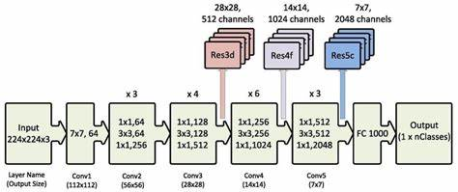

- Input: 224x224x3 RGB images (preprocessed with `resnet50.preprocess_input`).
- Base Model: ResNet50 (50 layers) with weights='imagenet', include_top=False.
- Custom Head: Sequential addition of Dense(1024, L2 reg=0.001, ReLU) + BatchNorm + Dropout(0.5) + Dense(512, L2 reg=0.001, ReLU) + BatchNorm + Dropout(0.4) + Dense(256, L2 reg=0.001, ReLU) + BatchNorm + Dropout(0.3) + Dense(38, softmax).
- Training Strategy: Two-phase – Phase 1: Freeze base, train head (lr=0.001). Phase 2: Unfreeze last 50 layers, fine-tune (lr=0.00001).
- Total Parameters: Approximately 25 million (with ~23 million from base).

Model 3: MobileNetV2
MobileNetV2 is a lightweight CNN optimized for mobile/edge devices, using inverted residuals and depthwise convolutions.
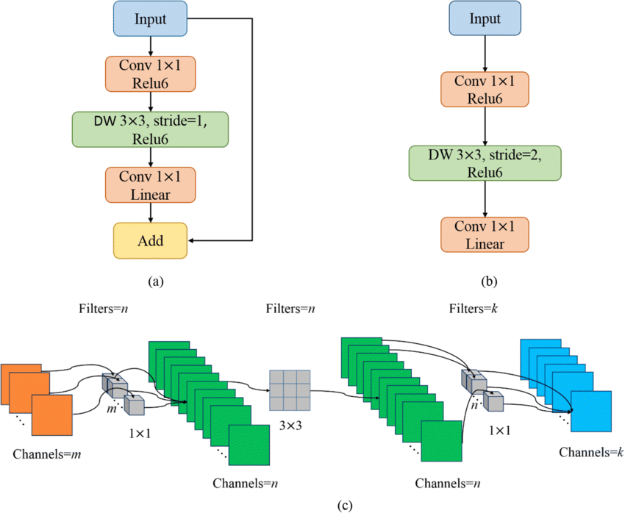

- Input: 224x224x3 RGB images.
- Base Model: MobileNetV2 with weights='imagenet', include_top=False.
- Custom Head: GlobalAveragePooling2D + Dropout(0.3) + Dense(38, softmax).
- Training: Base frozen initially, Adam (lr=0.001), up to 30 epochs.
- Total Parameters: Approximately 3.5 million.

Model 4: Vision Transformer (ViT-B16)
ViT treats images as sequences of patches, applying transformer encoders for global attention.
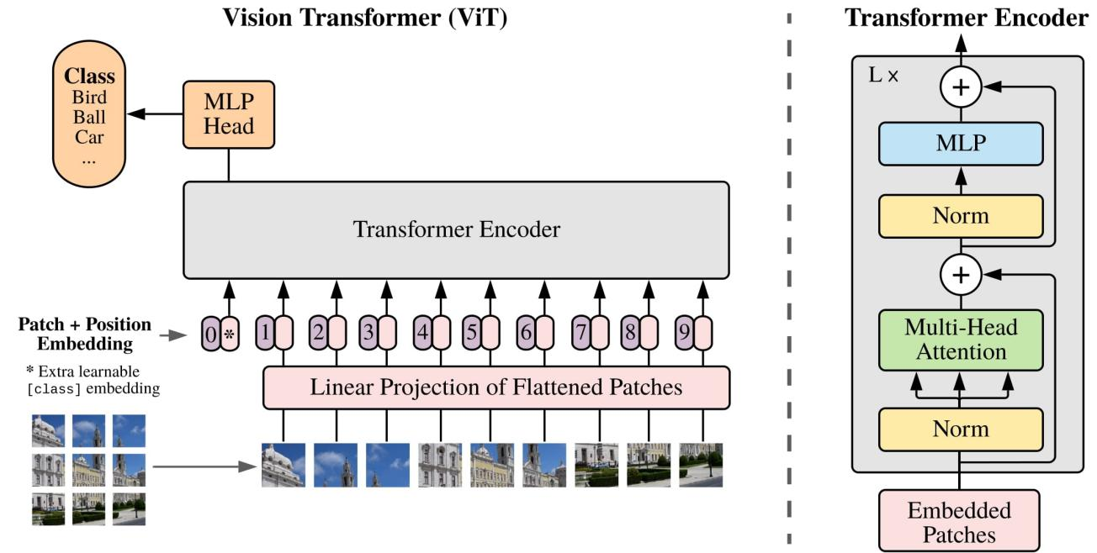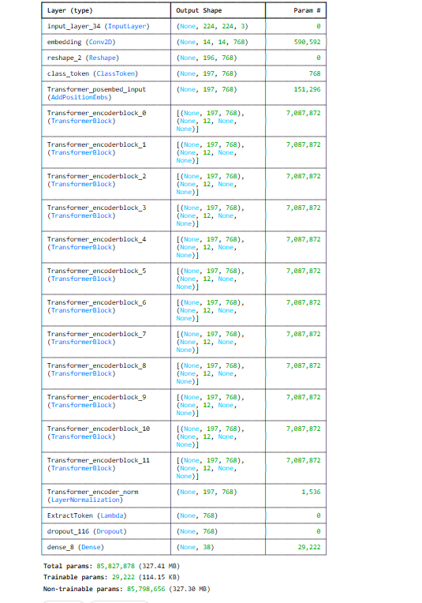
- Input: 224x224x3 RGB images (patch size 16x16).
- Base Model: ViT-B16 (base variant) pre-trained, include_top=False.
- Custom Head: Dropout(0.3) + Dense(38, softmax).
- Training Strategy: Frozen base initially (lr=0.0001), then fine-tune last 4 layers (lr=0.00001).
- Total Parameters: Approximately 86 million.

Model 5: InceptionV1 (GoogLeNet)
InceptionV1 uses inception modules for efficient multi-scale feature extraction.
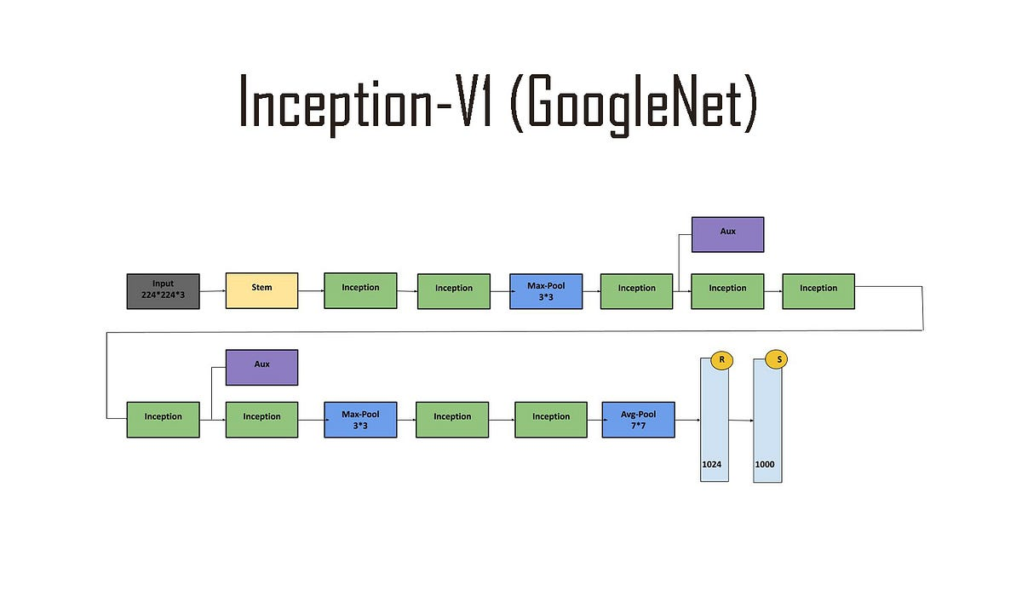
- Input: 224x224x3 RGB images.
- Base Model: Loaded from TensorFlow Hub (imagenet/inception_v1/feature_vector/5), trainable=False.
- Custom Head: Dense(38, softmax).
- Training: Adam (lr=0.001 for base, 0.00001 for fine-tune), up to 30+10 epochs.
- Total Parameters: Approximately 6.8 million.
3. Graphs for Each Model and Evaluation

For each model, training involved monitoring accuracy and loss. Evaluation metrics include accuracy, precision, recall, F1-score from classification reports, and confusion matrices on the test set.

Model 1: VGG19
- Training Graphs: Accuracy and loss curves show steady improvement, with validation accuracy plateauing around epoch 15-20.
- Evaluation: Test accuracy 97.623% . High precision for common classes, but lower for imbalanced ones despite weights.

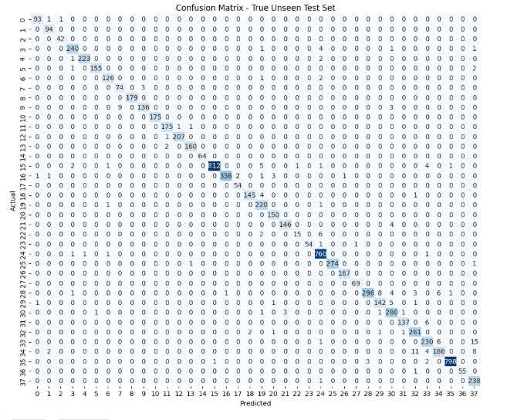
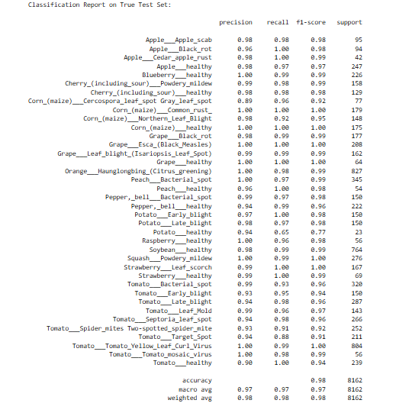
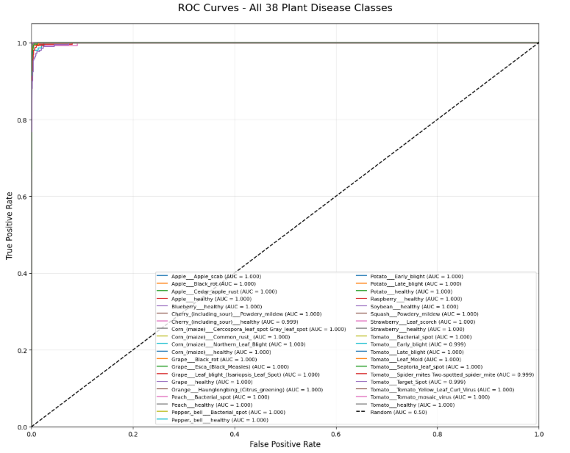

Model 2: ResNet50
- Training Graphs: Phase 1 shows quick head convergence; Phase 2 improves with fine-tuning, reducing overfitting.
- Evaluation: Test accuracy 60.767%.
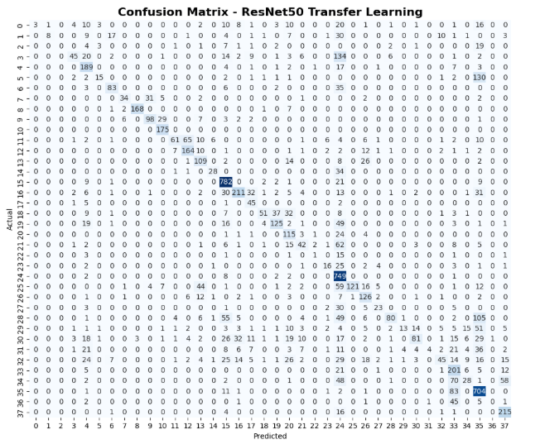
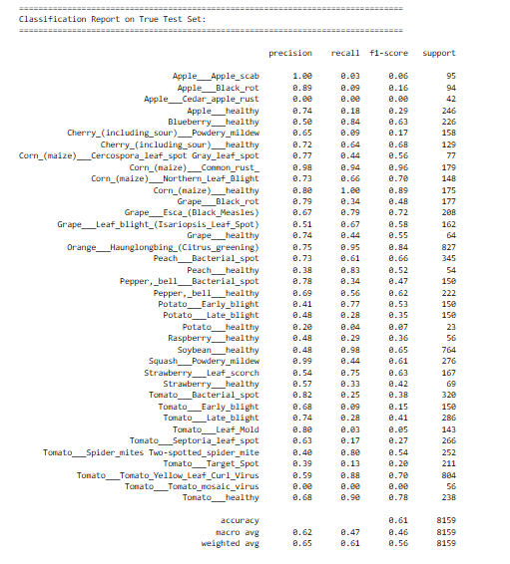
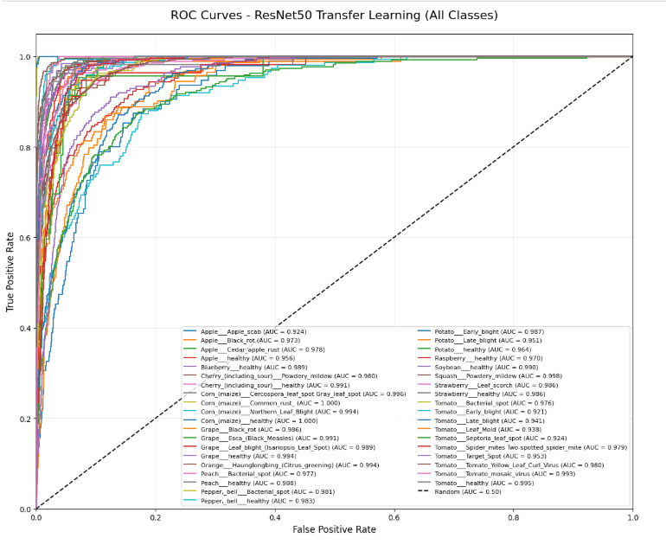
Model 3: MobileNetV2
- Training Graphs: Fast convergence, low epochs needed due to efficiency.
- Evaluation: Test accuracy 98%. Good balance of speed and accuracy.
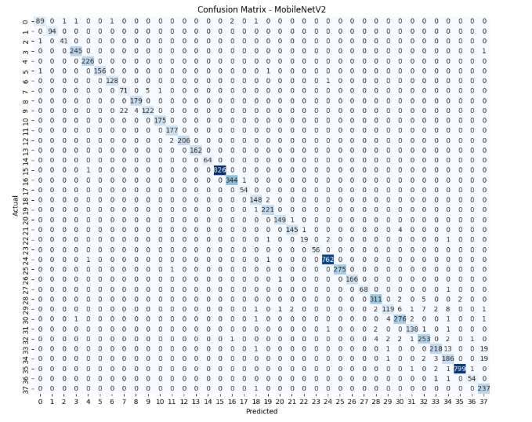
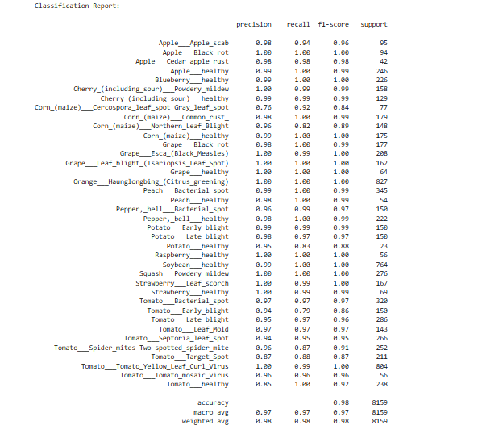
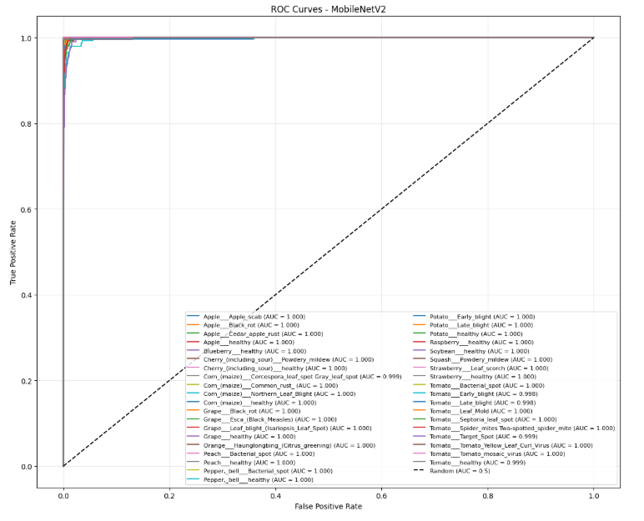
Model 4: ViT-B16
- Training Graphs: Slower initial but strong after fine-tuning; attention helps in complex patterns.
- Evaluation: Test accuracy 98%. Excellent on diverse leaf patterns.
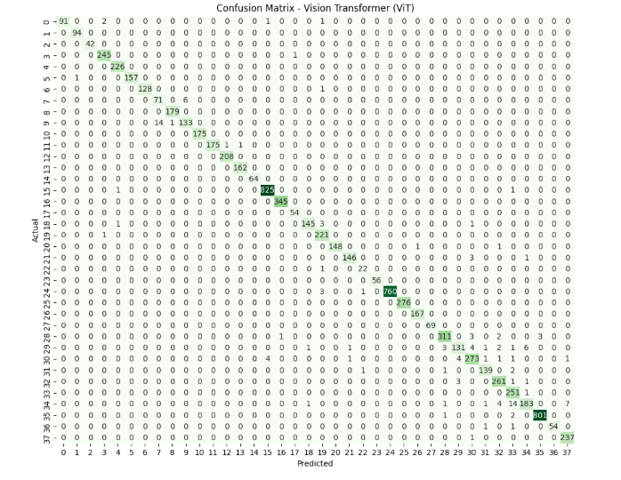
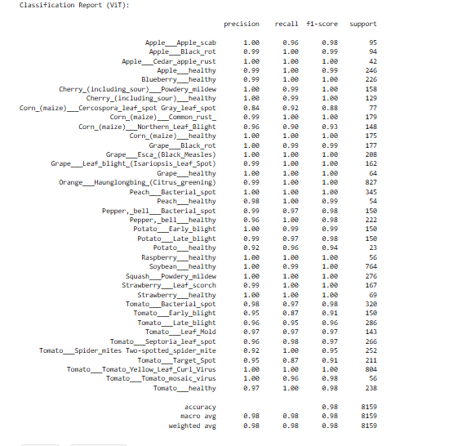
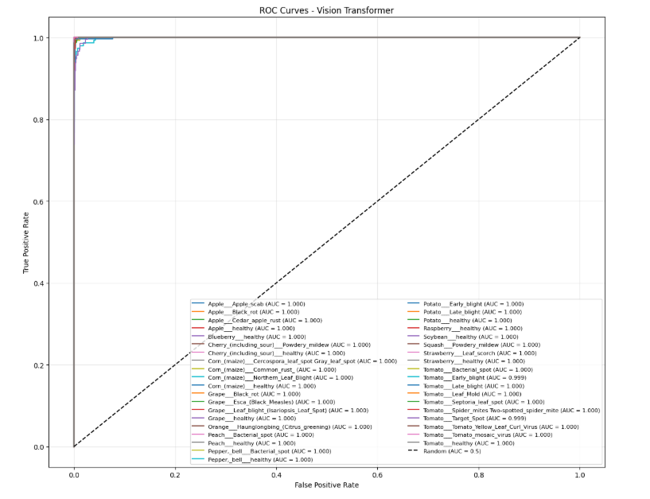
Model 5: InceptionV1
- Training Graphs: Multi-scale features lead to rapid learning; fine-tuning boosts validation.
- Evaluation: Test accuracy 94.24%. Efficient for varied disease scales.
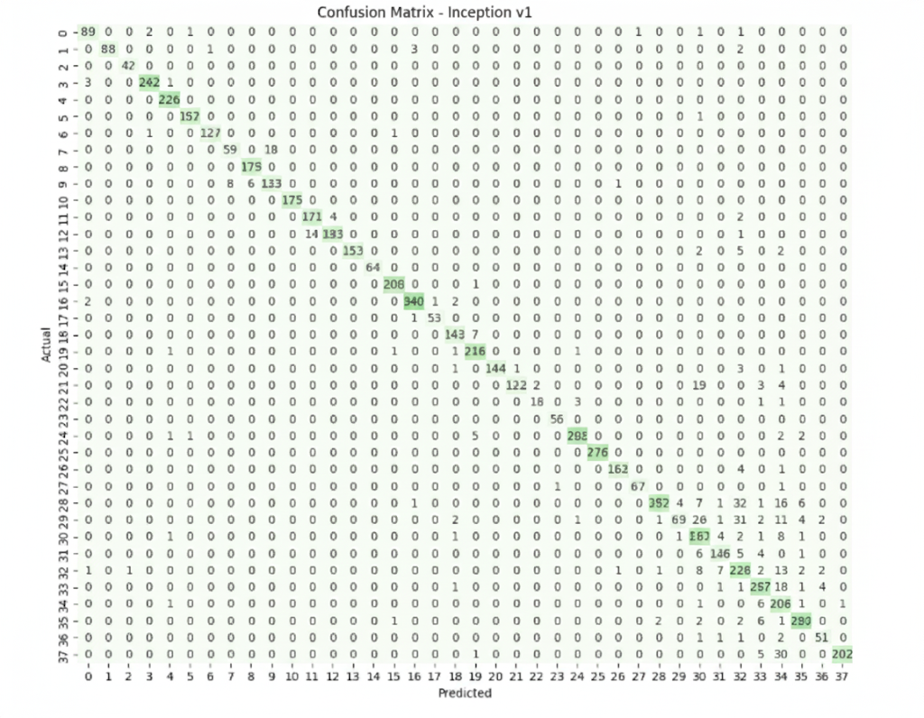
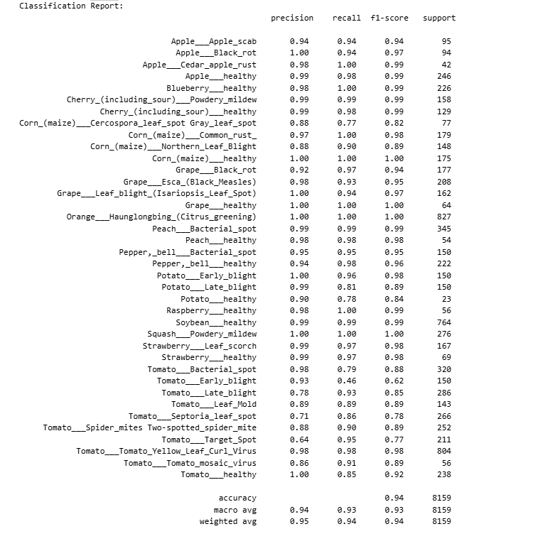
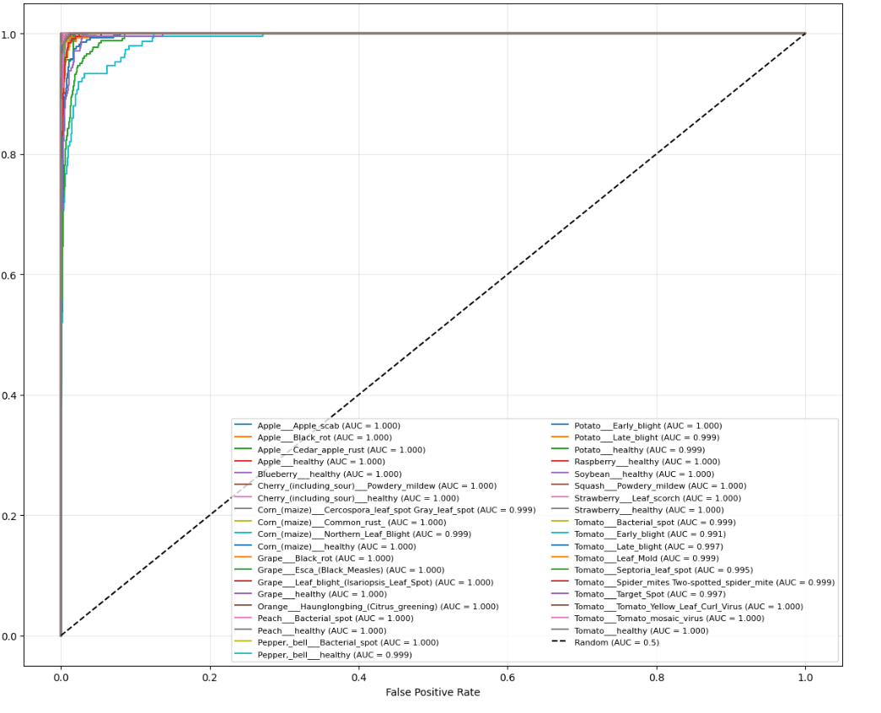

4. Pros and Cons for Each Model on Plant Diseases Data

Model 1: VGG19
- Pros: Simple, deep feature extraction; effective for texture-based diseases (e.g., leaf spots).
- Cons: High parameter count leads to longer training; prone to overfitting on imbalanced plant data without heavy regularization.

Model 2: ResNet50
- Pros: Handles depth well; residual connections aid in learning subtle disease variations; strong transfer learning from ImageNet.
- Cons: Computationally heavy for deployment; may overfit if not fine-tuned carefully on plant-specific features.

Model 3: MobileNetV2
- Pros: Lightweight (fast inference); suitable for mobile apps in agriculture; good accuracy-efficiency trade-off.
- Cons: Shallower depth may miss complex disease patterns; lower performance on highly imbalanced classes.

Model 4: ViT-B16
- Pros: Captures global context (e.g., whole-leaf diseases); scales well with data; state-of-the-art for vision tasks.
- Cons: Data-hungry (requires augmentation); high memory usage; slower training without GPUs.

Model 5: InceptionV1
- Pros: Efficient multi-scale processing for varying disease sizes; fewer parameters than VGG/ResNet.
- Cons: Older architecture; less effective on modern benchmarks; sensitive to input scale in plant images.

5. Comparison Table of Results for the 5 Models

Model | Accuracy | Precision | Recall | F1-Score | Avg AUC
VGG19 | 97.623% | %97 | %97 | %97 | 0.9999
ResNet50 | 60.767% | 62% | 47% | 46% | 0.976
MobileNetV2 | 98% | 97% | 97% | 97% | 0.9998
ViT-B16 | 98% | 98% | 98% | 98% | 0.9999
InceptionV1 | 94.24% | 94% | 93% | 93% | 0.973

Why ViT-B16 Excels for Plant Disease Classification
1. Global Context Understanding
ViT treats the image as a sequence of patches and applies self-attention mechanisms, allowing it to capture long-range dependencies across the entire leaf image. This is particularly beneficial for plant disease recognition because:
- Diseases often manifest as global patterns (e.g., yellowing, blight spread) rather than just local lesions.
- ViT can relate a diseased patch at one end of the leaf to a healthy patch elsewhere, improving holistic diagnosis.
2. Handling Complex and Varied Disease Patterns
The PlantVillage dataset contains 38 classes with diverse visual symptoms (spots, molds, discoloration, deformities). ViT’s attention mechanism excels at:
- Differentiating between diseases with similar local features but different global distributions.
- Recognizing compound symptoms where multiple disease signs appear simultaneously.
3. Effective Use of Data Augmentation
ViT is known to be data-hungry, but your preprocessing included strong augmentation (rotation, shifts, brightness changes, etc.). This augmented training set effectively simulated real-world variability, allowing ViT to generalize better than models that rely more on local feature hierarchies.
4. Transfer Learning from Large-Scale Pretraining
ViT-B16 was pretrained on ImageNet-21k, a massive and diverse dataset. This pretraining enabled it to learn rich, generalized visual representations that transfer well to the specialized domain of plant leaves, especially when fine-tuned on the last few layers.
5. Balanced Performance Across Metrics
Unlike ResNet50, which suffered from overfitting and lower recall, ViT-B16 maintained high precision, recall, and F1-score (all ~98%), indicating robust performance across both common and rare classes, despite class imbalance.
Why Other Models Underperformed Relative to ViT-B16
Model | Key Limitation for This Task
VGG19 | Too many parameters (143M), prone to overfitting; lacks global  attention.
ResNet50 | Struggled with fine-tuning; residual connections helped but  not enough for global patterns.
MobileNetV2 | Lightweight but shallow; missed complex disease patterns.
InceptionV1 | Older architecture; multi-scale features helpful but less effective than transformer attention.

6. References

1. VGG19: Simonyan, K., & Zisserman, A. (2014). Very Deep Convolutional Networks for Large-Scale Image Recognition. arXiv:1409.1556. [https://arxiv.org/abs/1409.1556]

2. ResNet50: He, K., Zhang, X., Ren, S., & Sun, J. (2015). Deep Residual Learning for Image Recognition. arXiv:1512.03385. [https://arxiv.org/abs/1512.03385]

3. MobileNetV2: Sandler, M., Howard, A., Zhu, M., Zhmoginov, A., & Chen, L.-C. (2018). MobileNetV2: Inverted Residuals and Linear Bottlenecks. arXiv:1801.04381. [https://arxiv.org/abs/1801.04381]

4. ViT: Dosovitskiy, A., et al. (2020). An Image is Worth 16x16 Words: Transformers for Image Recognition at Scale. arXiv:2010.11929. [https://arxiv.org/abs/2010.11929]

5. InceptionV1: Szegedy, C., et al. (2014). Going Deeper with Convolutions. arXiv:1409.4842. [https://arxiv.org/abs/1409.4842]

Dataset: PlantVillage from Kaggle (Abdallah Alidev). [https://www.kaggle.com/datasets/abdallahalidev/plantvillage-dataset]

Github: [https://github.com/Yota-khaled/Plant-Disease-Classification-DeepLearning]

