Roblox.com

Usability Review

Roblox.com (2006):
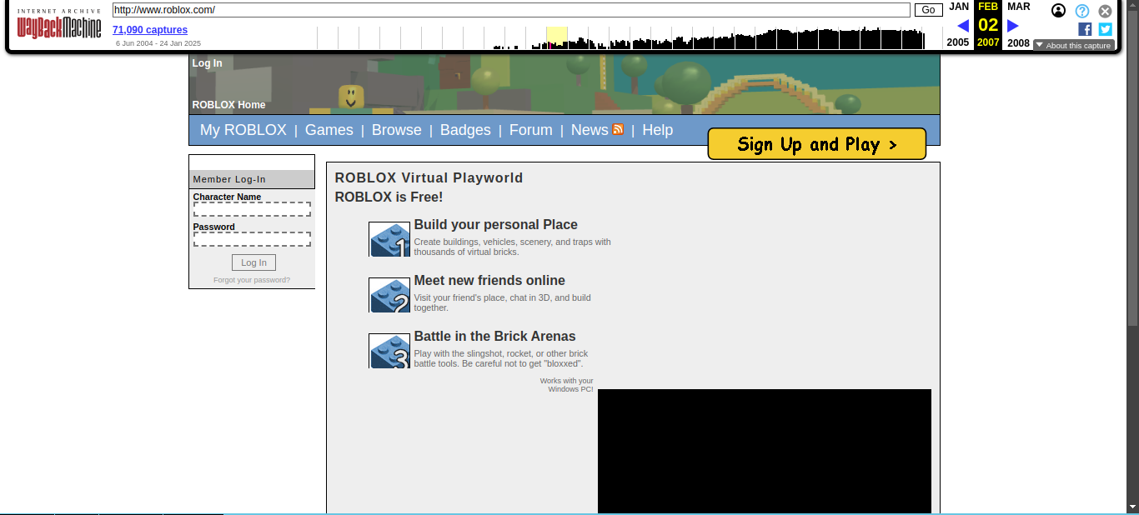
There may be a lot of things at fault due to the capabilities of a website made in 2006, so I will only point out how the sign-up button isn't "reactive." If you hover over the button, you don't really know if it is clickable or not. However, the designers did their best by differentiating the sign-up button with a different color and a button border. The site also had an old Google Ad viewer that worked via a Flash video plugin, which was interesting.

They did do many things well, though. The log-in box matched the schema for many of the old forums back then. The sort-of log-in box where you had the forum contents on the right and the log-in box was some small container at the top-left of the page. There was also the user bar at the top, which allowed returning users to navigate the site to places they wanted to go quickly. The only concern there is that new users clicking on some of those links would be classified as a flow error. Besides that, they also understood that most of the users coming on to the site were Roblox players and not Roblox developers, which allowed them to declutter the UI.

Roblox.com (now):

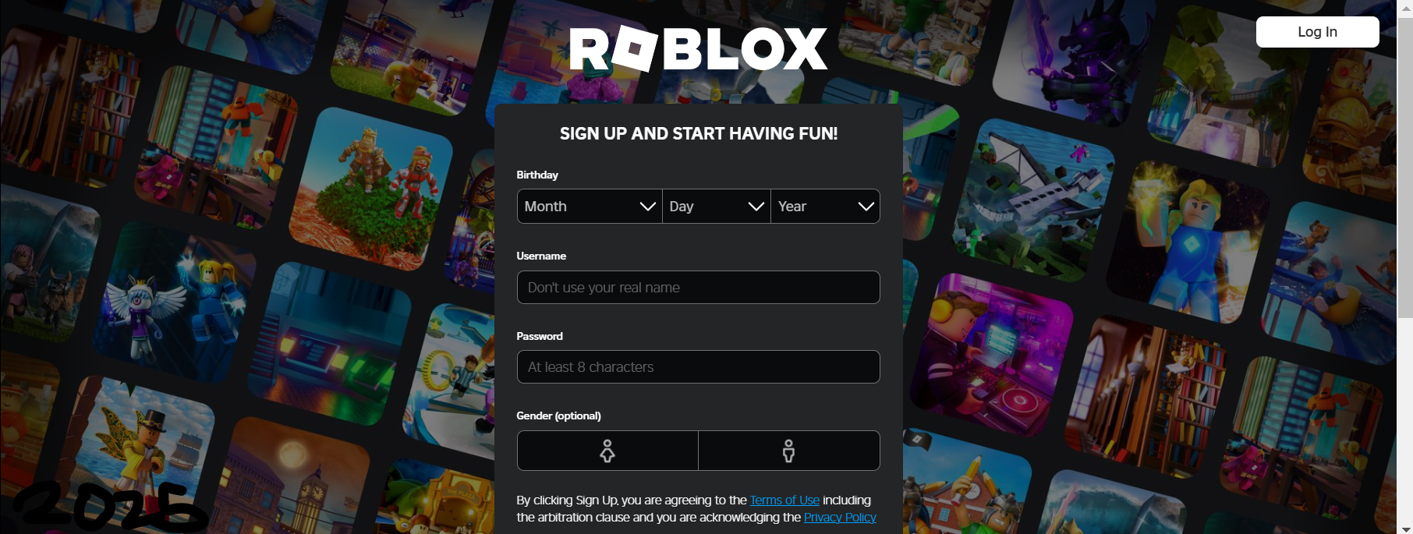
In terms of changes, the shift in user flow toward making account creation more central to the experience makes sense, especially given how Roblox relies on user accounts for interaction. The redesign of removing the top bar to prevent confusion for non-logged-in users is a smart move. It aligns well with a straightforward user expectation: you need an account to play games or access your profile. Removing unnecessary options for users who aren't logged in simplifies things and keeps the focus where it needs to be. The new website made ui and UX flow less error-prone and made it clearer what the initial site wanted a user to do before interacting with the website. The only fault, which I will also highlight below, is how, in design, you typically have to "bite the bullet" when deciding to design for a specific segment of your users. The decision, though, is usually justified with respect to the "purpose" of your website.

Usability Changes
Improvements:
- One of the main things the designers changed on the roblox.com site is that they expect that the people going onto the site do not have an account, so the user flow is directly there. It makes certain expectations on the user in order to make the user flow quicker, allowing the user to do what they want and getting them to do what the designer wants.
- Another update they made is the choice not to show the top bar of the website. This update aligns with the mental model matching and preventing user errors because even accessing those web pages of "my Roblox" or "games" would require the user to have an account beforehand anyway. Clicking on "my Roblox" or "games" would have produced an error that said you didn't have an account or you had to make an account to play the game. Removing all of that from the roblox.com page improves usability.

Suggestions:
- A suggestion that can be made is actually related to one of the things the designers changed in the newer iteration of the website, which is balancing the user flow for different users. On the one hand, they designed the site to make it easy for the user to sign up because they would need an account to do anything else. But, the problem is if you were a user that wasn't "sold" on making an account, you would need to hit the "log-in" button and then click the "charts" button to view the trending games, which by all means isn't intuitive. This UI adds "friction" to that specific user, which is the trade-off in designing for a specific user.
- Another suggestion, but also a small nitpick, is the birthday selection UI on the form. There is already a lot of controversy and effort that goes into the design of what the "best" date-picking ui should be or look like. But, there seems to be one glaring problem with the birthday selection in regards to the "designing for users" component. The year field only shows 2020 as the most recent year. A lot of Roblox's users are currently at the age of 3-5 as well. Maybe this is a good thing, better off, but from a UI/UX standpoint, it isn't "good."

ANDI Report:
The new page was rather simple to scan. There were 3 elements with no accessible names which were the form elements for selecting the birthday of the user. It seems like it should be a rather quick fix and I don't see that changing it would require a redesign.

Github.com

Usability Review

Github.com (2010):
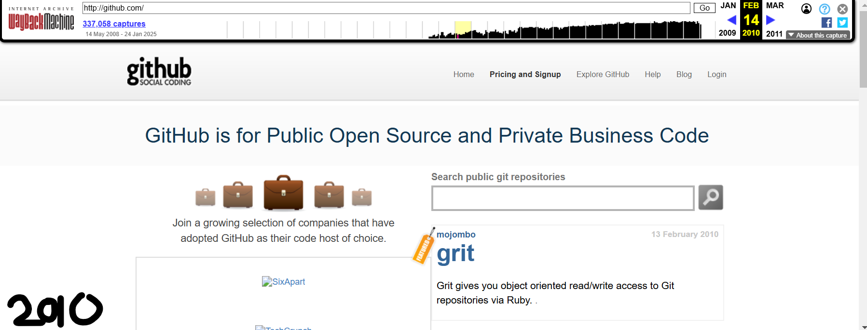

Again, it is easy to find fault with old websites, so I will focus on a design failure rather than a technical failure. That design failure is the fact that pricing and sign-up are on the same site/functionality. It doesn't match any particular mental model to have pricing and sign-up being the same link. It may lead users to assume that to sign up for Github, you may need to pay for it or that some features are restricted if you don't pay. The font size of any button element is drastically smaller and more complex to find than the large greeting text.

I found the search public git repositories to be a helpful feature. It was there because, in 2010, their goal was to convince users to use GitHub, and that was done by having the search bar for projects in GitHub as a daily feature. Interestingly, the 2010 project was grit, which is irrelevant, but the founder of that project is still going on today and worked on projects like Semver and was a founder for Redwoodjs. Besides that, they made sure to differentiate the "sign-up" from all of the other links to ensure the user focuses on the sign-up button. Another part they did well on is understanding the users and having an informed design. They had a scrolling bar that showed all the companies currently using GitHub and all the features with it. This design decision is usability-related because the designers acknowledge that there are enterprise and non-enterprise users, which some sites don't get.

Github.com (now):
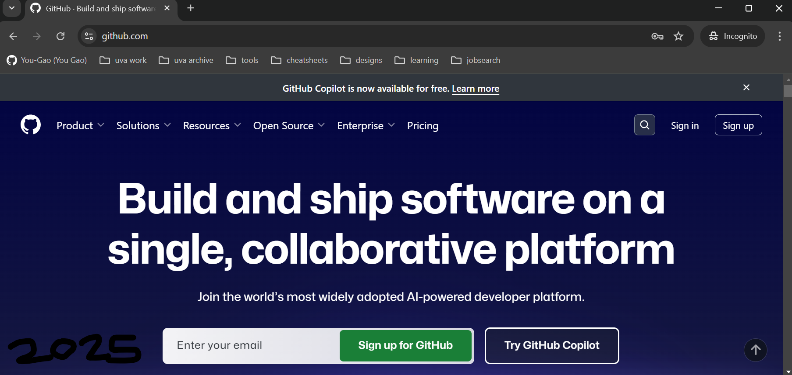
Github, like many other sites that have user authentication, handles excise tasks in a smart way. I don't mention this point in the roblox.com analysis, but most home pages, i.e., github.com, show you two different screens depending on whether you are logged in or not. This feature allows many of the modern sites to really just display a sign-up screen to ensure they do so but also allows them to short-cut user flow. Also, in the newer version of Github, the sign-up is as big if not bigger than the heading text of the website. It is also colored green, so it's visually distinct from all of the other elements. The newer does a great job of making their point. All of the main features they want you to click have a button outline, while the drop-downs are there at the top but not visually distinct.

They do have a glaring usability error, though, which is their jarring ui flow once you scroll past the "sign-up" and "try copilot buttons." There is a set of buttons that show code, plan, collaborate, automate, and secure. Clicking on them changes the text and picture element, but the problem is when you click on a button to change the text and image, you have to scroll up to see the image in full. This UX flow adds a lot of friction if the planned idea was to have the user click through all five options, as they would need to click, scroll up, and scroll down 5 times over.

Usability Changes
Improvements:
- In the older version, the sign-up button was smaller and harder to find, blending in with the rest of the page. In the newer version, the sign-up button is visually distinct, larger, and green, making it more prominent and easier to locate for users.
- The old design had a more general button, where both pricing and sign-up were tied to the same function, potentially causing confusion. The newer version smartly distinguishes between signed-in and not signed-in users, offering more targeted content and reducing friction in the user experience.
Suggestions:
- To fix the jarring UI flow after scrolling past the sign-up and "try copilot" buttons, GitHub could make the content change more seamless. Instead of requiring users to scroll up and down to see the updated content, they could implement a smoother interaction (e.g., sticky elements or a sliding content panel) that ensures the user can easily view all options without additional scrolling.

ANDI Report
0 accessibility warnings!

