**Design document**

**s3585502 Chih-Yuan Chen**

**s3583715　You Hao**

**1.Explain how your design will be able to store the information of games, athletes and user predictions.**

we create the ArrayList to store default data of each athletes and history of each temporary games result. The reason why for using the ArrayList is we do not have to assign particular size to the ArrayList to store data.

Moreover, we also use the Array to store temporary results of each games and user predictions. Therefore, we use the for statement to import data into the ArrayList from the Array.

**2.Explain how your class hierarchy will forbid a user from creating a “generic” type of participant (i.e. not an athlete nor an official)**

In our program, we only define two types of roles which are athletes class and official class. Both of them inherit participant class and have different attributes.

Thus, if users want to create a new type of participant, the type of participant that they create should be an athlete or an official.

**3.Explain the process by which your program will maintain a game and give a correct score to athletes according to their performance.**

First of all, we maintain a game via the driver class which can use methods from other classes to progress the game.

Moreover, we use the rank method which in the driver class to sort the result of athletic performance. Therefore, we set up temporary array to save athletic id and rank.

Thus, add point methods that in the driver class can accord the temporary array to find out athletic id which belongs to first rank or second rank or third rank to add a point.

**4.Explain how a user prediction can be checked with the actual game results.**

In this case, the predict method which is in the driver class can allow users to select athletic id to predict. Moreover, this method will save the id that users selected into an array. Therefore, the congrats method which is also in the driver will accord temporary array which store predicted id to check the temporary that store athletic id and ranks. Finally, the congrats can use predicted to find out first rank’s athletic id.

**Class diagram.**

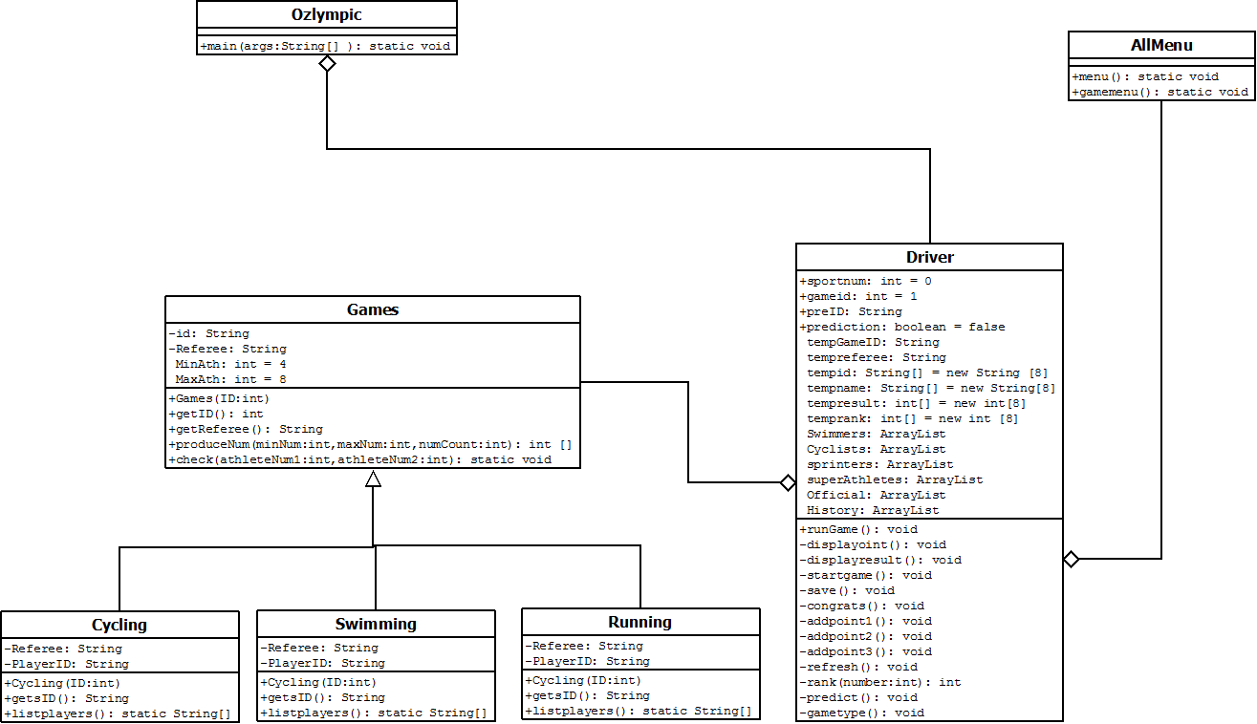

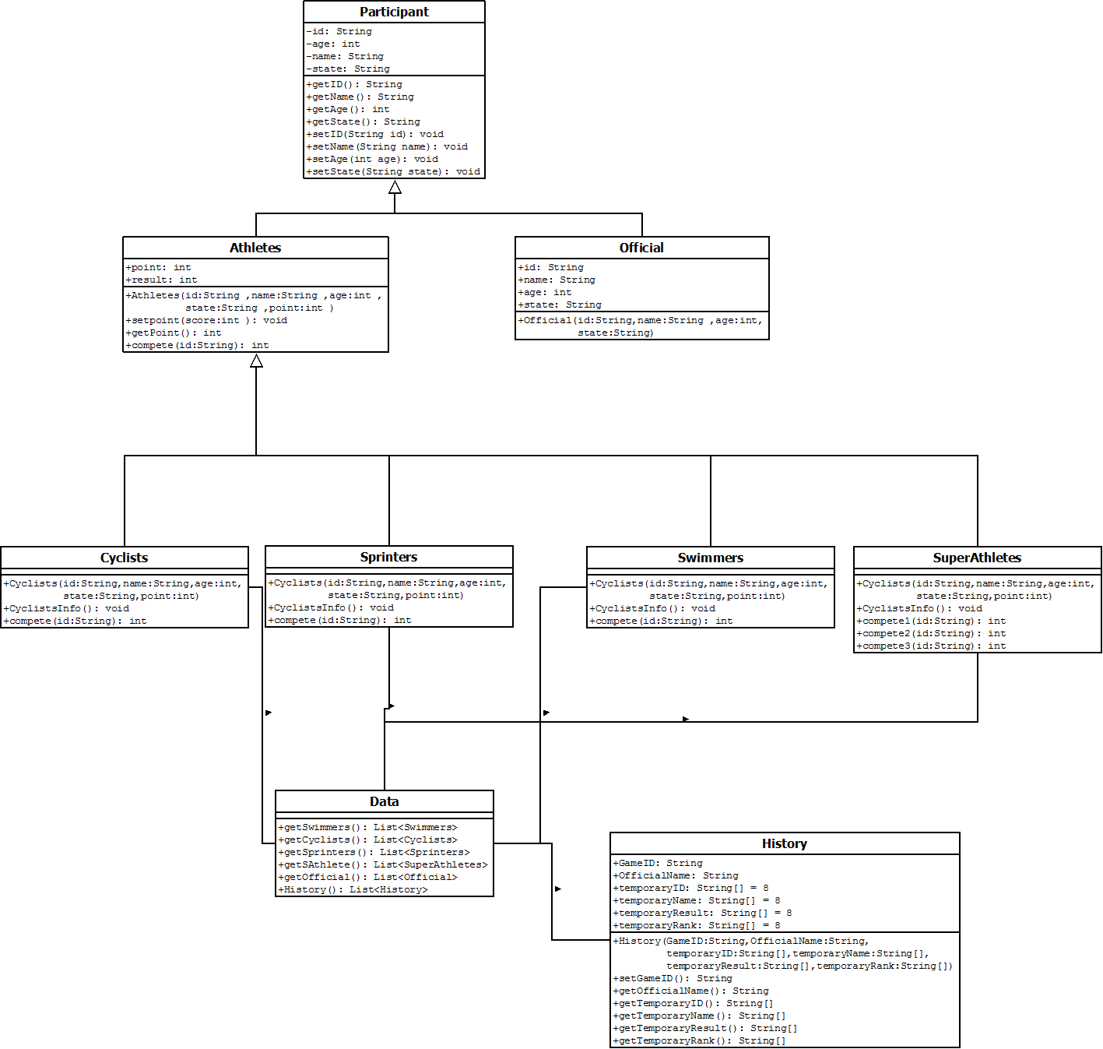

**Contribution:**

**Chih-Yuan Chen:**

Take charge of setting and defining all roles in the program such as participant, athletes, official, sprinters, cyclists, swimmers and super athletes. In addition, he also created data class to store all data and define and set up history class.

**You Hao:**

Take charge of driver class, game class, ozlympic class and menu class. He also takes charge of designing program construction and dealing with issues that be confronted.

**Summary:**

In brief, this project is quite challenging for us, but we learn a lot concept that cannot learn from the book via this assignment.

Although sometimes we may have different opinions about how to complete this project, the fantastic communication helps us to solve this issue.  
Moreover, this teamwork can motivate us to exchange our knowledge and skill of coding. Thus, we can help each other to improve skills.

At last, we like this teamwork assignment because it can support us to experience how to run a project as a team before we work into the industry. Hence, we hope we can have more teamwork assignment in the future to improve our communicated skill and increase teamwork experience.