|  |
| --- |
| Welcome to YouAddOn  How to install Document sync to Dropbox? |

# Buy and Download from https://youaddon.com

Buy it: <https://youaddon.com>

Login to <https://youaddon.com> > My Account > My Orders > Choose order > Download

# Install to SugarCRM/SuiteCRM from module loader

Login by admin from your CRM

Admin > Module Loader > Upload zip file and install it

# Configure

When you install successful.

Go to Admin > Connector > Set Connector Properties

1. Choose Dropbox tab:  
   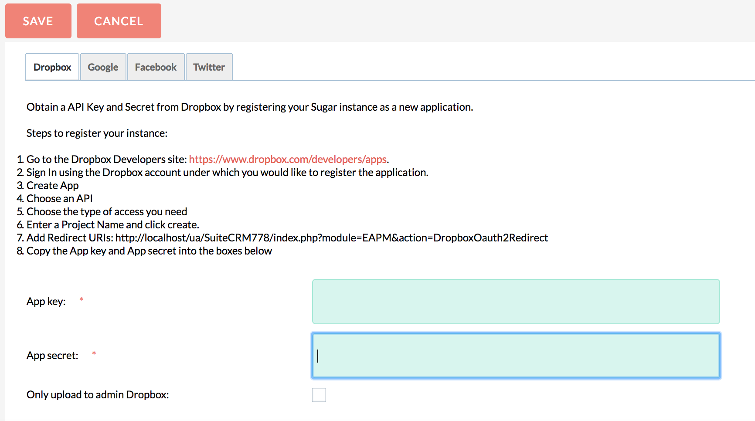
2. Create Dropbox API application and input at your CRM.
3. Need to add External Account for each user to active sync (instruction below).
4. Go to Admin > Studio > Document > Layout > EditView > set Source to layout > Save and Deploy

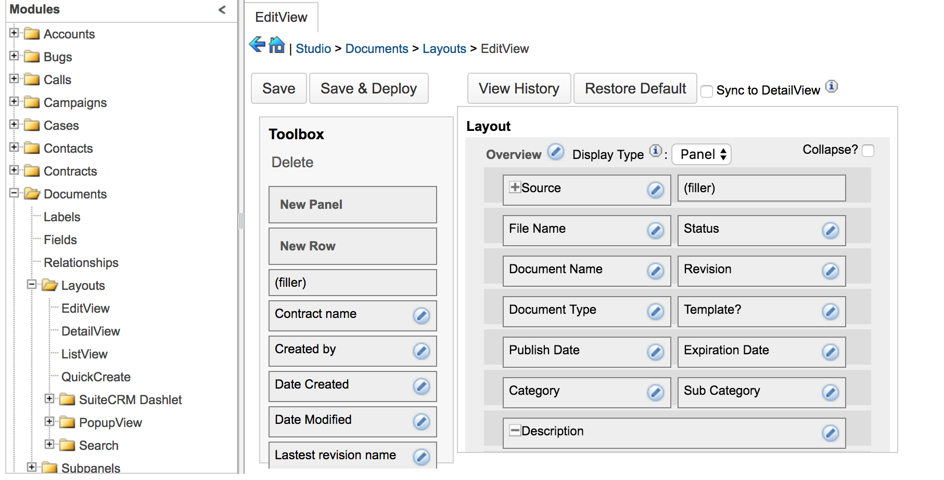

# Sync document to general Dropbox

To sync documents to general dropbox and share all users in company

Try it:

1. Go to Admin > Connector > Set Connector Properties > Dropbox
2. Check: Only upload to admin dropbox and click Save  
   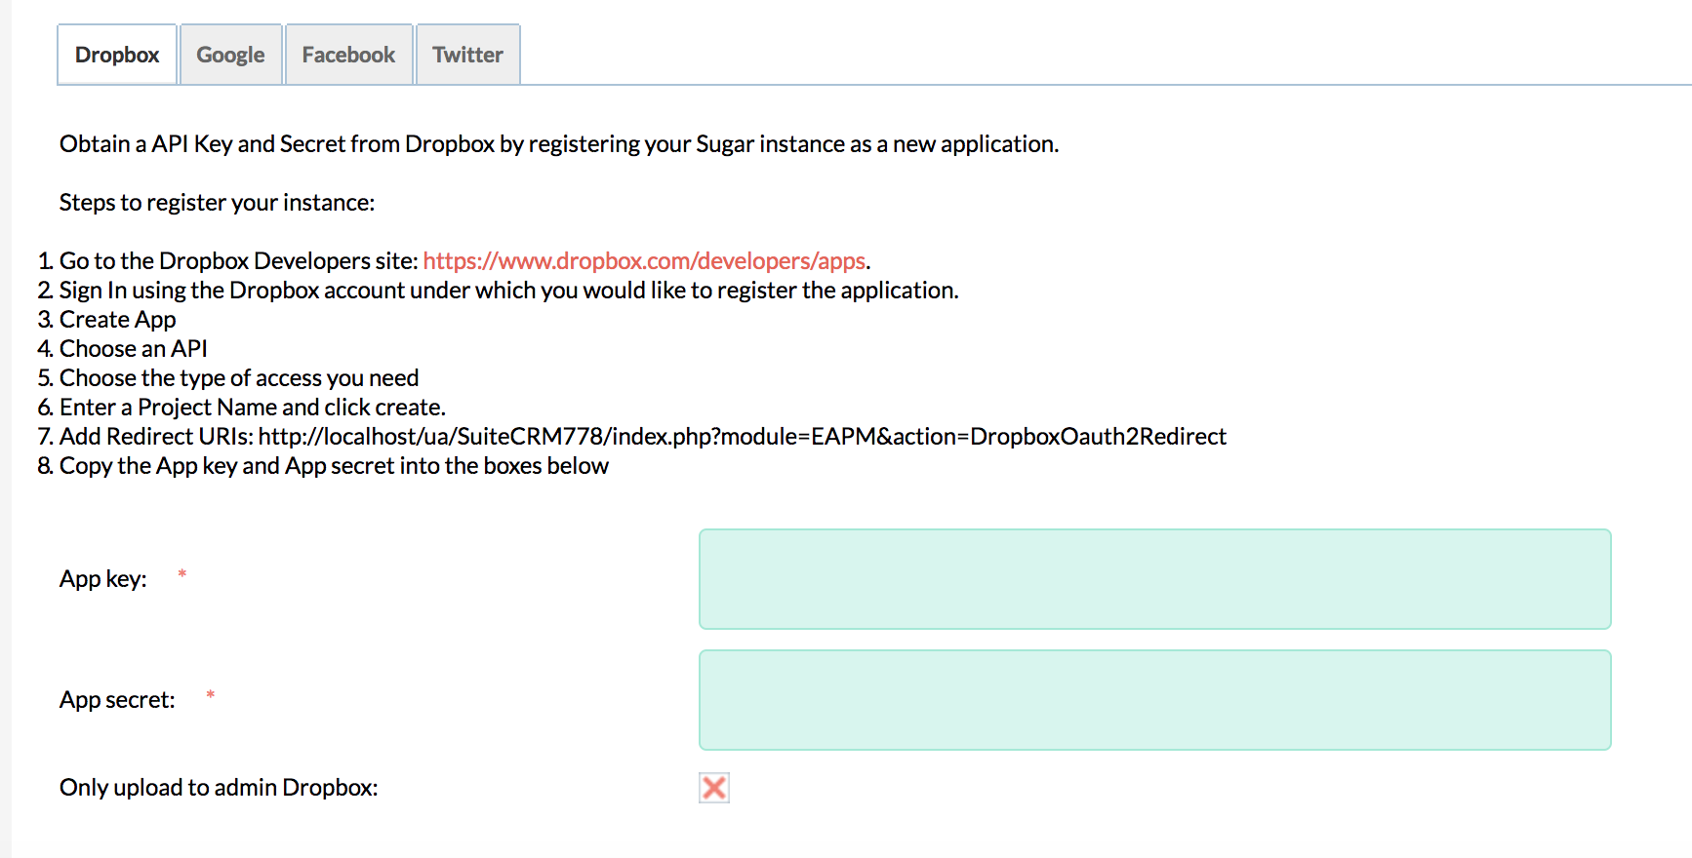
3. Admin go to your profile and create External Account with application is Dropbox > click Connect (username/password/url is account and url your crm)  
   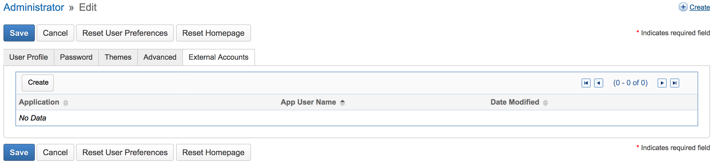

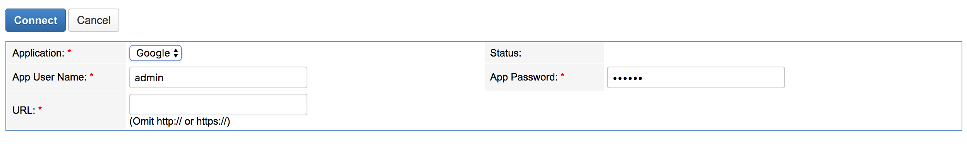

# End user create document

1. Go to Profile > Edit > External Account > Create



1. Add user with username/password/url of CRM account and CRM url > click Connect > Allow permission from Dropbox



1. Go to Documents > Create > Source > choose Dropbox > Save

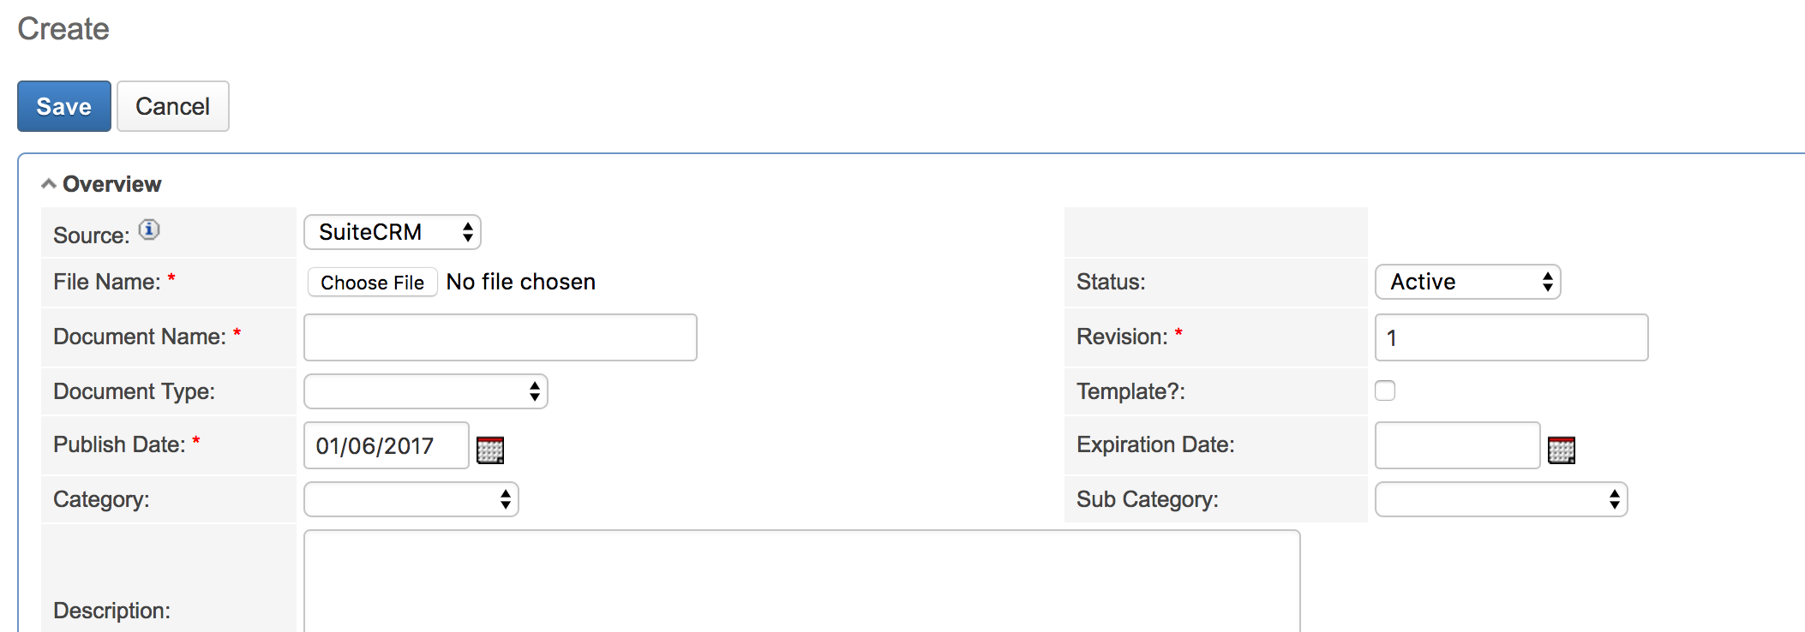

# More questions about Word?

|  |  |  |
| --- | --- | --- |
| Visit us site and create a ticket. | [Arrow with hyperlink to Word team blog web page](https://youaddon.com/) | |
|  | |  |