Simulation #3

ME 565 – Vehicle Dynamics

By: Andres F. Hoyos

Consider a vehicle weighting 3500 lbs, with a pitch moment of inertia of 25000 in-lb-sec^2. Center of gravity equally splits the wheelbase of 8 ft.

in.

1. Analytically determine the equivalent suspension stiffness and damping at each corner that will provide a 2 Hz ride frequency:

The desired frequency is 2 Hz which is equal torad/sec.

Ka and Kc can be calculated as:

and , given that l1 = l2.

Now, the equivalent stiffness coefficient at the front and rear (including both sides) is calculated:

→ (This comes from the Olley Ride Criteria)

To solve this exercise, the following Matlab script was developed:

%% Parameters:
Ws = 3500; % lbs
Iy = 25000; % in-lb-sec^2
l1 = 8*12; % in
l2 = 8*12; % in
g = 386.06; % in/sec^2
% K1 = 162.89; % 589.5; % lbs/in
% K2 = 114.02; % 842.14; % lbs/in
C1 = 0.0; % lbs*sec/in
C2 = 0.0; % lbs*sec/in
ms = Ws / g;
C2_array = logspace(log10(0.1), log10(100), 10);
C1_array = 0.7*C2_array;
%% 1.) Analytically determine equivalent suspension
% stiffness and damping at each corner that will provide a 2 Hz ride frequency.
omega_des = (2*2*pi);
% x_sp = -0.08*2*l1;
Ka = ms*omega_des^2; %(ms / (1 - x_sp*sqrt(ms/Iy)))*omega_des^2;
Kc = Ka*l1^2; %(Iy / (1 - x_sp*sqrt(ms/Iy)))*omega_des^2;
K2 = Ka / 1.7;
K1 = 0.7*K2;
Kb = K1*l1 - K2*l2;
%% Plot the results:
legends_mgx = {};
legends_mgth = {};
for i = 1:length(C2_array)
pitch_plane_model(K1, K2, C1_array(i), C2_array(i), l1, l2, ms, Iy);
legends_mgx{end+1} = ['Heave mag. plot with C1 = ' num2str(C1_array(i)) ', C2 = ' num2str(C2_array(i)) ' for x']; % Example legend entry for mgx
legends_mgth{end+1} = ['Pitch mag. plot with C1 = ' num2str(C1_array(i)) ', C2 = ' num2str(C2_array(i)) ' for theta']; % Example legend entry for mgth
% legend(legendEntries); % Update legend with the new entries
end
subplot(2,1,1);
legend(legends_mgx);
subplot(2,1,2);
legend(legends_mgth);

%%
function pitch_plane_model(K1, K2, C1, C2, l1, l2, ms, Iy)
A = [
0, 1, 0, 0;
(-K1 - K2)/ms, (-C1 - C2)/ms, (K1*l1 - K2*l2)/ms, (l1*C1 - l2*C2)/ms;
0, 0, 0, 1;
(K1*l1 - K2*l2)/Iy, (l1*C1 - l2*C2)/Iy, (-K1*l1^2 - K2*l2^2)/Iy, (-l1*l1*C1 - l2*l2*C2)/Iy;
];
B = [K1/ms, K2/ms; 0, 0; -l1*K1/Iy, l2*K2/Iy; 0, 0];
C = [1, 0, 0, 0; 0, 0, 1, 0];
D = [0, 0; 0, 0];
[magx,phasex,wx]=bode(ss(A,B(:,1),C(1,:),[0]),logspace(0,2));
mgx(1:50)=magx;
phx(1:50)=phasex;
[magtheta,phasetheta,wtheta]=bode(ss(A,B(:,1),C(2,:),[0]),logspace(0,2));
mgth(1:50)=magtheta;
phth(1:50)=phasetheta;
% Plot mgx
subplot(2,1,1); % This creates the first subplot in a 2-row, 1-column grid
semilogx(wx, 20*log10(mgx));
title('Magnitude of x');
xlabel('Frequency (rad/sec)');
ylabel('Magnitude (dB)');
hold on;
grid on;
% Plot mgth
subplot(2,1,2); % This creates the second subplot in the same grid
semilogx(wtheta, 20*log10(mgth));
title('Magnitude of theta');
xlabel('Frequency (rad/sec)');
ylabel('Magnitude (dB)');
hold on;
grid on;
% subplot(1,1,1),semilogx(wx,20*log10(mgx),wtheta,20*log10(mgth))
end

This script calculates the correct front and rear equivalent suspension stiffnesses for a ride frequency of 2 Hz (4*pi rad/sec), additionally, it plots the magnitude of the bode plot for the x and θ displacements (heave and pitch) for different damping values to then proceed to select an appropiate damper for the suspension system.

The calculated damping coefficients for a 2 Hz ride frequency are:

lbs/in,

lbs/in.

This means that for each corner of the vehicle, the coefficients of stiffness of the suspension are going to be:

lbs/in,

lbs/in,

lbs/in,

lbs/in.

The Matlab script generates the following plot:

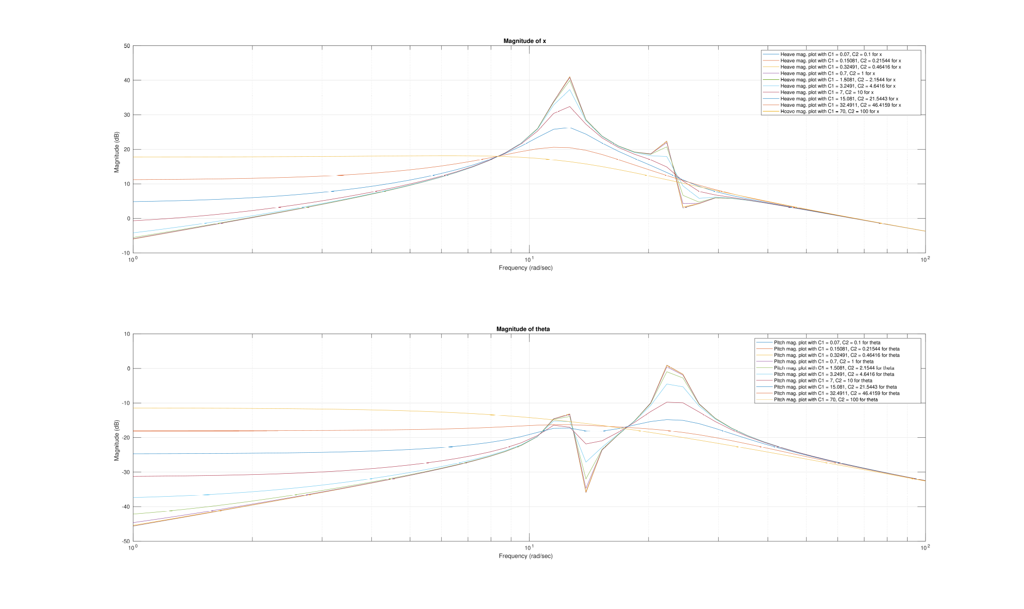
Figure 1: Magnitude plots for heave and pitch motions in dB for different dampers.

From figure 1, it can be seen the effects of increasing the damping rates for the pitch-plane model. An important trade-off can be seen from this plots. As the damping rates are increased, the resonance magnitude is decreased, but there is more amplification at higher frequencies.

It is important to mention that for this exercise, the front damping coefficient is always assumed to be 70% less than the rear one. So the relationship between the front and rear dampers is always constant.

The selected equivalent damping coefficients are:

lbs*sec/in and lbs*sec/in.

Validation:

To prove that the selected stiffnesses produce a ride natural frequency at 2 Hz, or 4π rad/sec (12.57 rad/sec), a bode plot of the undamped linear system is generated in Matlab:

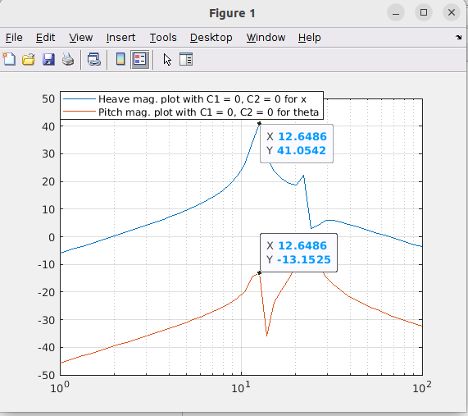

Figure 2: Shows that the ride natural frequencies for K1=589.5 lbs/in and K2 = 842.1 lbs/in is at 12.6 rad/sec that is roughly 2 Hz, as expected.

The Matlab script generates the following output:

2.) Using Olley ride criteria determine appropriate front and rear corner stiffnesses.

Similarly to the previous exercise, the following script is used to calculate the appropiate stiffnesses for a 1 Hz desired ride:

%% Parameters:
Ws = 3500; % lbs
Iy = 25000; % in-lb-sec^2
l1 = 8*12; % in
l2 = 8*12; % in
g = 386.06; % in/sec^2
% K1 = 162.89; % 589.5; % lbs/in
% K2 = 114.02; % 842.14; % lbs/in
C1 = 0.0; % lbs*sec/in
C2 = 0.0; % lbs*sec/in
ms = Ws / g;
C2_array = logspace(log10(0.1), log10(100), 10);
C1_array = 0.7*C2_array;

%% 2.) Using Olley ride criteria determine appropriate front and rear corner stiffnesses.
omega_des = (2*pi); % 1 Hz ride and heave desired frequencies
% x_sp = -0.08*2*l1;
Ka = ms*omega_des^2; %(ms / (1 - x_sp*sqrt(ms/Iy)))*omega_des^2;
Kc = Iy*omega_des^2; %(Iy / (1 - x_sp*sqrt(ms/Iy)))*omega_des^2;
K2 = Ka / 1.7;
K1 = 0.7*K2;
Kb = K1*l1 - K2*l2;
%% Plot the results:
legends_mgx = {};
legends_mgth = {};
for i = 1:length(C2_array)
pitch_plane_model(K1, K2, C1_array(i), C2_array(i), l1, l2, ms, Iy);
legends_mgx{end+1} = ['Heave mag. plot with C1 = ' num2str(C1_array(i)) ', C2 = ' num2str(C2_array(i)) ' for x']; % Example legend entry for mgx
legends_mgth{end+1} = ['Pitch mag. plot with C1 = ' num2str(C1_array(i)) ', C2 = ' num2str(C2_array(i)) ' for theta']; % Example legend entry for mgth
% legend(legendEntries); % Update legend with the new entries
end
subplot(2,1,1);
legend(legends_mgx);
subplot(2,1,2);
legend(legends_mgth);
function pitch_plane_model(K1, K2, C1, C2, l1, l2, ms, Iy)
A = [
0, 1, 0, 0;
(-K1 - K2)/ms, (-C1 - C2)/ms, (K1*l1 - K2*l2)/ms, (l1*C1 - l2*C2)/ms;
0, 0, 0, 1;
(K1*l1 - K2*l2)/Iy, (l1*C1 - l2*C2)/Iy, (-K1*l1^2 - K2*l2^2)/Iy, (-l1*l1*C1 - l2*l2*C2)/Iy;
];
B = [K1/ms, K2/ms; 0, 0; -l1*K1/Iy, l2*K2/Iy; 0, 0];
C = [1, 0, 0, 0; 0, 0, 1, 0];
D = [0, 0; 0, 0];
[magx,phasex,wx]=bode(ss(A,B(:,1),C(1,:),[0]),logspace(0,2));
mgx(1:50)=magx;
phx(1:50)=phasex;
[magtheta,phasetheta,wtheta]=bode(ss(A,B(:,1),C(2,:),[0]),logspace(0,2));
mgth(1:50)=magtheta;
phth(1:50)=phasetheta;
% Plot mgx
subplot(2,1,1); % This creates the first subplot in a 2-row, 1-column grid
semilogx(wx, 20*log10(mgx));
title('Magnitude of x');
xlabel('Frequency (rad/sec)');
ylabel('Magnitude (dB)');
hold on;
grid on;
% Plot mgth
subplot(2,1,2); % This creates the second subplot in the same grid
semilogx(wtheta, 20*log10(mgth));
title('Magnitude of theta');
xlabel('Frequency (rad/sec)');
ylabel('Magnitude (dB)');
hold on;
grid on;
end

Hence, the front and rear stiffnesses are:
lbs/in
lbs/in.

So the stiffnesses for each corner of the car are:
lbs/in, lbs/in.
lbs/in, lbs/in.

The selected dampers are the same as the previous exercise:

lbs*sec/in and lbs*sec/in.

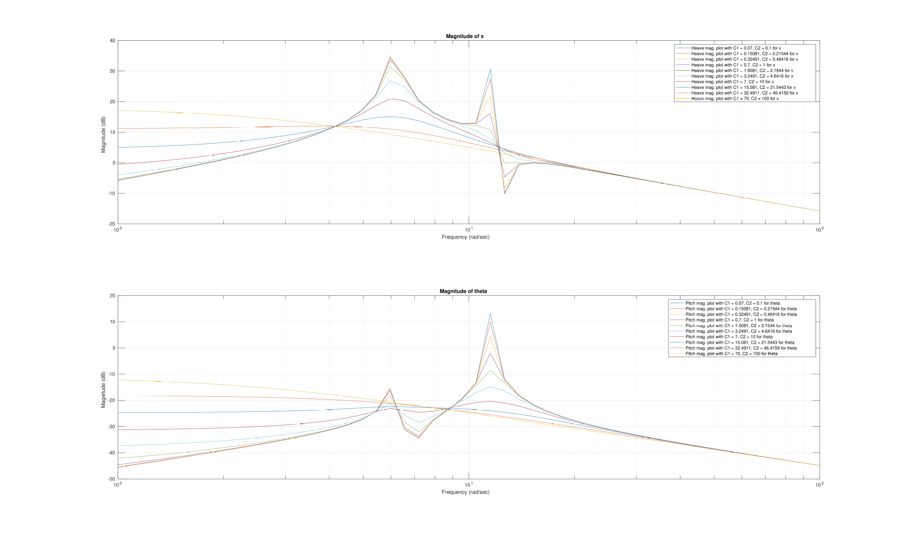

3.) Construct a block diagram of the pitch plane vehicle system. Simulate the system response to the vehicle experiencing a time phased 1 in step input.
A block diagram is developed in Simulink to test the pitch-plane model.
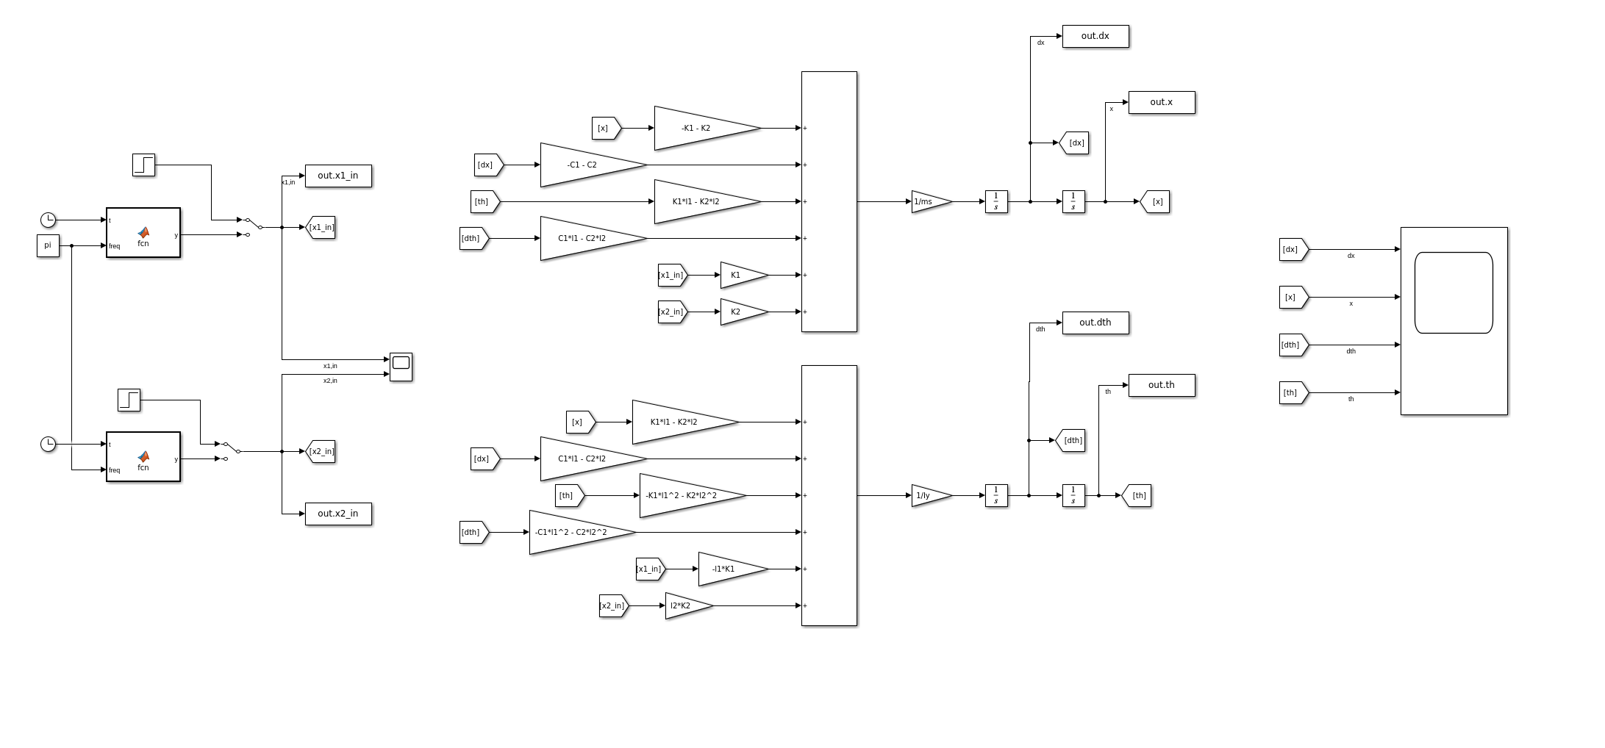

The system is excited with a time phased step input of magnitude of 1 inch and a phase difference of 1 second, this means that the rear suspension is excited by whatever input signal excited the front suspension 1 second ago (assuming the vehicle is moving forward). The input signal looks as follows:

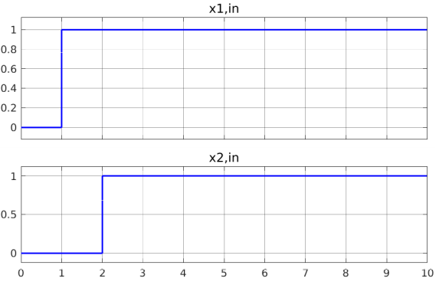

The time response for the states are plotted:

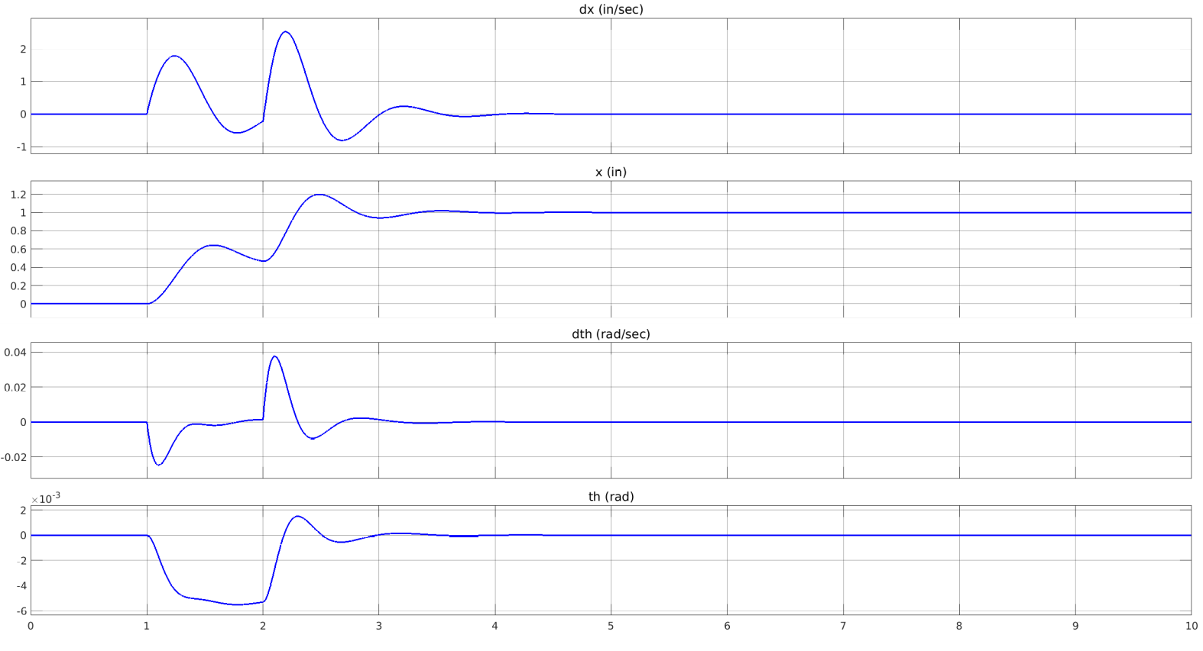

4. Use the above simulation to compare the response of the parameters determined in
1.) and 2.) above at various speeds.

The speed affects the system as it is directly related to the phase between the front and rear input. The less phase, the faster the road input encountered by the front axle will be encountered by the rear axle.

The following Matlab script was written to run the block diagrams at different speeds and record the time response plots of x, dx, th and dth:

%% Parameters:
Ws = 3500; % lbs
Iy = 25000; % in-lb-sec^2
l1 = 8*12; % in
l2 = 8*12; % in
g = 386.06; % in/sec^2
% K1 = 162.89; % 589.5; % lbs/in
% K2 = 114.02; % 842.14; % lbs/in
C1 = 0.0; % lbs*sec/in
C2 = 0.0; % lbs*sec/in
ms = Ws / g;
C2_array = logspace(log10(0.1), log10(100), 10);
C1_array = 0.7*C2_array;
%% 1.) Analytically determine equivalent suspension
% stiffness and damping at each corner that will provide a 2 Hz ride frequency.
omega_des_1 = (2*2*pi);
% x_sp = -0.08*2*l1;
Ka_1 = ms*omega_des_1^2; %(ms / (1 - x_sp*sqrt(ms/Iy)))*omega_des^2;
Kc_1 = Ka_1*l1^2; %(Iy / (1 - x_sp*sqrt(ms/Iy)))*omega_des^2;
K2_1 = Ka_1 / 1.7;
K1_1 = 0.7*K2_1;
C2_1 = 21;
C1_1 = 15;
Kb_1 = K1_1*l1 - K2_1*l2;
%% 2.) Using Olley ride criteria determine appropriate front and rear corner stiffnesses.
omega_des_2 = (2*pi); % 1 Hz ride and heave desired frequencies
% x_sp = -0.08*2*l1;
Ka_2 = ms*omega_des_2^2; %(ms / (1 - x_sp*sqrt(ms/Iy)))*omega_des^2;
Kc_2 = Iy*omega_des_2^2; %(Iy / (1 - x_sp*sqrt(ms/Iy)))*omega_des^2;
K2_2 = Ka_2 / 1.7;
K1_2 = 0.7*K2_2;
C1_2 = 21;
C2_2 = 15;
Kb_2 = K1_2*l1 - K2_2*l2;
%% 3.) Construct a block diagram of the pitch plane vehicle system.
% Simulate the system response to the vehicle experiencing a time phased 1 in step input.
% 4.) Use the above simulation to compare the response of the parameters determined in
% 1.) and 2.) above at various speeds.
% t_des = 1;
speeds = [30, 60, 100, 150]; % (l1 + l2) / t_des;
mph2in_sec = 1/0.0568182;
legends_x1_in = {};
legends_x = {};
line_width1 = 1.5;
line_width2 = 1.5;
for i = 1:length(speeds)
speed = speeds(i)*mph2in_sec; % Convert speed to in/sec before feeding into the Simulink model
% Simulate both configurations
% Config1: K1 = 589.5 lbs/in K2 = 842.1 lbs/in
% .........C1 = 15 lbs*sec/in, C2 = 21 lbs*sec/in
% Config2: K1 = 147.4 lbs/in K2 = 210.5 lbs/in
% .........C1 = 15 lbs*sec/in, C2 = 21 lbs*sec/in
% Simulate config1:
K1 = K1_1; K2 = K2_1;
out_1 = sim("block_sim3");
% Simulate config2:
K1 = K1_2; K2 = K2_2;
out_2 = sim("block_sim3");
legends_x1_in{end+1} = ['Speed = ' num2str(speeds(i))]; % Example legend entry for mgx
% Input plots:
figure(1);
% Plot:
subplot(2,1,1);
plot(out_1.x1_in, 'LineWidth', line_width1);
hold on;
grid on;
subplot(2,1,2);
plot(out_1.x2_in, 'LineWidth', line_width1); % line_width2
hold on;
grid on;
% Output plots:
figure(2);
subplot(4,1,1);
% plot(out_1.x, 'LineWidth', line_width2, 'Marker', '_', 'Color', [0, 0, 1]);
plot(out_1.x, '--', 'LineWidth', line_width2);
legends_x{end+1} = ['Config 1: Speed = ' num2str(speeds(i))];
hold on;
grid on;
% plot(out_2.x, 'LineWidth', line_width2, 'Marker', '_', 'Color', [1, 0, 0]);
plot(out_2.x, 'LineWidth', line_width2);
legends_x{end+1} = ['Config 2 Speed = ' num2str(speeds(i))];
subplot(4,1,2);
% plot(out_1.dx, 'LineWidth', line_width2, 'Marker', '*', 'Color', [0, 0, 1]);
plot(out_1.dx, '--', 'LineWidth', line_width2);
hold on;
grid on;
% plot(out_2.dx, 'LineWidth', line_width2, 'Marker', '+', 'Color', [1, 0, 0]);
plot(out_2.dx, 'LineWidth', line_width2);
subplot(4,1,3);
% plot(out_1.th, 'LineWidth', line_width2, 'Marker', '*', 'Color', [0, 0, 1]);
plot(out_1.th, '--', 'LineWidth', line_width2);
hold on;
grid on;
% plot(out_2.th, 'LineWidth', line_width2, 'Marker', '+', 'Color', [1, 0, 0]);
plot(out_2.th, 'LineWidth', line_width2);
subplot(4,1,4);
% plot(out_1.dth, 'LineWidth', 1.5, 'Marker', '*', 'Color', [0, 0, 1]);
plot(out_1.dth, '--', 'LineWidth', line_width2);
hold on;
grid on;
% plot(out_2.dth, 'LineWidth', 1.5, 'Marker', '+', 'Color', [1, 0, 0]);
plot(out_2.dth, 'LineWidth', line_width2);
end
figure(1)
subplot(2,1,1);
legend(legends_x1_in);
ylim([0,1.2]);
subplot(2,1,2);
legend(legends_x1_in);
ylim([0,1.2]);
figure(2)
subplot(4,1,1);
legend(legends_x);
subplot(4,1,2);
legend(legends_x);
subplot(4,1,3);
legend(legends_x);
subplot(4,1,4);
legend(legends_x);

The code generates the following plot:

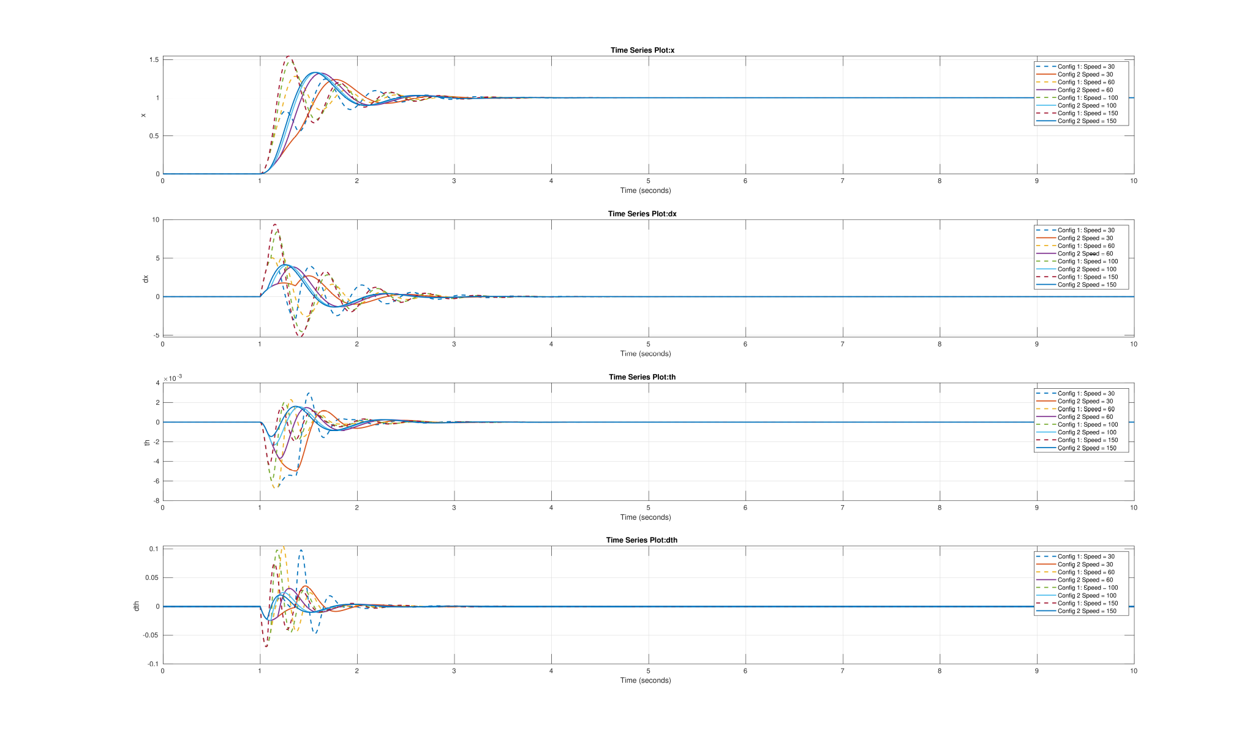
And the input plot generated by the code is:
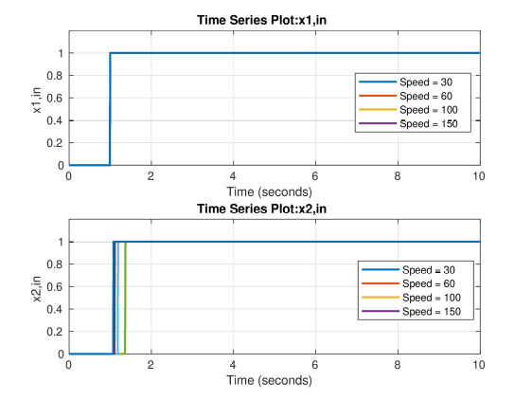

The step inputs x1,in and x2,in are same in magnitude, but with different phase as the front always encounters the road input first before the rear. The time phase between x1,in and x2,in was calculated by using:

5. Draw conclusions from your results.

From the previous results, it can be concluded that:
1. Configuration 2 has the better performance in terms of pitch response given that the magnitude of the time responses for the pitch and pitch rate are visibly less (3rd and 4th subplots).

2. Configuration 1 presents higher frequency oscillations during transient response, this is probably because the desired ride frequency is twice as that of configuration 2.

3. It can also be seen that at higher speeds, the magnitude of the heave mode seems to increase. This makes sense in the physical world as the x1,in and x2,in are going to have less time phase as the speed increases, which might cause that the vehicle to heave higher given the rapid succession of road inputs on the front and rear axles.

4. Also, as speed increases, the heave speed tends to increase.

5. As speed increases, the pitch and pitch rate dynamics are less significant, here we have experimentally proved that at higher speeds, the pitch mode starts becoming less significant and the heave mode becomes dominant in the pitch-plane dynamics behavior.

