Homework 5

ME 565 – Vehicle Dynamics

Student: Andres F. Hoyos

1.) Using the quarter car transfer functions derived in this lecture compare the effect of relative and inertial damping rates. Make a conclusion justified by your modeling results.

Equations of motion for the relative damped suspension:

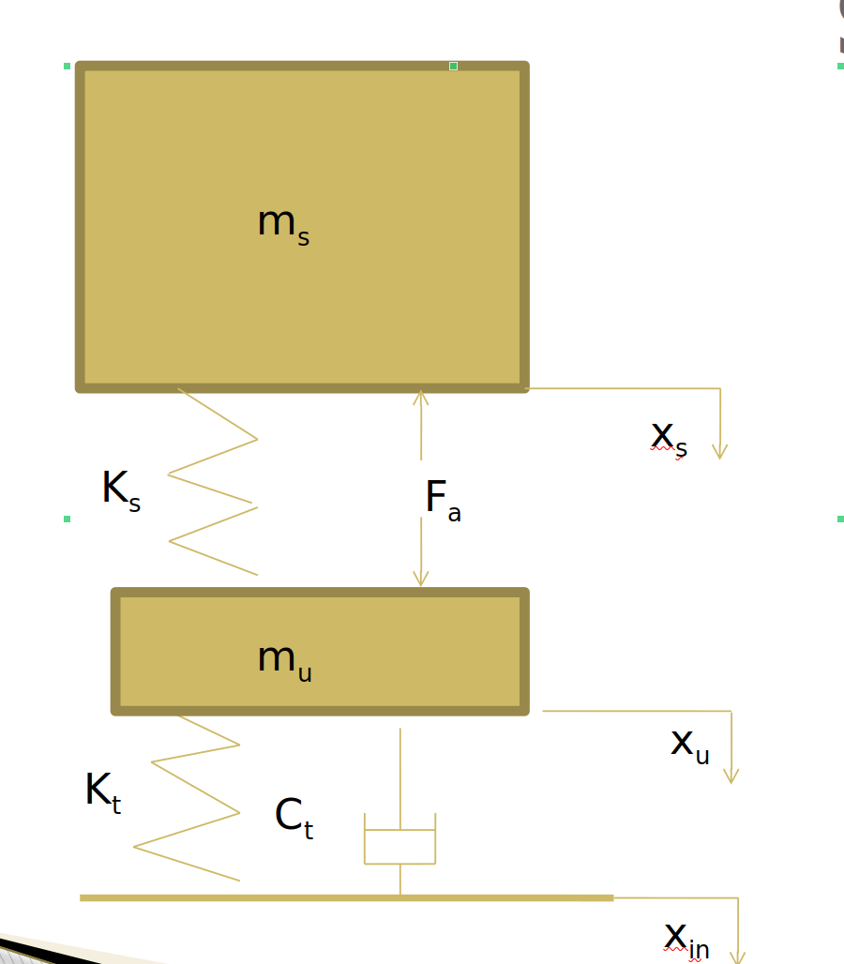

The equation of motion for the sprung mass is:

The equation of motion for the unsprung mass is:

The system expressed in state space:

Which can be expressed as a SISO system as follows:

Where each row of the C matrix will generate a different output (either sprung or unsprung mass displacement).

Equations of motion for the inertial damped suspension:

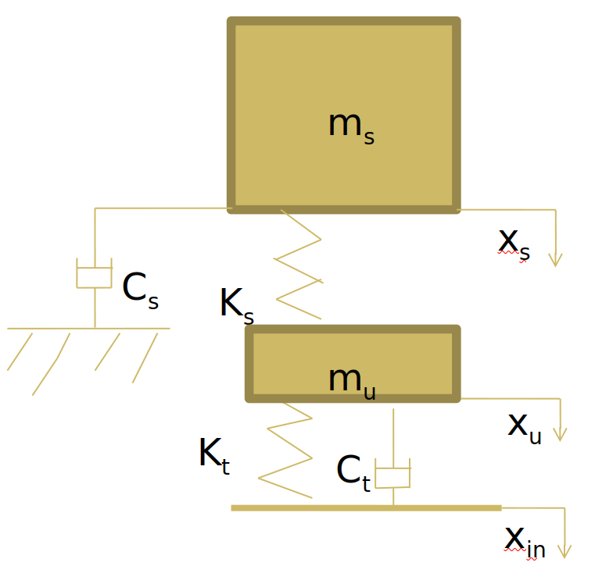

The equation of motion for the sprung mass is calculated by:

The equation of motion for the unsprung mass is:

Written in state-space form as always:

The state-space can be re-written as a SISO:

Output:

To approach this exercise, a code in Matlab is written to plot the transmissibilities for both the sprung and unsprung mass motions for the inertial and relative damping cases.

