Ter caSimulation 2
Quarter Car Model

Student: Andres F. Hoyos

Consider a two-mass quarter model with the following attributes:
Ks=100 lbs/in
Kt=1000 lbs/in
Ws=1000 lbs
Wu=100 lbs
Ct=0.01 lbs-sec/in

Part 1: Linear Analysis
Determine the optimal suspension damping parameter using frequency response methods and human sensitivity to vibrations. Construct a time domain simulation of the two-mass quarter car model and validate the choice of suspension damping parameter with results of the frequency analysis.
Consider inputs consisting of:
1.) A one inch step function beginning at t=1s.
2.) A ¼ inch step function beginning at t=1s.
3.) A +/- 1 inch sine wave input at 1 Hz.
4.) A +/- ¼ inch sine wave at 10 Hz.
5.) A 2 inch pothole 3 ft wide at 50 mph.

Figure 1: Quarter car model diagram.
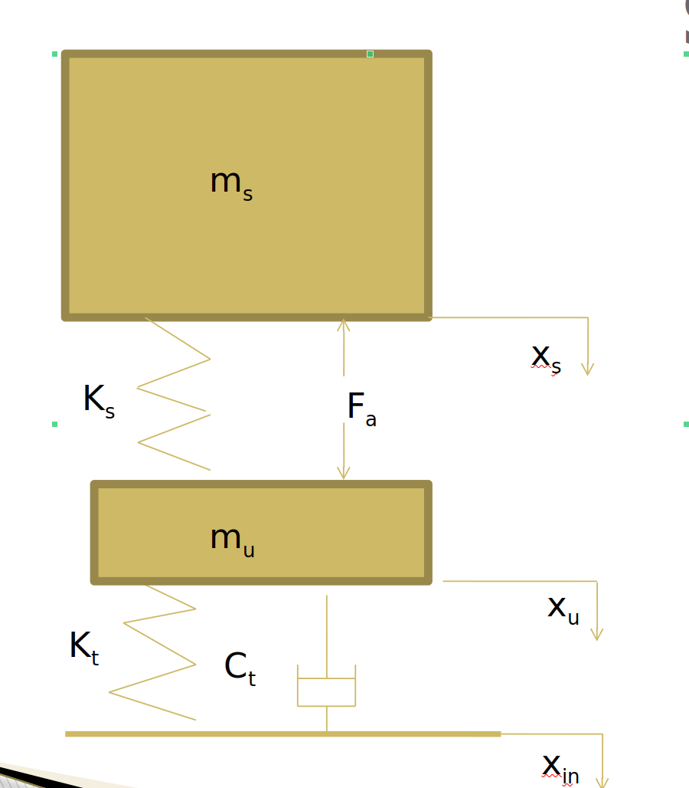

The equations of motion for the quarter car model are:

,

.

The linear system can be expressed in state-space form:

The C matrix will determine which output is required from the system.

Determining the optimal suspension damping coefficient:

