ReadMe

Code Project
decentralized_inference_cleanup_v1
(Note: less important functions or parameters (e.g., device) could be omitted in readme for more readability)
Classes: green font
Functions/methods: orange font
Code files: blue font

How to run code (Two shell script files + One python file)

Step 1:

command:
./run_exp-v2.sh
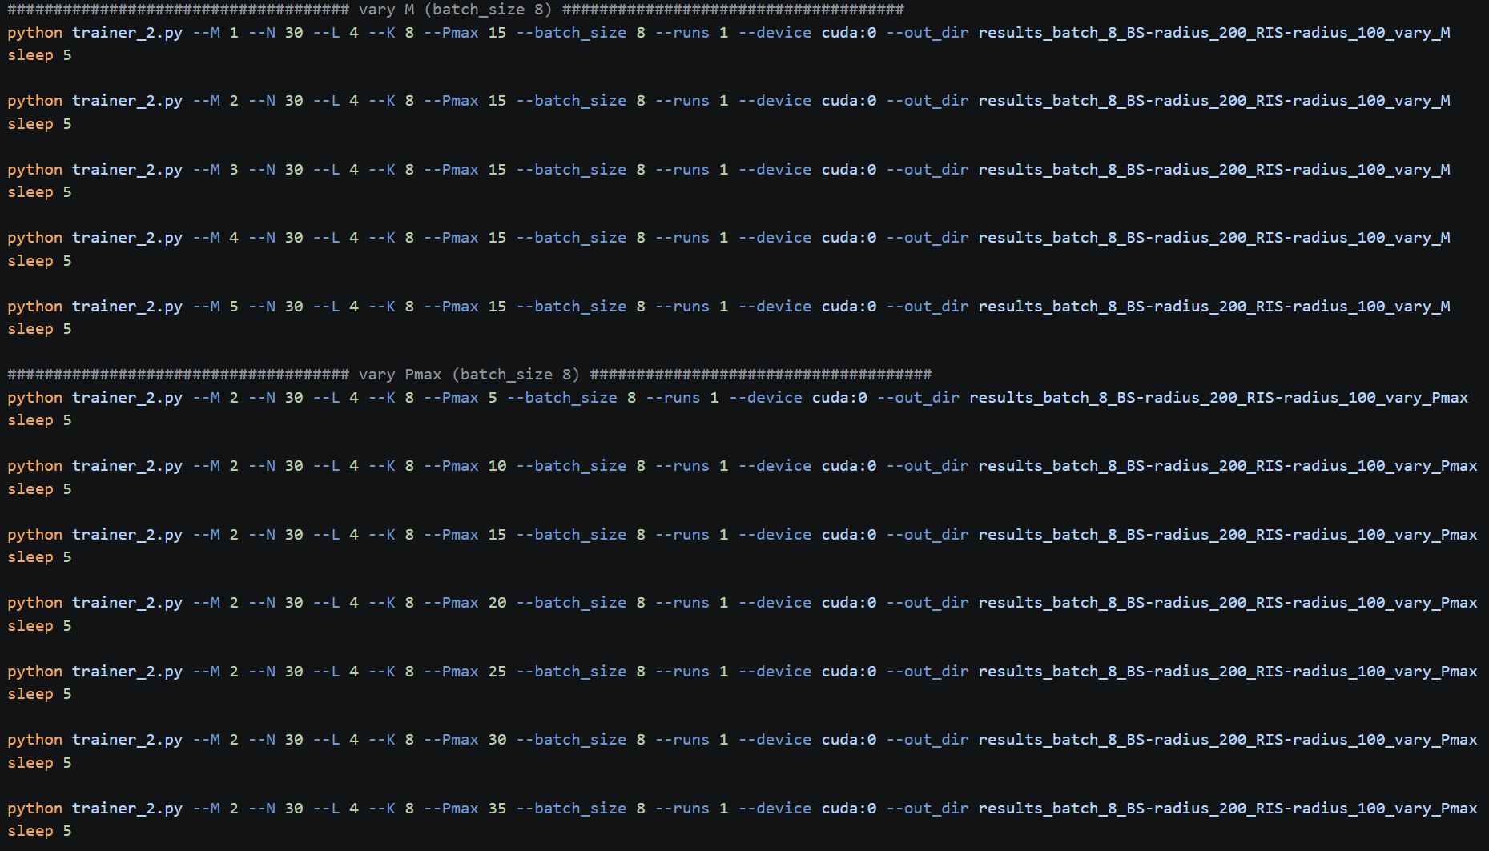

Explanation:
This shell script executes the trainer_2.py file for different values of $M$ (number of antennas per access point (AP)) and $P_{max}$ (power budget per access point (AP)).

Step 2:

command:
./excel_helper.sh

Explanation:
This shell script executes excel_helper.py, creating an excel file which organizes the results from the specified folder.

Step 3:

command:
python plot-v2.py

Explanation:
Plots the results from the specified excel file as a professional figure.

Explanation of code (Six python files)

(1) trainer_2.py

Overview
Main training and inference module

Classes
- Trainer

Trainer
This class
- Trains using centralized approach
- Inferences
  - Using centralized
  - Using decentralized

Initialization:
- Instantiates MyDataLoader from data.py
  - Calls BS_RIS_association()
- Instantiates node_update (GNN, DNN models) from model.py
- Sets association threshold
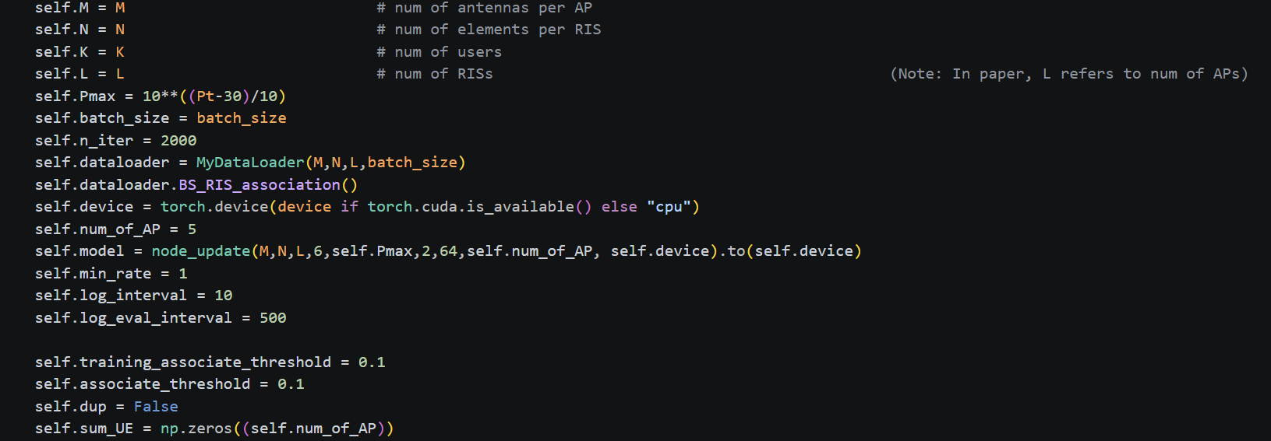

train_batch()
Description | Trains GNN/DNN
Input | None
Output | loss.item(), sum_rate.item(), rate.detach().cpu()

train()
Description | Calls train_batch()
Input | run_id, out_dir, log_dir, test_sample_val, test_sample_final
Output | None

eval():
Description | Inference
Input | test_sample,sigma,itera
Output | np.mean(sum_rate_array_centralized), np.mean(sum_rate_array_centralized_random_phase), np.mean(sum_rate_array_decentralized), np.mean(sum_rate_array_decentralized_random_phase), np.mean(sum_rate_array_centralized_discrete), np.mean(sum_rate_array_decentralized_discrete), np.mean(sum_rate_array_centralized_random_phase_discrete), np.mean(sum_rate_array_decentralized_random_phase_discrete)

(2) model_2.py

Overview
Specifies GNN, DNN architecture

Classes
- initial_layer (i.e., preprocessing layer)
- node_update_layer (i.e., message passing)
- BS_readout
- RIS_readout_AP (i.e., for RIS prediction at each AP)
- RIS_merge
- coeff_DNN2 (i.e., for power control)
- node_update

node_update
This class chains all of the GNN, DNNs together.
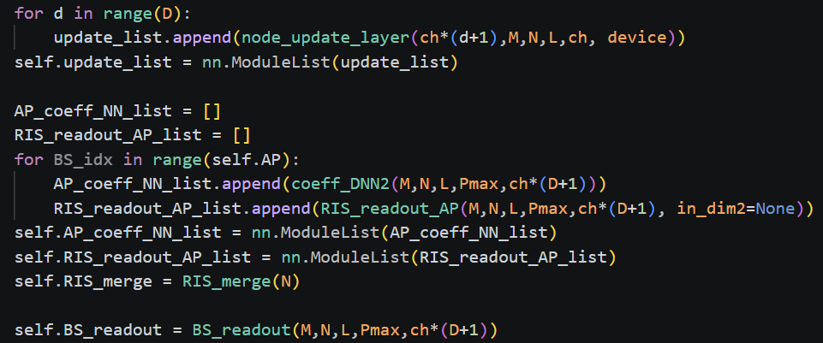
“training” in the code means: “centralized”, 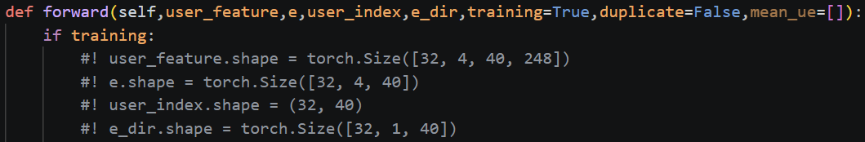

else: decentralized
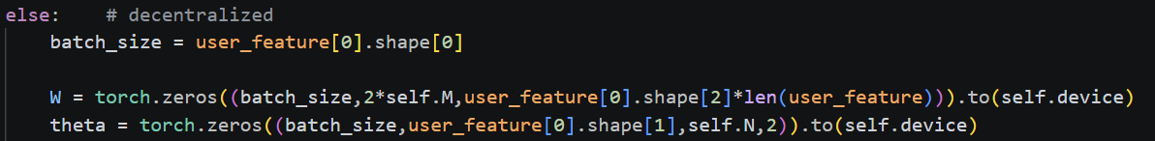

Code snippet for centralized:
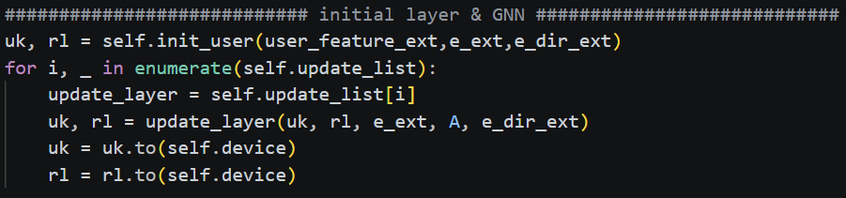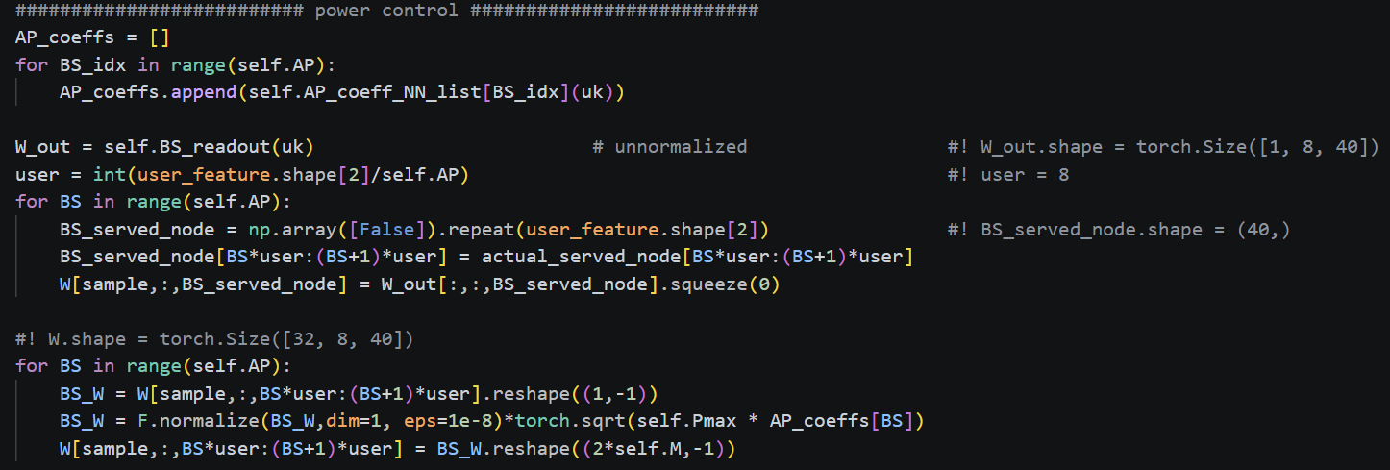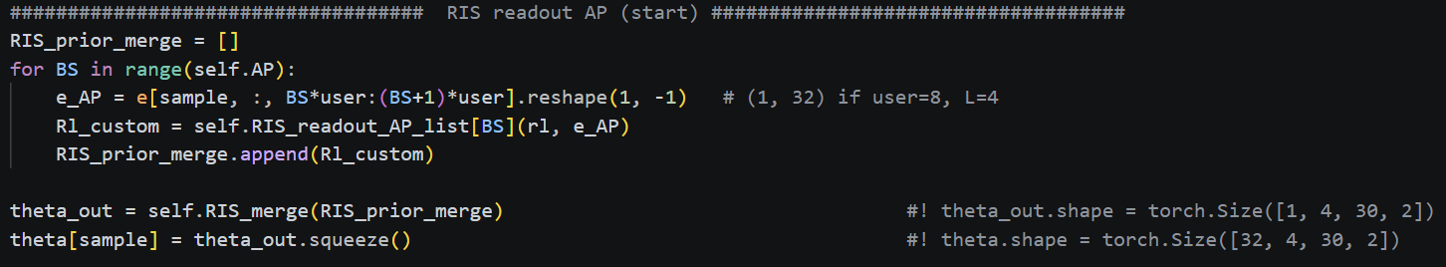

(3) data.py

Overview
Specifies wireless topology, data loading, and loss calculations.

Classes
- Base_station
- RIS
- MyDataLoader

MyDataLoader
This class
- Specifies and creates the wireless network topology
- Specifies how that data would be loaded
- Computes loss function

Initialization:
Defines BS and RIS locations using gen_fixed_location()
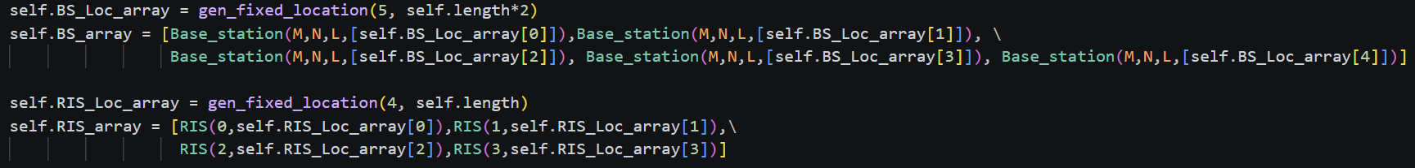

BS_RIS_association()
Description | Associates each Base Station (BS) with all RIS units.
Input | None
Output | None

BS_user_association()
Description | Add UEs to wireless network. Association determined by RSSI.
Input | K, ratio, testing_ratio
Output | None

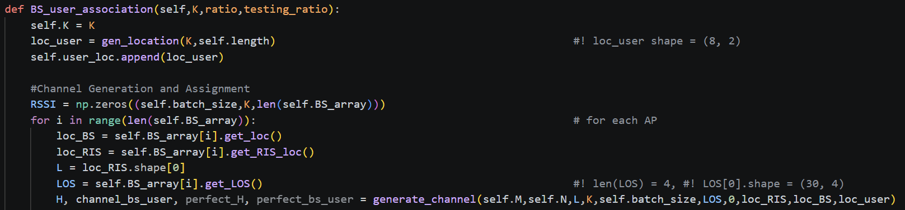

load_data()
Description | Generic data loading (to be called)
Input | BS
Output | user_feature, e, user_index, e_dir, user_index_for_testing

gen_training_data()
Description | Calls load_data() for centralized scenario
Input | K, ratio, testing_ratio
Output | user_feature, e, user_index, e_dir, user_index_for_testing

gen_testing_data()
Description | Calls load_data() for decentralized scenario
Input | K, ratio, testing_ratio
Output | user_feature, e, user_index, e_dir

compute_loss()
Description | Calls the cal_loss() function in utils_return_individual_rates.py
Input | W, theta, Pmax
Output | loss, sum_rate, rate

(4) utils_return_indivial_rates.py

Overview
Includes helper functions such as
- functions for topology generation
- channel simulation
- sum-rate calculations

Functions
- gen_location()
- gen_fixed_location()
- gen_BS_location()
- gen_LOS()
- generate_channel()
- discrete_mapping()
- cal_loss()

Classes
- Channel

Channel

generate_value()
Description | Inserts values for channel object
Input | mean_NLOS, cov_NLOS, LOS
Output | None

large_scale_loss()
Description | Large scale path loss
Input | fading_NLOS, exp_NLOS, fading_LOS, exp_LOS, dist
Output | self.mat

(5) excel_helper.py

Overview
Organizes the results from the generated folders to an excel file.

(6) plot-v2.py

Overview
Plots the results from the specified excel file into a professional figure.

