编译原理程序设计实验报告

——词法分析器设计
班级：计算机1603 姓名：陆文辉 学号：20164435
实验目标：写个词法分析器
实验内容：
1.概要设计:
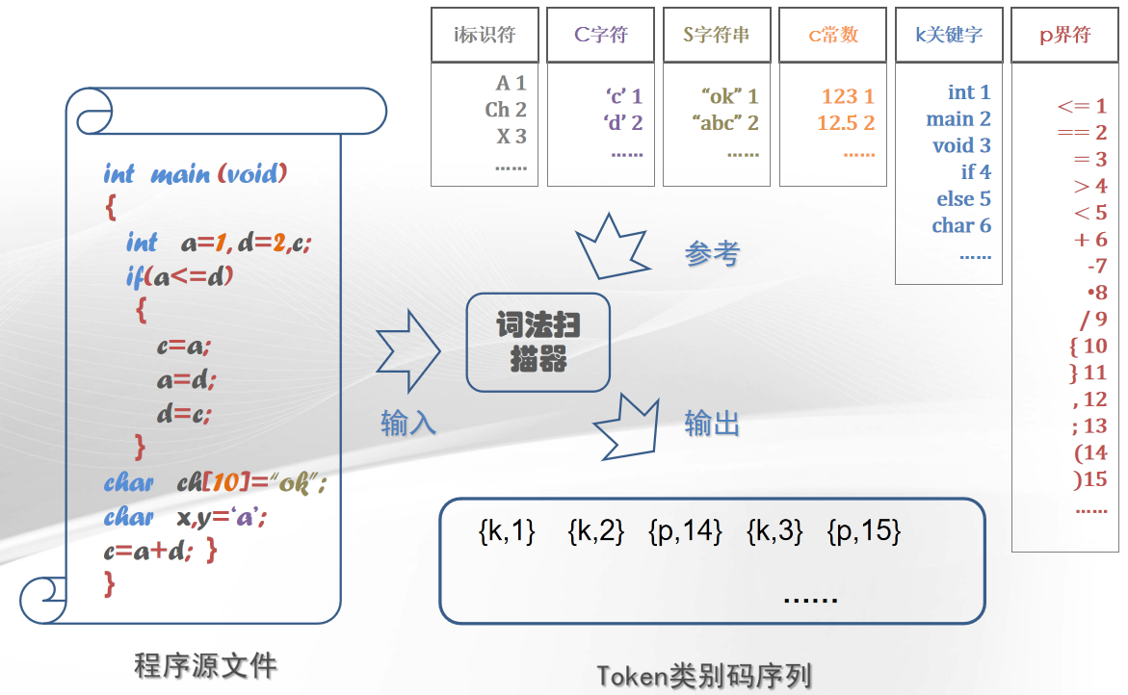
2.数据结构:
struct Token{
int type;//类型,有k,i,c,s,n,b 6种类型
k是关键字,i是标识符,c是字符,s是字符串,n是常数,b是界符
int id;//在同类集合里的序号
};
typedef std::string String;//用C++的字符串类
typedef std::map<String,int> Table;//各种表都用String当主键存在map里
#define Vector std::vector//用vector存字符串根据id返回字符串
3.流程图:
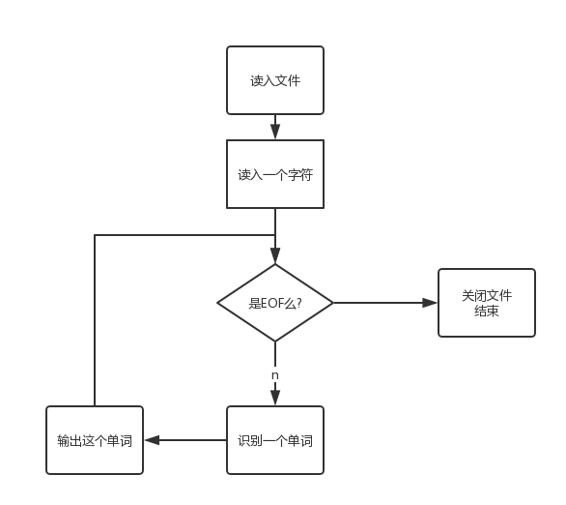
识别一个单词是:
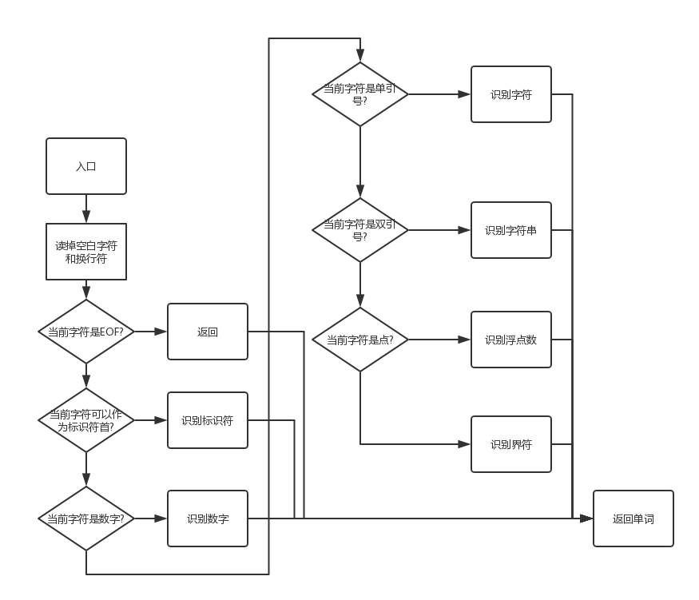
4.关键函数:
bool getNextChar();//读取下一个字符,保存在全局变量里
inline bool isDigit(char x);//判断x是否是数字
inline bool isHex(char x);//判断x是否是十六进制数字
inline bool isOct(char x);//判断x是否是八进制数字
inline bool isLowerCase(char x);//判断x是否是小写字母
inline bool isAlpha(char x);//判断x是否是字母
inline bool isIdfirst(char x);//判断x是否为标识符首字符
inline bool isBlank(char x);//判断x是否是空白字符
inline Token SaveAndReturn(String&now,int type);//保存type类型的Token,其字符串表示是now,返回这个Token
Token nextIdentifier(String now);//读取下一个标识符,已经读取的字符串是now
Token nextReal(String now);//读取下一个实数,已经读取的字符串是now
Token nextConst(String now);//读取下一个常数,已经读取的字符串是now
Token nextCharacter(String now);//读取下一个字符,已经读取的字符串是now
Token nextString(String now);//读取下一个字符串,已经读取的字符串是now
Token nextBoundary(String now);//读取下一个界符,已经读取的字符串是now
Token next(String param="");//读取下一个单词,已经读取了param
inline void init();//使用词法分析器前的初始化函数
源程序代码：
AnalyzerError.cpp:
#pragma once
#include<stdarg.h>
#include<Windows.h>
//printf colorful text,id means colorid
//Blue=1,Green=2,3=Blue+Green=Clay,Red=4,...
void colorPrintf(int id,const char*format,...){
HANDLE hwnd=GetStdHandle(STD_OUTPUT_HANDLE);
SetConsoleTextAttribute(hwnd,8+id);
va_list ap;va_start(ap,format);
vprintf(format,ap);va_end(ap);
SetConsoleTextAttribute(hwnd,7);
}
#define _throw_(str) colorPrintf(-4,str);break
//Used to Report Error
void dealWithException(bool complieover=true){
if(ERROR_CODE>0)
colorPrintf(7,"Line %d:%d ",LINE,COLS);
switch(ERROR_CODE){
case 0:if(complieover)_throw_("Complie Over\n");

case 1:_throw_("ERROR 1:Invaild real literial\n");
case 2:_throw_("ERROR 2:Character not ending\n");
case 3:_throw_("ERROR 3:String not ending\n");

case 11:_throw_("ERROR 11:Expression not ending\n");
case 12:_throw_("ERROR 12:Invaild expression\n");
case 13:_throw_("ERROR 13:Expression parenthesis does not match\n");
default:;
}
if(ERROR_CODE>0)exit(-1);
}
#undef _throw_
WordAnalyser.cpp:
#pragma once
#pragma warning(disable:4996)
#include<stdio.h>
#include<string>
#include<vector>
#include<map>
int ERROR_CODE,LINE=1,COLS=1;
#include"AnalyzeError.cpp"
char nowchar;//now visiting character
bool getNextChar(){//return is'\n'?
nowchar=getchar();COLS++;
if(nowchar=='\n'){
nowchar=getchar(),LINE++,COLS=1;
return true;
}else return false;
}
#define Vector std::vector
typedef std::string String;
typedef std::map<String,int> Table;//string->id
typedef unsigned int uint;
const int _K_=1,_I_=2,_N_=3,_C_=4,_S_=5,_B_=6;
const char description[7][11]={"","KeyWord ","Identifier","Number ","Character ","String ","Boundary "};
const String _keyWord[]={"goto","break","continue","false","true","int","float","void","long","double","for","while","return","do","char","sizeof","struct","class","static","const","auto","register","if","else","switch","case","default","enum","union","this","typedef","using","try","catch","throw","delete","new","extern","inline","namespace","operator","friend","private","public","protected"};
const String _boundary[]={";","[","]","(",")","{","}",",","<",">","=","+","-","|","/","?",".","~","!","%","^","&","*",":","->","::","++","--","<<",">>","<=",">=","==","!=","&&","||","+=","-=","*=","/=","%=","&=","^=","|=","<<=",">>="};
Table keyWordMap,identifierMap,numberMap,characterMap,stringMap,boundaryMap;
Vector<String> keyWord(_keyWord,_keyWord+45),identifier,number,character,string,boundary(_boundary,_boundary+46);
Table *string2id[7]={0,&keyWordMap,&identifierMap,&numberMap,&characterMap,&stringMap,&boundaryMap};
Vector<String>*id2string[7]={0,&keyWord,&identifier,&number,&character,&string,&boundary};
inline bool isDigit(char x){return '0'<=x&&x<='9';}
inline bool isHex(char x){return isDigit(x)||'a'<=x&&x<='f'||'A'<=x&&x<='F';}
inline bool isOct(char x){return '0'<=x&&x<='7';}
inline bool isLowerCase(char x){return 'a'<=x&&x<='z';}
inline bool isAlpha(char x){return isLowerCase(x)||'A'<=x&&x<='Z';}
inline bool isIdfirst(char x){return isAlpha(x)||x=='_'||x=='$';}
inline bool isBlank(char x){return x==' '||x=='\t';}
struct Token{
int type,id;
Token(int i=0,int t=0):id(i),type(t){}
inline bool operator==(const Token&other){return id==other.id&&type==other.type;}
inline bool operator!=(const Token&other){return !(*this==other);}
}Invalid;//Invalid means the invalid word, with ERROR_CODE can find reason.
//Save now into table And Return token
inline Token SaveAndReturn(String&now,int type){
if(!string2id[type]->count(now)){
id2string[type]->push_back(now);
(*string2id[type])[now]=id2string[type]->size()-1;
return Token(id2string[type]->size()-1,type);
}return Token((*string2id[type])[now],type);
}
//Recognize next identifier
Token nextIdentifier(String now){
while(isIdfirst(nowchar)||isDigit(nowchar)){
now+=nowchar;getNextChar();
}
if(!keyWordMap.count(now))
return SaveAndReturn(now,_I_);
return SaveAndReturn(now,_K_);
}
//Recognize next real
Token nextReal(String now){
bool e=false,dot=false;
if(now!="."){
dot=nowchar=='.';
if((nowchar|32)=='e')
dot=true,e=true;
getNextChar();
}if(dot&&!e)now+=".";if(e)now+="e";
if(e&&!isDigit(nowchar)){ERROR_CODE=1;return Invalid;}//invaild real literial
while(isDigit(nowchar)||(!e&&(nowchar|32)=='e')){
if(!e)e=(nowchar|32)=='e';
now+=nowchar;getNextChar();
}
if((nowchar|32)=='l'){
now+=nowchar;getNextChar();
}return SaveAndReturn(now,_N_);
}
//Recognize next const(including real)
Token nextConst(String now){
bool(*function)(char chr)=isDigit;
if(now[0]=='0'){
if((nowchar|32)=='x'){//hex
now+=nowchar;getNextChar();
function=isHex;
}else{//oct
function=isOct;
}
}int LL=0;//no suffix or L or LL
while(LL==0&&function(nowchar)||LL<=1&&(nowchar|32)=='l'){
LL+=(nowchar|32)=='l';
now+=nowchar;getNextChar();
}//suffix is b or B
if((nowchar|32)=='b')
now+=nowchar,getNextChar();
if(LL==0&&(nowchar=='.'||(nowchar|32)=='e'))
return nextReal(now);
return SaveAndReturn(now,_N_);
}
//Recognize next character
Token nextCharacter(String now){
bool in=true,transfer=false;
while(transfer||nowchar!='\''){
transfer=!transfer&&nowchar=='\\';
now+=nowchar;getNextChar();
if(nowchar==-1){
ERROR_CODE=2;
return Invalid;
}
}now+="'";getNextChar();
return SaveAndReturn(now,_C_);
}
//Recognize next string
Token nextString(String now){
bool in=true,transfer=false;
while(transfer||nowchar!='"'){
transfer=!transfer&&nowchar=='\\';
now+=nowchar;getNextChar();
if(nowchar==-1){
ERROR_CODE=3;
return Invalid;
}
}now+="\"";getNextChar();
return SaveAndReturn(now,_S_);
}
//Recognize next boundary
Token nextBoundary(String now){
if(now[0]=='/'&&nowchar=='/'){//line commit
while(!getNextChar());
return Invalid;
}
if(now[0]=='/'&&nowchar=='*'){//block commit
while(1){
do getNextChar();while(nowchar!='*');
getNextChar();
if(nowchar=='/'){
getNextChar();
return Invalid;
}
}
}
while(boundaryMap.count(now+nowchar)){
now+=nowchar;getNextChar();
}return SaveAndReturn(now,_B_);
}
#define nextif(condition,function) \
else if(condition){getNextChar();return function(param);}
//Recognize next word
Token next(String param=""){
while(nowchar=='\n')getNextChar();
param=String(1,nowchar);
if(nowchar==EOF){
ERROR_CODE=-1;//End of File
return Invalid;
}else if(isBlank(nowchar)){
do getNextChar();
while(isBlank(nowchar));
return next();
}
nextif(isIdfirst(nowchar) ,nextIdentifier)
nextif(isDigit(nowchar) ,nextConst)
nextif(nowchar=='\'' ,nextCharacter)
nextif(nowchar=='"' ,nextString)
nextif(nowchar=='.' ,nextReal)
nextif(true ,nextBoundary)
}
//init function, used to add some item into Map
inline void init(){
Invalid.id=Invalid.type=-1;
for(uint i=0;i<keyWord .size();i++)keyWordMap [keyWord [i]]=i;
for(uint i=0;i<boundary.size();i++)boundaryMap[boundary[i]]=i;
}
main.cpp:
#include"WordAnalyser.cpp"
int main(){
#ifdef LOCAL_DEBUG
freopen("../in.cpp","r",stdin);
#endif
getNextChar();init();
Token get;int cnt[7]={};
while(ERROR_CODE==0)//no error >0 and no end of file ==-1
while(Invalid!=(get=next()))
colorPrintf(get.type,"%4d of %s %d\t%s\n",
++cnt[get.type],description[get.type],get.id,(*id2string[get.type])[get.id].c_str());
dealWithException();
return 0;
}
程序运行结果：
输入：in.cpp:
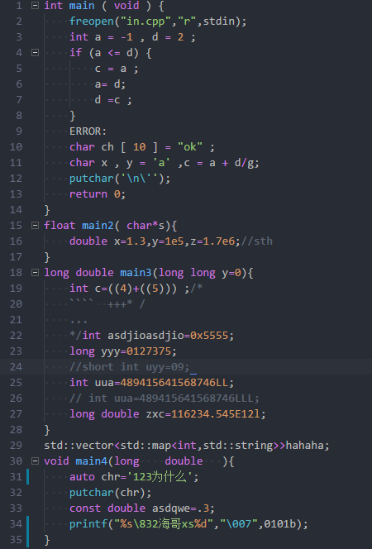
输出：
