编译原理程序设计实验报告

——中间代码生成
班级：计算机1603 姓名：陆文辉 学号：20164435
实验目标：在前两次课的基础上生成中间代码
实验内容：
1.概要设计:
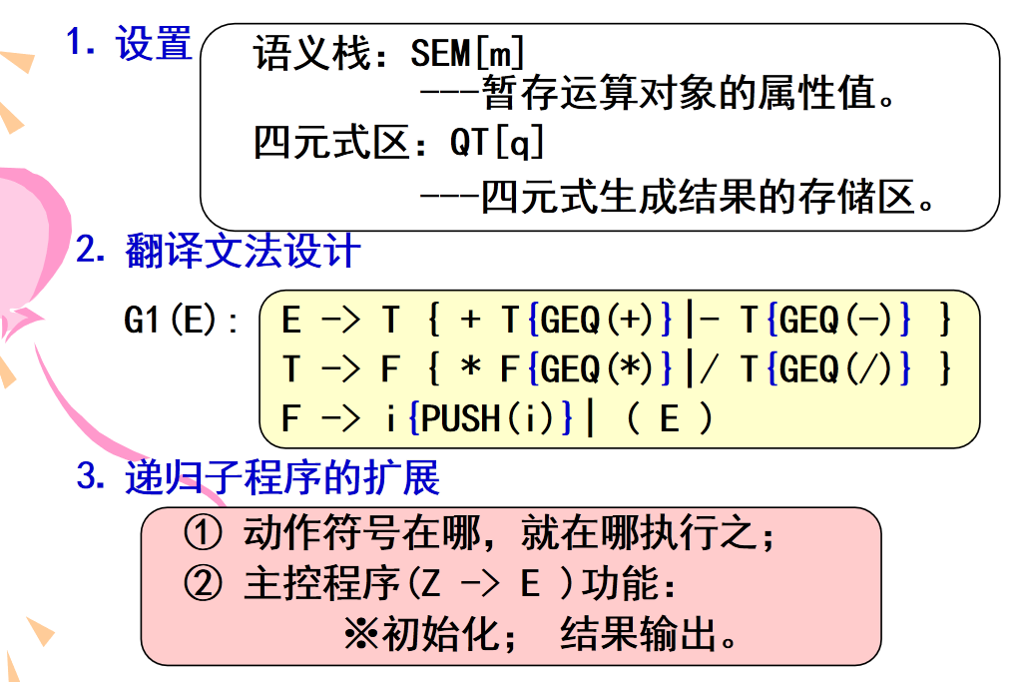
2.数据结构:没有新的数据结构
3.流程图:
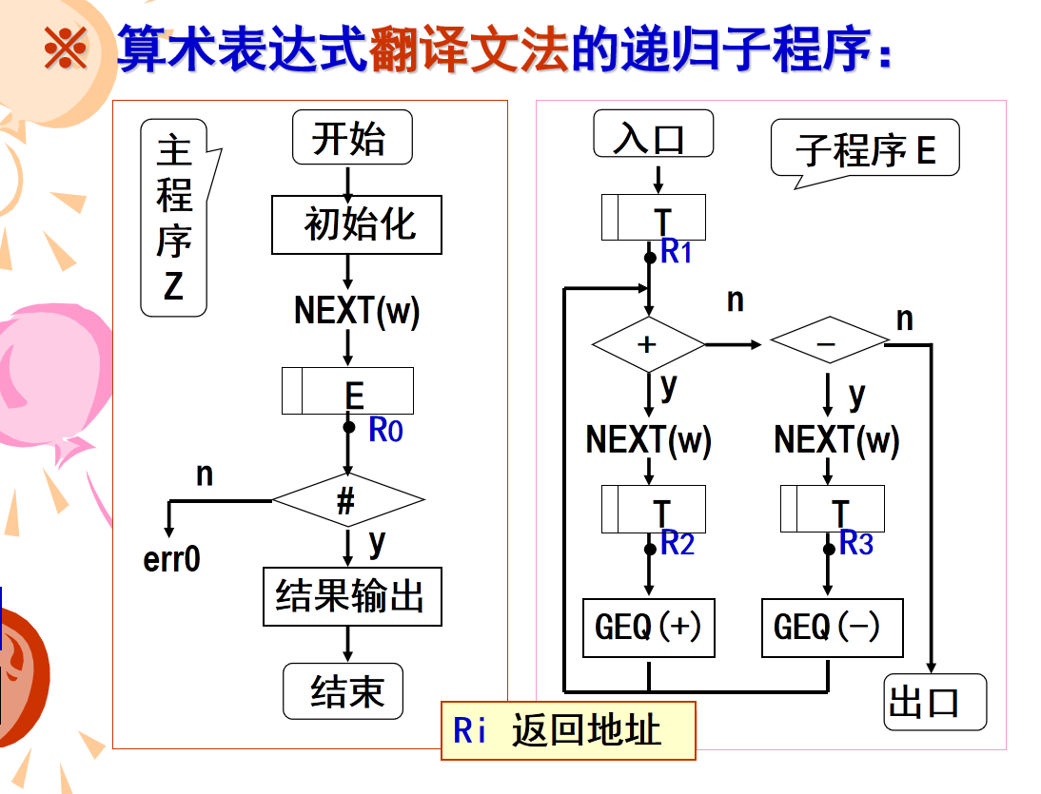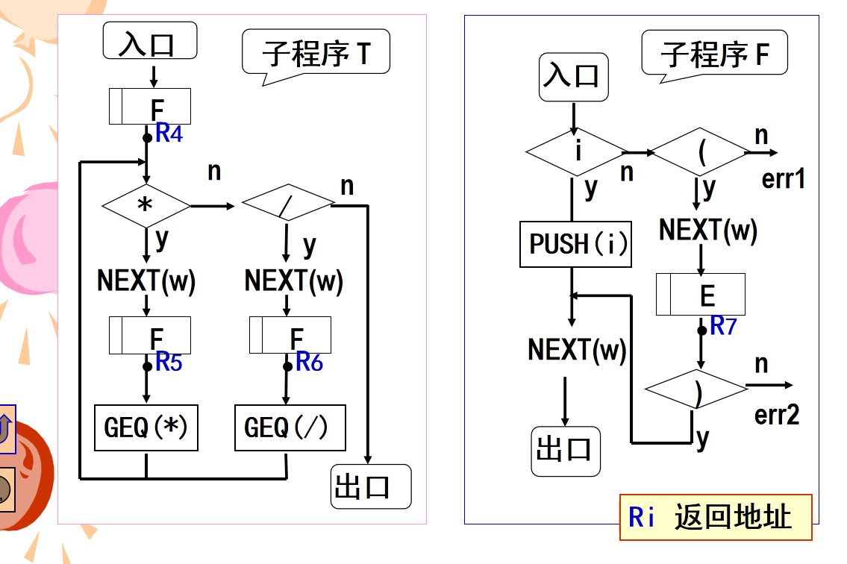
4.关键函数:
const char* STR(Token&x);//返回token的字符串表示
int E(Token&now);//识别E
int E1(Token&now);//识别E1
int T(Token&now);//识别T
int T1(Token&now);//识别T1
int F(Token&now);//识别F
int main();//主函数
源程序代码：
ExpGrammerAnalyserR.cpp:
#include"WordAnalyser.cpp"
typedef int(functype)(Token&now);
functype E,E1,T,T1,F;
String str;

#include<stack>
std::stack<Token>opn;

int tmpcnt=1;
const char* STR(Token&x){return (*id2string[x.type])[x.id].c_str();}
int E(Token&now){
if(T(now)>0)return ERROR_CODE;
if(E1(now)>0)return ERROR_CODE;
return ERROR_CODE;
}
int E1(Token&now){
if(now.type==_B_)
if(boundary[now.id]=="+"||
boundary[now.id]=="-"){
const char*op=STR(now);
str+=(*id2string[now.type])[now.id];
now=next();
if(T(now)>0)return ERROR_CODE;
Token second=opn.top();opn.pop();
Token first=opn.top();opn.pop();
char num[10];
sprintf(num,"t%d",tmpcnt++);
String tmp=num;
Token target=SaveAndReturn(tmp,_I_);
opn.push(target);
colorPrintf(2,"(%s,%s,%s,%s)\n",op,STR(first),STR(second),STR(target));
if(E1(now)>0)return ERROR_CODE;
return ERROR_CODE;
}return ERROR_CODE;
}
int T(Token&now){
if(F(now)>0)return ERROR_CODE;
if(T1(now)>0)return ERROR_CODE;
return ERROR_CODE;
}
int T1(Token&now){
if(now.type==_B_)
if(boundary[now.id]=="*"||
boundary[now.id]=="/"){
const char*op=STR(now);
str+=(*id2string[now.type])[now.id];
now=next();
if(F(now)>0)return ERROR_CODE;
Token second=opn.top();opn.pop();
Token first=opn.top();opn.pop();
char num[10];
sprintf(num,"t%d",tmpcnt++);
String tmp=num;
Token target=SaveAndReturn(tmp,_I_);
opn.push(target);
colorPrintf(2,"(%s,%s,%s,%s)\n",op,STR(first),STR(second),STR(target));
if(T1(now)>0)return ERROR_CODE;
return ERROR_CODE;
}return ERROR_CODE;
}
int F(Token&now){
if(now.type==_I_||
now.type==_N_||
now.type==_C_){
str+=(*id2string[now.type])[now.id];
opn.push(now);//push(i)
now=next();
}
else if(now.type==_B_&&boundary[now.id]=="("){
str+=(*id2string[now.type])[now.id];
now=next();
if(E(now)>0)return ERROR_CODE;
if(now.type==_B_&&boundary[now.id]==")"){
str+=(*id2string[now.type])[now.id];
now=next();
}else{
ERROR_CODE=13;
}
}
else
ERROR_CODE=12;
return ERROR_CODE;
}
int main(){
#ifdef LOCAL_DEBUG
freopen("in2.cpp","r",stdin);
#endif
getNextChar();init();
Token get=next();
int cnt=0;
while(ERROR_CODE==0){//no error >0 and no end of file ==-1
str="";
while(opn.size())
opn.pop();
E(get);
if(get.type==_B_&&
boundary[get.id]!="+"&&
boundary[get.id]!="-"&&
boundary[get.id]!="*"&&
boundary[get.id]!="/"&&
boundary[get.id]!="("
||get.type==-1&&ERROR_CODE==-1)
get=next();
else ERROR_CODE=11;
if(ERROR_CODE<=0){
printf("Expression %2d:%s->t%d\n",++cnt,str.c_str(),tmpcnt-1);
}
else COLS-=str.length();
}
dealWithException();
return 0;
}
程序运行结果：
输入：in2.cpp:
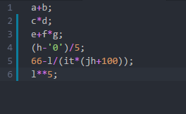
输出：
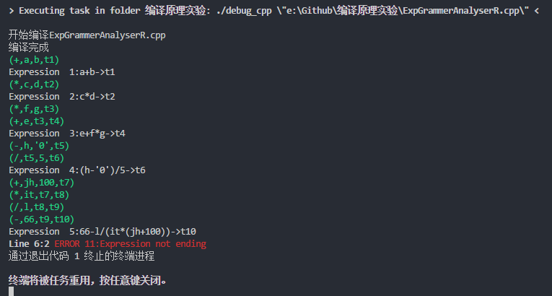
贴一下上次LL(1)分析器的四元式输出:(为了好看,把文法输出注释了)
