**README**

**Project Title:** Compact Stock Trading and Watching App

**What the App does and why the app is useful?**

This compact stock trading and watching app allows investors to create a stock portfolio of multiple stocks, to get latest and historical stock price information, and to get portfolio metrics i.e. portfolio returns, which helps investors make investment decisions.

**How to Run the Program?**

You will see the following java files for this project, StockTrackerGUI.java is the main file to run.

1. DailyDaily.java
2. HttoURLConn.java
3. Placeholder.java
4. PlotGraph.java
5. PorfCalculator.java
6. Portfolio.java
7. StockData.java
8. StockTrackerGUI.java - **MAIN file to run**

**Installing/ Built With:**

Java-json.jar

Javatuples-1.2.jar

Xchart-3.5.4.jar

**Notes:** They are under /lib/. Please make sure adding jars to the build path before running the application.

Special Notes: Because we are using the free version of API, there’s a limitation of 5 calls per min / 500 per day.

**Functionality:**

* Allow a user to add stocks to a portfolio:
  + input a stock ticker, quantity user intends to trade, date, and the target price user would like to trade the stock at.
  + By clicking the “Add Transaction” button, a stock will be successfully added to user’s portfolio.

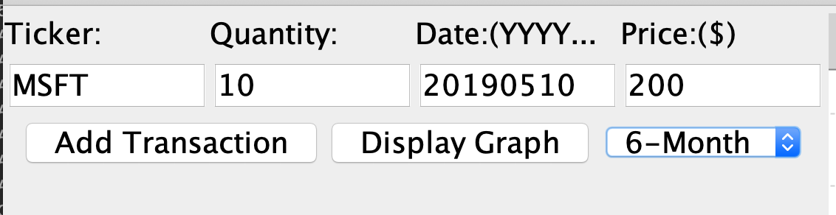

* Displaying historical price information in a graph:
  + By selecting from “3-month, 6 months, or 9-month history, user is able to see the historical price information of a given stock.

Example Graph:  6 months historical price of AAPL

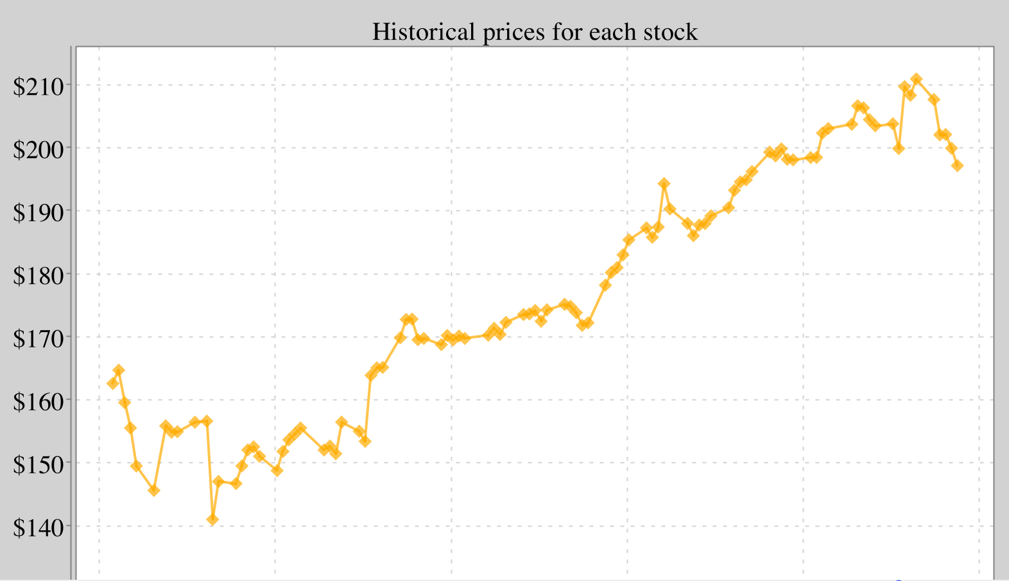

* Display the latest Price and Volume information of a given stock.

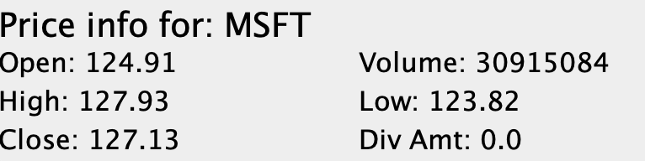

* Portfolio Metrics (Value of your Portfolio):
  + Given the stocks a user has added, the stock app is able to calculate various of metrics to provide user investment decisions.
  + Composition:  stock ticker and quantity a user wants to long.
  + Total value of your whole portfolio: the total value of user’s composition using latest stock price, despite the target price user is willing to trade.
  + Portfolio Stats for a given stock:
    - Average Cost: average cost of a stock based on the price you would like to invest.
    - Portfolio Diversity: Displays what % of current portfolio is currently occupied by this stock
    - Total Return from purchase: Based on the price of a given stock you would like to long/ short; we calculate the total return against latest stock price.
    - Total Return in percentage from Purchase: same as above in percentage.

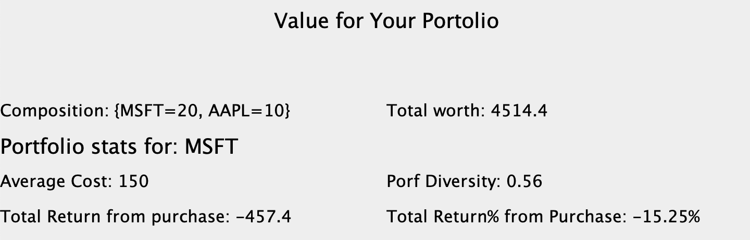

**Authors:**

Jessica Yujia Zhang

Yolanda Shao

You Myeomg Kim