User Manual
Contents
- Section 1: Introduction ------------------------------------------2
- Section 2: The Open Process and Start to Use -----------------------3
The opening process -------------------------------------------------3
Start to Use ---------------------------------------------------------4
(1) Use GUI ------------------------------------------------------4
(2) Use CLI -------------------------------------------------------5
- Section 3: Commands Description---------------------------------6
(1) rectangle <name> <x> <y> <width> <height> -----------------6
(2) line <name> <x1> <y1> <x2> <y2> ---------------------------6
(3) circle <name> <x> <y> <radius> ------------------------------7
(4) square <name> <x> <y> <side> ------------------------------8
(5) move <shapeName> <dx> <dy> ------------------------------9
(6) shapeat <x> <y> -------------------------------------------9
(7) undo ------------------------------------------------------10
(8) redo -------------------------------------------------------11
(9) help -------------------------------------------------------12
(10) quit -------------------------------------------------------13
- Section 4: Troubleshooting --------------------------------------14
(1) Unknown command!
(2) Command error! Please check 'help' for correct commands
(3) Command error in parameters!
- Section 5: Contact Information for Technical Support ---------------15

Section 1: Introduction
Welcome to use our system: Command LineE Vector graphIcs Software (CLEVIS). Our system supports users to create and manipulate vector graphics containing four kinds of fundamental shapes, which are Rectangle, Line, Circle and Square.
Additionally, to facilitate users to better control their process of creation and manipulation, my group mates developed a visualization panel to show these shapes and results in a direct way after each command inputted by the user being executed. In the provided cartesian coordinate system, users can also draw some basic graphics by inputting designed commands.
There are mainly two ways for users to use our systems—command line interface (CLI) and graphical user interface (GUI). In CLI, each time users enter a command, the information of execution result will be immediately and directly shown on the screen, and additional information to assist users to input valid command next time will also be printed out if the command fails to be executed. While in GUI, the information of execution results will not be directly shown on it as users can see the result directly, but it can be found in the cmd.exe window attached to the interface, which is specifically used to show the execution information.
Here comes the end of the Introduction section, it aims to give users a general understanding of what our system does, detailed guidelines on how to use it will be demonstrated in the following sections. One simple sentence to illustrate the system—enter different commands and adjust the parameters, then see how them works visibly.

Section 2: The Open Process and Start to Use
- The opening process
(1) Decompression
Decompress the ZIP file into a folder.
(2) Find the target program (to be modified and screenshots to be added)
Enter that folder, click the ProjectCode folder. After entering it, click The IntelliJ IDEA project folder and then click a file named “run” (run.bat file) inside that folder. After waiting one or two seconds, a cmd.exe window and Clevis – Graphical Editor window (GUI) would show up, indicating the open process is successful.
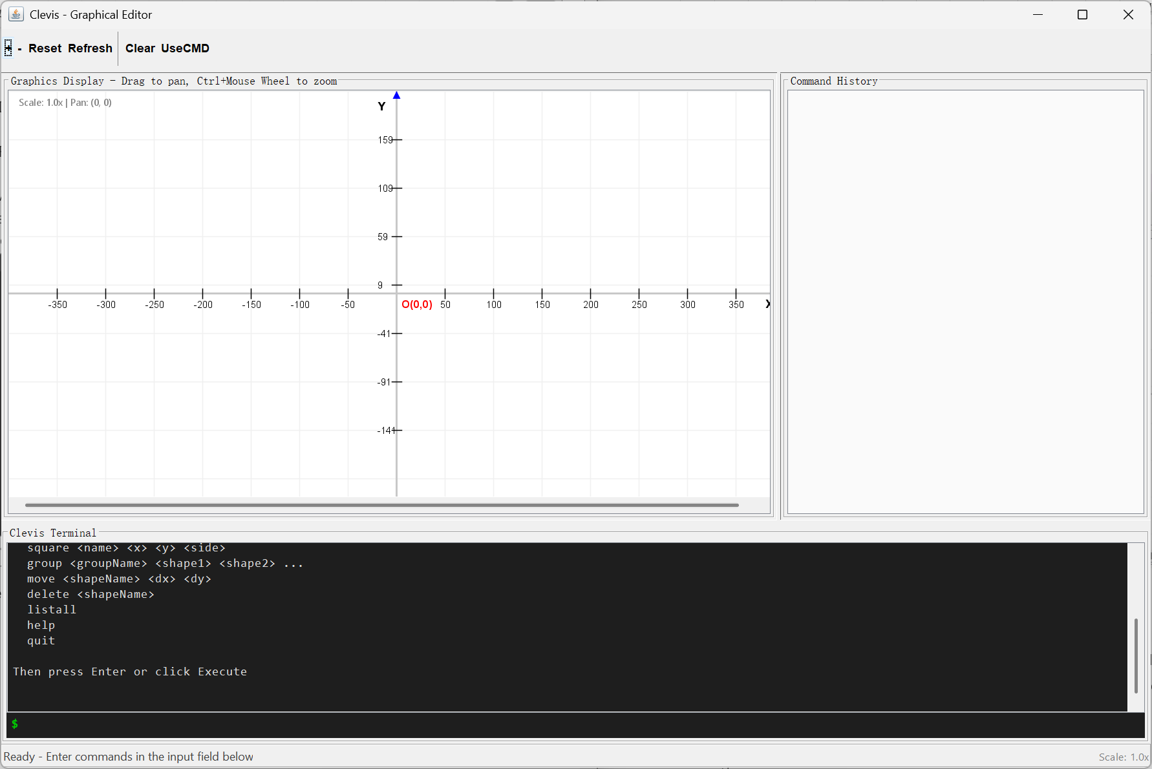
--the Clevis – Graphical Editor window (GUI)
Tips. If it fails to run after trying a few more times, you could see Section 6 in the User Manual to find our contact information and get help.
- Start to Use
As mentioned in the Introduction section, there are mainly two ways to use the system.
(1) Use GUI
The Clevis – Graphical Editor Window (GUI) is composed of three parts—Graphics Display, Command History and Clevis Terminal.
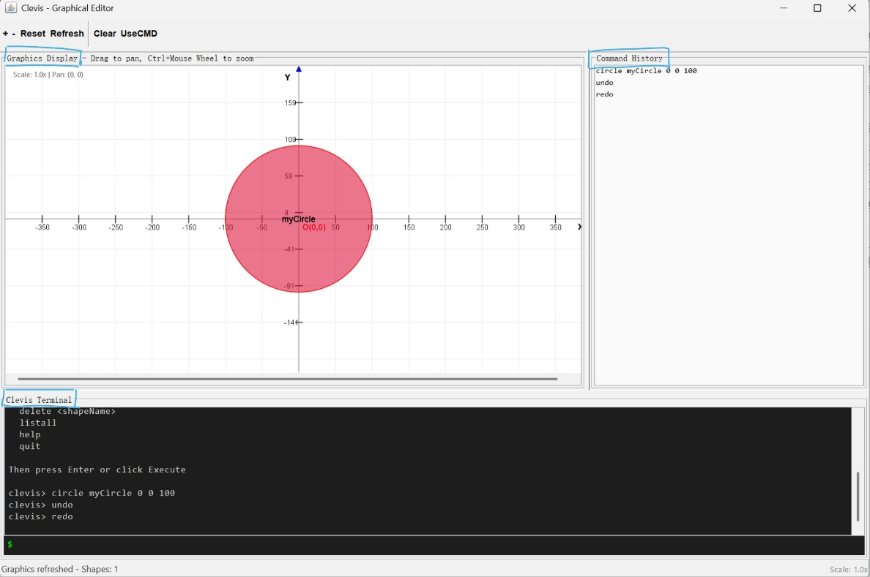
--an example to start using GUI (to be modified)
Graphics Display is the interface to explicitly show the graphics that users manipulate; there’re also a few convenient functions users may use.
①Drag to pan: Users are free to use their mouses to drag the template and go to anywhere they want to have a look.
②Ctrl + Mouse Wheel to zoom: Following this instruction, users can zoom in or out and have a good view of the whole graphics.
③Button “+” and Button “-“: Each time a click, zoom in and zoom out in a fixed scale, respectively.
④Button “Reset”: Recover the viewing perspective to its original state.
⑤Button “Clear”: Clear all existed shapes on the interface. This operation cannot be withdrawn by the “undo” command.
⑥Button “UseCMD”: Switch the current interface being used (which is GUI) to command line interface (CLI). After this operation, the GUI disappears and the previous attached cmd.exe window changes its function to support the command input.
Command History is the interface to note down the commands being executed whatever the execution result, i.e., input commands. Users may want to take a look at their previous operations or save the command history by copy and paste/screen shot so that they could have the same graphics next time entering the system, simply by following the historical commands.
Clevis Terminal is the interface to allow users to input commands. Users can input commands in the area identified by a green symbol $. Notes that historical commands can also be found in this part, by rolling the mouse wheel or dragging the grey bar on the right side.
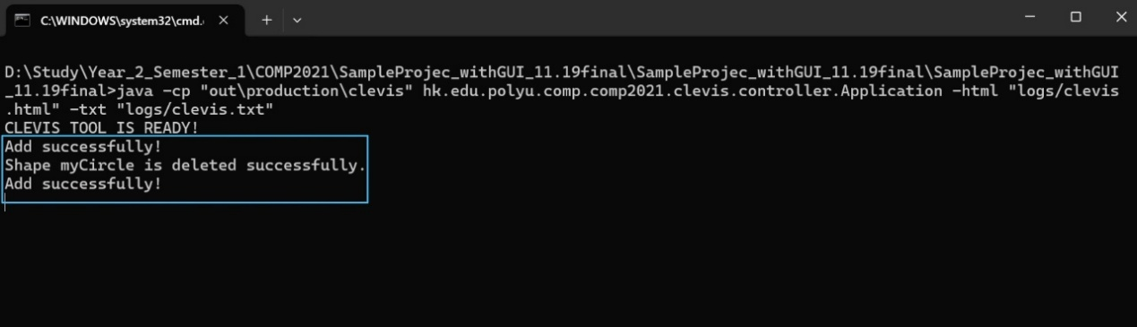
--the corresponding cmd.exe window to the previous screenshot of GUI that shows the execution information (to be modified)
The cmd.exe window is used to show detailed execution information in the whole process, whether it is successfully executed. If it fails to execute the command, additional information to let the users know what errors appear will be printed out.
(2) Use CLI
To use CLI, users should click the Button “UseCMD” in the above area of GUI, then the previous attached cmd.exe window changes its function to support the command input.
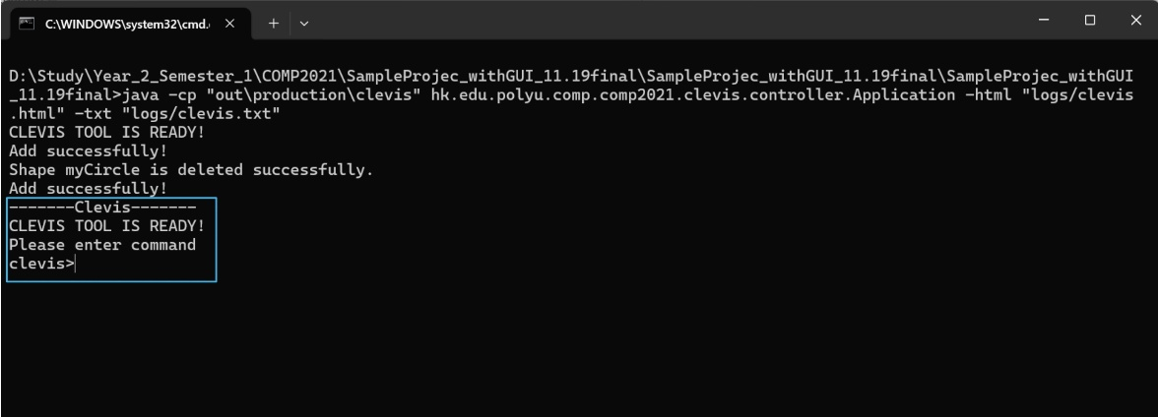
--the cmd.exe window after clicking Button “UseCMD” (contrast it with the previous screenshot) (to be modified)
In CLI, users can input commands in the line identified by the symbol “clevis>”. Each time users input a command and click “enter”, the execution result will be immediately and directly shown on the screen. If the command fails to be executed, additional information to help the user input the valid command next time will also be printed out.
Section 3: Commands Description
Before introducing each specific command, there are two basic but important rules to form any valid input command in our system.
- Every word in angle brackets<> should be replaced by specific content determined by the user and the angle brackets should be discarded, while words without <> cannot be changed (only supports the modification of the upper case or lower case to letters), which are used for the system to identify which specific operation should be performed.
- Separate each word with a space(“ ”), any other punctuations used to separate words will be considered as error.

(1) rectangle <name> <x> <y> <width> <height>

Functionality: This command allows the users to create a new rectangle.
How it can be used:
Users should give the rectangle to be created a unique name <name>. Parameters <x> and <y> specify the position of its top-left corner, which is (x,y). Parameters <width> and <height> declare the width and height of the rectangle, respectively.
Note that the last four parameters should only contain numbers, <x> and <y> don’t have a scope but <width> and <height> should be greater than zero, while it is free to use any characters in parameter <name>.
Step-by-step instruction: Suppose we want to create a rectangle, first we give it a name “myRectangle”. Suppose we want it to be in the center of the cartesian coordinate system, and we set <x> = -100, <y> = 50 to be the coordinate of its top-left corner. Then width <width> should be 100*2=200, height <height> should be 50*2=100. Finally, we put all elements together and form a command—rectangle myRectangle -100 50 200 100 .
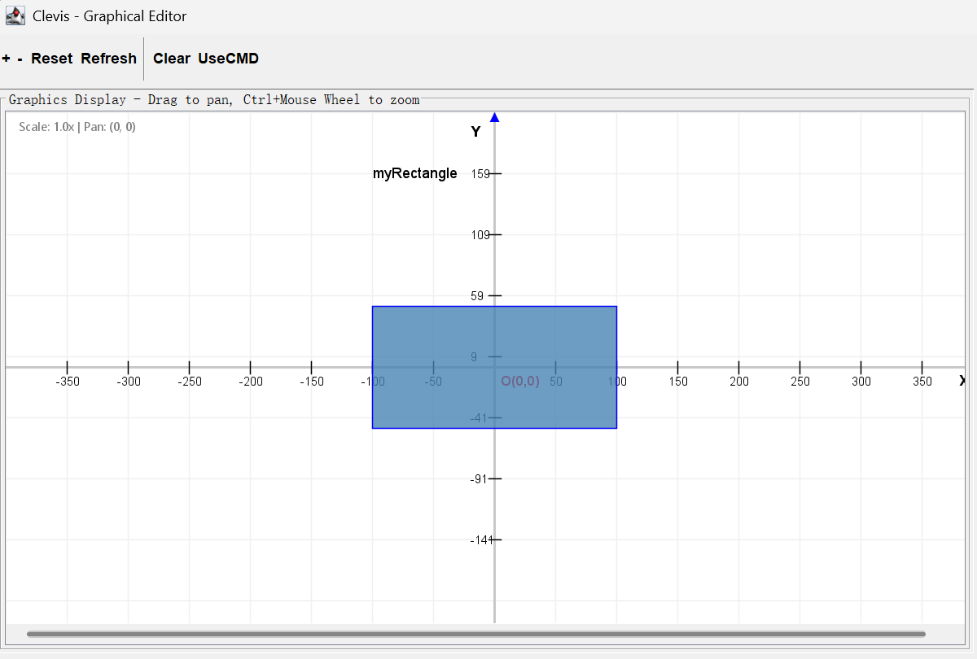
--the execution result of command “rectangle myRectangle -100 50 200 100” in GUI (to be modified)

(2) line <name> <x1> <y1> <x2> <y2>

Functionality: This command allows the users to create a new line segment.
How it can be used:
Users should give the line to be created a unique name <name>. Parameters <x1> and <y1> specify the position of one of its ends, which is (x1,y1). Parameters <x2> and <y2> declare the other end coordinate, which is (x2,y2).
Note that the last four parameters should only contain numbers, they all don’t have a scope but the two conditions <x1> = <x2> and <y1> = <y2> are not allowed at the same time, while it is free to use any characters in parameter <name>.
Step-by-step instruction: Suppose we want to create a line, first we give it a name “myLine”. Suppose we want it to across the origin, and we set <x1> = -100, <y1> = -100 to be the coordinate of its one end. Then the position of the other end should be <x2> = 100, <y2> = 100. Finally, we put all elements together and form a command—line myLine -100 -100 100 100 .
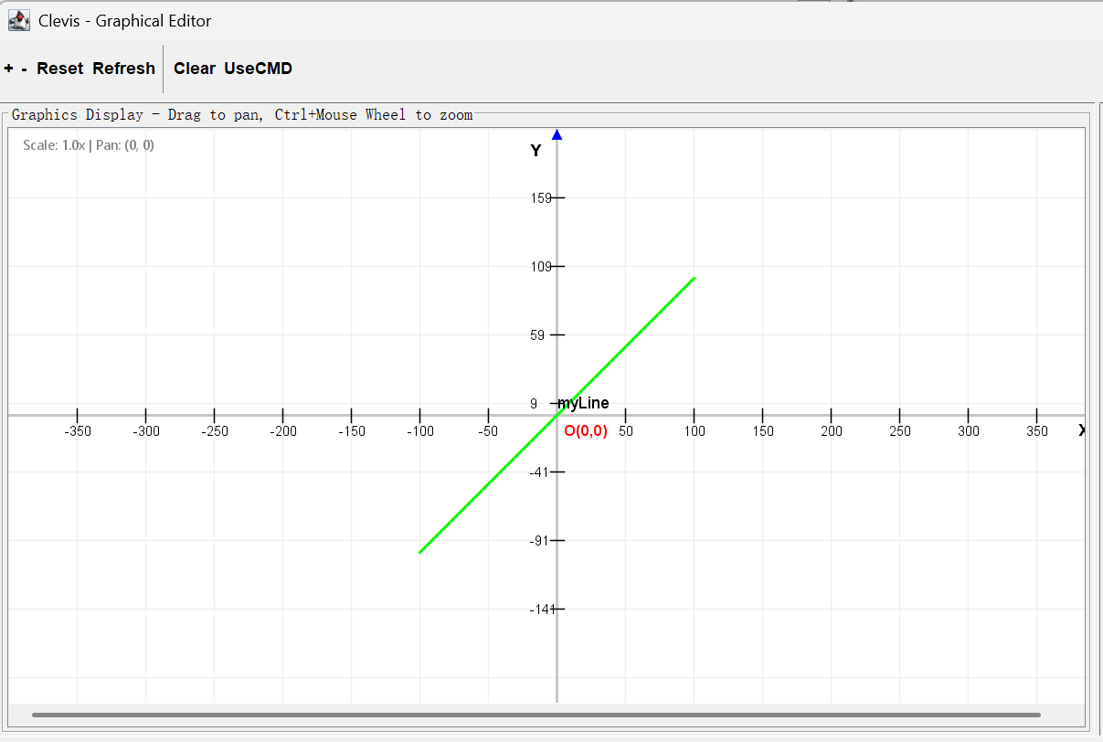
--the execution result of command “line myLine -100 -100 100 100” in GUI

(3) circle <name> <x> <y> <radius>

Functionality: This command allows the users to create a new circle.
How it can be used:
Users should give the circle to be created a unique name <name>. Parameters <x> and <y> specify the position of its center, which is (x,y). Parameter <radius> declares its radius.
Note that the last three parameters should only contain numbers, <x> and <y> don’t have a scope but <radius> should be greater than zero, while it is free to use any characters in parameter <name>.
Step-by-step instruction: Suppose we want to create a circle, first we give it a name “myCircle”. Suppose we want it to be in the center of the cartesian coordinate system, then we set <x> = 0, <y> = 0 to be the coordinate of its center. And we let <radius> equals to 100. Finally, we put all elements together and form a command—circle myCircle 0 0 100 .
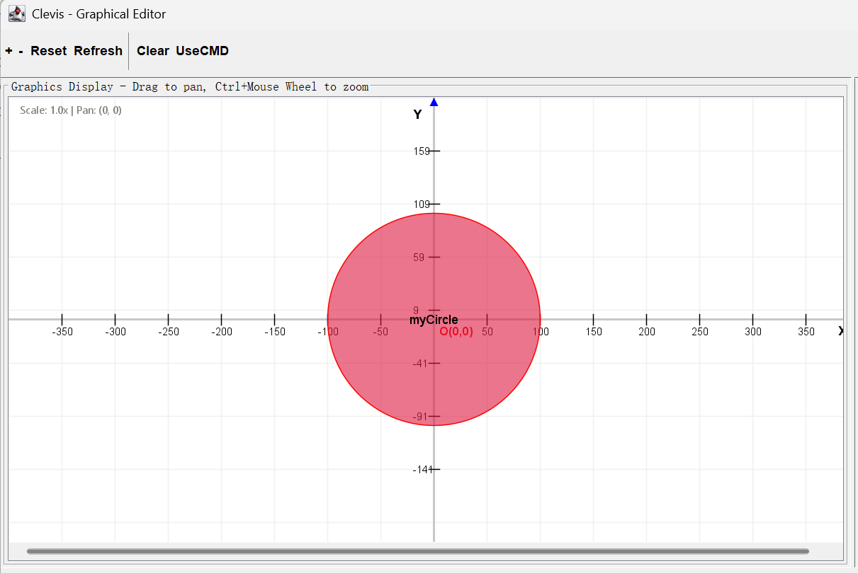
--the execution result of command “circle myCircle 0 0 100” in GUI

(4) square <name> <x> <y> <side>

Functionality: This command allows the users to create a new square.
How it can be used:
Users should give the square to be created a unique name <name>. Parameters <x> and <y> specify the position of its top-left corner, which is (x,y). Parameters <side> declares the side length of the square.
Note that the three parameters should only contain numbers, <x> and <y> don’t have a scope but <side> should be greater than zero, while it is free to use any characters in parameter <name>.
Step-by-step instruction: Suppose we want to create a square, first we give it a name “mySquare”. Suppose we want it to be in the center of the cartesian coordinate system, and we set <x> = -100, <y> =100 to be the coordinate of its top-left corner. Then side length <side> should be 100*2=200. Finally, we put all elements together and form a command—square mySquare -100 100 200 .
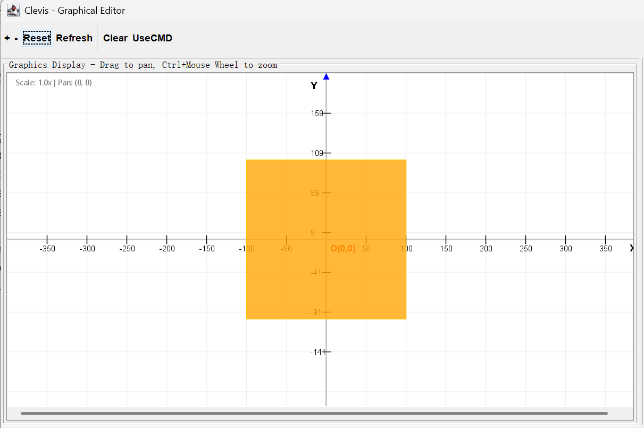
--the execution result of command “square mySquare -100 100 200” in GUI

(5) move <shapeName> <dx> <dy>

Functionality: This command allows the users to move a shape.
How it can be used: This command is useful when the users want to change the position of a shape on the interface to let the existing shapes have more flexibility and form complicated patterns. The shape will be moved horizontally by <dx> distance, vertically by <dy> distance. If the shape is a “group” shape, all its component shapes will be moved by same distance, same direction. Note that parameter <shapeName> should be replaced only by names of existing shapes, the last two parameters <dx> and <dy> should only contain numbers but they don’t have a scope. Error will happen if the system cannot find a shape with provided “existing” shape name.

(6) shapeat <x> <y>

Functionality: This command allows the users to find the topmost shape that covers a point.
How it can be used: Sometimes the users want to know if a point is covered by any of the existing shapes and which shape is if it covers. Our system defines that a shape covers a point if and only if the minimum distance from the point to the outline, i.e., not including the inside, of the shape is smaller than 0.05. It is designed to simulate the width of a line in real life, while in our system, we set the suppositional width of the line equals 0.05*2=0.1 . The position of the point is defined by parameter <x> and <y>, i.e., (x,y). If the point is covered by any of the existing shapes on the interface, the system would print out the topmost shape that covers the point, which means it has the highest Z-index among these shapes. If it cannot find such a shape, “Not found” will be printed out. Note that the last two parameters should only contain numbers, and <x> and <y> don’t have a scope.
Step-by-step instruction: The user enters the command: shapeat <x> <y>
Example: shapeat 10.5 20.3
The system will: a. Parse the command to extract the x and y coordinates (as double values). b. Check if the coordinates are valid numbers. If not, print an error (but the problem states that the last two parameters should only contain numbers, so we assume they are numbers).
The system then checks all existing shapes in the drawing (from topmost to bottommost, i.e., in reverse order of the Z-index, because the last added shape is on top) to see if the point (x, y) is covered by the shape.
For each shape, compute the minimum distance from the point (x, y) to the outline of the shape.
Note: The outline is the boundary of the shape (not the interior). For example:
    - For a rectangle: the distance to the four sides.
    - For a circle: the absolute difference between the distance from the center to the point and the radius.
    - For a line: the distance to the line segment.
If the minimum distance is less than 0.05, then the point is considered covered by that shape.
Since we are checking from topmost (highest Z-index) to bottommost, the first shape we find that covers the point is the topmost one. We then print the name of that shape and stop.
If no shape covers the point, print "Not found".

(7) undo

Functionality: This command allows the users to withdraw the effect of the last command that is executed successfully.
How it can be used: Sometimes users may make mistakes during their process of creating and manipulating their shapes and want to recover the interface to the last state. Then the simple command “undo” would realize this function and withdraw the effect of the last command. It works like a backward arrow button in the web pages. Note that this command works for all commands except boundingbox, intersect, list, listall, help and quit. One more important thing is that it would only work for commands that are executed successfully.
Step-by-step instruction: Suppose we create two circles “circle1” and “circle2” on the interface. Uncarefully, we let “circle2” overlap with “circle1” and we want to get back to the last step. Then, besides using command “delete circle2”, we can choose this command as it is easier to use—undo .
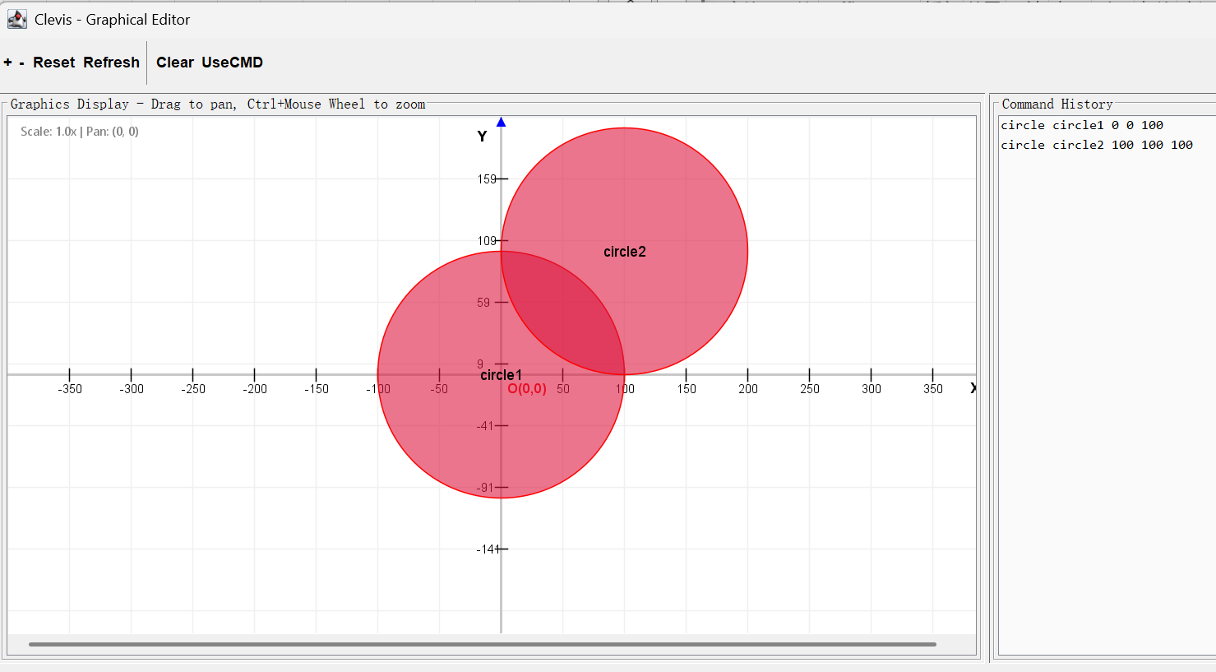
--the original state in GUI before using command ”undo”
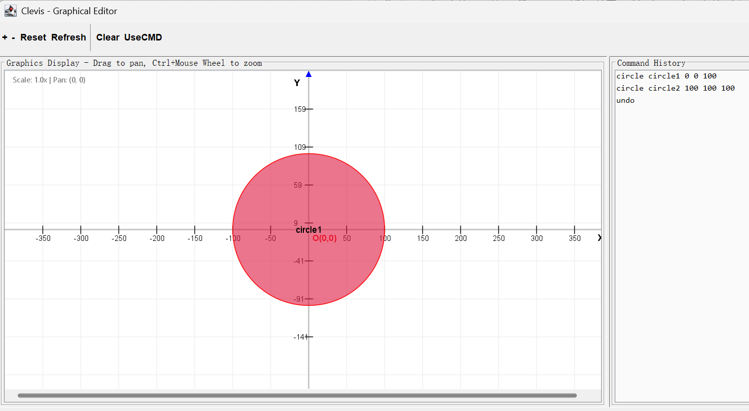
----the execution result of command “undo” in GUI
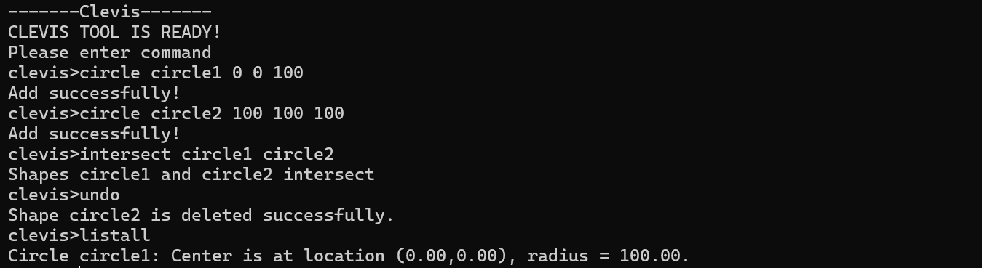
--the whole execution process in CLI (in cmd.exe window)

(8) redo

Functionality: This command allows the users to execute the last command again which is withdrawn by command “undo”.
How it can be used: This is the reverse process of command “undo”. If the users want to recover the state of the interface to the state before using the command “undo”, then the simple command “redo“ would realize this function and move the system state forward. It works like a forward arrow button in the web pages. Note that this command works for all commands except boundingbox, intersect, list, listall, help and quit. One more important thing is that it would only work after the usage of command “undo”.
Step-by-step instruction: In command(14), we use command “undo” to withdraw the creation of “circle2”. Suppose we want to get it back and manipulate its position in the future, then we use this command—redo.
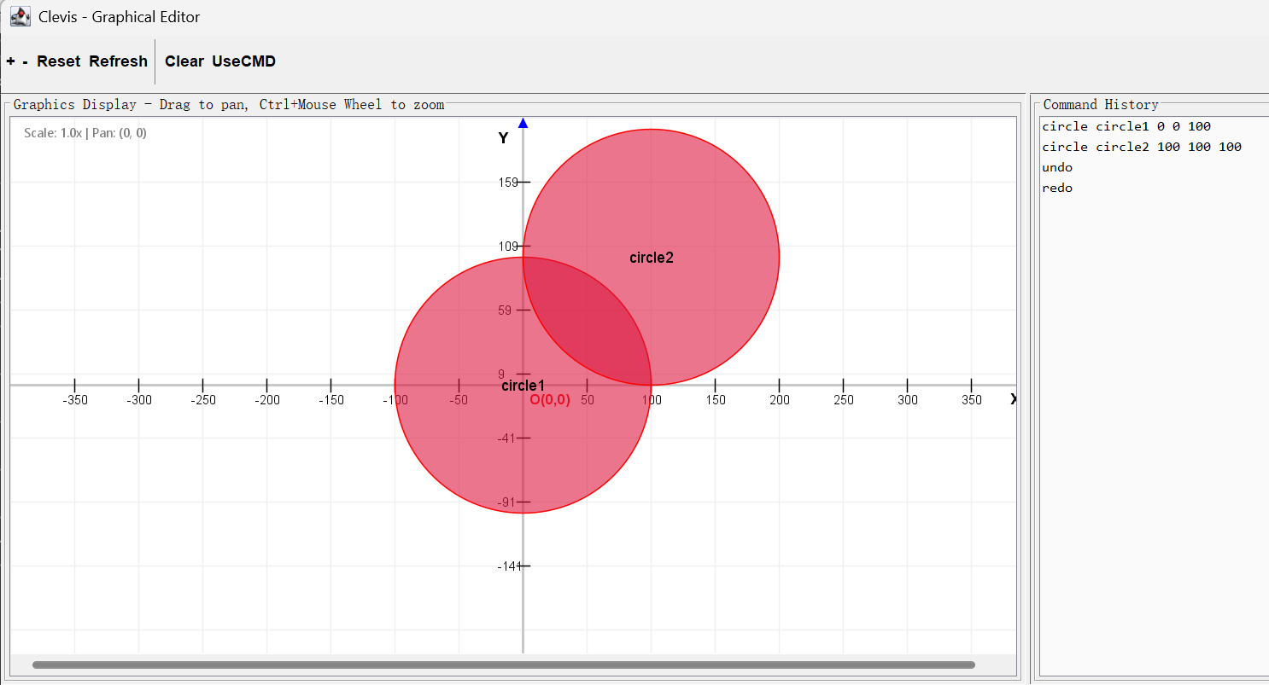
----the execution result of command “redo” in GUI (to be modified) (contrast it with the second screenshot in command(14) undo)

(9) help

Functionality: This command allows the users to check valid command syntax of all types.
How it can be used: As the users that haven’t got too familiar with our system may forget some valid command syntax, our system provides this simple command to help the users when they are in need.
Step-by-step instruction: Suppose we forgot a few valid command forms after a few days, then we can use this command—help, and the system will print out all valid command syntax.
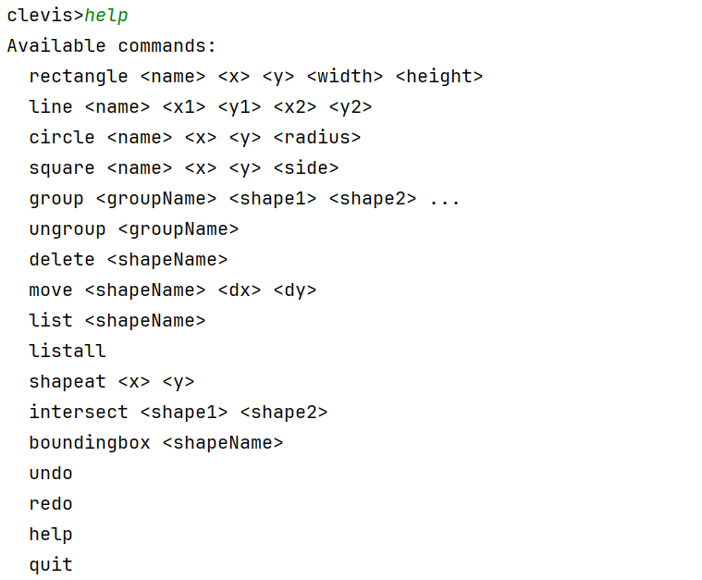
--the execution result of command “help” in CLI (in IntelliJ IDEA consoler)

(10) quit

Functionality: This command allows the users to terminate the current execution of the system.
How it can be used: This command is used when the users want to terminate the execution of the system. The system will print out “Quit successfully” and then terminate.
Step-by-step instruction: Suppose we want to terminate the system, then we use this command—quit, then the GUI/CLI interface prints out “Quit successfully” and the cmd.exe window and GUI window will disappear.
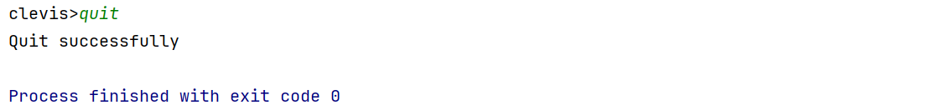
--the execution result of command “quit” in CLI (in IntelliJ IDEA consoler)

Section 4: Troubleshooting
In the process of using our system, it is common for the users to encounter some issues or errors. This section is used to direct the users to resolve these issues on their own by using the error information printed out by the system as hints. The contents below are three kinds of information that are considered to be errors in the system and their corresponding solutions.

(1) Unknown command!

Description: This error will happen if the system cannot correctly identify which specific type of command that the uesrs input. If the first word (which is used for the system identification) contains some spelling mistakes or it is not within the range of all seventeen commands, this error information will be printed out.
Solution: Input “help” command to see all commands that the system supports and their valid syntax.

(2) Command error! Please check 'help' for correct commands

Description: As every different type of command has a specific number of words in it, this error will happen if the input word count doesn’t match the excepted word count of that type of command.
Solution: Input “help” command to find the correct version of the needed command type.

(3) Command error in parameters!

Description: All different types of command has <parameter> in their syntax except “listall”, “undo”, “redo”, “help” and “quit”. Altogether, there’re three cases that this error would occur. The first case happens in the process of creating a single shape (command type “rectangle”, “line”, “circle”, “square”), if the interface already has a shape that has a name same to the shape to be created (Name collision problem), or the <parameter> to be filled with numbers is not valid. The second case happens in the process of creating a “group” shape (command type “group”), either Name collision problem or the system cannot find a shape with provided “existing” shape name (Not found problem). The third case happens in the process of ungrouping a “group” shape (command type “ungroup”), if the shape to be ungrouped is not a “group” type shape. Other command type “delete”, “move”, “list”, “shapeat”, “intersect”, “boundingbox” would have same cases above.
Solution: Repair and replace the command parameters with fitted contents based on the requirment of that specific command type.

Section 5: Contact Information for Technical Support
If the users encounter any problems that cannot be resolved by using this user maunal or if they wish to share feedback on the their experience with our system or any suggestions for improvement, we would be grateful to be contacted and welcome to all such communications from users.
Here’s my email address:
24106157d@connect.polyu.hk
And my group members’ email address:
24107566d@connect.polyu.hk
24108869d@connect.polyu.hk
24099038d@connect.polyu.hk

Wish you have a pleasant experience with our software.
Thank you!

End

