MMU Medical

A REPORT SUBMITTED TO MANCHESTER METROPOLITAN UNIVERSITY FOR THE DEGREE OF Software Engineering

IN THE FACULTY OF SCIENCE AND ENGINEERING



2022

By: Juba Benhadj 18043662

Department of Science and Engineering

Contents

List of Figures 4

Declaration 5

Acknowledgements 6

Chapter 1- Introduction: 5

1.1- Project Overview: 6

1.2-Aim and objectives: 6

1.3-Problem: 7

Chapter 2- Literature review: 8

2.1-Responsive web design: 8

2.2-Healthcare websites: 8

2.3-Active server page .NET framework: 9

2.4-Accessibilty features: 9

Literature review conclusion: 10

Chapter 3- Used Technologies: 10

3.1-Microsft ASP.NET framework: 11

3.2-C#: 11

3.3-Microsoft SQL (MSSQL): 11

3.4- Cascading Style Sheets (CSS): 11

3.5- HyperText Markup Language (HTML): 11

Chapter 4-Design: 11

4.1-Requirements: 12

4.2-Hardware and Software: 12

4.3-Website Design: 13

4.3.1-Brief description of the pages: 13

4.4-Design methodology: 16

4.5-Website layout and wireframe models: 16

Chapter 5-Implementation: 22

5.1-Creating the project and coding: 23

5.3-Different Pages: 32

Chapter 6-Testing and self-evaluation: 35

6.1-Testing: 35

6.2-Self-evaluation: 36

Chapter 7-Conclusion: 37

Appendix A 38

# List of Figures

1. Figure 1.1-Compairaison of three GP websites.
2. Figure 4.1-Website Sitemap
3. Figure 4.2-Website User Sequence Diagram
4. Figure 4.3-HomePage wireframe model
5. Figure 4.4-CovidPage wireframe model
6. Figure 4.5-AboutUsPage wireframe model
7. Figure 4.6-ContactUsPage wireframe model
8. Figure 4.7-LoginPage wireframe model
9. Figure 6.1- Google mobile test result

# Declaration

No part of this project has been submitted in support of an application for any other degree or qualification at this or any other institute of learning. Apart from those parts of the project containing citations to the work of others, this project is my own unaided work. This work has been carried out in accordance with the Manchester Metropolitan University research ethics procedures, and has received ethical approval number:36982

Signed:

Date:23/05/2022

# Acknowledgements

I would like to start by thanking my supervisor Andrew Schofield who has helped me so much throughout this year as well as last year in his previous class.

I would also like to thank my family and everyone who has helped me get through this long and rough journey.

Special mention to all the teachers and lecturers who helped get me here as well as my friends at university and at work.

# 

***Abstract:***

Technology has known an exponential growth over the last decades and it is nowhere its summum, the internet especially which is one of the most powerful tools known to humanity as it made the world smaller and more accessible for anyone anywhere.

One of the most important components of the internet are websites, they basically sit on top of the world wide web infrastructure and while technology has provided a lot of devices to allow any person to access it, websites kept changing and adapting to those devices in order to meet the demand.

One key aspect of this adaptation is a method of website design called responsive web design (RWD)so when browsing a site, it enables the content to adjust to the screen sizes of various devices.

This project's goal was to develop a general practitioner (GP) website that focuses on user experience and responsiveness. The site aims to provide patients or people in general an accessible and easy way to locate the information they need, while making sure that the information is genuine, up to date, always accessible and conveniently located in one spot.

Overall, the end product mainly meets the objectives of the project and most of the functionalities were achieved. But it was lacking some more accessibility features amongst other things and the practicality of certain components is limited.

List of abbreviations:

RWD: Responsive web design

ASP: Active server page

HTML: Hypertext Markup Language

CSS: Cascading Style Sheets

C#: C sharp

GP: General practitioner

GUI: Graphical user interface

MSSQL: Microsoft Sequel

VS: Visual Studio

# Chapter 1- Introduction:

# Project Overview:

The introduction of mobile and portable devices changed radically the internet usage and it revolutionized and shaped the lives of everyone. Guidance, browsing for knowledge or news, entertainment are just a few taps away nowadays.

To meet this rapid growth the industry came up with the RWD technique that basically solves a lot of design problems due to the different devices used by users. Offering a responsive layout saves a valuable time and money, for example a developer does not have to create multiple sites for each device because the more it is looked at; the more the realization that it is nearly impossible due to the rise of mobile and tablet usage.

The aim of this project is to develop a product (website) that is filled with medical information and useful links related to the COVID-19 pandemic using the RWD development methodology to make it possible to generate the web pages quickly and efficiently while dynamically adjusting for device size, guaranteeing a positive user experience on mobile, tablet, and desktop computers.

The implementation is a GP website written in the ASP.NET framework using HTML and CSS for the front-end user interface and C# in the back-end that connects to a database which allows sign-up and log-in.

This report covers the work undergone throughout the creation, development, design, and implementation of the product. Each chapter covers a substantive area of the work done.

# 1.2-Aim and objectives:

The purpose of the project is to create from scratch a GP website for a fictional medical practice called MMU medical that provides the following:

* User friendly graphical user interface (GUI).
* A repository of information and links.
* A responsive adaptive dynamic layout.
* Accessibility features.
* Making sure that visitors access and navigate the website with ease.
* Ensuring that users can easily access and navigate the website’s different sections

# 1.3-Problem:

The main issue tackled in this project is how most GP websites are replicas of each other, this is due

to practitioners using proprietary providers who offer a limited set of templates and designs which leads to a lack of originality as shown in this figure below:

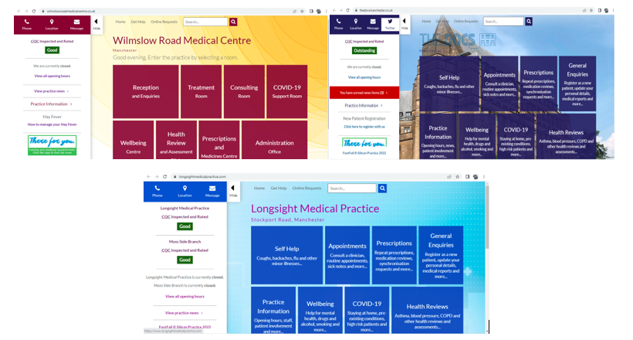

Figure 1.1-Compairaison of three GP websites.

Another problem is the user losing their way from an initial query because of the constant page changes and lack of navigation elements to help prospective patients find a specific topic. Many of them are filled with too much information which tends to frustrate users.

# Chapter 2- Literature review:

Websites have become the main public communication portal to the internet for individuals and organizations following the tremendous and rapid rise of internet usage. Nowadays many if not most interactions either personal or professional are conducted online, this puts a requirement for websites to engage visitors while providing a smooth and positive user experience.

# 2.1-Responsive web design:

The first pages created in the early days of web design were built to target a specific screen size or desktop, in the event of a user having a bigger or smaller screen than what the designer anticipated, results varied from a wrong display of navigations elements (footers or navigation bars for example) to a poor use of screen space when the page is loaded.

Ethan Marcotte is web designer best known for putting together the term web design and its foundations (Clarke, 2015). The concept of RWD, a collection of techniques that enables web pages to change their structure and look to adapt to various screen widths, resolutions, etc., emerged as more and more screen sizes and devices became accessible.

RWD relies on technologies that already existed such as flexible images, layouts, and media queries (Marcotte,2011), but when all these techniques were merged under the same banner the way web design was conceived has changed drastically. In short, the method allows web designer to put constraints when developing a website without having to worry about adaptivity nor scalability.

# 2.2-Healthcare websites:

It is no secret that when an individual enquires about a service, the first reflex is to search it on internet and find the quickest answer, due to that healthcare and medical infrastructures had to go digital to secure and offer a 24/7 online presence. Lacking an online presence for a practice leads potential patients to think that something is wrong.

Numerous positive aspects came out from the medical field going digital such as:

* Reliving doctors and improving efficiency due to the reduced need for physical consultation.
* Saves the patient cost and convenience.
* Provides online comfort and advice.
* Asynchronous access to data and information anywhere.

All of the above points show to the necessity of building a websites for the practice (MMU Medical) to improve presence, reputation and reach.

# 2.3-Active server page .NET framework:

.NET, pronounced as dot net is a development platform created by Microsoft for the creation of several application types. and ASP.NET is a framework that extends the base platform, it is used to build web applications and services.

It has become very popular amongst web designers due to the large and helpful set of tools and libraries it provides, its open-source free cross platform feature is one of the biggest draws because it means that it can be run on any operating system at no cost resulting in the production of fast, robust, and secure websites.

The availability of common web patterns libraries alongside Razor which provides syntax to merge HTML and C# code together that are both executed on different ends is what led the project to rely on this framework to build the dynamic webpages needed for the website.

# 2.4-Accessibilty features:

Making a web site more accessible means it is easier to use for everyone regardless of their circumstances or environment. The main accessibly features used on this project are the color contrast between different elements on the pages and a font size change tool that lets the user pick a suitable text size.

Some social conventions led us to believe that web accessibility benefits people with special needs, in reality; it helps everyone. Different factors affect how a person uses a website it can go from a disability or a temporary disability to a specific environment (Bird,2021), for example someone might experience a difficulty browsing a website because of a cataract or even a bright sunshine on public transport.

Ultimately this has led integrate key accessibility components in the project and reach the conclusion that the more design focuses on accessibility, the better results and satisfaction for every user while keeping a strong business and financial case since accessibility overlaps the best design practices.

## Literature review conclusion:

The critical research undergone for the literature review shows the roots and foundations of different technologies and techniques used for the project and how they relate to its development.

# Chapter 3- Used Technologies:

The chapter provides a summary of the key technologies utilised in the project's development. Each technique is introduced and explained in brief.

The chapter's significance stems from the fact that the project's architecture is shaped by the technologies, which also have a direct or indirect impact on decisions made throughout the design and implementation phases.

# 3.1-Microsft ASP.NET framework:

Microsoft ASP.NET framework is a web development platform that lays the foundation and programming model of the project development; it separates the front-end and back-end code into specific sections. It is a part of Microsoft .Net platform and it is known for producing web applications that are interactive and data-driven.

# 3.2-C#:

C#, pronounced C sharp is an object-oriented programming language that allows building many types of applications and in this instance, it is used to create a dynamic web application and perform connectivity with the MSSQL database.

# 3.3-Microsoft SQL (MSSQL):

MSSQL is the database server used to store and retrieve the information provided by the user upon registering with the fictional practice.

Out of all the relational database management systems available, one of the most popular is Microsoft SQL Server is and it is considered really secure due to the complex encryption.

# 3.4- Cascading Style Sheets (CSS):

CSS is the design language which controls all the elements displayed on the pages of the product. It has full ‘jurisdiction’ over the presentation of the HTML used.

# 3.5- HyperText Markup Language (HTML):

HTML is basically the glue that holds the different pages of the website together, it is a simple coding language that describes the structure and display of different elements in the browser.

# Chapter 4-Design:

This chapter highlights the identified requirements for the product and the first steps undertaken into the creation of the website.

# 4.1-Requirements:

Nowadays it is enough to design a simple website for a single device, in an effort to engage the potential users to the product some initial requirements have been gathered as shown in the below list:

* Fully responsive, dynamic, adaptive design for any device.
* User friendly GUI and plain understandable content.
* Logical and hierarchal presentation visually.
* Providing genuine and up to date information and links.
* Safe and secure authentication and personal data storage.
* Following the coding standards agreed upon by the W3C.
* Accurate placement and organization of design elements.
* Accessibility features to ensure an equal access to and opportunity for everyone.
* Efficiency.

# 4.2-Hardware and Software:

The hardware and software used to create this website are displayed in the section below:

**Hardware:**

* Laptop.
* Mobile phone.

**Software:**

* Programming Languages (as cited above in chapter 3)
* MSSQL database.
* Visual Studio
* Web Browsers.
* Mobile-Friendly Test.

# 4.3-Website Design:

The diagram below shows a sitemap for the product and all its pages as well as the relevant ones connected to the database:

Figure 4.1-Website Sitemap

## 4.3.1-Brief description of the pages:

**The home page** is the front and main page of the site, upon loading up the URL or opening the website it is the first page that shows up. It consists of a welcome section, contact details and a brief introduction to the fictional practice. The navigation elements such as the footer gives the user an easy way to navigate to the other pages, if on a mobile phone that element will transform to a dropdown menu.

Another key feature is the font size changer that allows the user to select the size of the text and it will be automatically saved for all the rest of the pages by cookies.

**Covid information** is the most important page content wise, it is filled with links and videos about the COVID-19 pandemic.

**About us** gives a short description of the practice.

**Contact us** Allows the user to send feedback or enquiries to the practice’s google mail account.

**Sign up** page allows new registration through validated input fields where a new user would provide basic information and set up a password. All the information then is saved in the database.

**Login** is for existing users.

**The database** is what stores the registered users information and allows logging in, below is the SQL script executed in MSSQL to create the database and constraint the different type of data.

**User Login Sequence Diagram:**

Figure 4.2-Website User Sequence Diagram

# 4.4-Design methodology:

The idea behind the website methodology is to build without fixed dimension so visitors would be able to access to a functional version of the practice’s website regardless of the device used.

As a result, the design methodology is focused both responsive and fluid layouts. Relying on media queries and targeted breakpoints, it allows the website to basically shrink into any device’s size.

The main difference between responsive and fluid design is the units used, while the first one uses fixed units, the latter uses percentage for scalability. Merging between the two styles achieves a key point in achieving desired functionality, adaptability to mobile, and on overall better and more positive user experience.

# 4.5-Website layout and wireframe models:

Website wireframes are considered to be what blueprints are for a construction project – a clear and detailed picture of the design plan.

The figures below show each page model of the site.

Figure 4.3-HomePage wireframe model

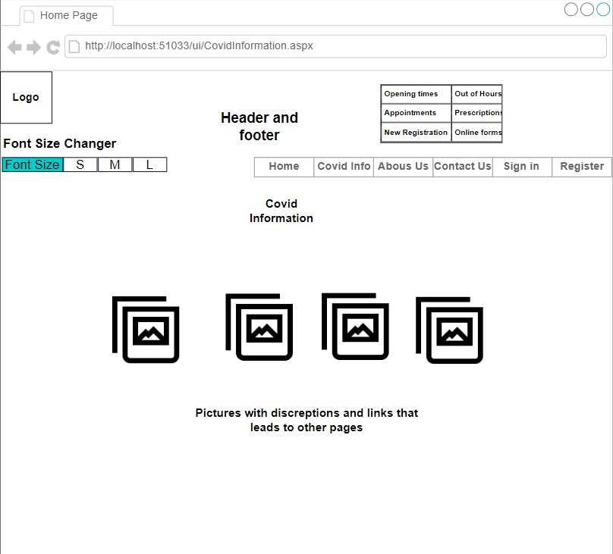

Figure 4.4-CovidPage wireframe model

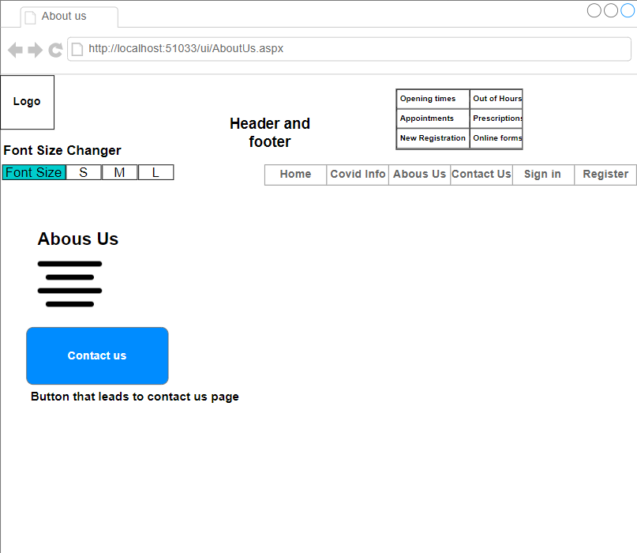

Figure 4.5-AboutUsPage wireframe model

Figure 4.6-ContactUsPage wireframe model

Figure 4.7-LoginPage wireframe model

# Chapter 5-Implementation:

Planning the site before starting to build pages and writing code is usually beneficial when developing a website. The creation of the site's general design and navigation may be made simpler with earlier planning.

The amount of preparation needed will frequently depend on the size of a website. Small and limited sites that only offer static information can be rather simple and only need minimal planning. In this project’s case more preparation is required due to the website being dynamic and adaptive in design while accessing a data store, authenticates users, and has accessibility features. In a few words with a plan less time is spent developing and maintaining the site.

**From sketch to prototype:**

This sketch is a draft of the website plan, it shows the content and the navigation primary needed

## 5.1-Creating the project and coding:

First of all opening the integrated development environment, Visual Studio in this instance on the start window after creating a new project with C# as the language , then web as the project type. After applying the language platform, ASP.NET Web app is selected as shown below

Doing that, Visual studio automatically generates a file with all the required libraries and configuration as well as packages for the build of the product.

Only files that are expressly referred to in the solution's project file (SLN)are included in a web application project. These are the only files that are compiled during a build, and they are the only ones that are shown in Solution Explorer.

The first lines of HTML are written to shape up the base of the website , creating the title, navigation elements and adding images and logos

While the first header’s purpose is to show users some information about the site, the second one consists of a menu to allow a quick switch between the different pages and the font size feature which is executed back-end when toggled and thanks to the cookies shown below, it stores the user’s session up to 30 days .

While writing HTML , CSS simultaneously supplied to establish the visual hierarchy and place of all the components

Images, logos , and different links are integrated to their respective place/page and the skeleton code starts to make more and more sense.

Mobile version with and without dropdown menu:

# 5.3-Different Pages:

All pages of the practice apart from login and sign up are linked together through the navigation footer, and all of them share the font size changer. This section will treat how the different pages were designed and the differences between them.

**Covid Information page** is a gird of images linked to genuine healthcare websites.

**Contact us page** is where a user can send feedback or ask about the practice with the contact us form.

There is also a map generated with the google iframe technology with a pin to the exact location of the practice.

The code below is to validate the different input field and let the user know about a potential error when completing, if correct it will send a pop notification to alert if the email is successfully sent.

# Chapter 6-Testing and self-evaluation:

## 6.1-Testing:

Some basic testing was undergone following the completion of the product, this section will talk about the successful and failed tests:

**Successful:**

* The dynamic design adapts to any device that the website was loaded in , also tested using google mobile friendly API as shown in the figure below

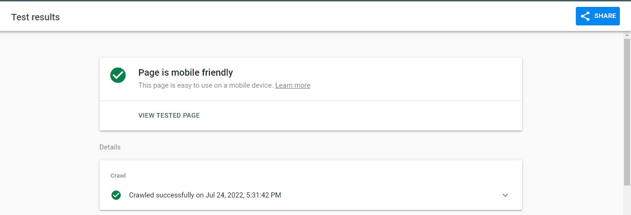

**Figure 6.1- Google mobile test result.**

* Successful sign-up and login and data storage.
* Successful font size change and session save.

**Failed:**

* Failed some input and field validation.
* Failing scalability on the main image for really small screens.

## 6.2-Self-evaluation:

The product operated with accuracy. It meets most of the requirements and issues were resolved with industry standards and best practices. Core operations implemented are fully functional even though they are slightly limited.

On the other hand, the website still feels lacking in terms of potential, for example logging does not add any extra functionality apart from a user icon, some navigation links are not active. Which would lead a user to think that the product is far from finished.

# Chapter 7-Conclusion:

In conclusion even though the product faces several shortcomings, it has successfully met the majority of the fundamental objectives while adhering to the responsive and dynamic viewpoint.

The report relies on relevant information from an appropriate range and adequate sources from theory to practice. Even though definitions and new concepts were introduced, the report failed to go more in depth and show the practical objective of all the tools discussed.

In general, the product and report are a mixed bag of positives and negatives, but this has been a very rewarding, insightful, and informative experience. New skills, different methodologies and professional procedures were learned.

With this product and project in general opening many doors, the next objective would be to fulfill the website’s full potential by adding more functionality and accessibility features such as keyboard accessibility and captions. Also integrating other useful technologies like JavaScript or Ajax to create more dynamic and interactive content. Lastly use the database to collect and store more information and create a frequently asked questions with the feedback and messages sent to the practice’s email.

After that the goal would be to look further on how to develop my core and basic skills in terms of programming and web development while adhering to the industry best practices to a professional standard.

.

# Appendix A

**References**

Bird, D (2021) 6 web accessibility features that benefit more people than you think. The big hack [online] [accessed on 13th July 2022]

Clark, J. A. (2015) Responsive web design in practice. Lanham: Rowman and Littlefield (Library technology essentials). Available at: https://mmu.on.worldcat.org/oclc/917558872

(Accessed: July 12, 2022).

Marcotte, E 2011, Responsive web design, A Book Apart, New York.

**Bibliography**

Chase, N. (2000) Active server pages 3.0 from scratch. Indianapolis, IN: Que Pub (Jesse Liberty's from scratch programming series). Available at: https://mmu.on.worldcat.org/oclc/45844557 (Accessed: July 15, 2022).

LaGrone, B. (2016) Web design blueprints. Packt Publishing. Available at: https://mmu.on.worldcat.org/oclc/948778916 (Accessed: July 19, 2022).

Tabor, K. (2016) Responsive web design toolkit : hammering websites into shape. Burlington, MA: Focal Press. Available at: https://mmu.on.worldcat.org/oclc/923326693 (Accessed: July 15, 2022).