Comparative Genomics 2018
Practical 1: Basic Genome Analysis
Group number: 10
Group members: Yuanyuan Xi, Youcheng Zhang

Summary

Comparative network analysis using STRING
1
taxa id NCBI STRING ID
Bradyrhizobium japonicum 375 1037409
Chlamydia trachomatis 813 272561
Dictyoglomus turgidum 513050 515635
Rhodopirellula baltica 265606 243090
Saccharomyces cerevisiae 4932 4932

2.

Experimental gene sets
3.
Command line:
python script: extractBlastGeneSymbol.py, 2HighestGeneSet.py
After the python script we can know that the highest two overlaps has 4 genes and 3 genes each. They are Line 19 and Line 23 in expetiments.txt
The two gene sets:
HIS5 BNA4 POL30 EHD3 PRP40 HIS5 LEU1 PMS1 HIS6 PIS1 PAN6 RNH1 PAC1 RNH1 CAR2 CPT1 SNU23 BNA7 PRP22 PRP43 SPE3 HIS5 CPT1 URK1 ADO1 MET14 DBP2 NPY1 SPE3 ALG9 AGX1 FDH1 PUT2 SUB2 PRO2 AGX1 SPE3 GUA1 ILV5 PRP28(4 genes)
EPT1 AAH1 BNA3 PIS1 BNA3 MET16 PUT2 PRI2 FAS1 FAS2 DAL1 FDH1 POL30 ALG11 HIS5 URK1 NPT1 FAS2 DUT1 TUM1 LEU2 PNP1 GDH2 RIB3 POL30 COX4 OST4 ISC1 SNU23 NPT1 OAR1 RNH1 URH1 RNH1 PAN6 GAD1 PMS1 QNS1 GLN1 HIS1 (3 genes)

Comparative network analysis using FunCoup and STRING
4.
I set confidence media(0.07), expension depth is 1 and no more than 5 interactions.
Gene set 1:
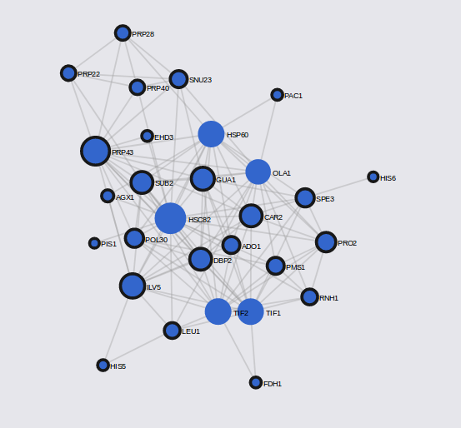
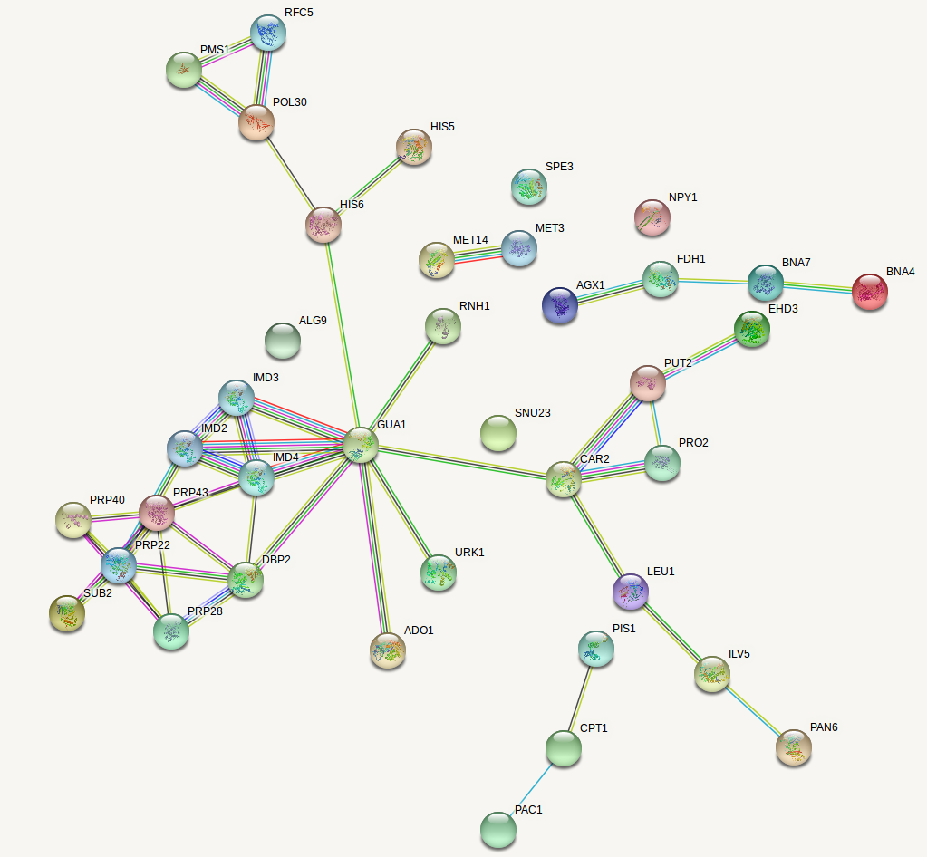
Gene set 2:
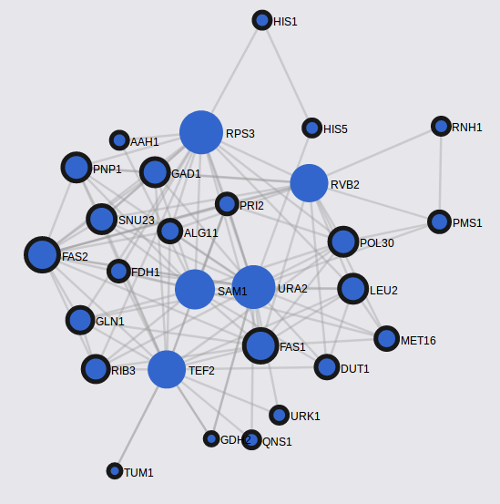
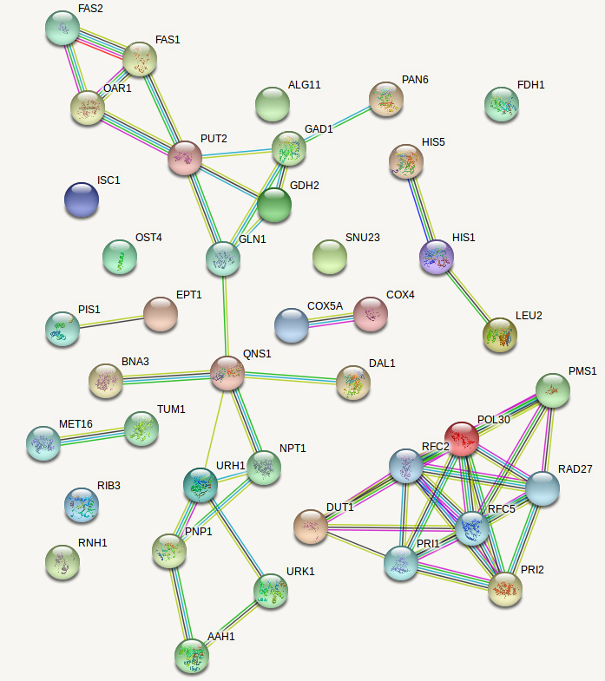
4.a
In STRING, nodes’ colors are query proteins and first shell of interactors and empty nodes are proteins of unknown 3D structure. The links are different interactions and hubs are
In FUNCUP, nudes are gene symbols and their sizes are node degree and links are interactions, and hubs are

