SEARPC: Secure Interaction in Vehicular Consortium Blockchains through Scoped Evidence Authorization and RSU Participation Control
Abstract
As connected vehicles and roadside units (RSUs) share safety-critical information about road obstacles, emergency braking, and congestion, trust judgments increasingly determine vehicle privileges and RSU participation. Cross-role reputation reuse, correlated identities, and prematurely applied audits can therefore turn local trust errors into excessive protocol influence. We propose SEARPC (Scoped Evidence Authorization and RSU Participation Control), a secure interaction framework that translates road-trust evidence into verifiable authorization and participation conditions. Its role-isolated and source-limited authorization mechanism separates data-provider and opinion-provider histories and bounds the support contributed by identities within one certified domain. Its canonical-audit-driven participation reconfiguration mechanism updates RSU eligibility only from delivered audits and replaces warned candidates while preserving committee size. Fast candidates provide proposal hints; the underlying Byzantine fault-tolerant protocol retains the fixed final quorum. Experiments on VeReMi NextGen observed no trusted authorization of malicious data providers across six attack-overlap conditions. The increase in influence caused by same-domain identity expansion was 56.0–62.8 percentage points lower than that of two stage-matched trust baselines. Under matched audit budgets, candidate sizes, and final quorums, paired 40-RSU trajectories reduced risk-weighted adversarial exposure by 10.80–11.83 percentage points relative to two published selection rules, with 100% legal commits. A 40-process certificate-handoff prototype reduced p95 confirmation latency and communication volume by 38.97% and 28.65%, respectively, compared with full participation. These results support safer road-warning sharing and RSU coordination by limiting undue privileges and sustained high-risk participation at modest integration cost. Code and reproduction materials are available at https://github.com/YouhangLi-Research/SEARPC-IoV.
Keywords: Internet of Vehicles; consortium blockchain; secure interaction; role authorization; certified domain; RSU participation control; Byzantine fault tolerance

1 Introduction

1.1 Research Motivation
The Internet of Vehicles (IoV) connects intelligent vehicles, roadside units (RSUs), and edge infrastructure into a collaborative traffic-sensing network. Sharing reports of road obstacles, emergency braking, congestion, and environmental changes extends the limited perception of an individual vehicle to the surrounding road area. Vehicle-trust models assess the reliability of reports and their sources [1]. Consortium blockchains provide authenticated identities, traceable records, and multiparty verification for information sharing across vehicles, RSUs, and operators [2].
Consider a newly detected road obstacle. A vehicle reports the event, nearby vehicles provide corroborating opinions, and the serving RSU aggregates the evidence. Registered RSUs then verify the proposed record and maintain the consortium ledger. Excessive weight assigned to a false report may prompt unnecessary rerouting or braking; malicious opinions that suppress a genuine report may delay a warning. Trust assessment therefore affects both the acceptance of an individual message and the timely delivery of safety information.
A consortium ledger preserves the integrity and traceability of traffic records, but valid credentials alone do not establish honest behavior. A registered vehicle or RSU may misbehave after accumulating a favorable history, and several identities under common governance may fabricate apparent consensus. When reputation determines high-weight reporting privileges, fast-candidate eligibility, or priority in block proposal, a local assessment error can alter protocol participation. Vehicular trust management must therefore control how evidence affects vehicle authorization and RSU participation after the initial message assessment.

1.2 Background and Current Approaches
Vehicular trust assessment has evolved from checking individual messages to evaluating entities over time. Early approaches use position, speed, timestamps, and consistency with neighboring observations [1]. Later approaches combine direct interactions, behavioral histories, and recommendations. TWSL incorporates interaction frequency, event timeliness, and trajectory similarity into local trust estimation [3]. Blockchain-based approaches further make identity, behavior, and verification records available across road regions and operators [2].
As reputation influences the selection of miners, validators, and endorsers, trust management increasingly determines which entities can affect subsequent protocol execution. Existing studies allocate participation roles through reputation voting [4] or select validators using transaction-derived trust scores [5]. These approaches improve message detection, reputation aggregation, and participant selection within their respective stages. Connections between these stages, however, often rely on a general reputation score without specifying which role or protocol state that score may influence.
The resulting research streams answer three distinct questions: whether a report is anomalous, whether an entity has a reliable history, and whether a node should participate. Two transitions remain insufficiently specified: how vehicle evidence becomes authorization within role and source boundaries, and how an RSU audit becomes a shared ledger record before changing participation. Without these transitions, even a statistically reasonable trust estimate can be applied to privileges beyond the role, source, or time to which its evidence belongs.

1.3 Research Problem and Design Objectives
We study how vehicle reports, neighbor opinions, and RSU audits can continuously produce vehicle authorization and RSU eligibility that all consortium replicas can verify consistently, while preserving the finality rules of the underlying Byzantine fault-tolerant (BFT) protocol [6]. The focus is the control process through which trust affects participation. Evidence use, source relationships, and audit effective times must remain consistent with the states they update. Reusing histories across roles, counting correlated identities as independent support, or applying an audit before shared delivery can otherwise cause excessive privileges, amplified evidence, and sustained participation by high-risk nodes.
To address these risks, we propose SEARPC, a secure interaction framework for vehicular consortium blockchains that establishes an executable and verifiable transition from road-trust evidence to protocol participation. SEARPC comprises two core mechanisms. Role-isolated and source-limited authorization confines behavioral history to its originating role and aggregates identities within one certified domain into bounded support, preventing reputation transfer across roles and amplification through correlated identities. Canonical-audit-driven participation reconfiguration allows only delivered audits to change RSU participation states and dynamically replaces high-risk candidates without changing committee size. Reconfigured candidates provide proposal hints, while the underlying BFT protocol confirms blocks using a fixed final quorum.
Together, the two mechanisms connect vehicle authorization and RSU participation into a continuous interaction process. Reports, opinions, and audits produce verifiable participation conditions with explicit authority boundaries. This reduces opportunities for false events to obtain high-weight treatment through unrelated histories or additional correlated identities, and limits prolonged occupation of fast positions by anomalous RSUs. Normal warnings retain their processing paths, and RSUs continue to coordinate through the underlying ledger protocol.

1.4 Main Contributions
This study contributes a secure interaction framework, two participation-control mechanisms, and an evaluation across vehicle evidence, protocol trajectories, and an executable prototype.
(1) We design SEARPC, a secure interaction framework for vehicular consortium blockchains that improves the security of road-warning sharing and RSU coordination while supporting lower confirmation and communication costs. The framework follows event reporting, neighbor corroboration, RSU verification, and ledger confirmation to translate local trust judgments into verifiable vehicle privileges and RSU participation conditions.
(2) We develop role-isolated and source-limited authorization and canonical-audit-driven participation reconfiguration. These mechanisms reduce opportunities for malicious entities to acquire disproportionate influence through unrelated reputations, correlated identities, or audit timing. The first separates vehicle histories by role and bounds aggregate support from each certified domain. The second updates RSU lifecycles from canonically delivered audits and replaces warned candidates while keeping candidate size and the BFT final quorum unchanged.
(3) We evaluate SEARPC using VeReMi NextGen, paired 40-RSU protocol trajectories, and a multiprocess certificate-handoff prototype, with seven published methods compared at matched decision stages. SEARPC observed no trusted authorization of malicious data providers in six attack-overlap conditions and reduced the influence increase from same-domain identity expansion by 56.0–62.8 percentage points. With matched audit budgets, candidate sizes, and final quorums, it reduced risk-weighted adversarial exposure by 10.80–11.83 percentage points while maintaining 100% legal commits. The prototype also achieved lower confirmation latency and communication volume than full participation. These findings support the feasibility of turning vehicular trust estimates into executable and auditable participation control.

1.5 Paper Organization
Section 2 reviews message assessment, vehicle reputation, and trust-driven participation. Section 3 presents the SEARPC architecture, its two mechanisms, and the finality boundary. Section 4 evaluates message evidence, vehicle authorization, RSU participation, and integration cost. Section 5 concludes the study and outlines future deployment directions.

2 Related Work
Research on trustworthy vehicular information sharing follows three main directions: assessing current road messages, maintaining long-term vehicle reputations, and using trust to select protocol participants. These directions differ in the decisions they produce and in the influence assigned to their outputs.
Message assessment uses position, speed, timestamps, and agreement among neighboring observations to detect false reports. TROVE models vehicular behavior through contextual reinforcement learning [1]. Trust in Vehicles considers context under dynamic attacks [7], while CaTCH evaluates consistency within sensor uncertainty ranges [8]. These approaches improve event assessment, but their outputs primarily describe message reliability rather than the role privileges that evidence may authorize later.
Reputation methods combine direct interactions, behavioral histories, and recommendations. BRS represents successful and unsuccessful evidence through a Beta posterior [9]. TWSL uses interaction frequency, event timeliness, and trajectory similarity to estimate local trust [3]. Such histories capture persistent behavior, yet a single entity-level score may conflate responsibilities when the same vehicle acts as both a data provider and an opinion provider.
Blockchain-based trust management makes assessments collected at different RSUs traceable and shareable. Yang et al. combine Bayesian message verification with on-chain reputation [2]. COBATS maintains consortium-wide trust and filters malicious recommendations [10], and DTMS uses trusted execution environments to improve verifiability [11]. These approaches strengthen record integrity and cross-region access, while typically assigning reputation or recommendation weight to individual authenticated identities.
In a pseudonymous vehicular network, credential validity and source independence are distinct. Conditional-privacy authentication verifies credentials while protecting identity [12], and binding reputation to persistent accountability supports tracing [13]. Nevertheless, one operator or governance source may control several valid identities. Identity-level opinion aggregation can then treat correlated credentials as independent corroboration. Authorization must account for the source relationships behind these identities.
Trust-driven consensus extends reputation from message assessment to participation. Kang et al. use reputation voting to select active and standby miners [4]. Info-Chain combines reputation with traffic conditions [14], and VT-chain determines validator eligibility from global trust [15]. These studies show that trust can guide protocol participation, but also increase the consequences of local assessment errors.
Yadav et al. derive trust from transaction history and entropy for DPoS participant selection [5]. BRBC maintains a dynamic participant set through adjudication, reputation thresholds, and admission rules [16]. Both provide implementable selection rules. Their score-based or threshold-based decisions, however, do not jointly specify how delayed audits become shared control records and how subsequent eligibility changes preserve a fixed final quorum.
Related consensus research also examines reputation-assisted view changes in PrestigeBFT [17], protocol-independent reputation-based leader selection in SWLE [18], and adaptive multileader scheduling in Barnacle [19]. These studies motivate optimizing the proposal path while preserving the base protocol's validation, locking, view-change, and final-quorum responsibilities.
Table I compares representative approaches in terms of behavioral evidence, role-specific states, source awareness, ledger records, participation control, and finality separation. It locates the control transitions addressed by SEARPC within the existing literature.
Table I Capabilities of Representative Vehicular Trust and Participation Approaches
Method | Behavioral evidence | Role-specific state | Uncertainty awareness | Source awareness | On-chain trust | Trust-driven participation | Finality separation
TWSL [3] | ✓ | × | ✓ | ✓ | ✓ | × | ×
COBATS [10] | ✓ | × | × | ✓ | ✓ | × | ×
Chen et al. [20] | ✓ | ✓ | ✓ | ✓ | ✓ | ✓ | ×
CAT [21] | ✓ | × | ✓ | ✓ | × | × | ×
Info-Chain [14] | ✓ | × | × | × | × | ✓ | ×
VT-chain [15] | ✓ | ✓ | × | ✓ | ✓ | ✓ | ×
Yadav [5] | ✓ | × | ✓ | ✓ | ✓ | ✓ | ×
Dynamic Reputation [22] | ✓ | × | ✓ | ✓ | × | ✓ | ×
V-Trust [23] | ✓ | × | × | × | × | ✓ | ×
SEARPC | ✓ | ✓ | ✓ | ✓ | ✓ | ✓ | ✓
A check mark denotes a capability explicitly modeled or used by the original method; a cross denotes a capability outside its stated design objectives. Role-specific states require distinct state or update semantics for different roles. Source awareness includes recommendation selection, weighting, or filtering; certified-domain constraints additionally identify common governance sources. Finality separation means that fast-participation changes preserve full block validation and the final quorum.
Despite substantial progress in message detection, vehicle reputation, and trust-driven selection, two gaps remain. First, entity-level reputation does not jointly bind authorization to behavioral roles and certified sources, leaving room for reputation transfer and correlated-identity amplification. Second, participant selection lacks a unified transition from shared RSU audits to lifecycle updates and fixed-size candidate reconfiguration, with a clearly defined handoff to the base BFT protocol.
SEARPC addresses these gaps by connecting event reports, neighbor corroboration, RSU audits, and ledger confirmation through verifiable authorization and participation conditions. Role-isolated and source-limited authorization uses the corresponding vehicle histories and produces one bounded representative per certified domain. Canonical-audit-driven reconfiguration updates RSU eligibility from shared audit records and replaces warned candidates at a fixed size. The resulting proposal hints are handed to the underlying BFT protocol for final confirmation. This extends vehicular security from deciding whether a road message is credible to controlling which privileges and participation opportunities its evidence can affect.

3 SEARPC Architecture and Core Mechanisms
SEARPC follows the collaborative handling of a road-safety event. Vehicle reports and neighbor opinions first produce role authorization and domain-level evidence. Canonically delivered RSU audits then update validator lifecycles and fixed-size fast candidates. Candidates supply proposal hints to the base BFT protocol, which performs full block validation and final confirmation. Table II summarizes the notation.
The architecture makes distributed trust judgments executable consistently across consortium replicas. It assigns evidence a role, a source relationship, and an effective height. Eligible vehicle evidence updates role authorization; delivered RSU audits update lifecycle states and fast-participation opportunities. The two mechanisms address undue vehicle privileges, correlated-source influence, and persistent participation by high-risk RSUs within a shared execution process.

3.1 System Architecture and Shared Execution State

3.1.1 Participants and Evidence Flow
Vehicles submit event reports $M_{e}$ to their serving RSU $R_{m}$ over V2I links, binding each report to an identity, timestamp, and event. Nearby opinion providers submit $O_{j,e}$. The evidence layer verifies signatures, freshness, and message integrity before using role state $E_{i,r}$ and certified domain $g(i)$ to construct event evidence. Registered RSUs maintain the consortium ledger and audit validators. The participation layer uses these records to update future candidates, with each state change linked to a specific entity and event or height.
The same physical vehicle $V_{i}$ may act as a data provider d in one interaction and an opinion provider o in another. SEARPC maintains $E_{i,d}$ and $E_{i,o}$ separately: the former describes event-reporting behavior, and the latter describes third-party recommendations. Authorization reads the state associated with the current action. A favorable history in one role therefore does not automatically confer privileges in another.
For each registered vehicle or RSU, $g(i)$ identifies a certified domain in G, attested by the consortium registration infrastructure. A domain is the aggregation unit used to account conservatively for common governance. IEEE 1609.2, IEEE 1609.2.2, and ETSI TS 103 097 provide foundations for secure messages and credential interoperability across policy domains [24]–[26]. A new pseudonym inherits its governed domain claim through $BindVerify({cred}_{i,t},h_{i},g_{i})\text{=}1$. An ordinary RSU receives only the scoped information needed for aggregation. An entity whose $g(i)$ cannot be verified consistently follows the newcomer path.
Participation decisions use observable evidence that has entered the shared state. Let $F_{h}^{obs}$ denote authenticated messages, audits, warnings, and block states delivered before height h. Candidate selection, same-size reconfiguration, and hint handoff are determined by $F_{h}^{obs}$, registration state, and purpose-bound randomness. Simulated fault labels generate attack behavior and support offline evaluation; online decisions use the observable records.
Let V be the registered validator set, with $|V|\text{=}N$. The underlying BFT finalizer $Π_{BFT}$ uses $N\text{=}3F\text{+}1$ and derives the fixed final quorum Q from this same registered set:
$N\text{=}3F\text{+}1,Q\text{=}2F\text{+}1$ | (1)
Fast candidates provide early proposal support. The base protocol $Π_{BFT}$ obtains and validates the full block ${Blk}_{h}$, performs locking, safe lock transfer, view changes, and proposal inheritance, and collects the fixed-Q final certificate $FC_{h}$ from registered validators. Evidence therefore changes who participates early while final confirmation remains governed by the base protocol.
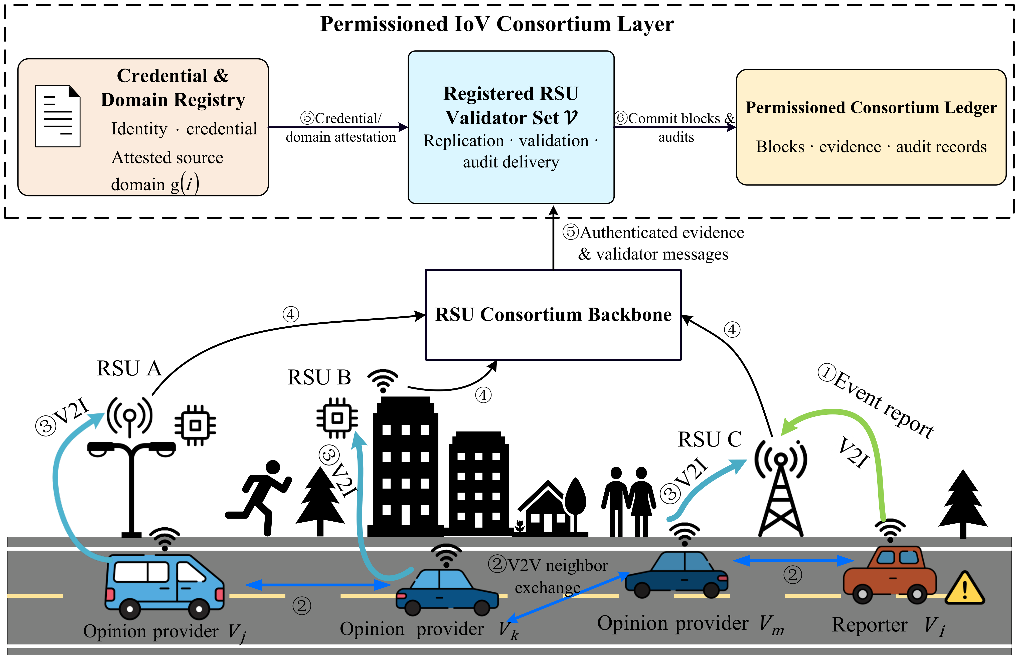

Fig. 1 SEARPC System Model and Evidence Flow in a Vehicular Consortium Blockchain
Fig. 1 follows a road event from vehicles to the RSU network and consortium ledger. After credential and domain verification, RSUs share reports, opinions, audits, and block states over the consortium backbone. These records provide common, verifiable inputs for vehicle authorization and RSU participation control.
Table II Main Notation
Symbol | Meaning
$V_{i}$, $R_{m}$ | Vehicle i; RSU m
$M_{e}$, $O_{j,e}$ | Event report; provider j's opinion on event e
$g(i)$, G | Entity's certified domain; set of domains
$E_{i,r}$, ($α_{i,r}$,$β_{i,r}$) | Beta-form evidence state of entity i in role r
$L_{i,r}^{δ}$, $U_{i,r}^{δ}$ | Lower and upper Beta-quantile readouts
$m_{g,e}$, $W_{g,e}$ | Representative opinion and outer weight of domain g
$RC_{e}$, $R_{e}^{c}$ | Event-risk summary and content-risk score
$A_{i,h}$, $s_{i}(h)$ | Delayed validator audit; consecutive failures visible before h
$C_{h}^{0}$, $C_{h}$ | Initial candidate; conditioned fixed-size candidate
k, $q_{k}$ | Fast-candidate size and local quorum
$QC_{h}^{fast}$, $FC_{h}$ | Pre-finality proposal hint; final certificate from $Π_{BFT}$
N, F, Q | Registered validators in $Π_{BFT}$; concurrent Byzantine bound; final quorum
$$S_{i}(h)$$ | Validator i's fast-path state at h: Active, Quarantine, or Probation
$I_{h}^{res}$, $χ_{h}$ | Same-size reconfiguration indicator; subsequent audit coverage
$$Π_{BFT}$$ | Base BFT finalizer responsible for validation, locking, view changes, proposal inheritance, and $FC_{h}$

3.1.2 Shared Records and Canonical Effective Times
Shared records let RSUs derive the same participation decision from the same evidence. Authentication, deduplication, and deterministic ordering establish a canonical effective height: the first height at which a record may change authorization or participation.
Local event assessment and replicated control use different inputs. Content risk may increase later observation, delivered validator audits update eligibility, and candidate ordering uses the seed projection. Archived commitments retain audit roots, registration state, and policy versions for verification. The shared evidence cut and state transition are:
$$F_{h}^{canon}\text{=}\{x|Valid(x)\text{=}1,h_{del}(x)≤h\},X_{h\text{+}1}\text{=}Φ(X_{h},F_{h}^{canon})$$
The seed projection $R_{seed}(h)$ identifies the schema, chain, height, audit root, complete registry root, and policy version needed to reproduce candidate ordering. Commitment $R_{seed}(h)$ precedes beacon $B_{h}$; purpose-specific randomness is $H(B_{h},R_{seed}(h),purpose)$.
$R_{risk}(h)$ records risk from the preceding closed slot; $R_{audit,core}(h)$ and $R_{audit,ext}(h)$ record the core audit plan and optional extension targets. These event-assessment and audit-planning fields do not enter the candidate seed.
Records are keyed by $(type,subject,source\text{_}height,record\text{_}id,schema\text{_}version)$. Duplicates apply once; conflicting same-key payloads are rejected deterministically. Audits take effect at the first cut after delivery. A risk record for event h−1 that misses height h is deferred, and height h uses ⊥.
For example, an RSU may fail at height h while the corresponding audit arrives only at $h\text{+}Δ$. Eligibility changes after delivery, not at the original failure height. Until then, control uses the records already available, and $Π_{BFT}$ handles unsuccessful fast proposals through its standard path. Replicas thus obtain the same outputs from the same canonical records.

3.1.3 Threat Model and Evidence Authority
An adversary may control registered vehicles or RSUs and perform role-dependent attacks, same-domain coordination, intermittent misbehavior, incorrect responses, or response withholding. The committee experiments fix the compromised RSU set and activate subsets in different time windows while retaining the credential set. Domain aggregation constrains identity multiplicity. Random candidate ordering assumes static corruption or a bounded corruption rate.
The network is partially synchronous [27]. Signatures are unforgeable, hashes are collision-resistant, and at most F validators are Byzantine concurrently. The base protocol $Π_{BFT}$ operates with $N\text{=}3F\text{+}1$ and $Q\text{=}2F\text{+}1$, including full block validation and its native locking and view-change rules. The registration infrastructure validates domain claims so that replicas map identities from a common certified source to the same aggregation unit.
Before road-event evidence affects participation, SEARPC specifies which states it may update. Type(e), Scope(e), and Canonical(e,h) identify its type, role scope, and delivery status; W(Type,Scope) gives the permitted states.
Combining evidence cannot enlarge its authority. For $d\text{=}f(e_{1},…,e_{n})$, authority(d) is the intersection of the inputs’ permitted updates. Hashing, serialization, and packaging preserve these permissions. Table III summarizes the mapping.
The permitted state update is therefore:
$$ΔX≠0⇒X∈W(Type(e),Scope(e))∧Canonical(e,h)\text{=}1$$
In road-event processing, reporting and opinion privileges read the corresponding role history $E_{i,r}$. Identities sharing $g(i)$ contribute one representative to cross-domain fusion, and delivered validator audits update eligibility from their effective height. The controller passes participation metadata and candidate support to $Π_{BFT}$ for final confirmation.
Fig. 2 summarizes the execution flow. Vehicle processing maps $M_{e}$ to $(p_{e},u_{e}^{dis})$, combines it with the matching role state $E_{i,r}$ for action authorization, and aggregates authenticated opinions $O_{j,e}$ by $g(j)$ into domain representatives and $RC_{e}$. At height h, canonical audits update lifecycle states and warnings and, when triggered, reconfigure $C_{h}^{0}$ into an equal-sized $C_{h}$. The resulting hint is handed to $Π_{BFT}$ for full block validation and a fixed-Q final certificate.
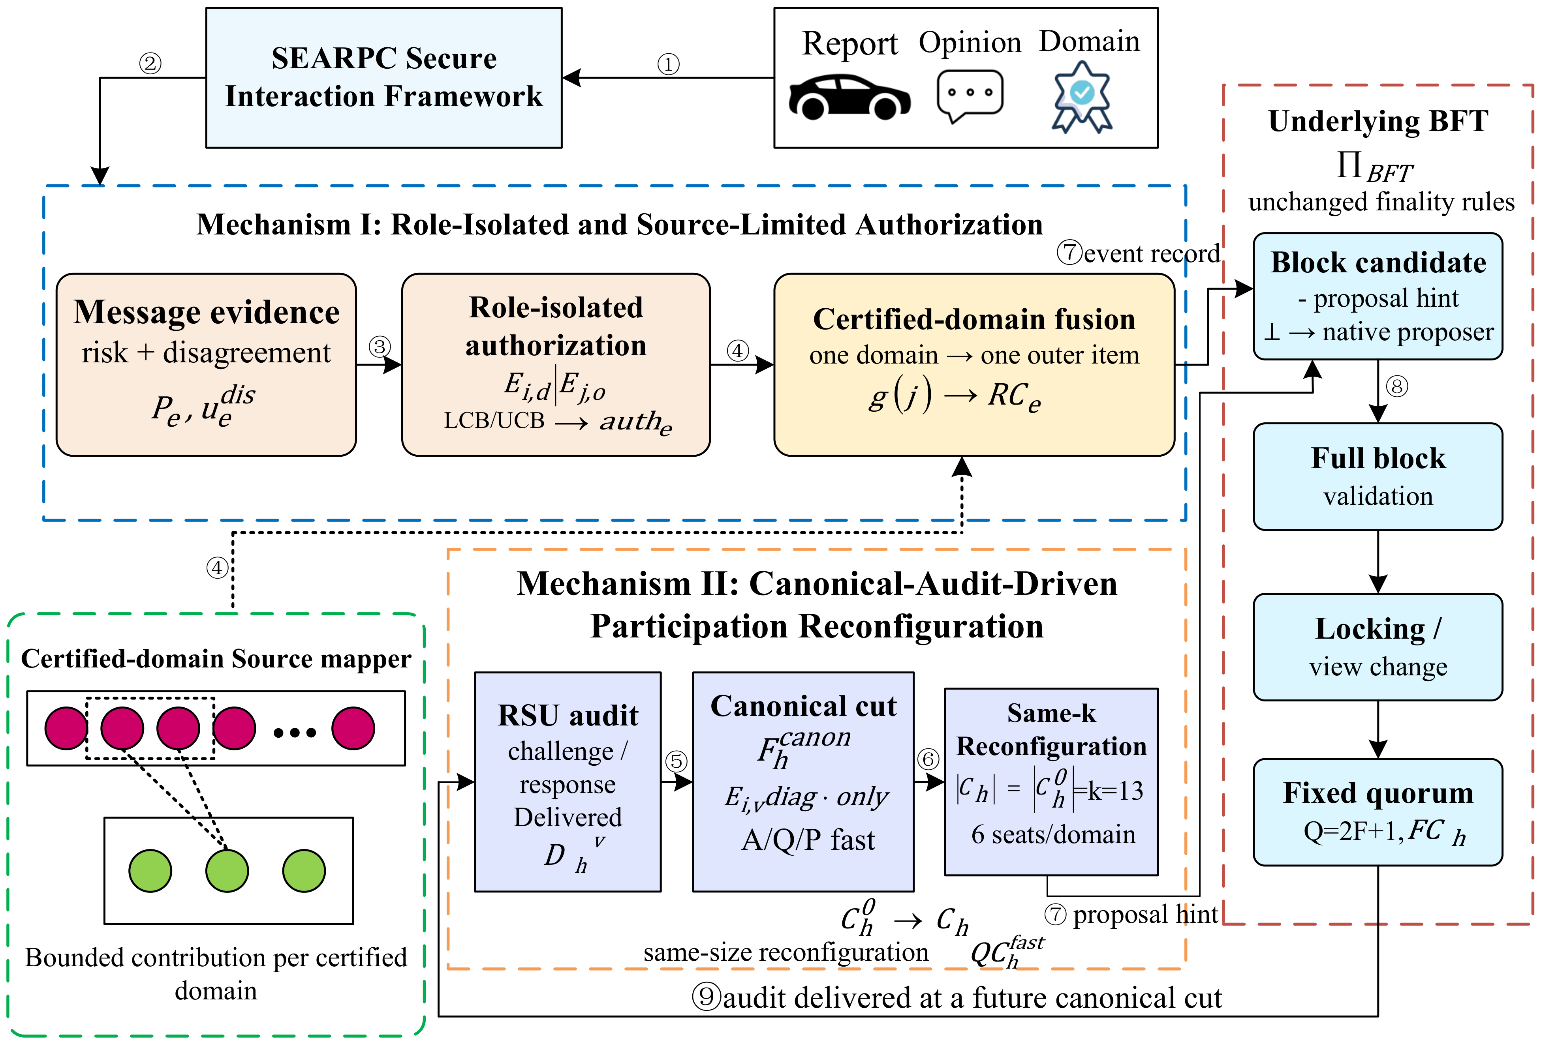
Fig. 2 SEARPC Evidence Authorization and Participation Control Framework
The vehicle-side mechanism converts message risk, role histories, and certified source relationships into scoped authorization and domain-level evidence. The RSU-side mechanism converts delivered audits into lifecycle states and fixed-size candidates. The fast path ends at a proposal hint and hands final confirmation to the base BFT protocol.
Table III Evidence Types, Write Authority, and Purpose Projections
Evidence/input | Scope | May write | Cannot write
Current message/opinion | local event | event score; role-local fusion | replicated state; seed; finality
Delivered data adjudication | role d | data-role state; provider authorization | other role; validator; finality
Delivered opinion adjudication | role o | opinion state/fusion weight | data role; validator; finality
Canonical validator audit | global challenge log | A/Q/P; warning; core audit plan; seed audit root | content state; final Q; locks
Canonical risk record | closed slot h-1; extension | optional gamma; extension audit plan | validator failure; core audit plan; seed
${Proj}_{seed}$ + $B_{h}$ | commit then reveal | committee seed capability only | risk/audit mutation; view/event grinding; finality
Registry entry | ID/key/domain/epoch/config | group/cap eligibility; seed registry root | domain honesty; civil identity; Byzantine bound
Fast hint | height/view/digest | proposal metadata | commit; lock; view change; final Q
Hidden ground truth | offline only | evaluation | every online state
Replicas with the same canonical audits, registry, policy version, height, and beacon derive identical purpose projections, committees, audit targets, and handoff fields. Deterministic record resolution covers out-of-order, duplicate, late, and conflicting deliveries as well as extreme risk values.

3.2 Role-Isolated and Source-Limited Authorization

3.2.1 Evidence Authorization with Role Isolation
The first mechanism separates behavioral history by vehicle role and limits the outer influence of identities from a common certified source. Processing starts with the current road report, uses the corresponding role history, and aggregates source-constrained opinions before authorizing an action. The message model estimates current risk, role state determines eligibility for higher privileges, and domain aggregation determines independent support. Beta-form states and their quantiles provide conservative readouts within these joint role and source constraints.
Road-message risk as an authorization input
When $V_{i}$ reports congestion, emergency braking, or another event, a binary decision alone loses information about risk magnitude and model agreement. Each message model m therefore estimates maliciousness probability $p_{e}^{(m)}$ from physical, temporal, and local-context features. The RSU retains both the ensemble center and the disagreement among predictions:
${\overset{´}{p}}_{e}\text{=}\frac{1}{M}\sum_{m\text{=}1}^{M}{p_{e}^{(m)}}$ (2a)
$u_{e}^{dis}\text{=}\sqrt{\frac{1}{M}\sum_{m\text{=}1}^{M}{{(p_{e}^{(m)}\text{-}{\overset{´}{p}}_{e})}^{2}}}$ (2b)
The disagreement $u_{e}^{dis}$ is observable during execution. Consistent predictions produce a smaller $u_{e}^{dis}$; pronounced disagreement reduces the effective contribution of the event to subsequent evidence updates and opinion fusion.
Models and calibration mappings are selected using training and validation data before deployment. Candidate mappings are evaluated for calibration and discrimination [28]. Calibration parameters and the binary operating point are then held fixed [29]. With the selected mapping Cal*, the online risk is:
$p_{e}\text{=}Cal({\overset{´}{p}}_{e})$ (2c)
Equation (2) provides calibrated risk and ensemble disagreement together, allowing both risk magnitude and predictive consistency to inform role evidence.
Behavioral evidence separated by role
A message score describes one report, whereas persistent privileges require a history associated with the current role. Vehicle $V_{i}$ may accumulate a good reporting record and later provide biased opinions for a collaborator. If both actions share one reputation, reporting honesty can become recommendation authority. SEARPC instead maintains separate data-provider and opinion-provider states, with an independent diagnostic record for RSU validation behavior.
For entity i and vehicle role r∈{d,o}, the Beta-form container $E_{i,r}$ stores positive and negative soft evidence $E_{i,r}^{\text{+}}$ and $E_{i,r}^{\text{-}}$ [9]. Validators retain the analogous $E_{i,v}$ for long-term diagnosis; their online eligibility follows the audit-driven lifecycle in Section 3.3.
$α_{i,r}\text{=}1\text{+}E_{i,r}^{pos}$ (3a)
$β_{i,r}\text{=}1\text{+}E_{i,r}^{\text{neg}}$ (3b)
When an adjudication of past behavior is delivered, let z∈[0,1] denote its success degree and w≥0 its evidence weight. Positive evidence increases by wz and negative evidence by w(1−z). Equation (3) updates only the role associated with that behavior.
Adjudications may arise from subsequent road observations, agreement across RSUs, or authorized traffic-management records. Authentication and canonical delivery precede role-state updates. In the experiments, dataset labels generate adjudication records with prescribed error rates and delays and support offline evaluation; online state updates consume the delivered records and their effective heights.
Both vehicle roles use the weighted-evidence representation in (3), but receive adjudications of their own actions. Message risk adjusts the strength of reporting evidence, while agreement between an opinion and the eventual adjudication determines opinion evidence. These updates preserve role isolation and produce the quantile readouts used for later authorization.
The role-evidence mean follows directly from the Beta-form state: $μ_{i,r}\text{=}\frac{α_{i,r}}{α_{i,r}\text{+}β_{i,r}}$.
The lower and upper quantile readouts are:
$L_{i,r}^{δ}\text{=}F_{Beta(α_{i,r},β_{i,r})}^{\text{-}1}(δ),U_{i,r}^{δ}\text{=}F_{Beta(α_{i,r},β_{i,r})}^{\text{-}1}(1\text{-}δ)$ (4)
The mean $μ_{i,r}$ describes the central estimate, while $L_{i,r}^{δ}$ and $U_{i,r}^{δ}$ reflect its supporting evidence concentration. SEARPC uses these bounds in three-state authorization rather than granting privileges from the mean alone.

3.2.2 Three-State Authorization with Evidence Sufficiency
Role isolation identifies the relevant history; quantile bounds determine whether that history sufficiently supports a privilege. For example, two opinion providers may both have μ=0.8, although one has only a few positive adjudications and the other has a long, consistent record. Their means coincide, but the low-evidence provider's lower bound may remain below the authorization threshold. This distinguishes apparent reliability from evidence sufficient for a high-impact action.
Let τ be the authorization threshold and $ϕ_{i,r}$ the malicious-state latch triggered by consecutive failures. The role state is:
$State(i,r)\text{=}\left\{\begin{matrix}\text{trusted}, & L_{i,r}^{δ}≥τ∧ϕ_{i,r}\text{=}0, \\ \text{malicious}, & U_{i,r}^{δ}\text{<}τ∨ϕ_{i,r}\text{=}1, \\ \text{uncertain}, & \text{otherwise}.\end{matrix}\right.$ (5)
A role becomes trusted when its lower bound crosses the threshold and its failure latch is clear. It becomes malicious when its upper bound falls below the threshold or the latch is set; otherwise, it remains uncertain. New entities accumulate evidence from the uncertain state. Consistently successful records open privileges, while persistent anomalies restrict the corresponding actions.
The vehicle-role latch is set after three consecutive failures and cleared after ten consecutive successes. This hysteresis responds to persistent misbehavior while retaining role separation: opinion privileges read $L_{i,o}^{δ}$, and data-provider privileges read $L_{i,d}^{δ}$.
Table IV Role States and Associated Protocol Actions
State | Data-provider action | Opinion-provider action | Validator path
trusted | Trusted-provider authorization; ordinary event assessment and adjudication retained | Continuous lower-quantile fusion weight | Delivered-audit lifecycle only
uncertain | Ordinary checking, recording, and adjudication; no trusted-provider privilege | Continuous lower-quantile weight without an additional hard cutoff | Delivered-audit lifecycle only
malicious | High-privilege service disabled; recording and adjudication retained | Zero fusion weight | Delivered-audit lifecycle only
Table IV maps each state to an action. Trusted states permit the matching privileged service, uncertain states retain ordinary processing, and malicious states disable the corresponding high-impact action. Each role reads its own history, preserving the distinction between trustworthy reporting and trustworthy recommendations.
Property 1 (Role non-interference). Consider two observable histories with identical role-r state $E_{i,r}$, current inputs, and shared non-role variables, but different histories for r′≠r. Their authorization outputs for r are identical. Data authorization does not read $E_{i,o}$, and opinion authorization does not read $E_{i,d}$. Fast-validator admission uses delivered audits, the resulting A/Q/P lifecycle, and warnings; diagnostic state $E_{i,v}$ has no control authority.
Property 1a (Conservative authorization under low evidence). For a fixed mean $0\text{<}μ\text{<}1$ and concentration c, a Beta-form state satisfies $Var(Θ_{c})\text{=}μ(1\text{-}μ)\text{/}(c\text{+}1)$. For fixed $0\text{<}δ\text{<}0.5$, its lower quantile converges to μ as $c→∞$. Low-evidence entities therefore retain a larger authorization margin around the same central estimate, while consistent delivered histories bring the lower bound closer to that estimate. With prior $Beta(1,1)$, the 5% lower quantile, and $τ\text{=}0.50$, four full-weight successes cross the trusted threshold.

3.2.3 Source-Limited Aggregation within Certified Domains
Authorization determines which actions evidence may enable; aggregation determines how much independent support multiple identities provide. Suppose an event receives seven valid opinions: five from domain A and one each from domains B and C. Identity-level fusion gives A a numerical advantage. SEARPC separates individual evidence strength from the outer influence of the common source through domain aggregation.
The individual weight of opinion provider j is:
$w_{j,e}\text{=}L_{j,o}^{δ}ρ_{e}$ (6a)
Event reliability $ρ_{e}$ combines ensemble disagreement with the data provider's role-evidence interval:
$ρ_{e}\text{=}{clip}_{[0,1]}[(1\text{-}u_{e}^{dis})(1\text{-}U_{i,d}^{δ}\text{+}L_{i,d}^{δ})]$ (6b)
Data-role authorization ${auth}_{e}$ determines whether the reporting vehicle may obtain a trusted-provider readout. Uncertain and malicious states follow ordinary checking and adjudication. Authorization controls the privilege, while messages remain subject to integrity checks, recording, and event assessment.
Opinion fusion uses continuous weight ${\tilde{w}}_{j,e}\text{=}1[State(j,o)≠malicious]L_{j,o}^{δ}ρ_{e}$. Malicious roles receive zero weight; uncertain and trusted roles retain weights reflecting their evidence concentration. Accordingly, $A_{mal}^{d}$ measures malicious data-provider actions that obtain high privileges. Event discrimination is evaluated separately using Macro-F1, Recall, and FPR.
The RSU groups opinions by $g(j)$. Let $J_{g,e}$ contain opinions from domain g that pass identity and integrity checks and have ${\tilde{w}}_{j,e}$>0. Role gating removes malicious opinions; uncertain and trusted opinions retain lower-quantile weights. The within-domain representative is their weighted median:
$m_{g,e}\text{=}wmed\{(o_{j,e},w_{j,e}):j∈J_{g,e}\}$ (7a)
The domain's outer weight is the largest individual weight within it:
$W_{g,e}\text{=}\max_{j∈J_{g,e}}w_{j,e}$ (7b)
Equation (7) separates a domain's representative opinion from its external weight. The five identities in domain A may jointly determine that representative, but cross-domain fusion receives one item whose weight is bounded by the largest individual weight. Additional same-domain identities therefore do not automatically add independent outer votes.
Let $G_{e}\text{=}\{g:J_{g,e}≠⌀\}$ be the domains with positive-weight opinions for the current event. Cross-domain fusion applies a weighted median to their representatives:
$o_{e}\text{=}wmed\{(m_{g,e},W_{g,e}):g∈G_{e}\}$ (8a)
The corresponding inter-domain disagreement is:
$d_{e}\text{=}\frac{\sum_{g∈G_{e}}{W_{g,e}}\text{abs}(m_{g,e}\text{-}o_{e})}{\sum_{g∈G_{e}}{W_{g,e}}}$ (8b)
Equation (8) retains one representative per certified domain while measuring agreement among independent sources. Larger inter-domain disagreement reduces the effective strength of the recommendation channel in the event summary.
Property 2 (Correlation-domain multiplicity bound). Each certified domain contributes one pair ($m_{g,e}$,$W_{g,e}$) to cross-domain fusion. Additional identities may alter its internal representative but do not increase the number of outer items. If malicious domains have total outer weight $W_{A}$<W/2, the weighted median remains within the interval of honest domain representatives. The bound constrains identity multiplicity under the certified domain mapping.
The event summary combines calibrated message credibility, data-role history, and domain-level recommendations in a Beta-form representation. Domain support, summary parameters, and the conservative risk readout are:
$\begin{matrix}ω_{e} & \text{=}min\left\{1,\frac{\sum_{g∈G_{e}}{W_{g,e}}}{max(1,|G_{e}|)}(1−d_{e})\right\}, \\ a_{e} & \text{=}1\text{+}ρ_{e}(1−p_{e})\text{+}μ_{i,d}\text{+}ω_{e}o_{e}, \\ b_{e} & \text{=}1\text{+}ρ_{e}p_{e}\text{+}(1−μ_{i,d})\text{+}ω_{e}(1−o_{e}), \\ R_{e}^{c} & \text{=}1−F_{Beta(a_{e},b_{e})}^{−1}(δ).\end{matrix}$ (9)
Equation (9) increases recommendation strength with independent certified support and reduces it with disagreement. With no effective domain, recommendation contribution is zero. Content risk is classified as low, medium, or high using previously fixed windows. It supports event analysis and optional subsequent observation, while core eligibility, candidate ordering, and finality use their authorized inputs.
Algorithm 1 combines role isolation, conservative authorization, and source-limited aggregation. It outputs data-provider authorization, the event summary, and a content-risk record. ME, ER, and AuthD denote message evidence extraction, event reliability, and data-provider authorization, respectively.
Algorithm 1 Role-Isolated and Source-Limited Authorization
Input: $M_{e},O_{e},E,D_{\text{<}t},g(⋅)$
Output: ${auth}_{e},RC_{e},z_{e}^{c}$
1 | $$E←ApplyAdj(E,D_{\text{<}t})$$
2 | $$(p_{e},u_{e}^{dis})←ME(M_{e})$$
3 | $$ρ_{e}←ER(p_{e},u_{e}^{dis},E_{i,d})$$
4 | $${auth}_{e}←AuthD(E_{i,d})$$
5 | $$foreachO_{j,e}∈ValidOps(O_{e})do$$
6 | $${\tilde{w}}_{j,e}←1[State(E_{j,o})≠malicious]L_{j,o}^{δ}ρ_{e}$$
7 | $$endfor$$
8 | $$O_{e}^{\text{+}}←\{O_{j,e}:{\tilde{w}}_{j,e}\text{>}0\}$$
9 | $${fusion}_{e}←⊥ifO_{e}^{\text{+}}\text{=}⌀,elseFuseDom(O_{e}^{\text{+}},\tilde{w},g)$$
10 | $$RC_{e}←RiskSum(p_{e},u_{e}^{dis},E_{i,d},{fusion}_{e})$$
11 | $$z_{e}^{c}←1[Level(Risk(RC_{e}))\text{=}high]$$
12 | $$QueueAdj(e)$$
13 | $$return{auth}_{e},RC_{e},z_{e}^{c}$$

3.3 Canonical-Audit-Driven RSU Participation Reconfiguration
The second mechanism continuously converts delivered RSU audits into future participation conditions. Consecutive failures remove anomalous nodes from the fast-candidate pool. Nodes recover eligibility through staged successes across audit domains. When candidate warnings reach the trigger, the mechanism replaces warned members at the same committee size. Shared audit records thereby change fast-participation opportunities while preserving the candidate and final-quorum sizes.

3.3.1 Canonical Audits and the A/Q/P Lifecycle
For validator i, $A_{i,h}$ records verifiable online behavior. A registered audit domain issues a freshness or availability challenge containing a nonce, height, deadline, and digest. A matching signed response before the deadline is successful; a missing or late response, invalid signature, or mismatched digest is a failure. The record updates future state after canonical delivery. Until then, the current state is retained.
${\tilde{s}}_{i}(h)\text{=}\left\{\begin{matrix}s_{i}(h^{\text{-}})\text{+}1, & \text{delivered audit fails}, \\ 0, & \text{delivered audit succeeds}. \\ s_{i}(h^{\text{-}}), & \text{no newly delivered audit}\end{matrix}\right.$ (10)
For an Active validator, (10) gives the pre-transition failure count. Algorithm 2 stores this count while the validator remains Active and resets it on entry to Quarantine; failures during recovery reset the recovery records. Diagnostic state $E_{i,v}$ accumulates alongside the audit history. Online eligibility uses delivered audit outcomes to update A/Q/P states and consecutive-failure count $s_{i}(h)$. Diversity-aware uniform sampling ($DIVERSE\text{_}UNIFORM$) constructs publicly verifiable candidates from the Active set.
Recovery requires records from at least two independent, accountable audit domains, reducing dependence on one observer. Its protection assumes those domains are not jointly compromised; governance and cross-auditing support this condition in deployment.
Property 3 (Temporal non-anticipation). Authorization, domain fusion, validator admission, and candidate conditioning at time t or height h are functions of delivered set $F_{t}^{obs}$. If a failure at h is audited only at $h\text{+}Δ$, states $E_{i,v}$, $s_{i}$, and the lifecycle change at subsequent effective heights. Algorithms 1–3 consume evidence in this canonical delivery order.
A/Q/P participation lifecycle
Let $S_{i}(h)$∈{active, quarantine, probation} denote validator i's fast-path state at height h, abbreviated as A, Q, and P. Active nodes enter the candidate pool. Quarantine suspends fast participation. Probation marks completion of the first recovery stage before Active eligibility is restored.
The lifecycle uses asymmetric recovery transitions:
A → Q when ${\tilde{s}}_{i}(h)$ ≥ 3; Q → P after 5 consecutive successes across at least 2 audit domains; P → A after a further 5 consecutive successes across at least 2 audit domains; Q/P → Q on any failure, resetting recovery counts. (11)
Predefined failure, recovery, and domain thresholds allow prompt suspension and gradual readmission. The lifecycle represents fast-participation eligibility; diagnostic state $E_{i,v}$ retains the longer behavioral history.
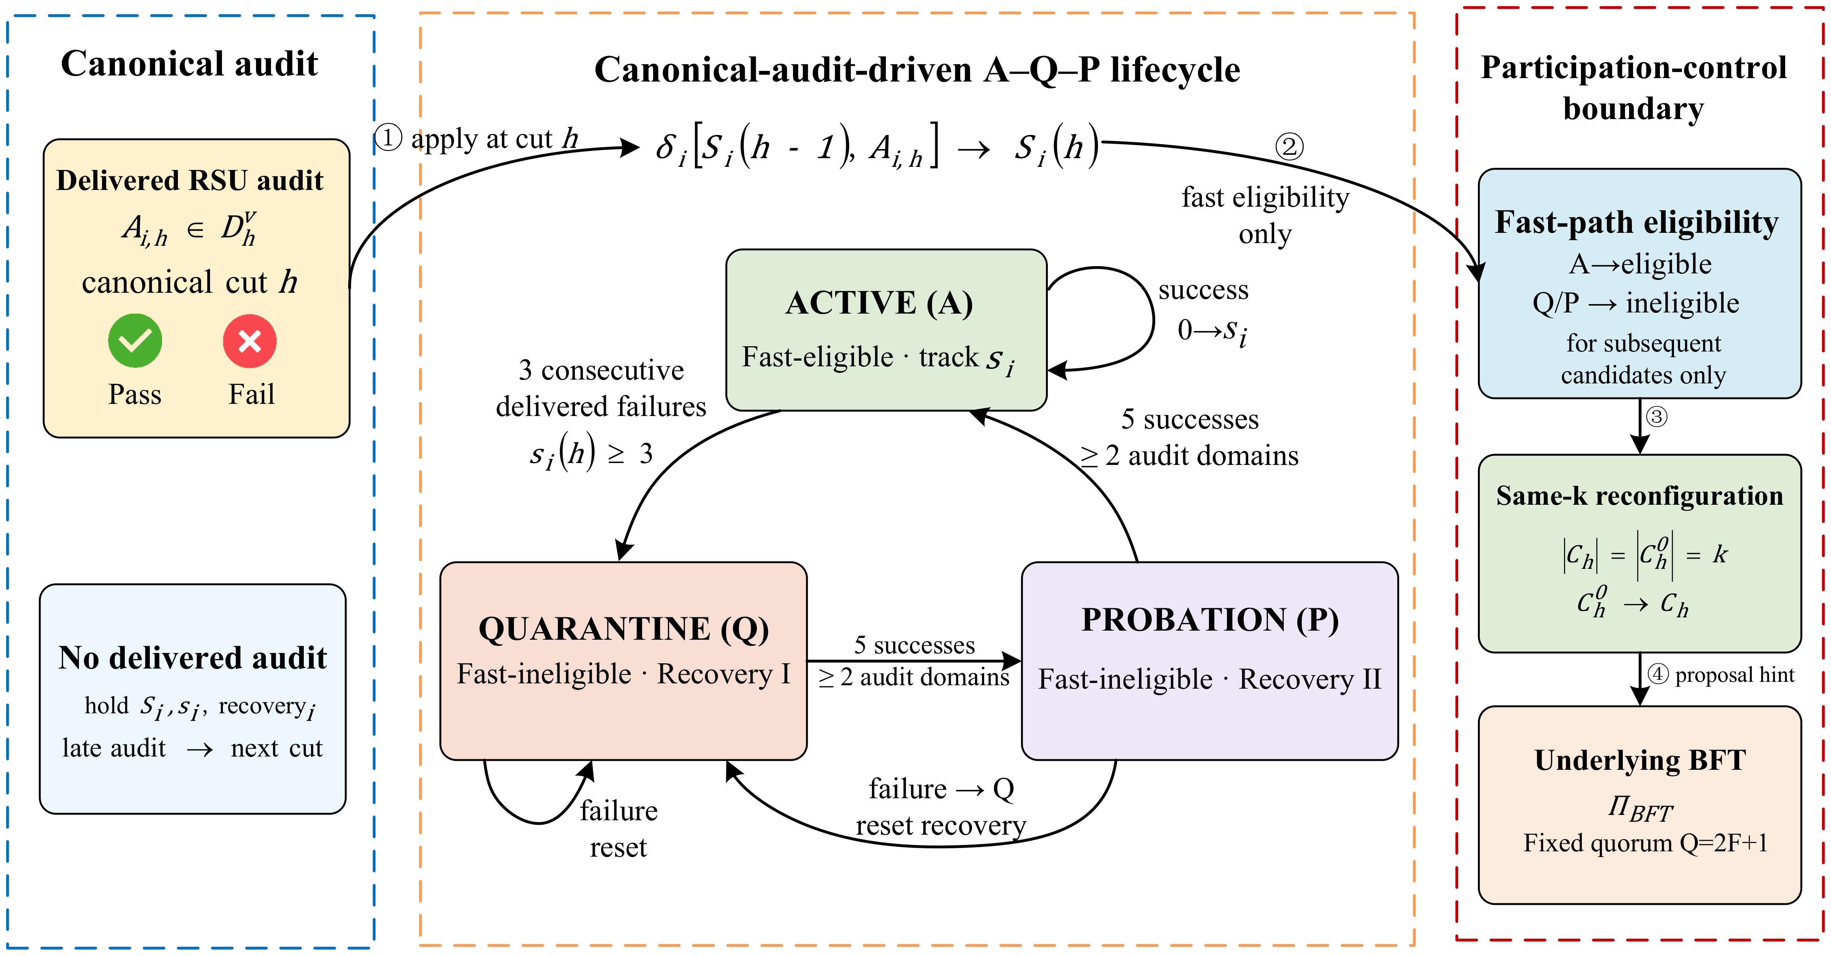
Fig. 3 Canonical-Audit-Driven A/Q/P Validator Lifecycle
In Fig. 3, Active, Quarantine, and Probation jointly determine fast-candidate eligibility. Failures suspend an anomalous RSU, and successful audits across domains restore participation in stages. Quarantine and Probation nodes remain registered validators, so lifecycle updates preserve the base protocol's final quorum.
Algorithm 2 updates diagnostic state, lifecycle state, failure counts, and recovery records from newly delivered audits. UpdDiag and AddRec denote diagnostic updates and recovery recording. Recovery success counts and audit-domain sets are denoted by $c_{i}^{rec}、G_{i}^{rec}$.
Algorithm 2 Canonical-Audit Lifecycle Update
Input: $D_{h}^{v},E^{v},S(h\text{-}1),s(h\text{-}1),rec$
Output: $E^{v},S(h),s(h),rec$
1 | $$(S(h),s(h),rec)←(S(h\text{-}1),s(h\text{-}1),rec)$$
2 | $$foreachA_{i}∈D_{h}^{v}do$$
3 | $$UpdDiag(E_{i}^{v},A_{i})$$ // diag. only
4 | $$ifA_{i}failsthen$$
5 | $$s_{i}←s_{i}\text{+}1ifS_{i}\text{=}active,else0$$
6 | $$ifS_{i}≠active∨s_{i}≥3then$$
7 | $$(S_{i},s_{i},{rec}_{i})←(quarantine,0,⌀)$$
8 | $$endif$$
9 | $$elseifS_{i}\text{=}activethen$$
10 | $$s_{i}←0$$
11 | $$else$$
12 | $$AddRec(i,domain(A_{i}))$$
13 | $$ifc_{i}^{rec}≥5∧|G_{i}^{rec}|≥2then$$
14 | $$S_{i}←probationifS_{i}\text{=}quarantine,elseactive$$
15 | $$ResetRec(i)$$
16 | $$endif$$
17 | $$endif$$
18 | $$endfor$$
19 | $$returnE^{v},S(h),s(h),rec$$

3.3.2 Fixed-Size RSU Participation Reconfiguration
At height h, the participation layer samples a publicly verifiable initial candidate $C_{h}^{0}$ of size k from Active set $A_{h}$. Shared audit warnings then determine whether an equal-sized reconfiguration is needed:
$C_{h}^{0}\text{=}{Sample}_{k,κ}(A_{h};σ_{h}^{0})$ (12a)
RSUs must be able to reproduce the same candidates from the same delivered records. The sampler ${Sample}_{k,κ}$ uses the canonical audit cut, complete registry state, and a seed for each selection purpose. It accepts an internally generated $SelectionCapability$. For purpose∈{primary,resample}, SEARPC commits to $R_{seed}(h)$ before revealing beacon $B_{h}$, then derives $σ_{h}^{purpose}$=$H(B_{h},R_{seed}(h),purpose)$. Late records are included at a later height.
The registry root binds all validator IDs, in order, to their credential digests, certified domains, eligibility, registry epochs, and configuration digests. Projection ${Proj}_{seed}$ extracts the canonical selection state. A deployed beacon $B_{h}$ can use threshold signatures, a verifiable random function, or distributed randomness.
$|C_{h}^{0}∩V_{g}|≤6,∀g∈G(k\text{=}13,κ\text{=}0.40)$ (12b)
Equation (12b) bounds seats from one certified domain. With integer seats, k=13 and κ=0.40 give $b_{g}\text{=}⌈κk⌉\text{=}6$, corresponding to $κ_{eff}\text{=}6\text{/}13\text{=}46.15\text{\%}$. This limits same-source occupation of fast seats. The committee's Byzantine fault condition is specified separately by $f_{k}$ and Property 4.
After forming $C_{h}^{0}$, the main path uses delivered validator warnings with fixed threshold $γ=2$. The optional content-risk extension is disabled by default. When enabled, a high-risk record $z_{h−1}^{c}=1$ delivered from the preceding closed slot lowers the warning threshold to 1 and expands subsequent observation coverage. Its effects are confined to those controls, leaving the A/Q/P updates, random seed, and final quorum governed by their original inputs.
If no member of $C_{h}^{0}$ reaches $γ_{h}$, selection is unchanged. Otherwise, the eligible Active pool becomes $A_{h}^{clean}$:
$A_{h}^{clean}\text{=}\{i∈A_{h}:s_{i}(h)\text{<}γ_{h}\}$ (13a)
An independently derived seed then produces the reconfigured candidate:
$C_{h}\text{=}{Sample}_{k,κ}(A_{h}^{clean};σ_{h}^{1}),|C_{h}|\text{=}k$ (13b)
Reconfiguration reuses the source-constrained sampler and preserves size k. If the filtered Active set cannot supply k eligible members, the controller returns an empty hint and the base BFT protocol continues its standard proposal path. The main experiments use k=13, local fault budget 4, and fast-hint threshold 9; the final quorum remains fixed.
Fast participation proceeds through $S_{i}(h)$ admission, public sampling of $C_{h}^{0}$, warning checks using $s_{i}(h)$, and same-size reconfiguration. Only the occupants of the k fast seats change; k and $q_{k}$ remain fixed.
Property 4 (Fast-hint quorum intersection). For k=3$f_{k}$+1 and $q_{k}$=2$f_{k}$+1, any two $q_{k}$ signer sets intersect in at least $f_{k}$+1 members. If the fast committee has $n_{h}^{Byz}$≤$f_{k}$ Byzantine members and an honest member signs at most one digest for a given (height,view), the intersection contains an honest signer. Two conflicting valid fast hints therefore cannot both form under these conditions. The event $n_{h}^{Byz}$>$f_{k}$ is recorded offline as fault-budget exceedance. Final confirmation follows the fixed-Q base protocol.
Let $I_{h}^{res}$∈{0,1} indicate reconfiguration at height h. The main path and optional extension allocate subsequent audit coverage separately:
$χ_{h}^{core}$=1 if $\max_{i∈C_{h}^{0}}s_{i}(h)\text{>}0$ or $I_{h}^{res}$=1; otherwise, $χ_{h}^{core}$=$χ_{0}$. For the extension, $χ_{h}^{ext}$=1 if $χ_{h}^{core}$=1 or $z_{h\text{-}1}^{c}\text{=}1$; otherwise, $χ_{h}^{ext}$=$χ_{0}$.
Coverage values $χ_{h}^{core}$ and $χ_{h}^{ext}$ allocate future audits and take effect from the next canonical cut. Validator audits drive the main path. The optional content extension is disabled by default, and its outputs are recorded separately.

3.3.3 Fast Hints and Handoff to BFT Finality
Candidate $C_{h}$ collects local signatures for one (height,view,digest). Reaching $q_{k}$ produces $QC_{h}^{fast}$, a certificate of candidate support for the block digest. This certificate enters the base finalizer as a proposal hint.
The controller packages block ${Blk}_{h}$ and certificate $QC_{h}^{fast}$ as ${Hint}_{h}$. On receiving the hint, $Π_{BFT}$ retrieves and validates the full ${Blk}_{h}$. A missing or timed-out hint, invalid signer set, mismatched digest, or unavailable block returns ⊥; the base proposer timer continues the standard path.
${Hint}_{h}\text{=}({Blk}_{h},QC_{h}^{fast}),QC_{h}^{fast}⇏Commit({Blk}_{h})$ (14a)
Equation (14a) separates proposal support from final confirmation: a hint cannot authorize commitment. The base protocol validates the block and collects the fixed-Q certificate. The corresponding final-execution boundary is:
$R_{final}^{SEARPC∘Π_{BFT}}⊆R_{final}^{Π_{BFT}}$ (14b)
Fixed finality and standard-path recovery
Property 5 (Finality non-interference). Assume $Π_{BFT}$ is safe under $N\text{=}3F\text{+}1$, $Q\text{=}2F\text{+}1$, and the stated network and cryptographic assumptions. SEARPC changes candidate metadata and proposal hints; $Π_{BFT}$ retains its validation, membership, and finality rules. Hence, valid final executions of the composed system belong to the execution set allowed by $Π_{BFT}$.
When candidate formation fails, $QC_{h}^{fast}$ is unavailable, or block validation fails, $Π_{BFT}$ continues its standard proposal and view-change procedure. Progress inherits the liveness conditions of $Π_{BFT}$.
Table V Fast-Hint Handoff and Base BFT Finality Responsibilities
Mode | SEARPC output | $Π_{BFT}$ action | Final quorum | Interpretation
hint-cached | Available $QC_{h}^{fast}$; ${Blk}_{h}$ cached | Full validation and native protocol processing | Fixed Q | Proposal support only
hint-fetch | Available $QC_{h}^{fast}$; retrieve ${Blk}_{h}$ | Fetch, full validation, and native processing | Fixed Q | Hint may be rejected
standard path | No usable hint | Standard proposal and view-change path | Same fixed Q | Base finality rules
no commit | — | $Π_{BFT}$ has insufficient valid signatures for a fixed-Q certificate | Q unchanged | $Π_{BFT}$ retains the uncommitted state
Table V distinguishes SEARPC's candidate selection, equal-sized replacement, and hint packaging from the base protocol's validation and finality responsibilities.
Algorithm 3 summarizes canonical-audit-driven reconfiguration and BFT handoff. Main results use $γ=2$ and $λ_{ext}=0$; the content-risk extension is enabled separately. VerifyCut, AuthSample, ReconfK, and ToBFT denote cut verification, authorized sampling, same-size reconfiguration, and BFT handoff.
Algorithm 3 Same-Size RSU Reconfiguration
Input: ${Snap}_{h},A_{h},S(h),s(h),k,κ,q_{k},χ_{0},B_{h},Π_{BFT},λ_{ext}(default\text{=}0),z_{h\text{-}1}^{c}$
Output: ${Hint}_{h},{Ctrl}_{h}$
1 | $$VerifyCut({Snap}_{h})$$
2 | $$(R_{full},R_{seed},R_{risk})←BindRoots({Snap}_{h};{Proj}_{seed},{Proj}_{risk})$$
3 | $$Commit(R_{seed})≺Reveal(B_{h})$$
4 | $$C_{h}^{0}←{AuthSample}_{k,κ}(A_{h};SeedCap(B_{h},R_{seed},primary))$$
5 | $$γ←1ifλ_{ext}\text{=}1∧z_{h\text{-}1}^{c}\text{=}1,else2$$
6 | $$σ_{h}^{res}←SeedCap(B_{h},R_{seed},resample)$$
7 | $$C_{h}←ReconfK(C_{h}^{0},A_{h},S(h),s(h),γ;σ_{h}^{res})$$
8 | $${Hint}_{h}←⊥$$
9 | $$if|C_{h}^{0}|\text{=}|C_{h}|\text{=}kthen$$
10 | $$obs←CollectSig(C_{h},h,q_{k},deadline)$$
11 | $$ifValidHint(obs)∧BlockAvailthen$$
12 | $${Hint}_{h}←({Blk}_{h},BuildHint(obs))$$
13 | $$endif$$
14 | $$endif$$
15 | $$(R_{in}^{c},T_{h},χ_{h})←CorePlan({Snap}_{h},S(h),s(h),χ_{0})$$
16 | $$R_{in}^{x}←⊥$$
17 | $$\text{if}λ_{ext}\text{=}1\text{then}$$
18 | $$(R_{in}^{x},T_{h}^{x},χ_{h}^{x})←ExtPlan({Snap}_{h},z_{h−1}^{c})$$
19 | $$(T_{h},χ_{h})←MergeAudit((T_{h},χ_{h}),(T_{h}^{x},χ_{h}^{x}))$$
20 | $$\text{end if}$$
21 | $$R_{out}←H(R_{in}^{c},R_{in}^{x},Sort(T_{h},χ_{h}))$$
22 | $$Challenge(T_{h})$$
23 | $$ToBFT(Π_{BFT},h,{Hint}_{h})\text{(base timer never waits)}$$
24 | $${Ctrl}_{h}←\{R_{full},R_{seed},R_{risk},R_{in}^{c},R_{in}^{x},R_{out},S,T_{h},C_{h}^{0},C_{h},Q\}$$
25 | $$\text{return}{Hint}_{h},{Ctrl}_{h}$$

3.4 Security Properties and Computational Complexity
Let M be the ensemble size, $T_{m}$ the number of trees per boosting model, $D_{m}$ the maximum tree depth, J the number of opinions per event, G the number of participating domains, H the risk-history window, A the Active-validator count, and B the block size in bytes. Participation-layer work consists of message inference, weighted medians, lifecycle updates, and candidate ordering. Full block validation, data availability, and final voting are performed by $Π_{BFT}$. Table VI summarizes these costs.
Table VI Computational Costs of SEARPC and Its Finality Handoff
Operation | Time complexity | Storage or communication
Ensemble message inference | O(M $T_{m}$ $D_{m}$) | M member probabilities
Role-evidence update | O(1) | O(1) state per entity and role
Within-domain and cross-domain medians | O(J log J + G log G) | At most one outer item per domain
Historical risk quantile | O(H log H), direct implementation | O(H) window state
Candidate sampling or reconfiguration | O(A log A) | O(A) ordered identifiers
Fast-candidate support | Θ(k²) | $QC_{h}^{fast}$ hint only; k=13
Handoff to $Π_{BFT}$ | O(1) interface metadata | ${Hint}_{h}$ may be accepted, ignored, or replaced
Full block and final voting | Defined by $Π_{BFT}$ | Native $Π_{BFT}$ responsibility
Standard path without a hint | Defined by $Π_{BFT}$ | Native proposal, view-change, and finality rules

SEARPC adds fixed-size candidate-support messages to the base protocol's native communication. Full block validation, availability checks, and fixed-Q voting retain their original scope; fast-candidate selection does not reduce the final confirmation set.

4 Experiments and Results
The evaluation follows evidence from road-message assessment to vehicle privileges and RSU participation. Three matched stages assess message-risk quality, role and source authorization, and audit-driven candidate reconfiguration. A process prototype additionally measures certificate-handoff cost under a fixed final quorum. Inputs, decision tasks, and resource budgets are aligned within each comparison, with external baselines, mechanism ablations, and protocol controls serving distinct purposes.

4.1 Experimental Setup and Comparisons

4.1.1 Stage-Matched Baselines and Fair Comparisons
SEARPC is compared with seven published methods at their corresponding stages: message evidence, role and source authorization, and participant selection. Table VII lists the methods, references, tasks, and matched settings. Yadav and BRBC are evaluated through their participant-selection rules under shared audit inputs and a fixed final quorum. Three SEARPC ablations isolate mechanism contributions. Static k=13, size-fixed k=13, and full participation provide protocol controls.
Table VII External Baselines, SEARPC Ablations, and Protocol Controls
Method (reference) | Matched task | Fair alignment
Random Forest (RF) [30] | Message evidence | Same features and Train/Validation-to-urban Test split
HistGradientBoosting (HGBDT) [31]–[33] | Message evidence | Same features and Train/Validation-to-urban Test split
CaTCH [8] | Message evidence | Same urban Test; official implementation and published parameters
Beta Reputation System (BRS) [9] | Role/source authorization | Same stream, delivery delay, and readout grid
Three-Weight Subjective Logic (TWSL) [3] | Role/source authorization | Same holdout and identity stream
Yadav trust-ranking rule [5] | Participant selection | Shared-7; 10 x 600 blocks; k=13; Q=27
BRBC threshold-eligibility rule [16] | Participant selection | Shared-7; 10 x 600 blocks; k=13; Q=27
SEARPC w/o Role Separation | Internal ablation | Shared vehicle history; other settings unchanged
SEARPC w/o Domain Cap | Internal ablation | Identity-level outer support; other settings unchanged
SEARPC w/o Same-k Reconfiguration | Internal ablation | Same audit-delivery rules, k, and Q; separate equal-budget attribution
Static k=13 | Protocol control | Fixed committee trajectory; no participation update
Fixed k=13 | Protocol control | Size-fixed k=13; deterministic rotation; same final quorum
Full set | Protocol control | All registered processes; same final quorum
SEARPC (this work) | Three matched stages | Same inputs, outputs, and stage budgets
Each external method is compared on the decision task it addresses. Ablations remove one SEARPC mechanism at a time, while protocol controls quantify the cost of candidate and full-participation paths. Table VIII summarizes the main findings by evaluation stage.
Table VIII Main Findings across the Evaluation Stages
Compared methods | Evaluation target | Primary metric | Headline result
RF [30], HGBDT [31]–[33], CaTCH [8], SEARPC | Road-message evidence | Macro-F1, FPR, ECE-15 | SEARPC FPR 3.96%; ECE-15 0.0086
BRS [9], TWSL [3], SEARPC | Role/source authorization | Malicious authorization; same-domain 1→7 influence | No malicious authorization in six conditions; same-domain Δ≈0.019
Yadav [5], BRBC [16], SEARPC | Participant selection | Risk-weighted adversarial exposure | SEARPC 8.025%; absolute reduction 10.797–11.832 pp
Full set, Fixed k=13, SEARPC | System integration | Fetch p95; wire | SEARPC 70.56 ms; 1019.6 KB/block
The results follow the path from evidence to participation: message assessment limits false alarms, authorization restricts role transfer and source amplification, and RSU control reduces adversarial exposure. The prototype measures whether candidate reconfiguration and certificate handoff remain close to the cost of a size-matched control. The following sections examine each stage in turn.

4.1.2 Vehicle Dataset, Protocol Trajectories, and Process Prototype
Vehicle experiments use separate highway and urban scenarios from VeReMi NextGen [34]. Message models, calibration mappings, and operating points are fitted only on highway training and validation data, then transferred to the urban test set. The latter contains 813,602 messages, split equally between Data Replay and Time Delay, with 406,801 messages per attack. Statistical resampling uses 2,038 receiver/source-file clusters. This split tests transfer to different road layouts and traffic conditions.
Role authorization, cold start, and source-domain experiments use the low-density urban InTAS_urban_2 training partition as a separate holdout. It does not enter message-model fitting, calibration, or threshold selection. The fixed highway model generates its message evidence; role overlap, domain mappings, and attack windows follow predefined indexing rules. Comparisons thus use the same evidence while varying authorization and source handling.
Protocol experiments use 40 registered RSUs, six certified domains, and ten paired trajectories with controlled node anomalies, audit outcomes, delivery delays, and participation changes. The process prototype uses N=16/40 and Q=11/27 to measure fixed-quorum certificate-handoff latency and communication. Fig. 4 summarizes the vehicle inputs, and Table IX lists evaluation scales and statistical units. Adjudication delivery checks cover error rates of 0%, 5%, and 10% and delays of 0, 10, and 30 events on controlled streams, verifying that online updates consume only delivered records.
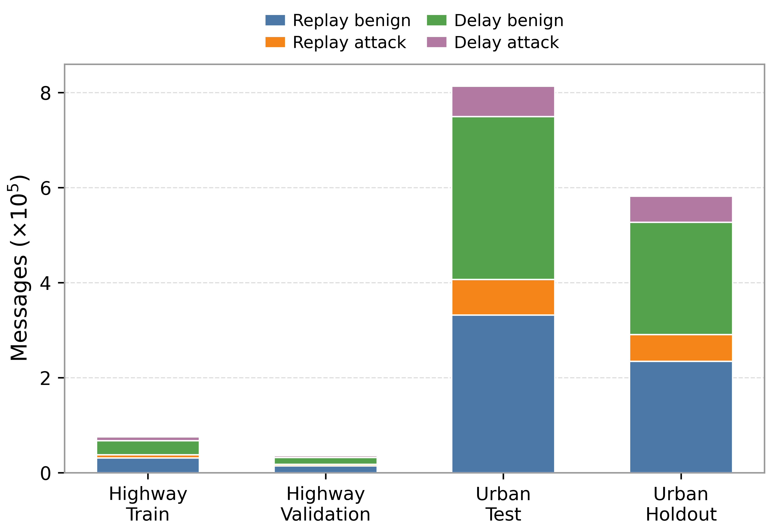  (a)Absolute archive-level message distribution across evaluation partitions | 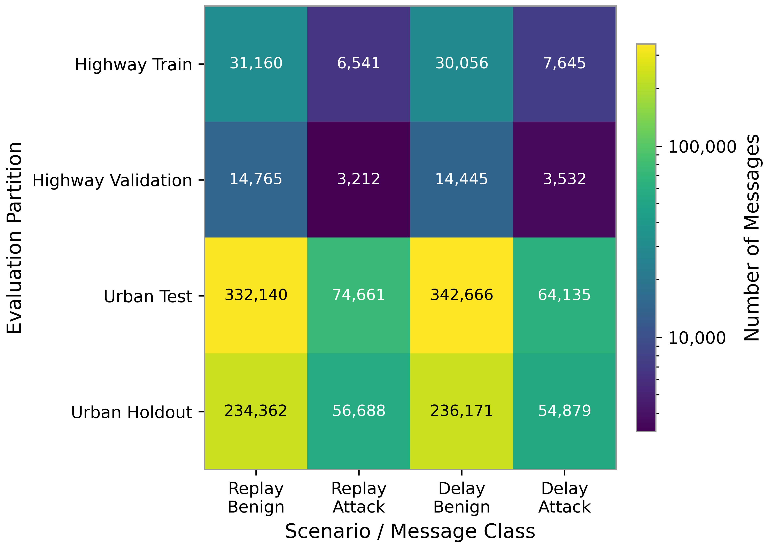  (b)Partition–scenario message-count heatmap
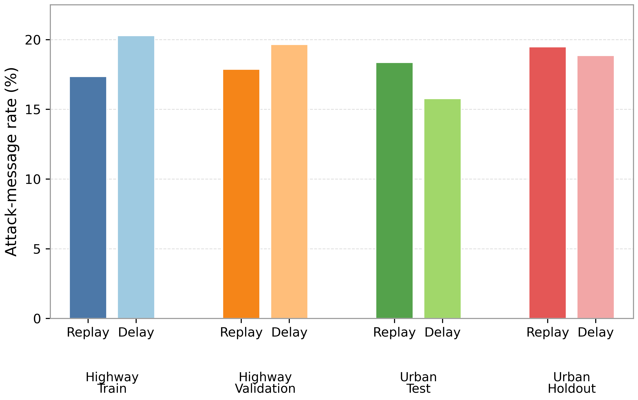
(c)Attack-message rates across Replay/Delay scenarios by evaluation partition
Fig. 4 VeReMi NextGen Partitions and Attack Inputs
The highway partition supplies training and calibration data, while urban partitions support cross-scenario testing and separate role and source experiments. Data Replay perturbs reported parameters through replay, and Time Delay introduces temporal inconsistencies. Together, they represent different forms of misleading road information.
Table IX Dataset, Protocol Scenarios, and Evaluation Scales
Task | Data / scenario | Scale | Statistical unit / protocol
Message evidence | VeReMi highway→urban Test | 813,602 messages; 2,038 clusters | 2,000 clustered bootstrap
Role authorization | Independent holdout; 0/50/100% overlap | 36,382 events/attack; 20 seeds | Paired opportunities
Quantile cold start | Unequal exposure | 2 attacks × 20 seeds | Mean vs quantile readout
Safety–coverage frontier | 91-point θ sweep | 2 methods × 2 attacks × 20 seeds | Empirical 0/0.5/1/2% risk budgets
Correlation-domain control | Concentrated/distributed | 1/3/5/7 identities; 20 seeds | Multiplicity and boundary controls
Participation control | 40 RSUs; 6 domains | 5 methods × 10×600 blocks | Canonical adaptive and external shared-7; k=13, Q=27
Fixed-Q certificate prototype | 16/40 processes; Cached/Fetch | 5×500 blocks/cell; 30,000 blocks | Fixed-Q certificate checks
Equal-audit budget | Shared/equal-7/adaptive | 3×5×6,000 blocks | Core SEARPC vs optional content-extension ablation
Adjudication delivery checks | 0/5/10% error; 0/10/30 events | 36 controlled-stream cases | Delivery semantics; fixed parameters
FSM parameter sensitivity | Failure trigger 2/3/4; per-stage recovery 3/5/10 | 9 cells × 10×600 blocks | Exposure–active-pool trade-off; fixed Q=27
VeReMi NextGen is the public vehicle dataset. The 40-RSU trajectories evaluate audit delivery and participation changes, and the process prototype measures candidate reconfiguration and certificate handoff. These complementary settings test vehicle evidence, protocol behavior, and execution cost.

4.1.3 Statistical Methods and Implementation Parameters
Statistical units follow the evaluation level. Message metrics use receiver/source-file cluster bootstrapping. Role, cold-start, and domain experiments use 20 paired seeds with two-sided Student-t 95% confidence intervals, direction consistency, and exact sign-flip tests. Committee comparisons use ten paired trajectories and 20,000 paired bootstrap resamples. Process measurements use independent launches as the statistical unit.
Table X specifies the algorithm parameters and execution environment.
The message backend contains five bootstrap HGBDT models implemented with scikit-learn's HistGradientBoostingClassifier [31]–[33]. Their mean estimates risk and their standard deviation measures disagreement. Platt and isotonic calibration are fitted on validation data and selected by Brier score. Role rules, domain mappings, committee size, audit budgets, and final quorum are fixed before result aggregation.
Table X Algorithm, Protocol, and Execution Parameters
Category | Parameter or implementation | Predefined setting
Message model | Ensemble / boosting | 5 members；200 iterations；learning rate=0.05；31 leaves；L2=1.0
Message features | Inputs | 17 current-message physical + 13 one-step temporal + rolling sender/receiver context
Probability calibration | Calibrator | Platt or isotonic; validation fit; selection by Brier score
Detection operating point | Threshold | Maximize malicious-class F1 subject to validation FPR≤5%; higher threshold breaks ties
Reputation prior | Beta prior | $Beta(1,1)$；state threshold $τ\text{=}0.50$
Evidence sufficiency | Bounds / state rule | 5% LCB；95% UCB；3-failure / 10-success state rule
Authorization readout | θ grid | 0.05–0.95; 91 predefined thresholds
Source correlation | Identities/domain layout | n∈{1,3,5,7}；concentrated main + distributed control
Validator set | N / domains / committee | N=40；6 domains；k=13；κ=0.40；$q_{k}$=9；Q=27
Audit feedback | Audit | 50/100% audit coverage；5% audit error；10-block delivery delay
Process prototype | N / Q / block | N=16/40；Q=11/27；16 KiB block；5 warm-up；500 measured；5 launches/cell
Cryptography and transport | Implementation | persistent localhost TCP；JSON/hex；SHA-256；Ed25519；persistent connections；reused thread pool
Ledger implementation | Protocol stack | Consortium-ledger certificate-handoff prototype; block integrity, signature verification, and fixed-quorum certificates
Software environment | Reproducible environment | Python 3.12.14; environment locks, scripts, and seeds retained
Allocated hardware | Container allocation | Linux 6.18.44 x86_64 container；8-vCPU quota；8 GiB RAM limit；single-host deployment
The process experiments execute block-integrity checks, Ed25519 signature verification, and fixed-Q certificate counting over same-host communication. The benchmark container runs Linux 6.18.44 x86_64 with an eight-vCPU quota, an 8 GiB RAM limit, and Python 3.12.14. Vehicle-role and domain experiments use 20 paired seeds; committee experiments use ten paired trajectories; each process configuration uses five independent launches.

4.2 Cross-Scenario Reliability of Road-Message Evidence

4.2.1 Message Detection on the Urban Test Set
Reliable vehicle authorization requires message-risk estimates that transfer across road environments with low false-alarm rates and useful probability calibration. SEARPC is compared with RF, HGBDT, and CaTCH on the same urban messages and attack partitions. Table XI reports discrimination and probability quality, and Table XII separates Data Replay from Time Delay. CaTCH provides binary decisions, so its comparison uses Macro-F1, Recall, and FPR.
Precision, Recall, and false-positive rate (FPR) first characterize detection. In (15), TP and TN are correctly identified attack and normal messages, FP counts normal messages classified as attacks, and FN counts missed attacks.
$$P\text{=}\frac{TP}{TP\text{+}FP},R\text{=}\frac{TP}{TP\text{+}FN},FPR\text{=}\frac{FP}{FP\text{+}TN}$$ | (15)
Higher Precision means that a larger share of alarms correspond to actual attacks; higher Recall means fewer malicious reports are missed. Lower FPR means that genuine congestion, obstacle, and emergency-braking reports are less often diverted to additional review.
The remaining metrics assess class balance, risk ranking, and calibration, each of which affects how message evidence can support later authorization.
$$F_{1}\text{=}\frac{2PR}{P\text{+}R},MacroF1\text{=}\frac{1}{C}\sum_{c\text{=}1}^{C}{F_{1,c}}$$ | (16)
Equation (16) computes F1 for each class and averages the class scores equally. Macro-F1 prevents the larger class from dominating the aggregate and measures balanced detection across the evaluated classes.
$$AP=\sum_{j=1}^{T}{\left(R_{j}−R_{j−1}\right)P_{j}}$$ | (17)
Equation (17) defines non-interpolated Average Precision (AP), reported as PR-AUC and computed by scikit-learn's average_precision_score. Each term weights Precision by the increase in Recall at a successive threshold; T is the number of thresholds. Higher AP indicates better ranking of malicious road reports, including when attacks are infrequent.
$$Brier\text{=}\frac{1}{n}\sum_{i\text{=}1}^{n}{{(p_{i}\text{-}y_{i})}^{2}}$$ | (18)
Equation (18) measures the mean squared difference between predicted probabilities and observed labels. A lower Brier score indicates more accurate probabilistic predictions, accounting for both discrimination and calibration.
$${ECE}_{15}=\sum_{b=1}^{B}{\frac{\left|S_{b}\right|}{n}\left|{\bar{p}}_{b}−{\bar{y}}_{b}\right|},B=15$$ | (19)
Equation (19) groups predicted maliciousness probabilities into 15 equal-width bins. In each nonempty bin, the mean predicted probability is compared with the observed malicious-message fraction. Lower ECE-15 supports using risk probabilities consistently in role authorization and evidence updates.
Table XI Urban Message Detection and Probability Quality with Best Values in Bold
Method | Macro-F1 ↑ | Recall ↑ | FPR ↓ | PR-AUC ↑ | Brier ↓ | ECE-15 ↓
RF | 0.8454 | 71.44% | 4.37% | 0.8198 | 0.0612 | 0.0130
HGBDT | 0.8288 | 67.98% | 4.65% | 0.7857 | 0.0670 | 0.0112
CaTCH [8] | 0.5441 | 14.25% | 5.90% | N/A | N/A | N/A
SEARPC | 0.8250 | 64.91% | 3.96% | 0.7933 | 0.0660 | 0.0086

4.2.2 Attack-Specific Evidence Quality and Calibration
Table XI shows a complementary trade-off: RF has the highest Macro-F1, whereas SEARPC has the lowest FPR and ECE-15. SEARPC generates fewer false alarms and better-calibrated continuous risk, qualities needed when an assessment affects subsequent privileges. Table XII examines these properties separately for each attack.
Table XII Attack-Specific Comparison of CaTCH and SEARPC on the Urban Test Set
Attack | Method | Messages | Macro-F1 ↑ | Recall ↑ | FPR ↓
Data Replay | CaTCH | 406,801 | 0.5841 | 20.70% | 6.01%
Data Replay | SEARPC | 406,801 | 0.8964 | 79.37% | 2.72%
Time Delay | CaTCH | 406,801 | 0.4941 | 6.75% | 5.80%
Time Delay | SEARPC | 406,801 | 0.7373 | 48.08% | 5.16%
Pooled | CaTCH | 813,602 | 0.5441 | 14.25% | 5.90%
Pooled | SEARPC | 813,602 | 0.8250 | 64.91% | 3.96%
CaTCH uses its public implementation and prescribed highway parameters on the same urban test set. Its native output is a binary consistency decision. SEARPC improves Recall and reduces FPR for both Data Replay and Time Delay, while retaining calibrated risk for subsequent role-evidence updates. This distinguishes immediate consistency checking from risk estimates used throughout the authorization process.
Fig. 5 shows attack-specific false-alarm rates, calibration errors, and reliability curves to explain the aggregate probability-quality results.
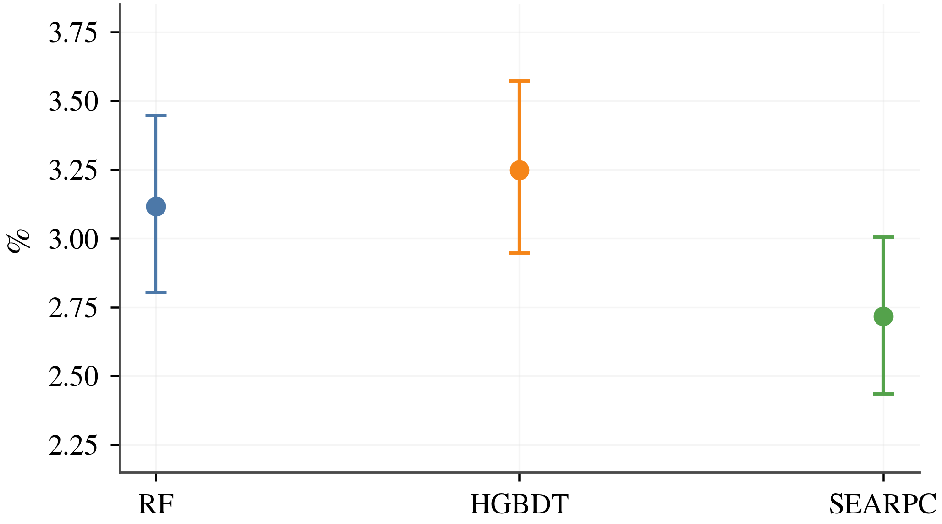  (a)Data Replay—FPR | 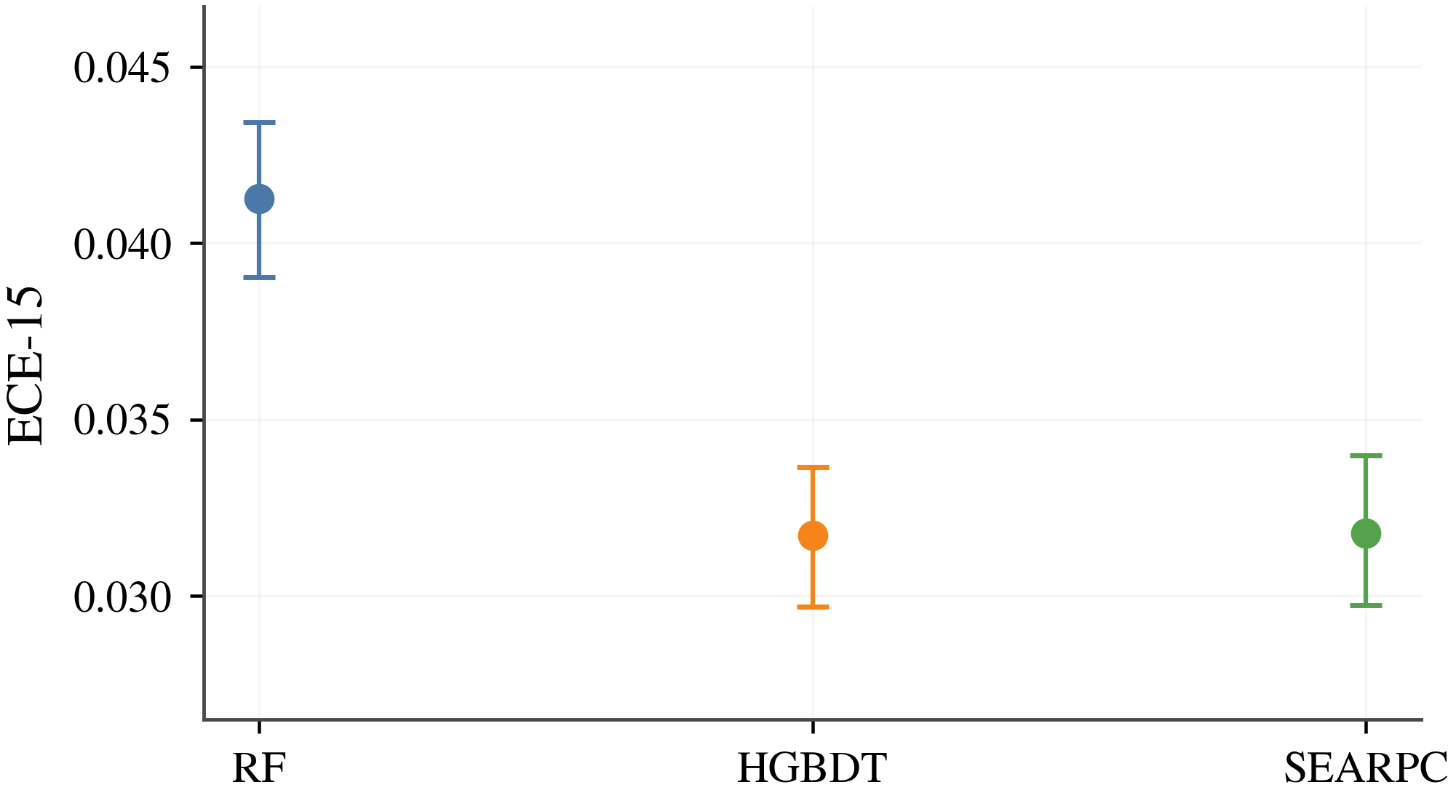  (b)Data Replay—ECE-15 | 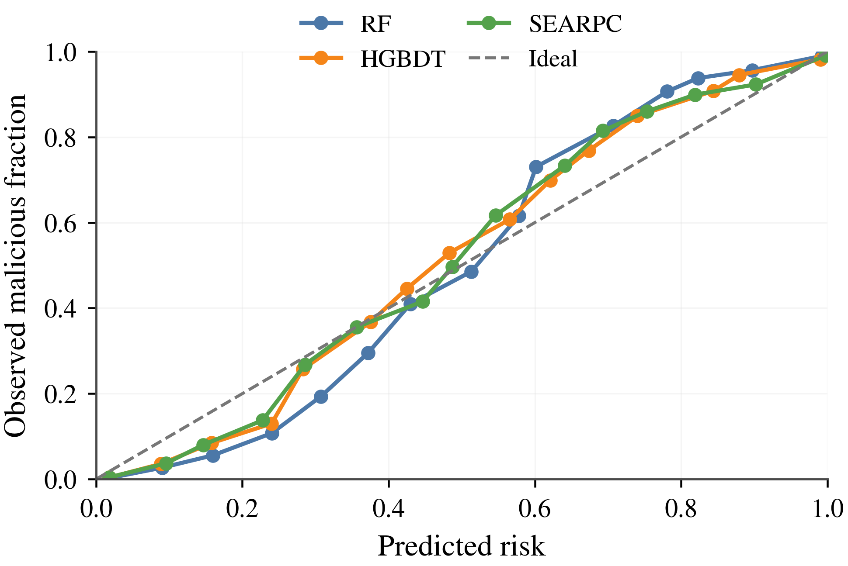  (c)Data Replay—Reliability
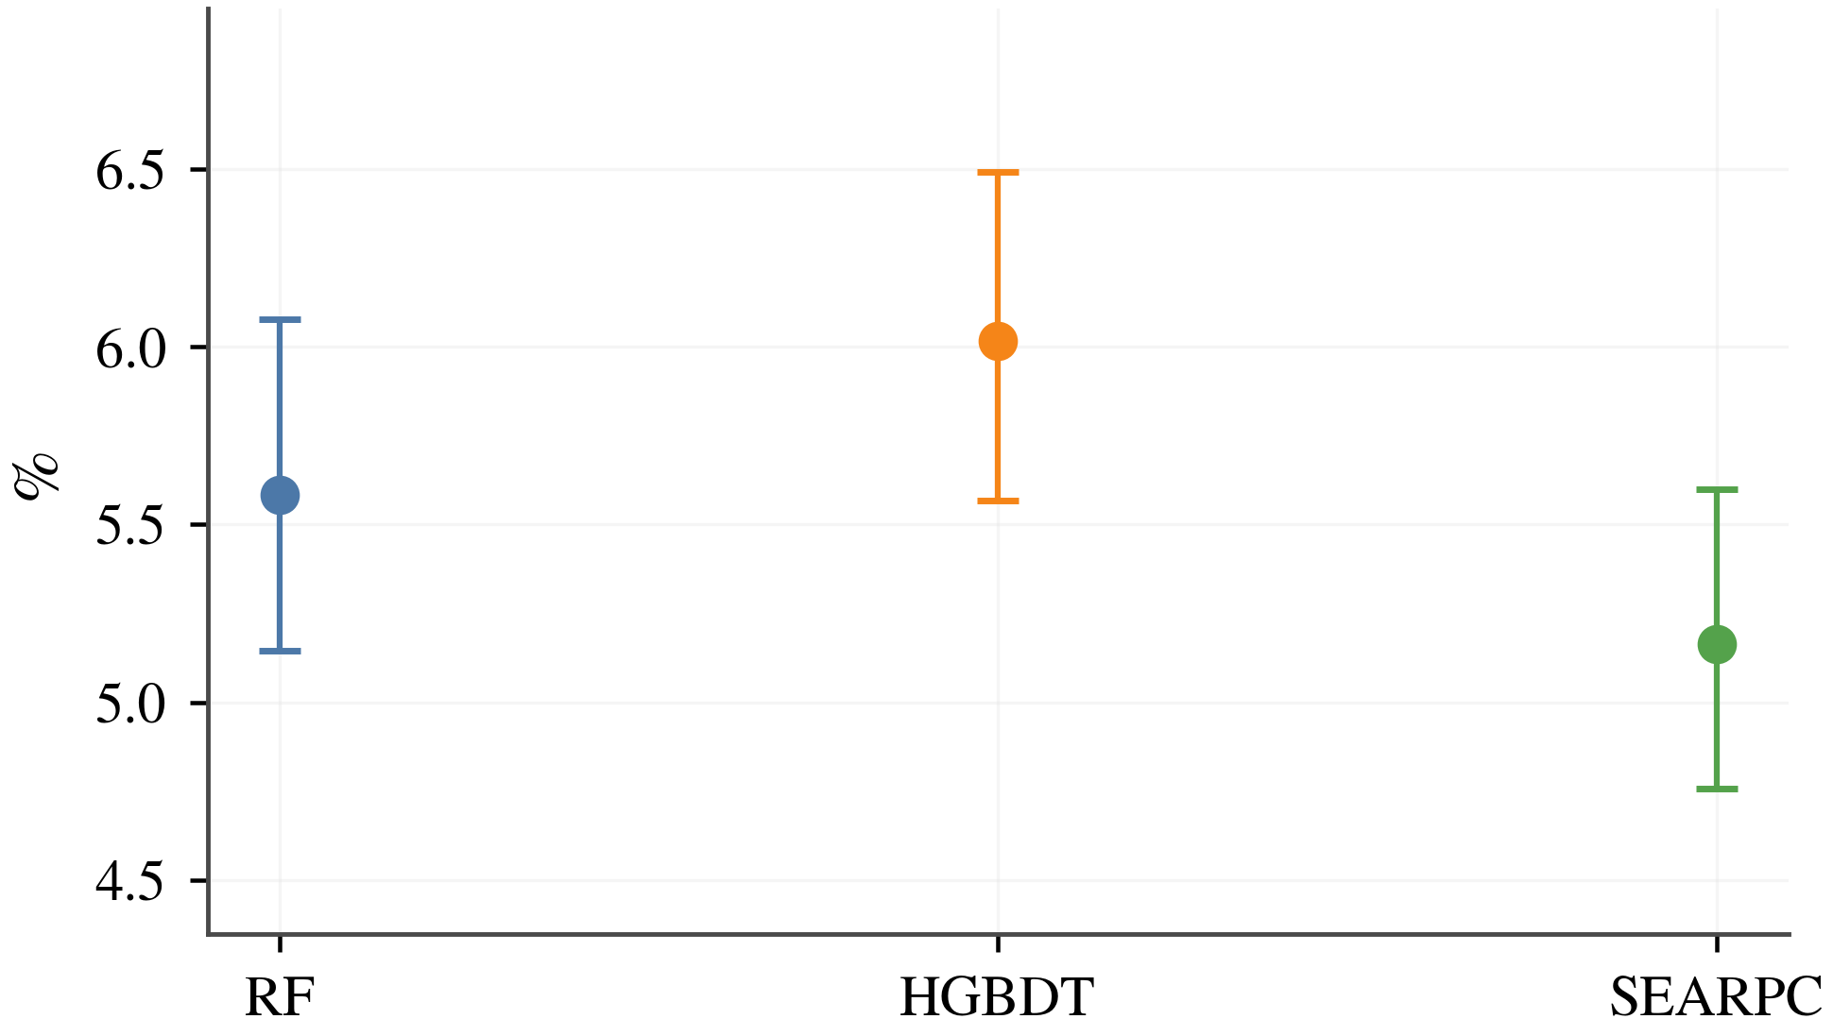  (d)Time Delay—FPR | 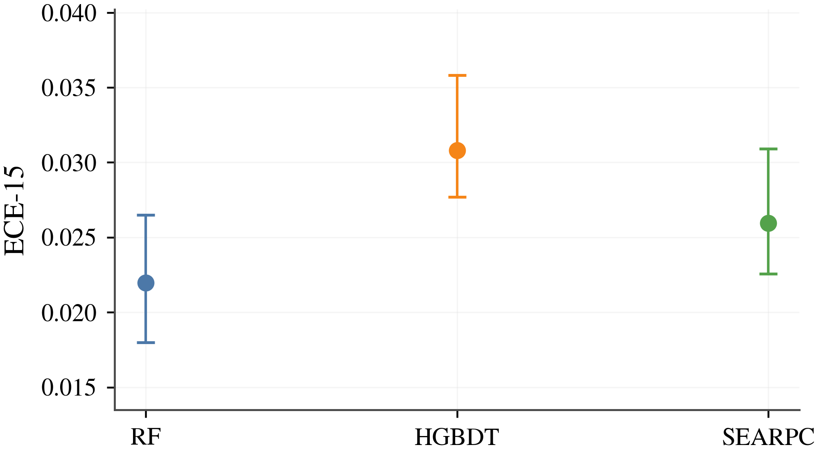  (e)Time Delay—ECE-15 | 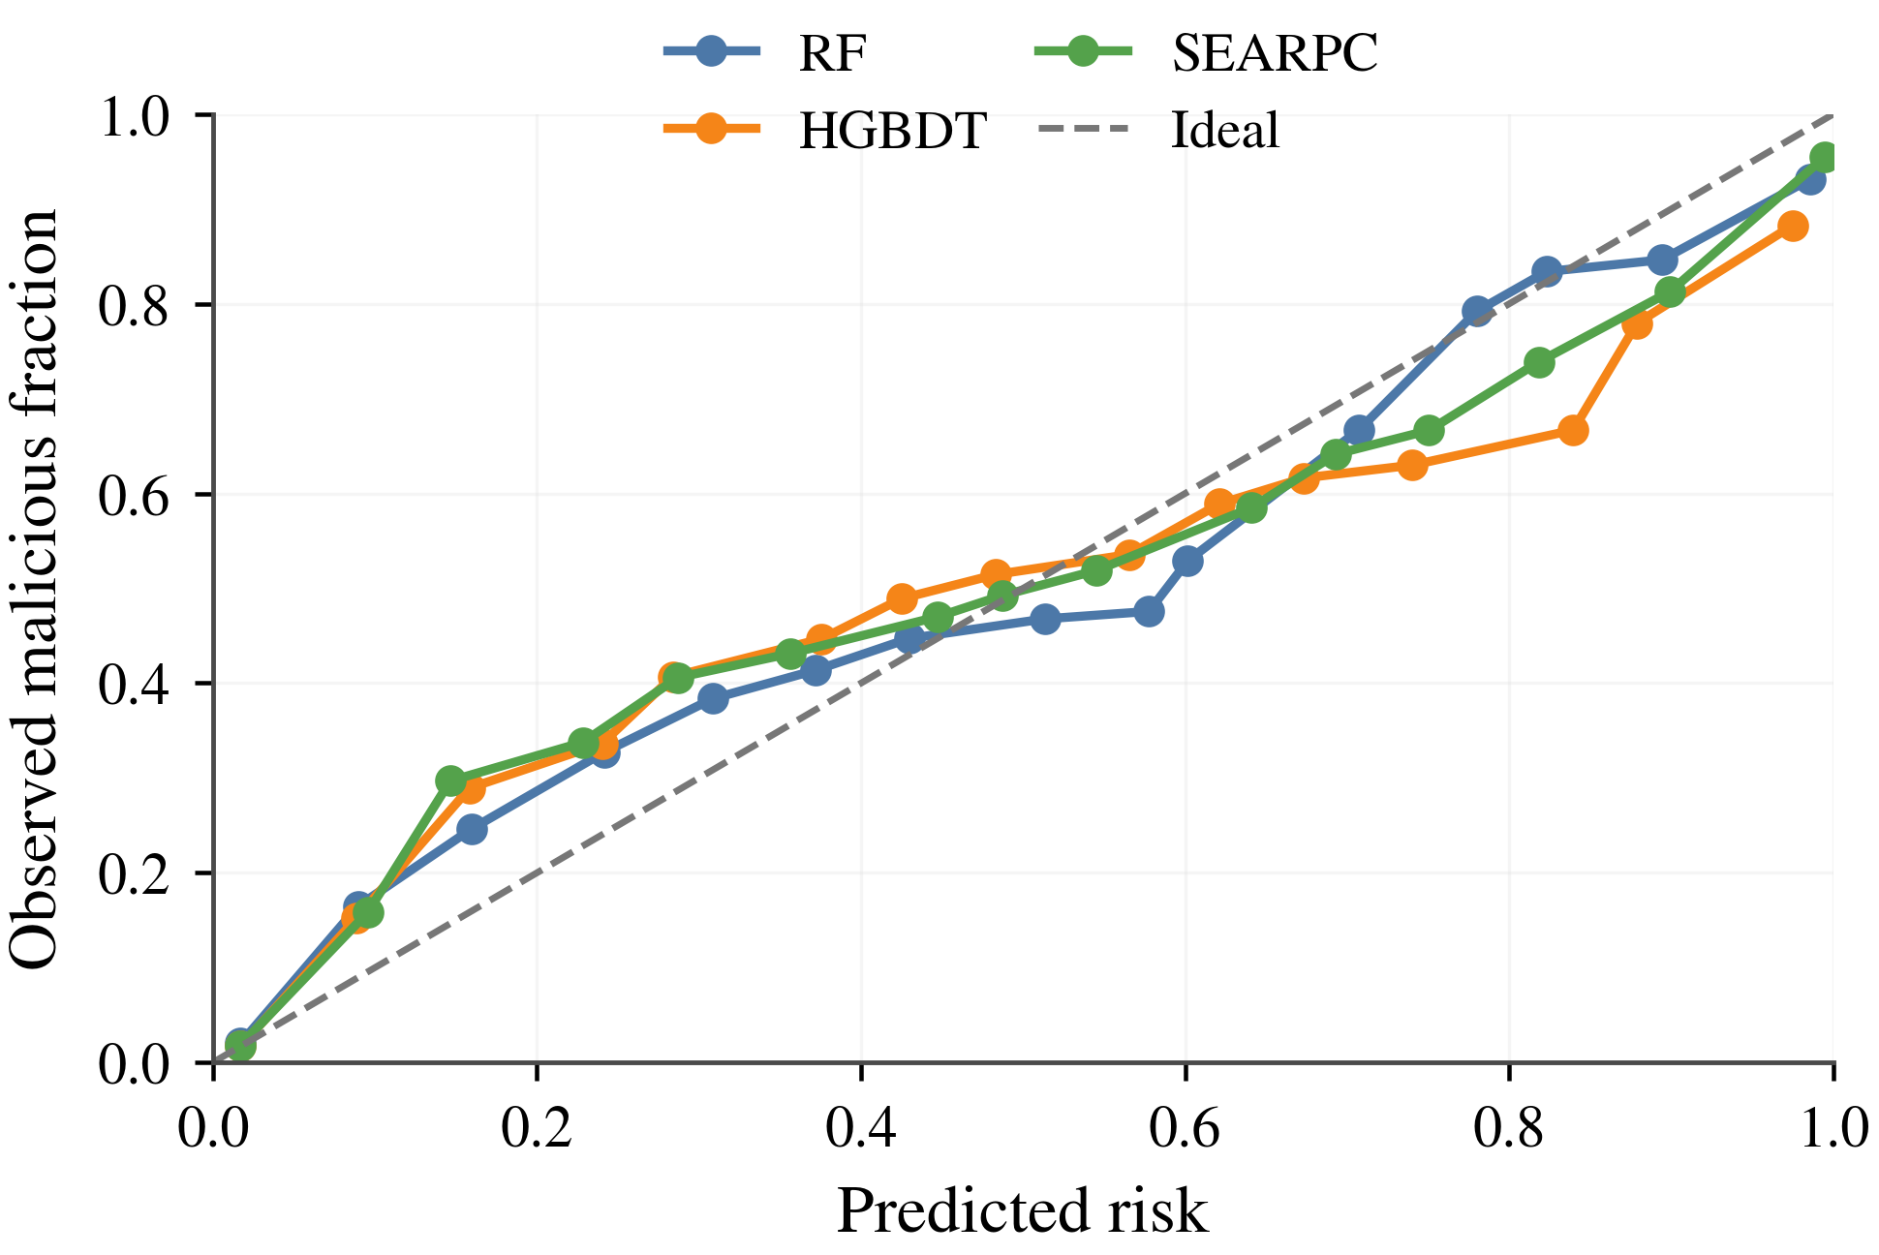  (f)Time Delay—Reliability
Fig. 5 Cross-Scenario Message Evidence Quality on the Urban Test Set
SEARPC's pooled FPR is 3.96%, 1.94 percentage points below CaTCH, and its ECE-15 is 0.0086. Macro-F1 increases from 0.5441 to 0.8250 and Recall from 14.25% to 64.91% relative to CaTCH. Fewer false alarms preserve timely treatment of genuine road events, while better calibration makes subsequent privilege decisions less sensitive to inconsistent risk scales. RF retains a modest Macro-F1 advantage, with higher FPR and calibration error; SEARPC provides a favorable combination for downstream authorization.

4.3 Role-Isolated and Source-Limited Authorization

4.3.1 Authorization Security under Cross-Role Attacks
The vehicle-side experiments test whether a favorable history in one role grants privileges in another and whether correlated identities amplify influence. SEARPC is compared with BRS and TWSL at the authorization stage. SEARPC w/o Role Separation and SEARPC w/o Domain Cap isolate the two constraints. Role overlap of 0%, 50%, and 100% denotes the overlap between data attackers and opinion attackers. Lower malicious trusted-authorization rates mean that attackers obtain fewer high-impact reporting privileges.
Authorization is evaluated for both security and availability. For data and opinion roles, $A_{mal}^{d}$ and $A_{mal}^{o}$ measure malicious authorization, while $C_{ben}^{d}$ and $C_{ben}^{o}$ measure benign coverage. Counts use role-action opportunities: one entity may contribute several opportunities across events and roles, and each decision reads the corresponding history already delivered at that time.
$$A_{mal}^{d}\text{=}\frac{N_{mal,tr}^{d}}{N_{mal}^{d}},C_{ben}^{d}\text{=}\frac{N_{ben,tr}^{d}}{N_{ben}^{d}}$$ | (20)
Table XIII Trusted Authorization of Malicious Data Providers at a Fixed Threshold over 20 Paired Seeds
Method | DR-0 | DR-50 | DR-100 | TD-0 | TD-50 | TD-100 | Worst ↓ | Zero cells ↑
SEARPC w/o Role Separation | 20.588% | 12.208% | 3.576% | 21.117% | 12.397% | 3.475% | 21.117% | 0/6
BRS [9] | 92.092% | 62.354% | 31.238% | 90.850% | 63.389% | 34.004% | 92.092% | 0/6
SEARPC | 0.000% | 0.000% | 0.000% | 0.000% | 0.000% | 0.000% | 0.000% | 6/6
Table XIII reports no trusted authorization of malicious data providers with SEARPC in any of the six attack-overlap conditions. Removing role separation produces rates of 3.475%–21.117%. Fig. 6 presents malicious authorization, benign coverage, and event discrimination together to assess security and usable reporting capacity.
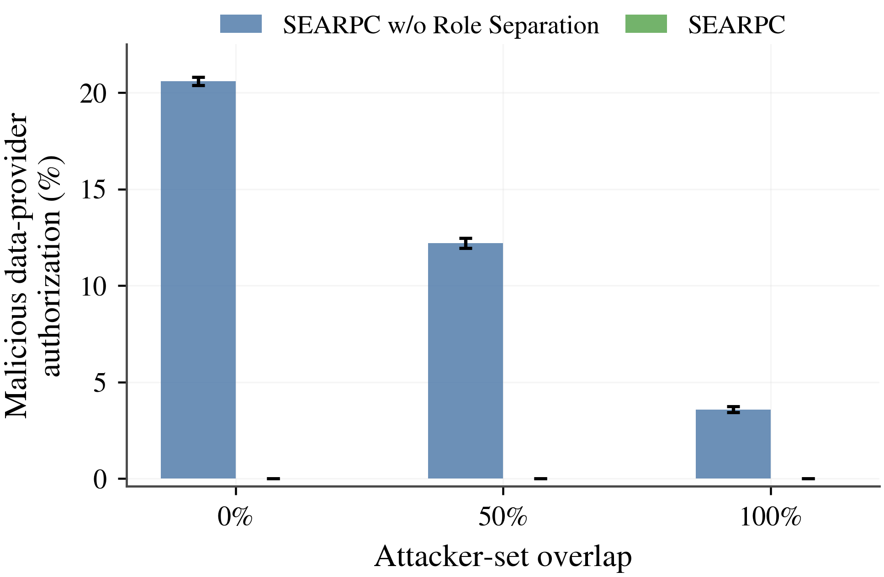  (a)Data Replay—Malicious data authorization | 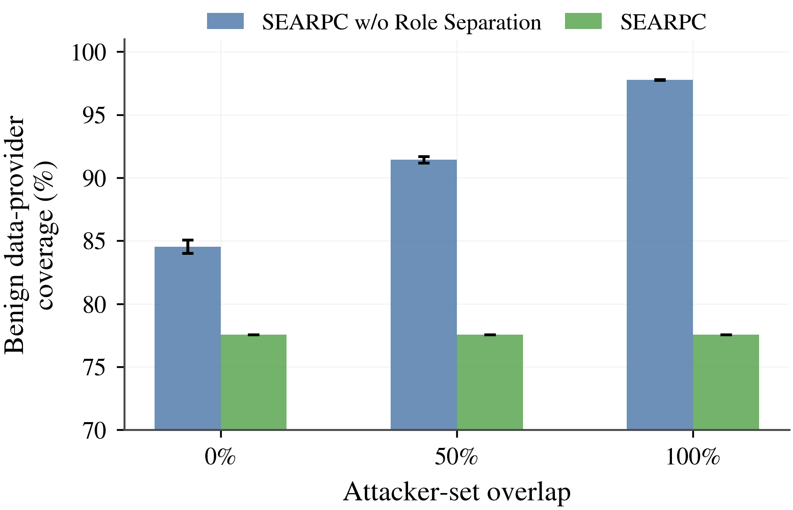  (b)Data Replay—Benign data coverage | 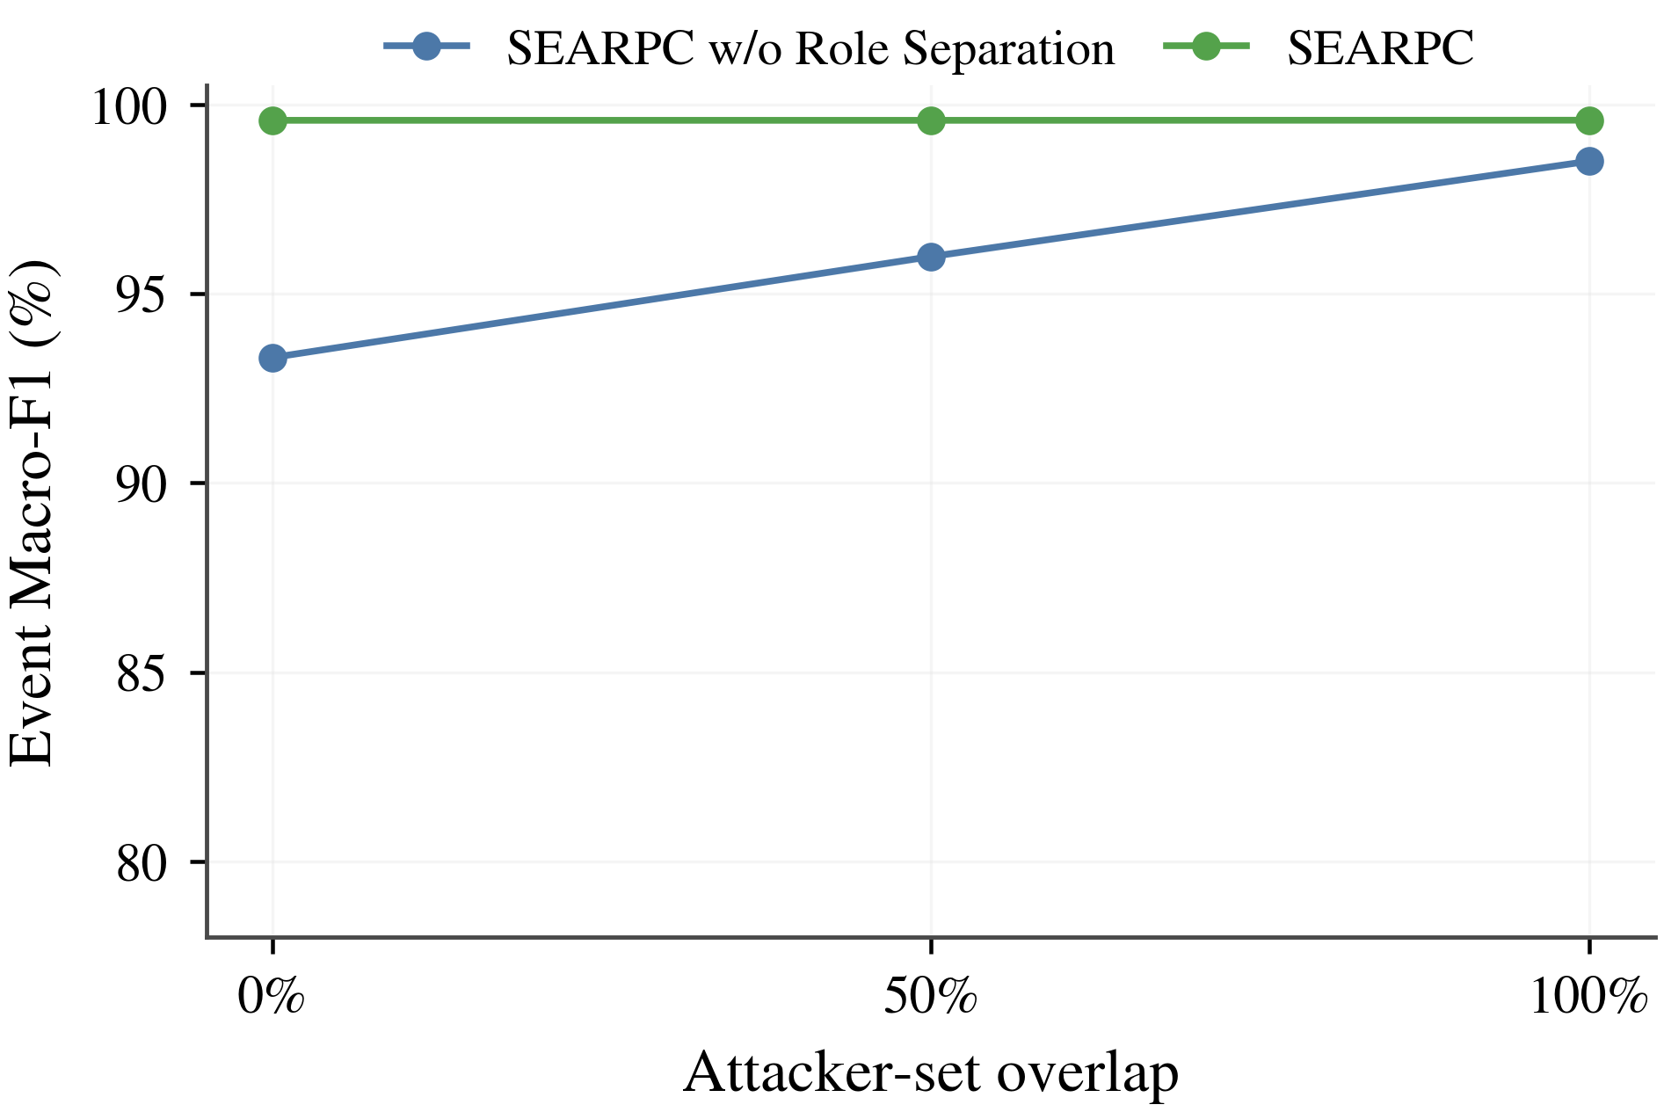  (c)Data Replay—Event Macro-F1
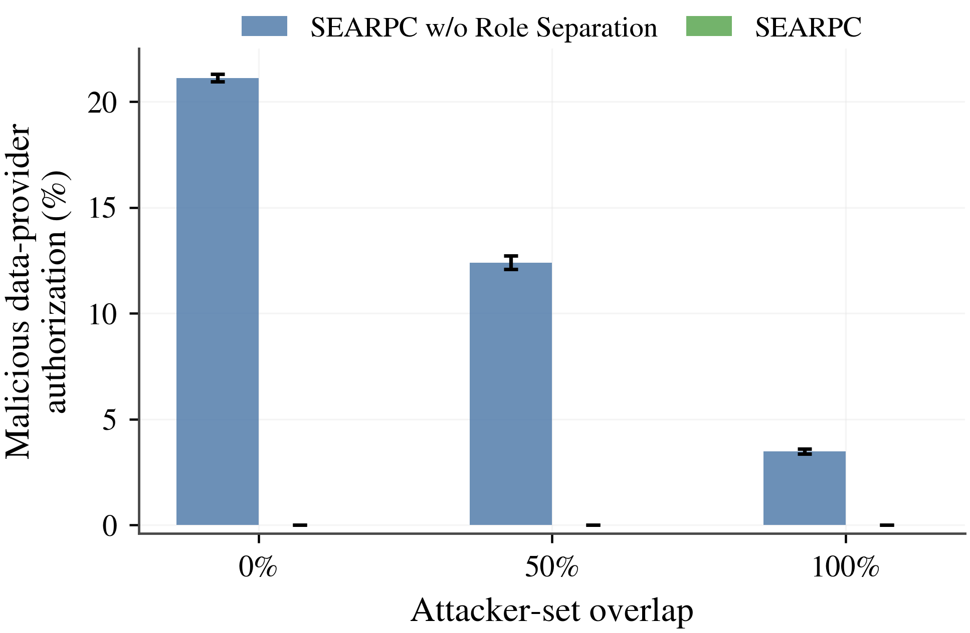  (d)Time Delay—Malicious data authorization | 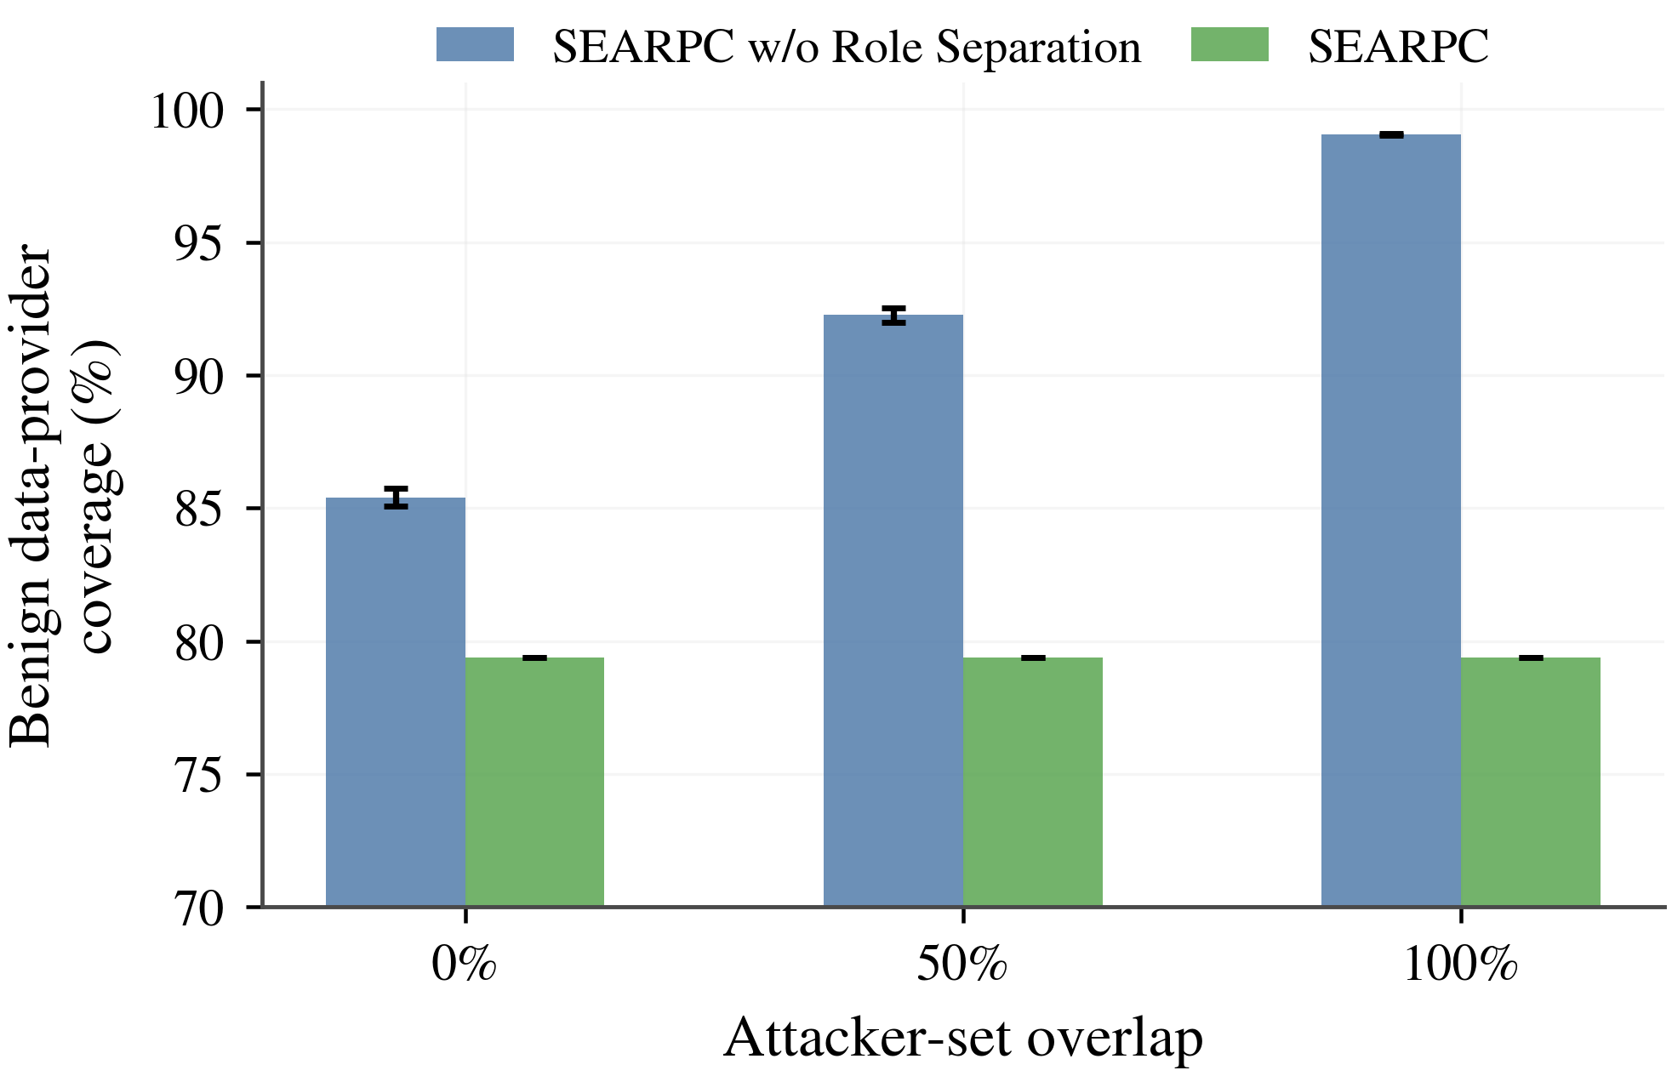  (e)Time Delay—Benign data coverage | 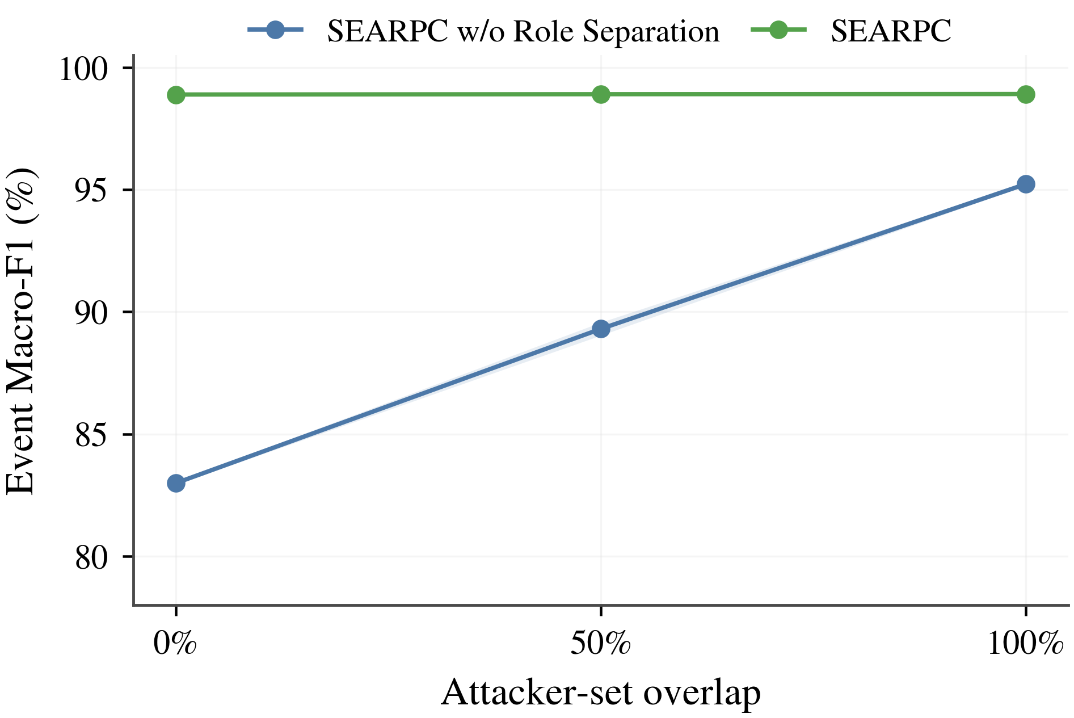  (f)Time Delay—Event Macro-F1
Fig. 6 Vehicle Authorization under Role-Attack Overlap
The observed malicious authorization rate is zero for SEARPC, compared with 3.475%–21.117% for SEARPC w/o Role Separation and 31.238%–92.092% for BRS. These correspond to absolute reductions of 3.475–21.117 and 31.238–92.092 percentage points. All six comparisons against the role-separation ablation have the same direction in 20/20 seeds, confidence intervals excluding zero, and two-sided exact p=1.91×10⁻⁶. Role-local histories thus prevent opinion reputation from opening privileged reporting in these conditions. At full overlap, the reverse-control setting loses only 0.771/0.998 percentage points of benign coverage, below the predefined five-point noninferiority margin.

4.3.2 Benign Coverage under Matched Security Constraints
To compare usable reporting capacity at the same security level, we keep online update rules fixed and scan 91 evaluation thresholds θ∈[0.05,0.95]. For each malicious-authorization budget ε, we maximize benign coverage. The scan describes an empirical security–coverage frontier and does not alter SEARPC's operational threshold $τ\text{=}0.50$. In Table XIV, N/F means that the specified grid contains no feasible operating point satisfying the authorization budget.
Table XIV Maximum Benign Coverage with Zero Observed Malicious Authorization
Method | DR-0 | DR-50 | DR-100 | TD-0 | TD-50 | TD-100
BRS [9] | N/F | N/F | 23.28% (θ=0.95) | N/F | N/F | N/F
TWSL [3] | 66.60% (θ=0.57) | 25.35% (θ=0.59) | 63.68% (θ=0.57) | 66.17% (θ=0.57) | 76.01% (θ=0.56) | 52.43% (θ=0.58)
SEARPC | 78.29% (θ=0.47) | 78.29% (θ=0.47) | 78.29% (θ=0.47) | 86.75% (θ=0.19) | 86.75% (θ=0.19) | 86.75% (θ=0.19)
Under the same zero-observed-authorization constraint, SEARPC preserves more opportunities for normal vehicles to obtain privileged processing. Fig. 7 compares feasible coverage across the six overlap conditions, showing how role isolation protects reporting capacity alongside authorization security.
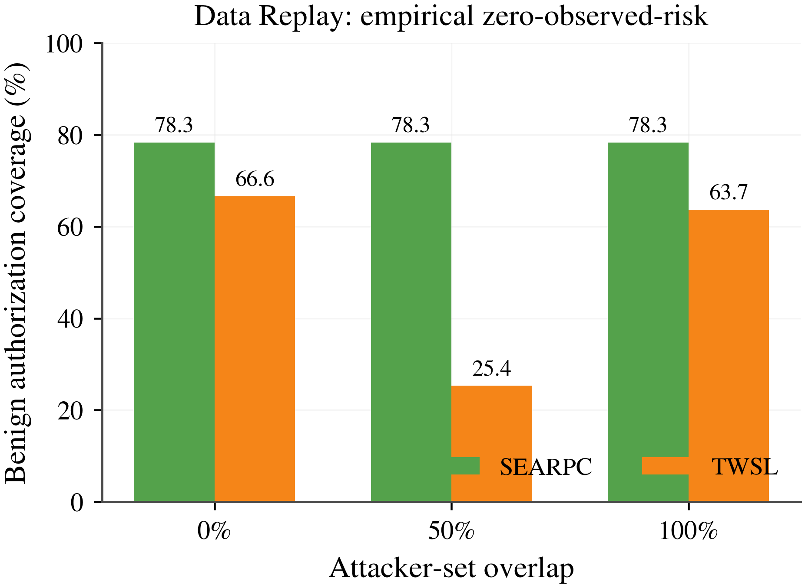  (a)Data Replay |  |  |  | 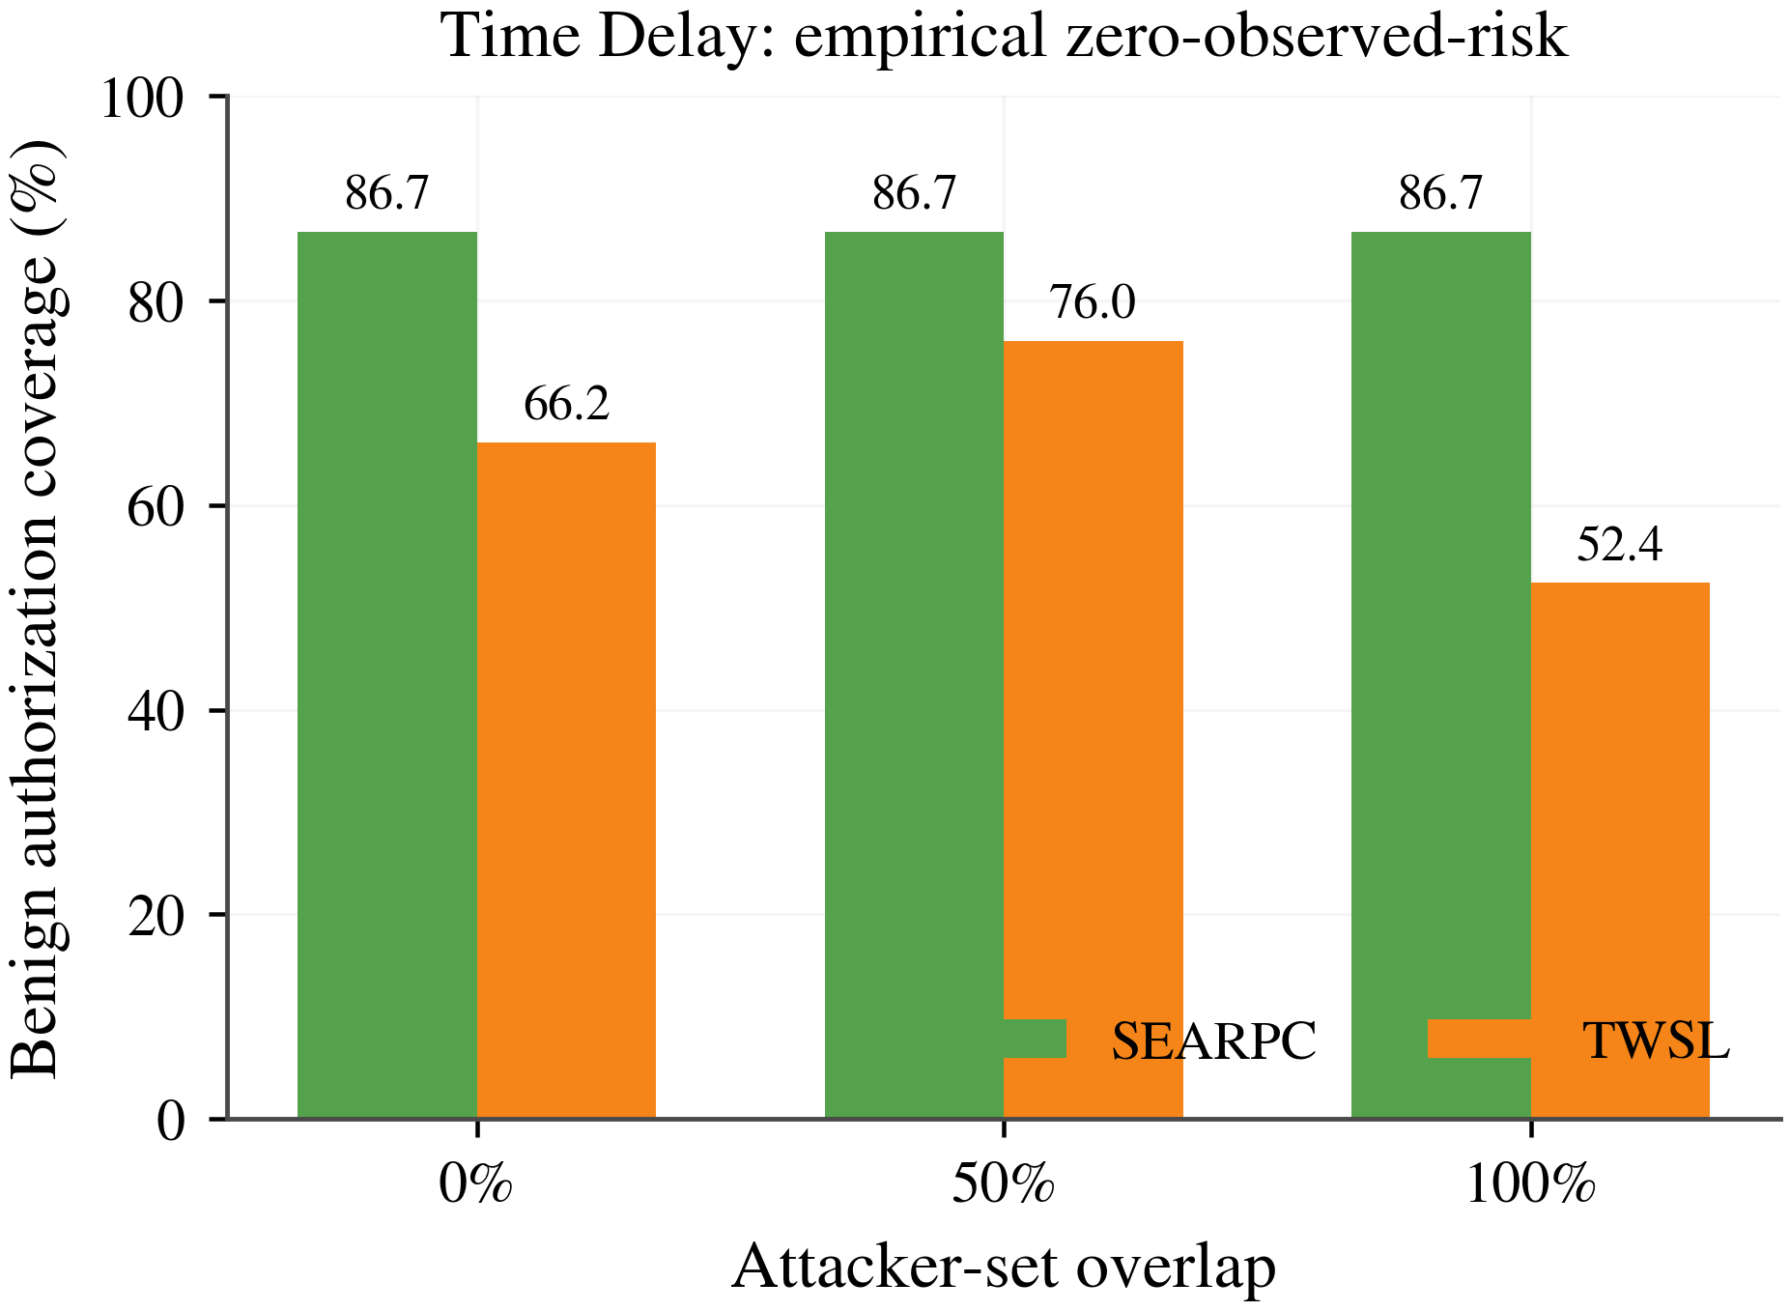  (b)Time Delay
Fig. 7 Benign Authorization Coverage under Matched Security Constraints
With observed $A_{mal}^{d}$=0, SEARPC achieves benign coverage of 78.29% for Data Replay and 86.75% for Time Delay. Its absolute advantage over TWSL is 10.74–52.94 percentage points across matched conditions, a relative increase of 14.13%–208.84%. BRS has a feasible point within θ≤0.95 only for Data Replay with 100% overlap, at 23.28% coverage. SEARPC reaches 78.29% in that condition, an advantage of 55.01 percentage points or 236.26% relative. Thus, the same empirical malicious-authorization budget permits substantially more genuine reports to use privileged processing.

4.3.3 Conservative Control during Cold Start
A newly encountered entity can acquire disproportionate influence if a few positive interactions are treated as a mature reputation. To quantify this effect, adversarial effective-weight share $S_{adv}$ measures the fraction of fusion weight assigned to attack-aligned domains. Lower values indicate less opportunity for low-evidence malicious opinions to dominate an event. Let $G_{adv}$ be the attack-aligned domains and $W_{g}$ the positive outer weight of domain g:
$$S_{adv}\text{=}\frac{\sum_{g∈G_{adv}}{W_{g}}}{\sum_{g:W_{g}\text{>}0}{W_{g}}}$$ | (21)
Table XV Adversarial Weight and Task Costs during Cold Start over 20 Paired Seeds
Method | DR adversarial share ↓ | TD adversarial share ↓ | DR ΔMacro-F1 (pp) | DR ΔFPR (pp) | TD ΔMacro-F1 (pp) | TD ΔFPR (pp)
Weighted mean | 0.530% | 0.514% | Reference | Reference | Reference | Reference
SEARPC | 0.150% (−71.6%) | 0.149% (−71.1%) | −0.059 | +0.019 | −0.204 | +0.019
Under unequal exposure, posterior-mean weighting assigns adversarial shares of 0.530% and 0.514% for Data Replay and Time Delay. SEARPC reduces these to 0.150% and 0.149%, absolute decreases of 0.380 and 0.365 percentage points and relative decreases of 71.6% and 71.1%. The largest Macro-F1 cost is 0.204 percentage points, and FPR increases by only 0.019 percentage points. Conservative quantile weighting therefore limits early malicious influence with a small measured event-classification cost.

4.3.4 Limiting Same-Source Identity Expansion
Several valid identities under common governance may jointly support a false event. To isolate the influence gained from identity count, $A_{early}$ accumulates the effective outer-weight share of attack-aligned domains before the first delayed adjudications arrive. Quantity $s_{1→7}$ measures the slope as same-domain identities increase from one to seven:
$$A_{early}\text{=}\frac{\sum_{e}{W_{e}^{adv}}}{\sum_{e}{W_{e}}},s_{1→7}\text{=}\frac{A_{early}(7)\text{-}A_{early}(1)}{6}$$ | (22)
In the concentrated setting, additional identities share one certified domain. A distributed-domain control assigns them to distinct domains, separating correlated-identity expansion from genuine source diversity. Independently certified domains retain separate representatives, preserving corroboration from distinct sources.
Table XVI Suppression of Concentrated Same-Domain Amplification over 20 Paired Seeds
Method | DR n=7 NoCap→Cap | DR slope NoCap→Cap (abs.; rel.) | TD n=7 NoCap→Cap | TD slope NoCap→Cap (abs.; rel.)
Posterior mean | 62.81%→20.35% | 0.096456→0.024619 (−0.071837; −74.48%) | 62.94%→20.36% | 0.096494→0.024425 (−0.072069; −74.69%)
SEARPC | 15.26%→2.60% | 0.024401→0.003173 (−0.021228; −87.00%) | 15.26%→2.56% | 0.024464→0.003185 (−0.021279; −86.98%)
Domain constraints reduce the influence-growth slope for both attacks and both evidence readouts, with the same direction in all 20 paired seeds. Table XVII examines early errors, full-window errors, and task metrics when the identity count reaches seven, assessing whether the influence reduction affects event assessment.
Table XVII Fusion Errors and Task Costs with Seven Same-Domain Identities
Method | Early error (DR / TD) | Window error (DR / TD) | ΔMacro-F1 (DR / TD) | ΔFPR (DR / TD)
Posterior mean | 57.30→0.20% / 57.40→0.10% | 0.3147→0.0426% / 0.3129→0.0399% | −0.032 / +0.785 pp | −0.072 / −0.249 pp
SEARPC | 0.20→0.20% / 0.10→0.10% | 0.0426→0.0426% / 0.0399→0.0399% | −0.058 / +0.679 pp | −0.068 / −0.236 pp
Early denotes the first 50 events after identities are added, and Window denotes the complete second attack window. Domain constraints reduce the posterior-mean setting's early error from approximately 57% to 0.1%–0.2%, with small changes in Macro-F1 and FPR. This indicates that the main benefit comes from limiting correlated support during the early window. Fig. 8 shows the complete response to identity counts from one to seven.
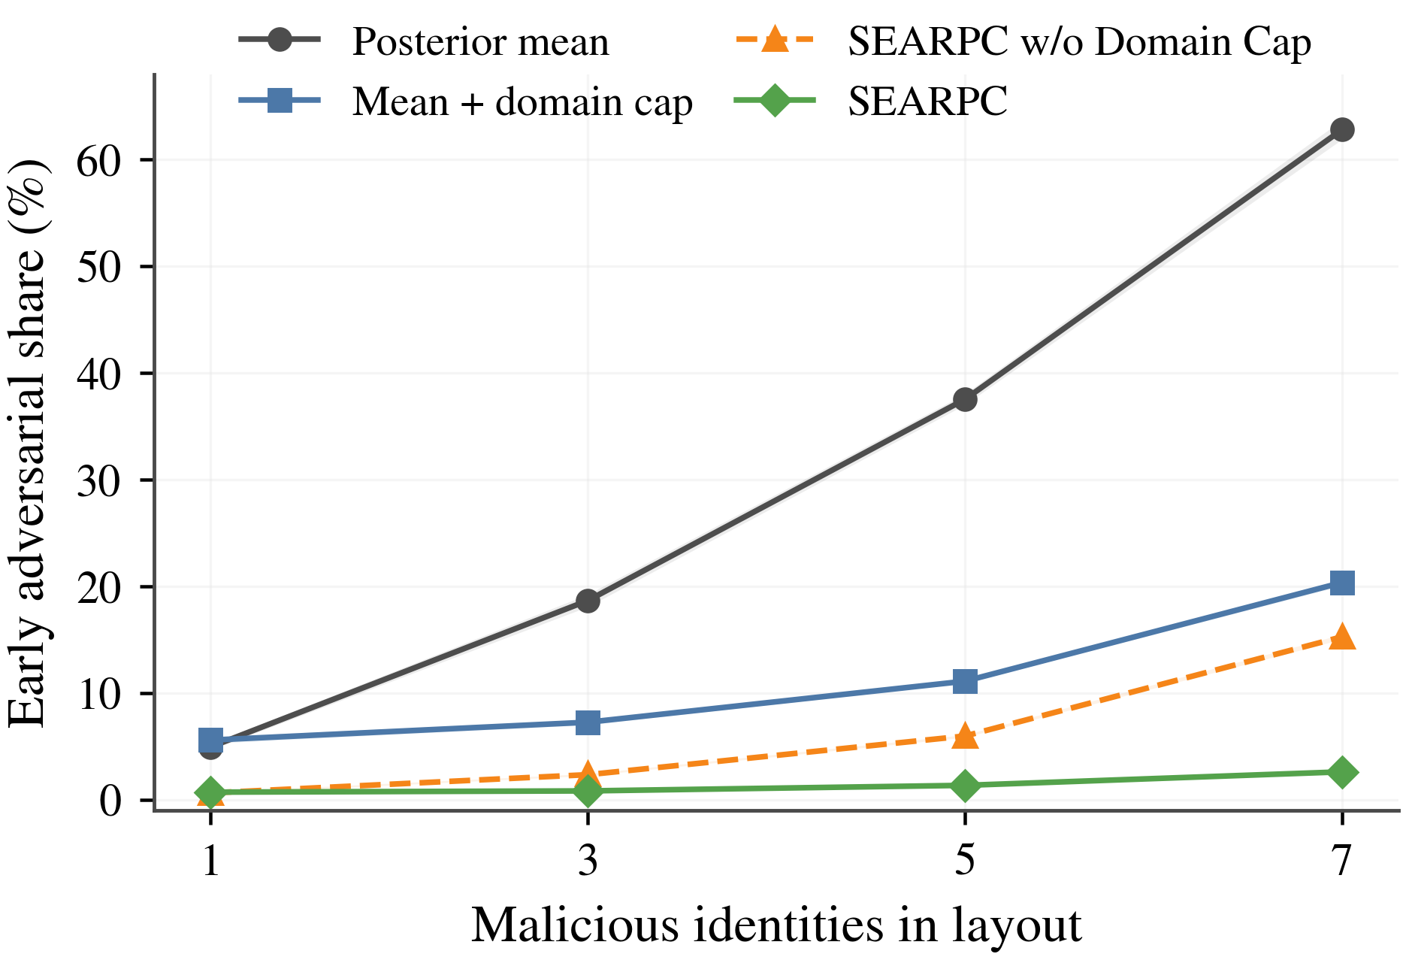  (a)Data Replay—Concentrated same-domain | 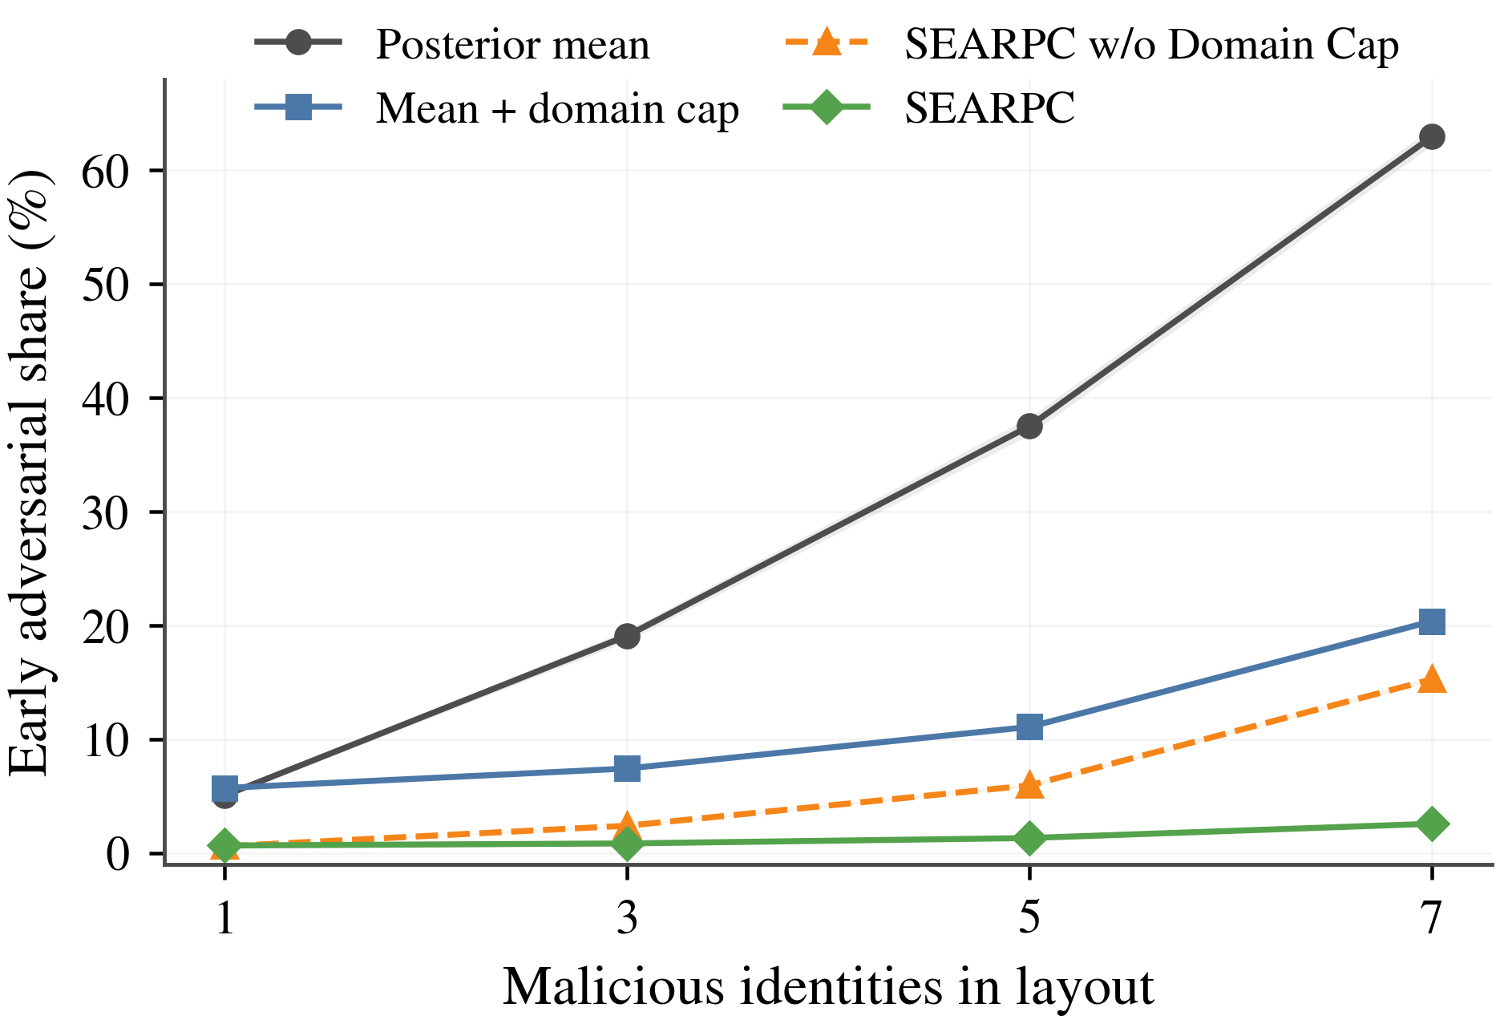  (b)Time Delay—Concentrated same-domain
Fig. 8 Influence of Same-Domain Identity Expansion on Aggregation
For posterior-mean readouts, Domain Cap reduces the Data Replay and Time Delay influence-growth slopes by 74.48% and 74.69%; for SEARPC readouts, the reductions are 87.00% and 86.98%. All four comparisons retain the expected direction in 20/20 seeds. At n=7, early error decreases from 57.30%/57.40% to 0.20%/0.10%. Additional credentials from the same certified source consequently do not act as equally numerous independent observations.
Table XVIII Same-Domain Amplification with Published Trust Methods over 20 Paired Seeds
Method | DR n=7 share ↓ | DR 1→7 Δ ↓ | TD n=7 share ↓ | TD 1→7 Δ ↓ | Bounded outer influence
BRS [9] | 62.81% | 0.579 | 62.94% | 0.579 | No
TWSL [3] | 72.25% | 0.647 | 72.41% | 0.647 | No
SEARPC | — | 0.019 | — | 0.019 | Yes
Table XVIII compares the total influence increase from one to seven identities. All four BRS/TWSL increments are positive across the 20 paired seeds. The comparison uses increments because the mechanisms assign different meanings to raw shares at n=7.
The concentrated-domain increase is 0.579–0.647 for BRS/TWSL and 0.019 for SEARPC: an absolute reduction of 0.560–0.628, equivalent to 56.0–62.8 percentage points, or a relative reduction of 96.70%–97.06%. Certified-domain representatives convert near-linear identity amplification into limited growth. The distributed-domain control does not show the same suppression, as expected when the added identities represent independent certified sources.

4.4 Canonical-Audit-Driven RSU Participation Reconfiguration

4.4.1 Experimental Design and Metrics
The RSU experiments compare SEARPC with the Yadav and BRBC participant-selection rules under identical registration, audit budgets, candidate sizes, and final quorums. SEARPC w/o Same-k Reconfiguration and Static $k=13$ then assess lifecycle control and reconfiguration. The matched methods retain $k=13$ and fixed $Q$ finality; delivered audit records determine subsequent fast participation. Main results use the validator-audit path with the content-risk extension disabled.
$$E_{RW}\text{=}\frac{\sum_{h}{R_{h}^{c}}I(n_{h}^{Byz}\text{>}f_{k})}{\sum_{h}{R_{h}^{c}}},f_{k}\text{=}floor\left(\frac{k\text{-}1}{3}\right)$$ | (23)
Risk-weighted exposure measures how often fast candidates exceed their fault budget, giving greater weight to high-risk road events. Standard-path handoff measures how often an unavailable hint requires $Π_{BFT}$ to continue through its standard proposal path. Together, they distinguish risky fast participation from reliance on the standard path during road-event confirmation.
Compromised RSUs withhold signatures on valid block digests in these trajectories. With $k=13$ and a hint threshold of $q_{k}=9$, more than four refusals cause a timeout. Under this model, Table XX’s latent post-control exceedance and standard-path handoff rates coincide. Exceedance is computed offline from compromised membership; handoff is measured from signatures, certificate checks, availability, and timeouts.
Tables XIX–XX pool 6,000 blocks for the rates and use ten paired trajectories for differences and confidence intervals. Legal commits indicate successful handoff under signature withholding. Finality relies on the base protocol assumptions in Property 5.
$$r_{fb}\text{=}\frac{N_{fb}}{H},r_{rs}\text{=}\frac{N_{rs}}{N_{fast}}$$ | (24)
Protocol trajectories count logical messages, while the process prototype measures serialized application bytes. Let $m_{h}$ and $b_{h}$ be the message count and byte volume at height h:
$$M_{wire}\text{=}\frac{1}{H}\sum_{h}{m_{h}},B_{wire}\text{=}\frac{1}{1000H}\sum_{h}{b_{h}}$$ | (25)
Equation (25) averages communication over successfully committed blocks, using 1 KB = 1000 bytes. Logical messages quantify coordination in the 40-RSU trajectories; application bytes quantify the RSU-link load per committed block in the process prototype.

4.4.2 Paired Comparisons with Published Selection Rules
Table XIX Participant Selection with Seven Shared Audits per Block over Ten Paired Trajectories
Method | RW exposure ↓ | Handoff ↓ | Full path ↓ | Active pool | Selected compromised ↓ | Wire (logical msg/block) ↓
Yadav [5] | 18.822% | 18.567% | 18.567% | 40.00 | 13.942% | 558.9
BRBC [16] | 19.857% | 19.967% | 19.967% | 38.82 | 19.491% | 581.3
SEARPC | 8.025% | 8.217% | 8.233% | 29.17 | 6.453% | 393.6
All three methods share seven audit targets and outcomes per block, a ten-block delivery delay, k=13, fast-hint threshold 9, and Q=27. SEARPC reduces exposure relative to Yadav by 10.797 percentage points (95% CI [9.891,11.742]) and relative to BRBC by 11.832 percentage points (95% CI [11.018,12.809]). Each comparison has the same direction in all ten trajectories (exact p=0.001953), with 100% legal commits.
Exposure is 18.822% for Yadav, 19.857% for BRBC, and 8.025% for SEARPC, corresponding to relative reductions of 57.36% and 59.59%. SEARPC uses delivered audit history to restrict the continuing eligibility of anomalous RSUs, reducing their opportunities to occupy fast positions. Matching candidate size, quorum, and audit resources isolates this participation-control effect. With 5% audit error and a ten-block delay, the mean Active pool is 29.17; false quarantines account for 8 of 487 quarantine transitions, or 1.64%.

4.4.3 Mechanism Ablations and Participation Dynamics
Table XX Participation-Reconfiguration Ablations and Paired Effects
Method | RW exposure ↓ | Latent post-control ↓ | Standard-path handoff ↓ | Resampling: warning + content | Wire (logical msg/block) ↓ | Δ exposure vs w/o same-k [95% CI]
Static k=13 | 23.088% | 23.417% | 23.417% | 0.00% + 0.00% | 622.43 | —
SEARPC w/o Same-k Reconfiguration | 8.285% | 8.550% | 8.550% | 0.00% + 0.00% | 407.22 | Reference
SEARPC | 5.732% | 5.917% | 5.917% | 9.15% + 0.00% | 376.68 | −2.553 pp [−3.137, −1.960]
Table XX shows how canonical audits, lifecycle updates, and equal-sized replacement reduce exposure and standard-path handoff while preserving candidate size and final quorum. Budget-matched comparisons retain the same direction. Fig. 9 compares mechanism ablations and published selection rules under their respective matched settings.
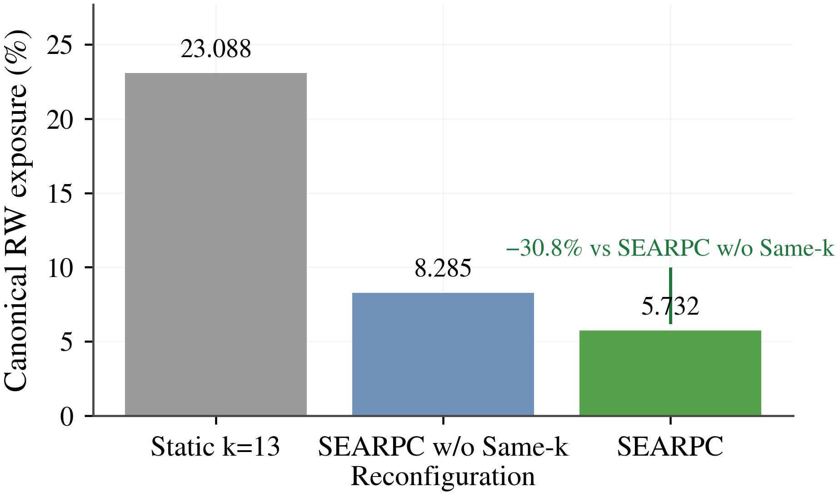  (a)Canonical exposure | 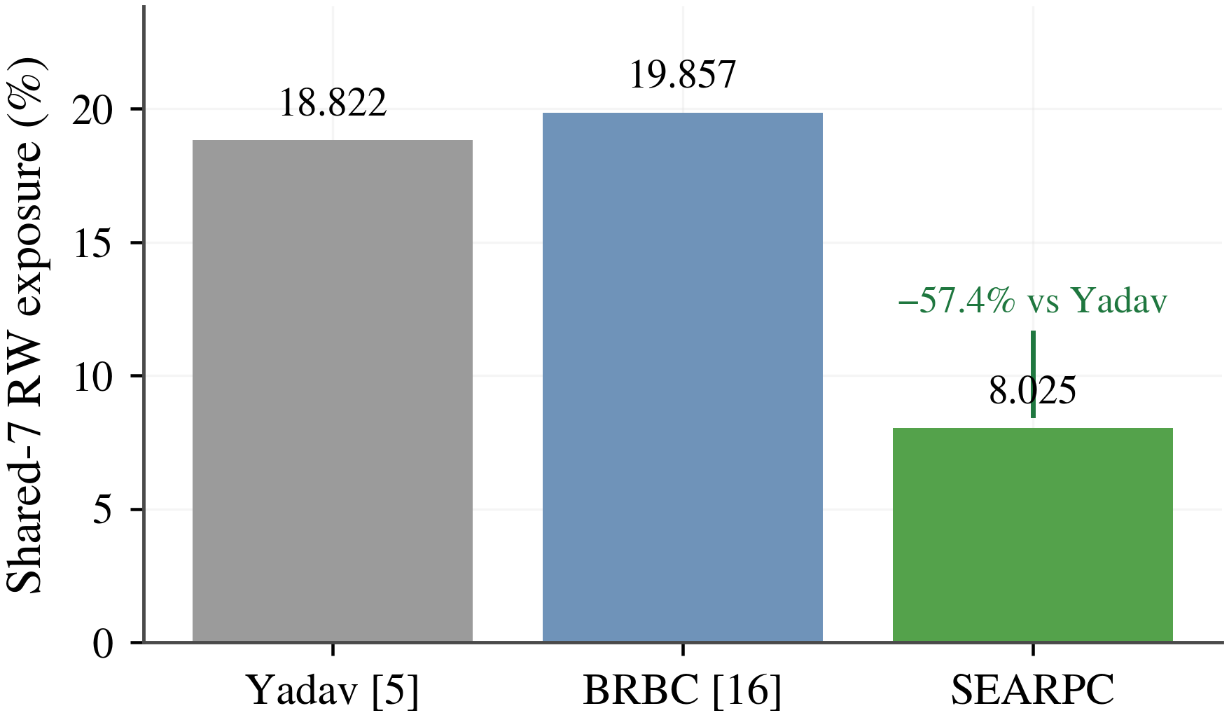  (b)Shared-7 external exposure
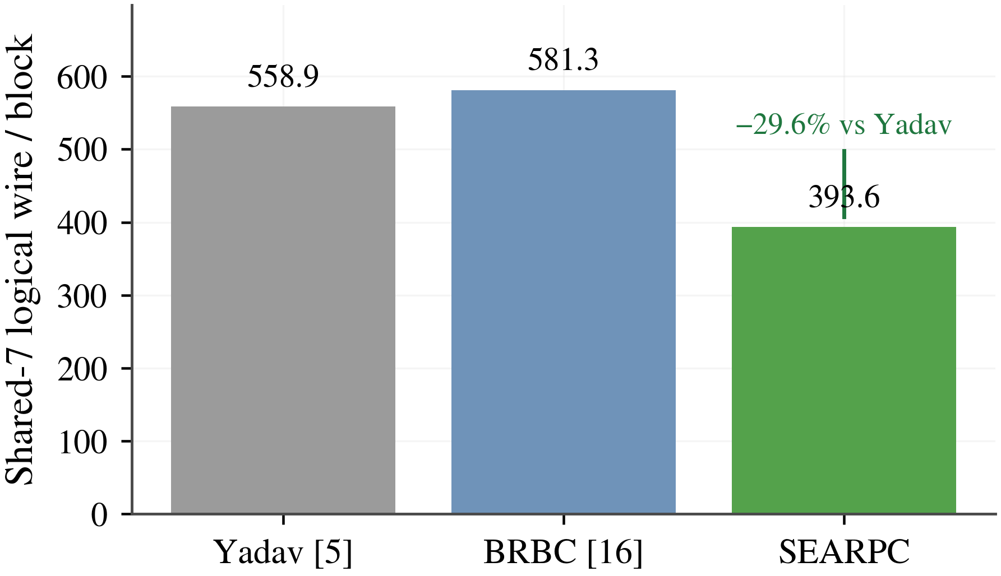
(c)Shared-7 wire
Fig. 9 Participation Control with Fixed Candidate Size and Final Quorum
The selection-rule adaptations of Yadav and BRBC use historical scores or eligibility thresholds. SEARPC additionally turns delivered audits into lifecycle transitions and warning-triggered replacement, limiting how long an anomalous RSU remains in a fast position. Fig. 10 traces the development of this effect through risk, lifecycle states, reconfiguration events, and cumulative exposure.

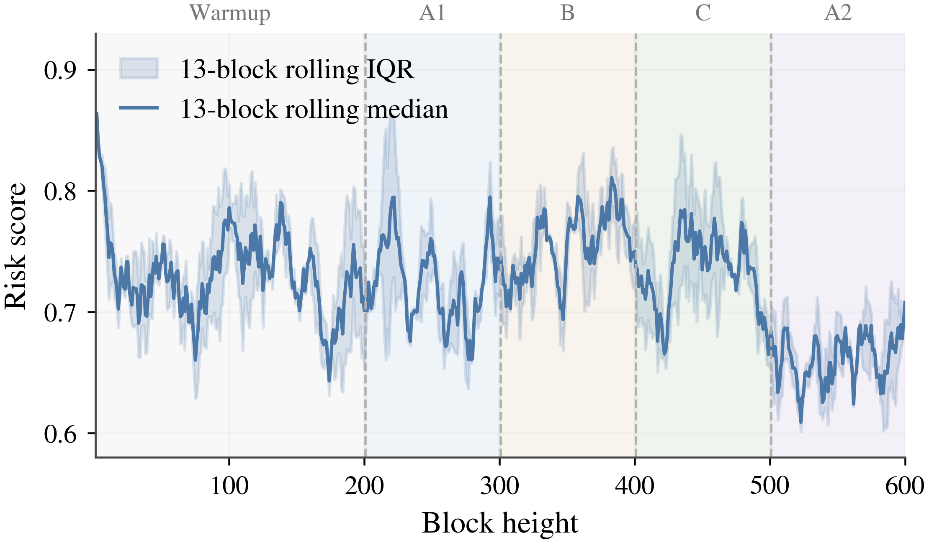  (a)13-block rolling risk median/IQR | 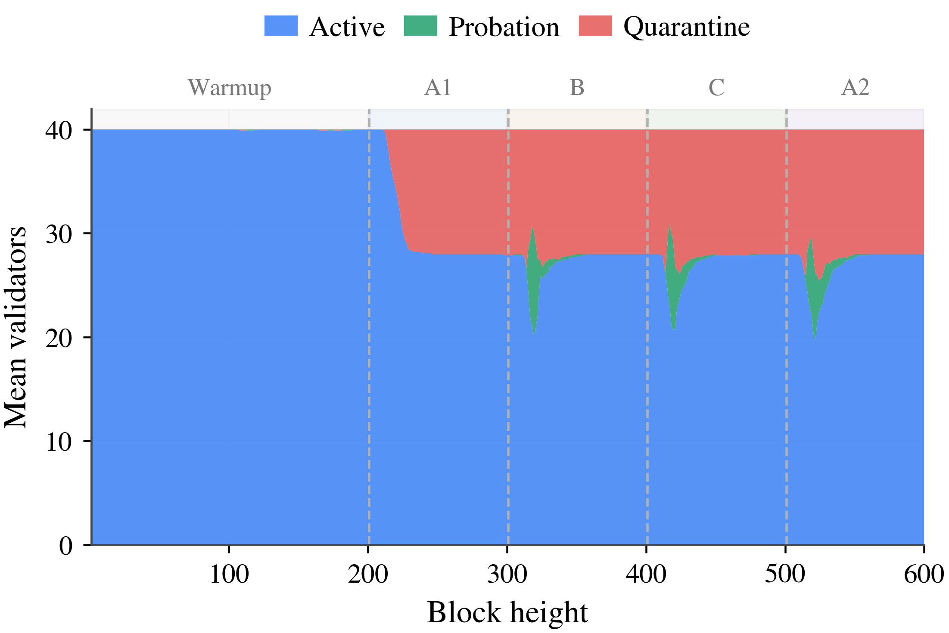  (b)SEARPC validator FSM
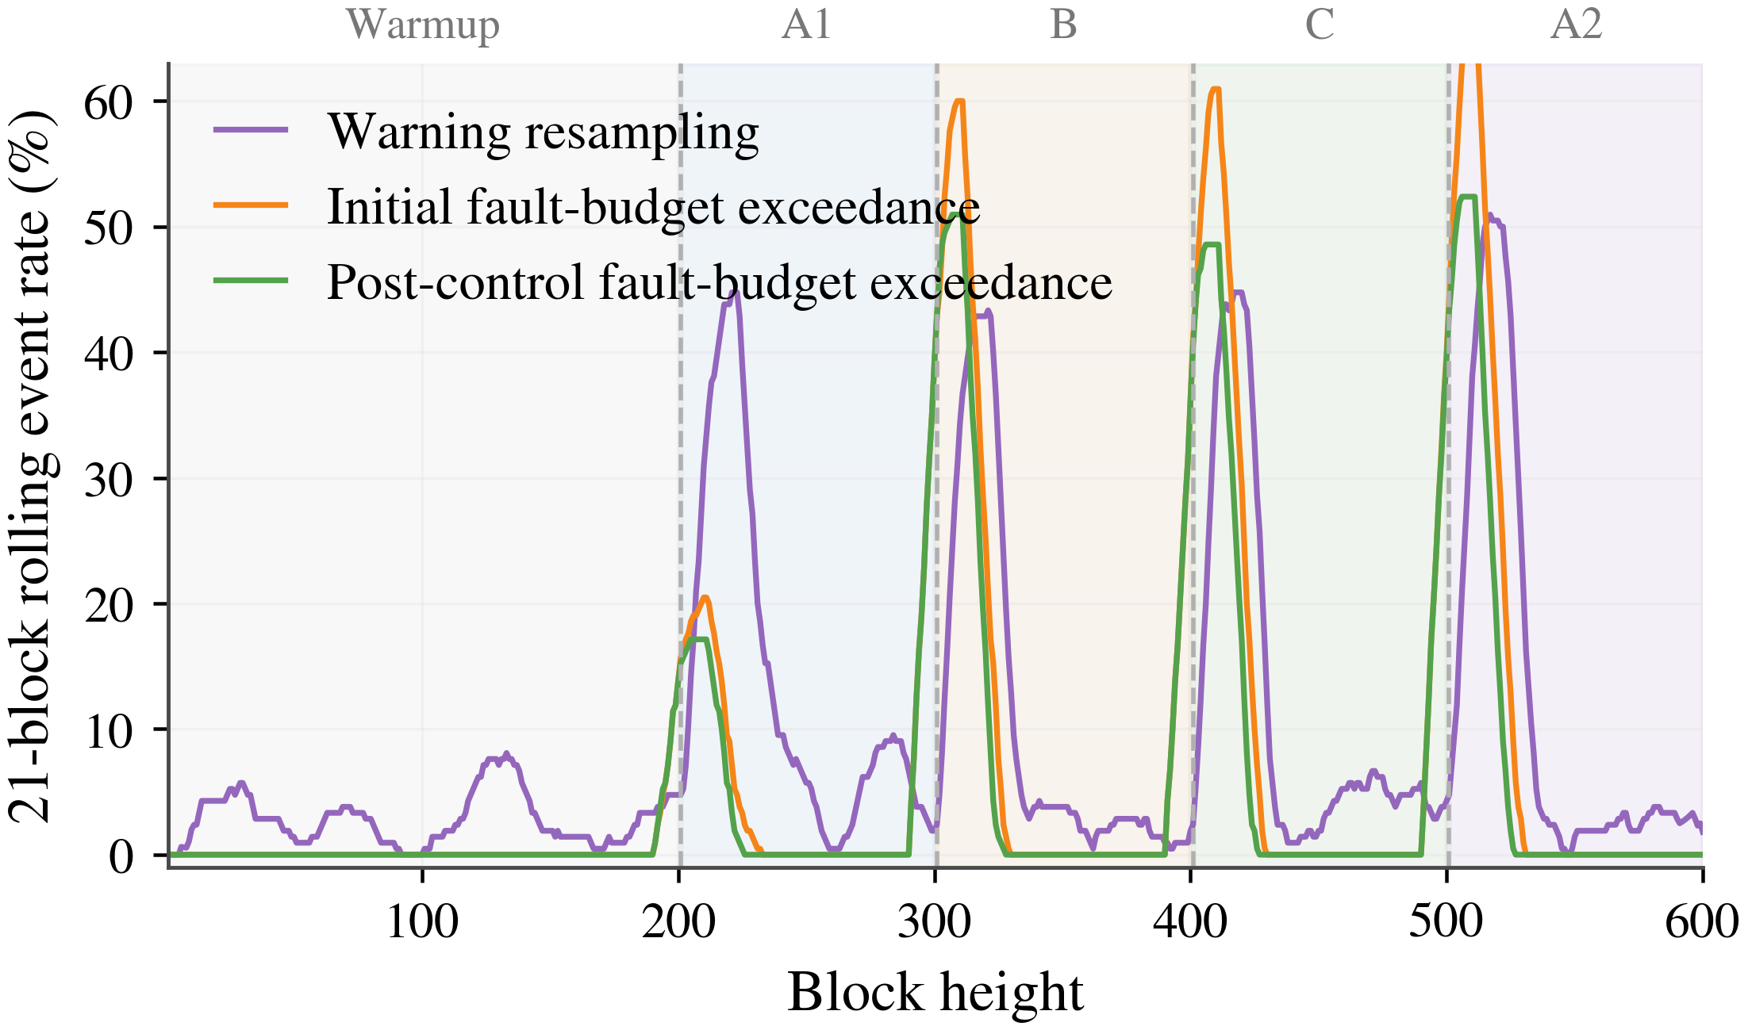  (c)21-block rolling protocol events | 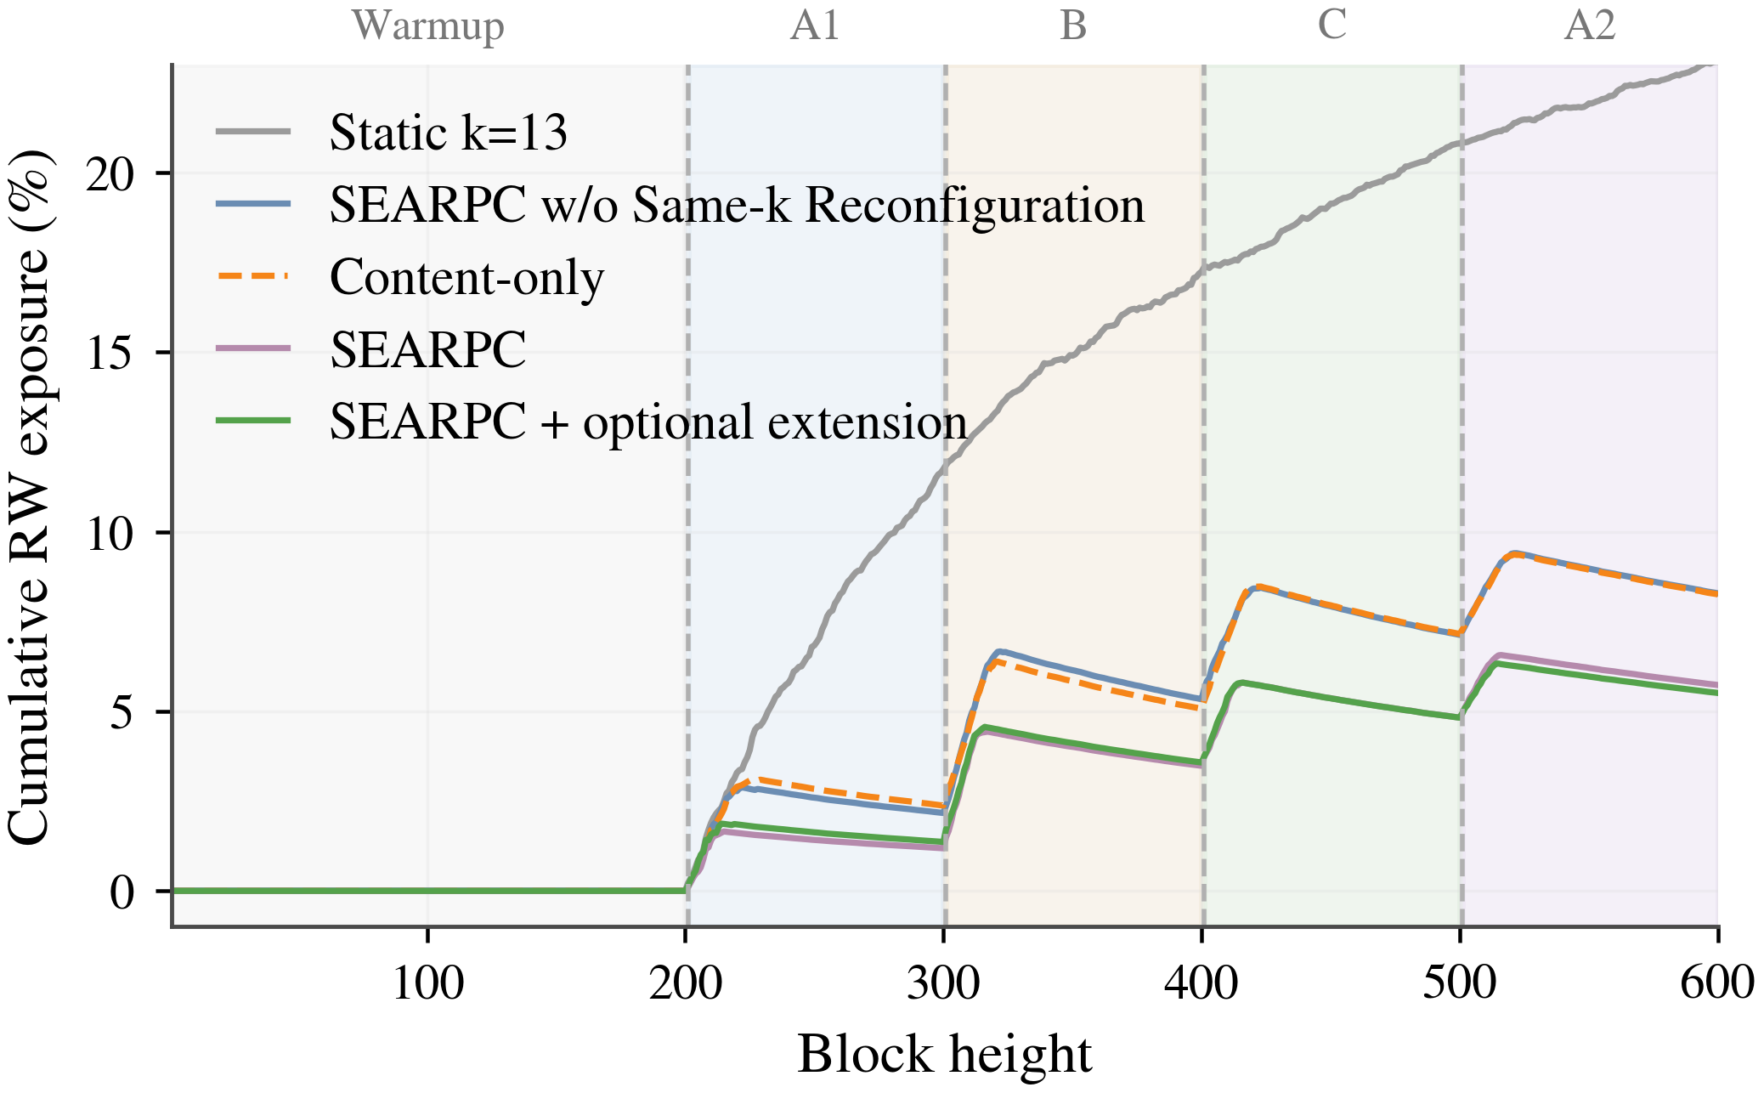  (d)Cumulative post-control exposure
Fig. 10 Audit-Driven RSU Lifecycle and Participation Reconfiguration
After authentication, deduplication, and canonical ordering, each audit changes Active, Quarantine, or Probation state at a definite effective height. As warned members leave, the controller selects an equal-sized eligible candidate. Exposure consequently accumulates more slowly than under static or non-reconfigured participation. This helps road-warning coordination reduce repeated reliance on anomalous RSUs without expanding candidate size.
In the canonical protocol setting, SEARPC reduces risk-weighted exposure from 8.285% for SEARPC w/o Same-k Reconfiguration to 5.732%, an absolute decrease of 2.553 percentage points or 30.82% relative (paired-difference 95% CI [−3.137,−1.960] percentage points). Standard-path handoff decreases from 8.550% to 5.917%, and mean logical messages decrease from 407.22 to 376.68 per block. Under a strictly equal audit budget, the exposure advantage is 0.615 percentage points, or 11.01% relative (95% CI [−0.980,−0.205], p=0.0215). This comparison identifies the additional contribution of reconfiguration with audit resources held constant.
The adjudication delivery checks pass all 36 controlled-stream cases across the nine error–delay settings, two attacks, and role/domain runners, with no early online consumption. These checks assess delivery semantics; their script and per-case records are provided under scripts/check_adjudication_delivery.py and artifact/results/adjudication_delivery_checks/. Lifecycle sensitivity also varies failure triggers over 2/3/4 and per-stage recovery successes over 3/5/10. Across the nine settings, exposure ranges from 5.585% to 6.055%, mean Active-pool size from 28.96 to 32.52, and Q remains 27. The mechanism therefore maintains similar exposure levels across the tested lifecycle parameters.

4.5 Integration Cost under a Fixed Final Quorum

4.5.1 Confirmation Latency and Communication
The process prototype compares three configurations with the same fixed $Q$. Full participation uses all registered processes. Fixed $k=13$ holds candidate size constant and rotates members deterministically with block height. The SEARPC candidate path uses a prescribed warning schedule for equal-sized reconfiguration. This schedule isolates candidate and certificate-handoff cost; the audit-driven lifecycle and security effects are evaluated in the 40-RSU trajectories. All configurations share block payloads, message encoding, Ed25519 keys, persistent TCP connections, thread pools, integrity checks, and the final quorum.
$$L_{p}\text{=}{Quantile}_{p}(\{l_{b}\}_{b\text{=}1}^{B}),p∈\{0.50,0.95\}$$ | (26)
Equation (26) computes p50 and p95 over committed-block latencies within each independent launch, then reports the median of the five launch-level quantiles. Communication is likewise summarized by the median of launch-level averages. Each launch has five warm-up blocks and 500 measured blocks. The p50 describes typical confirmation time, p95 captures the tail, and average bytes quantify sustained link demand.
Table XXI Performance of the 40-Process Fixed-Quorum Certificate-Handoff Prototype with Medians over Five Launches
Method | Cached p95 ms ↓ | Fetch p95 ms ↓ | Cached wire KB ↓ | Fetch wire KB ↓ | Commits/cell | Q
Full set | 106.24 | 115.62 | 1428.9 | 1428.9 | 2500/2500 | 27
Fixed k=13 | 79.10 | 89.81 | 1405.3 | 1020.4 | 2500/2500 | 27
SEARPC | 85.30 | 70.56 | 1405.3 | 1019.6 | 2500/2500 | 27
The SEARPC candidate path has communication volume close to the size-fixed 13-node control. Both bounded candidate paths have lower p95 latency and communication than full participation. The principal efficiency benefit comes from a bounded candidate path; the latency measurements describe the evaluated process configurations. Fig. 11 shows launch-level latency distributions and communication volume per block.
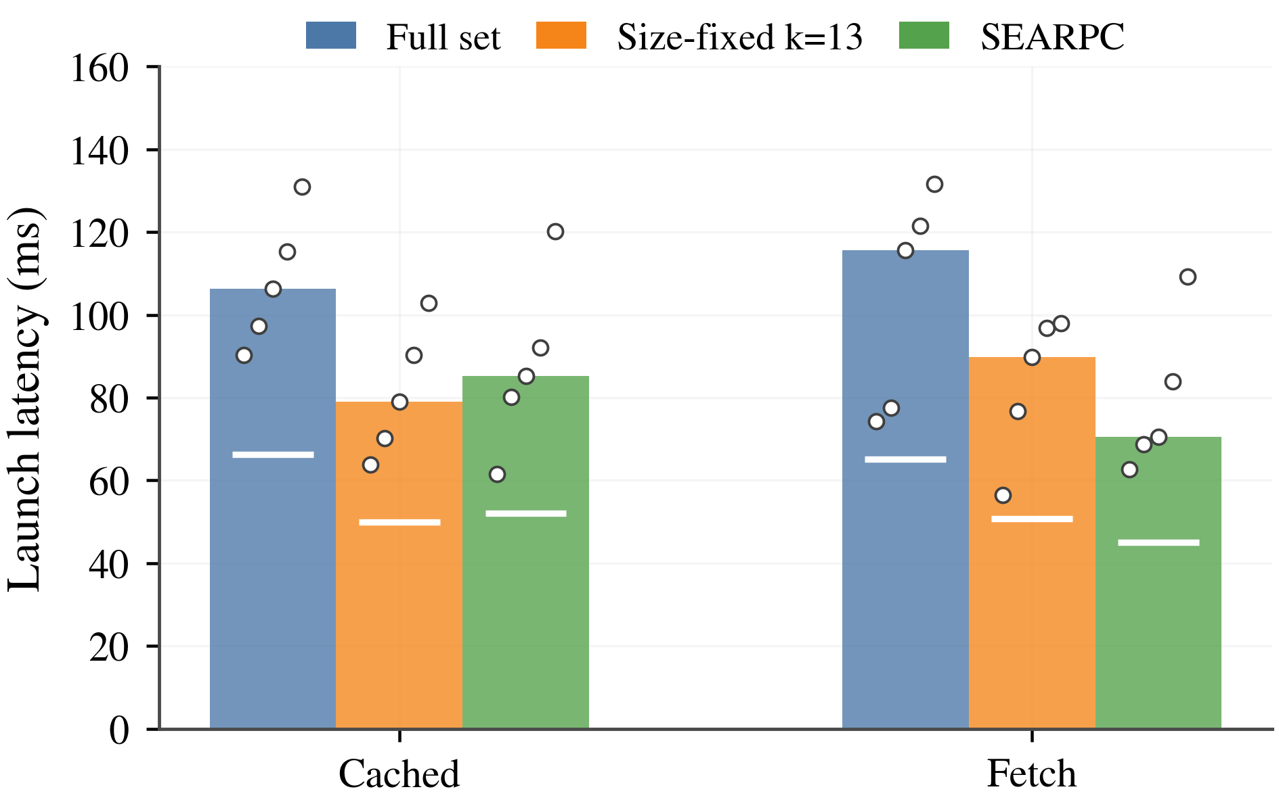
(a)40 processes—Launch latency profile
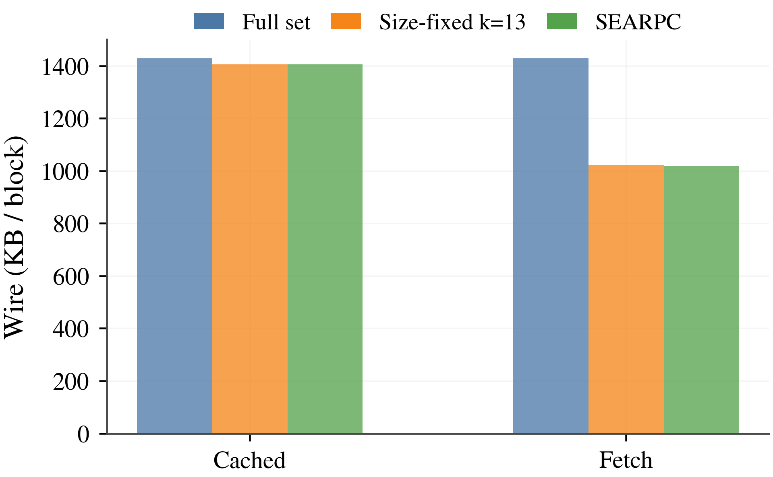
(b)40 processes—Wire KB/block
Fig. 11 Latency and Communication of the Fixed-Quorum Certificate-Handoff Prototype
In the 40-process Fetch configuration, the SEARPC candidate path reduces p95 latency from 115.62 to 70.56 ms, an absolute decrease of 45.06 ms or 38.97%. Communication decreases from 1428.9 to 1019.6 KB/block, saving 409.3 KB/block or 28.65%. Its Fetch p95 latency is 21.44% lower than that of the fixed-size $k=13$ control, while communication differs by 0.08%. Communication remains close to the size-matched path, and the timing comparison describes this same-host, five-launch setting. The 40-process setting is emphasized because fixed management overhead is proportionally larger with 16 processes.
Across 12 combinations of method, process count, and block availability, the prototype commits 30,000/30,000 measured blocks, retaining $Q=11/27$ for 16/40 processes. Separate mechanism tests cover out-of-order evidence, duplicates, conflicts, and cross-height replay. These tests support deterministic evidence control, while the process runs establish executable certificate handoff.

4.5.2 Deployment Scope
Vehicle experiments and 40-RSU trajectories assess authorization and participation security. The same-host TCP prototype measures reconfiguration and certificate handoff using a deterministic warning schedule. It checks block digests, signatures, and quorum counts. Deployment relies on the integrated BFT implementation for locking, view changes, and conflicting-proposal handling.

5 Conclusion and Future Work
This study presents SEARPC, a secure interaction framework that connects road-trust evidence to verifiable vehicle authorization and RSU participation. Role-isolated and source-limited authorization confines histories to their behavioral roles and bounds support from correlated identities. Canonical-audit-driven reconfiguration updates RSU lifecycles from shared audits and replaces warned candidates without changing their size. The base BFT protocol retains final confirmation. Evaluation on VeReMi NextGen, paired 40-RSU trajectories, and 16/40-process certificate-handoff prototypes observed no trusted authorization of malicious data providers in six overlap conditions, reduced the influence increase from same-domain identity expansion by 56.0–62.8 percentage points, and lowered risk-weighted adversarial exposure by 10.80–11.83 percentage points against stage-matched baselines. The 40-process candidate path reduced p95 latency and communication by 38.97% and 28.65% relative to full participation, with 100% legal commits. SEARPC thus supports safer road-warning sharing through executable authorization and participation control with lower measured confirmation and communication costs than full participation. Future work will examine cross-region RSU networks, privacy-preserving domain proofs, long-term dormant attacks, and deployed randomness beacons.

Data and Code Availability
The vehicle data originate from the public VeReMi NextGen dataset. Processed vehicle inputs, paired 40-RSU trajectories, the 16/40-process certificate-handoff prototype, baseline adapters, experiment scripts, results, and reproduction instructions are available at https://github.com/YouhangLi-Research/SEARPC-IoV. Raw VeReMi NextGen archives are obtained from their original provider. The repository documents their acquisition, preprocessing, and required input paths.

References
[1] J. Guo, X. Li, Z. Liu, J. Ma, C. Yang, J. Zhang, and D. Wu, “TROVE: A Context-Awareness Trust Model for VANETs Using Reinforcement Learning,” IEEE Internet of Things Journal, vol. 7, no. 7, pp. 6647–6662, 2020, doi: 10.1109/JIOT.2020.2975084.
[2] Z. Yang, K. Yang, L. Lei, K. Zheng, and V. C. M. Leung, “Blockchain-Based Decentralized Trust Management in Vehicular Networks,” IEEE Internet of Things Journal, vol. 6, no. 2, pp. 1495–1505, 2019, doi: 10.1109/JIOT.2018.2836144.
[3] J. Kang, R. Yu, X. Huang, M. Wu, S. Maharjan, S. Xie, and Y. Zhang, “Blockchain for Secure and Efficient Data Sharing in Vehicular Edge Computing and Networks,” IEEE Internet of Things Journal, vol. 6, no. 3, pp. 4660–4670, 2019, doi: 10.1109/JIOT.2018.2875542.
[4] J. Kang, Z. Xiong, D. Niyato, D. Ye, D. I. Kim, and J. Zhao, “Toward Secure Blockchain-Enabled Internet of Vehicles: Optimizing Consensus Management Using Reputation and Contract Theory,” IEEE Transactions on Vehicular Technology, vol. 68, no. 3, pp. 2906–2920, 2019, doi: 10.1109/TVT.2019.2894944.
[5] S. Yadav, K. Singh, A. K. Yadav, M. Shariq, S. A. Chaudhry, A. K. Das, and M. Manjul, “Efficient and Reliable Information Sharing for Internet of Vehicles Using Trust and Blockchain,” IEEE Transactions on Vehicular Technology, vol. 74, no. 11, pp. 16716–16728, 2025, doi: 10.1109/TVT.2025.3575775.
[6] M. Castro and B. Liskov, “Practical Byzantine Fault Tolerance,” in Proc. 3rd USENIX Symposium on Operating Systems Design and Implementation (OSDI), pp. 173–186, 1999.
[7] S. A. Siddiqui, A. Mahmood, Q. Z. Sheng, H. Suzuki, and W. Ni, “Trust in Vehicles: Toward Context-Aware Trust and Attack Resistance for the Internet of Vehicles,” IEEE Transactions on Intelligent Transportation Systems, vol. 24, no. 9, pp. 9546–9560, 2023, doi: 10.1109/TITS.2023.3268301.
[8] J. Kamel, A. Kaiser, I. Ben Jemaa, P. Cincilla, and P. Urien, “CaTch: A Confidence Range Tolerant Misbehavior Detection Approach,” in Proc. 2019 IEEE Wireless Communications and Networking Conference (WCNC), pp. 1–8, 2019, doi: 10.1109/WCNC.2019.8885740.
[9] A. Jøsang and R. Ismail, “The Beta Reputation System,” in Proc. 15th Bled Electronic Commerce Conference, pp. 324–337, 2002.
[10] Q. Fan, Y. Xin, B. Jia, Y. Zhang, and P. Wang, “COBATS: A Novel Consortium Blockchain-Based Trust Model for Data Sharing in Vehicular Networks,” IEEE Transactions on Intelligent Transportation Systems, vol. 24, no. 11, pp. 12255–12271, 2023, doi: 10.1109/TITS.2023.3286432.
[11] X. Chen, J. Ding, and Z. Lu, “A Decentralized Trust Management System for Intelligent Transportation Environments,” IEEE Transactions on Intelligent Transportation Systems, vol. 23, no. 1, pp. 558–571, 2022, doi: 10.1109/TITS.2020.3013279.
[12] G. S. Rawat, K. Singh, M. Shariq, A. K. Das, S. A. Chaudhry, and P. Lorenz, “BTC2PA: A Blockchain-Assisted Trust Computation With Conditional Privacy-Preserving Authentication for Connected Vehicles,” IEEE Transactions on Intelligent Transportation Systems, vol. 26, no. 1, pp. 1134–1148, 2025, doi: 10.1109/TITS.2024.3488184.
[13] H. L. Nakayiza, L. A. C. Ahakonye, D.-S. Kim, and J.-M. Lee, “PureTrust: A Soulbound Token-Based Blockchain Framework for Incentive-Driven Trust Management in V2X Networks,” IEEE Internet of Things Journal, vol. 13, no. 7, pp. 13734–13752, 2026, doi: 10.1109/JIOT.2026.3656576.
[14] K. Yan, W. Ma, Q. Yang, S. Sun, and W. Wang, “Info-Chain: Reputation-Based Blockchain for Secure Information Sharing in 6G Intelligent Transportation Systems,” IEEE Internet of Things Journal, vol. 11, no. 5, pp. 9198–9212, 2024, doi: 10.1109/JIOT.2023.3323011.
[15] X. Chen, G. Xue, R. Yu, H. Wu, and D. Wang, “A Vehicular Trust Blockchain Framework With Scalable Byzantine Consensus,” IEEE Transactions on Mobile Computing, vol. 23, no. 5, pp. 4440–4452, 2024, doi: 10.1109/TMC.2023.3294968.
[16] M. T. de Oliveira, L. H. A. Reis, D. S. V. Medeiros, R. C. Carrano, S. D. Olabarriaga, and D. M. F. Mattos, “Blockchain Reputation-Based Consensus: A Scalable and Resilient Mechanism for Distributed Mistrusting Applications,” Computer Networks, vol. 179, Art. no. 107367, 2020, doi: 10.1016/j.comnet.2020.107367.
[17] G. Zhang, F. Pan, S. Tijanic, and H.-A. Jacobsen, “PrestigeBFT: Revolutionizing View Changes in BFT Consensus Algorithms with Reputation Mechanisms,” in Proc. 2024 IEEE 40th International Conference on Data Engineering (ICDE), pp. 1930–1943, 2024, doi: 10.1109/ICDE60146.2024.00156.
[18] X. Liu, Z. Zhang, Z. Li, J. Sun, J. Liu, and P. Jiang, “Reputation-Based Leader Election under Partial Synchrony: Towards a Protocol-Independent Abstraction with Enhanced Guarantees,” in Proc. IEEE INFOCOM 2026—IEEE Conference on Computer Communications, pp. 1–10, 2026, doi: 10.1109/INFOCOM59046.2026.11571274.
[19] G. Danezis, Z. de Angeli, A. I. Vitanov, P. Jovanovic, L. Kokoris-Kogias, A. Sonnino, P. Tennage, and I. Zablotchi, “Barnacle: Adaptive Multi-Leader Scheduling for DAG-Based Consensus,” arXiv:2609.03978v2, 2026, doi: 10.48550/arXiv.2609.03978.
[20] H. Chen, X. Fu, Q. Yuan, Z. Zhuang, J. Kang, Z. Liu, J. Wang, and D. Niyato, “Trust Model-Based Consensus Optimization for Vehicle Platooning Networks: A Novel Deep Reinforcement Learning Approach With GenAI,” IEEE Transactions on Intelligent Transportation Systems, vol. 26, no. 8, pp. 11356–11371, 2025, doi: 10.1109/TITS.2025.3559672.
[21] Y. Song, Y. Cao, C. Cheong, D. He, K.-K. R. Choo, and J. Wang, “CAT: A Consensus-Adaptive Trust Management Based on the Group Decision Making in IoVs,” IEEE Transactions on Information Forensics and Security, vol. 19, pp. 7730–7743, 2024, doi: 10.1109/TIFS.2024.3442611.
[22] L. Zhang, L. Hang, K. Zu, Y. Wang, and K. Yang, “Dynamic Vehicle Reputation Consensus: Enhancing IoV Communication With a Blockchain Algorithm,” IEEE Transactions on Vehicular Technology, vol. 74, no. 3, pp. 4788–4806, 2025, doi: 10.1109/TVT.2024.3489629.
[23] R. Verma and K. Kataoka, “Enhancing Security and Achievability of PBFT-Based Consensus Development for Connected Vehicles With Location-Based Trust,” IEEE Transactions on Intelligent Transportation Systems, vol. 27, no. 3, pp. 3066–3085, 2026, doi: 10.1109/TITS.2025.3640392.
[24] IEEE Standard for Wireless Access in Vehicular Environments (WAVE)—Security Services for Application and Management Messages, IEEE Std 1609.2-2025, 2026.
[25] IEEE Guide for Wireless Access in Vehicular Environments (WAVE)—Multi-Jurisdictional Interoperability Using Security Credentials Originating in Disparate Policy Domains, IEEE Std 1609.2.2-2025, 2026.
[26] ETSI TS 103 097 V2.2.1, “Intelligent Transport Systems (ITS); Security; Security Header and Certificate Formats; Release 2,” Mar. 2026.
[27] C. Dwork, N. Lynch, and L. Stockmeyer, “Consensus in the Presence of Partial Synchrony,” Journal of the ACM, vol. 35, no. 2, pp. 288–323, 1988, doi: 10.1145/42282.42283.
[28] A. Niculescu-Mizil and R. Caruana, “Predicting Good Probabilities with Supervised Learning,” in Proc. 22nd International Conference on Machine Learning (ICML), pp. 625–632, 2005, doi: 10.1145/1102351.1102430.
[29] C. Guo, G. Pleiss, Y. Sun, and K. Q. Weinberger, “On Calibration of Modern Neural Networks,” in Proc. 34th International Conference on Machine Learning (ICML), Proceedings of Machine Learning Research, vol. 70, pp. 1321–1330, 2017. [Online]. Available: https://proceedings.mlr.press/v70/guo17a.html
[30] L. Breiman, “Random Forests,” Machine Learning, vol. 45, no. 1, pp. 5–32, 2001, doi: 10.1023/A:1010933404324.
[31] J. H. Friedman, “Greedy Function Approximation: A Gradient Boosting Machine,” The Annals of Statistics, vol. 29, no. 5, pp. 1189–1232, 2001, doi: 10.1214/aos/1013203451.
[32] F. Pedregosa et al., “Scikit-learn: Machine Learning in Python,” Journal of Machine Learning Research, vol. 12, pp. 2825–2830, 2011. [Online]. Available: https://jmlr.org/papers/v12/pedregosa11a.html
[33] Scikit-learn developers, “HistGradientBoostingClassifier,” scikit-learn documentation. Accessed: Oct. 5, 2026. [Online]. Available: https://scikit-learn.org/stable/modules/generated/sklearn.ensemble.HistGradientBoostingClassifier.html
[34] A. Hermann, J.-N. Remmers, D. Eisermann, B. Erb, and F. Kargl, “VeReMi NextGen: A Dataset for Evaluating Misbehavior Detection Systems in VANETs,” in Proc. 2026 IEEE Vehicular Networking Conference (VNC), Montreal, Canada, pp. 1–8, 2026, doi: 10.1109/VNC69225.2026.11629123.

