User manual

Table of Contents

Login 3

Main menu 3

Teacher View 4

Main UI: 4

Add UI: 4

Details UI: 5

Update UI: 6

Student View 6

Main UI: 6

Add UI: 7

Details UI: 7

Update UI: 8

[update Table of Contents when finished]

# 

# Login

To login you must enter a valid email and password:

You can login with the following:

Email: JohnSmith@tafensw.au

Password: John

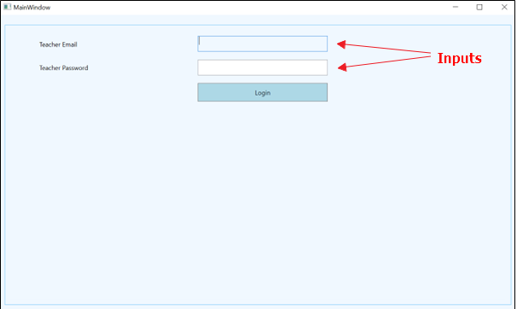

# Main menu

Once Logged in The can view the following entities by clicking on them

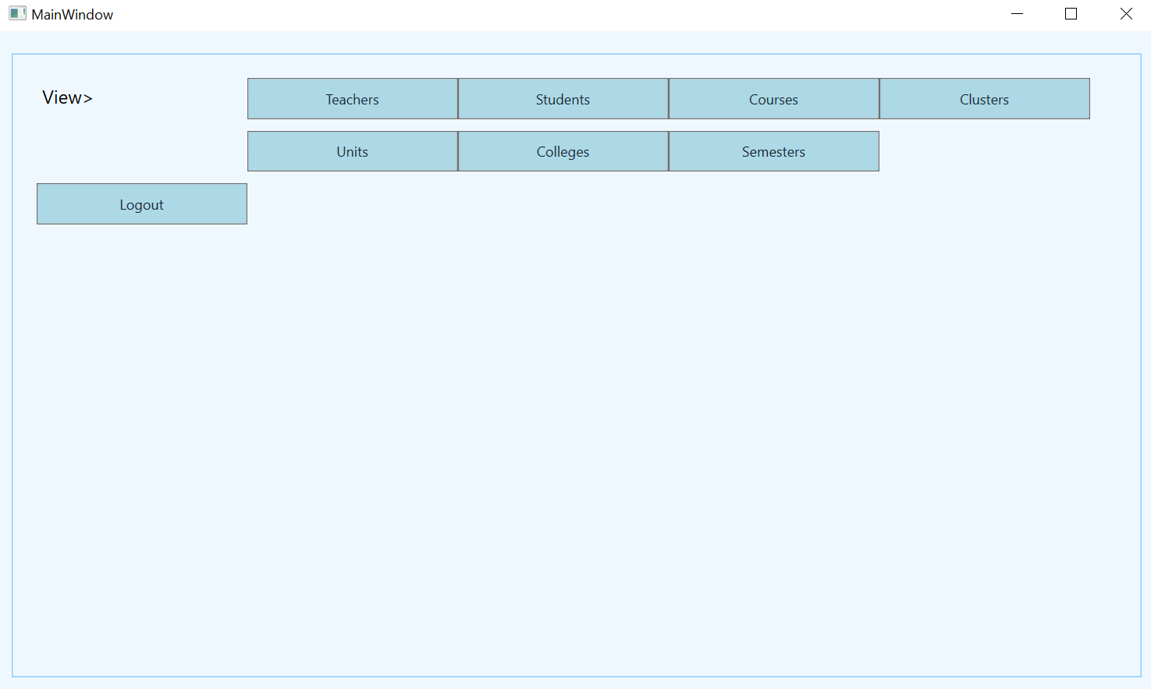

# Teacher View

## Main UI:

1.You can also search for full-time teachers currently teaching in locations other than their based location via the button.

2.Clicking on the details button will show the details of that specific teacher.

3.Clicking on the update button will allow you to update that specific teacher in the database.

4.Clicking on the delete button will allow you to delete that specific teacher but their password is required in order to delete.

5.You can also add a new teacher via the add teacher button

6.You can search a teacher by location, employment status and semester by selecting them first then clicking on the search button.

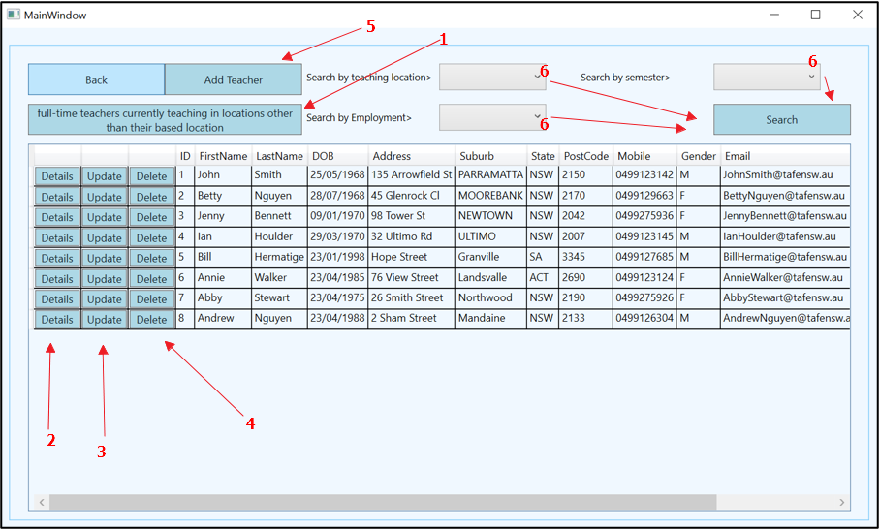

## Add UI:

Fill the following form in order to add a new teacher

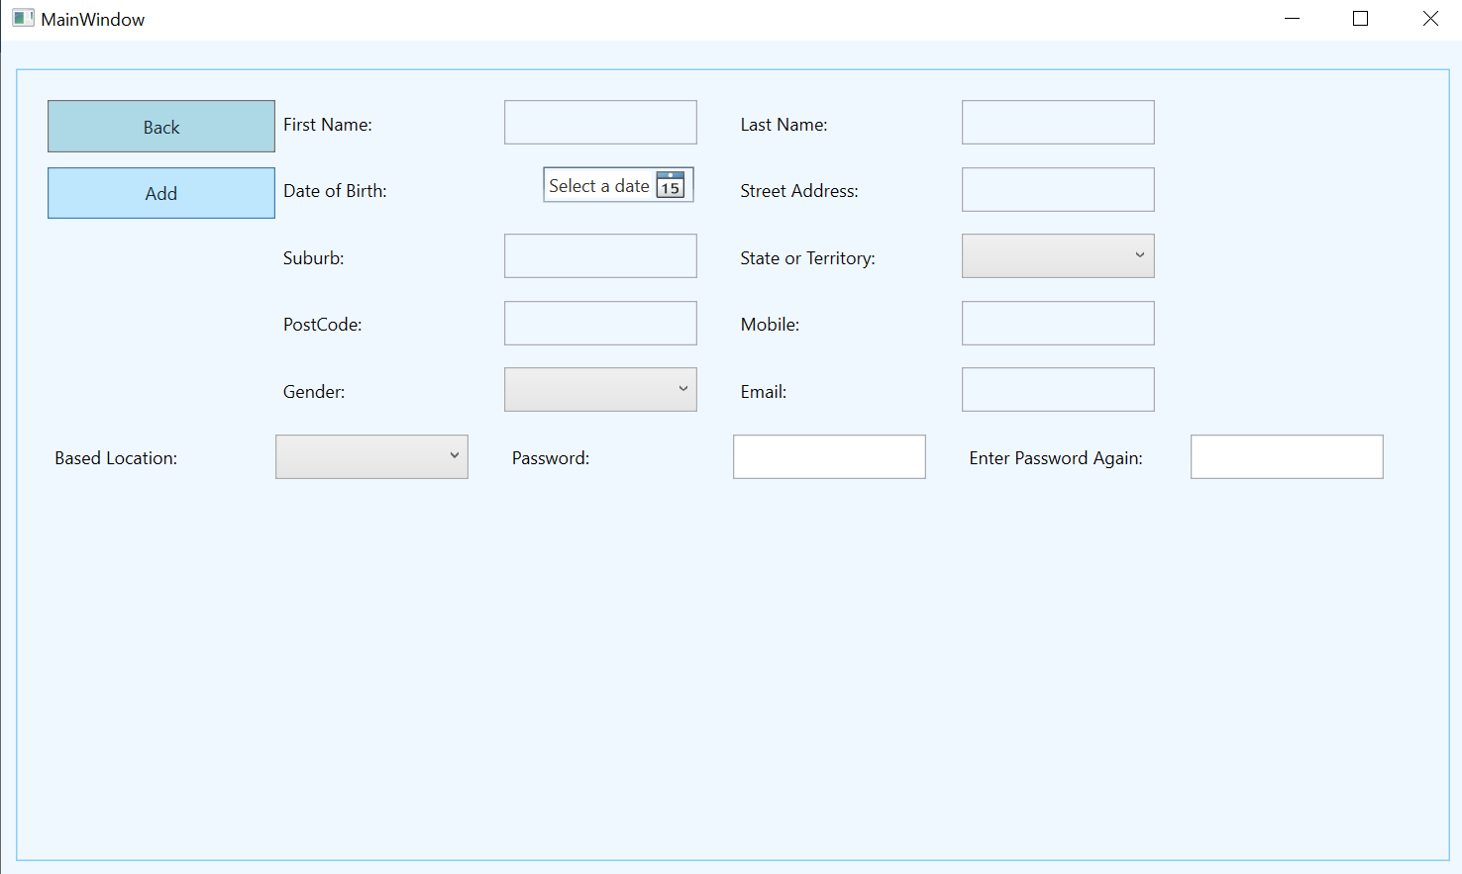

## Details UI:

All course taught button will display all course that the teacher has taught

Search locations and courses taught by semester button will display the locations and courses that a teacher has taught according to a semester.

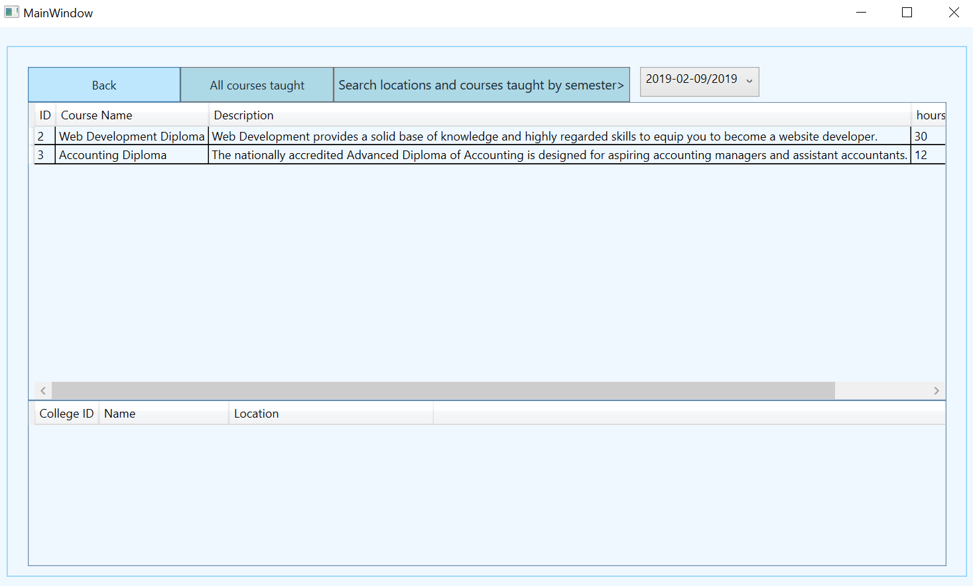

## Update UI:

Choose the following fields that you’d like to update as well as confirm the original password and click the update button to update in the database

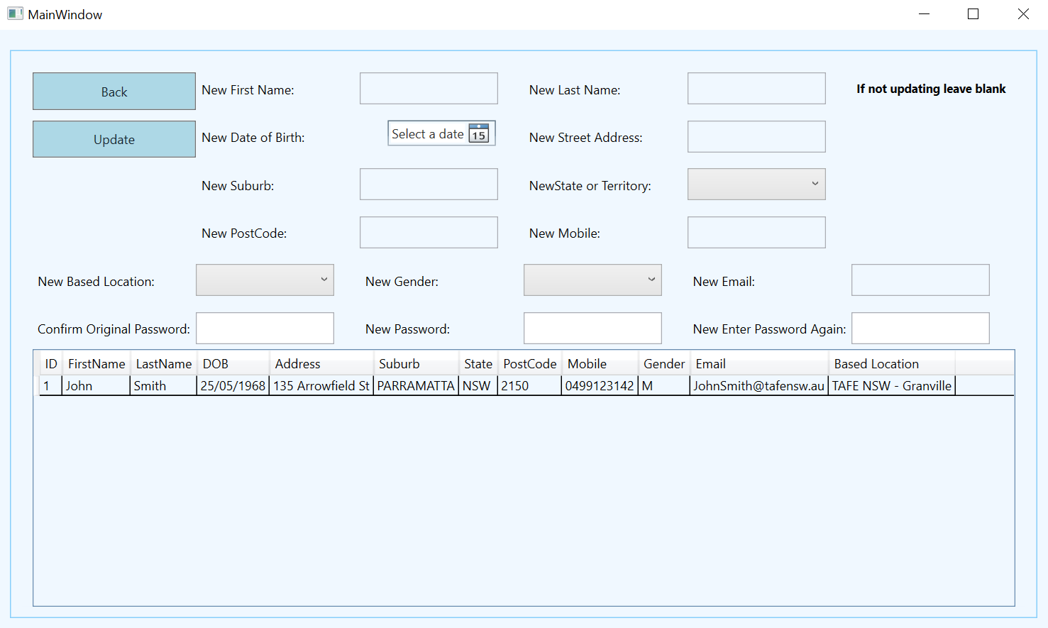

# Student View

## Main UI:

1.You can also search for student who have enrolled but not paid.

2.Clicking on the details button will show the details of that specific student.

3.Clicking on the update button will allow you to update that specific student in the database.

4.Clicking on the delete button will allow you to delete that specific student

5.You can also add a new student via the add student button

6.You can search a student by location, study status and semester by selecting them first then clicking on the search button.

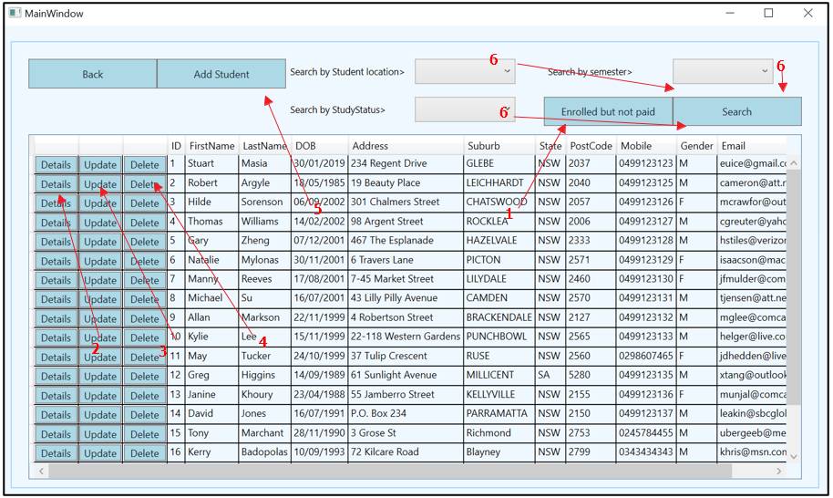

## Add UI:

Fill the following form in order to add a new student

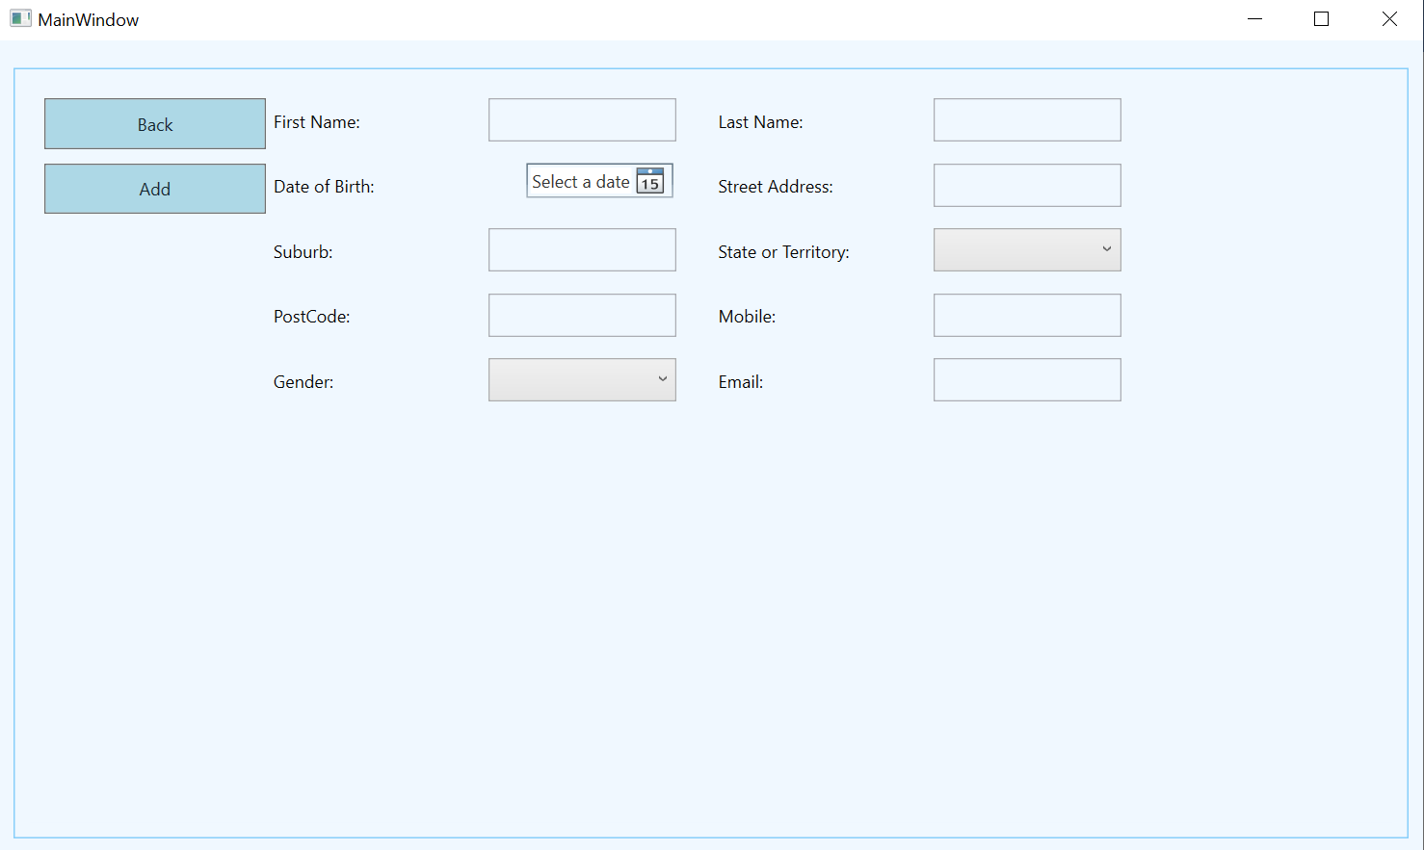

## Details UI:

This will display all student enrolments

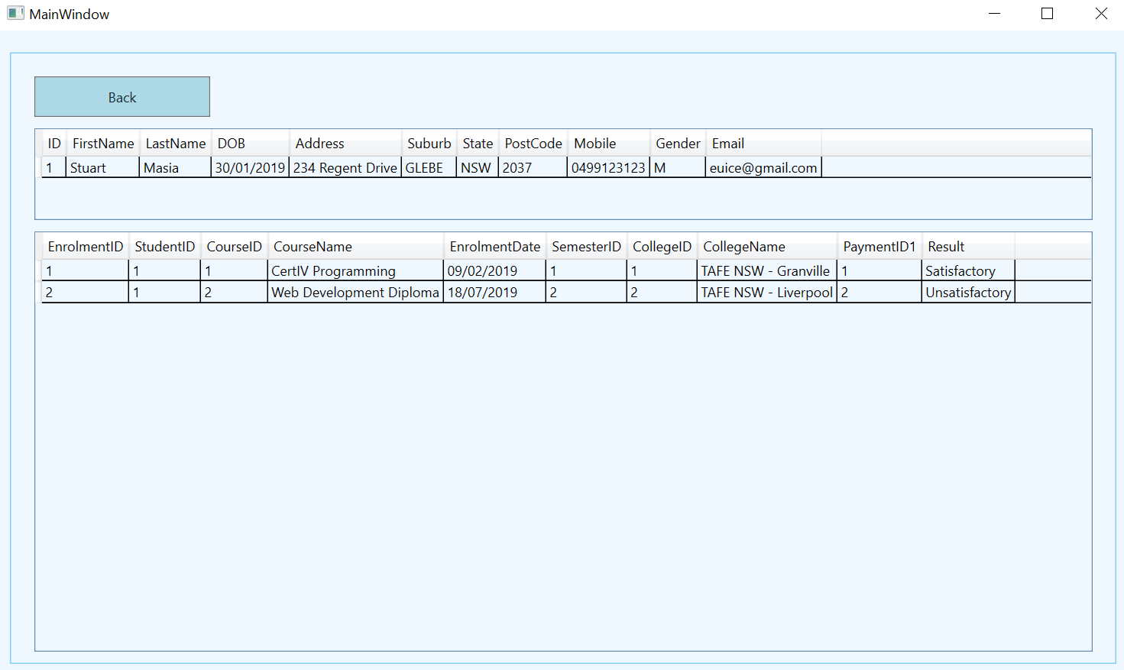

## Update UI:

Choose the following fields that you’d like to update and click the update button to update in the database

