

WEB222 Assignment 3

Due: Sat, Oct 19, 2019 @ 23:59

Objective: Practice writing HTML Containers / Media Elements, Updating the DOM with data

Specification: Update HTML & JavaScript code for each of the following pages according to the instructions outlined below. To begin, download the assignment3.zip file containing all of the files required for Assignment 3 from blackboard.

Un-compress the zip files somewhere on your local machine. When you're ready to begin editing the files, open the uncompressed folder (assignment3) in Visual Studio Code (https://code.visualstudio.com) using "Open Folder". You may test your html files in any modern browser (Chrome, Firefox, Safari, Internet Explorer, etc).

"Assignment 3 Home" - index.html:

Update the "Assignment 3 Home" page (index.html) with the following:

- Below Assignment 3 Home, add a professional greeting to the visitor, i.e.: "Welcome to my website, I will be demonstrating HTML5 principles and techniques, DOM manipulation"... and so on.

- Add a relevant header as a title for the next section (step 3)

- Add a short paragraph that introduces this website, i.e.: "This site contains 8 pages, including: Home, HTML Lists, HTML Tables, "... and so on. The text (e.g., Home, HTML Lists, etc) are relevant links to the 8 pages (e.g., list.html, table.html, and so on).

- Add a relevant header as a title for the next section (step 5)

- Add a short paragraph introducing HTML 5, i.e.: "This site utilizes HTML5: a markup language used for structuring and presenting content on the World Wide Web"... and so on.

1
"HTML Lists" - list.html:

Update the "HTML Lists" page with the following:

- Inside list.html, using HTML5, create a nested list with meaningful items using countries, provinces and cities. The nested list should contain at least one ordered list and at least one unordered list. (refer to the following screenshot)
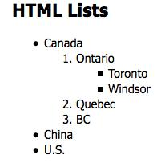

- Add a header “Fruit List” (<h2>) as a title for the next section (step 4)

- In list.html page, create a container (i.e.: <div>) with unique id value (e.g., “list1”). Be prepared for the following step 4.

- Use the fruits array inside the lists.js file (js/list.js) to write (using JavaScript) an ordered list

containing all the fruit inside the array to the above container (id “list1”, which was created in step 3) in the list.html page. Be sure to write to your container (using JavaScript) after the window has completely loaded (window.onload). The ordered list should look like the image below when complete:

- Add a header “Directory and File” (<h2>) as a title for the next section (step 7)

- In list.html page, create a container (i.e.: <div>) with unique id value (e.g., “list2”). Be prepared for the following step 7.

- Use the directory array inside the list.js file (js/list.js) to write (using JavaScript) a nested unordered list containing all the files and directories (with their files) inside the array to the above container (id “list2”, which was created in step 6) in the list.html page. (refer to the following screenshot).
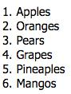

You will notice that files have the type "file" and consist of a "name" property, whereas

2
directories have the type "directory" and consist of a "name" property in addition to an array of files. Use these properties to correctly construct your nested unordered list (using JavaScript).

Be sure to write to your container after the window has completely loaded (using JavaScript).

The nested unordered list should look like the image below when complete:
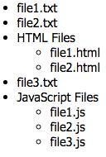

"HTML Tables" - table.html:

Update the "HTML Tables" page with the following:

- Inside table.html, create a table of the elements: <table style="border:1px solid;">, <tr>, <th>, <td> and <caption> with meaningful table contents, i.e.: a table of your hobbies, description and time spent etc. It includes at least 3 rows and 3 columns.

- Update the table.html page to include an additional container (i.e.: <div>) with a unique id value.

- Add a relevant header as a title for the next section (step 4)

- Use the users array inside the table.js file (js/table.js) to write a complete table containing all the users inside the array (and an appropriate header row), to your container in the table.html page.

You will notice that users consist of the properties: first_name, last_name, age, and email. Use these properties to correctly construct your table (using JavaScript) with the following headers: First Name, Last Name, Age and Email. You must also ensure that all email addresses are rendered as a valid "mailto" link and will open as a new message in the user's default mail client when clicked.

Be sure to write to your container after the window has completely loaded. The table should 3
look like the image below when complete:
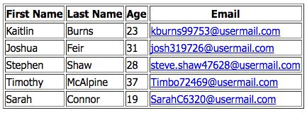

"HTML Images" - image.html:

Update the "HTML Images" page with the following:

- Find the given image with the file named ict.png under the "media" sub-folder included in the zip file. Show the image in your web page using a relative path. Ensure that when the image is not available, the text “ICT School, Seneca College” is visible on the page and make the image a hyperlink to the ICT School website which opens in a new tab while clicking.

- Update the image.html page to include an additional container (i.e.: <div>) with a unique id value.

- Add a relevant header as a title for the next section (step 4)

- Use the images array inside the image.js file (js/image.js) to write 5 new <figure> elements

to your container in the image.html page (using JavaScript). You will notice that each image in the array has the following properties: caption, alt and url. Use these properties to correctly construct (using JavaScript) your <figure> elements such that each element contains a valid image (using url and alt) as well as a caption underneath the image with the message contained within the caption property

Be sure to write to your container after the window has completely loaded (using JavaScript). The <figure> elements should look like the image below when complete (only the first 2 shown):

4
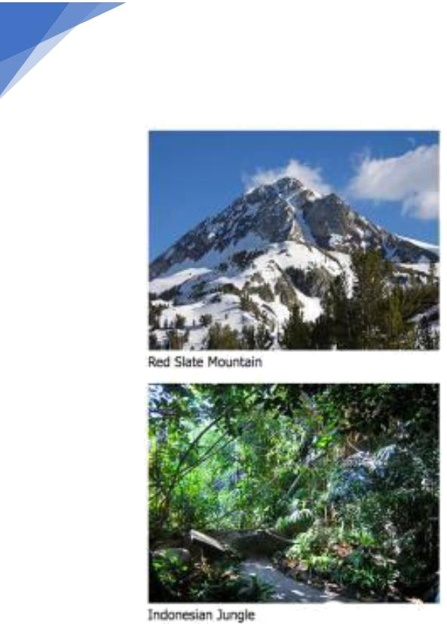

"HTML5 Audio" - audio.html:

Update the "HTML5 Audio" page with the following:

- Update the audio.html page to include an additional container (i.e.: <div>) with a unique id value.

- Use the audio object inside the audio.js file (js/audio.js) to render an audio player in your container within the audio.html page.

You will notice that the audio object consists of the properties: controls and source. Use these properties to correctly construct (using JavaScript) your audio player with (or without) controls, and the correct source options.

Be sure to write to your container after the window has completely loaded.

"HTML5 Video" - video.html:

Update the "HTML5 Video" page with the following:

- Update the video.html page to include an additional container (i.e.: <div>) with a unique id value.

- Use the video object inside the video.js file (js/video.js) to render a video player in your container within the video.html page.

You will notice that the video object consists of the properties: controls, width, height and source. Use these properties to correctly construct (using JavaScript) your video player with (or

5
without) controls, in the correct dimensions and using the correct source options.

Be sure to write to your container after the window has completely loaded. "Seneca College" - seneca.html:

Update the "Seneca College" page (Seneca.html) with the following:

Refer to the ICT logo image (the top image) from ICT website

https://ict.senecacollege.ca/. Without downloading this image file, show the image in your web page (i.e.: use an absolute link to the file) in size width 600 pixels, height 100 pixels.

HINT: Right-click on the image and choose "inspect" – this will take you directly to the html responsible for rendering this image and you can see the relative path to its location on the server.

Ensure that when the image is not available, the text “ICT” is visible on the page. Lastly, using HTML, define two clickable areas on the image (two equal rectangle shapes from left to right will be good). While mouse over left part, it shows “ICT”, mouse over right part, showing “Seneca College” (hint: use attribute title). Make/map the areas hyperlinked to ICT website and Seneca’s home website respectively (image Map).

"Honesty Statement" - honesty.html:

Update the "Honesty Statement" page with the following:

- Add date and your name in the provided places to complete the academic honesty declaration.

Other Requirements

- All tags/attributes must be in lower case.

- Make sure to update the title with relevant text on each of the pages.

- Each page footer must have your full name as Student name (zero will be assigned if you do not write your name)
- All of your html files MUST not contain any errors when tested using the W3C Markup Validation Service: https://validator.w3.org/

Submission:

- Zip all files (i.e., your assignment3 folder) as assignment3.zip

- Upload the zip file to My.Seneca under Assignments -> A3 (same submission procedure as Assignments 1 & 2)

6
• NOTE: Your HTML must not contain any errors when validated ( https://validator.w3.org/ )

Important Note:
• NO LATE SUBMISSIONS for assignments. Late assignment submissions will not be accepted and will receive a grade of zero (0). • After the end (11:00PM) of the due date, the assignment submission link on My.Seneca will no longer be available..

7

