ENME 485/691 Industrial AI | Homework 02 Report
Health Assessment of a Rotor Shaft with Unbalance Defects Using Logistic Regression
Group leader: You Jung Jun Group members: You Jung Jun, Rahul Ravi Vk, Merrick Carlisle summers

1. Introduction

1.1 Background and problem
A rotor-bearing testbed studies shaft health under mass unbalance. A disk on the shaft accepts screws to create a controlled unbalance (level 1: one screw, level 2: two screws), and an accelerometer on the bearing block measures vibration. Nominal speed is 20 Hz, sampling rate 2560 Hz. This study is mainly explore and investigate how the unbalance can affect the vibration result and to see whether the generated sensor data when they are balance and unbalance detectable thorough signal processing method and also detectable by machine learning algorithm especially using logistic regression. The goal is a logistic regression model that classifies 30 test records of unknown condition as healthy or faulty from vibration alone.

1.2 Raw data
Table 1. Data sets used (each record: 38,400 samples = 15 s at 2560 Hz).
Data set | Condition | Records | Labels
Training – healthy | Normal shaft | 20 | 0: healthy
Training – faulty | Unbalance level 2 (two screws) | 20 | 1: faulty
Testing | Unknown condition | 30 | to be assessed

Figure 1 shows that raw waveforms of healthy and faulty shafts are visually indistinguishable in the time domain; the overall vibration level is even slightly lower for the faulty class. Figure 2 shows why: in the frequency domain, the faulty shaft has a strong line at the actual shaft speed (1X ≈ 21.0–21.07 Hz, not the nominal 20 Hz), while broadband content in both classes is dominated by structural/bearing resonances at 400–800 Hz that carry no health information.
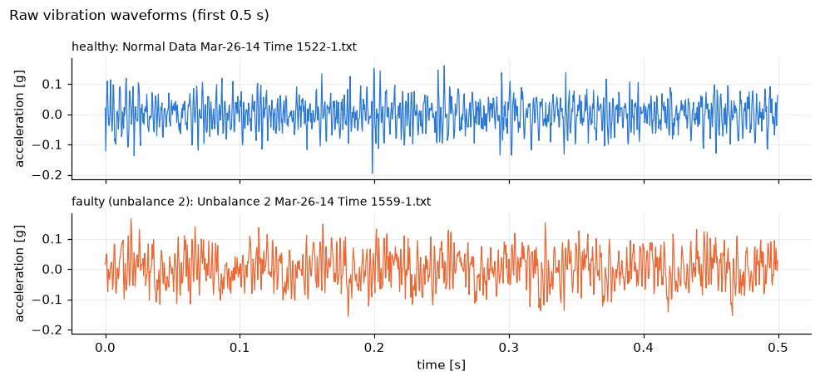
Figure 1. Raw acceleration waveform, healthy vs. faulty (unbalance level 2), first 0.5 s — time domain.
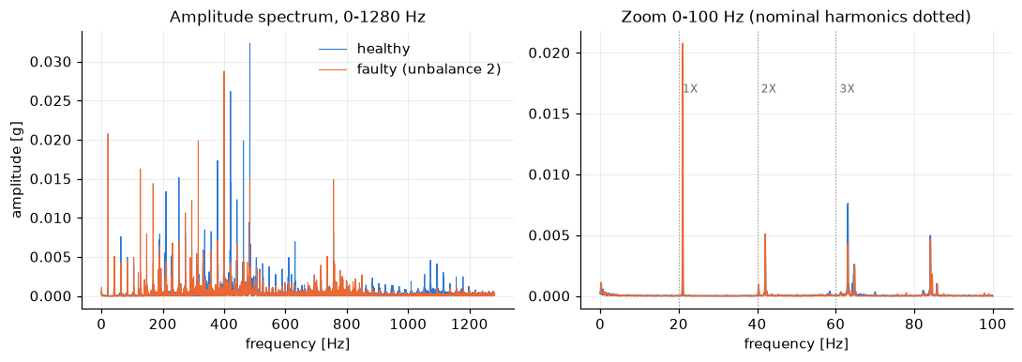
Figure 2. Amplitude spectrum of the same records — frequency domain. Left: full band, dominated by non-informative 400–800 Hz content. Right: zoom 0–100 Hz; the faulty shaft shows a clear 1X line.

2. Implemented Solution

2.1 Analytics process
Sample preparation.
Each vibration file contains 38,400 acceleration samples, corresponding to 15 s of data recorded at 2560 Hz. The training records are labelled as either healthy (0) or faulty (1). The 30 test records are arranged in chronological order and numbered from 1 to 30.
Feature extraction.
Features are extracted from both the time and frequency domains. In the frequency domain, an FFT is applied using a Hann window. The main features are the vibration amplitudes at the shaft rotational frequency and its harmonics: 1X, 2X, and 3X. Although the nominal shaft speed is 20 Hz, the actual rotational frequency is approximately 21 Hz. Therefore, the 1X frequency is identified by searching for the strongest peak within ±15% of the nominal shaft speed. Low-frequency RMS and the ratio between the 1X amplitude and RMS are also calculated.
In the time domain, RMS, peak value, crest factor, kurtosis, and skewness are calculated for each record. These features are calculated twice: first using the original raw vibration signal, and then using a 15–30 Hz band-pass filtered signal.
The purpose of the filter is to isolate the vibration around the shaft rotational frequency. The raw signals contain strong vibration components between approximately 400 and 800 Hz, which are present in both healthy and faulty records and therefore provide little information for detecting the unbalance fault.
Effect of filtering.
Figure 3 shows the effect of the 15–30 Hz band-pass filter. Before filtering, the healthy and faulty signals look very similar in the time domain. After filtering, however, the faulty signal shows a clear oscillation at approximately 21 Hz, while the healthy signal remains much smaller. This indicates that the unbalance fault is mainly associated with vibration near the shaft rotational frequency.
Feature comparison.
Figures 4–6 compare the ability of different features to distinguish healthy and faulty records. The Fisher discriminant ratio (FDR) is used to measure class separation, where a larger value indicates better separation.
The raw time-domain features provide poor separation, with FDR values below 0.6. This is mainly because these features are strongly influenced by broadband vibration that is not related to the unbalance fault.
The frequency-domain features perform much better. In particular, the 1X amplitude provides strong separation between the healthy and faulty records, with an FDR of 65.7.
After applying the 15–30 Hz band-pass filter, the time-domain features also become highly effective. The filtered RMS and peak values produce FDR values of approximately 74–76. This occurs because the filtered signal is dominated by the 1X vibration, so its RMS and peak values directly reflect the strength of the rotational-frequency vibration.

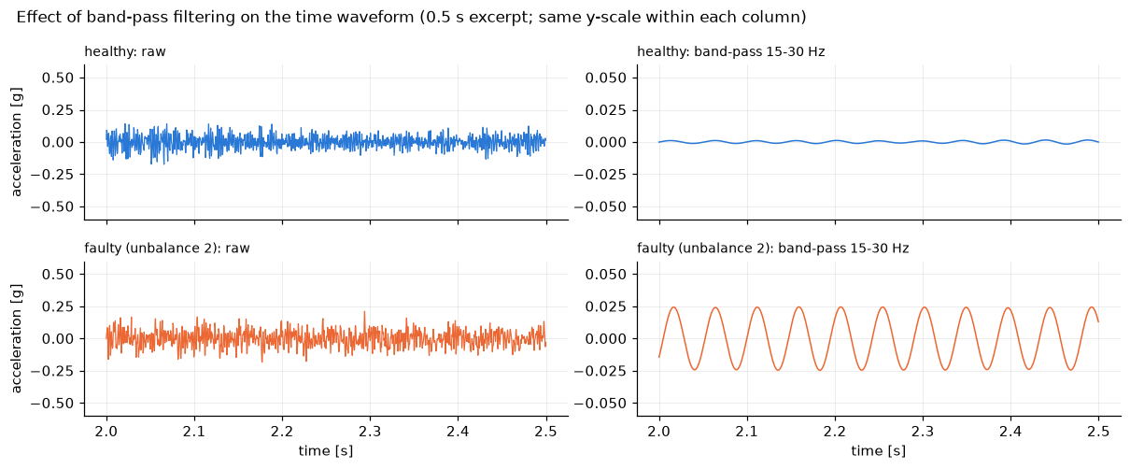
Figure 3. Effect of 15–30 Hz band-pass filtering. The raw healthy and faulty signals appear similar, while the filtered faulty signal shows a clear oscillation near the 1X rotational frequency.
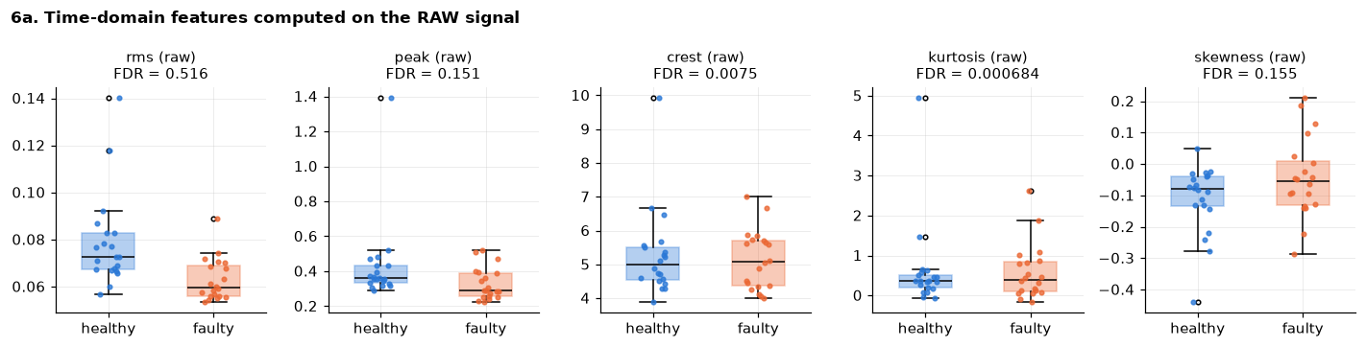
Figure 4. Raw time-domain features — healthy vs. faulty. All FDR < 0.6: no useful separation.
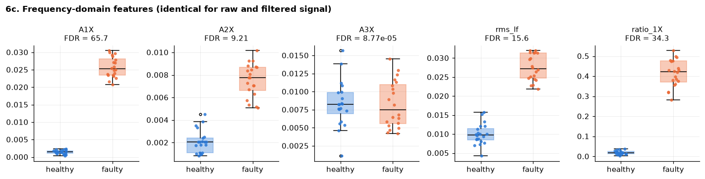
Figure 5. Frequency-domain features. A1X separates the classes with no overlap (FDR = 65.7); A3X is uninformative.
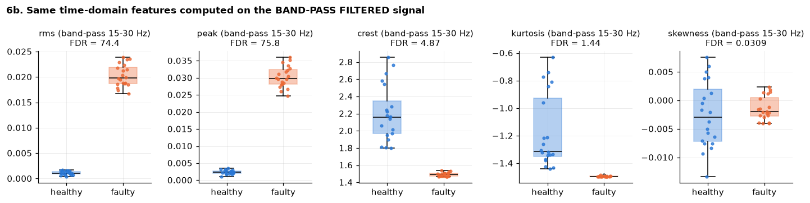
Figure 6. Same time-domain features after 15–30 Hz band-pass filtering. RMS and peak now rival A1X (FDR ≈ 74–76).

2.2 Model selection and logistic regression
Logistic regression models the fault probability as P(faulty|x) = σ(wᵀx + b). Because several features perfectly separate the training classes, an L2-regularized model (C=1) is fitted using standardized inputs. The implementation used Newton–Raphson and was cross-checked against scikit-learn.
Three feature sets were compared: 1X only, 1X + 2X, and all 15 extracted features. All achieved 100% accuracy under leave-one-out and 5-fold cross-validation, so model selection was based on simplicity and feature independence rather than accuracy. The A1X + A2X model was selected because it is compact, physically interpretable, and avoids relying on a single spectral component.

2.3 Solution flow chart
Figure 7 summarizes the analysis pipeline. The 70 vibration records are loaded and labelled, with the 40 training records assigned as healthy (0) or faulty (1).
For each record, three feature groups are extracted: frequency-domain features from the FFT (1X, 2X, 3X), time-domain statistics from the raw signal (RMS, peak, crest factor, kurtosis, skewness), and the same statistics after 15–30 Hz band-pass filtering.
Features are evaluated using the Fisher discriminant ratio and t-test. Candidate logistic regression models are then compared, and A1X + A2X is selected as the final input set. The model is trained using standardized features with L2 regularization, validated by leave-one-out and 5-fold cross-validation, and applied to the 30 test records to estimate fault probability and assign health labels.

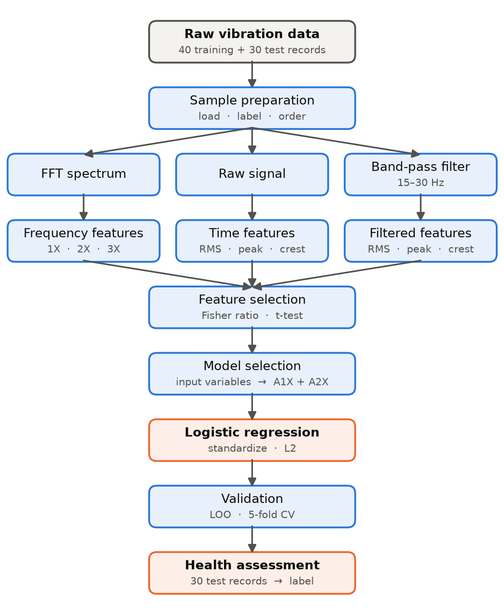
Figure 7. Flow chart of the solution process, top to bottom.

3. Results
Figure 9 places every test record on the fitted logistic curve of the selected (A1X, A2X) model. Training records sit at their true label; test records sit on the curve at their predicted P(faulty). Figure 10 shows the same model as a 2-D decision boundary, with training points colored by true class and test points as diamonds colored by the assigned class and labelled with their record-number range. Figure 8 gives the health label of every one of the 30 test records individually (health index = 1 − P(faulty); blue = healthy, orange = faulty).
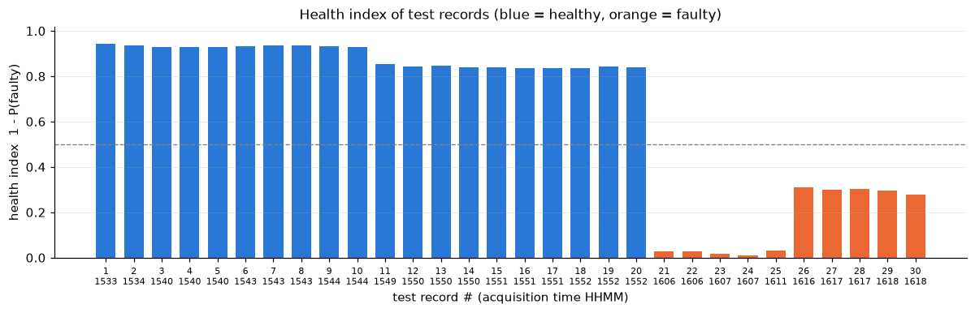
Figure 8. Health label of every test record (health index = 1 − P(faulty), selected model). Records 1–20 are healthy; records 21–30 are faulty.
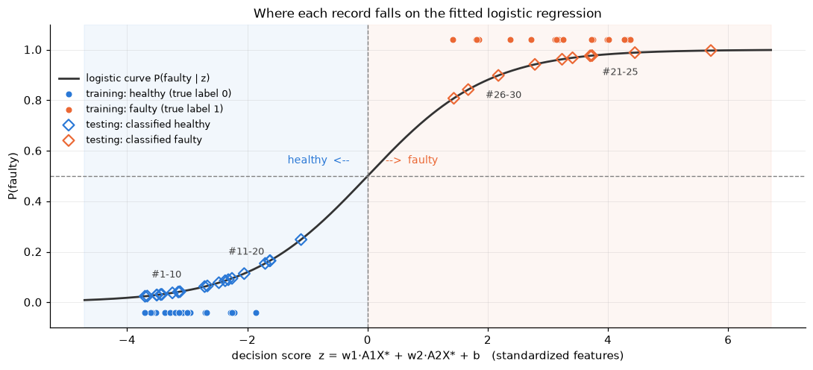
Figure 9. Logistic regression curve of the selected (A1X, A2X) model. Training records at true label 0/1; test records at their predicted probability.
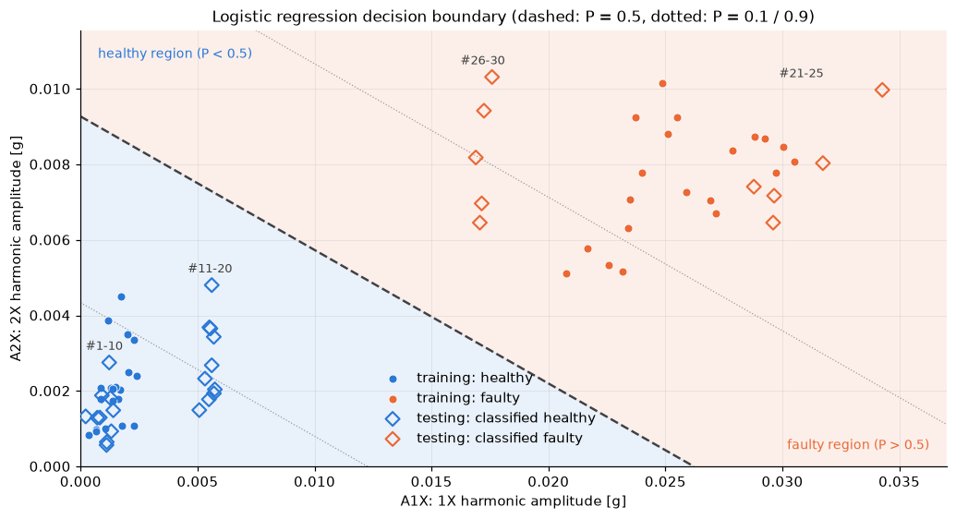
Figure 10. Decision boundary of the selected model in the A1X–A2X plane, with training and test records.
All 30 test records receive clear model predictions: records 1–20 are classified as healthy and records 21–30 as faulty. Within these groups, records 11–20 lie closer to the decision boundary than records 1–10, while records 26–30 have lower predicted fault probabilities than records 21–25. These differences may indicate intermediate operating conditions, but physical fault severity cannot be confirmed without labelled severity data.

4. Discussion
Shaft speed. The observed shaft frequency (≈21.05 Hz) differs from the nominal 20 Hz, so harmonic features must be located with a peak search rather than read at the nominal frequency.
Features. The 1X amplitude alone separates the training classes perfectly and is the primary health indicator, consistent with mass unbalance producing a synchronous force. Raw time-domain statistics fail because they are dominated by non-informative broadband content shared by both classes.
Filtering. Band-pass filtering does not improve frequency-domain features (a 15-s FFT already isolates the 1X bin), but it is decisive for time-domain features, turning RMS and peak into top-tier features by isolating the same 1X oscillation the spectrum already measures directly — filtering does not add new information, it makes the time domain able to see what the spectrum sees.
Modelling. Because the training classes are perfectly separable for several features, unpenalized logistic regression does not yield finite coefficients. L2 regularization was therefore used to obtain a stable finite solution. All candidate feature sets achieved 100% cross-validation accuracy on the 40 training records, so model selection was based on simplicity and interpretability rather than accuracy alone. For practical deployment, the classification threshold should be calibrated using additional labelled data or an engineering vibration criterion.
Results. The model predicts records 1–20 as healthy and records 21–30 as faulty. Differences in predicted probability are also visible within these groups, particularly for records 11–20 and 26–30. These patterns may reflect intermediate operating conditions, but they should not be interpreted directly as fault severity without labelled severity data.
Limitation. Only two labelled training conditions were available: healthy and level-2 unbalance. Therefore, the model can only perform binary classification and cannot validate intermediate fault severity. Additional labelled level-1 and other operating conditions would support multi-class classification or severity regression. The small training set also limits confidence in the reported 100% cross-validation accuracy.

5. Conclusion
- The 1X harmonic amplitude, located with a speed-tracking peak search, separates healthy and unbalanced shafts perfectly and is the primary health indicator; raw broadband time-domain statistics are not useful.
- Band-pass filtering around 1X does not improve frequency-domain features but converts otherwise-useless time-domain statistics (RMS, peak) into top-tier features, because they become direct time-domain estimates of the 1X amplitude.
- A compact two-feature logistic regression using A1X and A2X was selected because it matched the cross-validation accuracy of larger feature sets while remaining simple and physically interpretable.
- On the 30 test records, the model predicts records 1–20 as healthy and records 21–30 as faulty. Differences in predicted probabilities suggest possible intermediate operating conditions, although fault severity cannot be confirmed from the available training labels.

6. Appendix – Codes
All results above were produced by the Jupyter notebook hw2_rotor_bearing.ipynb (Python 3.13; numpy, scipy, pandas, scikit-learn, matplotlib). Code is reproduced below in execution order, grouped by notebook section; printed outputs are omitted for brevity (all reported numbers appear in the body above).

1. Setup
# Imports, constants, and a consistent plotting style used throughout the notebook.
import re
from pathlib import Path

import numpy as np
import pandas as pd
import matplotlib.pyplot as plt
from scipy import signal, stats
from sklearn.linear_model import LogisticRegression
from sklearn.pipeline import make_pipeline
from sklearn.preprocessing import StandardScaler
from sklearn.model_selection import cross_val_score, LeaveOneOut, StratifiedKFold

FS = 2560.0 # sampling rate [Hz]
F_ROT = 20.0 # nominal shaft speed [Hz] (1X)

# Locate the data folder whether the notebook is run from hw2/ or from the repo root.
DATA_DIR = next(p for p in (Path("../data/rotor-bearing"), Path("data/rotor-bearing")) if p.exists()).resolve()
OUT_DIR = Path("results"); OUT_DIR.mkdir(exist_ok=True)

# Fixed categorical colors: the same entity always gets the same color.
C_HEALTHY, C_FAULTY, C_TEST = "#2a78d6", "#eb6834", "#52514e"
plt.rcParams.update({
"figure.dpi": 110, "axes.spines.top": False, "axes.spines.right": False,
"axes.grid": True, "grid.alpha": 0.25, "grid.linewidth": 0.6,
"lines.linewidth": 1.2, "font.size": 9.5, "legend.frameon": False,
})
pd.set_option("display.precision", 5)
print("Data folder:", DATA_DIR)

2. Data loading
# Read one record: return the acceleration vector as a NumPy array.
def load_record(path: Path) -> np.ndarray:
lines = path.read_text().splitlines()
start = next(i for i, l in enumerate(lines) if l.strip().lower() == "acceleration") + 1
return np.array([float(v) for v in lines[start:] if v.strip()])

# Parse "... Time HHMM-idx.txt" into (time string, record index) for sorting/labeling.
def parse_name(path: Path):
m = re.search(r"Time (\d{4})-(\d+)", path.name)
return m.group(1), int(m.group(2))

def load_folder(folder: Path, label):
recs = []
for p in sorted(folder.glob("*.txt")):
t, idx = parse_name(p)
recs.append({"file": p.name, "time": t, "idx": idx, "label": label, "x": load_record(p)})
return recs

healthy = load_folder(DATA_DIR / "Training" / "Healthy", 0) # label 0 = healthy
faulty = load_folder(DATA_DIR / "Training" / "Faulty", 1) # label 1 = faulty (unbalance level 2)
testing = sorted(load_folder(DATA_DIR / "Testing", None), key=lambda r: (r["time"], r["idx"]))

print(f"healthy: {len(healthy)} records, faulty: {len(faulty)} records, testing: {len(testing)} records")
print("samples per record:", {len(r['x']) for r in healthy + faulty + testing}, "->", len(healthy[0]['x']) / FS, "s each")

3. Raw data description
# Per-class summary statistics of the raw acceleration signals.
def raw_stats(recs, name):
x = np.concatenate([r["x"] for r in recs])
return pd.Series({"records": len(recs), "samples/record": len(recs[0]["x"]), "mean": x.mean(),
"std": x.std(), "min": x.min(), "max": x.max()}, name=name)

pd.DataFrame([raw_stats(healthy, "healthy (train)"), raw_stats(faulty, "faulty (train)"), raw_stats(testing, "testing")])

# Time waveforms: one healthy and one faulty training record, first 0.5 s (about 10 shaft revolutions).
t = np.arange(len(healthy[0]["x"])) / FS
n_show = int(0.5 * FS)
fig, axes = plt.subplots(2, 1, figsize=(9, 4.2), sharex=True, sharey=True)
for ax, rec, c, name in [(axes[0], healthy[0], C_HEALTHY, "healthy"), (axes[1], faulty[0], C_FAULTY, "faulty (unbalance 2)")]:
ax.plot(t[:n_show], rec["x"][:n_show], color=c, lw=0.8)
ax.set_title(f"{name}: {rec['file']}", loc="left", fontsize=9)
ax.set_ylabel("acceleration [g]")
axes[1].set_xlabel("time [s]")
fig.suptitle("Raw vibration waveforms (first 0.5 s)", x=0.01, ha="left", fontsize=11)
fig.tight_layout(); plt.show()

4. Frequency-domain analysis
# Single-sided amplitude spectrum with a Hann window (amplitude-corrected by the window sum).
def amplitude_spectrum(x: np.ndarray):
x = x - x.mean()
w = np.hanning(len(x))
X = np.fft.rfft(x * w)
f = np.fft.rfftfreq(len(x), d=1 / FS)
return f, 2.0 * np.abs(X) / w.sum()

# Compare spectra of one healthy and one faulty record: full band and a zoom on the low frequencies.
fig, axes = plt.subplots(1, 2, figsize=(10, 3.6))
for rec, c, name in [(healthy[0], C_HEALTHY, "healthy"), (faulty[0], C_FAULTY, "faulty (unbalance 2)")]:
f, A = amplitude_spectrum(rec["x"])
axes[0].plot(f, A, color=c, lw=0.7, label=name)
axes[1].plot(f[f <= 100], A[f <= 100], color=c, lw=1.0, label=name)
ymax = axes[1].get_ylim()[1]
for k in (1, 2, 3):
axes[1].axvline(k * F_ROT, color="0.6", ls=":", lw=0.8)
axes[1].text(k * F_ROT + 1.0, ymax * 0.80, f"{k}X", color="0.4", fontsize=8, va="top")
axes[0].set(title="Amplitude spectrum, 0-1280 Hz", xlabel="frequency [Hz]", ylabel="amplitude [g]")
axes[1].set(title="Zoom 0-100 Hz (nominal harmonics dotted)", xlabel="frequency [Hz]")
axes[0].legend(loc="upper right")
fig.tight_layout(); plt.show()

# Class-averaged spectra (0-100 Hz): averaging over the 20 records of each class shows the systematic 1X difference.
def mean_spectrum(recs):
specs = [amplitude_spectrum(r["x"])[1] for r in recs]
return amplitude_spectrum(recs[0]["x"])[0], np.mean(specs, axis=0)

f, A_h = mean_spectrum(healthy)
_, A_f = mean_spectrum(faulty)
m = f <= 100
fig, ax = plt.subplots(figsize=(9, 3.4))
ax.plot(f[m], A_h[m], color=C_HEALTHY, label="healthy (mean of 20)")
ax.plot(f[m], A_f[m], color=C_FAULTY, label="faulty (mean of 20)")
f_peak = f[m][np.argmax(A_f[m] * (f[m] < 30))]
ax.annotate(f"1X peak at {f_peak:.2f} Hz", xy=(f_peak, A_f[m].max()), xytext=(35, A_f[m].max() * 0.9),
arrowprops=dict(arrowstyle="-", color="0.4"), fontsize=8.5, color="0.3")
ax.set(xlabel="frequency [Hz]", ylabel="amplitude [g]", title="Class-averaged amplitude spectra, 0-100 Hz")
ax.legend(); fig.tight_layout(); plt.show()
print(f"Measured shaft frequency (1X) from the faulty class mean spectrum: {f_peak:.3f} Hz (nominal {F_ROT:.0f} Hz)")

4.3 Effect of noise filtering
# Zero-phase Butterworth filters (second-order sections for numerical stability).
SOS_LP = signal.butter(4, 100.0, btype="low", fs=FS, output="sos") # low-pass 100 Hz
SOS_BP = signal.butter(4, [15.0, 30.0], btype="band", fs=FS, output="sos") # band-pass around 1X

TRIM = int(1.0 * FS) # drop 1 s at each end: filtfilt start-up transients would otherwise inflate peak/crest of quiet signals
def lowpass(x): return signal.sosfiltfilt(SOS_LP, x)[TRIM:-TRIM]
def bandpass(x): return signal.sosfiltfilt(SOS_BP, x)[TRIM:-TRIM]

# Filter frequency responses.
fig, ax = plt.subplots(figsize=(8, 2.8))
for sos, name, c in [(SOS_LP, "low-pass 100 Hz", "#4a3aa7"), (SOS_BP, "band-pass 15-30 Hz", "#1baf7a")]:
w, h = signal.sosfreqz(sos, worN=4096, fs=FS)
ax.semilogx(w[1:], 20 * np.log10(np.abs(h[1:]) + 1e-12), color=c, label=name)
ax.axvline(21.05, color="0.6", ls=":", lw=0.8); ax.text(21.5, -50, "1X", color="0.4", fontsize=8)
ax.set(ylim=(-80, 5), xlabel="frequency [Hz]", ylabel="gain [dB]", title="Filter magnitude responses (one pass; zero-phase filtering applies them twice)")
ax.legend(loc="lower left"); fig.tight_layout(); plt.show()

# Raw vs band-pass filtered waveforms: after filtering, the 21 Hz unbalance oscillation of the faulty shaft is obvious.
fig, axes = plt.subplots(2, 2, figsize=(11, 4.6), sharex=True)
for row, (rec, c, name) in enumerate([(healthy[0], C_HEALTHY, "healthy"), (faulty[0], C_FAULTY, "faulty (unbalance 2)")]):
x = rec["x"]; xb = bandpass(x); i0 = int(2.0 * FS) # excerpt from t = 2 s to 2.5 s
axes[row, 0].plot(t[i0:i0 + n_show], x[i0:i0 + n_show], color=c, lw=0.8)
axes[row, 1].plot(t[i0:i0 + n_show], xb[i0 - TRIM:i0 - TRIM + n_show], color=c, lw=1.0)
axes[row, 0].set_title(f"{name}: raw", loc="left", fontsize=9); axes[row, 1].set_title(f"{name}: band-pass 15-30 Hz", loc="left", fontsize=9)
axes[row, 0].set_ylabel("acceleration [g]")
for ax in axes[1]: ax.set_xlabel("time [s]")
for ax in axes[:, 0]: ax.set_ylim(-0.6, 0.6)
for ax in axes[:, 1]: ax.set_ylim(-0.06, 0.06)
fig.suptitle("Effect of band-pass filtering on the time waveform (0.5 s excerpt; same y-scale within each column)", x=0.01, ha="left", fontsize=11)
fig.tight_layout(); plt.show()

# Does filtering change the 1X amplitude read from the spectrum? (raw and filtered compared on the same trimmed length)
def one_x(x):
f, A = amplitude_spectrum(x); m = (f >= 17) & (f <= 23); return A[m].max()

def snr_1x_db(x):
f, A = amplitude_spectrum(x); m = (f >= 17) & (f <= 23)
noise = np.median(A[(f >= 10) & (f <= 35) & ~((f >= 20.5) & (f <= 21.6))]) # local noise floor next to the peak
return 20 * np.log10(A[m].max() / noise)

chk = pd.DataFrame([{"A1X_raw": one_x(r["x"][TRIM:-TRIM]), "A1X_lowpass": one_x(lowpass(r["x"])), "A1X_bandpass": one_x(bandpass(r["x"])),
"SNR_raw_dB": snr_1x_db(r["x"][TRIM:-TRIM]), "SNR_lowpass_dB": snr_1x_db(lowpass(r["x"]))} for r in healthy + faulty])
print("max |A1X_raw - A1X_lowpass| =", f"{(chk.A1X_raw - chk.A1X_lowpass).abs().max():.2e} g")
print("max |A1X_raw - A1X_bandpass| =", f"{(chk.A1X_raw - chk.A1X_bandpass).abs().max():.2e} g")
print("mean 1X SNR raw / low-pass =", f"{chk.SNR_raw_dB.mean():.1f} dB / {chk.SNR_lowpass_dB.mean():.1f} dB")

5. Feature extraction
# Harmonic amplitude: maximum of the spectrum inside a band around the expected frequency.
def band_peak(f, A, f_center, half_width):
m = (f >= f_center - half_width) & (f <= f_center + half_width)
i = np.argmax(A[m])
return A[m][i], f[m][i]

TD_STATS = ["rms", "peak", "crest", "kurtosis", "skewness"]

# Time-domain statistics of a signal, with a suffix telling which signal they came from.
def time_domain_features(x: np.ndarray, tag: str) -> dict:
rms = np.sqrt(np.mean(x ** 2)); peak = np.max(np.abs(x))
return {f"rms_{tag}": rms, f"peak_{tag}": peak, f"crest_{tag}": peak / rms,
f"kurtosis_{tag}": stats.kurtosis(x), f"skewness_{tag}": stats.skew(x)}

# Full feature vector for one record.
def extract_features(x: np.ndarray) -> dict:
f, A = amplitude_spectrum(x)
a1, f1 = band_peak(f, A, F_ROT, 0.15 * F_ROT) # 1X: search 17-23 Hz
a2, _ = band_peak(f, A, 2 * f1, 1.0) # 2X around 2 * measured 1X
a3, _ = band_peak(f, A, 3 * f1, 1.0) # 3X around 3 * measured 1X
lf = (f > 0) & (f <= 100)
d = {"A1X": a1, "A2X": a2, "A3X": a3, "f1X": f1,
"rms_lf": np.sqrt(np.sum((A[lf] / np.sqrt(2)) ** 2)), # band RMS from sinusoid amplitudes
"ratio_1X": a1 / np.sqrt(np.mean(x ** 2))}
d |= time_domain_features(x[TRIM:-TRIM], "raw") # raw signal (same trimmed length as the filtered one)
d |= time_domain_features(bandpass(x), "bp") # band-pass 15-30 Hz filtered signal
return d

def feature_table(recs):
rows = []
for r in recs:
d = extract_features(r["x"]); d.update(file=r["file"], time=r["time"], label=r["label"]); rows.append(d)
return pd.DataFrame(rows)

train = pd.concat([feature_table(healthy), feature_table(faulty)], ignore_index=True)
test = feature_table(testing)
FEATURES_SPEC = ["A1X", "A2X", "A3X", "rms_lf", "ratio_1X"]
FEATURES_RAW = [f"{st}_raw" for st in TD_STATS]
FEATURES_BP = [f"{st}_bp" for st in TD_STATS]
FEATURES = FEATURES_SPEC + FEATURES_RAW + FEATURES_BP
train.to_csv(OUT_DIR / "train_features.csv", index=False); test.to_csv(OUT_DIR / "test_features.csv", index=False)
train.groupby("label")[FEATURES + ["f1X"]].agg(["mean", "std"]).T.rename(columns={0: "healthy", 1: "faulty"})

6. Feature exploration and selection: raw vs band-pass filtered
# Helper: one box plot panel (healthy vs faulty) with jittered raw points.
rng = np.random.default_rng(0)
def fdr_of(feat):
h, fl = train.loc[train.label == 0, feat], train.loc[train.label == 1, feat]
return (h.mean() - fl.mean()) ** 2 / (h.var() + fl.var())

def box_panel(ax, feat, title):
title = f"{title}\nFDR = {fdr_of(feat):.3g}"
data = [train.loc[train.label == 0, feat], train.loc[train.label == 1, feat]]
bp = ax.boxplot(data, widths=0.5, patch_artist=True, medianprops=dict(color="black", lw=1),
flierprops=dict(marker="o", markersize=3, markerfacecolor="none"))
for patch, c in zip(bp["boxes"], (C_HEALTHY, C_FAULTY)):
patch.set(facecolor=c, alpha=0.35, edgecolor=c)
for i, (d, c) in enumerate(zip(data, (C_HEALTHY, C_FAULTY)), start=1):
ax.scatter(i + rng.uniform(-0.12, 0.12, len(d)), d, s=9, color=c, alpha=0.8, zorder=3)
ax.set_xticks([1, 2]); ax.set_xticklabels(["healthy", "faulty"]); ax.set_title(title, fontsize=9.5)

# Figure 6a: time-domain features of the RAW signal.
fig, axes = plt.subplots(1, 5, figsize=(13, 3.3))
for ax, st in zip(axes, TD_STATS):
box_panel(ax, f"{st}_raw", f"{st} (raw)")
fig.suptitle("6a. Time-domain features computed on the RAW signal", x=0.01, ha="left", fontsize=11, fontweight="bold")
fig.tight_layout(); plt.show()

# Figure 6b: the same five features computed on the BAND-PASS FILTERED (15-30 Hz) signal.
fig, axes = plt.subplots(1, 5, figsize=(13, 3.3))
for ax, st in zip(axes, TD_STATS):
box_panel(ax, f"{st}_bp", f"{st} (band-pass 15-30 Hz)")
fig.suptitle("6b. Same time-domain features computed on the BAND-PASS FILTERED signal", x=0.01, ha="left", fontsize=11, fontweight="bold")
fig.tight_layout(); plt.show()

# Figure 6c: frequency-domain features (unaffected by filtering).
fig, axes = plt.subplots(1, 5, figsize=(13, 3.3))
for ax, feat in zip(axes, FEATURES_SPEC):
box_panel(ax, feat, feat)
fig.suptitle("6c. Frequency-domain features (identical for raw and filtered signal)", x=0.01, ha="left", fontsize=11, fontweight="bold")
fig.tight_layout(); plt.show()

# Fisher discriminant ratio and Welch t-test for every feature.
def separability(feat):
h, fl = train.loc[train.label == 0, feat], train.loc[train.label == 1, feat]
tstat, pval = stats.ttest_ind(h, fl, equal_var=False)
return (h.mean() - fl.mean()) ** 2 / (h.var() + fl.var()), abs(tstat), pval

rows = []
for feat in FEATURES:
fdr, tt, pv = separability(feat)
group = "frequency-domain" if feat in FEATURES_SPEC else ("time-domain, raw" if feat.endswith("_raw") else "time-domain, band-pass")
rows.append({"feature": feat, "group": group, "FDR": fdr, "|t|": tt, "p-value": pv})
ranking = pd.DataFrame(rows).sort_values("FDR", ascending=False).reset_index(drop=True)

# Side-by-side table for the time-domain features: raw vs band-pass, and the gain factor from filtering.
compare = pd.DataFrame({
"FDR raw": [separability(f"{st}_raw")[0] for st in TD_STATS],
"FDR band-pass": [separability(f"{st}_bp")[0] for st in TD_STATS],
"p-value raw": [separability(f"{st}_raw")[2] for st in TD_STATS],
"p-value band-pass": [separability(f"{st}_bp")[2] for st in TD_STATS],
}, index=pd.Index(TD_STATS, name="time-domain feature"))
compare["FDR gain (x)"] = compare["FDR band-pass"] / compare["FDR raw"]
print("Reference: FDR of the 1X amplitude =", f"{separability('A1X')[0]:.1f}")
compare.style.format({"FDR raw": "{:.3f}", "FDR band-pass": "{:.3f}", "p-value raw": "{:.2e}", "p-value band-pass": "{:.2e}", "FDR gain (x)": "{:,.0f}"})

# Paired bar chart: Fisher ratio of each time-domain feature before (raw) and after (band-pass) filtering.
C_RAW, C_BP = "#86b6ef", "#1c5cab"
fig, axes = plt.subplots(1, 2, figsize=(13, 4.2), gridspec_kw={"width_ratios": [1, 1.25]})
ax = axes[0]
ypos = np.arange(len(TD_STATS)); h = 0.38
ax.barh(ypos + h / 2, compare["FDR raw"].clip(lower=1e-4), height=h, color=C_RAW, label="raw signal")
ax.barh(ypos - h / 2, compare["FDR band-pass"].clip(lower=1e-4), height=h, color=C_BP, label="band-pass 15-30 Hz")
ax.axvline(separability("A1X")[0], color=C_FAULTY, ls="--", lw=1.0)
ax.text(separability("A1X")[0], -0.8, "A1X reference ", color=C_FAULTY, fontsize=8, ha="right", va="center")
ax.axvline(1, color="0.6", ls=":", lw=0.8)
ax.set_yticks(ypos); ax.set_yticklabels(TD_STATS); ax.set_ylim(len(TD_STATS) - 0.5, -1.2) # inverted, with headroom for the label
ax.set(xscale="log", xlabel="Fisher discriminant ratio (log scale)", title="Time-domain features: effect of band-pass filtering")
ax.grid(axis="y", visible=False); ax.legend(loc="lower right")

# Overall ranking of all features, colored by group.
ax = axes[1]
group_color = {"frequency-domain": C_FAULTY, "time-domain, raw": C_RAW, "time-domain, band-pass": C_BP}
rk = ranking[::-1]
ax.barh(rk.feature, rk.FDR.clip(lower=1e-4), color=[group_color[g] for g in rk.group], height=0.65)
ax.axvline(1, color="0.6", ls=":", lw=0.8)
ax.set(xscale="log", xlabel="Fisher discriminant ratio (log scale)", title="All features ranked by separability")
ax.grid(axis="y", visible=False)
from matplotlib.patches import Patch
ax.legend(handles=[Patch(color=c, label=g) for g, c in group_color.items()], loc="lower right", fontsize=8.5)
fig.tight_layout(); plt.show()
ranking.style.format({"FDR": "{:.3f}", "|t|": "{:.2f}", "p-value": "{:.2e}"}).hide(axis="index")

7. Logistic regression
# Minimal logistic regression classifier (Newton-Raphson / IRLS with L2 penalty on the weights, not the intercept).
class LogisticRegressionScratch:
def __init__(self, l2=1.0, max_iter=100, tol=1e-10):
self.l2, self.max_iter, self.tol = l2, max_iter, tol

@staticmethod
def _sigmoid(z):
return 1.0 / (1.0 + np.exp(-z))

def fit(self, X, y):
X = np.asarray(X, float); y = np.asarray(y, float)
Xb = np.c_[np.ones(len(X)), X] # prepend the intercept column
w = np.zeros(Xb.shape[1])
R = self.l2 * np.eye(Xb.shape[1]); R[0, 0] = 0.0 # do not penalize the intercept
self.history_ = []
for it in range(self.max_iter):
p = self._sigmoid(Xb @ w)
grad = Xb.T @ (p - y) + R @ w # gradient of the negative penalized log-likelihood
H = (Xb * (p * (1 - p))[:, None]).T @ Xb + R # Hessian
step = np.linalg.solve(H, grad)
w -= step
nll = -np.sum(y * np.log(p + 1e-12) + (1 - y) * np.log(1 - p + 1e-12)) + 0.5 * self.l2 * w[1:] @ w[1:]
self.history_.append(nll)
if np.linalg.norm(step) < self.tol:
break
self.intercept_, self.coef_, self.n_iter_ = w[0], w[1:], it + 1
return self

def predict_proba(self, X):
return self._sigmoid(np.asarray(X, float) @ self.coef_ + self.intercept_)

def predict(self, X, threshold=0.5):
return (self.predict_proba(X) >= threshold).astype(int)

# Validate on the standardized 1X feature against scikit-learn (same objective: sklearn's C = 1 / lambda).
scaler_1x = StandardScaler().fit(train[["A1X"]])
Z1 = scaler_1x.transform(train[["A1X"]]); y = train.label.values
scratch = LogisticRegressionScratch(l2=1.0).fit(Z1, y)
sk = LogisticRegression(C=1.0).fit(Z1, y)
print(f"scratch : intercept = {scratch.intercept_: .5f}, coef = {scratch.coef_[0]: .5f}, converged in {scratch.n_iter_} Newton steps")
print(f"sklearn : intercept = {sk.intercept_[0]: .5f}, coef = {sk.coef_[0][0]: .5f}")
print("max |P_scratch - P_sklearn| on training data:", np.abs(scratch.predict_proba(Z1) - sk.predict_proba(Z1)[:, 1]).max())

# Convergence of the Newton iterations (penalized negative log-likelihood per step).
fig, ax = plt.subplots(figsize=(5.5, 2.8))
ax.plot(range(1, len(scratch.history_) + 1), scratch.history_, marker="o", ms=4, color="0.3")
ax.set(xlabel="Newton iteration", ylabel="penalized neg. log-likelihood", title="From-scratch logistic regression: convergence")
fig.tight_layout(); plt.show()

7.2 Four logistic regression models
# Define the four feature sets / models and evaluate them with cross-validation.
MODELS = {
"A: 1X only": ["A1X"],
"B: harmonics 1X-3X": ["A1X", "A2X", "A3X"],
"C: all features": FEATURES,
"D: band-pass time-domain": ["rms_bp", "crest_bp"],
}
def make_model():
return make_pipeline(StandardScaler(), LogisticRegression(C=1.0, max_iter=1000))

fitted, cv_rows = {}, []
for name, feats in MODELS.items():
X = train[feats].values
fitted[name] = make_model().fit(X, y)
loo = cross_val_score(make_model(), X, y, cv=LeaveOneOut()).mean()
kf = cross_val_score(make_model(), X, y, cv=StratifiedKFold(5, shuffle=True, random_state=0)).mean()
cv_rows.append({"model": name, "n_features": len(feats), "train accuracy": fitted[name].score(X, y),
"LOO-CV accuracy": loo, "5-fold CV accuracy": kf})
pd.DataFrame(cv_rows).set_index("model")

# Model A: fitted sigmoid over the 1X amplitude, with training points and the p = 0.5 decision threshold.
lr_a = fitted["A: 1X only"]
grid = np.linspace(0, max(train.A1X.max(), test.A1X.max()) * 1.05, 400)
p_grid = lr_a.predict_proba(grid[:, None])[:, 1]
thr_1x = grid[np.argmin(np.abs(p_grid - 0.5))]

fig, ax = plt.subplots(figsize=(9, 3.8))
ax.plot(grid, p_grid, color="0.25", lw=1.6, label="P(faulty | A1X)")
ax.scatter(train.A1X[y == 0], np.zeros((y == 0).sum()) - 0.03, s=22, color=C_HEALTHY, label="healthy (train)")
ax.scatter(train.A1X[y == 1], np.ones((y == 1).sum()) + 0.03, s=22, color=C_FAULTY, label="faulty (train)")
ax.scatter(test.A1X, lr_a.predict_proba(test[["A1X"]].values)[:, 1], s=34, facecolor="none", edgecolor=C_TEST, lw=1.2, label="test (unknown)")
ax.axhline(0.5, color="0.6", ls="--", lw=0.8); ax.axvline(thr_1x, color="0.6", ls="--", lw=0.8)
ax.text(thr_1x, 0.53, f" threshold A1X = {thr_1x:.4f} g", fontsize=8.5, color="0.35")
ax.set(xlabel="1X harmonic amplitude A1X [g]", ylabel="P(faulty)", title="Model A: logistic regression on the 1X amplitude")
ax.legend(loc="center right"); fig.tight_layout(); plt.show()

# Model B: decision boundary in the A1X-A2X plane (A3X fixed at its training mean) with the test records overlaid.
lr_b = fitted["B: harmonics 1X-3X"]
g1 = np.linspace(0, max(train.A1X.max(), test.A1X.max()) * 1.05, 250)
g2 = np.linspace(0, max(train.A2X.max(), test.A2X.max()) * 1.1, 250)
G1, G2 = np.meshgrid(g1, g2)
P = lr_b.predict_proba(np.c_[G1.ravel(), G2.ravel(), np.full(G1.size, train.A3X.mean())])[:, 1].reshape(G1.shape)

fig, ax = plt.subplots(figsize=(8.5, 4.2))
cs = ax.contourf(G1, G2, P, levels=np.linspace(0, 1, 11), cmap="Oranges", alpha=0.45)
ax.contour(G1, G2, P, levels=[0.5], colors="0.3", linewidths=1.2, linestyles="--")
ax.scatter(train.A1X[y == 0], train.A2X[y == 0], s=24, color=C_HEALTHY, label="healthy (train)")
ax.scatter(train.A1X[y == 1], train.A2X[y == 1], s=24, color=C_FAULTY, label="faulty (train)")
ax.scatter(test.A1X, test.A2X, s=38, facecolor="none", edgecolor=C_TEST, lw=1.2, label="test (unknown)")
fig.colorbar(cs, ax=ax, label="P(faulty)")
ax.set(xlabel="A1X [g]", ylabel="A2X [g]", title="Model B: decision boundary (dashed: P = 0.5)")
ax.legend(loc="lower right"); fig.tight_layout(); plt.show()

# Model C: standardized coefficients show which features drive the all-feature model.
lr_c = fitted["C: all features"]
coef = pd.Series(lr_c[-1].coef_[0], index=FEATURES).sort_values()
fig, ax = plt.subplots(figsize=(7, 3.4))
ax.barh(coef.index, coef.values, color=[C_FAULTY if v >= 0 else C_HEALTHY for v in coef.values], height=0.6)
ax.axvline(0, color="0.4", lw=0.8); ax.grid(axis="y", visible=False)
ax.set(xlabel="standardized coefficient (positive pushes toward 'faulty')", title="Model C: logistic regression coefficients")
fig.tight_layout(); plt.show()

# Model D: decision boundary in the band-pass RMS / crest-factor plane (time-domain features only, no FFT).
lr_d = fitted["D: band-pass time-domain"]
g1 = np.linspace(0, max(train.rms_bp.max(), test.rms_bp.max()) * 1.1, 250)
g2 = np.linspace(0, max(train.crest_bp.max(), test.crest_bp.max()) * 1.1, 250)
G1, G2 = np.meshgrid(g1, g2)
P = lr_d.predict_proba(np.c_[G1.ravel(), G2.ravel()])[:, 1].reshape(G1.shape)
fig, ax = plt.subplots(figsize=(8.5, 4.2))
cs = ax.contourf(G1, G2, P, levels=np.linspace(0, 1, 11), cmap="Oranges", alpha=0.45)
ax.contour(G1, G2, P, levels=[0.5], colors="0.3", linewidths=1.2, linestyles="--")
ax.scatter(train.rms_bp[y == 0], train.crest_bp[y == 0], s=24, color=C_HEALTHY, label="healthy (train)")
ax.scatter(train.rms_bp[y == 1], train.crest_bp[y == 1], s=24, color=C_FAULTY, label="faulty (train)")
ax.scatter(test.rms_bp, test.crest_bp, s=38, facecolor="none", edgecolor=C_TEST, lw=1.2, label="test (unknown)")
fig.colorbar(cs, ax=ax, label="P(faulty)")
ax.set(xlabel="RMS of band-pass (15-30 Hz) signal [g]", ylabel="crest factor of band-pass signal", title="Model D: decision boundary (dashed: P = 0.5)")
ax.legend(loc="upper right"); fig.tight_layout(); plt.show()

8. Health assessment of the test data
# Score every test record with the four models and assemble the results table.
res = test[["file", "time", "A1X", "A2X", "rms_raw", "rms_bp"]].copy()
for name, feats in MODELS.items():
key = name.split(":")[0]
res[f"P_fault_{key}"] = fitted[name].predict_proba(test[feats].values)[:, 1]
res[f"label_{key}"] = np.where(res[f"P_fault_{key}"] >= 0.5, "faulty", "healthy")
label_cols = [f"label_{k}" for k in "ABCD"]
votes = (res[label_cols] == "faulty").sum(axis=1)
mean_p = res[[f"P_fault_{k}" for k in "ABCD"]].mean(axis=1)
res["final_label"] = np.where((votes > 2) | ((votes == 2) & (mean_p >= 0.5)), "FAULTY", "HEALTHY")
res["models_agree"] = (votes == 0) | (votes == len(label_cols))
res["health_index"] = 1 - res["P_fault_A"]
res.insert(0, "#", np.arange(1, len(res) + 1))
res.to_csv(OUT_DIR / "test_health_assessment.csv", index=False)

fmt = {c: "{:.4f}" for c in ["A1X", "A2X", "rms_raw", "rms_bp"]} | {c: "{:.3f}" for c in res.columns if c.startswith("P_fault") or c == "health_index"}
def color_label(v):
return f"color: {C_FAULTY}; font-weight: bold" if v == "FAULTY" else (f"color: {C_HEALTHY}; font-weight: bold" if v == "HEALTHY" else "")
res.style.format(fmt).map(color_label, subset=["final_label"]).hide(axis="index")

# Summary counts of the assessment.
print("Final labels:", res.final_label.value_counts().to_dict())
print("Records where the four models disagree:", int((~res.models_agree).sum()))
print("\nLabel counts by model:")
print(pd.DataFrame({k: res[f"label_{k}"].value_counts() for k in "ABCD"}).fillna(0).astype(int))

# Probability of fault for every test record (chronological order), one marker per model.
markers = {"A": ("o", "#2a78d6", "model A: 1X only"), "B": ("s", "#1baf7a", "model B: 1X-3X"), "C": ("^", "#4a3aa7", "model C: all features"), "D": ("D", "#eda100", "model D: band-pass time-domain")}
fig, ax = plt.subplots(figsize=(11, 4))
for k, (mk, c, lab) in markers.items():
ax.scatter(res["#"], res[f"P_fault_{k}"], marker=mk, s=30, facecolor="none", edgecolor=c, lw=1.3, label=lab)
ax.axhline(0.5, color="0.5", ls="--", lw=0.9); ax.text(30.4, 0.53, "decision threshold", fontsize=8, color="0.4", ha="right")
ax.set_xticks(res["#"]); ax.set_xticklabels([f"{n}\n{t}" for n, t in zip(res["#"], res.time)], fontsize=7)
ax.set(xlabel="test record # (acquisition time HHMM)", ylabel="P(faulty)", ylim=(-0.05, 1.05), title="Predicted probability of fault for the 30 test records")
ax.legend(loc="upper left"); fig.tight_layout(); plt.show()

# Health index (model A) per test record, colored by the final majority-vote label.
fig, ax = plt.subplots(figsize=(11, 3.6))
colors = [C_FAULTY if l == "FAULTY" else C_HEALTHY for l in res.final_label]
ax.bar(res["#"], res.health_index, color=colors, width=0.7)
ax.axhline(0.5, color="0.5", ls="--", lw=0.9)
ax.set_xticks(res["#"]); ax.set_xticklabels([f"{n}\n{t}" for n, t in zip(res["#"], res.time)], fontsize=7)
ax.set(xlabel="test record # (acquisition time HHMM)", ylabel="health index 1 - P(faulty)", ylim=(0, 1.02), title="Health index of test records (blue = healthy, orange = faulty)")
ax.grid(axis="x", visible=False); fig.tight_layout(); plt.show()

# Test records on the A1X axis alongside the training classes: reveals the intermediate group.
fig, ax = plt.subplots(figsize=(9, 2.8))
rng = np.random.default_rng(1)
ax.scatter(train.A1X[y == 0], rng.uniform(-0.15, 0.15, (y == 0).sum()) + 2, s=20, color=C_HEALTHY, label="healthy (train)")
ax.scatter(train.A1X[y == 1], rng.uniform(-0.15, 0.15, (y == 1).sum()) + 1, s=20, color=C_FAULTY, label="faulty (train)")
ax.scatter(res.A1X, rng.uniform(-0.15, 0.15, len(res)) + 0, s=30, facecolor="none", edgecolor=C_TEST, lw=1.2, label="test")
ax.axvline(thr_1x, color="0.5", ls="--", lw=0.9); ax.text(thr_1x, 2.55, f" model A threshold {thr_1x:.4f} g", fontsize=8, color="0.4")
ax.set_yticks([0, 1, 2]); ax.set_yticklabels(["test", "faulty", "healthy"]); ax.set_ylim(-0.5, 3.4)
ax.set(xlabel="1X harmonic amplitude A1X [g]", title="Distribution of the 1X amplitude: training classes vs test records")
ax.grid(axis="y", visible=False); ax.legend(loc="upper right", ncol=3); fig.tight_layout(); plt.show()

# Group the test records by acquisition-time cluster to summarise the assessment compactly.
def time_group(t):
h, m = int(t[:2]), int(t[2:])
return "15:33-15:44" if h == 15 and m < 48 else ("15:49-15:52" if h == 15 else ("16:06-16:11" if m <= 11 else "16:16-16:18"))
res["time_group"] = res.time.map(time_group)
summary = res.groupby("time_group").agg(records=("file", "count"), mean_A1X=("A1X", "mean"), mean_P_fault_A=("P_fault_A", "mean"),
mean_P_fault_B=("P_fault_B", "mean"), mean_P_fault_C=("P_fault_C", "mean"), mean_P_fault_D=("P_fault_D", "mean"),
n_faulty_final=("final_label", lambda s: (s == "FAULTY").sum()))
summary

8.1 Decision boundary and logistic curve
# Fit a two-feature logistic regression and precompute everything both graphs need.
PAIR = ["A1X", "A2X"]
lr_pair = make_model().fit(train[PAIR].values, y)

test_p = lr_pair.predict_proba(test[PAIR].values)[:, 1]
test_pred = np.where(test_p >= 0.5, "faulty", "healthy")
test_edge = np.where(test_pred == "faulty", C_FAULTY, C_HEALTHY)

# Label each test cluster with its record-number range (clusters follow the acquisition time groups).
cluster_labels = res.groupby("time_group")["#"].agg(lambda n: f"#{n.min()}-{n.max()}")
res["cluster"] = res.time_group.map(cluster_labels)
print("test records assigned by the 2-feature model:", pd.Series(test_pred).value_counts().to_dict())

# Graph 1: decision boundary in the A1X-A2X plane with training and test records.
g1 = np.linspace(0, max(train[PAIR[0]].max(), test[PAIR[0]].max()) * 1.08, 300)
g2 = np.linspace(0, max(train[PAIR[1]].max(), test[PAIR[1]].max()) * 1.12, 300)
G1, G2 = np.meshgrid(g1, g2)
P = lr_pair.predict_proba(np.c_[G1.ravel(), G2.ravel()])[:, 1].reshape(G1.shape)

fig, ax = plt.subplots(figsize=(9.5, 5.2))
ax.contourf(G1, G2, P, levels=[0, 0.5, 1], colors=[C_HEALTHY, C_FAULTY], alpha=0.10) # two regions
ax.contour(G1, G2, P, levels=[0.5], colors="0.25", linewidths=1.6, linestyles="--") # boundary P = 0.5
ax.contour(G1, G2, P, levels=[0.1, 0.9], colors="0.6", linewidths=0.8, linestyles=":") # P = 0.1 and 0.9
ax.scatter(train[PAIR[0]][y == 0], train[PAIR[1]][y == 0], s=34, color=C_HEALTHY, edgecolor="white", lw=0.5, label="training: healthy", zorder=3)
ax.scatter(train[PAIR[0]][y == 1], train[PAIR[1]][y == 1], s=34, color=C_FAULTY, edgecolor="white", lw=0.5, label="training: faulty", zorder=3)
for lab, c in [("healthy", C_HEALTHY), ("faulty", C_FAULTY)]:
m = test_pred == lab
ax.scatter(test[PAIR[0]][m], test[PAIR[1]][m], s=48, marker="D", facecolor="none", edgecolor=c, lw=1.4, label=f"testing: classified {lab}", zorder=4)
for cl, grp in res.groupby("cluster"): # cluster labels
cx, cy = test.loc[grp.index, PAIR[0]].mean(), test.loc[grp.index, PAIR[1]].max()
ax.annotate(cl, (cx, cy), xytext=(0, 9), textcoords="offset points", ha="center", fontsize=8.5, color="0.25")
ax.text(0.98, 0.04, "faulty region (P > 0.5)", transform=ax.transAxes, ha="right", color=C_FAULTY, fontsize=9)
ax.text(0.02, 0.96, "healthy region (P < 0.5)", transform=ax.transAxes, ha="left", va="top", color=C_HEALTHY, fontsize=9)
ax.set(xlabel=f"{PAIR[0]}: 1X harmonic amplitude [g]", ylabel=f"{PAIR[1]}: 2X harmonic amplitude [g]",
xlim=(g1[0], g1[-1]), ylim=(g2[0], g2[-1]), title="Logistic regression decision boundary (dashed: P = 0.5, dotted: P = 0.1 / 0.9)")
ax.legend(loc="lower center", bbox_to_anchor=(0.47, 0.02)); fig.tight_layout(); plt.show()

# Graph 2: the fitted logistic curve. Every record is placed at its decision score z = w·x + b; P(faulty) = 1 / (1 + e^-z).
z_train = lr_pair.decision_function(train[PAIR].values)
z_test = lr_pair.decision_function(test[PAIR].values)
zz = np.linspace(min(z_train.min(), z_test.min()) - 1, max(z_train.max(), z_test.max()) + 1, 400)

fig, ax = plt.subplots(figsize=(10, 4.6))
ax.axvspan(zz[0], 0, color=C_HEALTHY, alpha=0.06); ax.axvspan(0, zz[-1], color=C_FAULTY, alpha=0.06)
ax.plot(zz, 1 / (1 + np.exp(-zz)), color="0.2", lw=1.8, label="logistic curve P(faulty | z)")
ax.axhline(0.5, color="0.5", ls="--", lw=0.9); ax.axvline(0, color="0.5", ls="--", lw=0.9)
# training records at their true class (0 = healthy, 1 = faulty), slightly offset from the curve for readability
ax.scatter(z_train[y == 0], np.full((y == 0).sum(), -0.04), s=34, color=C_HEALTHY, edgecolor="white", lw=0.5, label="training: healthy (true label 0)", zorder=3)
ax.scatter(z_train[y == 1], np.full((y == 1).sum(), 1.04), s=34, color=C_FAULTY, edgecolor="white", lw=0.5, label="training: faulty (true label 1)", zorder=3)
# test records sit on the curve at their predicted probability
for lab, c in [("healthy", C_HEALTHY), ("faulty", C_FAULTY)]:
m = test_pred == lab
ax.scatter(z_test[m], test_p[m], s=48, marker="D", facecolor="none", edgecolor=c, lw=1.4, label=f"testing: classified {lab}", zorder=4)
for cl, grp in res.groupby("cluster"):
zc, pc = z_test[grp.index].mean(), test_p[grp.index].mean()
ax.annotate(cl, (zc, pc), xytext=(0, -18 if pc > 0.5 else 14), textcoords="offset points", ha="center", fontsize=8.5, color="0.25")
ax.text(-0.3, 0.55, "healthy <--", ha="right", color=C_HEALTHY, fontsize=9); ax.text(0.3, 0.55, "--> faulty", ha="left", color=C_FAULTY, fontsize=9)
ax.set(xlabel="decision score z = w1·A1X* + w2·A2X* + b (standardized features)", ylabel="P(faulty)", ylim=(-0.1, 1.1),
title="Where each record falls on the fitted logistic regression")
ax.legend(loc="center left", bbox_to_anchor=(0.0, 0.72), fontsize=8.5); fig.tight_layout(); plt.show()
w, b = lr_pair[-1].coef_[0], lr_pair[-1].intercept_[0]
print(f"fitted model: z = {w[0]:.3f}·A1X* + {w[1]:.3f}·A2X* + {b:.3f} (features standardized with training mean/std)")

