ENME 485/691 Industrial AI | Homework 03 Report
Health Assessment of a Rotor Shaft with Unbalance Defects Using a Support Vector Machine
Group leader: You Jung Jun Group members: You Jung Jun, Rahul Ravi Vk, Merrick Carlisle Summers Submitted: October 2026

1. Introduction

1.1 Background and problem
A rotor-bearing testbed is used to study the health of a rotating shaft under mass unbalance. A disk on the shaft accepts screws that create a controlled unbalance. One screw is unbalance level 1 and two screws are unbalance level 2. An accelerometer on the bearing block records the vibration at 2560 Hz. The nominal shaft speed is 20 Hz and the measured speed is about 21 Hz. Unbalance produces a force that rotates with the shaft, so its signature is a rise of the vibration at the shaft frequency (1X).
The goal is to classify the condition of the shaft into three classes, healthy, unbalance level 1 and unbalance level 2, from the vibration signal alone, using a support vector machine (SVM). The model is trained on 60 labelled records and applied to 30 test records.

1.2 Raw data
Table 1. Data sets used (each record has 38,400 samples, 15 s at 2560 Hz).
Data set | Condition | Records | Use
Training, healthy | Normal shaft | 20 | class 0
Training, unbalance level 1 | One screw on the disk | 20 | class 1
Training, unbalance level 2 | Two screws on the disk | 20 | class 2
Testing | Condition listed in the homework appendix | 30 | to be assessed

Figure 1 shows one raw waveform per class. The three conditions look alike in the time domain, and the overall vibration level even decreases slightly with unbalance (RMS of 0.079, 0.072 and 0.063 g). Figure 2 shows the class-averaged spectra. The left panel overlays the three classes over the full band. The content between 400 and 800 Hz sets the overall level and is the same in all classes. The right panels show each class separately from 0 to 100 Hz with its own amplitude scale, because the level-2 line would otherwise hide the other two. The line at the shaft frequency grows from 0.0014 g for the healthy shaft to 0.0055 g for level 1 and 0.0257 g for level 2. The information is confined to a narrow band around 21 Hz.
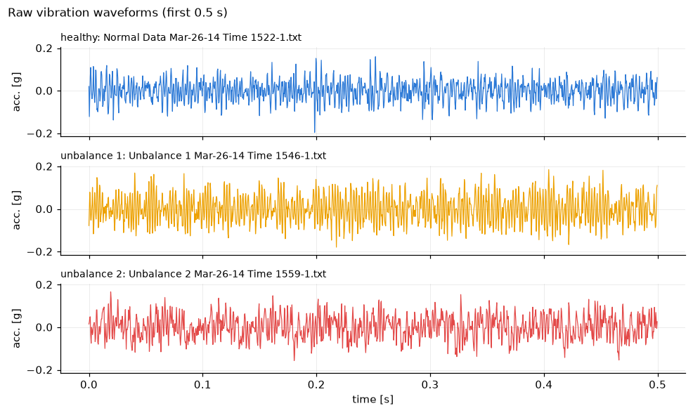
Figure 1. Raw vibration waveforms of the three classes (time domain).
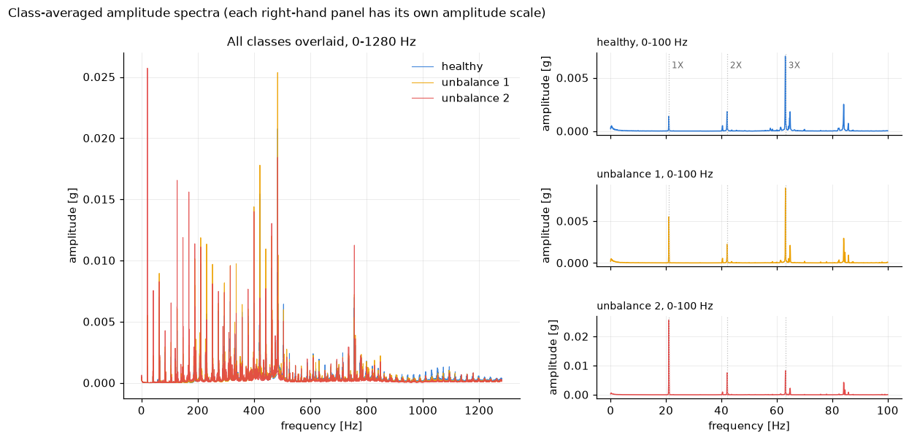
Figure 2. Class-averaged amplitude spectra. Left, all classes overlaid. Right, one panel per class from 0 to 100 Hz.

2. Implemented Solution
2.4 Alternative feature extraction methods
(1) Rahul
(2) Merrick

2.1 Analytics process
Sample preparation. Each file is parsed into a 38,400-sample vector. Training records are labelled 0, 1 and 2 by folder. Test records are ordered chronologically and numbered 1 to 30.
Feature extraction. Multiple features are extracted in the time domain and the frequency domain, 23 per record. The time-domain features are RMS, peak-to-peak, standard deviation, peak, crest factor, kurtosis, skewness, shape factor and impulse factor, computed on the raw signal. The frequency-domain features come from a Hann-windowed FFT and are the amplitudes of the 1X, 2X and 3X harmonics, the 0 to 100 Hz band RMS and the ratio of the 1X amplitude to the overall RMS. The 1X peak is searched between 17 and 23 Hz so that the true shaft speed is tracked. The nine time-domain features are then computed a second time on a 15 to 30 Hz zero-phase band-pass filtered signal. Figure 3 shows the effect of the filter. The raw waveforms of the three classes look alike, while the filtered waveforms are sinusoids at the shaft frequency whose amplitude grows with the unbalance level.
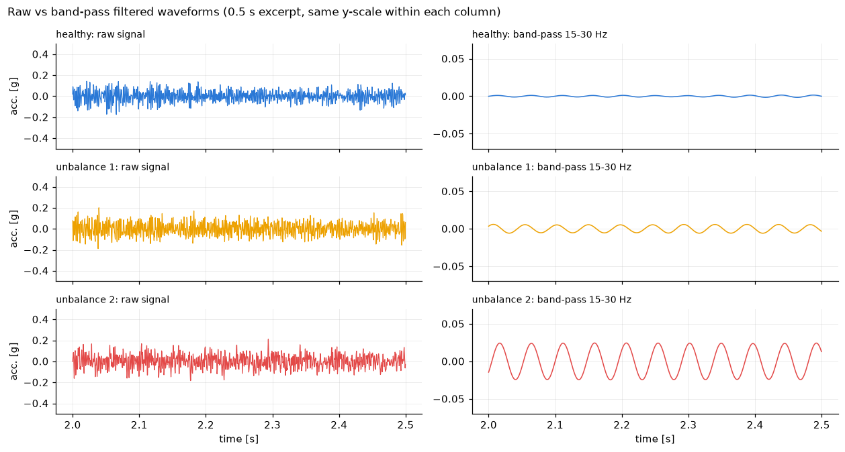
Figure 3. Raw and band-pass filtered waveforms of the three classes.
Feature selection. A filter method, a wrapper method and an embedded method were implemented. The filter method is the one-way ANOVA F-statistic, the wrapper method is recursive feature elimination with cross-validation (RFECV) and the embedded method is the weight of a linear SVM together with an L1-penalized SVM. Figures 4 to 6 show the class distributions with the F value in each panel title and Figure 7 compares the rankings of the methods. The three methods agree, with a rank correlation of 0.78 to 0.97 between them. The time-domain features of the raw signal do not separate the classes. The best of them, RMS, has F = 5.7 and most have p > 0.1. The frequency-domain features separate the classes well. The 1X amplitude has F = 1120, the 2X amplitude separates level 2 only and 3X carries nothing. The time-domain features of the band-pass filtered signal are the strongest of all, with F = 1260 to 1300 for peak-to-peak, peak, RMS and standard deviation, because for a sinusoid these statistics measure its amplitude. RFECV found that one feature, the band-pass peak, already reaches 100 % cross-validation accuracy. The L1-penalized SVM kept two features, the band-pass peak-to-peak and the band-pass crest factor, and discarded the other amplitude features as redundant copies of the same 1X information. Each method therefore delivered a candidate input set for the SVM, eight features from the ANOVA filter (all with F above 100), one from RFECV and two from the L1-SVM. Table 2 gives the class means of the key features in numbers.
Table 2. Class mean ± standard deviation of key features on the training records (mg).
Feature | Healthy | Unbalance 1 | Unbalance 2
1X amplitude (FFT) | 1.45 ± 0.59 | 5.55 ± 0.28 | 25.72 ± 2.94
2X amplitude (FFT) | 2.08 ± 1.04 | 2.24 ± 1.02 | 7.56 ± 1.47
RMS, band-pass 15 to 30 Hz | 1.14 ± 0.39 | 4.40 ± 0.21 | 20.28 ± 2.19
Peak-to-peak, band-pass 15 to 30 Hz | 4.75 ± 1.18 | 14.08 ± 0.59 | 60.46 ± 6.29
RMS, raw signal | 78.5 ± 19.7 | 71.8 ± 13.0 | 62.9 ± 9.0
Peak-to-peak, raw signal | 771 ± 360 | 686 ± 142 | 613 ± 166

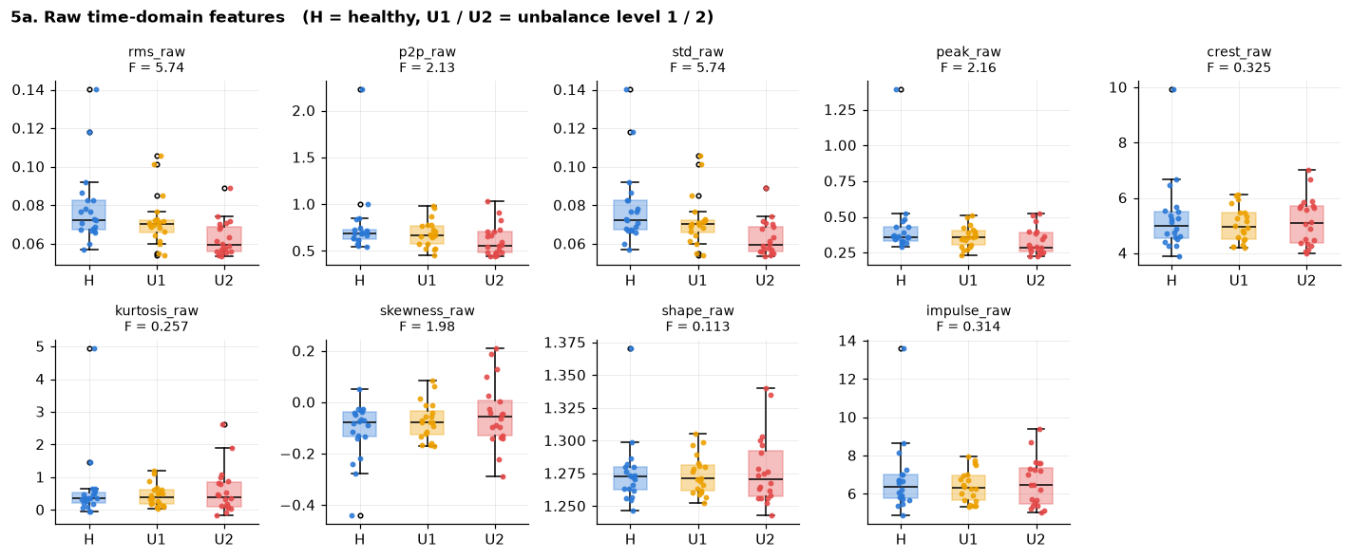
Figure 4. Raw time-domain features by class.
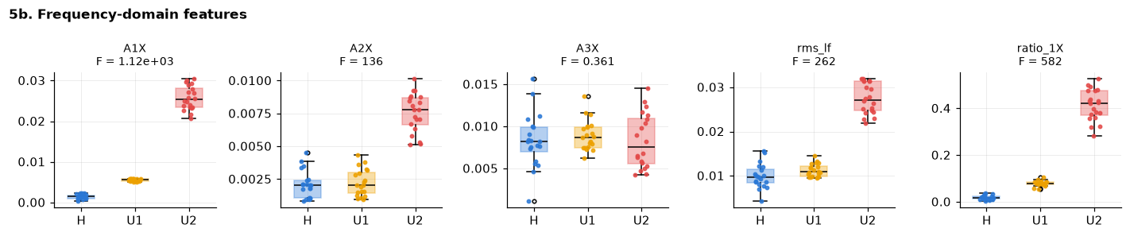
Figure 5. Frequency-domain features by class.
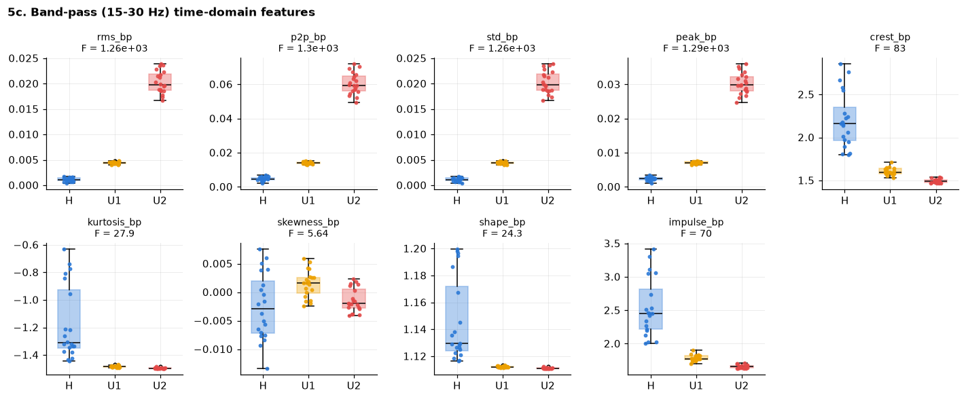
Figure 6. Band-pass filtered time-domain features by class.
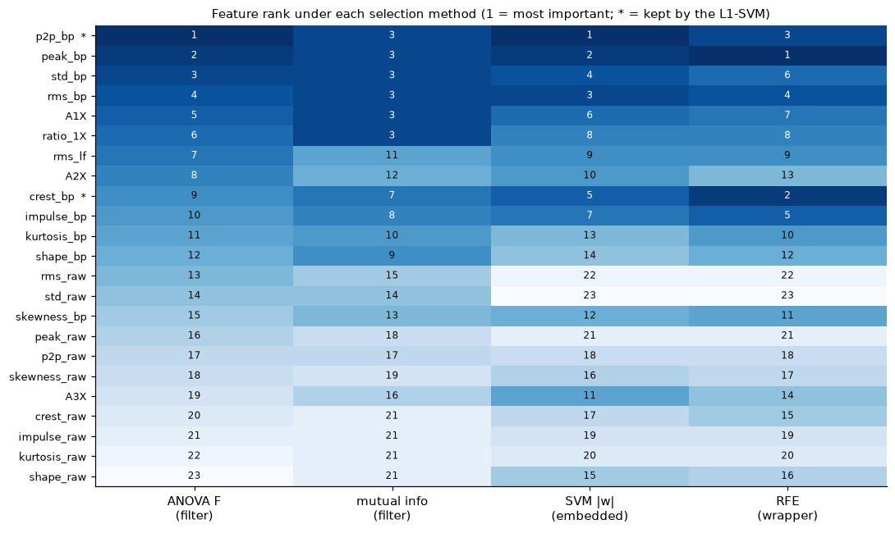
Figure 7. Feature rank under the filter, embedded and wrapper methods.

2.2 Solution flow chart
Figure 8 summarizes the process from top to bottom. The 90 records are loaded and labelled. Each record follows three signal paths, the FFT spectrum, the raw waveform and the band-pass filtered waveform, which yield the frequency-domain and time-domain features. Feature selection with the filter, embedded and wrapper methods ranks the features and defines the four feature sets. For each set an SVM is tuned by cross-validated grid search, the tuned models label the 30 test records, and the labels are scored with a confusion matrix, accuracy, precision and recall.
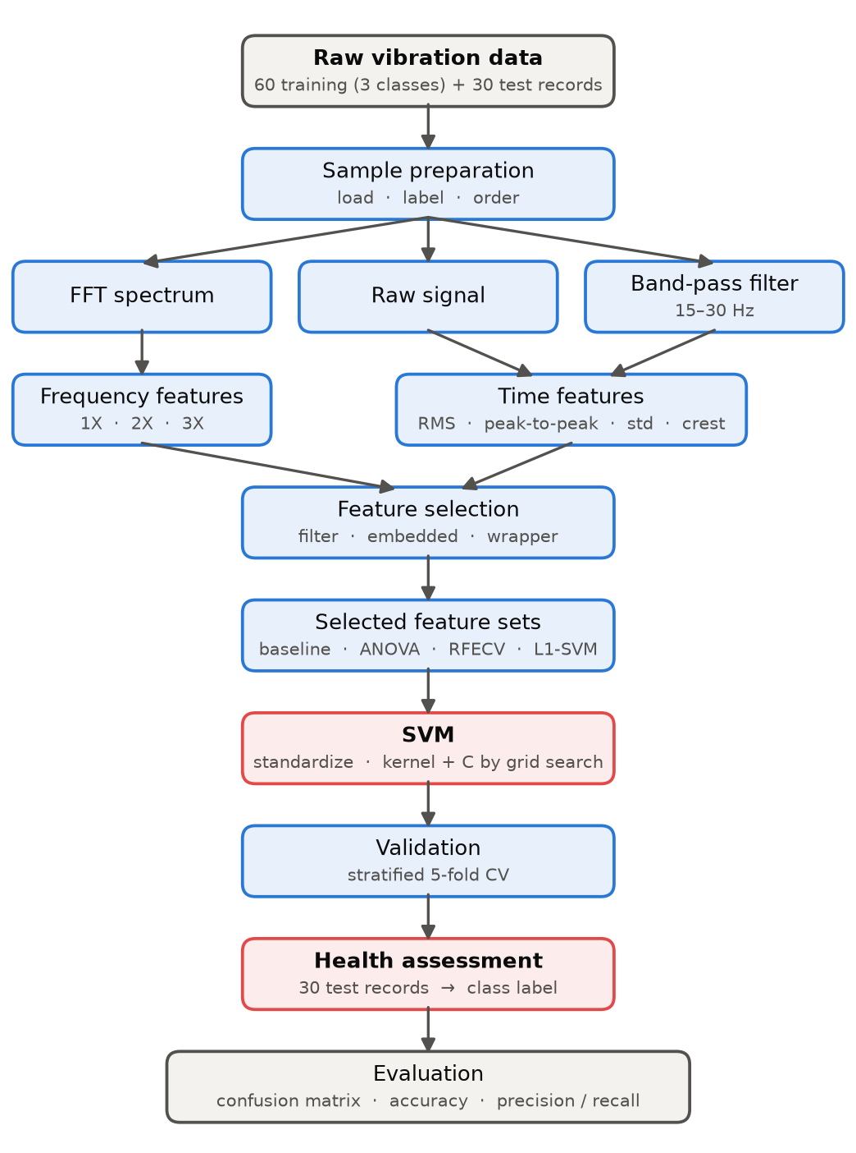
Figure 8. Flow chart of the solution process.

2.3 Support vector machine
The SVM was trained on the feature sets delivered by the selection step, so that selection feeds prediction. Set A keeps all nine raw time-domain features as a baseline without selection. Set B is the ANOVA filter selection with eight features, set C is the RFECV selection with the single band-pass peak, and set D is the L1-SVM selection with the band-pass peak-to-peak and the band-pass crest factor. For each set, a pipeline of standardization and SVM was tuned by grid search over the kernel (linear, RBF, polynomial), the penalty C and the RBF width, with stratified 5-fold cross-validation on the 60 training records.
The linear kernel was selected for every informative set, because the classes are linearly separable in the standardized feature space and the RBF and polynomial kernels reached the same accuracy without adding anything. Separability has a side effect. Many grid points tie at 100 % cross-validation accuracy, so the data do not decide C. Ties were broken with a training-only rule, the simplest kernel first and then the largest C, which is the hard-margin solution that places each boundary midway between the closest training records of neighbouring classes. A linear SVM implemented from scratch with the Pegasos algorithm gave the same hyperplane as scikit-learn on the healthy versus faulty problem (direction cosine 0.9999), which confirmed the implementation. The three-class problem is solved with one-vs-one voting.

3. Results
Table 3. Tuned SVM per selected feature set, with cross-validation accuracy on the 60 training records and accuracy on the 30 test records.
Feature set | Features | Best kernel | CV accuracy | Test accuracy | Test errors
A, raw baseline (no selection) | 9 | linear | 0.48 | 0.33 | 20 / 30
B, ANOVA filter | 8 | linear | 1.00 | 1.00 | 0 / 30
C, RFECV wrapper | 1 | linear | 1.00 | 1.00 | 0 / 30
D, L1-SVM embedded | 2 | linear | 1.00 | 1.00 | 0 / 30

Table 3 gives the main result. The baseline SVM on the raw time-domain features performs at chance level on the test set, with 10 of 30 records correct, and no kernel improves it. The three selected sets reach 100 % cross-validation accuracy and classify all 30 test records correctly. Set C, the single band-pass peak selected by RFECV, is the primary model because it is the smallest set with a perfect score.
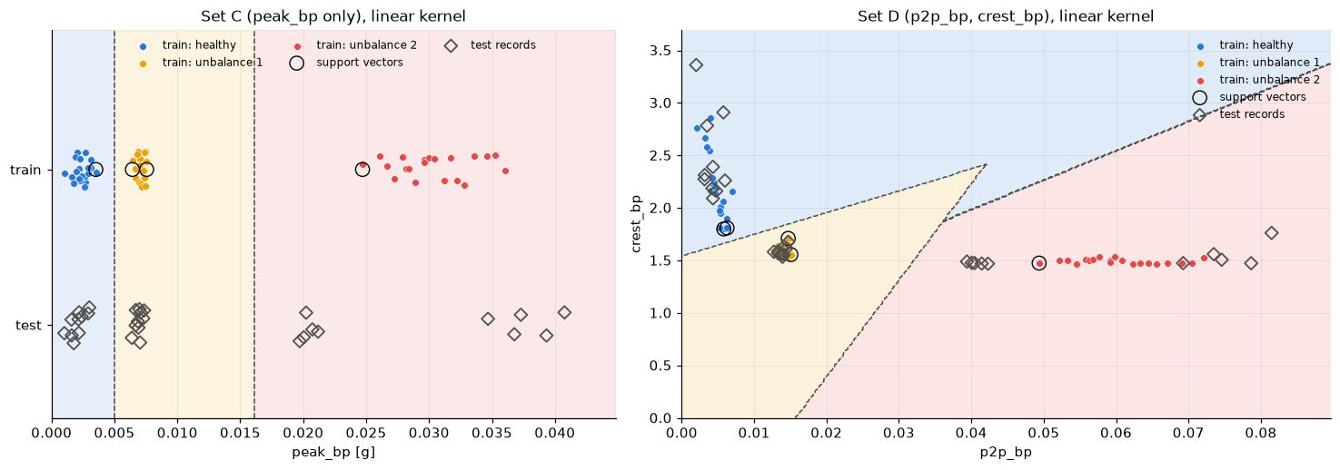
Figure 9. Decision thresholds of the one-feature set C (left) and decision regions of the two-feature set D (right), with support vectors and test records.
Figure 9 shows the two smallest selected models. For set C the SVM reduces to two thresholds on the band-pass peak, at 0.005 g and 0.016 g. For set D the decision regions in the peak-to-peak and crest-factor plane show the three well separated clusters, the support vectors (circled) as the few training records nearest to the boundaries, and all test records (diamonds) inside the region of their true class. Figure 10 shows the test confusion matrices of the four feature sets. The rows are the true conditions of the test records, which are listed in the appendix of the homework document and were used only for scoring, never for training. The columns are the SVM predictions. The primary model gives a diagonal 10/10/10 matrix with precision and recall of 1.000 for every class. Figure 11 lists the health label assigned to each of the 30 test records next to its true condition. Records 1 to 10 are healthy, 11 to 20 are unbalance level 1 and 21 to 30 are unbalance level 2.
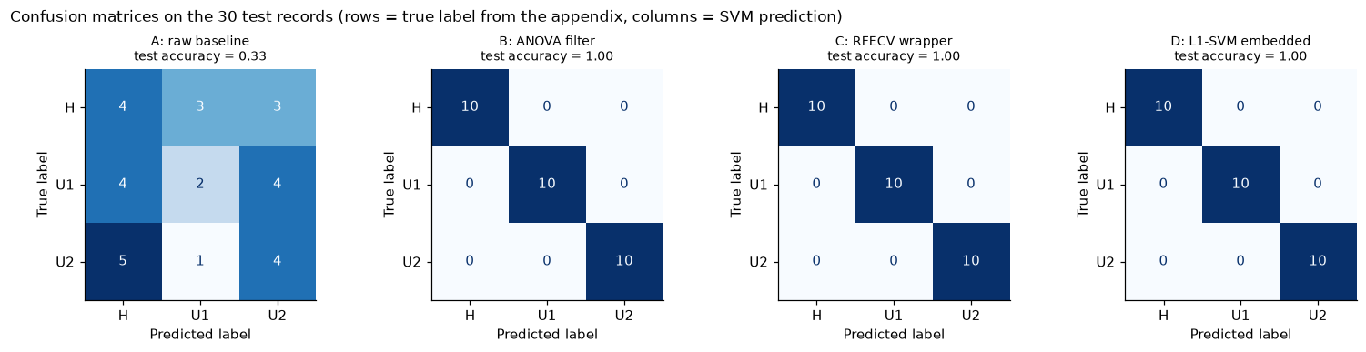
Figure 10. Confusion matrices on the 30 test records for the four feature sets.
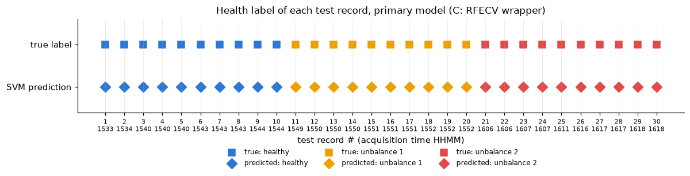
Figure 11. Health label of each test record, true condition and SVM prediction.
Figure 12 places the test records on the primary feature, the band-pass peak, next to the training clusters. Records 21 to 25 lie inside or above the level-2 training cluster, while records 26 to 30 (0.020 to 0.021 g) lie in the gap between the level-1 cluster, which ends at 0.0076 g, and the level-2 cluster, which starts at 0.0247 g. The hard-margin threshold sits at 0.016 g, so the five records are assigned to level 2 in agreement with their true condition, but they are the records with the smallest margin. A sensitivity check made this concrete. With C = 0.01, one of the grid points that also reaches 100 % cross-validation accuracy, the threshold moves to 0.0213 g and the same five records are labelled level 1, which drops the test accuracy to 83 %. With C of 0.1 or more the threshold stays near the midpoint and all 30 records are correct.
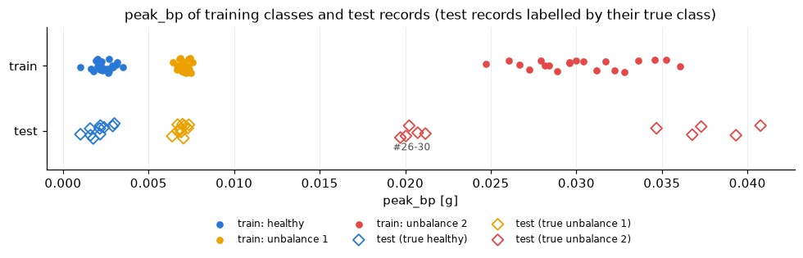
Figure 12. Band-pass peak of training classes and test records.

4. Discussion
Extracted features. Time-domain statistics of the raw signal are nearly useless on this testbed, because mass unbalance adds a synchronous force at 21 Hz while the overall vibration level is set by 400 to 800 Hz structural content that is identical in all three conditions. Two routes reach the useful band. The FFT gives the 1X and 2X amplitudes directly, and a band-pass filter around the shaft frequency makes the ordinary time-domain statistics measure the same 1X component. Speed tracking of the 1X peak is essential, since reading the spectrum at the nominal 20 Hz would destroy the feature.
Feature selection. The filter, embedded and wrapper methods gave the same ranking, so the result does not depend on the criterion, and each delivered an input set that the SVM confirmed with 100 % accuracy. The ANOVA filter ordered the features by margin, the SVM weights ranked the shape features (crest and impulse factor of the filtered signal) higher because the classifier uses them together with an amplitude feature, and the L1 penalty and RFECV showed that a single amplitude feature is sufficient and that the amplitude features are redundant copies of one another.
Modelling technique. The classes are linearly separable in every selected set, so the linear kernel was selected and cross-validation could not discriminate between kernels, penalties or sets. The choice of C then rests on the tie-break rule, and the sensitivity check shows that it matters for a one-feature model. A small C pulls the level-1 / level-2 threshold toward the level-2 cluster and mislabels the five intermediate test records, while the hard-margin solution places it midway and labels them correctly. The two-feature set D is not sensitive to this choice, because the crest factor separates the sinusoidal unbalance records from the noise-like healthy records independently of the amplitude. The SVM gives hard labels but no probability, and the distance to the boundary plays the role of a confidence measure.
Results. All 30 test records are classified correctly by the three selected sets. Records 26 to 30 are correctly labelled level 2 but sit between the two unbalance training clusters, which suggests a smaller effective unbalance than the training level 2, for example a different screw position. A three-level classifier only resolves the levels it was trained on. A continuous severity indicator such as the band-pass peak or the 1X amplitude is more informative when the unbalance can take intermediate values.
Limitations. The test set is small, 10 records per class, and was recorded on the same day as the training data, so the perfect score is not a guarantee for other speeds, loads or sensors. The perfect separability also means that the hyper-parameter search and the wrapper selection had nothing to trade off.

5. Conclusion
- Time-domain statistics of the raw signal (RMS, peak-to-peak, standard deviation) cannot separate healthy, level-1 and level-2 unbalance. An SVM trained on them performs at chance level (33 %) on the test set.
- The same statistics on a 15 to 30 Hz band-pass filtered signal, or the 1X and 2X FFT amplitudes, separate the three classes perfectly (ANOVA F above 1000). Filter, wrapper and embedded selection methods agree and delivered input sets of eight, one and two features, each of which the SVM confirmed with 100 % accuracy.
- A linear-kernel SVM is selected for every informative set because the classes are linearly separable. Ties in cross-validation accuracy are broken toward the hard-margin solution, which places thresholds midway between neighbouring clusters. With a small C the one-feature model would mislabel the five intermediate test records, so the tie-break matters.
- On the 30 test records the primary model predicts every record correctly, records 1 to 10 healthy, 11 to 20 unbalance level 1 and 21 to 30 unbalance level 2, a diagonal 10/10/10 confusion matrix with precision and recall of 1.0 for every class. Records 26 to 30 lie between the two unbalance clusters and are the least certain. For deployment the two-feature set D (band-pass peak-to-peak and crest factor) is the more robust choice.

6. Appendix – Codes
All results were produced by the Jupyter notebook hw3_rotor_bearing_svm.ipynb (Python 3.13 with numpy, scipy, pandas, scikit-learn and matplotlib). The code cells are reproduced in execution order, grouped by notebook section. Printed outputs are omitted.

1. Setup
# Imports, constants, and a consistent plotting style used throughout the notebook.
import re
from pathlib import Path

import numpy as np
import pandas as pd
import matplotlib.pyplot as plt
from matplotlib.patches import Patch
from scipy import signal, stats
from sklearn.svm import SVC
from sklearn.pipeline import make_pipeline
from sklearn.preprocessing import StandardScaler
from sklearn.model_selection import GridSearchCV, StratifiedKFold, cross_val_score, cross_val_predict
from sklearn.feature_selection import f_classif, mutual_info_classif, RFECV
from sklearn.svm import LinearSVC
from sklearn.metrics import confusion_matrix, accuracy_score, classification_report, ConfusionMatrixDisplay

FS = 2560.0 # sampling rate [Hz]
F_ROT = 20.0 # nominal shaft speed [Hz] (1X)

DATA_DIR = next(p for p in (Path("../data/rotor-bearing-hw3"), Path("data/rotor-bearing-hw3")) if p.exists()).resolve()
OUT_DIR = Path("results"); OUT_DIR.mkdir(exist_ok=True)

CLASSES = ["healthy", "unbalance 1", "unbalance 2"] # class index 0, 1, 2
COLORS = {"healthy": "#2a78d6", "unbalance 1": "#eda100", "unbalance 2": "#e34948"}
C_TEST = "#52514e"
CMAP = plt.matplotlib.colors.ListedColormap([COLORS[c] for c in CLASSES])
plt.rcParams.update({
"figure.dpi": 110, "axes.spines.top": False, "axes.spines.right": False,
"axes.grid": True, "grid.alpha": 0.25, "grid.linewidth": 0.6,
"lines.linewidth": 1.2, "font.size": 9.5, "legend.frameon": False,
})
pd.set_option("display.precision", 4)
print("Data folder:", DATA_DIR)

2. Data loading
# Read one record and parse the acquisition time / record index from the file name.
def load_record(path: Path) -> np.ndarray:
lines = path.read_text().splitlines()
start = next(i for i, l in enumerate(lines) if l.strip().lower() == "acceleration") + 1
return np.array([float(v) for v in lines[start:] if v.strip()])

def parse_name(path: Path):
m = re.search(r"Time (\d{4})-(\d+)", path.name)
return m.group(1), int(m.group(2))

def load_folder(folder: Path, label):
recs = []
for p in sorted(folder.glob("*.txt")):
t, idx = parse_name(p)
recs.append({"file": p.name, "time": t, "idx": idx, "label": label, "x": load_record(p)})
return recs

# True label of a test record, following the appendix table of the assignment.
def test_label(path: Path):
t, _ = parse_name(path)
if path.name.startswith("Data"):
return 0 # healthy
return 1 if int(t) < 1600 else 2 # 15:49-15:52 -> level 1, 16:06-16:18 -> level 2

healthy = load_folder(DATA_DIR / "Training" / "Healthy", 0)
unbal1 = load_folder(DATA_DIR / "Training" / "Faulty" / "Unbalance 1", 1)
unbal2 = load_folder(DATA_DIR / "Training" / "Faulty" / "Unbalance 2", 2)
testing = sorted([dict(r, label=test_label(DATA_DIR / "Testing" / r["file"])) for r in load_folder(DATA_DIR / "Testing", None)],
key=lambda r: (r["time"], r["idx"]))
training = healthy + unbal1 + unbal2

print(f"training: {len(healthy)} healthy, {len(unbal1)} unbalance 1, {len(unbal2)} unbalance 2 | testing: {len(testing)} records")
print("test labels (from appendix):", np.bincount([r["label"] for r in testing]), "= healthy, unbalance 1, unbalance 2")
print("samples per record:", {len(r["x"]) for r in training + testing}, "->", len(healthy[0]["x"]) / FS, "s each")

3. Raw data description
# Per-class summary statistics of the raw acceleration signals.
def raw_stats(recs, name):
x = np.concatenate([r["x"] for r in recs])
return pd.Series({"records": len(recs), "mean [g]": x.mean(), "std [g]": x.std(), "min [g]": x.min(), "max [g]": x.max()}, name=name)

pd.DataFrame([raw_stats(healthy, "healthy"), raw_stats(unbal1, "unbalance 1"), raw_stats(unbal2, "unbalance 2"), raw_stats(testing, "testing")])

# Time waveforms of one record per class (first 0.5 s, about 10 shaft revolutions).
t = np.arange(len(healthy[0]["x"])) / FS
n_show = int(0.5 * FS)
fig, axes = plt.subplots(3, 1, figsize=(9, 5.4), sharex=True, sharey=True)
for ax, rec, cls in zip(axes, (healthy[0], unbal1[0], unbal2[0]), CLASSES):
ax.plot(t[:n_show], rec["x"][:n_show], color=COLORS[cls], lw=0.8)
ax.set_title(f"{cls}: {rec['file']}", loc="left", fontsize=9); ax.set_ylabel("acc. [g]")
axes[-1].set_xlabel("time [s]")
fig.suptitle("Raw vibration waveforms (first 0.5 s)", x=0.01, ha="left", fontsize=11)
fig.tight_layout(); plt.show()

# Hann-windowed single-sided amplitude spectrum, and class-averaged spectra in the 0-100 Hz band.
def amplitude_spectrum(x: np.ndarray):
x = x - x.mean(); w = np.hanning(len(x))
return np.fft.rfftfreq(len(x), d=1 / FS), 2.0 * np.abs(np.fft.rfft(x * w)) / w.sum()

def mean_spectrum(recs):
f = amplitude_spectrum(recs[0]["x"])[0]
return f, np.mean([amplitude_spectrum(r["x"])[1] for r in recs], axis=0)

fig = plt.figure(figsize=(12.5, 5.6))
gs = fig.add_gridspec(3, 2, width_ratios=[1.3, 1], hspace=0.6, wspace=0.22)
ax0 = fig.add_subplot(gs[:, 0]) # left: all classes overlaid, full band
for recs, cls in zip((healthy, unbal1, unbal2), CLASSES):
f, A = mean_spectrum(recs)
ax0.plot(f, A, color=COLORS[cls], lw=0.7, label=cls, alpha=0.9)
ax0.set(title="All classes overlaid, 0-1280 Hz", xlabel="frequency [Hz]", ylabel="amplitude [g]"); ax0.legend()
for i, (recs, cls) in enumerate(zip((healthy, unbal1, unbal2), CLASSES)): # right: one panel per class, own y-scale
ax = fig.add_subplot(gs[i, 1]); f, A = mean_spectrum(recs); m = f <= 100
ax.plot(f[m], A[m], color=COLORS[cls], lw=1.0)
for k in (1, 2, 3):
ax.axvline(k * 21.05, color="0.75", ls=":", lw=0.8)
if i == 0: ax.text(k * 21.05 + 1, ax.get_ylim()[1] * 0.8, f"{k}X", color="0.4", fontsize=8)
ax.set_title(f"{cls}, 0-100 Hz", loc="left", fontsize=9); ax.set_ylabel("amplitude [g]")
if i < 2: ax.tick_params(labelbottom=False)
ax.set_xlabel("frequency [Hz]")
fig.suptitle("Class-averaged amplitude spectra (each right-hand panel has its own amplitude scale)", x=0.01, ha="left", fontsize=11)
plt.show()

4. Feature extraction
# Time-domain statistics of a signal, suffixed with the signal they come from.
TD_STATS = ["rms", "p2p", "std", "peak", "crest", "kurtosis", "skewness", "shape", "impulse"]

def time_domain_features(x: np.ndarray, tag: str) -> dict:
rms = np.sqrt(np.mean(x ** 2)); peak = np.max(np.abs(x)); mean_abs = np.mean(np.abs(x))
return {f"rms_{tag}": rms, f"p2p_{tag}": np.ptp(x), f"std_{tag}": x.std(), f"peak_{tag}": peak,
f"crest_{tag}": peak / rms, f"kurtosis_{tag}": stats.kurtosis(x), f"skewness_{tag}": stats.skew(x),
f"shape_{tag}": rms / mean_abs, f"impulse_{tag}": peak / mean_abs}

# Zero-phase band-pass filter around 1X (4th-order Butterworth, forward-backward), with edge trimming.
SOS_BP = signal.butter(4, [15.0, 30.0], btype="band", fs=FS, output="sos")
TRIM = int(1.0 * FS)
def bandpass(x): return signal.sosfiltfilt(SOS_BP, x)[TRIM:-TRIM]

def band_peak(f, A, f_center, half_width):
m = (f >= f_center - half_width) & (f <= f_center + half_width)
i = np.argmax(A[m]); return A[m][i], f[m][i]

# Full feature vector for one record.
def extract_features(x: np.ndarray) -> dict:
f, A = amplitude_spectrum(x)
a1, f1 = band_peak(f, A, F_ROT, 0.15 * F_ROT)
a2, _ = band_peak(f, A, 2 * f1, 1.0)
a3, _ = band_peak(f, A, 3 * f1, 1.0)
lf = (f > 0) & (f <= 100)
d = {"A1X": a1, "A2X": a2, "A3X": a3, "f1X": f1,
"rms_lf": np.sqrt(np.sum((A[lf] / np.sqrt(2)) ** 2)), "ratio_1X": a1 / np.sqrt(np.mean(x ** 2))}
d |= time_domain_features(x[TRIM:-TRIM], "raw")
d |= time_domain_features(bandpass(x), "bp")
return d

def feature_table(recs):
rows = []
for r in recs:
d = extract_features(r["x"]); d.update(file=r["file"], time=r["time"], label=r["label"]); rows.append(d)
return pd.DataFrame(rows)

train = feature_table(training)
test = feature_table(testing)
FEAT_RAW = [f"{s}_raw" for s in TD_STATS]
FEAT_SPEC = ["A1X", "A2X", "A3X", "rms_lf", "ratio_1X"]
FEAT_BP = [f"{s}_bp" for s in TD_STATS]
FEATURES = FEAT_RAW + FEAT_SPEC + FEAT_BP
y_train, y_test = train.label.values, test.label.values
train.to_csv(OUT_DIR / "train_features.csv", index=False); test.to_csv(OUT_DIR / "test_features.csv", index=False)
print(f"{len(FEATURES)} features per record: {len(FEAT_RAW)} raw time-domain, {len(FEAT_SPEC)} frequency-domain, {len(FEAT_BP)} band-pass time-domain")
train.groupby("label")[FEATURES].mean().T.rename(columns=dict(enumerate(CLASSES)))

# Band-pass filtered time-domain data: raw (left) vs 15-30 Hz filtered (right) waveform, 0.5 s excerpt per class.
i0 = int(2.0 * FS) # excerpt from t = 2.0 s to 2.5 s (clear of the trimmed filter edges)
fig, axes = plt.subplots(3, 2, figsize=(11.5, 6.2), sharex=True)
for row, (rec, cls) in enumerate(zip((healthy[0], unbal1[0], unbal2[0]), CLASSES)):
x = rec["x"]; xb = bandpass(x)
axes[row, 0].plot(t[i0:i0 + n_show], x[i0:i0 + n_show], color=COLORS[cls], lw=0.8); axes[row, 0].set_ylim(-0.5, 0.5)
axes[row, 1].plot(t[i0:i0 + n_show], xb[i0 - TRIM:i0 - TRIM + n_show], color=COLORS[cls], lw=1.0); axes[row, 1].set_ylim(-0.07, 0.07)
axes[row, 0].set_title(f"{cls}: raw signal", loc="left", fontsize=9)
axes[row, 1].set_title(f"{cls}: band-pass 15-30 Hz", loc="left", fontsize=9)
axes[row, 0].set_ylabel("acc. [g]")
for ax in axes[-1]:
ax.set_xlabel("time [s]")
fig.suptitle("Raw vs band-pass filtered waveforms (0.5 s excerpt, same y-scale within each column)", x=0.01, ha="left", fontsize=11)
fig.tight_layout(); plt.show()

5. Feature exploration and selection
# Box plot helper: one panel per feature, three classes.
rng = np.random.default_rng(0)
def box_panel(ax, feat, title):
data = [train.loc[train.label == k, feat] for k in range(3)]
bp = ax.boxplot(data, widths=0.5, patch_artist=True, medianprops=dict(color="black", lw=1),
flierprops=dict(marker="o", markersize=3, markerfacecolor="none"))
for patch, cls in zip(bp["boxes"], CLASSES):
patch.set(facecolor=COLORS[cls], alpha=0.35, edgecolor=COLORS[cls])
for i, (d, cls) in enumerate(zip(data, CLASSES), start=1):
ax.scatter(i + rng.uniform(-0.12, 0.12, len(d)), d, s=8, color=COLORS[cls], alpha=0.85, zorder=3)
ax.set_xticks([1, 2, 3]); ax.set_xticklabels(["H", "U1", "U2"]); ax.set_title(title, fontsize=9)

def box_grid(feats, suptitle, ncol=5):
nrow = int(np.ceil(len(feats) / ncol))
fig, axes = plt.subplots(nrow, ncol, figsize=(2.6 * ncol, 2.7 * nrow))
for ax, feat in zip(np.ravel(axes), feats):
F = f_classif(train[[feat]].values, y_train)[0][0]
box_panel(ax, feat, f"{feat}\nF = {F:.3g}")
for ax in np.ravel(axes)[len(feats):]:
ax.axis("off")
fig.suptitle(suptitle, x=0.01, ha="left", fontsize=11, fontweight="bold"); fig.tight_layout(); plt.show()

box_grid(FEAT_RAW, "5a. Raw time-domain features (H = healthy, U1 / U2 = unbalance level 1 / 2)")
box_grid(FEAT_SPEC, "5b. Frequency-domain features")
box_grid(FEAT_BP, "5c. Band-pass (15-30 Hz) time-domain features")

# Three-class separability ranking: ANOVA F-statistic and p-value for every feature.
F, p = f_classif(train[FEATURES].values, y_train)
ranking = pd.DataFrame({"feature": FEATURES, "F": F, "p-value": p,
"group": ["raw time-domain"] * len(FEAT_RAW) + ["frequency-domain"] * len(FEAT_SPEC) + ["band-pass time-domain"] * len(FEAT_BP)})
ranking = ranking.sort_values("F", ascending=False).reset_index(drop=True)

group_color = {"raw time-domain": "#86b6ef", "frequency-domain": "#eb6834", "band-pass time-domain": "#1c5cab"}
fig, ax = plt.subplots(figsize=(8.5, 6))
rk = ranking[::-1]
ax.barh(rk.feature, rk.F.clip(lower=1e-2), color=[group_color[g] for g in rk.group], height=0.65)
ax.set(xscale="log", xlabel="ANOVA F-statistic (log scale)", title="Three-class feature separability")
ax.grid(axis="y", visible=False)
ax.legend(handles=[Patch(color=c, label=g) for g, c in group_color.items()], loc="lower right")
fig.tight_layout(); plt.show()
ranking.style.format({"F": "{:.3g}", "p-value": "{:.2e}"}).hide(axis="index")

5.2 Wrapper and embedded methods
# Standardized training matrix shared by the selection methods below.
scaler_all = StandardScaler().fit(train[FEATURES].values)
Z_all = scaler_all.transform(train[FEATURES].values)
CV = StratifiedKFold(n_splits=5, shuffle=True, random_state=0) # stratified 5-fold splitter, reused in section 6

# Filter 2: mutual information between each feature and the class label.
mi = mutual_info_classif(Z_all, y_train, random_state=0)

# Embedded 1: weights of the tuned linear SVM on all features (one-vs-one gives three pairwise classifiers; take the mean |w|).
svm_lin = SVC(kernel="linear", C=1).fit(Z_all, y_train)
w_abs = np.abs(svm_lin.coef_).mean(axis=0)

# Embedded 2: L1-penalized linear SVM. Sweep the penalty and count the surviving (non-zero) features.
l1_path = []
for C in [0.01, 0.02, 0.05, 0.1, 0.2, 0.5, 1.0]:
l1 = LinearSVC(penalty="l1", dual=False, C=C, max_iter=20000).fit(Z_all, y_train)
alive = np.any(np.abs(l1.coef_) > 1e-6, axis=0)
cv_acc = cross_val_score(make_pipeline(StandardScaler(), LinearSVC(penalty="l1", dual=False, C=C, max_iter=20000)), train[FEATURES].values, y_train, cv=CV).mean()
l1_path.append({"C": C, "features kept": int(alive.sum()), "CV accuracy": cv_acc, "kept": [f for f, a in zip(FEATURES, alive) if a]})
l1_tab = pd.DataFrame(l1_path)
# smallest penalty that still gives perfect cross-validation accuracy
C_L1 = l1_tab.loc[l1_tab["CV accuracy"] >= l1_tab["CV accuracy"].max() - 1e-9, "C"].min()
l1_keep = l1_tab.loc[l1_tab.C == C_L1, "kept"].iloc[0]
print(f"L1-SVM: smallest C with the best CV accuracy = {C_L1} -> keeps {len(l1_keep)} feature(s): {l1_keep}")
l1_tab[["C", "features kept", "CV accuracy"]].style.format({"CV accuracy": "{:.3f}"}).hide(axis="index")

# Wrapper: recursive feature elimination with 5-fold cross-validation, using the linear SVM as the estimator.
rfecv = RFECV(SVC(kernel="linear", C=1), step=1, min_features_to_select=1, cv=CV, scoring="accuracy").fit(Z_all, y_train)
n_feat = np.arange(1, len(FEATURES) + 1)
mean_acc, std_acc = rfecv.cv_results_["mean_test_score"], rfecv.cv_results_["std_test_score"]
rfe_selected = [f for f, keep in zip(FEATURES, rfecv.support_) if keep]
print(f"RFECV: smallest subset reaching the best CV accuracy = {rfecv.n_features_} feature(s): {rfe_selected}")

fig, ax = plt.subplots(figsize=(8, 3.2))
ax.fill_between(n_feat, mean_acc - std_acc, mean_acc + std_acc, color="#86b6ef", alpha=0.4, label="±1 std over folds")
ax.plot(n_feat, mean_acc, marker="o", ms=4, color="#1c5cab", label="mean CV accuracy")
ax.axvline(rfecv.n_features_, color=COLORS["unbalance 2"], ls="--", lw=1, label=f"selected: {rfecv.n_features_} feature(s)")
ax.set(xlabel="number of features kept (RFE eliminates the smallest-weight feature at each step)", ylabel="5-fold CV accuracy",
ylim=(0.3, 1.03), title="Wrapper method: recursive feature elimination with cross-validation")
ax.legend(loc="lower right"); fig.tight_layout(); plt.show()

# Side-by-side comparison of the four criteria: rank of every feature under each method (1 = most important).
comp = pd.DataFrame({"feature": FEATURES, "ANOVA F": F, "mutual info": mi, "linear SVM |w|": w_abs,
"RFE order": rfecv.ranking_, # 1 = kept to the end, larger = eliminated earlier
"L1-SVM kept": [f in l1_keep for f in FEATURES]})
for col in ["ANOVA F", "mutual info", "linear SVM |w|"]:
comp[f"rank {col}"] = comp[col].rank(ascending=False).astype(int)
comp["rank RFE"] = comp["RFE order"].rank(method="min").astype(int)
comp = comp.sort_values("rank ANOVA F").reset_index(drop=True)

rank_cols = ["rank ANOVA F", "rank mutual info", "rank linear SVM |w|", "rank RFE"]
print("Spearman correlation between rankings (1 = identical order):")
print(comp[rank_cols].corr(method="spearman").round(2).to_string())

fig, ax = plt.subplots(figsize=(10, 6))
mat = comp[rank_cols].values
im = ax.imshow(mat, cmap="Blues_r", aspect="auto", vmin=1, vmax=len(FEATURES))
ax.set_xticks(range(len(rank_cols))); ax.set_xticklabels(["ANOVA F\n(filter)", "mutual info\n(filter)", "SVM |w|\n(embedded)", "RFE\n(wrapper)"])
ax.set_yticks(range(len(comp))); ax.set_yticklabels([f + (" *" if k else "") for f, k in zip(comp.feature, comp["L1-SVM kept"])], fontsize=8.5)
for i in range(mat.shape[0]):
for j in range(mat.shape[1]):
ax.text(j, i, mat[i, j], ha="center", va="center", fontsize=8, color="white" if mat[i, j] <= 8 else "#0b0b0b")
ax.set_title("Feature rank under each selection method (1 = most important; * = kept by the L1-SVM)", fontsize=10); ax.grid(False)
fig.tight_layout(); plt.show()
comp[["feature"] + rank_cols + ["L1-SVM kept"]].style.hide(axis="index")

6. Support vector machine
# Minimal linear soft-margin SVM trained with Pegasos (stochastic sub-gradient descent on the hinge loss).
class LinearSVMScratch:
def __init__(self, lam=0.01, n_epochs=2000, seed=0):
self.lam, self.n_epochs, self.seed = lam, n_epochs, seed

def fit(self, X, y):
X = np.asarray(X, float); y = np.where(np.asarray(y) > 0, 1.0, -1.0)
n, d = X.shape; rng = np.random.default_rng(self.seed)
w, b, t = np.zeros(d), 0.0, 0
w_sum, b_sum = np.zeros(d), 0.0
for _ in range(self.n_epochs):
for i in rng.permutation(n):
t += 1; eta = 1.0 / (self.lam * t)
if y[i] * (X[i] @ w + b) < 1: # margin violated: hinge sub-gradient active
w = (1 - eta * self.lam) * w + eta * y[i] * X[i]; b += eta * y[i]
else:
w = (1 - eta * self.lam) * w
w_sum += w; b_sum += b
self.coef_, self.intercept_ = w_sum / t, b_sum / t # averaged iterate (more stable)
self.hinge_ = np.mean(np.maximum(0, 1 - y * (X @ self.coef_ + self.intercept_)))
return self

def decision_function(self, X): return np.asarray(X, float) @ self.coef_ + self.intercept_
def predict(self, X): return (self.decision_function(X) >= 0).astype(int)

# Binary check (healthy = 0 vs faulty = 1) on two standardized features.
Xb = train[["A1X", "A2X"]].values; yb = (y_train > 0).astype(int)
scaler_b = StandardScaler().fit(Xb); Zb = scaler_b.transform(Xb)
lam = 0.01; C_equiv = 1.0 / (lam * len(Zb)) # Pegasos lambda <-> sklearn C = 1 / (lambda n)
scratch = LinearSVMScratch(lam=lam).fit(Zb, yb)
sk = SVC(kernel="linear", C=C_equiv).fit(Zb, yb)
print(f"scratch : w = {scratch.coef_.round(3)}, b = {scratch.intercept_:.3f}, mean hinge loss = {scratch.hinge_:.4f}")
print(f"sklearn : w = {sk.coef_[0].round(3)}, b = {sk.intercept_[0]:.3f} (C = {C_equiv:.3g})")
print("training accuracy scratch / sklearn:", accuracy_score(yb, scratch.predict(Zb)), "/", accuracy_score(yb, sk.predict(Zb)))
print("direction cosine between the two weight vectors:", np.dot(scratch.coef_, sk.coef_[0]) / np.linalg.norm(scratch.coef_) / np.linalg.norm(sk.coef_[0]))

# Visual check: both hyperplanes (and sklearn's margin / support vectors) on the standardized A1X-A2X plane.
fig, ax = plt.subplots(figsize=(7.5, 4.5))
for k, cls in enumerate(CLASSES):
m = y_train == k
ax.scatter(Zb[m, 0], Zb[m, 1], s=26, color=COLORS[cls], label=cls, zorder=3)
ax.scatter(Zb[sk.support_, 0], Zb[sk.support_, 1], s=110, facecolor="none", edgecolor="black", lw=1.0, label="support vectors (sklearn)", zorder=4)
xx = np.linspace(Zb[:, 0].min() - 0.3, Zb[:, 0].max() + 0.3, 200)
for mdl, c, name, ls in [(scratch, "0.2", "from scratch", "-"), (sk, "#4a3aa7", "sklearn", "--")]:
w, b = (mdl.coef_, mdl.intercept_) if mdl is scratch else (mdl.coef_[0], mdl.intercept_[0])
for off, lw in [(0, 1.6), (1, 0.7), (-1, 0.7)]:
ax.plot(xx, (off - b - w[0] * xx) / w[1], color=c, ls=ls, lw=lw, label=f"{name}: w·x + b = 0" if off == 0 else None)
ax.set(xlabel="A1X (standardized)", ylabel="A2X (standardized)", ylim=(Zb[:, 1].min() - 0.6, Zb[:, 1].max() + 0.6),
title="Linear SVM, healthy vs faulty: scratch vs scikit-learn (thin lines: margins)")
ax.legend(loc="upper right", fontsize=8); fig.tight_layout(); plt.show()

6.2 Multi-class SVM: kernel and hyper-parameter selection
# Feature sets and the hyper-parameter grid.
FEATURE_SETS = {
"A: raw baseline": FEAT_RAW, # no selection, all raw time-domain features
"B: ANOVA filter": [f for f, Fv in zip(FEATURES, F) if Fv > 100], # filter method, section 5.1
"C: RFECV wrapper": rfe_selected, # wrapper method, section 5.2
"D: L1-SVM embedded": l1_keep, # embedded method, section 5.2
}
for name, feats in FEATURE_SETS.items():
print(f"{name:20s} {len(feats):2d} feature(s): {feats}")
GRID = [
{"svc__kernel": ["linear"], "svc__C": [0.01, 0.1, 1, 10, 100]},
{"svc__kernel": ["rbf"], "svc__C": [0.1, 1, 10, 100], "svc__gamma": ["scale", 0.01, 0.1, 1]},
{"svc__kernel": ["poly"], "svc__C": [0.1, 1, 10], "svc__degree": [2, 3], "svc__gamma": ["scale"]},
]
CV = StratifiedKFold(n_splits=5, shuffle=True, random_state=0)

# Tie-break among grid points with the best mean CV accuracy: simplest kernel first, then the largest C (max margin).
def pick_best(cv_results):
df = pd.DataFrame(cv_results)
cand = df[df.mean_test_score >= df.mean_test_score.max() - 1e-12].copy()
cand["kernel_rank"] = cand["param_svc__kernel"].map({"linear": 0, "rbf": 1, "poly": 2})
cand["C"] = cand["param_svc__C"].astype(float)
return int(cand.sort_values(["kernel_rank", "C"], ascending=[True, False]).index[0])

searches, rows = {}, []
for name, feats in FEATURE_SETS.items():
pipe = make_pipeline(StandardScaler(), SVC())
gs = GridSearchCV(pipe, GRID, cv=CV, scoring="accuracy", refit=pick_best).fit(train[feats].values, y_train)
gs.best_params_ = gs.cv_results_["params"][gs.best_index_] # not filled automatically when refit is a callable
gs.best_score_ = gs.cv_results_["mean_test_score"][gs.best_index_]
searches[name] = gs
best = gs.best_params_
rows.append({"feature set": name, "n features": len(feats), "best kernel": best["svc__kernel"], "C": best["svc__C"],
"gamma / degree": best.get("svc__gamma", best.get("svc__degree", "-")),
"CV accuracy": gs.best_score_, "CV std": gs.cv_results_["std_test_score"][gs.best_index_],
"train accuracy": gs.best_estimator_.score(train[feats].values, y_train)})
cv_table = pd.DataFrame(rows).set_index("feature set")
cv_table.style.format({"CV accuracy": "{:.3f}", "CV std": "{:.3f}", "train accuracy": "{:.3f}"})

# How the kernels compare within each feature set (best C / gamma per kernel).
fig, ax = plt.subplots(figsize=(9, 3.6))
width = 0.25; kernels = ["linear", "rbf", "poly"]; kcol = {"linear": "#2a78d6", "rbf": "#1baf7a", "poly": "#4a3aa7"}
for j, k in enumerate(kernels):
vals = []
for name, gs in searches.items():
res = pd.DataFrame(gs.cv_results_); vals.append(res.loc[res["param_svc__kernel"] == k, "mean_test_score"].max())
ax.bar(np.arange(len(searches)) + (j - 1) * width, vals, width, color=kcol[k], label=k)
ax.set_xticks(np.arange(len(searches))); ax.set_xticklabels([n.split(":")[0] + ":" + n.split(":")[1][:22] for n in searches], fontsize=8.5)
ax.axhline(1 / 3, color="0.6", ls=":", lw=0.8); ax.text(len(searches) - 0.6, 0.35, "chance (1/3)", color="0.4", fontsize=8)
ax.set(ylim=(0, 1.05), ylabel="best 5-fold CV accuracy", title="Kernel comparison per feature set")
ax.grid(axis="x", visible=False); ax.legend(loc="upper center", bbox_to_anchor=(0.5, -0.14), ncol=3); fig.tight_layout(); plt.show()

# Cross-validated confusion matrices on the training data (out-of-fold predictions of the tuned models).
fig, axes = plt.subplots(1, 4, figsize=(14, 3.4))
for ax, (name, gs) in zip(axes, searches.items()):
feats = FEATURE_SETS[name]
y_oof = cross_val_predict(gs.best_estimator_, train[feats].values, y_train, cv=CV)
ConfusionMatrixDisplay(confusion_matrix(y_train, y_oof), display_labels=["H", "U1", "U2"]).plot(ax=ax, colorbar=False, cmap="Blues")
ax.set_title(f"{name}\nCV accuracy = {accuracy_score(y_train, y_oof):.2f}", fontsize=9); ax.grid(False)
fig.suptitle("Out-of-fold confusion matrices on the 60 training records", x=0.01, ha="left", fontsize=11)
fig.tight_layout(); plt.show()

6.3 Decision regions of the tuned SVM
# Decision plots of the selected sets. Left: one-feature SVM (set C). Right: two-feature SVM (set D) with support vectors and test records.
def plot_regions(ax, feats, params, title):
pipe = make_pipeline(StandardScaler(), SVC(**{k.replace("svc__", ""): v for k, v in params.items()}))
pipe.fit(train[feats].values, y_train)
x0 = np.concatenate([train[feats[0]], test[feats[0]]]); x1 = np.concatenate([train[feats[1]], test[feats[1]]])
g0 = np.linspace(0, x0.max() * 1.1, 300); g1 = np.linspace(0, x1.max() * 1.1, 300)
G0, G1 = np.meshgrid(g0, g1)
Z = pipe.predict(np.c_[G0.ravel(), G1.ravel()]).reshape(G0.shape)
ax.contourf(G0, G1, Z, levels=[-0.5, 0.5, 1.5, 2.5], colors=[COLORS[c] for c in CLASSES], alpha=0.14)
ax.contour(G0, G1, Z, levels=[0.5, 1.5], colors="0.3", linewidths=1.0, linestyles="--")
for k, cls in enumerate(CLASSES):
m = y_train == k
ax.scatter(train.loc[m, feats[0]], train.loc[m, feats[1]], s=26, color=COLORS[cls], edgecolor="white", lw=0.4, label=f"train: {cls}", zorder=3)
sv = pipe[-1].support_
ax.scatter(train.iloc[sv][feats[0]], train.iloc[sv][feats[1]], s=100, facecolor="none", edgecolor="black", lw=0.9, label="support vectors", zorder=4)
ax.scatter(test[feats[0]], test[feats[1]], s=42, marker="D", facecolor="none", edgecolor=C_TEST, lw=1.2, label="test records", zorder=5)
ax.set(xlabel=feats[0], ylabel=feats[1], title=title, xlim=(g0[0], g0[-1]), ylim=(g1[0], g1[-1]))
return pipe

fig, axes = plt.subplots(1, 2, figsize=(13.5, 4.8), gridspec_kw={"width_ratios": [1, 1.15]})
rng = np.random.default_rng(1)
# --- set C: one feature -> thresholds on the feature axis
nameC = "C: RFECV wrapper"; fC = FEATURE_SETS[nameC]; pipeC = searches[nameC].best_estimator_
ax = axes[0]
if len(fC) == 1:
xg = np.linspace(0, max(train[fC[0]].max(), test[fC[0]].max()) * 1.1, 4000)
zc = pipeC.predict(xg[:, None])
for k, cls in enumerate(CLASSES):
if (zc == k).any(): ax.axvspan(xg[zc == k].min(), xg[zc == k].max(), color=COLORS[cls], alpha=0.12)
for b in xg[1:][np.diff(zc) != 0]:
ax.axvline(b, color="0.3", ls="--", lw=1.0)
for k, cls in enumerate(CLASSES):
v = train.loc[train.label == k, fC[0]]
ax.scatter(v, np.full(len(v), 1) + rng.uniform(-0.12, 0.12, len(v)), s=26, color=COLORS[cls], edgecolor="white", lw=0.4, label=f"train: {cls}", zorder=3)
sv = pipeC[-1].support_
ax.scatter(train.iloc[sv][fC[0]], np.full(len(sv), 1), s=100, facecolor="none", edgecolor="black", lw=0.9, label="support vectors", zorder=4)
ax.scatter(test[fC[0]], np.zeros(len(test)) + rng.uniform(-0.12, 0.12, len(test)), s=42, marker="D", facecolor="none", edgecolor=C_TEST, lw=1.2, label="test records", zorder=5)
ax.set_yticks([0, 1]); ax.set_yticklabels(["test", "train"]); ax.set_ylim(-0.6, 1.9); ax.grid(axis="y", visible=False)
ax.set(xlabel=f"{fC[0]} [g]", xlim=(xg[0], xg[-1]), title=f"Set C ({fC[0]} only), {searches[nameC].best_params_['svc__kernel']} kernel")
ax.legend(loc="upper center", ncol=3, fontsize=8)
else:
plot_regions(ax, fC[:2], searches[nameC].best_params_, f"Set C ({fC[0]}, {fC[1]})"); ax.legend(loc="upper right", fontsize=8)
# --- set D: two features -> decision regions
nameD = "D: L1-SVM embedded"; fD = FEATURE_SETS[nameD]
plot_regions(axes[1], fD[:2], searches[nameD].best_params_, f"Set D ({fD[0]}, {fD[1]}), {searches[nameD].best_params_['svc__kernel']} kernel")
axes[1].legend(loc="upper right", fontsize=8); fig.tight_layout(); plt.show()

7. Health assessment of the test data
# Predict the test records with every tuned model and score against the appendix labels.
res = test[["file", "time"] + FEATURES].copy()
res.insert(0, "#", np.arange(1, len(res) + 1))
res["true"] = [CLASSES[k] for k in y_test]
acc_rows = []
for name, gs in searches.items():
key = name.split(":")[0]
pred = gs.best_estimator_.predict(test[FEATURE_SETS[name]].values)
res[f"pred_{key}"] = [CLASSES[k] for k in pred]
acc_rows.append({"feature set": name, "CV accuracy": gs.best_score_, "test accuracy": accuracy_score(y_test, pred),
"test errors": int((pred != y_test).sum())})
acc_table = pd.DataFrame(acc_rows).set_index("feature set")

# Primary model: best CV accuracy, fewer features on ties.
order = sorted(searches, key=lambda n: (-searches[n].best_score_, len(FEATURE_SETS[n])))
BEST = order[0]; best_key = BEST.split(":")[0]
res["predicted"] = res[f"pred_{best_key}"]; res["correct"] = res.predicted == res.true
res.to_csv(OUT_DIR / "test_health_assessment.csv", index=False)
print("primary model:", BEST, "|", searches[BEST].best_params_)
acc_table.style.format({"CV accuracy": "{:.3f}", "test accuracy": "{:.3f}"})

# Sensitivity check for the one-feature set C: where does the level-1 / level-2 threshold land for different C values that all tie at 100 % CV accuracy?
fC = FEATURE_SETS["C: RFECV wrapper"]
xg = np.linspace(0, max(train[fC[0]].max(), test[fC[0]].max()) * 1.1, 20000)
rows_c = []
for C in [0.01, 0.1, 1, 10, 100]:
pipe = make_pipeline(StandardScaler(), SVC(kernel="linear", C=C)).fit(train[fC].values, y_train)
z = pipe.predict(xg[:, None]); thr = xg[1:][np.diff(z) != 0]
cv_acc = cross_val_score(make_pipeline(StandardScaler(), SVC(kernel="linear", C=C)), train[fC].values, y_train, cv=CV).mean()
pred = pipe.predict(test[fC].values)
rows_c.append({"C": C, "CV accuracy": cv_acc, "threshold H/U1 [g]": thr[0], "threshold U1/U2 [g]": thr[1],
"test accuracy": accuracy_score(y_test, pred), "records 26-30 labelled": CLASSES[int(np.bincount(pred[25:30]).argmax())]})
gap = (train.loc[train.label == 1, fC[0]].max(), train.loc[train.label == 2, fC[0]].min())
print(f"{fC[0]}: training gap between unbalance 1 and unbalance 2 = {gap[0]:.4f} to {gap[1]:.4f} g (midpoint {np.mean(gap):.4f} g); "
f"test records 26-30 lie at {test[fC[0]].iloc[25:30].min():.4f}-{test[fC[0]].iloc[25:30].max():.4f} g")
pd.DataFrame(rows_c).style.format({"CV accuracy": "{:.3f}", "threshold H/U1 [g]": "{:.4f}", "threshold U1/U2 [g]": "{:.4f}", "test accuracy": "{:.3f}"}).hide(axis="index")

# Confusion matrices on the 30 test records for all four feature sets.
fig, axes = plt.subplots(1, 4, figsize=(14, 3.4))
for ax, name in zip(axes, searches):
key = name.split(":")[0]
cm = confusion_matrix(res.true.map(CLASSES.index), res[f"pred_{key}"].map(CLASSES.index), labels=[0, 1, 2])
ConfusionMatrixDisplay(cm, display_labels=["H", "U1", "U2"]).plot(ax=ax, colorbar=False, cmap="Blues")
ax.set_title(f"{name}\ntest accuracy = {acc_table.loc[name, 'test accuracy']:.2f}", fontsize=9); ax.grid(False)
fig.suptitle("Confusion matrices on the 30 test records (rows = true label from the appendix, columns = SVM prediction)", x=0.01, ha="left", fontsize=11)
fig.tight_layout(); plt.show()

# Primary model: confusion matrix and per-class precision / recall.
y_pred_best = res.predicted.map(CLASSES.index).values
fig, ax = plt.subplots(figsize=(4.2, 3.8))
ConfusionMatrixDisplay(confusion_matrix(y_test, y_pred_best, labels=[0, 1, 2]), display_labels=CLASSES).plot(ax=ax, colorbar=False, cmap="Blues")
ax.set_title(f"Primary model ({BEST}): test accuracy = {accuracy_score(y_test, y_pred_best):.3f}", fontsize=9.5); ax.grid(False)
plt.setp(ax.get_xticklabels(), rotation=20, ha="right"); fig.tight_layout(); plt.show()
print(classification_report(y_test, y_pred_best, target_names=CLASSES, digits=3))

# Health label of every test record: true label vs predicted label, in chronological order.
fig, ax = plt.subplots(figsize=(11, 3.2))
for k, cls in enumerate(CLASSES):
m = res.true == cls
ax.scatter(res["#"][m], np.full(m.sum(), 1), s=70, marker="s", color=COLORS[cls], label=f"true: {cls}")
m = res.predicted == cls
ax.scatter(res["#"][m], np.full(m.sum(), 0), s=70, marker="D", color=COLORS[cls], label=f"predicted: {cls}")
for n, ok in zip(res["#"], res.correct):
if not ok: ax.annotate("x", (n, 0.5), ha="center", va="center", color="black", fontsize=11, fontweight="bold")
ax.set_yticks([0, 1]); ax.set_yticklabels(["SVM prediction", "true label"]); ax.set_ylim(-0.6, 1.6)
ax.set_xticks(res["#"]); ax.set_xticklabels([f"{n}\n{t}" for n, t in zip(res["#"], res.time)], fontsize=7)
ax.set(xlabel="test record # (acquisition time HHMM)", title=f"Health label of each test record, primary model ({BEST})")
ax.grid(axis="y", visible=False); ax.legend(loc="upper center", bbox_to_anchor=(0.5, -0.32), ncol=3, fontsize=8)
fig.tight_layout(); plt.show()

# Per-record results table (true label from the appendix, prediction of every feature set, primary prediction).
KEY_FEATS = list(dict.fromkeys(FEATURE_SETS["C: RFECV wrapper"] + FEATURE_SETS["D: L1-SVM embedded"] + ["A1X"])) # selected features + 1X for reference
show = res[["#", "file"] + KEY_FEATS + ["true"] + [f"pred_{n.split(':')[0]}" for n in searches] + ["predicted", "correct"]]
def color_cls(v):
return f"color: {COLORS[v]}; font-weight: bold" if v in COLORS else ""
show.style.format({f: "{:.4f}" for f in KEY_FEATS}).map(color_cls, subset=["true", "predicted"] + [c for c in show.columns if c.startswith("pred_")]).hide(axis="index")

# Where the test records sit relative to the training classes on the primary model's feature.
feat0 = FEATURE_SETS[BEST][0]
fig, ax = plt.subplots(figsize=(9, 3.2))
rng = np.random.default_rng(1)
for k, cls in enumerate(CLASSES):
v = train.loc[train.label == k, feat0]
ax.scatter(v, np.full(len(v), 1) + rng.uniform(-0.12, 0.12, len(v)), s=22, color=COLORS[cls], label=f"train: {cls}")
for k, cls in enumerate(CLASSES):
m = res.true == cls
ax.scatter(res[feat0][m], np.zeros(m.sum()) + rng.uniform(-0.12, 0.12, m.sum()), s=40, marker="D", facecolor="none", edgecolor=COLORS[cls], lw=1.2, label=f"test (true {cls})")
lo, hi = train.loc[train.label == 1, feat0].max(), train.loc[train.label == 2, feat0].min() # gap between the two unbalance clusters
mid = res[feat0][(res[feat0] > lo) & (res[feat0] < hi)]
if len(mid):
ax.annotate(f"#{res['#'][mid.index].min()}-{res['#'][mid.index].max()}", (mid.mean(), -0.3), ha="center", fontsize=8, color="0.3")
print(f"test records between the unbalance-1 and unbalance-2 training clusters on {feat0}: {sorted(res['#'][mid.index])} (values {mid.min():.4f}-{mid.max():.4f} g; train U1 max {lo:.4f}, U2 min {hi:.4f})")
ax.set_yticks([0, 1]); ax.set_yticklabels(["test", "train"]); ax.set_ylim(-0.6, 1.6)
ax.set(xlabel=f"{feat0} [g]", title=f"{feat0} of training classes and test records (test records labelled by their true class)")
ax.grid(axis="y", visible=False); ax.legend(loc="upper center", bbox_to_anchor=(0.5, -0.28), ncol=3, fontsize=8); fig.tight_layout(); plt.show()

